An introduction to Visio

Using Visio to construct Data Flow Diagrams (Data Flow Model Diagrams) DFDs

Under the Software and database option in Visio 2010

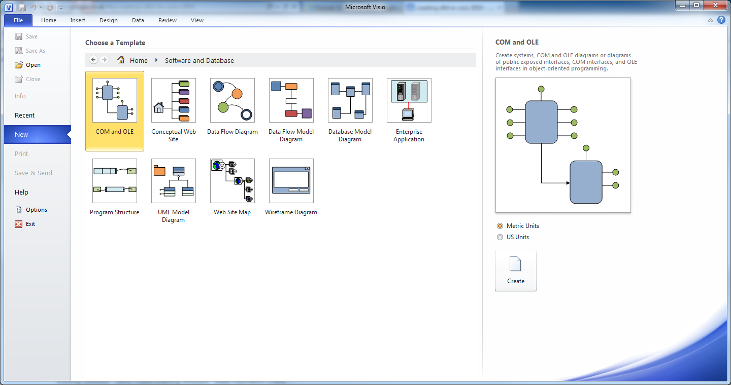
Choose Data Flow Diagram and create leave the units as Metric.
A well-documented version of DFD design is that of Gane-Sarson. Visio provides the following shapes;
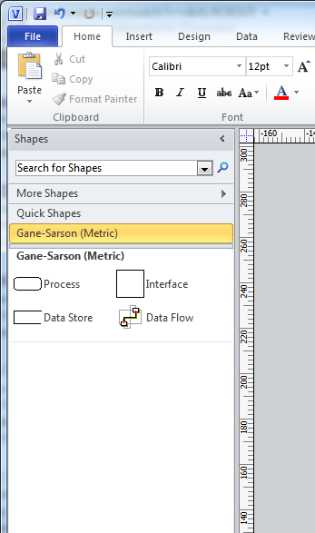
We drag and drop the shapes onto the drawing paper area and start to build our diagram.

Here are some good example of DFDs (Modern Systems Analysis and Design 7th edition Hoffer et al 2014 Pearsons Educational)

A retail clothing store.
How data is managed and flows through the store

Context Diagram

Management
Report

Report

Store
Manager

Customer
Receipt
Payment
0

Point of Sale
System

Level-0 Diagram

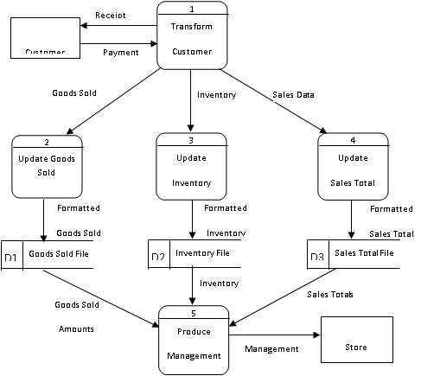

The following context and level-0 data flow diagrams represent one way to model a help desk process

Context Diagram

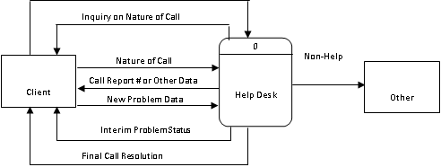

Level 0 Diagram
Open Call Information
5
Determine
Problem
Status
D2
Call Report File

Other
Unit

Client
Inquiry on Nature of Call
1
Receive
Call
Help Desk
Call Information
First Call
Information
Closed Call Problem
Resolution
Previous
Call
Information
Call
Information
Non-Help
Desk Call
Information
Call Report
Information
Final Call Resolution
New Problem Data
2
Determine
Direction
of Call
4
Create
Call
Report
D1
Call Queue
D1
Call Queue
7
Record
New
Information
8
Research
Problem
9
Close
Call
Report
Closed Call
Indication
New Information on Problem
Call
Report
Problem
Data
New
Problem
Data
Interim Problem Status
Problem
Information
Call
Call Report # or Other Data
Help Desk
Call Information
Open Call
Information
3
Determine
if First
Call
6
Transfer
Call
Inquiry on Nature of Call
Nature of Call

