University of Wales Trinity Saint David.
School of Engineering.


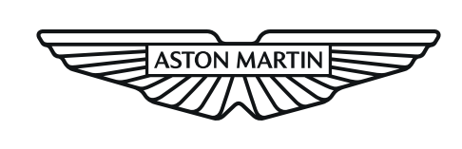

Name: Matthew Dewhurst

Student Number: 2113040

Date: 21/08/23

Subject: Stress Analysis & Dynamics
ACMA5010

Title: Analysis and Simulation of a
Centrifugal Clutch

Degree: BEng Manufacturing Systems

Table of Contents
1.0 Task A 3
1.1 Introduction. 3
1.2 Centrifugal Clutch Development. 4
1.3 Centrifugal Clutch Application. 6
1.4 Use of Electromagnetic Clutch 7
2.0 Task B 8
2.1 Question 1. 8
2.2 Question 2. 8
2.3 Question 3. 9
2.4 Question 4. 9
2.5 Question 5. 9
2.6 Question 6. 10
2.7 Question 7. 11
3.0 References. 13

1.0 Task A

1.1 Introduction.
The centrifugal clutch is a mechanical clutch that is commonly used in various machinery and vehicles to transmit rotational power from an engine to a driven component, in order to facilitate gear changes. This type of clutch operates based on the principles of centrifugal force; this is a concept used to demonstrate the outward force experienced by an object moving in a curved path, although no real force pushes the object outward. This is a product of the objects tendency to move in a straight line and the requirement for an inward force to keep it in a curved path.

Most commonly used in the system of a combustion engine the primary function of the centrifugal clutch is to engage and disengage the power of the engine from the transmission or drivetrain based upon the amount of revolutions per minute. As a result, where variable speed is not critical in an application, centrifugal clutches are a simple and effective device for transmitting power. With the application of a centrifugal clutch, a typical clutch paddle is not required in order to shift the clutch. The speed exerted by the engine can be dictated without the shifting through gears and this makes the centrifugal clutch more effective at high speeds.

(Figure 1 – Image of the contents within a centrifugal clutch.
Reference - (Lanceral, 2021).
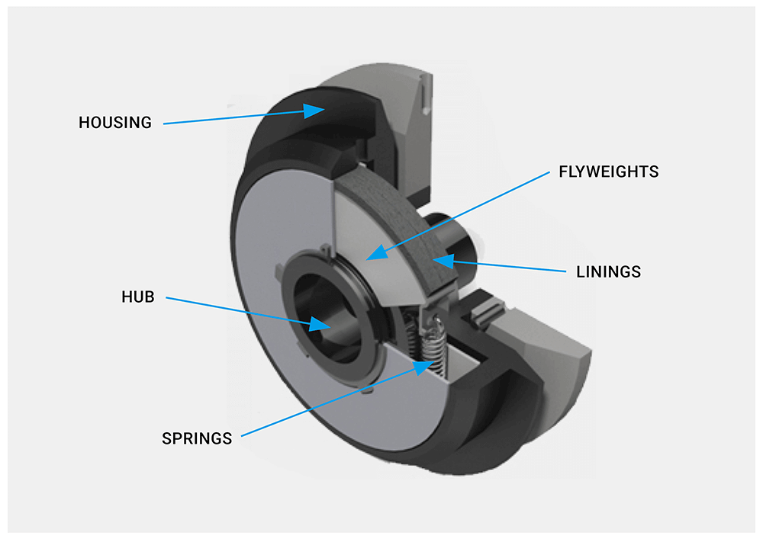

1.2 Centrifugal Clutch Development.
The centrifugal clutch dates back to the late 19th century and has seen continuous development and innovation for application in a wide range of machinery. This versatile type of clutch contains various parts in its construction but has three fundamental components, the hub, spring, and shoe.

(Figure 2 – Image that demonstrates the development of a centrifugal clutch.
Reference - (Dewhurst, 2023).

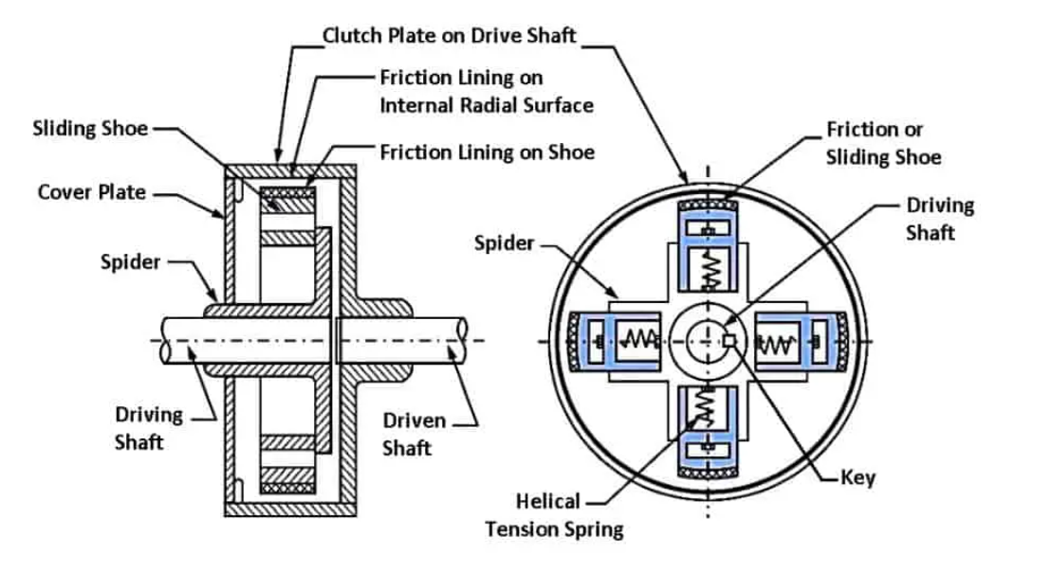
To create force to push the shoes of the centrifugal clutch outwards, the hub houses the driven force or otherwise known as the driving shaft. It allows the driven shaft to connect with the clutch and apply rotation, as one source explains that “The rotation of the hub forces the shoes or flyweights outwards until they come into contact with the clutch drum, the friction material transmits the torque from the flyweights to the drum.” (Lancereal (2019)). To ensure that the clutch receives an optimal amount of rotation, the hub is usually constructed from hard wearing materials such as steel. An improvement upon the use of steel to construct the hub component, is the introduction of stainless steel which has corrosion resistant properties. In applications such as small vehicles and lawn mowers, the hub is susceptible to moisture which could cause corrosion and weakening of the part.

Within the centrifugal clutch, a clutch spring is used to create a control between the engagement and disengagement of the clutch shoes. This means that the user has control over the acceleration and deceleration of the equipment in use. This is achieved by utilising the clutch spring to provide tension and therefore exert force onto the clutch shoes. Within the centrifugal clutch assembly there are multiple springs which creates a uniform force around the full circumference of the housing. The clutch springs are also commonly produced using steel as it is resistant to bending, however the heat produced by the clutch during continuous use can cause the steel springs to weaken. Therefore, high quality centrifugal clutches will utilise heat treated high carbon steel; this improved material offers greater wear resistance as a result of hardening the material. Applications such as motorsport and go-kart racing will benefit from the use of high carbon steel as they exert large demand onto the centrifugal clutch system, leading to immense levels of heat being produced within the clutch.

Under exertion of centrifugal force, the shoe of the clutch will extend outboard towards the housing as the force exceeds the force of the spring. When the shoes of the centrifugal clutch contact the clutch plate, friction is generated and therefore creates power that can be transmitted from the engine to the equipment at hand. As one source demonstrates, “The clutch’s shoes, also known as flyweights, push outward against the drum during engagement. When the clutch is idle, the springs connected to each shoe contract to prevent torque transfer.” (Sachin (2022)). Due to the heat being dissipated by the friction of the shoe, a heat resistant material must be used for this application to accommodate the generation of power. As a result, the shoe component of the centrifugal clutch is commonly manufactured using a range of metals and synthetic materials. One example is the use of semi-metallic friction materials as they have proven to have long life spans, due to the heat tolerance and durability which are properties that are derived from the combination of metal and synthetic fibres. These characteristics are therefore suitable for the application of controlling and ceasing heavy machinery. Alternatively, in some applications the shoes of centrifugal clutches are produced using ceramic friction materials as one source describes, “Ceramic friction materials are made of porcelain that is combined with sintered metals, such as copper, and are used for gentle stopping of motion. The main advantage of ceramic friction materials is how quiet and clean their operation is. They produce very little dust or noise when in use.”

1.3 Centrifugal Clutch Application.
Centrifugal clutches are commonly used in applications that require automatic engagement and disengagement of transmission based upon the speed of rotation. An example of this is the use within small engine vehicles such as go-karts and off road ‘buggies’, as the clutch allows the engine to idle without moving and can be engaged when acceleration is applied. The automatic engagement of the clutch benefits these vehicles as it eliminates the need for the user to change through gears manually as well as improving the acceleration for greater performance. Another example of the application of centrifugal clutches is within gardening equipment such as lawnmowers and chainsaws, as the clutch will engage when the engine reaches a specific speed or RPM. The centrifugal clutch is suitable for gardening appliances as it allows safer operation, due to giving the user the ability to engage the chain or cutting device as they please and when it is safe to do so.

There are many other benefits to the use of centrifugal clutches, including the low cost due to the limited amount of parts required to produce the clutch. Fewer parts are needed compared to other clutch types, creating a simplistic and cost effective component. Leading on from this, the basic construction of the centrifugal clutch is also beneficial for servicing requirements as the clutch is low maintenance and therefore the up-keep of the system is inexpensive. When researching the benefits of the centrifugal clutch, one source suggests that there is a reduced likelihood of the engine stalling and causing subsequent damage as “Heavy loads and abrupt starts can put a burden on engines. Instead, progressive engagement with the load is safer. Centrifugal clutches specialize in smooth and shockless acceleration.” (The BLM Team. (2021)) As a result, within small engine vehicle applications, the user can benefit from an improved driving experience.

1.4 Use of Electromagnetic Clutch.
An electromagnetic clutch functions through utilising two rotating shafts to engage and disengage the transmission of power, the principles of electromagnetism support the connection between the two shafts of the clutch. The input shaft is connected to a source of power such as an engine or motor, while the output shaft is connected to a load which is usually a transmission or gearbox. The electromagnetic clutch typically consists of 2 primary components, the electromagnetic coil, and an armature. When an electrical current is applied to the electromagnetic coil, it generates a magnetic field. The magnetic field then attracts the armature and causes it to move towards the coil. This connection between the armature and coil leads to the interaction between input and output shafts of the system, resulting in the transmission of power from one shaft to another and ultimately results in the engaged state of the clutch.

Due to the difference in properties, the applications of an electromagnetic clutch differ from those of the centrifugal clutch. As one source describes, there are many uses for the electromagnetic clutch as, “They can be used for remote application because they do not require linkage to actuate the clutch. They are used in printing machinery, conveyor drives, copier machines and factory automation. In an automobile, it replaces clutch pedal by a simple switch button. A smaller EM clutch is used to drive the compressor of air conditioning system.” (EMworks (2023)). The wide variety of applications is a result of the many advantages that an electromagnetic clutch offers, some examples of these advantages are ease of installation, wide torque range and silent operation. An illustration of an electromagnetic clutch is demonstrated below, it can be distinguished through its use of an armature.

(Figure 3 – Image that demonstrates the construction of an electromagnetic clutch.
Reference - (Dewhurst, 2023).

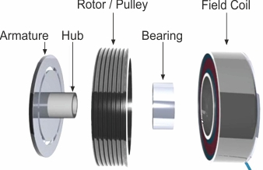

2.0 Task B

2.1 Question 1.
The internal radius of the centrifugal clutch can be determined by the addition of the distance between the centre of the shaft to the edge of the shoe, the clearance to the outer drum and the drum wall thickness. The resultant figure can then be multiplied by two to gain the diameter of the outer drum.

Distance of shoes centre of mass from centre of shaft = 95mm.
Distance between outer drum and centre of mass of shoe = 9mm.
Drum wall thickness = 4mm

Therefore,
Outer radius of drum (r) = 95+9+4 = 108mm

Diameter = (radius of outer drum (r) x 2)

Meaning,
Total outer diameter (d) = 108mm x 2 = 216mm.

2.2 Question 2.
To calculate the engagement speed of the centrifugal clutch, the angular velocity of the driving shaft that is required to allow the shoes to engage the drum must be found.

The force that the spring will exert can be calculated, using the formula F = -K x 𝓍.

F = -7500 x 0.009 = -67.5N

The centrifugal force is an equal opposite amount, and therefore = 67.5N

To find the angular velocity, or otherwise known as engagement speed, the centrifugal force formula must be re-arranged to find the product of ω.

F = m $ω^{2}$ r

Radius of drum excluding wall thickness = 0.104m

67.5 = 0.275 x $ω^{2}$ x 0.104

$ω^{2}$ = √$\frac{67.5}{0.275 x 0.104}$= 2360.13986014

$ω^{2}$ = √2360

$ω$ = 48.58 rad/s

$ω$ = 463.9 RPM

$ω$ = 464 RPM

2.3 Question 3.
To find the radial force acting on the clutch when the driving shaft is rotating at 550 RPM, the centrifugal force formula can be utilized.

550rpm = 57.595 rad/$s^{2}$

F = m $ω^{2}$ r
$F=0.275$x 57.59$5^{2 }$x 0.104 – 67.5
$$F=27.37N$$

This figure demonstrates the force of 1 shoe within the centrifugal clutch, however there are 4 shoes within the system.

F = 27.37 x 4
F = 109.48N
Overall force acting on clutch = 109.48N

2.4 Question 4.
At a driving shaft speed of 550 RPM, the value of the torque transmitted to the driven shaft can be calculated using the following formula.

Torque = Friction x Centrifugal Force x Radius

Torque = 0.35 x 109.48 x 0.104

Torque = 3.985 Nm.

2.5 Question 5.
A graph to display the torque transmitted at the driving shaft as a result of the driving shaft speed, from 450 RPM to 700 RPM can be seen below in figure 4. This graph demonstrates the increase in increments of 25 RPM.

(Figure 4 – Excel Graph that demonstrates increase in torque (N/M) due to an increase in drive shaft speed (RPM) with a friction coefficient of µ 0.35) - (Dewhurst, 2023).

2.6 Question 6.
If a coefficient of friction of 0.3 and 0.4 are adopted with the same analysis, the resultant speeds are displayed in figure 5.

(Figure 5 – Excel Graph that demonstrates increase in torque (N/M) due to an increase in drive shaft speed (RPM), with friction coefficients of µ 0.3 and µ 0.4.) - (Dewhurst, 2023).
As demonstrated by figure 5, an increase in the friction coefficient results in the amount of torque produced per RPM. This is due to an increase in the amount of friction between the shoes and clutch, which therefore means that less slippage occurs in the system. This is highlighted by using examples from figure 5, as with a friction coefficient of (µ) 0.4 results in a torque value of 4 Nm with an RPM of around 540 RPM. Whereas a friction coefficient of (µ) 0.3 leads to a torque value of 3 Nm with 540 RPM. This trend would continue as friction coefficient is increased and a wider sample range could be gathered on different coefficient values to demonstrate this.

However, this information cannot be considered to be entirely accurate as external and environmental factors have not been taken into account, as factors such as temperature, wear of the clutch or shoes and water ingress can have a detrimental effect on the friction coefficient of the system. These factors will also cause the friction coefficient to deteriorate over time, so should be monitored closely by the user.

2.7 Question 7.
To calculate the angular acceleration of the drum that will achieve the maximum possible torque the following formula must be used.

$$α=\frac{t}{I}$$

The value of ‘$t'$ can be taken from previous calculations and applied to this formula.

Torque ‘t’ = 12.54 Nm.

$$α=\frac{12.54}{I}$$

The value of $'I'$ is unknown, therefore the following formula can be used as a result of the drum being considered a solid disc.

$$I=\frac{1}{2} ×m ×r^{2}$$

$$I=\frac{1}{2}×0.75 ×{0.104}^{2}$$

$I=0.004056$ Kg/m²

With the value of $'I'$ now being known, the value of $'α'$ can be calculated using the following formula.

$$α=\frac{T}{I}$$

$$α=\frac{12.54}{0.004056}$$

$α=3091.72$ rads/s²

3.0 References.
EMworks (2023) Electromagnetic clutch, EMWorks. Available at: https://www.emworks.com/application/electromagnetic-clutch#:~:text=They%20are%20used%20in%20printing,compressor%20of%20air%20conditioning%20system. (Accessed: 01 September 2023).
IQSdirectory (2023) Industrial Quick Search, What Are They? How Do They Work? Types. Available at: https://www.iqsdirectory.com/articles/friction-material.html (Accessed: 25 August 2023).
JBJ Technologies (2023) Electromagnetic-clutches. Available at: https://www.jbj.co.uk/electromagnetic-clutches.html (Accessed: 01 September 2023).
Kumar, A. (2022) An Engineer’s guide for working of a centrifugal clutch, Skill. Available at: https://skill-lync.com/blogs/an-engineers-guide-for-working-of-a-centrifugal-clutch (Accessed: 25 August 2023).
Kumar, S. (2023) What is centrifugal clutch? - working principle, applications, advantages, disadvantages, Marinerspoint Pro. Available at: https://marinerspointpro.com/centrifugal-clutch/ (Accessed: 25 August 2023).
Lancereal (2019) Centrifugal Clutch explained – an engineer’s guide to a centrifugal clutch, Lancereal. Available at: https://www.lancereal.com/centrifugal-clutch-explained/ (Accessed: 21 August 2023).
O’Keefe, P. (2012) ‘Engineering Expert Witness Blog’, Mechanical Power Transmission – Centrifugal Clutch Shoe Wear, pp. 1–10.
Sachin (2022) Centrifugal clutches: A selection guide, BLM Automatic Clutch. Available at: https://www.blm-cm.com/blog/centrifugal-clutches-a-selection-guide/ (Accessed: 25 August 2023).
The BLM Team. (2021) Advantages and disadvantages of centrifugal clutches, BLM Automatic Clutch. Available at: https://www.blm-cm.com/blog/advantages-disadvantages-centrifugal-clutches/ (Accessed: 30 August 2023).

