

Modern Technology

Student Name: | Dimitrina Zheleva
Student Number: | 1806472
Module No: | BMSK4003
Module Title: | Digital skills and research methods
Lecturer: | Balendran Kandasamy

Table of Contents
Introduction 3
Smartphones. 4
Samsung Galaxy S9 or iPhone XS. 5
Cloud storage. 7
Google Drive or Dropbox 7
Social media. 9
Evidence of my online presence: 10
Conclusion 12
Bibliography 13
Appendix 1 14
Appendix 2 15

Introduction

This report will be focused on the modern technologies. During the report will be discussed how the technologies can being used in a business. What are the benefit to use them? Technology has entered so many people's lives in recent years that we can no longer imagine life without them. The means of communicating communicate with people and have entered many economic sectors. business is almost unthinkable without using the Internet. Does not matter if the business is small or big it needs to use advanced technology for business. They are classified into two types – Software and Hardware Technologies. Some of the most used business software include: Time tracking software, Accounting software, Customer management software, Human resource, Inventory software. The common used hardware includes smartphones, tablets, computers, wireless printers, cloud data storage and more. In our everyday life, we are almost entirely dependent on technology.

Smartphones.
The software development capacity over smartphone is wide. Can monitor orders, online magazines, answer customer requests and thereby help improve your everyday consumer experience. Depending on your business type, you can use apps to make your relationship with them easier. The best way to determine what you are using and what you can improve to be fully satisfied with it. Both for example say, if your company targets a broader audience and your primary relationship is through social media sites as well as company website, you can answer your questions quickly and easily via your smartphone. Software business account management apps have also been produced to quickly refresh your data at a certain time, or you can respond on- the- go when you receive a message from a user. Phone systems are going to evolve daily, a precondition for the introduction of progressively creative and useful software packages and smart phone programs. Every business needs sector- type of software and systems. Since a few years earlier, designers created desktop- only products. Now, besides web apps, there have been developed and many smart phone applications. They are becoming increasingly popular, and it is even possible to send SMSS credit without credit information (SMS land direkt utan uc). As well You can order specific applications that are right for your business. For example, instead of buying barcode scanners to track your products, with one application installed on your phone, you can scan any code using its camera. In addition to helping businesses, the smartphone can drive cars and even make non-contact payments. The smartphones have helped in a different way in the business. Can speak with customers, suppliers, staff, managers and more. Else send messages, emails, files, invoices, photo. Support conference call, printing of documents, store data and everything needed for a computer. Over and above that can be using every ware thank to its small size.

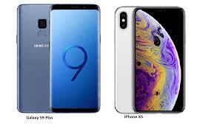

Samsung Galaxy S9 or iPhone XS.
Samsung Galaxy S9 and iPhone XS are closely matched in size. The design is not match different from the last year models, with a little change to the look. Both are built with a glass front and back, but iPhone XS with stainless frame and Samsung Galaxy S9 with aluminium frame. The mix of glass and metal helps the phone not to break easy. Both are a dust and water resistance, but iPhone XS can resist deeply. Samsung Galaxy S9 can be used as portable computer by plugging into Dex Pad. Samsung Galaxy S9 front-facing camera is 8MP whit f/1,7 aperture compare with iPhone XS – 7MP, f/2,2 both with 12MP rear camera, but iPhone XS dual sensor. Apple brand have made it is that the iPhones are more secure due to the fact that apple have created a cloud feature that will allow you to save all your information from past phones and accounts which can help save you lots of time. Although recently Samsung have realised a feature when you get a new phone you can log in through google account and that can save some things. iPhone XS use Apple App Store and Samsung Galaxy S9 use Google Play Store to download apps.
Personally I would recommend Samsung galaxy s9 because of its really powerful batteries and ergonomic designs which makes it useful for work with one hand, and it also has a better camera and display system. In addition it can act as a personal computer thanks to accessory Samsung Dex the new version of Samsung Knox guarantees the security of personal information. the download speed is 1.2Gbpsalso the s9 is waterproof. all these thing makes the Samsung s9 a suitable solution for ordinary users as well as for business. It is sold in 3 different colours black white and purple. As well the price for Samsung Galaxy S9 – 64 GB is £599.00, but for Apple iPhone XS 64 is £999.00 (www.currys.co.uk).

 | Samsung Galaxy S9 | iPhone XS
measures | 147.7 x 68.7 x 8.5mm | 143.6 x 70.9 x 7.7mm
Operating system | Android Oreo (8.0) | iOS 12
weighs | 163g | 177g
IP68 water resistance for 30 minutes | 1.5 meter underwater | 2 meters underwater
headphones | 3,5mm jack | XS wirelessly
USB-C port | Yes | No
RAM / Processor | 4GB / 845 / Exynos 9810 | 4GB / Apple A12
Stereo speakers | Yes | Yes
display | 5.8 inch | 5.8 inch
resolution | 2,960 x 1,440 | 2,436 x 1,125
Dolby Vision / HDR | No / Yes | Yes / Yes
Battery | 3000 mAh | 3000 mAh
Storage / Micro CD card slot | 64GB up to 256GB / Yes | 64GB up to 512GB / No
Rear camera / front camera | 12 MP one image sensor / 8MP | 12 MP Dual sensor / 7MP
Wireless and fast charging | Yes | Yes
sorces | https://www.techradar.com/uk/news/iphone-xs-vs-galaxy-s9 | https://www.techradar.com/uk/news/iphone-xs-vs-galaxy-s9

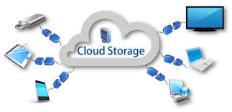

Cloud storage.
Google drive and One drive provide plenty of space, but Box is focuses on the business. Cloud Storage is a way to store, monitor, and retrieve your files from data stored on cloud servers. Sticking your files in the cloud is a convenient way to manage data all without fear of loosing it. Although it is not so conversant to many people, the most active internet users are already using these online storage services. You can access the stored files from your phone, tablet, desktop or any other device with an internet connection. Every cloud storage service gives you convincing offers. Many of the prevalent cloud storage services are Google Drive, Dropbox, OneDrive, Mega, Copy, Box and few other. Both of these cloud storage services, giving opportunity to store files from one device and retrieve them from any other device connected to the internet. Personal storage: services that allow individuals to store and sync data across multiple devices. Public storage: a cloud storage provider that fully manages data for an offsite company. Private storage: The cloud storage provider works on premises in the data center of an organization. Hybrid storage: public and private cloud storage mix.

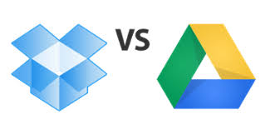

Google Drive or Dropbox

Google Drive is a cooperation of some of the features of Google one roof. Your Gmail can be connected to Google Drive for quick access to all necessary documents. The option Auto backup for photos is available and drag and drop easy. Completely free 15 GB of space. Online search possibilities actually help you interpret PSD files, many other image formats, and are easily integrated with the Gmail account. The benefit or disadvantage of Drive is the inaccessibility of mobile apps for both Windows and iOS.
Dropbox is free, but can be upgrade for £8 per month. Using a computer, there really is no relevant file upload size limit. You can view popular file formats with the built- in viewer. It also maintains the file history of the uploaded file for a period of one month along with log details. The storage capacity can be significantly increased by objecting mates. Documents can be posted in a short period and there is an alternative for choosy syncing.

There are many benefits to use cloud storage: Is it easily upgraded, always up, no IT maintenance cost, Off side data storage, shared Resources, productivity anywhere, Disaster assistance, lower cost of ownership.
Google Drive is better with strong customer support and is cheaper options, with many third party apps.
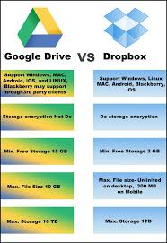

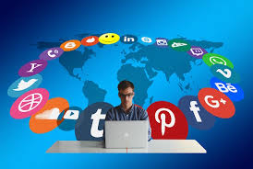

Social media.
Social media are technologically mediated media, created and used to communicate, share files, photos, media, information, ideas and other. There are different forms social media: images, text, audio and video recordings. They allow both social groups, individuals, and companies to communicate and share views, opinions, experiences, and other information. Some of the popular social media are twitter, Facebook, Instagram, discussion forums and more. By applying a set of theories of media research, Kaplan and Heinlein classifying six different types of social media: collaborative projects as Wikipedia, blogs and microblogs as Twitter, public content such as You Tube, social networks as Facebook, virtual gaming sites and virtual social worlds. Instagram has more than 300 million subscribers from around the word. Instagram passed Twitter and now rang second after Facebook. Instagram has amazingly many followers. The businesses achieved great result and improved their bottom lines with Instagram. By fowling many companies which are active on the platform can be seen what work in relation in the other businesses. Screenshots of the interesting photos can be used as inspiration for creating own content. The photos need to be high quality and can add characteristic. Creating Instagram Stories is easy to send images and video in format as slideshow. The social platform has several ad objectives which can be used to adverse in Instagram. The social media is necessary for any business.

Evidence of my online presence:

https://www.linkedin.com/in/dimitrina-zheleva-8b8103179/
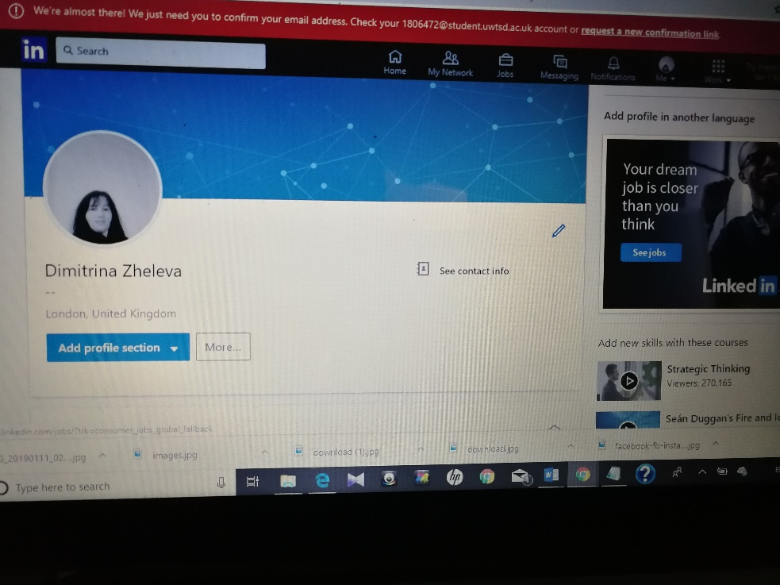

https://twitter.com/Dimitri40106297
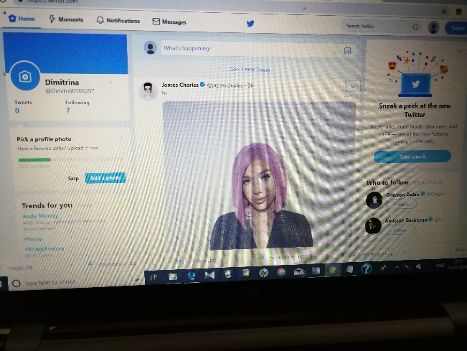
https://www.facebook.com/dimitria.zheleva.7

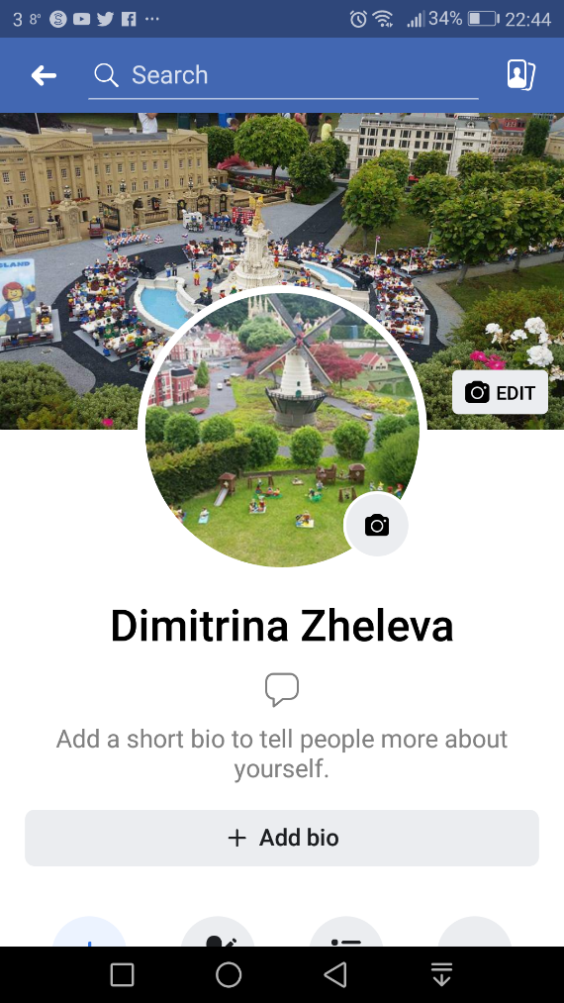

Conclusion

Modern technology has evolved a lot in the past century especially in the world of business. For example it has made a lot of things easier than they would have been in the past 10 years for example now we have computers and smartphones which we can have for many uses like copy and pasting saving work and transferring it from device to device and also now we have things like google witch we helps us get information about nearly anything from business work to flights to different countries. also in nearly every shop there is a self check out service witch leads to unemployment so that more and more people are starting to louse there jobs. But paying with contactless cards or mobile phones can save some time. Thanks to cloud storage now we do not need to carry around disks or hard drivers or to carry around our documents or pictures we only need to log in to our account and we will have access to all stored data. Now social media allows business to grow by advertising there business / product which is used by big and small companies to grow more and make more profit. Now we don’t need to travel far to meet our partners now we can just make conference calls or video calls to discuss about the future business.

Bibliography

https://www.techradar.com/uk/news/iphone-xs-vs-galaxy-s9

Kaplan A.M., Heinlein M, (2010) Users of the world, unite! The challenges and opportunities of social media, Business Horizons, Vol. 53 Issue 1 (p.61)

https://neilpatel.com/blog/succeed-instagram-business/ [2019]

https://epis.bg/internet/instagram-prevze-biznesa/ [2019]
https://www.tutorialspoint.com/articles/onedrive-vs-dropbox-vs-google-drive-vs-box [2019] https://www.eexploria.com/google-drive-vs-dropbox-features/[2019]
https://www.currys.co.uk/gbuk/search-keywords/xx_xx_xx_xx_xx/samsung%2Bgalaxy%2Bs9/xx-criteria.html[2019]

https://www.currys.co.uk/gbuk/phones-broadband-and-sat-nav/mobile-phones-and-accessories/mobile-phones/362_3412_32041_xx_ba00011553-bv00312946%207cbv00312947/xx-criteria.html [2019]

www.google.com[2019]
www.dropbox.com[2019]

Appendix 1

Appendix 2

