ECAY4001 Ass 2 Student Number: 1806352
How should an independent advocate ensure that they support the needs of their client and ‘hear their voice’? Link to theory, policy and practice?
This portfolio contains all information that an independent advocate would need to work with looked after children within the care system. This portfolio is created for an independent advocate working within Wales focusing on supporting foster children during their time within foster care. As an independent advocate working with Wales it is essential to know the latest statistics, legislation and practises to ensure that the looked after children are supported correctly. Furthermore this portfolio will discuss how advocacy is becoming more widely recognised as an essential service children within care should be able to access and receive support. This portfolio will further contain information explaining why advocacy has become a necessity within the modern world and what legislation caused the changes seen today.
As an independent advocate it is essential to work with the looked after children to ensure that they are being heard by the multiple social workers and case workers surrounding their case. It is the role of the independent advocate to ensure that the looked after children are empowered to speak up when unhappy with their circumstances and when they feel they are being mistreated or ignored.
This portfolio contains the 1989 Children’s Act (Section 24D) (Appendix 1) This has been included as it is the foundation of advocacy for looked after children. This is placed within the portfolio as it contains a base of what independent advocacy is. In it is stated that each local authority will be considered responsible to “establish a procedure for considering representations (including complaints) made to them by,” This primarily was directed to children within care, and care leavers as it created a way for them to have their voice heard. This is essential background knowledge for an independent advocate beginning their career within Wales as it shows that even back in 1989 it was clear that representation was a necessity for children within care. This is relevant legislation as it is kept regularly up to date and was last updated with all changes on the 17th of March 2019.
Another important piece of legislation included in this portfolio that will create a strong foundation for an independent advocate within Wales is strong knowledge of the United Nations Convention on the rights of the child, otherwise known as the UNCRC (Appendix 2). This was adopted by the UK Government in 1991 and was put in place as the foundation for child welfare decisions by the Welsh Government in 2004 to ensure that children’s rights were being considered and protected at every turn. Within this there are two rights that specifically apply to providing and promoting the voice of a child. Article 12 provides a view that any child who is able to form their own opinions or views have the right to speak freely and be listened to. This also states that the information can be provided from the child themselves or directly through a representative speaking for the child, such as an independent advocate. This is an important article within the legislation as it is a law that is abided by Wales strongly and is consistently used as a foundation for policies to be built upon.
Another article found within the 54 established that embody the UNCRC that directly relates to advocacy is article 13 (Appendix 3). This article is focused on hearing the voice of children was it states that children must have the freedom to speak up and express themselves. This also states that the child has the right to express themselves through any source they require varying from writing to orally being heard. This is important to consider as an independent advocate as it supports the ideology that children will express themselves in varying ways and thus an advocate must be able to adapt themselves to work with the medium the child prefers while still providing them with the power to speak up. All information contained within the UNCRC is relevant to any independent worker working within an advocacy environment.
Children within the care network need consistent support and will not trust an independent advocate if they cannot be relied upon. It is essential as an independent advocate that all legislation is at the forefront of the mind to ensure that the relevant child is being provided with everything possible. Furthermore, it is essential that the advocate works with the child to ensure the level of care they are receiving is correct and that any grievances they have are being spoken and dealt with.
Independent Advocacy services were initially established in 2000 after a recommendation from The Waterhouse Report (Appendix 4). This was established after a clear lack of care was provided to children in care within the county council areas of Gwynedd and Clwyd. These findings pushed the government to become aware of the drastic lack of services available for young children within care.
After these events there were many changes put into place. This was swiftly followed by a review of the advocacy provisions within Wales and the standards being upheld which led to the national standards for advocacy being published in 2003.
All of these policies and legislations are essential knowledge for an independent advocate working within wales as they explain where advocacy has been and where is originated from. However there is current legislation that is vital for a practising independent advocate to be aware of and to follow.
In 2011 the Welsh Children’s commissioner carried out an extensive review of independent advocacy. This review is contained within this portfolio (Appendix 5). The review discovered that independent advocacy was being provided with the 22 local authorities. However the review also found that that many children within care were completely unaware of their right to access and advocacy professional. This is an area of concern as a child cannot access help if they aren’t made aware of it. This was an extensive review conducted across all welsh local authorities and a variety of methods were used to provide a clear image of the effect’s advocacy had on children and the experiences they had, varying from positive to negative. The consensus discovered from this review is that children were simply unaware of the concept of advocacy and had a lack of understanding towards the use of it. There also was a clear sign that some social workers were not providing the option of an advocate to the looked after child as they felt they were doing the role already and it was unnecessary to add another professional into their lives. Although understandable as an independent advocate it is important to understand that the looked after child may not have an understanding of the role an advocate plays and thus it will be essential that using the correct language for the child an explanation is made and an understanding is come to otherw2ise a looked after child may be resistant to communicating with the advocate. A looked after child will not often work with an individual whom they see has no purpose or is of no help to themselves.
As an independent advocate it will be key to listen to the looked after child and not judge. It will be their role to support the beliefs of the child and to aid them discover the power within to speak up. In situations where this is not plausible it will be important to ensure that the advocate has a clear understanding of the child, thus their views can be correctly represented, and their wishes can be correctly expressed.
It is essential as an independent advocate that there is a clear understanding of the fact that in March 2018 6,407 children were being looked after by the local government (Appendix 6). This is an increase of eight percent from the year before. This means there is a need for independent advocacy more than ever before. It will be essential to make independent advocates accessible for those children and to provide a consistent level of care for those children. While the number of children being looked after by local authorities is consistently rising the demand for advocacy is further increasing. This also effects the way an advocate will work, they must be knowledgeable and efficient to ensure the correct procedures are followed through. Furthermore they must be organised as they must know which children are facing which issues and how they can directly empower them to allow them to take some control within their lives.
A very important piece of legislation contained within this portfolio is the Social Services and Well- being (Wales) Act 2014. This piece of legislation is continually relevant for all working with looked after children. This code sets out how there is a responsibility with local authorities to ensure that there is “access to advocacy services and support is available to individuals.” (Gov.wales, 2014) This alone is a key message that independent advocates must abide by. The purpose of this legislation is to ensure that individual needs are being listened to when the local authority is making judgement on their life. An independent advocate must be able to speak for the child while only expressing their needs and fighting for what the client wants, not what the advocate believes they should receive. It will be essential as in independent advocate that the client’s requests come first and foremost and that all outside opinions or judgements are put out of mind.
Within this legislation there are many sections that relate to an independent advocate working with looked after children. These are all contained within the portfolio and their relevance and importance will be explained. It is the local authority’s responsibility to ensure that a looked after child is “advised of the availability of independent advocacy services.” (Gov.wales, 2014) As seen in 2011’s review discussed above, this is not always completed as it should be. It is the independent advocates role to ensure that the looked after child knows entirely why the advocate is there. It is the advocate’s role to empower the child and to ensure that a bond of trust is in place.
As an independent advocate is essential to be aware that there is a safeguarding responsibility. (Appendix 7) A looked after child may divulge information to them in confidence and thus it will be the independent advocates responsibility to ensure that they follow the correct procedures to prevent any further harm to the looked after child. Advocates must work to empower a looked after child and to ensure they are providing them with the agency to speak up and be heard.
Another role an independent advocate assumes for looked after children is that of a support network when the child is going through a complaints procedure. As seen in section 112 of the Social Services and Well- being (Wales) Act 2014 (Appendix 7) an advocate must be able to understand the complaints procedure so they can fully support the child from initiation of the process to resolution. The advocate must enable the child to seek the resolution they require and must provide all information possible to the child to increase the chances that they will get the result they require. They must be able to support and advice the looked after child throughout the whole process and thus must have a clear understanding of the issue and fully understand the perspective of the child.
An independent advocate must be prepared to work with a looked after child from every situation and must be able to adapt themselves to work with a wide variety of situations. Each child will have their own barriers and it is important that an advocate has solutions to the barriers in place. An advocate must understand all of the policies included in the portfolio and any others relevant to the case they are dealing with at the time. An advocate must also be able to support their client and explain the services available to themselves.
With looked after children an independent advocate will be able to attend LAC reviews to ensure that throughout the meeting the child’s views are heard and not brushed over. Furthermore if a child has an issue with the results of their LAC review or with the way it was conducted an independent advocate can guide them through the complaints process. This is an essential moment for a looked after child to have the ongoing support of an independent advocate as there are many decisions such as placement that can otherwise be changed without the careful consideration of how this may affect the child.
Advocates can change the future for a child by simply providing them with the voice to have their opinions heard. As seen in this portfolio (Appendix 8) shows how advocacy can change a looked after child’s life. In 2012 a young male in care spoke to one of children’s society’s advocacy programmes to find advice about restarting contact with his father. After an extensive discussion with an advocate within the young male’s placement the advocate discovered that he was unhappy in his placement and was mistreated in a care unit he had previously been placed in. As a result of him trusting the advocate he was working with and making the complaints he was moved into a new placement and the unit he was mistreated in was investigated and is no longer allowed to house children. This all resulted in him living a happier settled life.
In summary, an independent advocate holds an incredibly important position within a looked after child life. It is their responsibility to ensure the child is afforded every opportunity that is available to them. It is further their role to support them throughout any complaints procedures and to enable them to speak up for themselves. Advocacy is becoming more widely recognised daily within wales as seen in (Appendix 9) of my portfolio. Adverts such as these are appearing in news articles, on websites and in newspaper which is raising the awareness of the use of an advocate. As an independent advocate all the information in this portfolio will be relevant to the majority of cases they will face and will provide them with a strong knowledge base to ensure that they are supporting the needs of the child and providing a platform for their voice to be heard from. The independent advocate will work as a bridge between the looked after child and the local authority providing their care. They could very well change the future of the looked after child by being the support network they require.

Word Count: 2424

References
Advocacywestwales.org.uk. (2019). [online] Available at: http://advocacywestwales.org.uk/aww/wp-content/uploads/2018/09/AR-2017-2018.pdf [Accessed 11 Mar. 2019].
Anon, (2019). [online] Available at: https://gov.wales/docs/dhss/publications/151218part10en.pdf- [Accessed 9 Mar. 2019].
Ascymru.org.uk. (2019). Who we are :: AS Cymru. [online] Available at: https://www.ascymru.org.uk/about/who-we-are [Accessed 9 Mar. 2019].
Downloads.unicef.org.uk. (2019). [online] Available at: https://downloads.unicef.org.uk/wp-content/uploads/2010/05/UNCRC_united_nations_convention_on_the_rights_of_the_child.pdf?_ga=2.67238417.1655840613.1552830904-506456846.1552440313 [Accessed 6 Mar. 2019].
Gov.wales. (2019). [online] Available at: https://gov.wales/docs/dhss/publications/151218part10en.pdf [Accessed 9 Mar. 2019].
Legislation.gov.uk. (2019). Children Act 1989. [online] Available at: https://www.legislation.gov.uk/ukpga/1989/41/section/24D [Accessed 6 Mar. 2019].
Legislation.gov.uk. (2019). Children Act 1989. [online] Available at: https://www.legislation.gov.uk/ukpga/1989/41/section/24D [Accessed 9 Mar. 2019].
Lukeclements.co.uk. (2019). Independent Advocacy | Luke Clements. [online] Available at: http://www.lukeclements.co.uk/rhydian-social-welfare-law-in-wales/independent-advocacy/ [Accessed 11 Mar. 2019].
Pona, I. (2019). The great value of advocacy for children in care. [online] The Children's Society. Available at: https://www.childrenssociety.org.uk/news-and-blogs/our-blog/great-value-advocacy-children-care [Accessed 8 Mar. 2019].

Appendix
1: 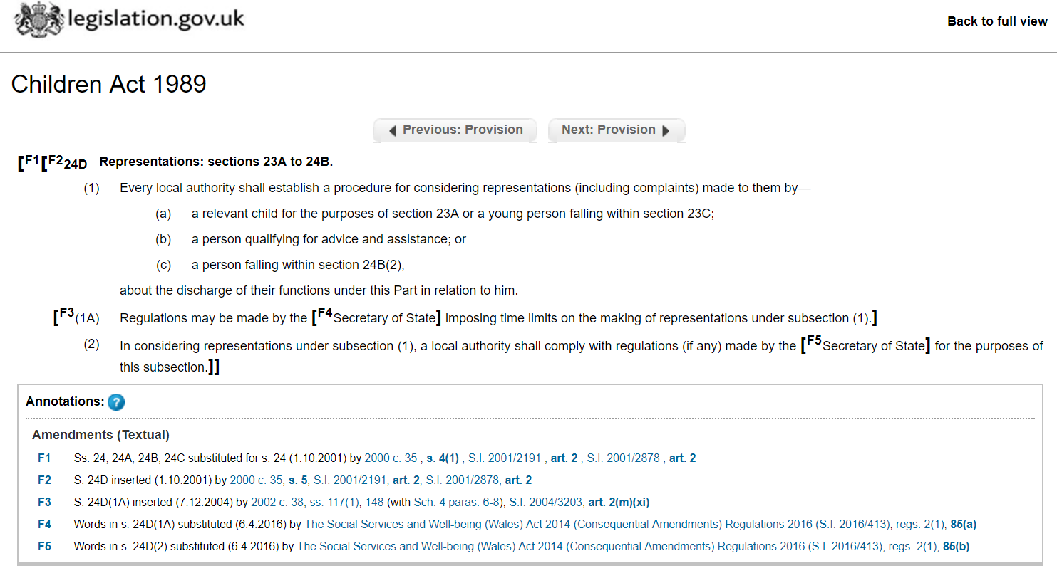

2 & 3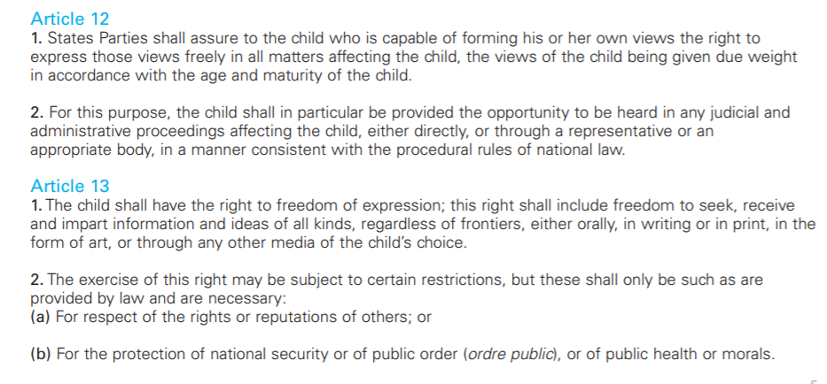

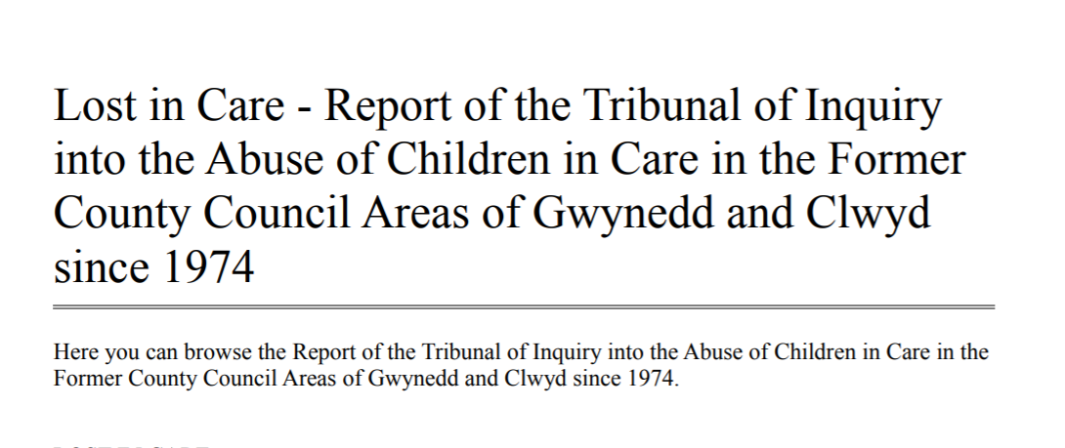
4:
5:
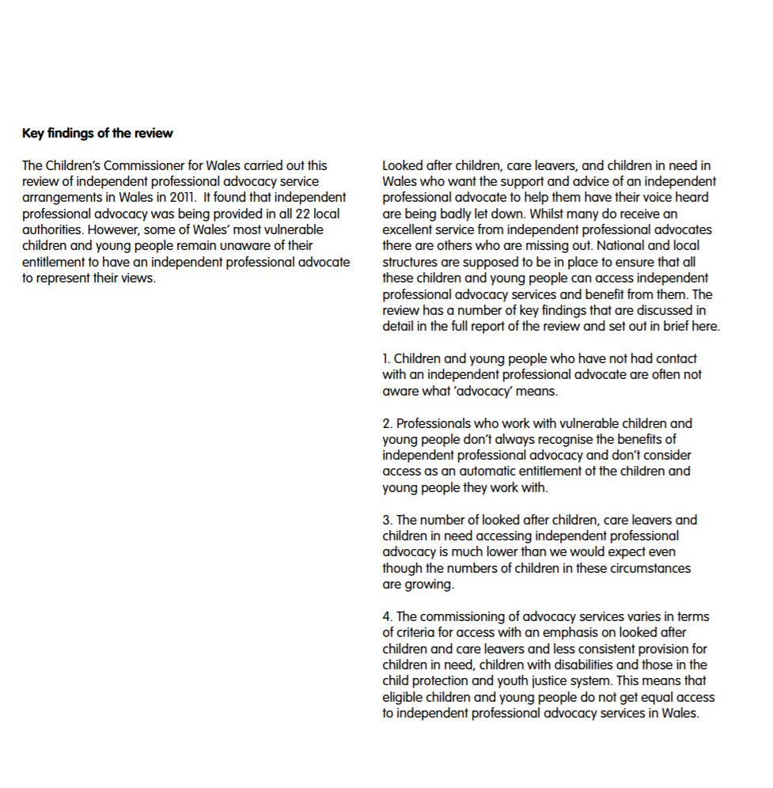

6:
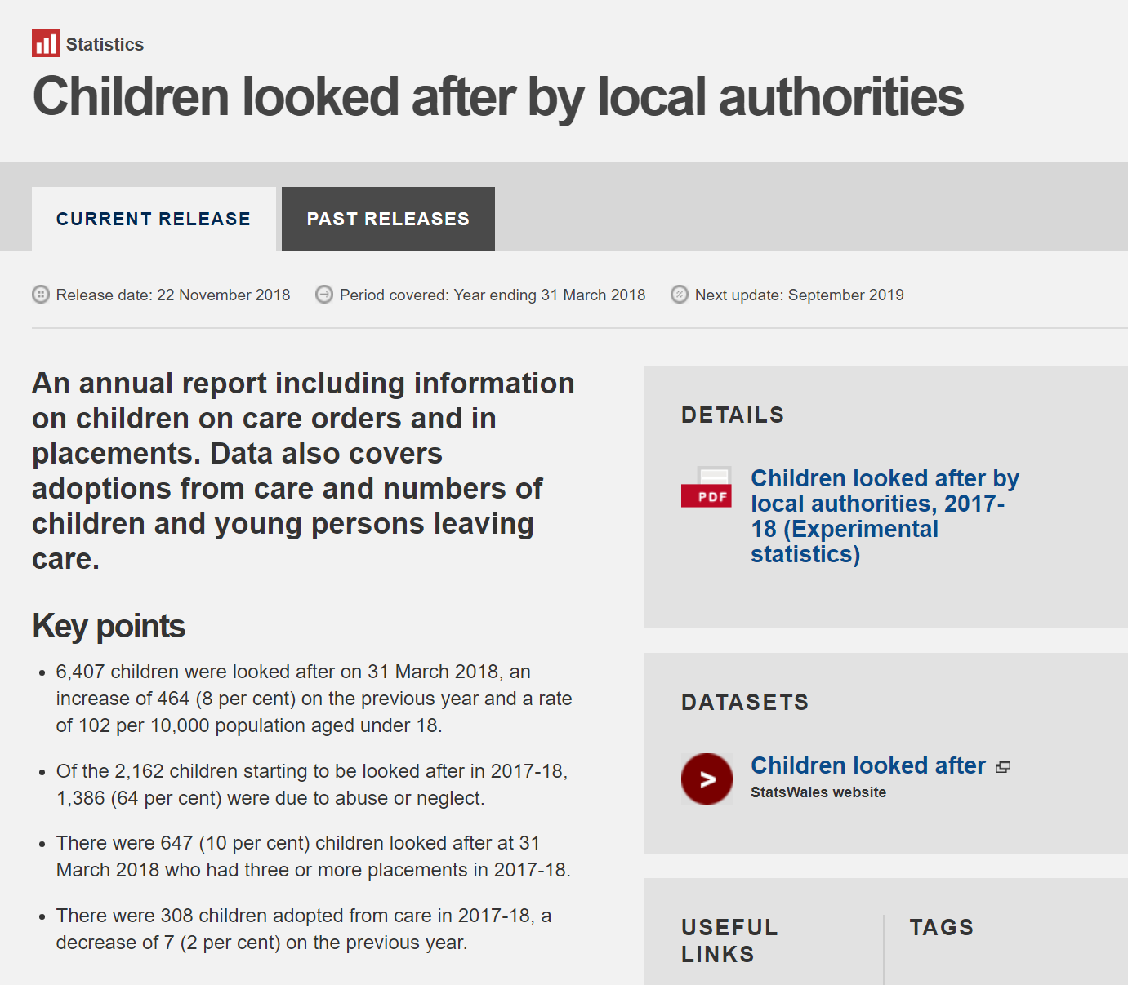

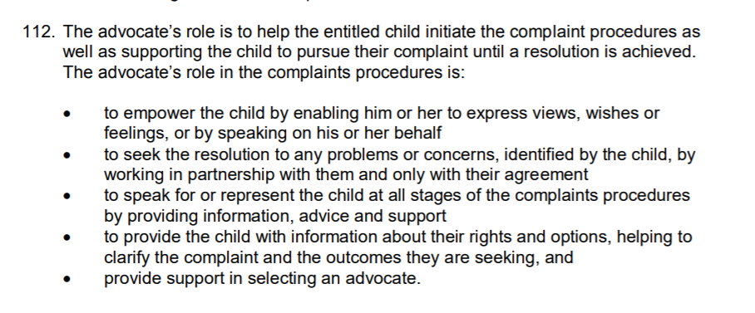
7

8
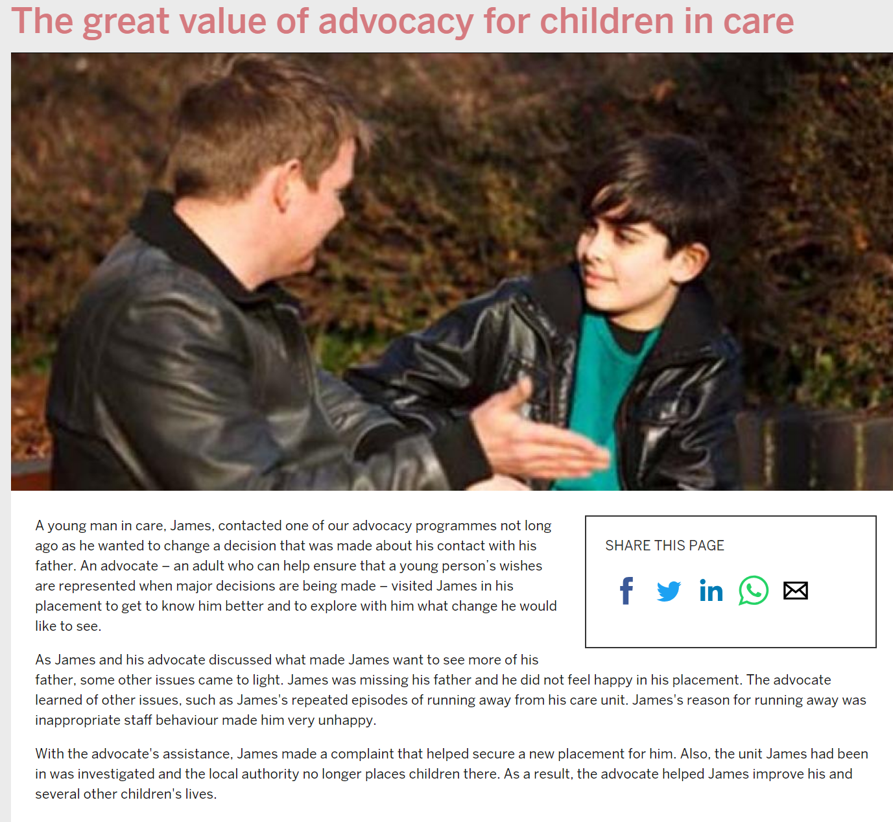

9

