Creativity, Value Creation and Health & Social Care Improvement Portfolio
Health and Social Care,
Table of Contents
Task 1 – Concept Map 2
Task 2 – Self‑Reflection on the Convergent/Divergent Paperclip Thinking Activity 3
Task 3 – Case Study of a UK Innovation: Remote Monitoring of Long‑Term Conditions 4
Task 4 – Research Task: Mental Health Stigma and Access to Care 5
Task 5 – Podcast: Introducing My Innovation Idea (Script) 6
Task 6 – NHS Leadership Framework Analysis 7
Task 7 – Self‑Reflection Journal Entry 9
Reference List 9

Task 1 – Concept Map
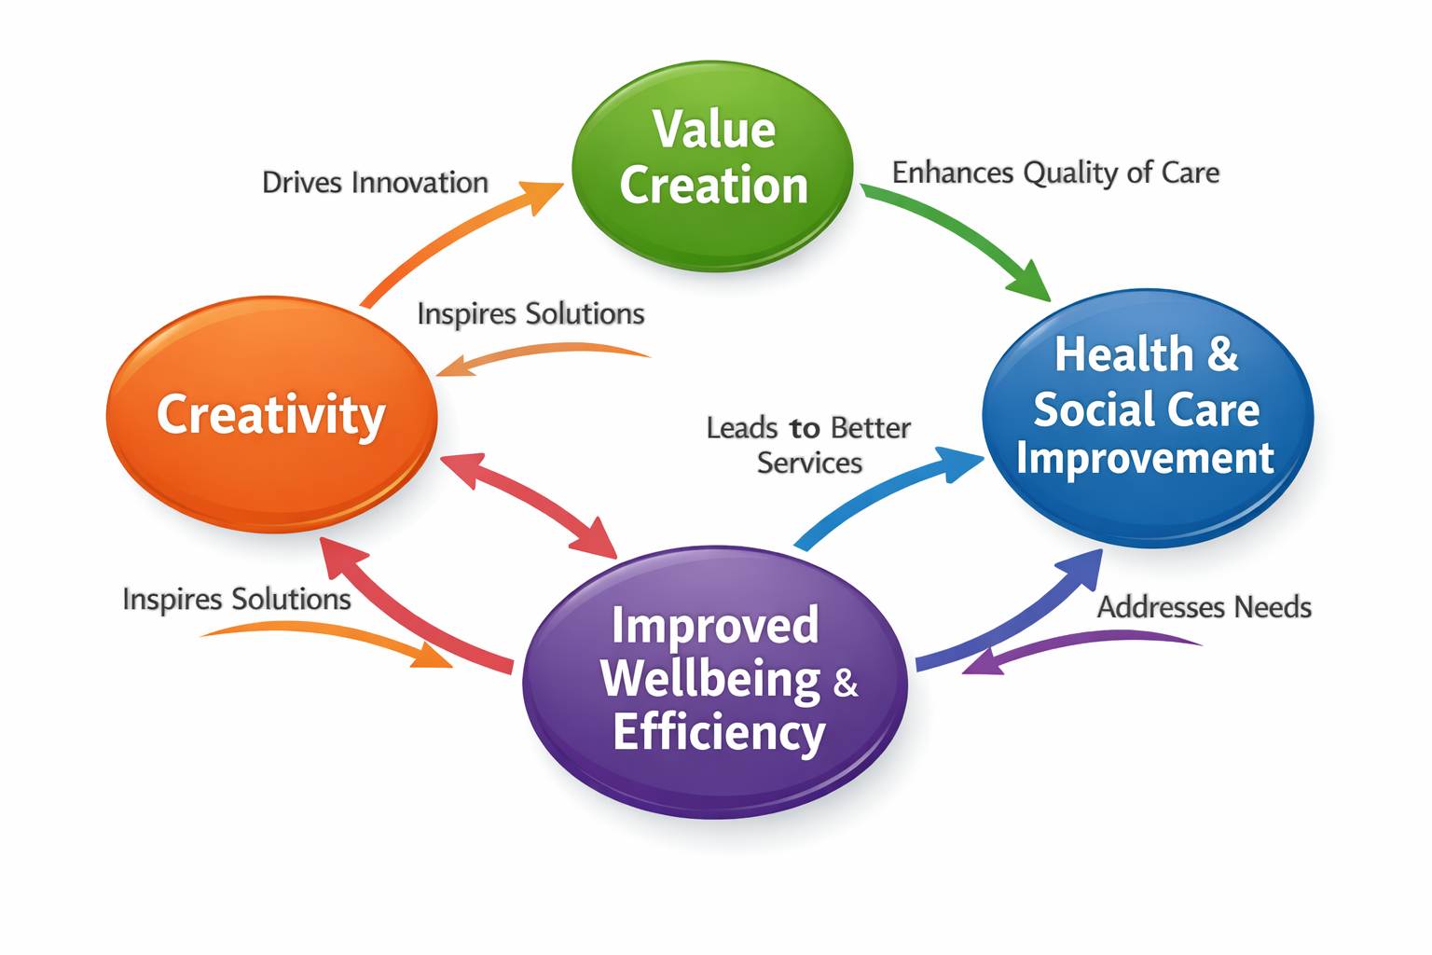
Figure 1. Concept map linking creativity, value creation and health & social care improvement.
Creativity, value creation and health and social care improvement are interlinked concepts. Creativity involves generating novel and useful ideas that can solve complex problems; in health and social care it can be fostered through human‑centred design and supported by leadership that empowers frontline staff to experiment and explore new approaches Value creation in health care, meanwhile, is defined by improvements in patient outcomes relative to the cost of delivering care This means value is not created simply by reducing costs; it is realised when care leads to better capability, comfort and calm for patients The concept map shows how creativity drives innovation and leads to the generation of new solutions such as digital tools, redesigned pathways or new services. Those innovations create value by improving outcomes and experiences for patients and reducing wasteful activities. Value creation then feeds back into health and social care improvement, leading to safer, more effective and more person‑centred services. As services improve, the environment becomes more supportive of further creative activity, creating a virtuous cycle. Leadership plays a pivotal role in this relationship. Zuber and Moody (2018) note that healthcare needs fresh thinking and creative problem solving and that frontline nurses feel unsupported to take risks Their research highlights enabling conditions such as psychological safety, clarity of goals and active experimentation, which encourage staff to contribute creative ideas. Teisberg et al. (2020) emphasise that value‑based health care requires multidisciplinary teams to design comprehensive solutions and measure outcomes When teams are empowered to innovate and evaluate, they can generate value for patients and reduce costs. Thus, creativity fuels value creation, and together they drive continuous improvement in health and social care.

Task 2 – Self‑Reflection on the Convergent/Divergent Paperclip Thinking Activity
In Week 2, we participated in a paperclip thinking exercise, brainstorming several uses for a paperclip before identifying the most plausible ones. The Improvement Cymru toolkit suggests that divergent thinking fosters creativity and collaboration by allowing participants to submit diverse ideas without judgement. Convergent thinking prioritises and refines these ideas using logic and evidence. In the divergent phase, each group member quickly suggested several uses for a paperclip, from holding documents together or unlocking a phone SIM tray to making jewellery or emergency fishing hooks. The facilitator established a safe environment by highlighting that no idea was incorrect, promoting psychological safety.Initially, I felt self-conscious about suggesting unconventional ideas, but as more creative proposals surfaced, I gained confidence (Health Innovation Yorkshire and, 2026). The encouraging environment allowed me to openly contribute without fear of censure. The divergent phase produced many ideas, showing communal creativity. Some people led talks, limiting quieter voices. The convergent phase aided in focus but limited creativity prematurely, favouring practical over novel ideas (Zuber, 2018). Iterative creativity and value creation are shown in the exercise. Divergent thinking encourages discovery, allowing teams to rethink methods and produce possibilities. Convergent thinking evaluates ideas to maximise value and match resources. Facilitators must combine inclusive involvement with decision-making, as highlighted in the process. Using psychological safety and structured brainstorming tools like nominal group technique promotes equitable input and prevents dominating voices from compromising innovation.Conclusion: Health and social care creativity requires expansive and focused thought. Divergent thinking generates options, while convergent thinking validates ideas and aligns with corporate goals.Action plan: To promote fair involvement in future group activities, I will encourage quieter colleagues to offer their ideas early and recommend using sticky notes or digital tools. I will also schedule time for divergent investigation before converging to maintain creativity and find practical solutions. Gibbs' cycle—description, feelings, assessment, analysis, conclusion, and action planning—helps me evaluate my learning and plan improvements.

Task 3 – Case Study of a UK Innovation: Remote Monitoring of Long‑Term Conditions
Background, challenge: Long-term diseases like Type 2 diabetes, COPD, and heart failure strain primary and secondary care resources. Traditional treatment for exacerbations involves clinic visits and hospitalisations. Health Innovation Yorkshire and Humber reported on a pilot employing the ‘Luscii’ remote monitoring solution in January 2026 to support patients with numerous long-term ailments. The program sought to empower patients and eliminate unnecessary medical procedures and hospitalisations.A creative approach: Creative thinking involved using digital technologies and human-centered design to reimagine care routes. Patients used cellphones or tablets to measure vitals at home. Data was securely sent to clinicians for real-time trend analysis and preemptive intervention (Teisberg, 2020). Continuous remote support replaced episodic appointments in this arrangement. The pilot modified primary care workflows to include distant data into decision-making. Through teaching and feedback, the solution promoted self-management and confidence in patients (Bouttell, 2026).Created value: The Leeds pilot review revealed a 47% reduction in A&E visits and an 80% reduction in unscheduled inpatient admissions. Patients felt more empowered to manage their diseases at home. An economic review at Imperial College Healthcare NHS Trust predicted savings of almost £398,000 in hospital costs for 146 newly diagnosed heart failure patients within 90 days. Value creation is demonstrated by improved patient outcomes (fewer admissions and improved self-management) compared to remote monitoring costs. A national evaluation by Eastern AHSN and ARC East of England found that remote heart failure monitoring can minimise hospitalisations and mortality. The review found multiparameter monitoring effective and advised careful patient selection and explicit guidelines. Non-invasive remote monitoring is beneficial for lower-risk patients, as supported by the Luscii pilot.Health and social care lessons: The initiative shows that service design creativity and digital innovation may benefit patients and the NHS. To ensure success, co-design pathways with clinicians and patients, provide training and support, and establish explicit data review governance. The pilot shows that remote monitoring's success depends on patient engagement and condition. The initiative shows how human-centered technology may improve patient experience and minimise service demand when deployed properly.

Task 4 – Research Task: Mental Health Stigma and Access to Care
Mental health stigma in the UK hinders treatment. Two scholarly research explain why stigma endures and hampers help-seeking across cultures. This narrative review defines stigma as a pervasive combination of negative preconceptions, prejudice, and discrimination that hinders mental health disorder diagnosis and treatment. The authors emphasize that stigma causes people to fear and shun mental health care, delaying treatment even for severe symptoms. It impacts patients, families, healthcare workers, and society. Family guilt can lead to withdrawal, and professional demoralization can lower treatment quality. Stigma causes underfunding and neglect of mental health services. The review shows that stigma varies by culture and is influenced by societal norms and beliefs, suggesting that therapies should be culturally adapted.Stigma harms in various ways, according to the review. It delays treatment because people fear being labeled or shunned. Social isolation and prejudice further marginalize mental illness, hurting job and personal relationships (Health Innovation Yorkshire and, 2026). Stigma predicts drug discontinuation, reducing treatment adherence. A cross-sectional survey of UK young adults suggests that eliminating stigma involves education to challenge stereotypes and contact-based interventions to promote empathy and understanding. This study examined why 203 young persons aged 18-25 may not seek mental health care. The study discovered that 35% of participants with emotional or mental health issues did not seek formal or informal assistance. Key challenges identified in the study include stigmatizing ideas about mental illness, difficulty expressing concerns, self-reliance preference, and difficulty getting treatment. The study also found that young people may think professional aid is ineffective or worry about confidentiality.A major issue was stigma. People feared being judged or labeled and being seen as weak or inadequate. Such views prevented individuals from discussing mental health with doctors or loved ones. To minimize stigma and promote help-seeking, authors recommend public awareness campaigns and mental health literacy programs. Early screening and focused outreach in primary care can also identify distress and guide young people to appropriate support. These studies demonstrate that stigma affects individuals, families, professionals, and society. Negative preconceptions and discrimination hinder or prevent help-seeking, worsening results and quality of life. Stigma effects mental illness patients, families, and professionals, leading to exhaustion and under-resourced treatments. Effective initiatives must address stigma holistically by educating the public, challenging misconceptions via direct interaction, and providing culturally relevant and accessible services.

Task 5 – Podcast

Task 6 – NHS Leadership Framework Analysis
Healthcare Leadership Model overview: Since 2013, the NHS Healthcare Leadership Model has offered a behavioural framework for leadership development in clinical and non-clinical jobs, with updates until 2025. Effective leadership is found at all levels when people inspire, connect, and develop others. Universal application, behavioural focus, and gradual development underpin the approach. It has nine interrelated components that represent leadership behaviours.1. Inspiring shared purpose: Leaders are curious in improving services and follow NHS values (Zuber, 2018). They inspire teams to provide high-quality care by creating a shared purpose (Improvement Cymru Academy, n.d.).2. Careful leadership: Effective leaders build secure, supportive environments by understanding their teams' different requirements. Staff well-being affects patient outcomes, thus empathetic leadership is crucial.3. Information evaluation: Leaders evaluate diverse information with analytical rigour and sensitivity to different viewpoints. This facilitates evidence-based decision-making.4. Connecting our service: Leaders understand how health and social care services interact and how decisions cascade. Systems thinking helps them predict implications and form partnerships.5. Share the vision: Leaders collaborate with stakeholders to shape futures, involving patients, communities, and staff.6. Team engagement: Leaders foster diverse teams via meaningful involvement and shared decision-making.7. Holding to account: Leaders set expectations and provide assistance and resources (Bouttell, 2026). Accounting promotes learning and progress, not blame.8. Building capability: Leaders coach and reflect to develop individual and group capacities in their daily work.9. Building networks and appealing narratives, leaders influence change beyond formal authority.The concept promotes continual development through a four-part behavioural scale: essential, proficient, strong, and exemplary. The non-hierarchical growth enables junior personnel to excel in certain areas while senior executives may need to improve in others. Focusing on behaviours rather than responsibilities fosters a democratic and inclusive leadership style. To foster innovation, apply the ‘Engaging the Team’ dimension. The ‘Engaging the Team’ dimension promotes innovation and concern. It promotes inclusive teams that feel appreciated and involved in decision-making. A leader can actively create psychological safety so that all team members, regardless of job or seniority, can contribute ideas without fear of ridicule to foster creativity. According to Improvement Cymru, encouraging divergent thinking and using tools like brainstorming and nominal group approach can help teams create diverse ideas.By including quieter members and varied opinions, the leader should promote fair participation. After brainstorming, the leader leads convergent thinking to assess patient outcomes, feasibility, and NHS values. Keep value creation in mind by communicating purpose and goals. Giving constructive feedback and acknowledging contributions boosts engagement and creativity. Leaders may harness their teams' brains, turn innovative ideas into practical breakthroughs, and improve care results by incorporating these habits.

Task 7 – Self‑Reflection Journal Entry
Creative thinking has changed from a spontaneous, individual act to a systematic, collaborative process essential to health and social care improvement thanks to this curriculum. The concept map showed me how creativity drives innovation, value, and improvement. I now understand that health care value is improved outcomes relative to cost and that innovation must be used to achieve this.I learned the value of divergent and convergent thinking and psychological safety in unlocking collaborative creativity from the paperclip thinking exercise (Ahad, 2023). Gibbs' cycle helped me assess emotions, evaluate successes, and plan activities to better my profession. I discovered that fostering quieter voices and balancing exploration and decision-making are vital (Salaheddin, 2016).Remote monitoring case study demonstrates how co-designed digital innovation with patients and professionals can reduce hospital admissions and empower people. I learned from mental health stigma research that improving access to care needs changing attitudes and service design (McLeod, 2025).This module has influenced my professional practice by emphasising creative, evidence-based solutions that prioritise patient-centered principles. My teams will be encouraged to think creatively, use reflective models to learn, and prioritise innovations that improve patient outcomes.

Reference List
Ahad, A.A., Sanchez‑Gonzalez, M., and Junquera, P. (2023) ‘Understanding and addressing mental health stigma across cultures for improving psychiatric care: a narrative review’, *Cureus*, 15(5): e39549.
Bouttell, L. (2026) ‘The NHS healthcare leadership model: a complete guide to the 9 dimensions of leadership’, *Quarterdeck*, 4 January 2026.
Castle‑Clarke, S., Robinson, S. and Garner, J. (2021) ‘Beneficial changes network case study: remote monitoring’, *National Institute for Health Research Applied Research Collaboration*, Eastern England.
Health Innovation Yorkshire and Humber (2026) ‘Remote monitoring to support patients with multiple long‑term conditions’, *Health Innovation Network* case study, 21 January 2026.
Improvement Cymru Academy (n.d.) ‘Divergent & convergent thinking’, *Improvement Cymru Academy Toolkit Guide*. Available at: https://performanceandimprovement.nhs.wales/ [Accessed 25 March 2026].
McLeod, S. (2025) ‘Gibbs’ reflective cycle’, *Simply Psychology*. Available at: https://www.simplypsychology.org/gibbs‑reflective‑cycle.html [Accessed 25 March 2026].
Salaheddin, K. and Mason, B. (2016) ‘Identifying barriers to mental health help‑seeking among young adults in the UK: a cross‑sectional survey’, *British Journal of General Practice*, 66(651): e686–e692.
Teisberg, E., Wallace, S. and O’Hara, S. (2020) ‘Defining and implementing value‑based health care: a strategic framework’, *Academic Medicine*, 95(5): 682–685.
Zuber, C. and Moody, L. (2018) ‘Creativity and innovation in healthcare: tapping into organizational enablers through human‑centered design’, *Nursing Administration Quarterly*, 42(5): 62–75.

