Assignment 2: Continental Hotel Budget Planner

Mahin Sultana (2022862)



Financial Management for the hotel Industry BMIH5007

Lecturer’s name: Dale Clarke

Executive Summary
This is about Continental hotel budget planner which will present the information about zero-based budgeting, traditional budget, budget control and many more. This is an information which will show how to apply and show the different type of budget calculation that work was done in excel platform. However, there will be 3 major topics which has been analyse and research such as the different between zero-based budget and traditional budget, understand the information of implementation and sustainability. Let’s begin the report.

Table of Contents

Executive Summary 2
Introduction 3
The budget planner Calculation 5
A. Your understanding of traditional based budget and zero-based budget 6
B. The process of zero-based budget and how can this be implemented 7
C. Can budgeting control support sustainability 8
Conclusion 10
References 11

Introduction
As there is one of the ways that market place has been using called the zero-based budgeting which makes analyse and justify every expense. The zero-based budget force you to bring strategic goal of the company. By the way, it confronts conventional by thinking and bringing different challenges with expectation. This budget is to make understand the business company’s key strategic goals (Guido. J, 2014, pp.72).
As of this zero-based budgeting, there is some calculation which provide to understand how zero-based budget work by regarding each month which will show some advantage and disadvantage.
Further on, the continental hotel will be showing different analyse about traditional budget and zero-based budgeting. Then how the zero-based budget has been implemented. Overall, the analyse of sustainability that will present about different way of budgeting control. The last part will end with a conclusion.

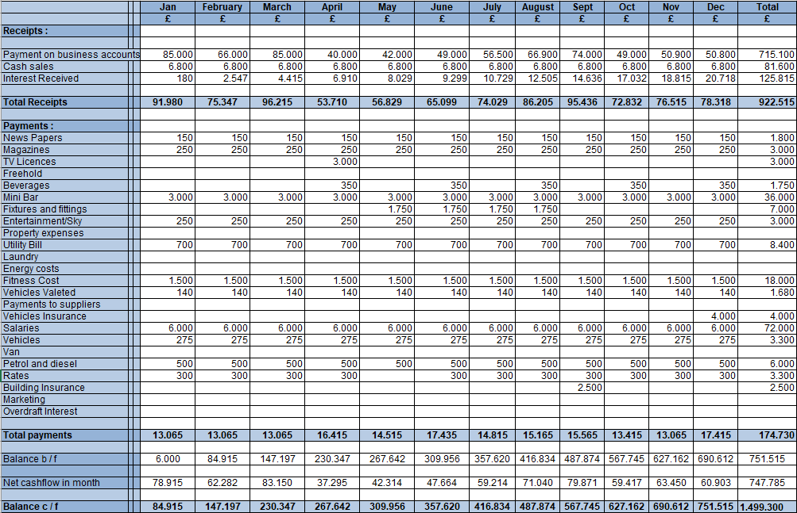
The budget planner Calculation

- Your understanding of traditional based budget and zero-based budget
The traditional based budget is a method of projecting the business’s revenue and the expenses which show in upcoming year based on the previous budget. A budget is one of the accounting tools that brings help to predict and analyse the business earning and deal with expense. By verifying previous budget, traditional budget brings a template which justify the predictions. As the continental hotel business grows, the main point is to stick to the budget as close as possible to avoid overspending (Blankely-Gray. R, 2018). Other ways to created budget in the continental hotel business such as zero-based budget.
The definition of zero-based budgeting is showing all the expenses for each calculation of accounting by justifying and approving the period which base on the past spends. As the zero-base can start from the beginning of each budget which can create a real information with analysing and how can you allocate your funds (British Business Bank, 2022). The budget will present what is needed during the upcoming period which will show each budget if it is higher or lower from the previous one. This is one of the budgets that is used in the continental hotel which gives technique how to use it and create a need to upcoming period. Zero-based budgeting can also be useful to the managers how they can tackle lower costs in the continental hotel (Kagan. J, 2022).
In excel, the budgeting planner calculation present different amount which increases and decreases each month such as the total receipts and total payment. As in the net cashflow can show how much cash the company generates, whether it’s positive or negative provide in a month. The calculation of balance budget shows different version, it is upgrading the income and expenses for a 12 months period. Overall, the whole budget is calculated during the last month of the year.
There are different between traditional budgeting (TB) and zero-based budget (ZBB) such as TB also need a refence point and ZBB have to start from the beginning, TB is simplistic and ZBB is complicated which re-evaluation, TB also base on information or historic which turn around accounting and ZBB is on estimated data such as decision making, TB bring similar costing of the previous year and ZBB drives profitability (Mukhopadhyay. S, 2022).

B. The process of zero-based budget and how can this be implemented
Although, there is a process to runs the continental hotel business with zero-based budgeting with five steps about the basic implementation such as:
- To start a brand-new account from zero which will have to create a new annual budget from the beginning without the last year actual baseline,
- Evaluate every cost of the area that brings action to achieve the goal. Remove and reduce unnecessary activities or services with the team,
- Identify or justify cost-effective with all the other budget, relevant and cost-saving areas.
- Streamline: control what activities should performed and how will it be done Think about the new tasks and target essential things.
- Execute all comprehensive plans and responsibilities which evaluate the process. The other thing is to communicate clear plans, do better roles and be sure about the budget (Anaplan, 2022).
As for implementing a Zero-based budget, it requires qualified personnel and who has special training but it will be costly and time consuming (CFI team, 2021). It is all about how to process and take challenges such as be careful with the process and well-planned approach (Serven. L, 2022).

C. Can budgeting control support sustainability
The budgeting control is one of the procedures that continental hotel uses to track different spending such as track actual budget or against planned budgets. This can help to keep thing under control and also able to create more accurate budgets and improve the profits in continental hotel. When a budget is established, it is mainly important to pursue and also verify if the actual performance matches the original plan. As budget control can also allow to track and measure spending against the initial forecast. This is the system that encourage to take action against any variance to keep the company going cost-efficiently. The budgetary control is running process that mainly manual reviews which has shown as monthly, quarterly or annually. Overall, it will be automatically got through with accounting, well also taking decision and verify action as required (Spendesk, 2022).
Sustainability is present by a process which maintain and support action that continuously used over time. As in the continental hotel business, the sustainability shows to prevent the depletion of natural or physical resources which can show that they will stay active for long term (Brown. R. J, 2021). It is also one of the operations that emerging as a mainly attached with the top managers. However, the managers are focused in sustainability such as concerned about the future profitability and the reputation among the stakeholders which shows also the environmentally conscious customer, employees, partners and big investors (Khuntia. J, 2018, pp.756).
As the financial is very important in business which the budget is included of the process. The budgeting is a tool in financial management the sustainable development. It also mainly useful for capital and resource of the company such as in continental hotel. The budgeting is to help and manage to control the business operation. However, sustainability, globalization and communication are the field which the continental hotel needs to develop better and make good performance (Akkuck. U 2018, pp.42-60).

There is another of control as cost control which is simply way to bring saving and make sure in a competitive side for a longer term (Money donut, 2022).
So, budgeting and cost control gives the detail of estimation of the costs, to agree of a setting budget and controlling the cost that is against the budget which can show such as:
- decide the income and expensive profiles for the work,
- develop the budget and funding,
- Implement the method of managing income and expenditure (Praxis, 2019).
Overall, the budget control is an extension process of budgeting, no budget can think about to be complete without budget control process and to make sure that the objectives have been met (CFA Journal, 2022).

Conclusion
In general, the traditional budgeting is a system that depends on the same year’s spending to do the budgeting for the current year (Thakur. M,2022). As the zero-based budgeting is to develop new budget which focus to make decision and to constant look at the business with motivation and targets (Aguilar. O, 2022). The budgeting planning calculation was described how the cost count in 12 months and explained the net cashflow and balance of budget which are important in a business.
The budget is important to help planning organization or goal- oriented plan. However, the planning and controlling expenditure is important, as budgeting provides clear numbers analyse or major figures about the amount of money the continental hotel has (Finance. M, 2022).
Overall, the budget control is one of preparation that has to be done by a process. Then, comparing the budget performance how well the company is. At the end, is the performance correction to improve the operations (Educba, 2022). This is the way to analyse the budget.

References
Aguilar. O, (2022) Zero-based budgeting. Available at: https://www2.deloitte.com/us/en/pages/operations/articles/zero-based-budgeting.html
Anaplan, (2022) The ultimate guide to zero-based budgeting (ZBB). Available at: https://www.anaplan.com/blog/zbb-zero-based-budgeting-guide/
Akkuck. U (2018) Budgeting as a Tool for Sustainable Development, pp.42-60
British Business Bank, (2022) Zero-based budgeting. Available at: https://www.british-business-bank.co.uk/finance-hub/zero-based-budgeting/#moduleWhatisit
Blankely-Gray. R, (2018) Understand How Traditional Budgeting Can Impact Your Small Business. Available at: https://www.patriotsoftware.com/blog/accounting/traditional-budgeting-system-process-advantages-disadvantages/. (Accessed: 23 January 2018)
Brown. R. J, (2021) Sustainability. Available at: https://www.investopedia.com/terms/s/sustainability.asp#:~:text=In%20the%20broadest%20sense%2C%20sustainability,available%20for%20the%20long%20term. (Accessed: 15 November 2021)
CFA Journal, 2022) Budget Control: Concept, Purpose, and Importance. Available at: https://www.cfajournal.org/budget-control/.
CFI team, (2021) Zero-Based Budgeting. Available at: https://corporatefinanceinstitute.com/resources/knowledge/accounting/zero-based-budgeting/. (Accessed: 6 January 2021)
Educba, (2022) budgetary control. Available at: https://www.educba.com/budgetary-control/
Finance. M, (2022) Why is Budgeting important? Available at: https://efinancemanagement.com/budgeting/why-is-budgeting-important
GoCardless, (2020) What is a zero-based budget? Available at: https://gocardless.com/guides/posts/what-is-zero-based-budget/
Guido. J, (2014) Business Planner2015: Market with a zero-based budget. 53 (10), pp.72
Kagan. J, (2022) Zero-Based budgeting (ZBB). Available at: https://www.investopedia.com/terms/z/zbb.asp. (Accessed: 14 march 2022)
Khuntia. J, (2018) Production and operations management. Information Technology and Sustainability: Evidence from an Emerging Economy, 27(4) pp.756
Money donut, (2022) cost control. Available at: https://www.moneydonut.co.uk/accounting/budgeting-and-cost-control/cost-control
Mukhopadhyay. S, (2022) Traditional Budgeting vs Zero Based Budgeting. Available at: https://www.wallstreetmojo.com/traditional-budgeting-vs-zero-based-budgeting/#h-traditional-budgeting-vs-zero-based-budgeting-infographics
On accounting, (2021) different between traditional budgeting and zero-based budgeting. Available at: https://onaccounting.co.za/difference-between-traditional-budgeting-and-zero-based-budgeting/#:~:text=Traditional%20Budgeting%20refers%20to%20the,and%20thus%20started%20from%20scratch.
Praxis, (2019) budgeting and cost control. Available at: https://www.praxisframework.org/en/knowledge/budgeting-and-cost-control
Serven. L, (2022) What is zero-based budgeting? 8 tips for successful implementation. Available at: https://blog.board.com/budgeting-planning-forecasting/top-tips-implementing-zero-based-budgeting/644/
Spendesk, (2022). Budgeting control. Available at: https://www.spendesk.com/en/glossary/budgeting-control/
Thakur. M, (2022) Traditional budgeting. Available at: https://www.wallstreetmojo.com/traditional-budgeting/

