Ashiq Baz – 1816380 Introduction to Physiology – BMHP5003_BIRM
Task 1: Individual Academic Poster Mumtaz Goolam
Anatomy human body of digestive system
The digestive system describes the alimentary canal, its accessory organs and variety of digestive processes that prepare food eaten in the diet for absorption. The alimentary canal begins at the mouth, passes through the thorax, abdomen, and pelvis, and ends at the anus (Cleveland Clinic, 2021).
Pharynx - or throat, is the passageway leading from the mouth and nose to the esophagus and larynx. The pharynx permits the passage of swallowed solids and liquids into the esophagus, or gullet, and conducts air to and from the trachea, or windpipe, during respiration
Salivary Glands: produce saliva, which moistens food to make it easy to swallow and contains enzymes (proteins) to help break it down Parotid Submandibular
Sublingual
Soft palate – helps keep food out of the respiratory tract

Hard Palate- provides space for the tongue to move feely
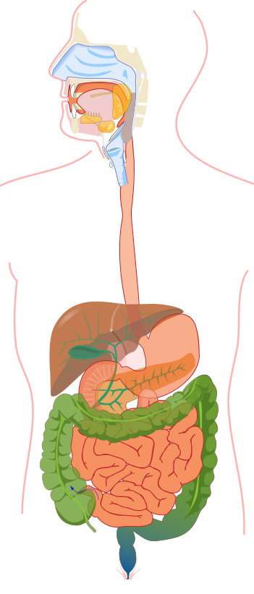
Tongue – it manipulates food for mastication and swallowing as part of digestive process. Also, primary organ for taste.

Mouth – Insert FFod
Oropharynx – forms part of the pharynx and serves the respiratory and digestive system
Larynx – the voice box is used for producing sound, breathing, and to protect the trachea against food aspiration.
Liver - filter blood coming from the digestive tract before passing it to rest of the body
Oesophagus – The GI tract moves food down the tube to the stomach (25cm long tube)
Gall Bladder – stores bile produced by the liver and helps break down fatty acid
Diaphragm – helps you breathe and barrier method for birth control

Pancreas - plays an important role in digestion and in regulating blood sugar
Stomach – secretes acid and enzymes that digest food
Small Intestine – digest process by absorbing nutrients from food and into the bloodstream

Duodenum
Transverse colon
Ascending colon Jejunum
Lleum Descending colon
Large Intestine - absorption of water from the indigestible residue of food
Caecum Appendix
Rectum – receive stool from colon, inform you stool needs to be evacuated or hold until evacuated
Sigmoid colon
Anal canal
Food processed by adults on average:
365 kg a year
28,000 kg during their lifetime
(Poti, Braga and Qin, 2017).
Anus - is the opening and end of digestive tract where stool leaves the body
Alimentary canal:
Mouth, pharynx, oesophagus, stomach, small & large intestine, rectum, and anal canal (Robinson, 2020).
(Waugh and Grant, 2018).
Hollow organs: mouth, oesophagus, stomach, small & large intestine, and anus.
Solid organs: liver, pancreas, and gall bladder
(Poti, Braga and Qin, 2017).
Accessory organs:
3 pairs of salivary glands, the pancreas, the liver and biliary tract (Visible Body, 2021).
4 layers of Alimentary canal:
Mucosa, Submucosa, Muscalaris, & Serosa (Quora, 2021).
Digestive system activities can be grouped into 5 headings:
Ingestion: this is the taking of food into the alimentary tract, i.e., eating and drinking
Propulsion: this mixes the contents and moves them along the alimentary tract
Digestion: this consists of mechanical breakdown of foods by, for example mastication (chewing). Chemical digestion of food into small molecules by the action of enzymes present in secretions produced by glands and accessory organs of the digestive system
Absorptions: this is the process by which the products of digestion pass through the walls of some organs of the alimentary canal into the blood and lymph capillaries for circulation and use by body cells
Elimination: food that has been eaten but cannot be digested and absorbed is excreted from the alimentary canal in faeces by the process of defaecation. The fate of absorbed nutrients and how they are used by the body are explored and the effects of ageing on the digestive system are considered
(Owlcation, 2020).

The digestive processes gradually break down the foods eaten until they are in a form suitable for absorptions. For example, meat, even when cooked, is chemically too complex to be absorbed from the alimentary canal. Digestion releases its constituents: amino acids, mineral salts, fat and vitamins. Digestive enzymes responsible for these changes are secreted into the canal by specialised glands, some of which are in the walls of the canals, and some outside the canal but with ducts leading into it (NIDDK, 2017).
After absorptions, nutrients provide the raw materials for the manufacture of new cells, hormones and enzymes. The chemical energy needed for these and other processes, and for the disposal of waste materials, is generated from the products of digestion (Marengo, 2021).

Inflammatory Bowel Disease (IBD)
Ulcerative colitis is a type of bowel disease that causes long-term inflammation of the cells that line your rectum and colon (also called the large intestine). This may lead to sores called ulcers that can bleed and keep your body from digesting food like it should. You can take medicine to calm the inflammation and learn ways to ease its effects on your daily life.
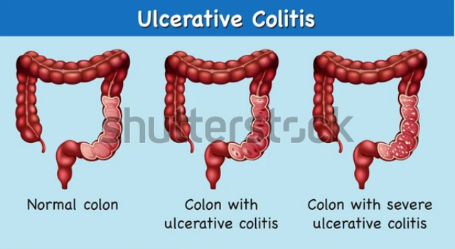(Shutterstock, 2021).

Medication: Aminosalicylates (ASAs), Corticosteroids, Immunosuppressants
If medication does not work, then surgery to remove your colon may be an option. During surgery, your small intestine will either be diverted out of an opening in your abdomen (an ileostomy) or be used to create an internal pouch that's connected to your anus called an ileoanal pouch. Surgery for ulcerative colitis involves permanently removing the colon (a colectomy). Once your colon is removed, your small intestine will be used to pass waste products out of your body instead of your colon. This can be achieved by creating:
- an ileostomy – where the small intestine is diverted out of a hole made in your tummy; special bags are placed over this opening to collect waste materials after the operation
- an ileoanal pouch (also known as a J-pouch) – where part of the small intestine is used to create an internal pouch that's then connected to your anus, allowing you to poo normally
Ileoanal pouches are increasingly used because an external bag to collect waste products is not required. As the colon is removed, ulcerative colitis cannot come back again after surgery. But it's important to consider the risks of surgery and the impact of having a permanent ileostomy or ileoanal pouch.
Aftercare: dietary advice to help the condition, small portions, plenty of fluid (avoid coffee and alcohol), and take plenty of supplements to boost the immune system i.e. minerals and vitamins. Exercise with a suitable exercise plan. i.e. yoga, breathing exercise. Counselling speaking to others with the same conditions and manage to relieve stress (NHS, 2019).
References
Cleveland Clinic (2021) The Structure and Function of the Digestive System. [Online] Available at: https://my.clevelandclinic.org/health/articles/7041-the-structure-and-function-of-the-digestive-system (Accessed: 22nd June 2021).
Marengo, K. (2021) How is Protein Digested? [Online] Available at: https://www.healthline.com/health/protein-digestion#enzymes (Accessed: 23rd June 2021).

National Health Service (2019) Ulcerative colitis [online] Available at: https://www.nhs.uk/conditions/ulcerative-colitis/ (Accessed: 27th June 2021).
National Institute of Diabetes and Digestive and Kidney Diseases (2017) Your Digestive System And How It Works. [Online] Available at: https://www.niddk.nih.gov/health-information/digestive-diseases/digestive-system-how-it-works (Accessed: 22nd June 2021).
Owlcation (2020) How Digestion Works: 5 Stages of Human Digestion. [Online] Available at: https://owlcation.com/stem/5-Stages-of-Human-Digestion-Digestive-Processes (Accessed: 24th June 2021).
Poti, J.M., Braga, B. and Qin, B. (2017) ‘Ultra-processed food intake and obesity: what really matters for health-processing or nutrient content?’, Current obesity reports, 6(4), pp. 420–431. DOI: 10.1007/s13679-017-0285-4.
Quora (2021) How can you describe the 4 layers of the alimentary canal?. [online] Available at: https://www.quora.com/How-can-you-describe-the-4-layers-of-the-alimentary-canal (Accessed: 3rd July 2021).
Robinson, J. (2020) Your Digestive System. [Online] Available at: https://www.webmd.com/heartburn-gerd/your-digestive-system (Accessed: 22nd June 2021).
Shutterstock (2021) Ulcerative colitis [online] Available at: https://www.shutterstock.com/image-vector/diagram-showing-ulcerative-colitis-illustration-1027902256 (Accessed: 27th June 2021).
Visible Body (2021) Accessory Organs: Glands and Organs That Facilitate the Process of Digestion. [Online] Available at: https://www.visiblebody.com/learn/digestive/digestive-accessory-organs (Accessed: 22nd June 2021).
Waugh, A. and Grant, A. (2018) Ross & Wilson Anatomy and Physiology in Health and Illness. 13th Ed. Edinburgh: Elsevier.

