Reshaping the strategic direction of Saudi Aramco by focussing on customer care

Table of Contents
1. Introduction 4
1.1 Overview of Saudi Aramco 4
1.2 Annual Revenue 4
1.3 Values and Mission Statement 5
2. Strategic Management 5
2.1 What is Strategy 5
2.2 Chosen Organisation Strategy 6
2.2.1 Ownership and Structure 6
2.2.2 Corporate strategy 6
2.2.3 Business Strategy 6
3. Conclusions 6
4. Recommendations 6
References 7

Executive summary 300

1. Introduction

1.1 Overview of Saudi Aramco
Strategic analysis is one of the most effective and crucial components of strategic management, helping companies make informed decisions about their future direction. The following report has chosen “Saudi Aramco” to reshape the company's strategic direction. Saudi Aramco is one of the largest integrated oil and gas companies in the world, and it is responsible for managing Saudi Arabia's hydrocarbon resources. Aramco's history dates back to 1933 when Saudi Arabia and the “Standard Oil Company of California (SOCAL)” signed a concession agreement (Aramco, 2024a). As a global company, Aramco extends its business parameters by building several international investments. Since 1933, the company served over 41 years and played long-term roles “as caretakers of Saudi Arabia’s vast hydrocarbon resources”. By having more than 73000 workforces, the company manages the country’s 25132 billion barrels of oil by optimising production and increasing long-term value (Aramco, 2024b).

1.2 Annual Revenue
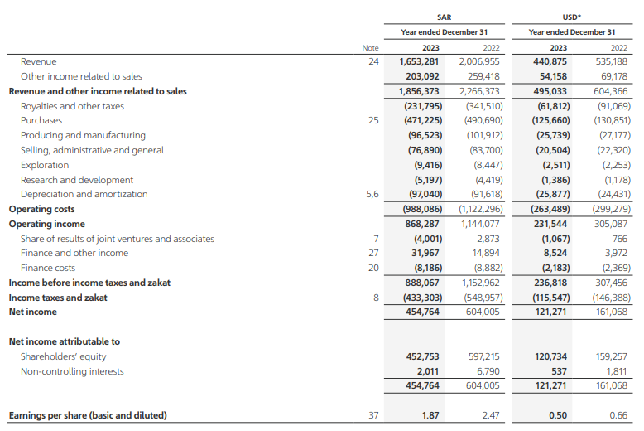
Figure 1: Annual Revenue of Saudi Aramco
(Source: Aramco, 2024c)
According to Figure 1, the total revenue of Saudi Aramco is addressed as 440,875 billion US dollars in 2023, which has also dropped from its previous year’s revenue (Aramco, 2024c). It has been found that in 2022, the company achieved a total of 535,188 billion US dollars. Thus, it addressed that the company has gained poor market share in 2023 in comparison with 2022.

1.3 Values and Mission Statement
The company’s mission statement and values are going to be highlighted below:
Vision: “Aramco’s vision is to be the world’s preeminent integrated energy and chemicals company, operating in a safe, sustainable and reliable manner” (Aramco, 2024d).
Values: Corporate values of the company are:
- Safety: A safe and respectful work environment is a core value of Aramco.
- Citizenship: Aramco is committed to being a positive influence in communities and a good corporate citizen (Aramco, 2024e).
- Integrity: Aramco's employees' ethical standards are the foundation of its integrity.
- Accountability: Aramco employees are responsible for their actions in meeting corporate objectives.
- Excellence: Aramco's excellence is reflected in all aspects of the workplace.

2. Strategic Management

2.1 What is Strategy
Strategy refers to a plan of action, which helps to achieve goals by defining a specific course of action. It involves goals and priorities and determines how to achieve them. It can also be said that strategy provides a roadmap to achieve success and helps a company to achieve competitive advantage (). Based on an effective strategy, the company can address business goals.

2.2 Chosen Organisation Strategy

2.2.1 Ownership and Structure
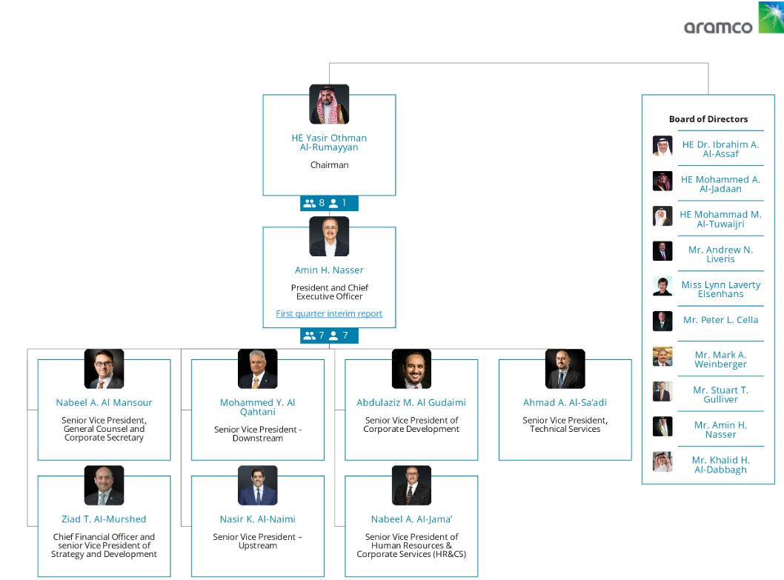
Figure 2: Organisation structure of Saudi Aramco
(Source: Organimi, 2024)
According to Figure 2, it has been found that the company operates a hierarchical organisational structure, which is made up of a “Board of Directors”, a “corporate management team”, and key business units. The major responsibility of the “board of directors” is to oversee the company’s management, strategy and governance.

2.2.2 Corporate strategy

2.2.3 Business Strategy

3. Conclusions

4. Recommendations

References
Aramco, 2024a. Our history. https://www.aramco.com/en/about-us/our-history
Aramco, 2024b. Our perspective. https://www.aramco.com/en/about-us
Aramco, 2024c. Consolidated statement of income. https://www.aramco.com/-/media/publications/corporate-reports/annual-reports/saudi-aramco-ara-2023-english.pdf
Aramco, 2024d. Our vision. https://www.aramco.com/en/investors/annual-report
Aramco, 2024e. Our values. https://www.aramco.com/en/about-us/our-governance/our-values
Organimi, 2024. Saudi Aramco's Organizational Structure [Interactive Chart] | Organimi. https://www.organimi.com/organizational-structures/aramco/

