
Napier Wood Construction,
Lion Way,
Swansea
SA7 9FB
Caerphilly County Borough Council,
Caerphilly,
CF83 3HU
12th December 2025,
Dear Sir or Madam,
RE: Ysgol Y Twyn: 1 Form entry infant school for 90 pupils, with 48 PT Nursery provision, and Twyn Community Hall and Caerphilly Story Gallery.
Thank you for considering Napier Wood Construction to be a part of your new development, we are happy to accept the role of Lead Consultant in the development of Ysgol Y Twyn. We would like to ensure you that we will be delivering this project to comply with the appropriate standards. The Welsh Government (WG) has collaborated with the Meridian (who are involved with Mutal Investment Model (MIM), which is a Welsh initiative for fostering investments in public infrastructure) and the Development Bank of Wales, to create the Welsh Education Partnership (WEP), the WG play a vital role in this partnership with the development and funding which has shown a strong partnership between the government and education institutions. (GOV.UK, 2025) In this framework it requires that BIM level 2 maturity is to be used on all projects since 2016. The WG also outlines the requirements of adhering to the BIM BS EN ISO Standards 19650, which include sections ISO 19650-1, ISO 19650-2, ISO 19650-3, ISO 19650-4, ISO 19650-5 and ISO 19650-6.
As the chosen lead consultants on this project, we want to present you with the letter to outline how we meet with the BIM maturity level requirements for this project and how we will produce the need for a whole life assessment monitoring using a COBie-compatible CAFM system, along with having access a virtual model within Revizto.
At Napier Wood Construction we would like to ensure the following requirements and practices are met to produce and deliver a Successful BIM project.

Our team and what to expect
The team which we have chosen to work on this project, have a long history of completing BIM projects successfully, they have all team members have all received certifications on all standards of BSI BIM ISO 19650. We will be following the BIM Execution Plan (BEP) for the digital aspect of this project which will be closely managed by our BIM Coordinator, Bethan Jones and the overall project will be overseen by our dedicated BIM manager Morgan Williams.
If needed we will provide training to our stakeholders to ensure that there is a smooth transition with any collaboration, this will be inline with RIBA plan of work with the ISO standards. The team has all the latest BIM technology to carry the project including clash detection tools, advanced 3D modelling software, common data environment (CDE), COBie-complaint systems.

Estyn
Due to the nature of this project being a school with community engagement, it is important to take into consideration working with Estyn.
Estyn is the education and training inspectorate for Wales, funded by the Welsh Government to inspect education and training in Wales, directed by a range of legalisation and regulation. (Estyn.com, 2025) Estyn look to ensure the teaching, learning, wellbeing support and guidance from schools and always looking to improve and lead for future education. Estyn know the importance and wants to emphasize the importance of community engagement with schools. As the school is going to be offering a community hall and story gallery, it is important to take into consideration when and how this area will be used for the public and when it will be used for school, to ensure the safety and wellbeing of the children and the community who will be using the space. By engaging with Estyn, it will allow a clear understanding of being able to still pass inspections from Estyn and remain open to the community.

Compliances of BIM with industry framework
As required, we will ensure to be fully compliant with the BS EN ISO 19650, set of standards from beginning to end of the project’s delivery. These standards will then provide a framework for managing and sharing information about the project throughout all stages of the project’s life cycle.
‘BIM standards streamline the organisation, digitization and exchange of critical project data across the entire lifecycle of buildings and infrastructure. These standards foster collaboration, enhance efficiency and consistency from design to construction to operation and beyond. By providing clear framework for information management and security, BIM standards help professionals deliver projects that meet modern demands for innovation, sustainability, and interoperability. (iso.org, 2025)
The breakdown of the standards we are using throughout the project are as followed:
BS EN ISO 19650-1: talk about the concepts and principles (published 2018)
BS EN ISO 19650-2: Delivery phase of assets (published 2018)
BS EN ISO 19650-3: Operation phase of the assets (published 2020)
BS EN ISO 19650-4: Information exchange (published 2022)
BS EN ISO 19650-5: Security-minded approach of information management (reviewed 2025)
BS EN ISO 19650-6: Health and safety information (published 2025)
(ISO.ORG, 2025)
By having all the stages broken down clearly it will allow easy access of information from each stage of the project. It is important to have this information clearly noted so that after the construction stage of the building has been completed and the building is now in use, if any information is needed in the future, there will be easy access to the information and clear description of where everything is. This helps with the overall lifecycle of the building as it makes it adaptable in the future.

Common Data Environment (CDE)
A Common Data Environment (CDE) centralises project data, enabling real-time collaboration, streamlined workflows, and better decision-making. By reducing errors and improving efficiency, CDEs help construction teams compete project on time and on budget. (Trimble, 2022) At Napier Wood Construction, we are dedicated to asset management and BIM-driven designs, with the use of Autodesk Construction Cloud (ACC) which will be communicated through the Computer Aided Facilities Management (CAFM). By storing all the information with a CAFM, it allows everyone who is working on the project to store and share digital information, the benefits of doing this will allow access to crucial information, such as bill of quantities, reports and virtual models on accessed via Revizto, as needed. All data is accessible in real time; this allows the project to run seamless and efficient from start to finish. By running work in real time, it stops any risk of clashes or misinformation being shared between the different parties working on the project.

BIM Execution Plan (BEP)
The most important part of BIM is information, The objective of developing a BIM Execution Plan (BEP) is to facilitate the management of the information in a BIM project. It can be defined a plan to prepared to streamline, how the model’s information will be executed. (united BIM, 2025) It is important to ensure that BEP is executed correctly so that it is clear to anyone who reads the document can see who is responsible for each section of the data which has been provided. By having everything clearly laid out it stop any avoidance of responsibility.
At the start of the project a detail BIM execution plan (BEP) will be made collaboratively, then as the project goes through the development the BEP will be reviewed to address any changes or challenges they may have faced, this will make the workflow more streamline, as everyone will have access to the information and know how the project is running if it is to schedule or not and where they need to be. By having these reviews at each stage, it will allow the project to monitor the financial side to see if they are keeping with in budget. Overall, by using BEP it should increase productivity and enhance collaboration.

Construction-Operations Building Information Exchange (COBie)
Construction Operation Building Information Exchange (COBie) is a non-proprietary data format for the publication of a subset of building information models (BIM) focused on delivering asset data as distinct from geometric information (the NBS, 2018)
We will be using the COBie, as a standard for capturing and formatting data, so that the essential information regarding the asset and the life cycle of the project during the exchange. This will ensure that there is a smooth transition during each step of the project, from planning to the construction to the operation this information will all be stored in a structures spreadsheet and handed over to the client at the end of the project using a Computer Aided Facility Management (CAFM). This will then allow the clients to easily access any information they needed about the project in the future.

Level of Information Need (LOIN)
It is crucial to understand the Level of Information Need, as it gives a clear breakdown of what information is needed at each level, as well as amount of information need at each stage of the project.
By having this information and understanding the LOIN it can help with any decision-making process, it allows a team to have clear communication about the project which can make a more efficient collaboration and project delivery. (plannerly, n/a) Appended to this letter are examples of the RIBA Plan Of Work and the different Level of Information Needed at each stage.
We look forward to working with Caerphilly County Borough Council and to the success in delivering this project.
Yours sincerely
Jocasta Napier
Napier Wood Construction

RIBA Plan of Work
The Royal Institute of British Architects (RIBA) Plan of Work, framework has been developed to eight clear steps which breaks down the building process. This makes the stages information of the building more manageable to share from the client to the architect and builders. (Harper Latter Architects, 2025) The RIBA plan of work 2020 template has the following breakdown of the stages:
Stage 0 – Strategic Definition
Stage 1 – Preparation and Briefing
Stage 2 – Concept Design
Stage 3 – Spatial Coordination
Stage 4 – Technical Design
Stage 5 – Manufacturing and Construction
Stage 6 – Handover
Stage 7 – Use
(Riba.org. 2020 Page 2)
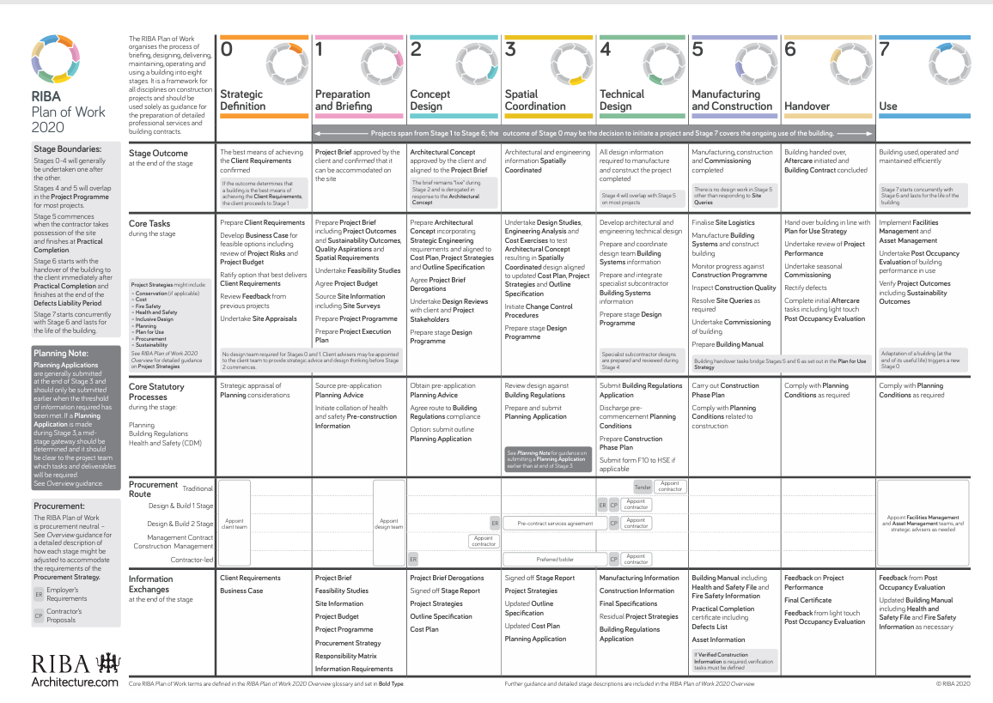
Figure 1 - RIBA Plan of Work 2020 table (RIBA, Page 40)
Thie RIBA framework provides an improved way to relay information, it details the responsibilities, tasks and benchmarks, for each party to achieve. It allows clear communication throughout the project, helps to reduce any risk to the project.

Level of Information Need

Level of Detail (LOD)
The LOD specification helps professionals in the industry to articulate how an element’s geometry and associated information have evolved throughout the entire process. It signifies the degree to which different members of the team can rely on information associated with and element. It also helps designers define the inherent characteristics od the elements in a model at different stages of development. The clarity in illustration gives depth to a model, signifying how much and at which level should rely on a model’s element. (United-BIM, 2025)
When the project progresses, the amount of graphical detail needed will increase, which reflects the growing complexity of the design. An example of this would be a shower, at the start of the project the bathroom area, will just show as a room with a basic designs, such as squares to stand as placeholders to show where everything will be placed, so they are able to know the what is in room and that everything will fit, this will remain in place into stages 2 and 3 of RIBA plan pf work, the Concept Design and Spatial Coordination. As the project the progresses, the placeholders in the bathroom will be replaced and evolve into a more detailed design and precise specification and geometry, of the shower size and location within the bathroom. Eventually, the details will be updated again to show even more details, exact connections, accurate dimensions and any plumbing, heating and mechanical requirements. Below is an example of the level of details, through each development stage shown below:
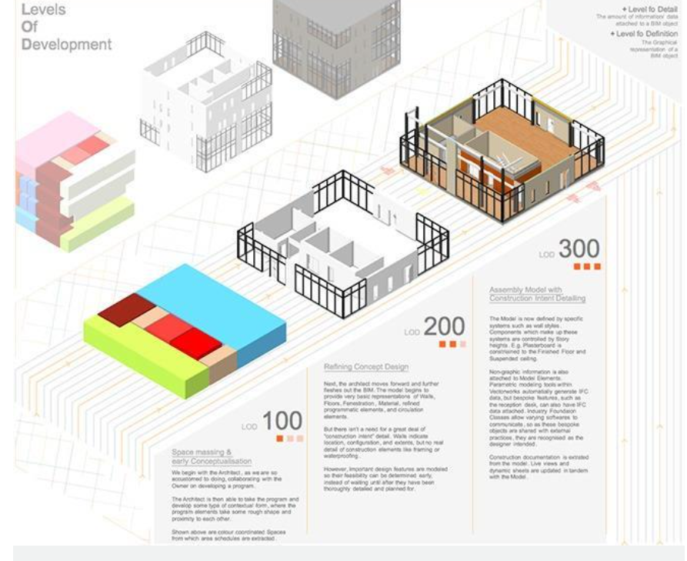
Figure 2 - example of the Level of Details, (building design, 2017)

Level of Information (LOI)
The non-graphical data embedded within or associated with the element. This includes properties like materials, performance criteria, manufacturer details, cost data and any other attributes. (Bim Solutions,2024) As a project progresses the level of information change, during the early stages of a project the amount of information needed will be minimal such as the types of materials being used and estimated costs, then as the project moves along this information will be provided, there will be invoices with exact figures, along with details of costs for operations, maintenance schedules, staffing and warranty data.
The LOI, is full of data rich information, which is useful for all stages of the project, it provides information on the performance of the project from start to finish. By incorporating LOI and LOD with the LOIN and RIBA framework, will ensure a united team for communication, the project time line and discussion at each step of the project to make sure it is running effectively and efficiently collaborating for each person who is working on the project, by continuing to use this method it should support a successful out of a project.

How the Level of Information Need (LION) is conveyed in the Employer’s Information Requirements (EIR) and Asset Information Requirements (AIR).
The LION has a vital role to play in the development of both the AIR and the EIR, as it can help manage, which information is needed for both the employer and the asset.
The AIR is a document which forms part of the ISO 19650 process, the asset data the organisation or owner would like to be delivered on a project’s completion. (Global Bim, 2024) Caerphilly County Borough Council will need to make sure the EIR outlines what they require for the COBie compliant data, so they are able to advise what they need from the whole life assessment for monitoring in the future, in order to do this correctly they will also need to advise the importance of providing LOIN through the project.
The employer’s information requirements (EIR) define the information that is required by the employer from both their own internal team and from suppliers for the development of the project and for operation of the completed built asset. (Designing Buildings, 2023) By defining the EIR, to a concise set of information which focus on maintaining the asset, this will the reduce the risk overloading the AIR with any information which isn’t needed, this will then allow for efficient management of the remaining information. This will the allow Caerphilly County Borough Council to be able to enhance their own operations, while they can effectively meet the projects data requirements.

References
Figure 1 - RIBA Plan of Work 2020 table (RIBA, Page 40) 7
Figure 2 - example of the Level of Details, (building design, 2017) 8

ISO.ORG (2025) Building Information Modelling (BIM) Available at: https://www.iso.org/sectors/building-construction/building-information-modelling (accessed 11/12/2025)
BSI (2025) BSI Standard Development, Available at: https://standardsdevelopment.bsigroup.com/Home/About (accessed 11/12/2025)
Harper Latter Architects (2025) What is the RIBA Plan of Work: A guide for UK Homeowners. Available at: https://www.harperlatterarchitects.co.uk/post/what-is-the-riba-plan-of-work-a-guide-for-uk-homeowners (Accessed 12/12/2025)
RIBA, page 40 (2020) RIBA Plan of Work 2020 Overview, Available at https://www.riba.org/media/syneeeto/2020ribaplanofworkoverviewpdf.pdf (Accessed 05/12/2025)
RIBA, page 2 (2020) RIBA Plan of Work 2020 Overview, Available at https://www.riba.org/media/syneeeto/2020ribaplanofworkoverviewpdf.pdf (Accessed 05/12/2025)
Fim (2025) The Welsh Education Partnership – WEPco, Available at: https://fimlimited.co.uk/projects/welsh-education-partnership/ (Accessed 05/12/2025)
WEPco (2025) The Welsh Education Partnership, Available at: https://wepco.co.uk/
Gov.Wales (2025) Review of roles and responsibilities of education partners in Wales and delivery of school improvement arrangements: update letter to the Cabinet Secretary for Spring 2025, Available at: https://www.gov.wales/review-roles-and-responsibilities-education-partners-wales-and-delivery-school-improvement-update-html (Accessed 05/12/2025)
Vale of Glamorgan (2025) Sustainable Communities for Learning, Available at: https://www.valeofglamorgan.gov.uk/en/living/schools/schools_in_the_vale/Sustainable-Communities-for-Learning/Sustainable-Communities-for-Learning.aspx (Accessed 05/12/2025)
GOV.Wales (2025) Sustainable Communities for Learning rolling programme, Available at: https://www.gov.wales/sustainable-communities-learning-rolling-programme-html (Accessed 05/12/2025)
GOV.Wales (2018) WEP Strategic Partnering Framework, Building Information Modelling, Market Engagement Paper, Available at: https://www.gov.wales/sites/default/files/publications/2018-12/building-information-modelling-paper-phase-2.pdf (accessed 06/12/2025)
United BIM (2025) BIM Execution Plan (BXP) Available at: https://www.united-bim.com/bim-execution-plan-bep-guide-for-successful-bep-design-and-execution/
NBS (2018) What is COBie? https://www.thenbs.com/knowledge/what-is-cobie (accessed 06/12/2025)
NBS (2015) BIM Levels of Information Available at: https://www.thenbs.com/knowledge/bim-levels-of-information (accessed 06/12/2025)
United BIM (2025) BIM Level of Development/ LOD 100, 200, 300, 350, 400, Available at: https://www.united-bim.com/bim-level-of-development-lod-100-200-300-350-400-500/ (accessed 07/12/2025)
Building Design (2017) CPD 5 2017: BIM levels of detail, Available at: https://www.bdonline.co.uk/cpd/cpd-5-2017-bim-levels-of-detail/5086956.article (accessed 06/12/2025)
GOV.WALES (2022) Sustainable Communities for Learning Programme business case guidance, Available at: https://www.gov.wales/sites/default/files/publications/2022-01/sustainable-communities-for-learning-business-case-guidance-2022.pdf (accessed 06/12/2025)
GOV.WALES (2018) 21st Century Schools and Education Funding Programme, Available at: https://www.gov.wales/sites/default/files/publications/2019-05/guides-to-making-your-21st-century-schools-and-educational-facilities-sustainable.pdf (accessed 07/12/2025)
Trimble (2022) What is a BIM Execution Plan and what should it include? Available at: https://www.trimble.com/blog/construction/en-US/article/what-is-a-bim-execution-plan-and-what-should-it-include (accessed 08/12/2025)
Trimble (2022) What is a common data environment and how is it used in construction? Available at: https://www.trimble.com/blog/construction/en-US/article/what-is-a-common-data-environment-and-how-is-it-used-in-construction-2 (accessed 08/12/2025)

Autodesk Construction Cloud (2024) What’s a Common Data Environment (CDE) and Why It Matters) Available at: https://www.autodesk.com/blogs/construction/common-data-environment/?msockid=07cf1254e30f65af0a9e07fde2ef64ef (accessed 07/12/2025)
GOV.uk (2025) Construction Industry Scheme (CIS) Available at: https://www.gov.uk/what-is-the-construction-industry-scheme (accessed 07/12/2025)
GOV.uk (2025) Sustainable Communities for Learning – Monmouthshire, Available at: https://www.monmouthshire.gov.uk/sustainable-communities-for-learning/ (accessed 07/12/2025)
Estyn (2024) Inspection explained (parents and carers) Available at: https://estyn.gov.wales/inspection-explained-parents-and-carers/ (accessed 10/12/2025)
Estyn (2025) About Estyn. Available at https://estyn.gov.wales/about-us/ (accessed 10/12/2025)
Construction Excellence in Wales (2025) Industry intelligence reporting for Welsh government, Available at: https://cewales.org.uk/welsh-government/# (accessed 11/12/2025)
Caerphilly (2025) Caerphilly Council, Available at: https://www.caerphilly.gov.uk/main.aspx?lang=en-GB (Accessed 11/12/2025)
Plannerly (N/A) LOIN, Level of information need in BIM projects following ISO 19650, Available at: https://plannerly.com/level-of-information-need-loin-bim/ (accessed 11/12/2025)
BSI Group (2023) Little book of BIM , Available at: https://www.bsigroup.com/siteassets/pdf/en/insights-and-media/insights/white-papers/little_book_of_bim_global_0623_final_web.pdf (accessed 08/12/2025)
Bim Solutions (2024) Level of Information Need Available at: https://bimsolutions.ltd.uk/articles/levelofinformationneed (accessed 10/12/2025)
BIM Global Network (2025) Asset Information Requirements (AIR) Template. Available at: https://globalbim.org/info-collection/asset-information-requirements-air-template/ (accessed 10/12/2025)
Designing Buildings (2023) Employer’s information requirements EIR. Available at: https://www.designingbuildings.co.uk/Employer%27s_information_requirements_EIR (Accessed 08/12/2025)

