COMPONENT 1: COURSEWORK: INDIVIDUAL WRITTEN REPORT
Name of the student:
Name of the university:
Student’s ID:
Module code: LCBB4012
Executive summary
The focus of this specific study has been on understanding the significance of time management. The different elements that are associated with the concept of time management has been analysed and presented in this specific study. The different strategies that are associated with time management has been evaluated in the study. It has presented a cleared description of the Pomodoro Technique and the Eisenhower Matrix.
Contents
Introduction 4
Definition of time management 4
Importance of time management 4
Time management strategies 5
Conclusion 7
References 8

Introduction
In the contemporary world, individuals are required to perform different types of activities in their daily lives for their personal, educational and professional aspects. In order to seamlessly achieve the goals in daily life time management is one of the most important factors that individuals focus on. The focus of this study will be to understand the concept of time management in detail by identifying the significance of the concept. The study will also focus on identifying the different time management strategies that can improve skills and capabilities among individuals.

Definition of time management
Time management can be defined as a process that includes planning and controlling the time that is spent on different activities to increase productivity and efficiency (Aeon et al., 2021). It is the approach that involves prioritizing different activities or tasks and setting realistic goals to avoid distractions and achieve different types of goals within a specific time frame. The key elements that are present in the concept of time management include planning, prioritization, time allocation, delegation, time tracking, goal setting and focus.

Importance of time management
The concept of time management has evolved differently over the decades but the significance has been one of the most critical factors. It has been observed that effective time management is significant because it increases productivity among individuals by providing them with the opportunity to achieve strategic goals in less time (Brough et al., 2022). It also helps in reducing stress by effectively managing the workload which eventually improves the functionality among individuals. According to different studies that have been conducted it has been also that time management promotes work-life balance as it helps in prioritizing the different aspects of personal and professional fields. This eventually helps in increasing satisfaction in the personal and professional areas thereby increasing the quality of life among the people. The efficiency of individuals in different activities increases when they are able to manage their time efficiently. This is because they need to stress less about meeting the deadlines as they have already managed the different activities and tasks as per their priority level (Mitsea et al., 2021). They are able to focus more on the quality of the activities rather than stress about finishing the job within the deadlines.
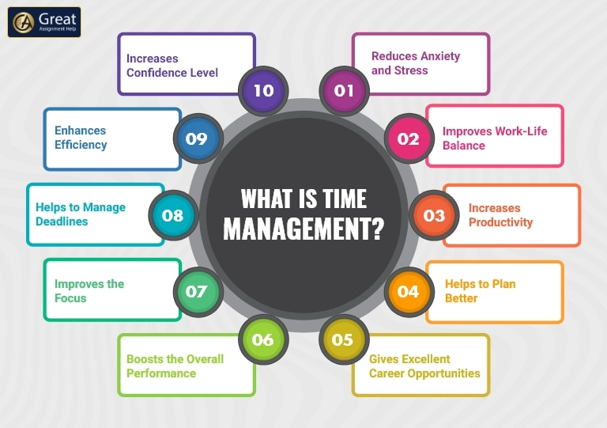
Figure 1: Significance of time management
(Source: Mitsea et al., 2021)

Time management strategies
Pomodoro Technique:
One of the widely recognized strategies or techniques for time management that is used by students and professionals across different fields is the Pomodoro technique. It is a time management method that focuses on dividing the world into different intervals that are 25 minutes each with short breaks in between every interval. This is followed by a longer break after four work intervals that promotes the ability of an individual to focus with maximum efficiency (Costales et al., 2021). In this specific technique, an individual dedicates 25 minutes to a specific task while ensuring that there are no distractions. This specific time frame of 25 minutes is known as Pomodoro. After the completion of each pomodoro the individual takes a break of 3 to 5 minutes and after the completion of four consecutive pomodoros a longer break of around 30 minutes is considered to prevent burnout. This technique is used as an iterative process throughout the workday to manage the different activities and ensure minimum distractions that can negatively impact the workflow or efficiency.
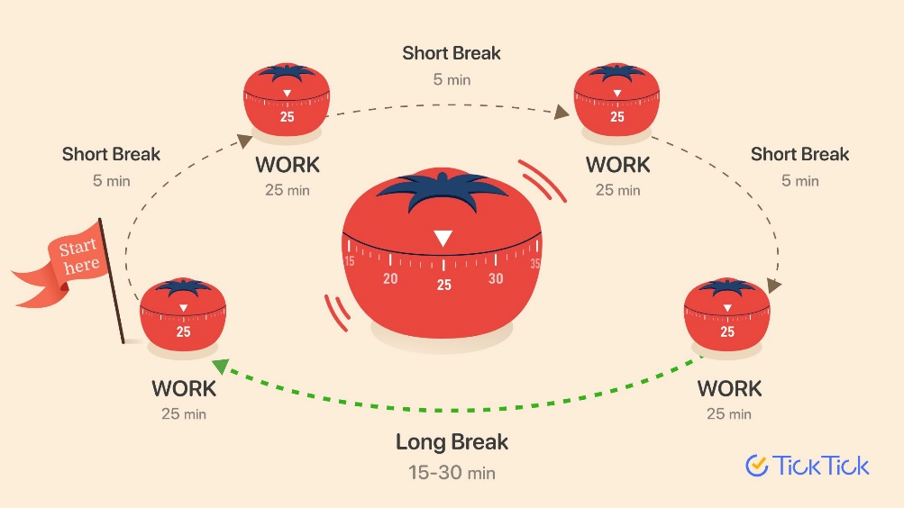
Figure 2: Pomodoro technique
(Source: Costales et al., 2021)
Eisenhower Matrix:
The Eisenhower matrix is a technique for time management that privatizes different tasks and activities on the basis of their importance and urgency. With the help of the matrix, it is possible to distinguish between the different activities that require urgent or immediate attention. It identifies the different activities that can contribute to the long-term goals which helps in understanding their significance. The matrix that is present in this specific technique ensures that there are four quadrants on the basis of which the tasks can be categorized. These four quadrants include urgent and important, urgent but not important, not urgent but important and neither important nor urgent (Dmytryshyn and Goran, 2022). The critical evaluation of the tasks and categorization across the matrix helps in making sure that an individual is able to identify the most crucial tasks and distinguish them from the least crucial tasks. This helps the individuals make sure that they are focusing on important areas rather than being distracted by tasks that are not urgent or important.
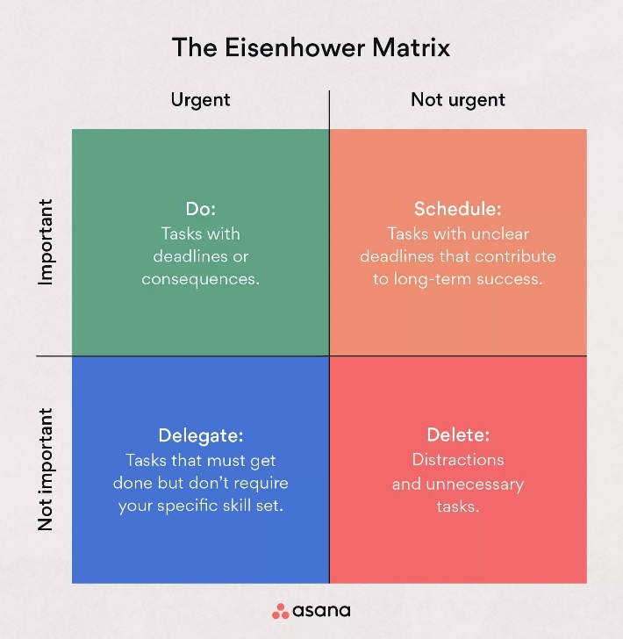
Figure 3: Eisenhower Matrix
(Source: Dmytryshyn and Goran, 2022)

Conclusion
From the analysis of the study it can be contributed that time management is one of the most important skills that contributes in the enhancement of personal and professional capabilities. Individuals must focus on enhancing their time management skills as it will not only help in improving their ability to achieve goals but it will also promote the work life balance.

References
Aeon, B., Faber, A. and Panaccio, A., (2021). Does time management work? A meta-analysis. PloS one, 16(1), p.e0245066.
Brough, P., Timms, C., Chan, X.W., Hawkes, A. and Rasmussen, L., (2022). Work–life balance: Definitions, causes, and consequences. Handbook of socioeconomic determinants of occupational health: From macro-level to micro-level evidence, pp.473-487.
Costales, J., Abellana, J., Gracia, J. and Devaraj, M., (2021, October). A learning assessment applying Pomodoro technique as a productivity tool for online learning. In Proceedings of the 13th International Conference on Education Technology and Computers (pp. 164-167).
Dmytryshyn, M. and Goran, T., (2022). Proposal of an effective time management system. Management: Journal of Contemporary Management Issues, 27(2), pp.283-298.
Mitsea, E., Drigas, A. and Mantas, P., (2021). Soft Skills & Metacognition as Inclusion Amplifiers in the 21 st Century. International Journal of Online & Biomedical Engineering, 17(4).

