DATABASE MANAGEMENT SYSTEMS

ACCC5001

Lecture: Student:
Joy Botu Adrian Alexescu

Table of Contents

Abstract 3
Introduction 3
Description 3
Aim 3
Conceptual, logical and physical model 4
Conceptual model 4
Logical model 4
Physical model for ESim: 5
Tables Description 7
Advantages for using our database 8
References 17

Abstract

In this report, we will try to implement some of modelling techniques available, which we are considering are most suitable for our client, ESim company, in order to accomplish their business transformation managing system from ordinary filling system into a database management system.

Introduction

Description: ESim Company is a company with 5 branches located in United Kingdom, where are working 10 staff, which have as main activity sells of Sim Cards (prepay) for existent or new customers. Because they are a small company, the owners wish to invest a small amount of capital into this transformation, from an ordinary file system into a database management system. Our database will contain many information regarding every branch, staff, customers, product or sale of company; will help staff in all daily activities; but also, company owners in generating and analysing different reports regarding daily/monthly sales, staff KPI (Key Performance Indicator) and many others.
Aim: Our aim is to help ESim to achieve their goal. Our DBMS (Database Management System) will contain many personal details about company staff, which will be allocated to a different branch. An existent client can open a sale or can be added to database as a new client, where the sale will be saved with all details regarding customer, staff, date and amount of that sale.

Conceptual, logical and physical model

Conceptual model
Is an overall view of our new database structure which follow to be implemented, named as a data model also, which will contain entities: branches, staff, customers, product and sales, with their relationship between them (Connolly, 2015).
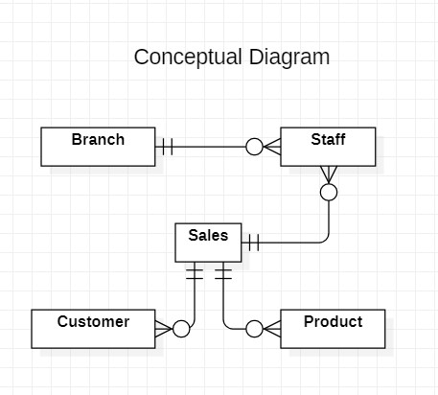

Logical model
Logical model has as main goal to establish all entities involved in project (branch, staff, sales, customer and product), all their attributes, constraints and relationships between them.
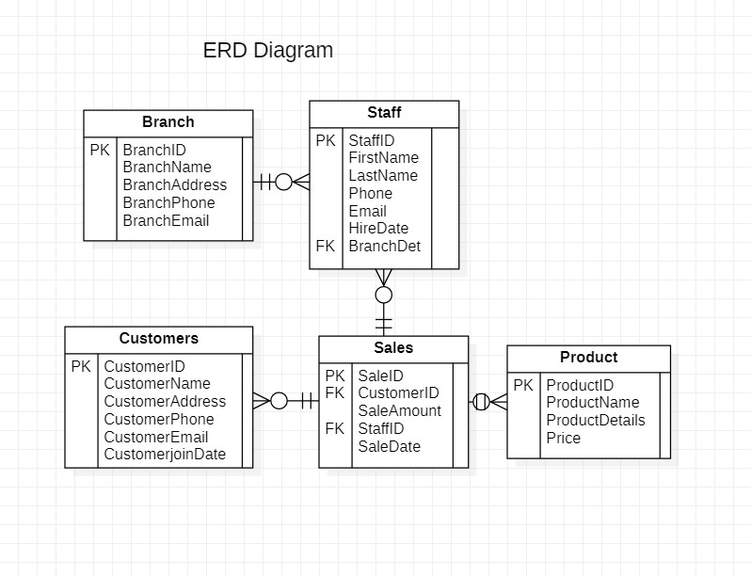

Physical model for ESim:
Physical model database has as purpose to show table structure (table names, table columns, data type, constraints, primary key=PK, foreign key=FK)

Branch – BranchID: Integer (PK)
BranchName: Varchar (50)
BranchAddress: Varchar (50)
BranchPhone: Varchar (15)
BranchEmail: Varchar (50)
Product – ProductID: Integer (PK)
ProductName: Varchar (50)
ProductDetails: Varchar (50)
Price: Decimal (18,2)

Staff – StaffID: Integer (PK)
FirstName: Varchar (50)
LastName: Varchar (50)
Phone: Varchar (15)
Email: Varchar (50)
HireDate: Date
BranchDet: Integer (FK)
Customers – CustomerID: Integer (PK)
CustomerName: Varchar (50)
CustomerAddress: Varchar (50)
CustomerPhone: Varchar (15)
CustomerEmail: Varchar (50)
CustomerjoinDate: Date
Sales – SaleID: Integer (PK)
CustomerID: Integer (FK)
SaleAmount: Varchar (50)
StaffID: Integer (FK)
SaleDate: Date

Tables Description

We are proposing to use following Tables with their attributes and constraints which are covering all your company requirements:
- Branch table: Table will contain information with branch name, branch address, branch phone and branch email and auto-increment.

Attributes: BranchID, BranchName, BranchAddress, BranchPhone, BranchEmail;
Constraint: Branches ID will be unique.

- Customers table: Table will contain information about customer name, customer address, customer phone number, customer email and the date when they joined in your company, from all branches. On your request, we can modify the appearance of table, that some of client’s sensitive data to be revealed only in branches where they opened their accounts, for security reasons.

Attributes: CustomerID, CustomerName, CustomerAddress, CustomerPhone,
CustomerEmail, CustomerjoinDate
Constraint: Customer ID will be unique for this table, and Customer Email need to
follow pattern “example@example” (implemented a Check Constraint
which will not allow to modify existing records or new records to keep
integrity and structure of your company table).

- Product table: Table will contain information about products name, product description and price per item.

Attributes: ProductID, ProductName, ProductDetails, Price;
Constraint: ProductID will be unique.

- Staff table: Table will contain information with first staff name, last staff name, staff phone number staff email, date when they have been hired into your company and with their branch’s allocation.

Attributes: StaffID, FirstName, LastName, Phone, Email, HireDate, BranchDet;
Constraint: Staff ID will be unique; email need to have format “example@example”
and their telephone numbers cannot have less or more than 10 numbers
for keeping integrity of table (used 2 Check Constraint); BranchDet is
a foreign key, taking data from table Branch.

- Sales table: Table will stock information with all sales, will hold information
about customer who closed that sale, amount of each sale, date and member of staff who closed that sale.
Attributes: SaleID, CustomerID, SaleAmount, StaffID, SaleDate;
Constraint: SaleID will be unique, CustomerID and StaffID foreign keys taking data
from tables Customers and Staff.

Advantages for using our database

- Company can view or save all staff reports from all branches in ascending order (in this example):

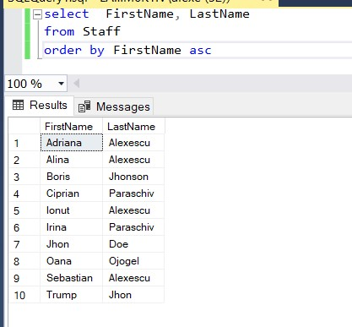

- Company can view all staff from all branches with their hiring dates in descending order (in this example) from the last hired person until the oldest:
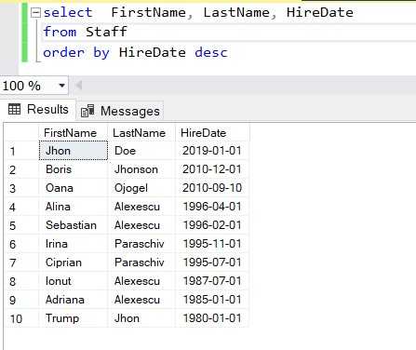

- Company can view (or to save) report with all customers in ascending order by their name:
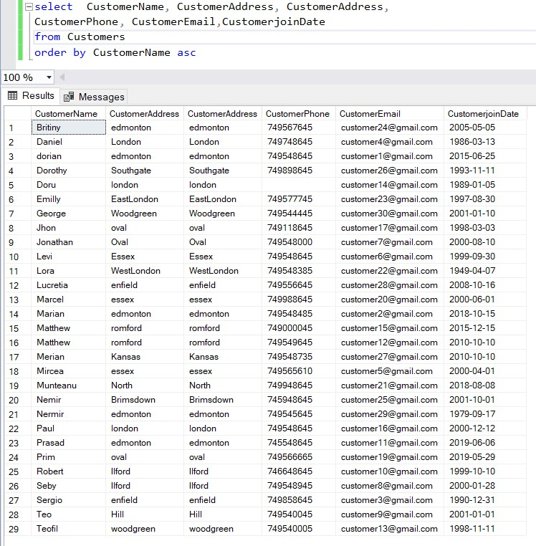

- Company can run different queries regarding customers, for example, to view all customers which have joined after 1st January 2000:
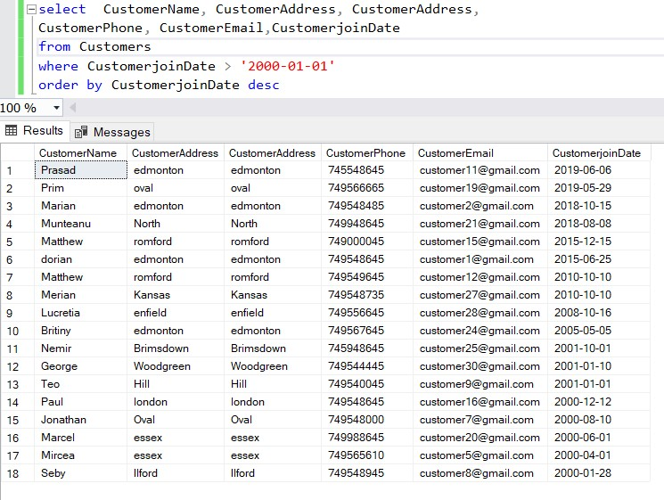

- Company can view reports regarding sales, for example, report with all sales after 1st January 2002:
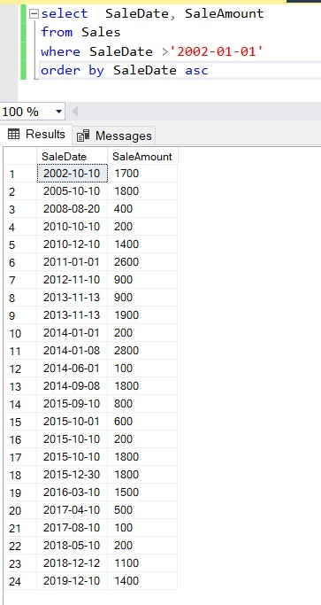
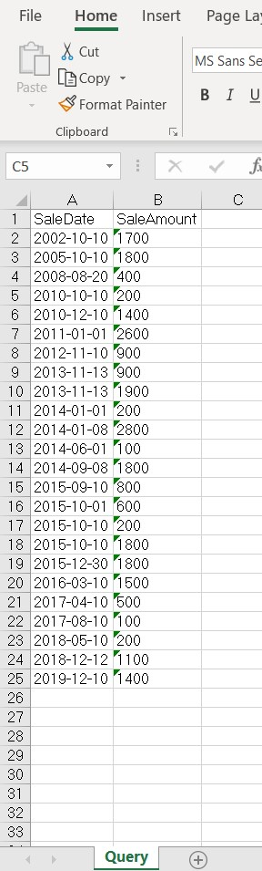
- Company can view reports with all sales, amount of sale, date and staff who closed that sale:
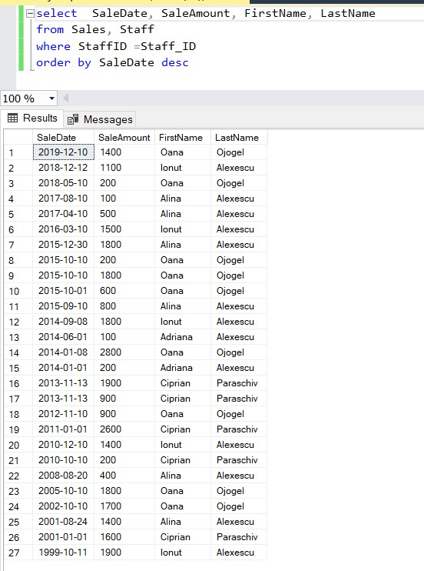

- Company can view and save reports regarding all sales within 1 year, with details regarding staff name, amount and date of sale:

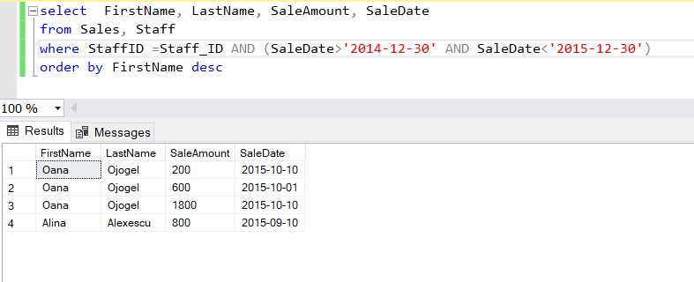

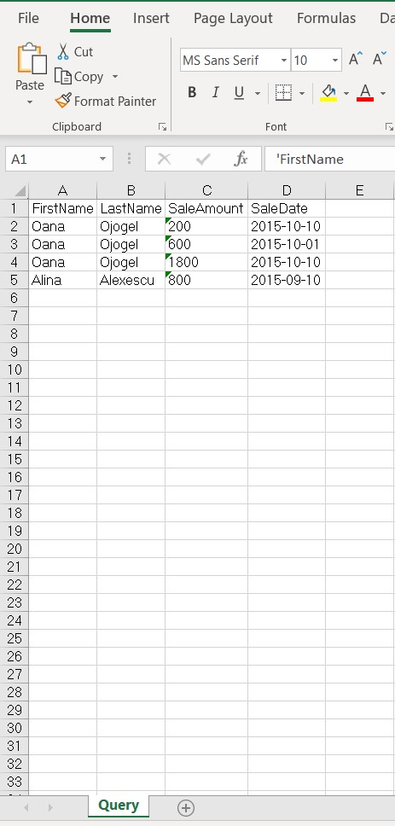

References

Connolly, T. a. B. C., 2015. Database systems. s.l.:Pearson Education UK..

