Assignment 2: Destination Management: Tower of London
Program: BA International Hotel Management
Module: Sustainable Hospitality & Tourism Management
Module code: BMIH5006
Student name: Hasna Jahan
Student ID number: 2109022
Lecturer Name: Ruth Taylor-Davies

Table of Contents
Introduction 1
Principles of Sustainable Tourism 1
Regulations 3
Principles 3
Regulations 3
Responsibility 4
Travel aspects 4
Butler’s life cycle model 4
Doxey’s Irridex 6
Data and Statistics 8
Recommendations for the future development of the Tower of London 8
Conclusion 9
References 10

Introduction
The Tower of London is a historic castle located on the north bank of the River Thames in central London, England. It has a rich history spanning almost 1,000 years and is one of the city's most iconic tourism destinations. The Tower of London was founded in 1066 by William the Conqueror. Over the centuries, it has served various purposes, including a royal palace, treasury, prison, and armoury. The Tower of London is generally open to the public every day except on December 24-26 and January 1 (Denny, 2020). It operates with specific opening and closing times, which can vary, so it is best to check the official website for the most up-to-date information. The Tower of London is conveniently located near other popular attractions in London. Visitors can explore the Tower Bridge, take a Thames River cruise, or visit nearby tourist destinations like the Tower Hill Memorial and the HMS Belfast. The main objectives of this report are to identify sustainable tourism which is mainly to minimise the negative impact and maximize the positive aspects of tourism. Principles of sustainable tourism and their activities furthermore some regulations related to the issues.

Principles of Sustainable Tourism
There are mainly three pillars of sustainable tourism. They are Economic sustainability, Socio-Cultural sustainability, and Environmental sustainability. Sustainable tourism creates a better holiday experience for tourists and locals.
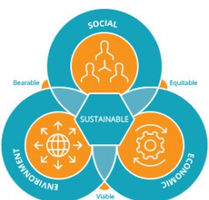
Figure 01: Principles of Sustainable Tourism
Sources: (Bramwell, 2019)
Economic Sustainability: As a prominent tourist destination, the Tower of London has a huge economic effect. It makes money by selling tickets, gift stores, and other numerous services. This economic sustainability is critical for the site's upkeep, historical relevance, and job prospects (Fabio, Anil and McAleer, 2020). The proceeds go toward continuous upkeep, repair, and the development of educational activities and exhibitions. Furthermore, the economic operations of the Tower of London contribute to the local economy by producing employment and supporting allied businesses like hospitality and transportation. Stonehenge and the British Museum are also some famous tourist places where every day lots of people visit. These places contribute to economic effect make money by selling tickets and other numerous services.
Socio-Cultural Sustainability: The Tower of London fulfils an important role in conserving and promoting London's and the United Kingdom's socio-cultural legacy. It is an educational resource, providing visitors with information on the country's history, monarchy, and architectural legacy (Sharma, 2020). Tourist guides give guided tours and tell fascinating stories to visitors, improving their understanding of the Tower's cultural value. The Tower of London contributes to the sociocultural framework of the neighbourhood by engaging with the local community, employing local citizens, and involving surrounding companies. Also, British Museum represents socio-cultural and historical representation to travellers.
Environmental Sustainability: Long-term tourism must preserve the environmental integrity of the Tower of London and its surroundings. Waste management, energy efficiency measures, and sustainable procurement methods are among the efforts done to reduce the site's environmental effects (Megan, 2019). The facility, for example, aspires to lower its carbon footprint, appropriately manage water use, and minimize trash output through recycling and sustainable waste disposal procedures. Furthermore, the Tower of London has biodiversity programs in place, such as attempts to improve habitat for local species and encourage sustainable gardening methods. Hyde Park has a natural environment that attracts travelers every year, it is not only a tourist place but also an eco-friendly place that reduces carbon emissions and is also an inhabitant of many birds and species, that maintain a balance to maintain environmental sustainability. The Tower of London exhibits a commitment to sustainable tourism principles throughout the three pillars of sustainability, although there is always potential for improvement. Continued efforts may be made to improve economic sustainability by diversifying revenue streams and providing further assistance to local firms (Pineda et al., 2019). Strengthening relationships with the local community and including them in decision-making processes can help to ensure socio-cultural sustainability. Finally, by investing in renewable energy sources and implementing more thorough environmental management techniques, there is an opportunity to promote environmental sustainability. The Tower of London can contribute to the long-term preservation of its historical value, create pleasant socio-cultural experiences, and safeguard the environment for future generations of tourists by constantly analyzing and implementing sustainable practices (Pineda and Brebbia, 2021). The general principle of tourism is to offer the tourist customers fairly and give them better services in a safe and clean environment.

Regulations

Principles
Tourism-related organizations help to provide facilities that are constantly provided for tourists. They try to ensure the maintenance of quality services for the tourist. Hotels, motels, flats, beds, and lodges are common accommodations for tourists. Tourism-related organizations also try to use many renewable energy sources for maintaining sustainable tourism (French, Collier and Craig-Smith, 2020). Renewable energies generate energies that produce no greenhouse gas emissions from fossil fuels and reduce air pollution. They use renewable energy sources from sunlight, wind, water from rain, and waves from the river or sea. From the use of renewable energy usage in the tourism industry it helps to provide better services and facilities for the tourist.

Regulations
The UK Government announces the break free from plastic pollution act of 2023, which will maintain a ban on the supply of a single-use of plastic in England (Satyender, 2020). The regulation has declared that the use of plastic should be as low as possible.

Responsibility
To provide a sustainable tourist facility organization should maintain some CSR activities. To maintain sustainable tourism such as responsible use of natural resources, pollution conservation, accountable use of local products, and alliance and cooperation with all the organizations to improve the quality of the hospitality (Goodwin, 2019). Conservation of biodiversity, landmarks, and cultural traditions. Also, to maintain sustainable tourism major security should be maintained for a better travel experience, convenient travel facilities should be provided and also a convenient travel cost should be provided to ensure a better travel experience.

Travel aspects
The travelling industry includes numerous sectors and activities related to transportation, accommodation and tourism-related services (Vogel, 2021). Here is an analysis of the travelling aspects of the industry. Transportation is a main part of the travel industry. Without it, the travel industry cannot become as massive as today. Air travel, road transport, rail services, and marine travel are the main source of transportation to visit the Tower of London. Air travel is commonly used for long-distance journeys. It offers speed and convenience for the travellers who come from abroad. British Airways provide convenient packages for travellers to visit London. Road trips and rail travel are also popular in London for scenic routes. Hop-On Hop-Off bus is a very popular bus service to see London city and the Tower of London (Yuo, Chen and Tseng, 2022).

Butler’s life cycle model
Butler’s lifecycle model is used to evaluate the state of any tourism destination. It is also known as the tourism area cycle (TALC) (Butler, 2016). The model has some stages that a tourism industry goes through including development, renovation, visitor’s interest and the changes of the destination. Each stage is described below:
- Exploration: it is the first stage where a destination is initially unknown to the tourists and not so popular with the travellers. The place may have limited development and infrastructure as well as several visitors. Very few tourists are attracted to the destinations either enthusiasts or nature lovers (McKercher, 2018).
- Involvement: after some time the destination gains some fame and name from the travellers who have visited the place and a good review passed through (Babu, Mishra and Bivraj Bhusan Parida, 2018). Therefore, the number of travellers is starting increasing and investors are starting to invest in the destination. Many local businesses started to shift in the tourism sector such as hotels, restaurants, resorts and tour travel guides. From a very small tourism, the destination started to flourish.
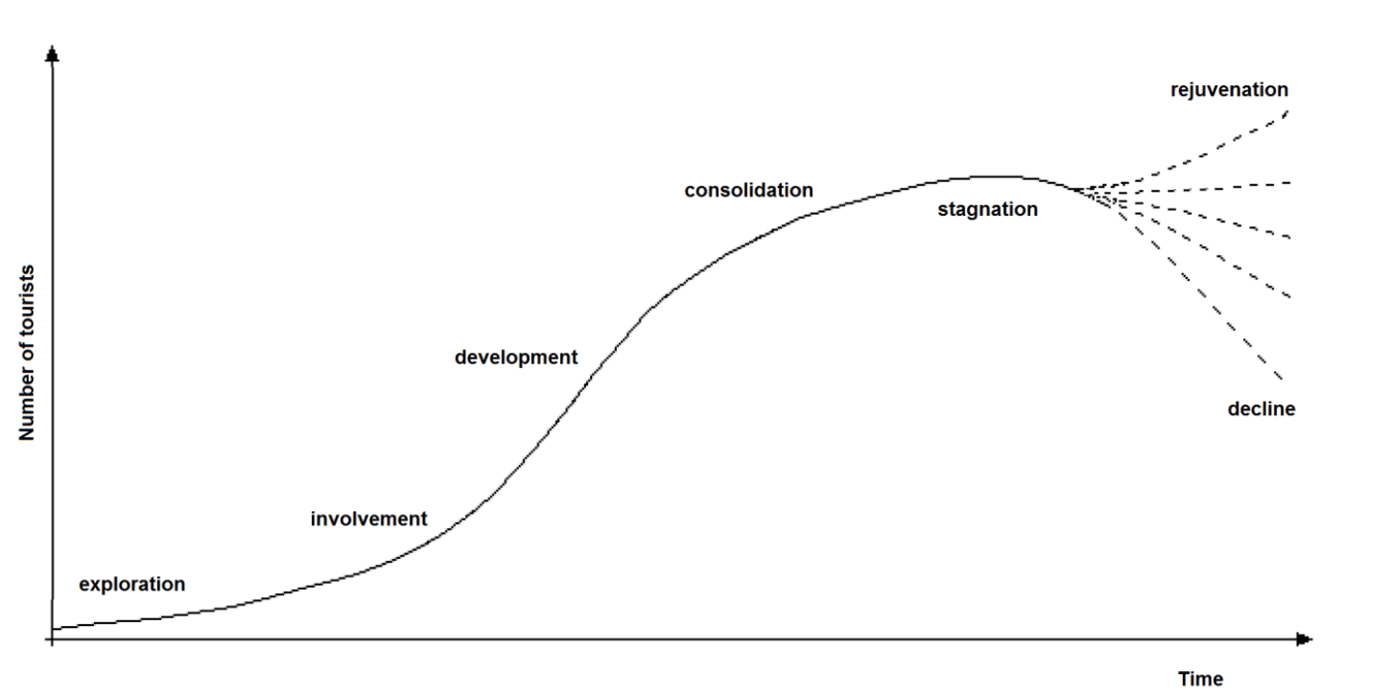
Figure2: Butler’s lifecycle model
Source: (Butler, 2016)
- Development: At a certain time, the destination started to develop. More investments are starting to come, it can be local as well as international stakeholders. Tourism destination started to become more important for economic purposes. There are many types of development such as accommodations, attractions, and amenities which started to develop. The attraction of tourist increase and demand rises. Therefore, government and law enforcement support started to implement in the places. The sustainability of the destination gets more importance in that destination (Butler, 2019).
- Consolidation: In this stage, the destination is at the peak of popularity. The number of travellers and tourists is now at its best. The destinations are well known and help the stakeholders to gain potential economic advantage. When it becomes popular and many types of products and services are emerging in the destination. Some concerns also emerged in the stage such as pollution, over crowed, and sociocultural changes.
- Stagnation: The decline of tourism is the stage of Stagnation. In this phase, the tourists are less interested in the destination. Several factors can cause the effects to include, including travel patterns alteration, changes in consumer preferences, or the emergence of newer, more attractive destinations (Andrianto and Kusumah, 2021).
- Rejuvenation or Decline: If a proper measure has been taken to the stagnation stage, the destination can become popular again. It is called Rejuvenation. On the other hand, a destination can be impacted by irresponsible maintenance. The destination can decline as it refers. The maintenance can be conducted through changing and implementing technology, innovation and marketing. The fluctuation of the traveller’s preference are both positive and negative
The Tower of London is a historic place in the UK. With time it become so popular among tourists and now it becomes the heart of London. The Tower of London has gone through a series of stages that can be evaluated by Butler’s life cycle model. In the beginning, the Tower of London was a palace and was used for royal purposes. With time it become popular among tourists and people came to explore its history. In the 19th century, it was developed for the people to preserve the heritage and aware people of the history of the tower.
Now, the Tower of London is in the consolidation stage, where it is at its peak and the most popular tourist destination in the UK (Fidgeon, 2020). Not only the locals but all around the world, tourists come to see the most iconic and popular tourist attractions in London.

Doxey’s Irridex
Doxey Irridex, also known as Doxey's Irritation Index. The model is developed by Professor David Doxey. There are four stages in the model. Unlike the butler’s model, it provides feelings, opinions and behaviours of locals toward tourists.
- Euphoria: The euphoria stage is the first stage of the Doxey Irridex. On the stage, the locals are welcoming toward the visitors. Due to the development of tourism, many opportunities won’t open for the residents that benefit economically.
- Apathy: When tourism started to flourish in a particular destination, apathy started to grow. The locals become more formal with the customers. The initial interests of the tourists become reduced and less participate in the destination (Jotham Kariuki Wanjohi, 2019).
- Irritation: In the irritation stage, locals are no more taking tourism as a positive advantage rater experience it as a issue and challenges. Some factors influence the hosts such as overcrowding, increased traffic congestion, air pollution, rising price hike, and changes in the social and cultural values of the community. Negative attitudes towards tourists and tourism development can emerge during this stage.
- Antagonism: the last and most important stage of the model is antagonism. Residents grow a deep adverse feeling towards tourism and tourists. Due to the community disruptions, the residents are aware of the effects of tourism and its consequences (Akis, Peristianis and Warner, 2018). On the stage, the locals create resistance and protests to live happily.
People around the Tower of London have gone through the stages of Doxey irridex. In the very beginning when the tower of London become so popular and residents started to like the matter as the job was more open for the locals. At that time the opportunities are so crucial for the locals and experienced euphoria. To some extent, the tourists are also the reasons for apathy and irritation. The constant flow of tourists caused overcrowding in the place. Which disrupts the locals and hamper the daily life of the residents.

Data and Statistics
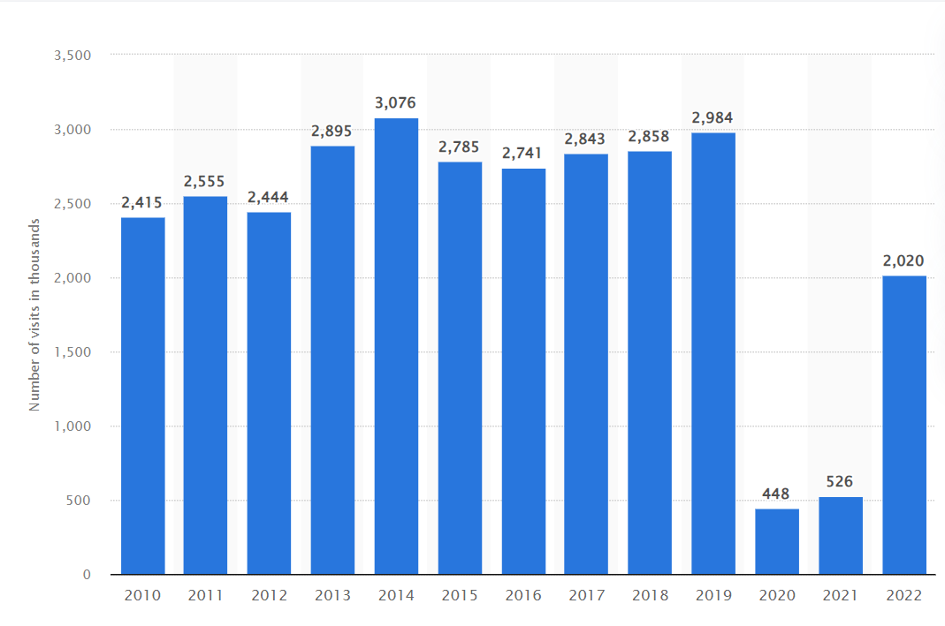
Number of visits to the Tower of London in England from 2010 to 2022 (in 1000)
Figure: Number of visits to the Tower of London in England from 2010 to 2022
Source: (Sharma, 2020)
The popularity of The Tower of London is explainable from the statistics above. It shows that for the last 10 years, the visitors was constantly increasing. Due to the pandemic of Covid-19, the number of visitors were decreased in 2020 and 2021. That time the number of visitors was bellow one fourth from normal time. It caused 32% less revenue overall in the London. In 2022, the visitors increase again but not like before (The Guardian, 2020).

Recommendations for the future development of the Tower of London
There is some recommendation for the development of the Tower of London with a focus on sustainability practice:
- The tower of London is in the urban area and the middle of the city. Therefore, the crowd can cause a lot of pollution in the city. To mitigate the risks, waste reduction and recycling need to be ensured. They need more eco-friendly and biodegradable materials in the tourist destination. The transformations need to be designed for sustainability and have no environmental effects.
- The culture of the UK is very ancient and the Tower of London plays a crucial role in the heritage of London. Therefore, the tower needs to be preserved and several measures need to be taken to save the historically valuable destination and landscape. To promote sustainability, the tower needs regular maintenance and restoration.
- To save tourism, local community engagement is necessary. The collaborative approaches with the locals and residents add value to tourists around the world. In this case, the locals are getting priority and no irritation will appear.
Conclusion
In conclusion, the Tower of London is a historic and iconic tourist destination in London. The destination has experienced many stages of development. The developments are offered by Butler's life cycle model. There are several steps that the Tower of London go through. From exploration and involvement, the Tower of London is now in the state consolidation stage. It is the peak of The Tower of London which many tourists come here every day to see the historic tower. The residences are also gone through different stages. According to Doxey's Irridex model, there are four stages. In the euphoria stage, locals are friendly toward the tourist, whereas, irritation and antagonism are comparatively more disruptive experiences to the locals. Several sustainability measures need to be taken to save the Tower of London for the future includes, including sustainable management practices, preservation culture, and local community engagement.

References

Akis, S., Peristianis, N. and Warner, J. (2018). Residents’ Attitudes to Tourism Development: the Case of Cyprus. Tourism Management, 17(7), pp.481–494.
Andrianto, T. and Kusumah, A.H.G. (2021). The Journey of Mapping the Entire Destination Lifecycle. Jurnal Kepariwisataan: Destinasi, Hospitalitas Dan Perjalanan, 5(1), pp.10–19.
Babu, S., Mishra, S. and Bivraj Bhusan Parida (2018). Tourism Development Revisited: Concepts, Issues and Paradigms. SAGE Publications India Pvt Ltd eBooks. SAGE Publishing.
Bramwell, B. (2019). Sustainable Tourism Management: Principles and Practice. Tilburg, The Netherlands: Tilburg University Press.
Butler, R. (2016). The Tourism Area Life Cycle: Applications and Modifications. Clevedon, Uk; Buffalo: Channel View Publications.
Butler, R.W. (2019). 6. Overtourism and the Tourism Area Life Cycle. Overtourism, 1(2), pp.76–90.
Denny, V.F. (2020). Tower of London. Minneapolis, Mn: Bellwether Media, Inc.
Fabio, C., Anil, M. and McAleer, M. (2020). Economics of Sustainable Tourism. Routledge.
Fidgeon, P.R. (2020). Tourism Education and Curriculum Design: a Time for Consolidation and review? Tourism Management, 31(6), pp.699–723.
French, C.N., Collier, A. and Craig-Smith, S.J. (2020). Principles of Tourism. Sydney: Longman Australia.
Goodwin, H. (2019). Taking Responsibility for Tourism: Responsible Tourism Management. Woodeaton, Oxford: Goodfellow Publishers.
Jotham Kariuki Wanjohi (2019). Attitude Assessment of Sighted Pupils Towards Visually Impaired Peers in Integrated Primary Schools: a Case of Nakuru. 03-00.
McKercher, B. (2018). Destinations as Products? a Reflection on Butler’s Life Cycle. Tourism Recreation Research, 30(3), pp.97–102.
Megan, E.W. (2019). Sustainable Tourism on a Finite Planet. Taylor & Francis.
Pineda, F.D. and Brebbia, C.A. (2021). Sustainable Tourism V. Southampton: Wit Press; Billerica, Ma.
Pineda, F.D., Brebbia, C.A., De, I. and And, N. (2019). Sustainable Tourism. Southampton: Wit Press.
Satyender, S.M. (2020). Ethical, Legal and Regulatory Aspects of Tourism Business. Richard.
Sharma, K.K. (2020). Tourism and socio-cultural Development. New Delhi: Sarup & Sons.
The Guardian (2020). ‘Bored’ Ravens Straying from Tower of London as Tourist Numbers Fall. [online] The Guardian. Available at: https://www.theguardian.com/environment/2020/aug/20/bored-ravens-straying-tower-london-tourist-numbers-fall-legend-birds-monarchy [Accessed 2 Nov. 2021].
Vogel, H.L. (2021). Travel Industry Economics. Springer Nature.
Yuo, T., Chen, W.V. and Tseng, T.A. (2022). Optimising the Routes of the Hop-On Hop-Off Sightseeing Bus: a New Method Explored. SSRN Electronic Journal, 23(54).

