Nathan J Morris

A local housing developer has received planning consent and has signed a Section 278 agreement to provide highway access for a housing estate on SA1.
Work is proposed to start on 6th March 2023.
Essay
The following document will include a detailed Construction Method Statement for three of the major activities related to this project.

Contents
1.Detailed work breakdown structure 2
2.Construction method statements 3
Earthworks – Clear vegetation 3
Traffic management and access 6
Paving layer installation 9
3. Critical path analysis 12
4. Reports for time, cost, and resource 14
Task cost overview 14
Resource overview 16
Time overview 17
Figures and tables 18
Figure 2 – Site set up overview. 18
Figure 3 – Wales and west utility plans 19
Figure 4 – National grid utility plans 20
Figure 5 – Welsh water utility plans 21
Table 1 - Resource task sheet with costs 21
Appendix 22
Appendix A 22
Appendix B 22
Appendix C 23
Appendix D 24
Appendix E 25
Appendix F 26
Appendix G 27
References 28

Word count - 2104

1.Detailed work breakdown structure

Below is a summary via screen grabs of the Microsoft project Gantt chart which has been used to create a detailed work breakdown structure for all the major activities related to the construction project. The full Gantt chart will be added to the submission portal to be viewed separately.

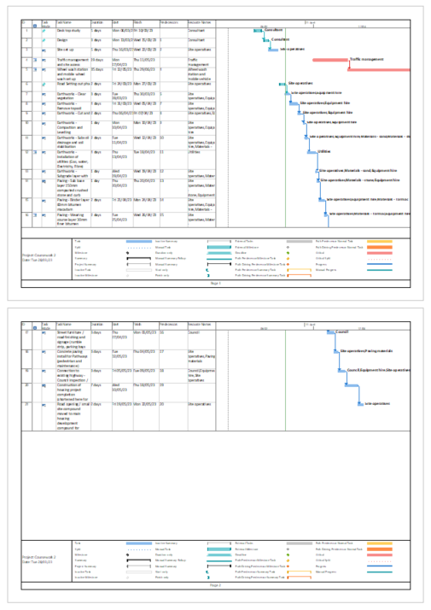
Figure 1 – Project Gantt chart

2.Construction method statements

Earthworks – Clear vegetation

Purpose and scope
Method statement for the vegetation clearance stage of the project (earthworks stage). This method statement will describe the process for site clearance of vegetation by the contractor and outline the clear step by step process for this activity ensuring statutory environmental compliance.
Responsibilities
The responsibility for vegetation clearance will fall with the construction manager on site and they will ensure these tasks outlined below are carried out in accordance with this procedure.
Workforce
• Site engineer
• Equipment operators
• Ecologist
• Site supervisor
Equipment
• Excavators
• Earth removal lorry
• Dozers/Loaders
• Survey equipment
• Other hand operated tools (if required)
PPE
• Safety helmet – to BS EN 397.
• Hearing protection – to BS EN 352-1.
• Eye protection – safety glasses to BS EN 166.
• Gloves – to BS EN388(4343) Cut Level 3 or 5.
• Dust masks – high filtration to BS EN149FF-P3
• Safety Boots – steel toecap/mid sole
• Reflective Jackets/vests

Methodology for Earthworks – clear vegetation - compaction
Preliminary Activities
The site boundary will be marked out clearly, and all staff briefed on the land to be cleared.
The site setting out phase drawing will have been submitted and approved by the contractor prior to clearance work taking place.
All underground asset plans and site surveys will have been completed prior to excavation works starting.
Enquiries have been made to all utility companies requesting the information on any existing services located in the adopted carriageway footpath and verge area on Langdon road, up to the proposed new connection from the existing carriageway to the proposed development site on SA1 see Figure 1.
Local Utility drawings of the area can be seen in Figures 2-4.
A topographic survey of the proposed development will be undertaken in the setting out stage of the above-mentioned area. This survey will record the position of the manholes, the invert / cover levels as well as any junction boxes, valves, and other service-related infrastructure visible in that area.
As well as the topographic survey the appointed surveying contractor will conduct an electromagnetic scan of the area using ground penetrating radar to pinpoint any services in the adopted highway and footpath in the above-mentioned vicinity, these will then be marked out on site.
This information will then be collated, and a drawing constructed of this infrastructure which will be provided to all staff prior to work commencing and a copy displayed in the site compound.
Known utility information such as the existing DCWW – Welsh water drainage pipe is of sufficient depth (>900mm) and will be unaffected by the section 278 works to form the entrance to the development. This depth of cover is deemed sufficient to not need relocation by the Design manual for roads and bridges specification table (Standards for highways, 2020).
The majority of services were found to be located in the adopted footbath on the other side of Langdon Road, opposite to the development and therefore not be affected by the 278 agreement. However, connections off these and new services will be required and these will be laid in accordance with the footway and design manual for roads and bridges 2020.
Meetings with the relevant utility companies have been held and they will be working in conjunction with us to install their equipment as per schedule of works (W/C 19/04/23).
Ecological surveys will be undertaken in line with NRW regulations to confirm no protected or invasive species are present.
Anyone entering site will recieve a site safety induction.
All tools and equipment should be inspected prior to use.
A Permit to excavate will need to be approved by the site manager prior to any work being carried out, the on site Ecologist will also confirm the task can go ahead and after a site walkover.
Execution methodology
Before site clearance activities start all staff will be given a toolbox talk on the task ahead and their roles and responsibilities as well as all health and safety briefings.
The site should be clear of any existing debris that may damage the machinery.
Topsoil shall be removed by machine set to a maximum of 150mm depth in accordance with British standard BS8601: 2013 (BSI group,2023) specification subsoil. Any excess material should either be stored on site safely for reuse after testing by the site team as per Development Industry Code of Practice (DoWDICoP). Or removed via lorry and disposed of in accordance with local environmental standards.
Any soil found to contain contaminants will be documented segregated and the site manager notified. All hazardous material shall be disposed of as as per local environmental plan.
Any holes created from the removal of large woody vegetation shall be backfilled and compacted.
Clearing activities shall be filed/recorded on daily basis in line with the programme of works.
Safety Requirements
Only trained operators or banks-men (Competent staff) will be allowed to operate specialised machinery during site clearance.
Site staff involved in the activities under this Method statement will be required to wear the basic PPE outlined above.
All accidents / near misses should be reported to the site manager immediately.
All site operators will have the valid license and third-party certificate.
Adequate safety signs shall be provided and displayed correctly in line with chapter 8 guidance.
Surrounding services if present will be protected to prevent from damages.
All equipment should be tagged, in date and have the registration certificate, ownership certificates, and insurance.
Daily housekeeping will be carried out during and after the working day is complete and these will be monitored by the site supervisor.

Traffic management and access

Purpose and scope
Method statement for the traffic management and site access stage of the project. This method statement will describe the process for traffic management and site access by the contractor and outline the clear step by step process for this activity ensuring statutory compliance.
Responsibilities
The responsibility for traffic management and site access will fall with the site manager on site and they will ensure these tasks outlined below are carried out in accordance with this procedure.
Workforce
• Site Manager
• Traffic management contractor
• Site supervisor
• Gatesman / Banksman
• Site operatives

Equipment
• Stop / Go boards
• Temporary traffic lights
• Road traffic signs / pedestrian access signage
• Pedestrian footpath ramps

PPE
• Safety helmet – to BS EN 397.
• Hearing protection – to BS EN 352-1.
• Eye protection – safety glasses to BS EN 166.
• Gloves – to BS EN388(4343) Cut Level 3 or 5.
• Safety Boots – steel toecap/mid sole
• Reflective Jackets/vests

Methodology for traffic management and site access
Preliminary Activities
The site boundary will be marked out clearly and fenced off using heras style fencing panels, and all staff briefed on the site layout and access / egress routes, this can be seen in figure 2.
Contractors and suppliers will be informed of the site layout and temporary access and egress routes prior to arriving (Site access layout plan can be seen in Figure 2).
Traffic management contractors will set up temporary traffic lights on Langdon road in accordance with chapter 8 signing lighting and guarding requirements (Gov.uk,2023), this will facilitate access to the site compound and allow safe passage of pedestrian vehicles along Langdon road

Execution methodology
Before site access and traffic management provisions are set up, all staff will be given a toolbox talk on the task ahead and their roles and responsibilities as well as all health and safety briefings.
The site manager will brief all staff on access and egress routes as well as site operating times and delivery locations.
Once staff are happy with this, the traffic management contractor will set up the temporary traffic lights in accordance with Section 8 requirements (Gov.uk,2023).
Stop / Go boards will be used as a back up to the temporary traffic lights and used as and when required, these will be used by the Banksman / appropriately trained site operatives.
All plant and materials will be loaded and unloaded within the designated zones and no plant and materials will be loaded or unloaded on Langdon road or any other public highway / footpath. These requirements will be enforced by the site manager and all visitors to site will need to report to the main site office where they will be briefed of the site rules and have a site induction.
Site access shall resume in conjunction with the traffic management contractors traffic light schedule, this will be monitored and adjusted accordingly to maintain a consistent flow of traffic.

Safety Requirements
Only competent appropriately trained staff will use stop / go boards when needed.
Site staff involved in the activities under this Method statement will be required to wear the basic PPE outlined above.
All accidents / near misses should be reported to the site manager immediately.
Traffic management contractors will be appropriately trained and have their training certificates present, and their signage and guarding will be checked by the local highways inspector periodically.
All equipment should be tagged, in date and have the registration certificate, ownership certificates, and insurance.
Daily housekeeping will be carried out before, during and after normal working hours and these will be monitored by the site supervisor.

Paving layer installation

Purpose and scope
Method statement for the installation of the road paving stage of the project. This method statement will describe the installation of the paving stage by the contractor and outline the clear step by step process for this activity ensuring statutory compliance.
Responsibilities
The responsibility for the road paving install will fall with the site manager on site and they will ensure these tasks outlined below are carried out in accordance with this procedure.
Workforce
• Site Manager
• Foreman
• Site supervisor
• Equipment operators
• Site operatives

Equipment
• Stop / Go boards
• Temporary traffic lights
• Paving machine
• Steel roller
• Compactor
• skid steer / bobcat
• Surveying equipment
• Tipper truck
• Tarmac delivery vehicle
• Various hand tools
• Grading stick
• Spreader / wheelbarrow

Materials
• Hot mix ashphalt in accordance with BS 598987 (BSI,2023) Coarse and fine.
• Bitumen binder

PPE
• Safety helmet – to BS EN 397.
• Hearing protection – to BS EN 352-1.
• Eye protection – safety glasses to BS EN 166.
• Gloves – to BS EN388(4343) Cut Level 3 or 5.
• Safety Boots – steel toecap/mid sole
• Reflective Jackets/vests

Methodology for paving layer installation
Preliminary Activities
The contractor / site manager shall ensure that the correct permits, tools, appropriately trained competent staff, and equipment are available before any work begins.
Prior to mobilizing on-site, all major equipment will need to have been serviced and display all appropriate calibration certificates as well as machine operatives having their training records present and in date.
The site manager will make sure that access roads are clear and the site is accessible for the length of the work with any updates conveyed to all site staff.
The site team with the assistance of the site manager will ensure all manpower, tools and materials are present ready for the planed works.
The required diversion routes while new road surfacing works occurs shall be marked on all drawings and issued to all staff and contractors beforehand.
Execution methodology
Installation of sub base in line with specification in appendix E, the material shall be hard, clean and free from any organic material.
The material will be delivered to site by tipper lorries and spread evenly using appropriate machinery.
The material will then be compacted in layers to the specified thickness using a vibrating roller and alignment checked and approved by the site manager.
CBR testing will then occur to confirm required specifications have been reached detailed in appendix E.
Following the successful installation of the sub base, the base course, binder course and wearing layer can be laid as follows.
The base course shall be laid in accordance with the mentioned specifications and will meet BS 1621 (BSI group,2023) standard for asphalt, it will comprise of a courser crushed rock mixed with asphalt and a bitumen binder and delivered to site in tipper trucks.
The mix will be approximately 160C and shall be laid in a single layer to the required specification and rolled in layers to reach the required depth.
The compaction should not include vibration for the first two passes and should be rolled approximately 8 times longitudinally.
After the base course a binder layer of a bitumen bound aggregate layer should be installed in line with specification and as above.
Following the binder course a wearing / surface course layer consisting of finer aggregate mixed with asphalt should be installed as per specification and in one single layer in line with the above methodology.

Safety Requirements
All contractors and staff on site should be fully briefed in the safe working procedures for the task with tool box talks held prior to any work commencing.
Site staff involved in the activities under this Method statement will be required to wear the basic PPE outlined above.
All accidents / near misses should be reported to the site manager immediately.
All workers shall ensure tools / machinery are in good working order and any defects reported to the foreman immediately.
All equipment should be tagged, in date and have the registration certificate, ownership certificates, and insurance.

3. Critical path analysis

The critical path for this project can be identified in the following images, however, for ease of use, the Microsoft project file will be attached to this coursework enabling a more in depth look at this.
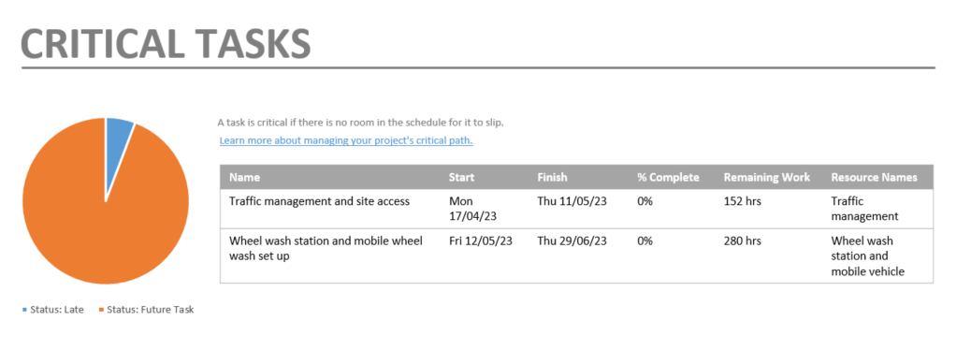

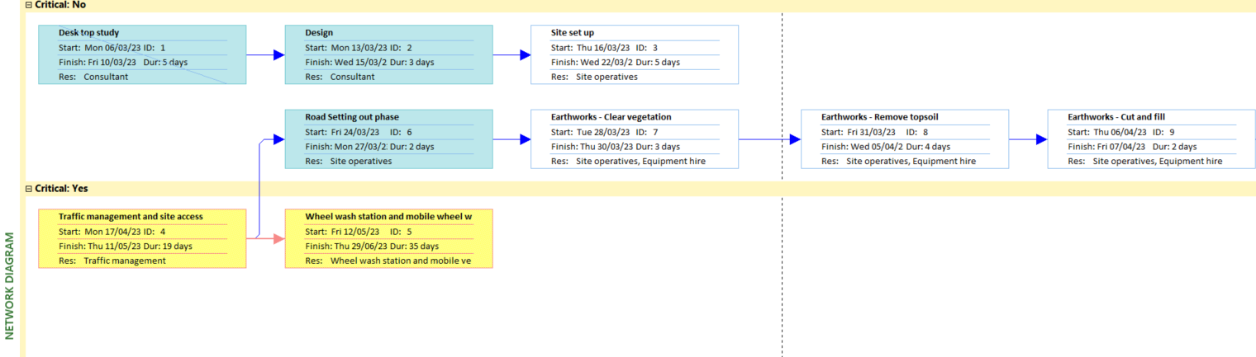

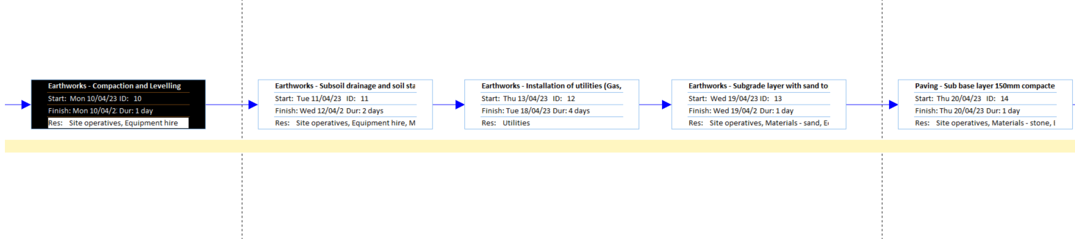
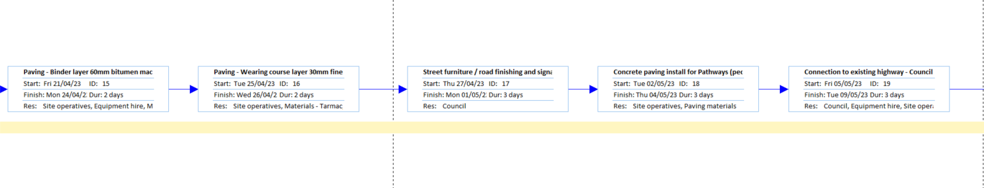
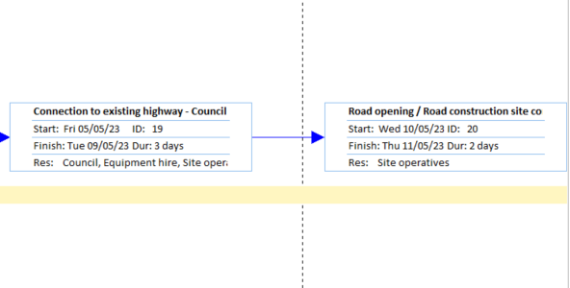

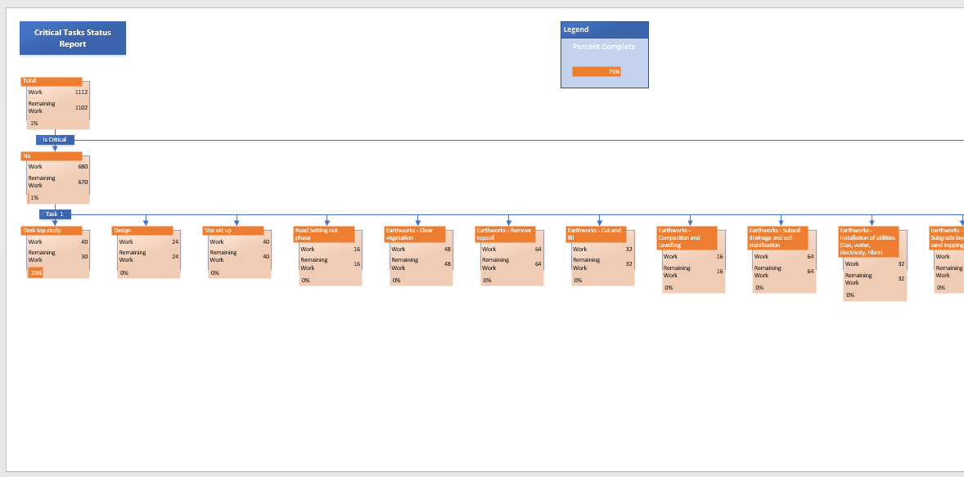
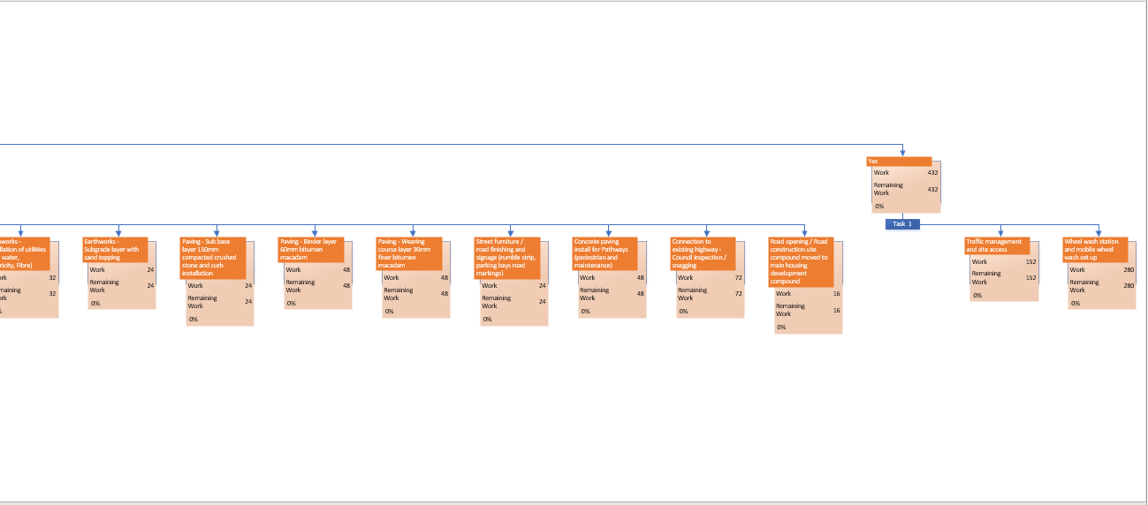

4. Reports for time, cost, and resource

Below time, cost and resource information has been imported from Microsoft project. The Microsoft project file will be attached to this coursework if the reader requires a more detailed breakdown of these specific reports. The below reports are simply screen grabbed for ease of viewing.


Task cost overview

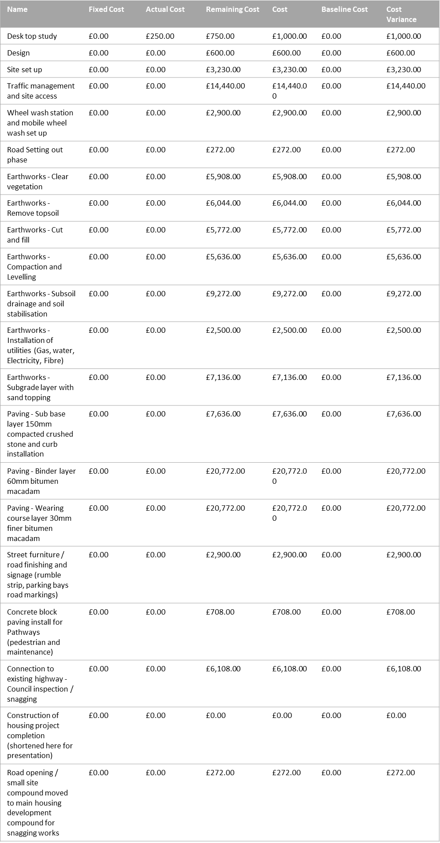

Resource overview
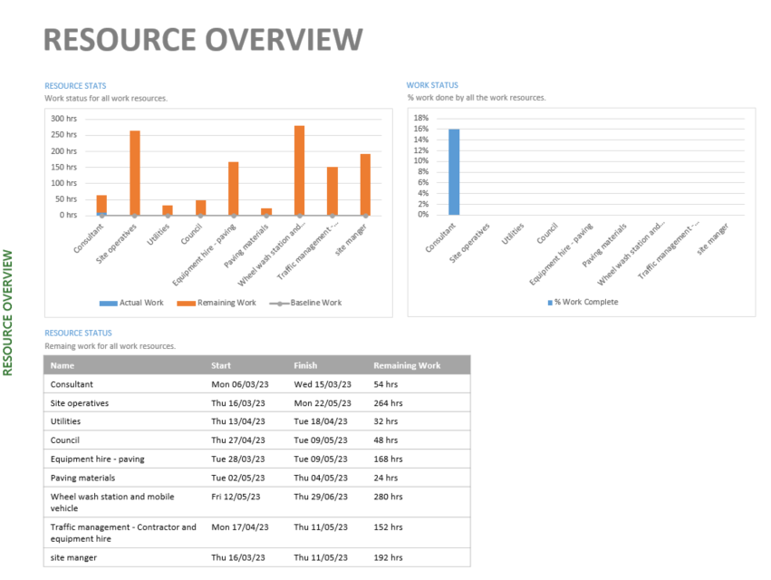

Time overview

The total time for the three major activities above including cost and resource for them are as follows.
Costs are broken down into more detail in the resource task sheet found in Figure 5. All costs have been researched in accordance with Spons and other relevant cost forecasting sites.

Task | Time (days) | Cost | Resource
Earthworks – subsoil and drainage stage | 10 | £23,360 | 4 site operatives,  Paving equipment hire, Materials – sand and stone.
Traffic management and site access | 19 | £14,440 | Site manager plus  Traffic management contractors for 19 days.
Paving layer road construction | 5 | £49,180 | 4 Site operatives, paving contractor, various plant and materials.

Figures and tables

Figure 2 – Site set up overview.
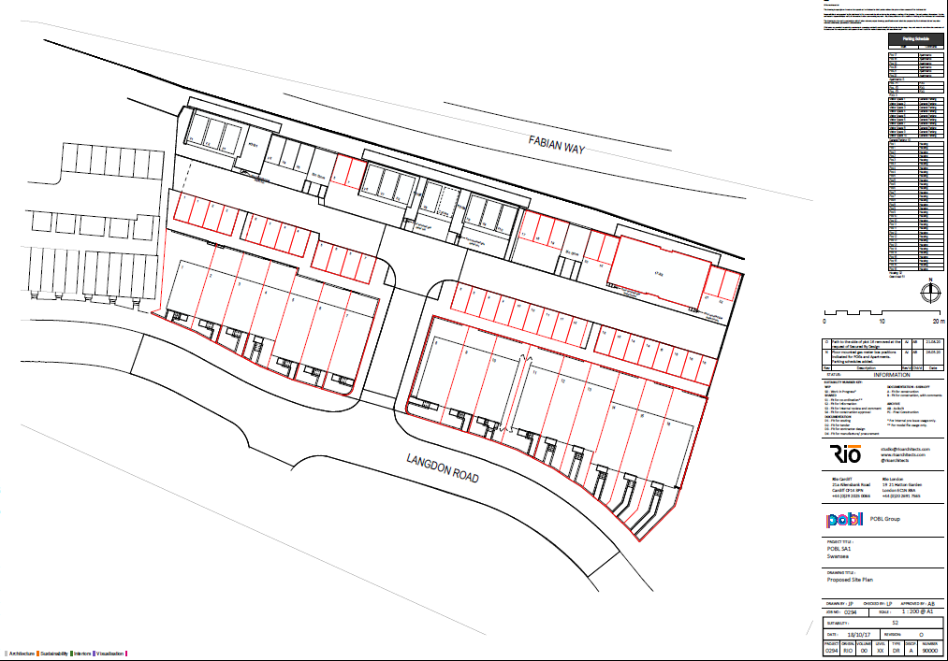
Temporary traffic lights
Heras fencing
Site storage
Wheel wash point
Temporary access point
Proposed site set up with connection to Langdon Road and proposed road layout (Swansea planning portal,2023).

Figure 3 – Wales and west utility plans

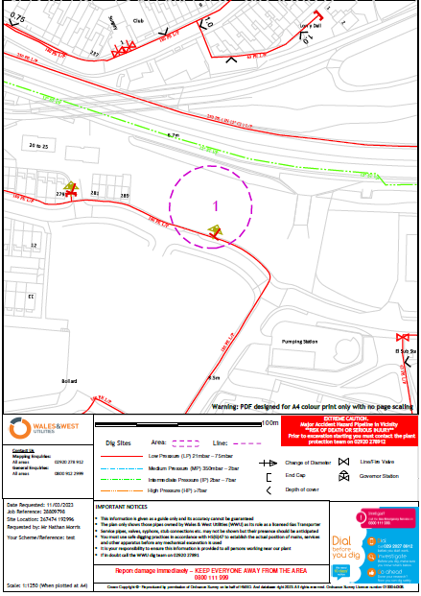

Figure 4 – National grid utility plans

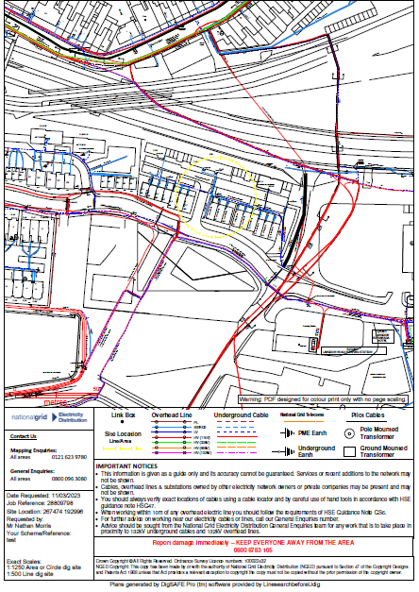

Figure 5 – Welsh water utility plans

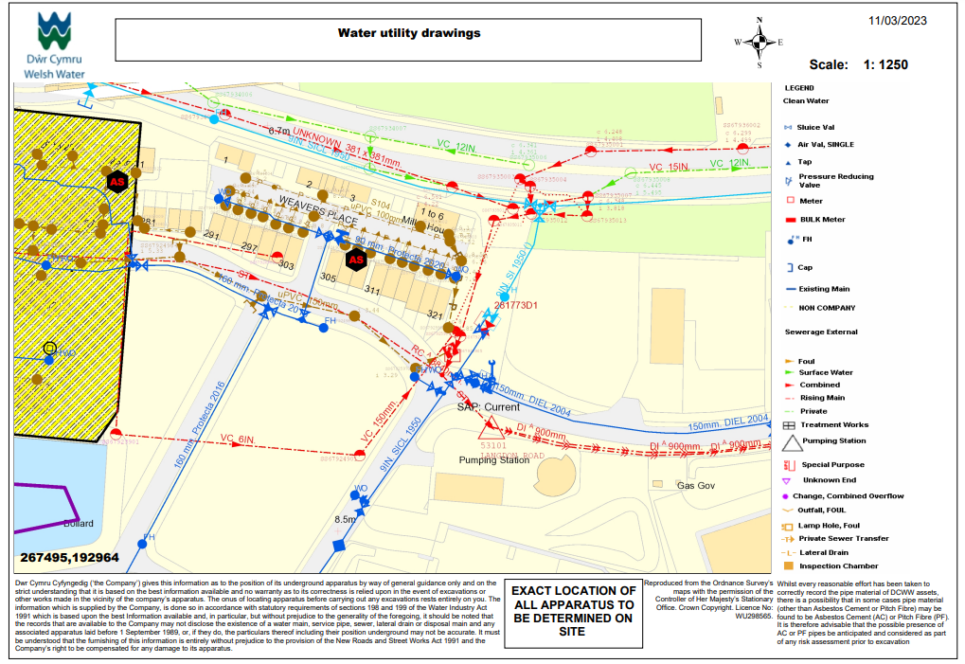

Table 1 - Resource task sheet with costs
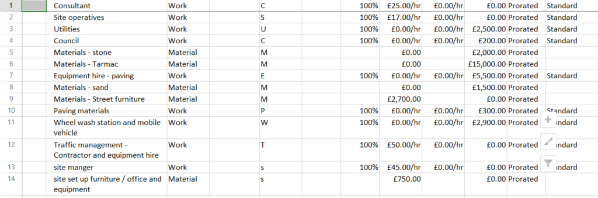

Table 1 – Resource task sheet with costs

Appendix

Appendix A
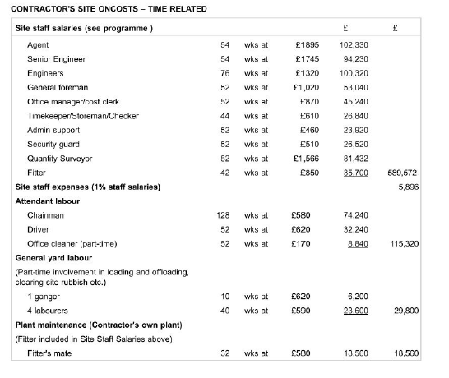
Appendix A – Sample of contractor labour costs per job role (Aecom,2023)

Appendix B
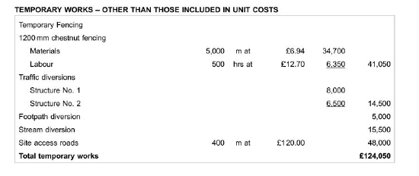
Appendix B – Sample of Temporary works costs (Aecom,2023)

Appendix C

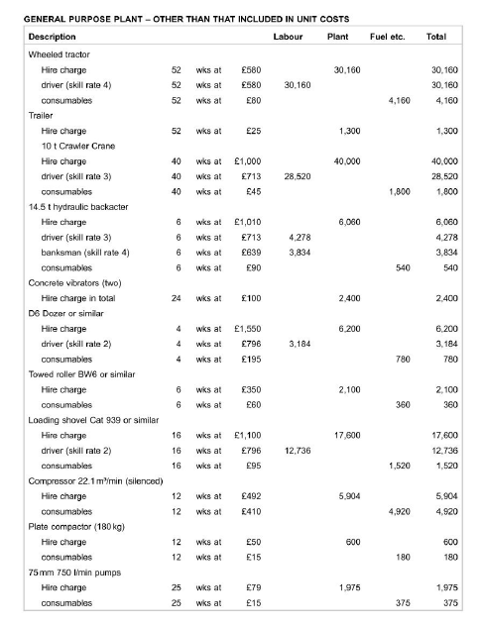
Appendix C – Sample of General purpose plant costs per (Aecom,2023)

Appendix D

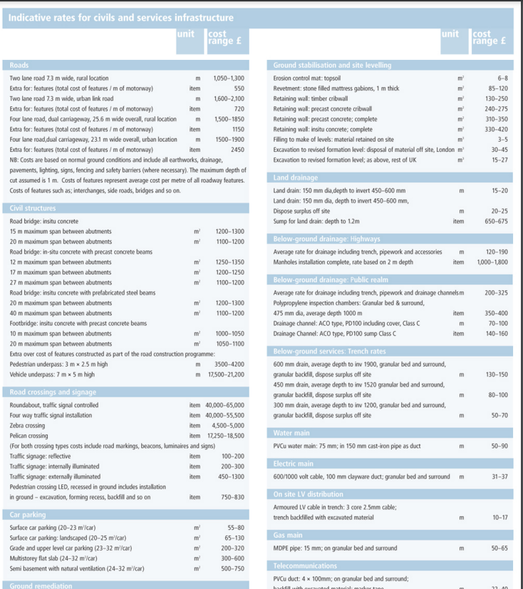

Appendix D – Sample of Latest costs for road construction UK (Building.co.uk,2023)

Appendix E

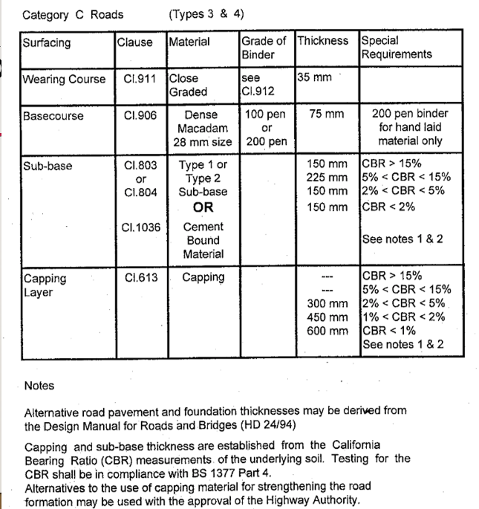
Appendix E – Category C road surfacing requirements (Standardsforhighways.co.uk, 2023)

Appendix F

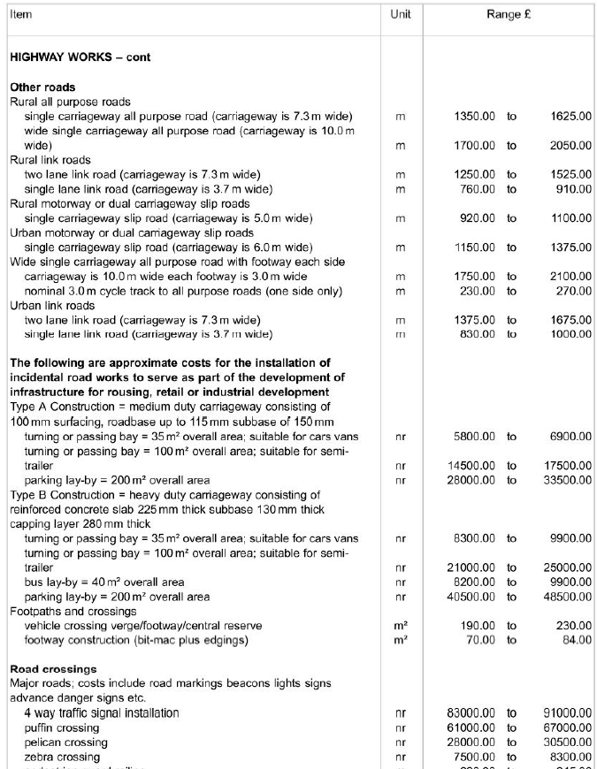
Appendix F – Category C road surfacing requirements costs (Aecom,2023)

Appendix G

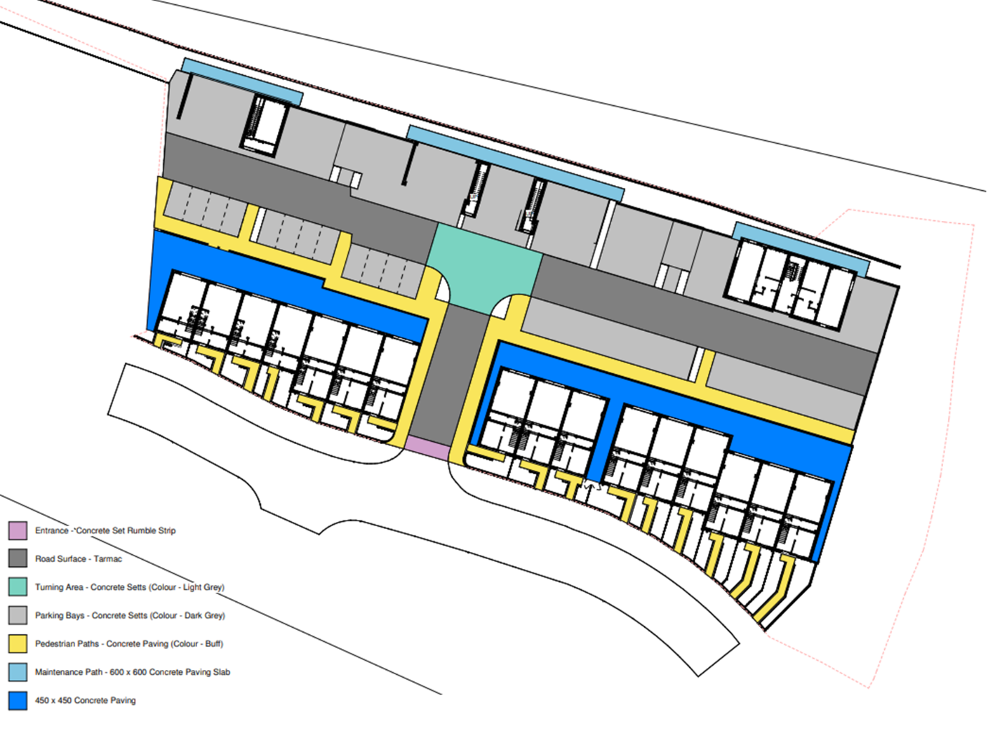
Appendix G – Site plan – Planning portal (Swansea.go.uk,2023)

References

Aecom (2023) Spon's architects' and builders' price book. Abingdon, UK: CRC Press.
British Standards Institution - Project - BSI Group (no date) British standards - Asphalt. Available at: https://standardsdevelopment.bsigroup.com/projects/9022-06584 (Accessed: March 21, 2023).
Building - road construction costs (2023) Building.co.uk. Available at: https://www.building.co.uk/download?ac=1539683 (Accessed: March 24, 2023).
HIGHWAYS ENGLAND, 2020. FOOTWAY AND CYCLEWAY DESIGN. DESIGN MANUAL FOR ROADS AND BRIDGES. [online] LONDON: http://www.standardsforhighways.co.uk. Available at: <http://www.standardsforhighways.co.uk/ha/standards/dmrb/vol7/section2/DMRB%20HD%2039%2020.pdf> [Accessed 01 March 2023].
Natural environment survey and assessment instructions - GOV.UK (no date) NRW environmental survey guidance. NRW. Available at: https://assets.publishing.service.gov.uk/government/uploads/system/uploads/attachment_data/file/1121023/Natural_Environment_Survey_Instructions_FINAL_V2.1_Nov_2022.pdf (Accessed: March 22, 2023).
O'Flaherty, C.A. and Hughes, D. (2015) Highways: The location, design, construction and maintenance of road pavements. London: ICE Publishing.
PITMAN, P.H.I.L. (2017) External Works, roads, and drainage: A practical guide. London. 1st edition. CRC Press.
Reference guide to consent for examination or treatment - gov.uk (2023) traffic management chapter 8. Available at: https://assets.publishing.service.gov.uk/government/uploads/system/uploads/attachment_data/file/138296/dh_103653__1_.pdf (Accessed: March 9, 2023).
Reference guide to consent for examination or treatment - gov.uk (2023) Construction code of practice. Available at: https://assets.publishing.service.gov.uk/government/uploads/system/uploads/attachment_data/file/138296/dh_103653__1_.pdf (Accessed: March 01, 2023).
The Planning Portal - Swansea (2023) Swansea planning portal. Available at: https://www.swansea.gov.uk/article/5873/The-planning-portal (Accessed: March 31, 2023).
Trade, D.for B.and (2023) Designated standards: PPE, GOV.UK. GOV.UK. Available at: https://www.gov.uk/government/publications/designated-standards-ppe (Accessed: March 29, 2023).
Transport, D.for (2022) Traffic signs manual, GOV.UK. GOV.UK. Available at: https://www.gov.uk/government/publications/traffic-signs-manual (Accessed: March 29, 2023).

