HUMAN RESOURCE MANAGEMENT
BMMB7007
Tata Consultancy Services (TCS) - “Building on Belief”
Jigar Rameshbhai Patel
Student ID - 2230413

Executive Summary
This report provides an overview of the HRM priority area within TCS, focusing on employee engagement. Employee engagement in TCS is the priority area because of the nature of the work and global presence. The employee is more productive, innovative and loyal to the business which leads to profitable business operations.
TCS's hiring process includes a mix of freshers and experienced recruits, where freshers are recruited from prestigious institutes across the world and attract large numbers of applicants. Experienced professionals are recruited by a recruitment agency or through direct interviews. Due to the nature of the work environment, TCS faces certain weaknesses including low morale, lack of communication and recognition and inadequate opportunities for employee development.
TCS has strong Corporate Social Responsibility helping its employee’s motivational needs through five level theory of physiological, safety, social, esteem and self-actualisation and the two-factor theory of hygiene and motivation. The long-term success of the business is the ability to attract and retain the best talent across all age working groups. To do this an organisation has to invest in employee engagement activities where personal and work life is balanced. The business organisation have to work through employee engagement to make employee at every level feel engaged and valued. Multinational organisations like TCS have to face the challenge to create good relationships within geographically dispersed teams. Human resource management has to address the challenges of managing teams across the border.
HR plays an important role in creating a positive work environment which led to employee engagement and retention including work-life balance, recognising employee contributions and rewards for diverse work.
Recommendations
TCS needs to implement effective employee engagement strategies, such as regular feedback mechanisms, recognition programs, career development opportunities, and a supportive work environment. The weak area is covered in Maslow’s hierarchy of needs pyramid and Herzberg’s two-factor theory of motivation and hygiene.
These strategies should be tailored to the specific needs of TCS employees and aligned with the overall organizational goals. By improving employee engagement, TCS can create a positive work culture that fosters employee satisfaction, retention, and overall business success.
The work-life balance needs to be improved in TCS as it is a fast-paced IT industry with high workloads and long working hours including weekends and holidays, Employees may face stress in balancing personal and work life.
The employee retention turnover ratio needs to be improved as the cost associated with new recruitment and training, loss of talent, reduce productivity and high turnover rate with new employees.

Contents
Executive Summary 2
Introduction 5
Overview of TATA Consultancy Services (TCS) 5
Maslow’s Hierarchy of Needs 6
Herzberg’s two-factor theory of motivation and hygiene 7
Employee Engagement 9
Employee Retention 9
Attrition in Information Technology Industry 9
Motivation 10
Strategic Human Resource Management (SHRM) 10
Harvard Model 11
Recommendations 12
Conclusion 13
References 14
Appendices 17

Introduction
In the 21st-century Information Technology plays an important role in maintaining society's needs. TCS is providing their services in various business sectors around the globe and HR practices in multinational organisations face many challenges including attracting and retaining top talent, managing diversity, ensuring employee engagement, managing work transitions and adapting to new technology.
TCS has strong Corporate Social Responsibility (CSR) and has implemented several initiatives to make a positive impact on society in education, health and the environment. It has a decentralised HR model, where every unit is responsible for managing the specific area of business to ensure consistency in policies and practises across the business. This report will identify the main area of weakness in HR practises and possible solutions for them.
This report will evaluate and recommend employee engagement within TCS regarding low employee satisfaction, lack of communication and feedback, inadequate recognition and rewards and work-life balance. These issues in an organisation lead to a high employee turnover ratio, poor performance and low productivity.

Overview of TATA Consultancy Services (TCS)
TATA Consultancy Services (TCS) is a multinational information technology services, consulting and IT solution organisation founded by Mr Fakir Chand Kohli known as the father of Indian IT, brings together a young team of enthusiastic US-returned IT professionals (www.tcs.com, 2022.) is one of the largest conglomerates in India is a part of TATA Group. TCS has operations in over 50 countries with more than 600,000 employees, 153 nationalities, and 35.7% women’s workforce all over the world (TCS, n.d.).
TATA Consultancy Services has clients in various industries, including banking, telecommunication, retail, capital market, insurance, travel, logistics and healthcare providing services like application development, maintenance, infrastructure management and engineering services. The company has a very diverse workforce from different backgrounds, cultures and nationalities as it is a multinational organisation. TCS places a strong value on diversity, equality and inclusion. It has taken several initiatives to promote the work culture within the organisation. TCS is well known for its strong corporate social responsibility and ethical practices and has won three prestigious industry prizes for HR management (www.tcs.com, 2022.).
TCS's dedicated Resource Management Group (RMG) ensures that the organisation makes the most out of the human capital by analysing, upskilling and reskilling the workforce. RMG headed by Chief Human Resource Officer (CHRO) is responsible for developing and implementing HR strategies with the business objective and directly reports to the CEO.

Maslow’s Hierarchy of Needs
According to (the Institute of Management Great Britain, 1998) this theory invented by Abraham Maslow in 1943 which gives outlines five levels of human needs, with the basic at the bottom and the complex at top of the pyramid. TCS recognises the importance of all levels of Maslow’s model to promote workforce motivation and engagement and ensure its policies and initiatives are effective.
- Self-Actualisation: TCS has creativity and innovation among the employees, offering opportunities for both personal and professional growth by recognising the employee contribution towards the success of an organisation. The company has invested in its new AI-based technology addressing the core strategic talent need of the organisation.
- Esteem needs: TCS provides opportunities for career growth and advancement, recognition and rewards programs, and a culture of respect and appreciation to promote employee self-esteem and confidence. The company also encourages employees to take ownership of their work and provides opportunities for them to work on challenging and meaningful projects.
- Belonging and Love needs: Belonging and love needs are important for any organisation to promote motivation and engagement. TCS has been arranging lots of social activities, community activities and volunteer initiatives, for example, the annual global marathon where employees around the world participate together to celebrate achievement. Voluntary community services like blood donation, and environmental clean-up drives encourage employees and giving back to society.
- Safety needs: Safe and secure work environment is a pillar of the organisation. TCS have safety and security policies that cover all employee safety, cyber safety and data privacy. The company provides regular training through awareness programs to educate the safety and emergency procedures. The company has a dedicated crisis management team that is responsible for employee safety in emergencies. Overall company has given a safe work environment to its employees to maximise the positive attitude towards the workplace.
- Physiological needs: These are the basic need such as food, water, shelter, air and sleep. Clean and hygienic cafeteria offering healthy food options, clean and comfortable restrooms and shower facilities to ensure that employees have access to clean water and proper sanitation (Kevin John McGuire, 2012). The company also provides ergonomic workstations to reduce physical stress, onsite medical facilities, regular health check-up, and fitness facilities.
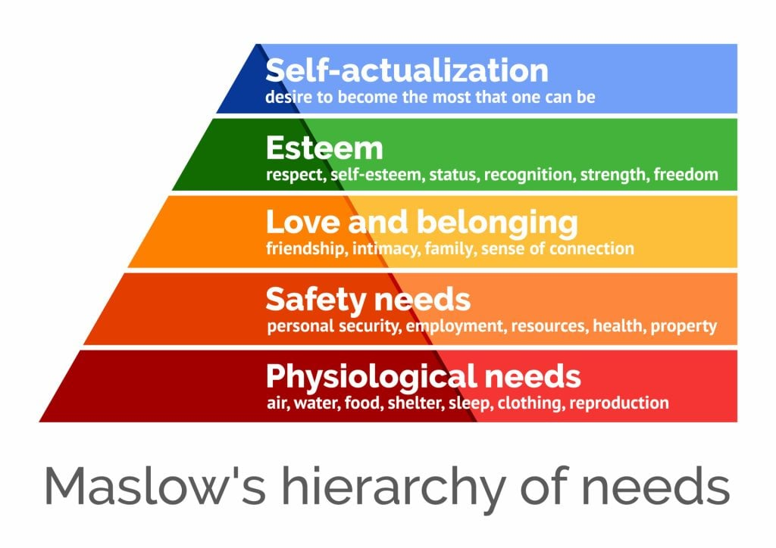
Figure 1

Herzberg’s two-factor theory of motivation and hygiene
The Herzberg two-factor theory is well-known for motivation that focuses on employee job satisfaction and dissatisfaction depending on hygiene factors and motivators is an extension of Maslow’s Hierarchy of Needs. Hygiene factors such as salary, security and work condition are basic factors that prevent job dissatisfaction whereas motivator factors like achievement, growth and recognition increase satisfaction (Pardee, 1990).
By applying this theory to TCS can understand the factors that motivate its employees and those that can lead to job dissatisfaction and how can it improve its HR practices.

- Hygiene factors: Herzberg's hygiene factors are the basic job requirements that, if not met, can lead to job dissatisfaction. These factors include job security, salary, working conditions, and company policies (Manktelow and Birkinshaw, 2018). TCS can ensure that its employees have fair and competitive compensation packages, safe working conditions, clear policies and procedures, and job security.
- Motivational factors: Herzberg's motivational factors are the job characteristics that can lead to job satisfaction and motivate employees to perform at a high level. These factors include challenging work, recognition, opportunities for growth and development, and autonomy (Herzberg, 1959). TCS can provide employees with meaningful work that challenges them, recognition for their contributions, opportunities for professional development and career advancement, and a degree of autonomy to perform their work.
TCS can use the Herzberg two-factor theory to develop HR management practices that focus on both hygiene and motivational factors. By providing a positive work environment that meets employees' basic needs and offers opportunities for personal and professional growth, TCS can increase job satisfaction, motivation, and productivity. Additionally, TCS can use employee feedback and surveys to identify areas where improvements can be made to its HR practices, ensuring that the company is meeting the needs of its employee’s engagement, retention and productivity.

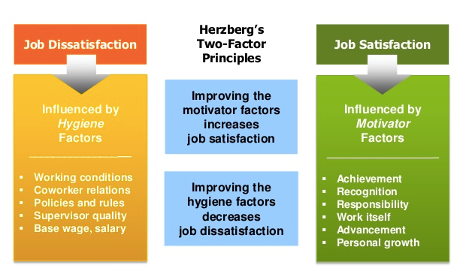
(Armstrong, 2007)
Figure 2

Employee Engagement
Employee engagement is a crucial part of any organisation's success and may face challenges in keeping employees engaged due to factors like work-life balance, job prospects and growth (Mone and London, 2018). TCS has implemented several initiatives to ensure that the human force working in the company is motivated, productive and satisfied with what they are doing for achieving organizational goals.
TCS’s employee engagement initiatives have done a positive impact on performance, and job satisfaction, and that are working in the company are more likely to stay for longer periods. A study by Haldorai and Thambusamy (2017) examined the impact of employee engagement on the turnover intentions of TCS employees in India. The study found that employee engagement was a significant predictor of turnover intentions and that employees who were highly engaged were less likely to leave the company. The studies suggest that employee engagement is an important factor for employee performance, satisfaction, and retention at TCS. By implementing effective employee engagement initiatives, TCS can create a friendly work culture that nurtures employee motivation and productivity leading to better performance and retention.

Employee Retention
According to Das and Baruah (2013), retention strategies need to be implemented to retain talented employees which is a crucial part of the cost associated with recruits. Retaining employees and avoiding talent loss is a big challenge for a multinational company like TCS. It is difficult to track every move by the top management and whether the same is implemented at ground level or not. If the promises made by an organisation are not fulfilled there are more chances that employees will look for other opportunities which leads to an early exit from the company (Goldstein et al., 2017). As stated by Eskildsen and Nussler (2000) that the employee thinks about employment with the current employer to be continued or to look for some other opportunities. Thus, in such cases, it’s the employer at fault and becomes the reason for their skilled employees to leave them early.

Attrition in Information Technology Industry
IT industry is certainly growing as the economy of the country grows. With the revolution of technological advancement IT industry has shown tremendous growth there are many opportunities available in the job market for employees (Andrew Franklin Prince, 2011). TCS is aware of the challenge faced by globalization that they are forced to retain their best-skilled employees to stand against the competition. TCS over the years have invested in lots of initiatives to identify the factors that contribute towards attrition and taken proactive steps to overcome them. TCS has managed to keep its attrition rate around 21% in previous years.

Motivation
Companies are having trouble keeping their staff members because hiring educated workers is crucial for any employer. For all sectors, employee retention has become a crucial task (Demers, 2002). TCS's upper management and HR departments have to put a lot of effort into developing retention strategies and when implementing talent management strategies, the company must evaluate their existing HR procedures. To achieve organisational effectiveness and achievement, human resources are crucial. An individual may change to a different, more suitable work if unsatisfied with the one they are currently performing. Retaining employees is crucial for organisations in the current business environment. A business that offers its employees a flexible and challenging work environment has been seen to thrive in a cutthroat industry. (Herman, 1999).

Strategic Human Resource Management (SHRM)
Strategic HRM also known as ‘people strategy’ is a planned framework for employees to be hired, managed and developed in ways that support an organisation's long-term goal (CIPD, 2021).
TCS talent cloud is an internal initiative implemented that gives managers the best team to complete a particular project and employee track record is monitored by top management through AI-Based technology. Top management can access the real-time progress and performance of employees and team performance, how they produce results, execute priorities and their level of engagement. Below we have applied Ulrich’s Hr model and Harvard model in TCS:

Ulrich’s Model
The Ulrich model of HRM is a widely used framework for HR transformation that focuses on four key roles of HR: strategic partner, administrative expert, employee champion, and change agent as shown below (Ulrich and Brockbank, 2005). This model is the perfect fit for large organisations like TCS, where a multicultural workforce works all around the world and is designed in such a way as to ensure that every employee of the company is clear of their roles and responsibilities. Ulrich's model is still having a great deal of importance and relevance for modern and technological businesses like TCS. 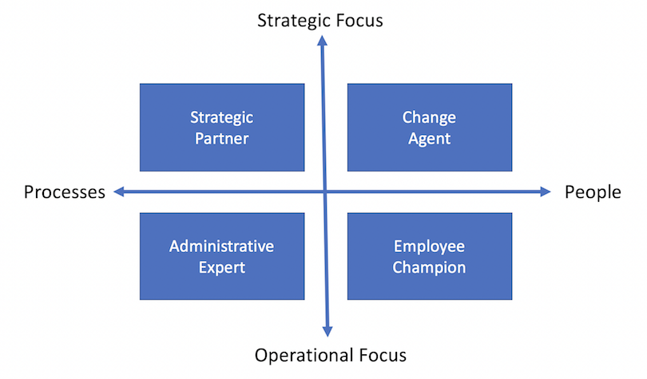
Figure 3

Harvard Model
The Harvard model offered by (Beer et al., 1984) provided one of the most comprehensive statements on the nature of HRM and the issue of management goals. This model is considered a ‘soft HRM’ approach due to its focus on people rather than outcome (Bratton and Gold, 2017). The dimensions included in the model are stakeholders, interests, situational factors, HRM policy choices, HR outcomes, long-term consequences, and a feedback loop (Oxford Univ Press, 2021). The outputs flow directly into the organization and the stakeholders.
TCS can develop its HR practices that are specially made as per the needs of the organisation and its stakeholders, which will help TCS to build a competitive advantage through its Resource Management initiatives.
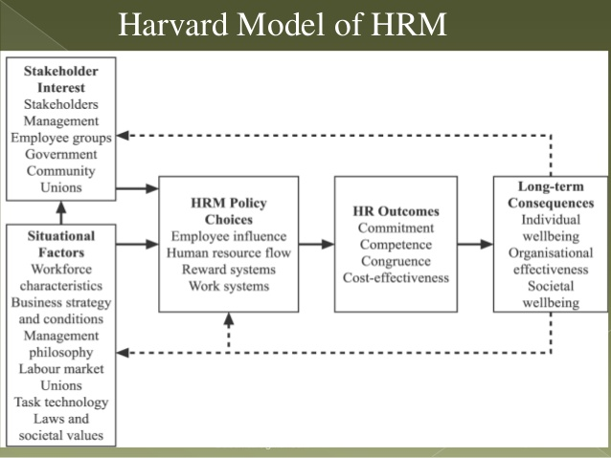
Figure 4

Recommendations
The following recommendation needs to be implemented to improve employee engagement, employee satisfaction, recognition and rewards and work-life balance. The recommendations are based on the theory of Maslow’s Hierarchy of Needs model, Ulrich’s Model of HRM and Harvard's Model of HRM.
TCS has reported a low level of employee satisfaction leading to low motivation and engagement. Regular employee feedback and recognition of employee mechanisms should be implemented to address the concerns and suggestions, on some meetings with the managing team to recognise the employee achievement and contribution towards the organisation.
The communication process from top management to bottom-level employees should be transparent to ensure that information is received by the employees in an accurate and timely manner about the company policies, and procedures. Company mission and goals should align with the employee roles and responsibilities.
Work-life balance plays an important factor in an organisation's success, many TCS employees have reported poor work-life balance, which leads to stress, burnout and disengagement. TCS should promote the work-life balance by offering flexible work arrangements like working from home, providing support services, and on-site child care assistance. TCS should promote work-life balance to fill the gap between the personal and professional commitment of the employee.
Employee attrition is a major issue faced by many Multinational organisations nowadays. Every organisation has their retention policy to retain them, but the company need to analyse how effective the currently implemented policy is in helping the business. The talented workforce of the company doesn’t leave because of the salary or pay but for the other reason. HR managing team should be highly skilled to retain them as employee spends maximum time with managers in the company that influence the decision-making of employee.

Conclusion
Employee engagement is the critical HRM priority area directly affecting employee satisfaction, retention, and overall business performance (Peach, 2020). The analysis of TCS's current employee engagement practices highlighted weaknesses including inadequate communication, lack of recognition and rewards and career development resulting in negative outcomes such as low morale, high turnover rate and reduced productivity.
To address the challenges, TCS should apply various HRM models to develop effective workplace engagement. The Maslow Hierarchy of Needs can be used to understand the needs and motivations of employees and design engagement programs that furnish those needs. According to Ulrich and Brockbank (2005), the model is highly effective for modern businesses to develop an HR strategy that works with employee engagement efforts and business goals.
The Harvard models can guide TCS in creating a sustainable approach to managing its human capital by investing in employee development and training initiatives, and a positive work culture that supports employee well-being diversity and inclusion and work-life balance.
In summary, TCS must rank employee engagement and develop a general strategy that reports the acknowledged weaknesses. The use of HRM models such as Maslow, Ulrich, and Harvard can support the creation of a framework for effective engagement initiatives. By doing so, TCS can improve employee satisfaction, reduce turnover rates, enhance overall business performance and achieve the goals of the company for future growth.

References
Adhikari, S., & Shaw, S. (2017). Employee engagement and its impact on organizational performance: A study with special reference to Tata Consultancy Services (TCS). Indian Journal of Commerce and Management Studies, 8(1), 25-30.
Andrew Franklin Prince (2011). Employer and Employee Perception on Attrition in Bpo Industry. LAP Lambert Academic Publishing.
Armstrong, M. (2007). A handbook of employee reward management and practice. 2nd ed. Philadelphia: Kogan Page.
Beer, M., Spector, B., Lawrence, P.R., Mills, D.Q. and Walton, R.E. (1984). Managing human assets : the ground breaking Harvard Business School program. New York: Free Press.
Bratton, J. and Gold, J. (2017). Human resource management : theory and practice. 6th ed. London: Palgrave Macmillan.
CIPD (2021). Strategic Human Resource Management | Factsheets | CIPD. [online] CIPD. Available at: https://www.cipd.co.uk/knowledge/strategy/hr/strategic-hrm-factsheet.
Das, B.L. and Baruah, M. (2013). Employee Retention: A Review of Literature. IOSR Journal of Business and Management (IOSR-JBM), Vol. 14, Iss. 2, pp. 08-16.
Demers, E. (2002). Discussion of High-Technology Intangibles and Analysts’ Forecasts. Journal of Accounting Research, 40(2), pp.313–319. doi:https://doi.org/10.1111/1475-679x.00049.
Eskildsen, J.K. & Nussler, M.L. (2000), "The managerial drivers of employee satisfaction and loyalty", Total Quality Management, vol. 11, no. 4-6, pp. S581-S588.
Goldstein, H.W., Pulakos, E.D., Passmore, J. and Semedo, C. (2017). The Wiley Blackwell handbook of the psychology of recruitment, selection and employee retention. Chichester, West Sussex Wiley Blackwell.
Haldorai, K. and Thambusamy, R., 2017. Employee engagement and turnover intentions: A study with reference to Tata Consultancy Services (TCS). International Journal of Human Resource Management and Research
Herzberg, F. (1959). The Motivation to Work. 2nd ed. New York: Wiley.
Institute Of Management Great Britain (1998). Abraham Maslow : the hierarchy of needs. Corby: Institute Of Management Foundation.
Kevin John McGuire (2012). Maslow’s hierarchy of needs. An introduction. GRIN Verlag.
Kruse, K. (2015). Employee engagement 2.0 : how to motivate your team for high performance : a ‘real-world’ guide for busy managers. Richboro, Pa: The Kruse Group, San Bernardino, Ca.
Manktelow, J. and Birkinshaw, J.M. (2018). Mind tools for managers : 100 ways to be a better boss. Hoboken, New Jersey: John Wiley & Sons, Inc.
Maxwell, G. (2020), Work-Life Balance in Large Organizations, Society for Human Resource Management, Alexandria.
Mone, E.M. and London, M. (2018). Employee engagement through effective performance management a practical guide for managers. New York Routledge.
Oxford Univ Press (2021). Oxford Handbook of Contextual Approaches to Human Resource Management. S.L.: Oxford Univ Press.
Pardee, R.L. (1990). Motivation theories of Maslow, Herzberg, McGregor & McClelland. A literature review of selected theories dealing with job satisfaction and motivation.
Peach, L.H. (2020). Employee Relations in IBM. Employee Relations, 5(3), pp.17–20. doi:https://doi.org/10.1108/eb055014.
TCS (n.d.). Worldwide. [online] www.tcs.com. Available at: https://www.tcs.com/who-we-are/worldwide.
Ulrich, D. and Brockbank, W. (2005). The HR Value Proposition. Harvard Business School Press: Boston.
www.tcs.com. (2022). How TCS’ resource management group is keeping its workforce driven. [online] Available at: https://www.tcs.com/who-we-are/tcs-way/article/resource-management-group-human-capital-driven.

Appendices

