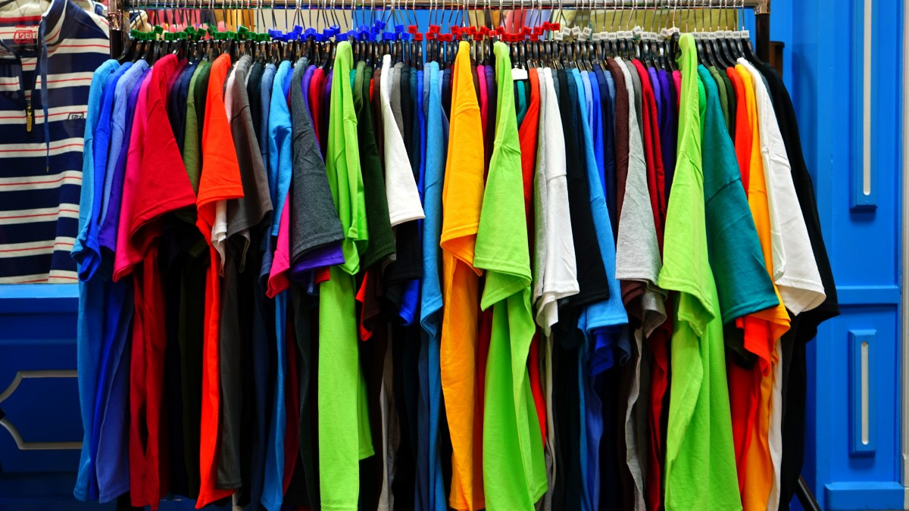
Fast Fashion Is So Last Year

How many times have you stood in front of an overflowing wardrobe yet have nothing to wear? This article looks at the world of fast fashion and its impact on climate change and the challenges faced within the retail business sectors.

Written by Christine Joy

Stay on trend by adopting a slow fashion approach and help decarbonize our planet.

Fast Fashion
“Fast fashion is the term used to describe clothing designs that move quickly from the catwalk to stores to meet new trends. The collections are often based on designs presented at Fashion Week events. Fast fashion allows mainstream consumers to purchase trendy clothing at an affordable price”
www.investopedia.com

Research completed by Greenpeace shows 40 percent of clothes in our wardrobes are rarely or never worn.[₁]

Clothes are often only worn for a few occasions before being discarded, with millions of clothing items ending up in landfills.

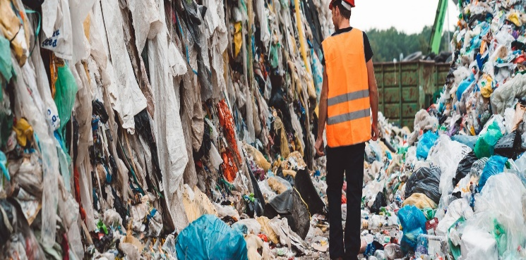

Getty image, 80 percent of clothing ends up in landfills within two years

Fast Fashions Market share

The fashion industry is designed to make you feel out of trend, with big budget PR campaigns and some fashion retailers releasing a massive 52 new micro collections a year. There is no wonder why many consumers have a see now, buy now, wear now purchasing behavior. Fast fashion promotes a throw away culture. This consumerism is having a devastating impact on our planet. [₂]

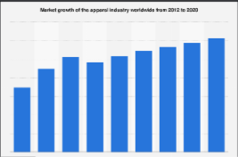
Statista image, market growth rate of the global clothing industry 2012 – 2020 [3]

The global fashion industry is one of the largest at over $3 trillion dollars and accounts for 2 percent of the worlds Gross Domestic Product (GDP) [₄]

Before the economic boom of the 1950’s we used to have one special outfit and make do and mend. Hand me downs were common practice as well as secondhand clothing. Clothes were also repurposed in many creative ways. Almost every girl and women held needlecraft abilities, and many items of clothing were fashioned at home. Dressmaking and tailor shops were common within the highstreets.

The economic boom gave way to capitalism and the production of commodities through a system that has profit seeking as its primary goal.

Within the fashion industry, the produce of new materials such as Nylon and Polyester made great advances. These were able to me manufactured at rapid rates. They became the on-trend material and due to its cheap production costs, clothing was able to be manufactured quickly and cheaply making way for the beginning of the fast fashion consumerism as we know of today.

We are starting to emerge from this scene, as people become more socially and environmentally aware. Could we be seeing the start of a new industrial revolution of the 21st century forced by ethical values?

The revolution has begun with the increasing popularity to acquire unique clothing items such as vintage and retro. Both the consumers and the fashion industry are tapping into this growing market.

The birth of slow fashion

Slow fashion is the movement of designing, creating, and buying garments for quality and longevity. It encourages slower production schedules, fair wages, lower carbon footprints, and (ideally) zero waste.
www.thegoodtrade.com

Early players within the slow fashion retailers have started to emerge.

Paragon UK. They are transparent within their production and their factories are regularly audited to ensure they are safe and meet industry expectations.

ThredUP. They offer an online clothing thrift store

Outland Denim UK. They employ, train, educate and empower women who have experienced sex trafficking and champion the cause. As well as having transparent and sustainability ethics.

Mud Jeans Champion Fair production, circular economy, and sustainable materials.

Nobody Denim Display strong ethics and are embracing the sustainable business market

Kuyichi Environmental and socially responsible shop. Using organic and recycled materials.

Triarchy a sustainable and transparent brand, whose charities include rainwater catchment systems and donation of a proportion of profits.

Levi Following bad press Levi are attempting to make a mend and have launched a sustainable brand by using recycled and ecofriendly materials.

Patagonia Environmental, animal welfare, social responsibility, transparency, and ecofriendly materials. Patagonia ticks the boxes when it comes to sustainability.

Rapanaui Everything they make is designed to be sent back to them when worn out to be recycled into new material.

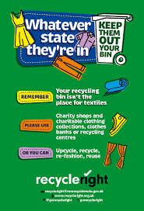

Image Recyclingright.org.uk. A promotion ran by recycle right to educate people about the textile recycling.

In addition to clothing retailers are also producing sustainable footwear.

“Over 24 billion pairs are produced each year, with over 90% of these likely to end up in landfill often within 12 months of purchase”
Revivo.com

Revivo a footwear company who recondition returned worn out shoes to prevent them from entering landfills

Sustainability

We hear this word bounced about a lot, but what does it mean and how are businesses coping with the challenge of increased demand of sustainable products?

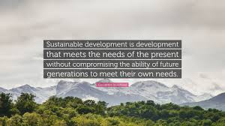

Image quote fancy.com. The definition of sustainability as defined by Brundtland in 1987

Brundtland Report [₅]

Sustainability is one of the most heated discussions within the fashion industry. [₆] On whether it decreases competitiveness, impacts on job growth and the economic well-being of countries who adopt sustainable policies.

Backed by a government led intervention, sustainable fashion will be supported by more complex studies looking at dirty production, energy, and other goods to encourage sustainable growth [7]

While finding a balance between sustainability and competitiveness is important, it is argued that companies with a greater ability to adapt and innovate will benefit immensely from the growing trends towards sustainability. [8]

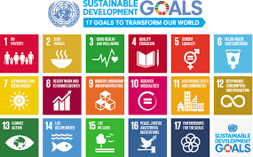

Image UN.org Sustainable development goals (SDG) outline 17 key elements.

(SDG 12) A shift in consumption patterns is emerging towards trends of sustainable behaviors and attitudes. A UN high level Meeting on sustainable development [₉] has defined plans to engage the fashion industry to take action and rethink the true costs of garments and all resources used within the production process to achieve improved environmental and social impacts.

Climate Change

Fashion accounts for around 10 percent of global carbon emissions [₁₀] and 20 percent of industrial water pollution (SDG6) [₁₁] when both these factors are combined, fast fashion is one of the dirtiest industries in the world, above the heavy co₂ emitting aviation industry. (SDG13)

These pollutants are causing devastating impacts to our earth's atmosphere.

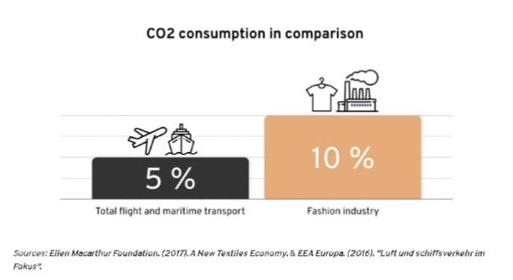

Image Ellen Macarthur foundation. The percentage of co₂ emitted by the fashion industry compared to aviation and marine transport.

The Fashion Chain

To tackle co₂ within the fashion industry, the whole process chain needs to adapt to change. Designers seeking sustainable designs and materials. Farmers reviewing new crops, water consumption and pesticides within their yields. Factories to review human rights, working conditions, water consumption and hazardous dyes and other processes. Transportation and packaging are also key aspects in reducing co₂ and a consideration of factory placement will assist to reduce emissions. Consumer and retailer’s education of recycling and adoption of a slow fashion.

Agriculture

After the initial design, the fashion industries environmental impact begins, within the farming of materials used to make clothes. These can be natural fibres such as cotton, silk, and wool through to more chemically engineered fibres such as polyester, polyamide and elastic.

The most common natural fibre is cotton or cotton blend, which equates to about 40 percent of clothing materials. Cotton is grown in over 80 countries around the world and the main problem with the cultivation of cotton is its high-water consumption. For 1KG of cotton, it takes 11,000 litres of water.

In addition, copious amounts of pesticides are used in the cultivation of cotton with two-thirds of the cotton grown being genetically modified.

Although “organic cotton” can also be grown more sustainably, without the use of these pesticides, it also consumes enormous amounts of water and frequently farmed in developing countries under questionable working conditions.

The remaining 60 percent of material used within clothing is synthetic. Polyester for example is made of polyethylene terephthalate (PET) with its base material being petroleum, coal, limestone, and gas.

A staggering 98 million tons of crude oil is used each year in the manufacturing of polyester, which is 0ne percent of the oil produced worldwide. If production and consumption continued at the same levels, these figures could rise to 300 million tons of oil by 2050 which would equate to 26% of human co₂ emissions. [₁₂]

(= 6 kg co₂ per T-Shirt) (= 2 kg co₂ per T-Shirt).

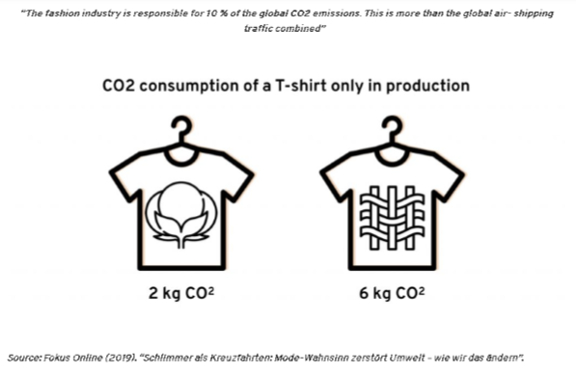

Image Fokus online. Production of polyester releases three times more co₂ than Cotton.

Each year 2 million metric tons of pesticides are used in the agricultural industry on yields for fashion. The health impacts are widely publicized from skin irritation, effects on nervous systems to cancerogenic toxins. [13]

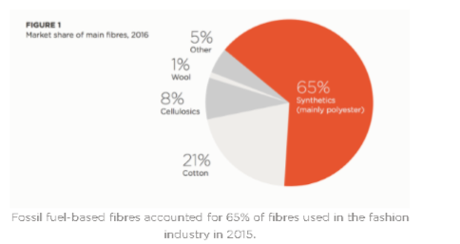
Image common object article shows the percentage of fossil fuel-based fibres.

How Well Do You Know Your Fabrics?

Conventional fabrics are very polluting as they consume a lot of water, take resources from the soil, and use a lot of pesticides and synthetic fertilizers.

Cotton farming is responsible for 24 percent of insecticides and 11 percent of pesticides despite using only 3 percent of the world’s arable land (SDG 3)

To produce one t-shirt, it takes 2,700 litres of water, that is enough for one person to drink for three years. [_{14]}

Denim is a subsidiary material from cotton, which consumes a staggering 3781 litres of water per pair of jeans, when adding in the different stress effects e.g. distressed denim. The sandblasting process consumes further water and causes severe health risks to the workers. [₁₅]

Silk has a low CO2 footprint, with little land impact. Mulberry trees are farmed for their leaves only and fed to the silkworms. Whilst growing mulberry trees does consume some water, the trees also aid to balance the co₂ emissions in our atmosphere.

Wool is a natural fibre with low environmental impact when compared to cotton and synthetic equivalents. The downside is if unsustainable farming resources are used and the risks to animal welfare.

Linen, often avoided by consumers due to its easy creasing. Linen is produced from flax plants, which consume hardly any water and pesticides, the production therefore is very low without any added dyes and is fully biodegradable.

Nylon is made from crude oil and produces Nitrous Oxide which is even more damaging to our atmosphere than co₂. The manufacturing process is very water and energy heavy.

Econyl is an eco-friendly nylon which is made using recycled plastics and very little water. Many fashion brands are switching from traditional Nylon.

Yulex is a natural material manufactured from rubber plants in sustainable factories. Its elasticity and its strength make for an ideal alternative to synthetically produced equivalents.

Hemp is a natural fibre and is extremely environmentally friendly, grown with little water and pesticides, hemp also returns nutrients into the soil. Hemp become less environmentally friendly when dyed due to the chemicals used.

Tencel, although semi synthetic, 99 percent of the nontoxic solvent used is recycled back into the system. Tencel is a great alternative to cotton, it is made from eucalyptus trees which consume 80 percent less water than the cotton equivalent and can be grown without pesticides.

New Fabrics

The global challenges the fashion industry face is sustainability, and the key element is engineering and investing in eco-friendly materials.
MYX is a mushroom based fabric is a new organic textile using mushroom spores and pant fibres. Championed by Stella McCartney.
Pinatex is a natural material made from pineapple leaf and used as an alternative to leather and petroleum-based textiles.
Frumat is a Bio-leather made from apple mulch.
BioGlitzis a yarn made from eucalyptus trees which is biodegradable and an alternative to glitter.
Mango a Biodegradable alternative to polyester
As well as new fabrics and materials there are also eco-friendly packaging and micro filters for washing machines in development to capture microplastics before they are released in wastewater.

Water Pollution

In addition, the textiles industry has been identified in recent years as a major contributor to plastic entering the ocean (SDG 14)

Synthetic material is virtually impossible to biodegrade causing a severe impact to oceans. When polyester clothing is washed it releases micro plastic particles which end up in our rivers, oceans, and seas. The fashion industry is responsible for 35 percent of microplastic particles entering our seas and oceans. [₁₆]

The impact of these microparticles on the eco system is having a massive impact, furthermore for as long as the marine life is absorbing these particles, they will in end up in human food consumption and in turn our bodies.

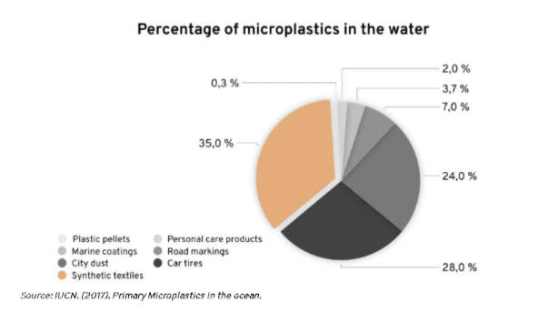
Image common objective.com shows the percentage of microplastics in the water from synthetic textiles. E.g. polyester.

Dye

[₁₇] The dye industry is regarded as a noticeable pollution and contains CR IV Chromium which is a highly toxic chemical, enough to cause death in humans.

It is used primarily to turn animal hides into leather. These tanneries which are centered in South-East Asia operate with little control and produce 7.7 million litres of wastewater and 88 million tons of solid waste each day. [₁₈]

Factories

The global fashion industry employs over 75 million people worldwide, most of them women. As a key economic sector, it has a key role in achieving the Sustainable Development Goals (SDGs). [₁₉]

Fast fashion is also linked to dangerous working conditions (SDG 8) due to unsafe processes and hazardous substances used in production. (SDG 3)

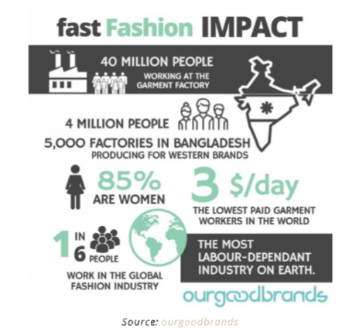

Image Our good brands. Shows key statistical information on the makeup of clothing factories.

Factories and Human Rights

On the 24 April 2013, the Rana Plaza building in Bangladesh collapsed. 1,138 people died and another 2,500 were injured, making it the fourth largest industrial disaster in history.

The owner was jailed for murder amongst other charges of corruption. He ignored pleas from workers about over crammed conditions and cracks which had emerged within the building’s walls. He even added a further three floors to extort further trade. [₂₀]

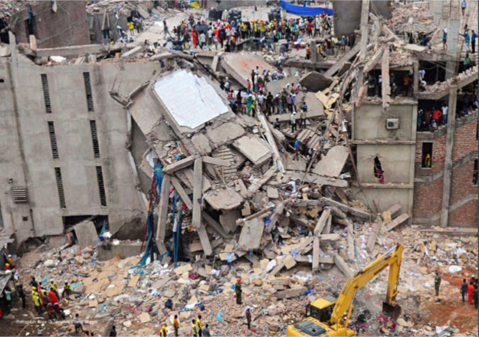

Getty image: Collapse of the Rana Plaza, killing, 1,138 people.

Forced labour, child labour, sexual harassment, discrimination, and dangerous working conditions are just some of things that people making our clothing go through. Although human rights are controlled by a set of standards governed by International laws, human rights abuse still occurs within the fashion industry.

The Global Slavery Index estimates that 36 million people are living in some form of modern slavery today. [₂₁]

The pressure to produce low-cost clothing to supply the fast fashion industry denies people to escape poverty. As employers work long hours with low wages keeping them in a constant cycle of poverty.

The results impact on health and safety as well as the quality of the clothes being produced. An example of this can be seen in Bangladesh, where the minimum wage only covers 60 percent of the cost of living in a slum. [21]

The fashion industry is also known for its subcontracting factors, which exploit loopholes within the framework. [23]

Demographics and GenZ

With the world population set to soar to 9 billion within the next 30 years. _{[24]}

The impacts of an ageing demographic will be another challenge the fashion industry will face as the older generations typically spend less on fashion. They are also some of the thriftiest shoppers especially when precuring clothing which is kept for many years and often purchased second hand.

The demands for slow fashion and sustainability are on the rise, there is increased value for retailers to engage with climate change and review their whole production to ensure community values and respect of all within the supply chain ethics are adopted and demonstrated.

This is reinforced by GenZ, their knowledge in social, political and climate change ethics, especially regarding the implications for clothing and fashion consumption. The most notorious GenZ advocator of sustainability is Greta Thunber [₂₅]

With Western Europe seeing the highest increase notably Italy, Germany, Greece, and Spain, where GenZ make up 40 percent of the global consumers
and will hold a purchasing power of $143 Billion by
the end of 2020. [₂₆]

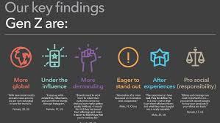
Image Ambista.com. Shows the key ethics GenZ hold.
Sustainability, social responsibility and being unique.

Top Tips

- Buy less
- Buy used
- Quality over quantity
- Eco materials
- Cotton instead of polyester
- Be unique, instead of branded clothing
- Wash less
- Repair and recycle

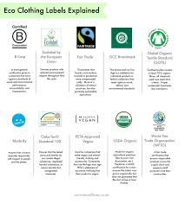

Image Moralfibers.co.uk is a chart which explains eco-friendly labels.

References

- Gestaltung, C., & Druck, D. (2020, May 28). IT IS ENOUGH. Greenpeace. https://www.greenpeace.de/presse/publikationen/es-reicht. Accessed Monday 16th November 2020.
- Haggblade, S. (1990). The flip side of fashion: Used clothing exports to the third world. The Journal of Development Studies, 26(3), 505-521.
- Bedford, E. (2020, August 9). Global apparel market growth 2012-2020. Statista. https://wwwstatista.com/statistics/727541/apparel-market-growth-global. Accessed Friday 13th November 2020.
- F. (2020, November 13). Global fashion industry statistics - International apparel. Fashionunited. https://fashionunited.com/global-fashion-industry-statistics. Accessed Friday 13th November 2020
- Brundtland, G.H. and Khalid, M. (1987). Our Common Future. New York.
- Aiginger, K. (2014). Industrial policy for a sustainable growth path (No. 469). wIFO working Papers.
- (5) Acemoglu, D., Aghion, P., Bursztyn, L., & Hemous, D. (2012). The environment and directed technical change. American economic review, 102(1), 131-66.
- Nidumolu, R., Prahalad, C. K., & Rangaswami, M. R. (2009). Why sustainability is now the key driver of innovation. Harvard business review, 87(9), 56-64.
- U. (2018, July 16). Partnership On Sustainable Fashion programme. Unece.Org. https://www.unece.org/fileadmin/DAM/timber/meetings/2018/20180716/un Accessed Saturday 14th November 2020
- Zaffalon, V. (2010). Climate change, carbon mitigation and textiles. Textile World, 34-35.
- (9) Kant, R. (2012). Textile dyeing industry and environmental hazard. Natural science, 22-26
- (10) Niinimäki, K., Peters, G., Dahlbo, H. et al. The environmental price of fast fashion. Nat Rev Earth Environ 1, 189–200 (2020). https://doi.org/10.1038/s43017-020-0039-9 Accessed Friday 13th November 2020.
- Petty, W. (2019, January 20). Can Fashion Stop Climate Change? CommonObjective. https://www.commonobjective.co/article/can-fashion-stop-climate-change ****** copy the full web*** Accessed Saturday 14th November 2020
- Rusinek, M. J., Zhang, H., & Radziwill, N. (2018). Blockchain for a Traceable, Circular Textile Supply Chain: A Requirements Approach. Software Quality Professional, 21(1).
- WWF. (2013, January 16). The Impact of a Cotton T-Shirt. Worldwildlife.Org. https://www.worldwildlife.org Accessed Saturday 14th November 2020
- Hernandez, E., Nowack, B., & Mitrano, D. M. (2017). Polyester textiles as a source of microplastics from households: a mechanistic study to understand microfiber release during washing. Environmental science & technology, 51(12), 7036-7046.
- A., Majone, F. Cytotoxic and clastogenic effects of soluble and insoluble compounds containing hexavalent and trivalent chromium. Br J Cancer 44, 219–235 (1981). https://doi.org/10.1038/bjc.1981.173
- Mustapha, S., Tijani, J.O., Ndamitso, M.M. et al. The role of kaolin and kaolin/ZnO nanoadsorbents in adsorption studies for tannery wastewater treatment. Sci Rep 10, 13068 (2020). https://doi.org/10.1038/s41598-020-69808-z
- UN Alliance aims to put fashion on path to sustainability. (2018, July 13). Unease.Org. https://www.unece.org/info/media/presscurrent-press-h/forestry-and-timber/2018/un-alliance-aims-to-put-fashion-on-path-to-sustainability/doc.html. Accessed Saturday 14th November 2020
- Rana Plaza Collapse. (2017, August 29). Bbc.Co.Uk. https://www.bbc.co.uk/news/world-asia-41082448. Accessed Tuesday 17th November 2020
- Gallagher, A. T. (2017). What's wrong with the Global Slavery Index?. Anti-Trafficking Review, (8).
- Machin, S., Manning, A., & Rahman, L. (2003). Where the minimum wage bites hard: Introduction of minimum wages to a low wage sector. Journal of the European Economic Association, 1(1), 154-180.
- Stevenson, M, & Cole, R. (2018). Modern slavery in supply chains: a secondary data analysis of detection, remediation, and disclosure. Supply Chain Management, 12(3), 81–99. https://doi.org/10.1108/SCM-11-2017-0382
- National Research Council, & Committee on Population. (2000). Beyond six billion: Forecasting the world's population. National Academies Press
- Guillén, M. F. (2016). Global Turning Points: The Challenges For Business And Society In The 21St Century (2nd ed.). Cambridge University Press. 53-54
- Maori-Davis, D. (2020, January 28). Gen Zers have a spending power of over $140 billion, and it’s driving the frenzy of retailers and brands trying to win their dollars. Business Insider. https://www.businessinsider.com/retail-courts-gen-z-spending-power-over-140-billion-2020-1?r=US&IR=T. Accessed Monday 16th November 2020

