
BA (Hons) Leadership and Management Skills for the Workplace

Module : Leading and Implementing Change (LIC)
Module code : LCLM6003

Strategic Change Plan
Title: A Strategic Change Management Report for Jaguar Land Rover: Navigating Digital Disruption, Industry 4.0, and Organisational Culture Transformation within the Volatile UK Automotive Sector

Student name: Junior Ngimbi
Student number: 2314796
Lecturer’s Name: Dr. Eric Osei

Executive Summary
The report offers a detailed strategic change management plan for Jaguar Land Rover in the aim to successfully reverse the trend of the falling revenue stream, market share and operational results in such a dynamic global commerce landscape (Jaguar Land Rover [JLR], 2023). There are substantial risks for JLR in the UK, such as difficult trade after Brexit, powerful foreign EV producers, and the stringent net zero carbon obligations (Beaury et al., 2020). The company needs to move beyond manufacturing and adopt a digital first mindset (Sousa and Rocha, 2019), else it risks losing out on its market position. This would include implementing cutting-edge automation, the cloud, and artificial intelligence solutions to improve business management and gain back lost profits (William et al., 2023). Analysis shows JLR’s UK manufacturing sites are exposed to key technology and data engineering skills (De Mauro et al., 2018). To correct these shortcomings, this report examines and applies change management frameworks that are based in evidence and that differ from the linear model of change management with a more iterative and research-driven approach (Stouten, Rousseau and De Cremer, 2018). They have a big emphasis on transformational leadership (Hussain et al., 2018) and how to deal with resistance to change in the region manufacturing plants, from mechanical systems to software-defined architectures. The proposals for change plan include specific measurable targets for upskilling the workforce alongside a forty-five-million-pound financial framework for allocating funding. It contains a clear stakeholder communication strategy with transparency and a set of performance measures to assess success in the process of transforming over the 24 months in order to have JLR as an agile leader in sustainable luxury mobility (Lewis, 2025).

Table of Contents
Executive Summary 1
Introduction to Jaguar Land Rover (JLR) 3
Environmental Analysis and Impact of Recent Disruptions 5
External Environmental Scan via PESTLE 5
Digital Disruption, Industry 4.0, and Artificial Intelligence 7
Technological Literacy and Organisational Capability Gaps 9
Critical Evaluation of Change Management Models 10
Theoretical Comparison: Lewin vs. Emerging Evidence-Based Frameworks 10
Institutional Change Dynamics and Success Determinants 11
Leadership Dynamics and Organisational Culture 12
Leadership Approaches in High-Volatility Environments 12
Cultural Deconstruction and the Challenge of "Modern Luxury” 13
Strategic Change Management Plan (The Proposal) 15
Objectives and Strategic Restructuring 15
Financial and Investment Framework 15
Stakeholder Communication Strategy 16
Evaluation, KPI Tracking and Feedback Loops 16
Conclusion 17
References 18

Introduction to Jaguar Land Rover (JLR)
Jaguar Land Rover or JLR is a luxury, iconic British car manufacturing company that at present is a subsidiary of Tata Motors (JLR, 2023). Traditionally, JLR was well-known in terms of its two branded system which distinguished between Jaguar automobiles and Land Rover off roaders. Nevertheless, the company has just experienced a significant commercial reorganisation to alter the perception of the positioning of its luxury cars in the international market (JLR, 2023). JLR has transformed its design to House of Brands (JLR, 2023). Under this new arrangement, its operations have been divided into four different luxury marques that include Range Rover, Defender, Discovery and Jaguar.
This business plan contemplates developing brand value at an individual level and retaining all the engineering capabilities and platform development within one unified, corporate system within the United Kingdom (JLR, 2023). This report is commissioned by the board of directors to provide answers to some of the alarming trends as pointed out by them as the new Strategic Manager (Senior). These problems are an overall stagnation of corporate revenues, a decreasing market share of high-end vehicles, and declining working results at manufacturing locations (Tata Motors, 2023). The primary goal of the report is to develop an elaborate and practical strategic change management plan, drawing strategic reference from the operational findings outlined in the report. The plan will assist JLR to counteract macroeconomic hardships, shifting environmental regulations and novel social challenges within the UK and worldwide automotive markets (William et al., 2023). The report presents a systematic plan to safeguard the future profits, local employment, and brand value at JLR by examining external shocks and internal capability gaps (Stouten et al., 2018).
To speed up this House of Brands organisation, the overall Reimagine corporate strategy of JLR is to actively eliminate the ambiguity of the market and to bring the unique design DNA of each, the very definite marque, to the limelight (JLR, 2023). As announced by JLR, this structural move has a deeper rationale: that of enhancing the particular traits and position of the Range Rover, Defender, Discovery, and Jaguar and transforming them into individualised symbols of modern luxury (JLR, 2023). Most important, this brand improvement is accompanied by a vigorous move towards electrification and sustainability. JLR has endured a scientific roadmap to attain full net-zero status of carbon footprint in its complete global supply-chain, products and manufacturing process by 2039 (JLR, 2023). With this targeted branding, the business aims at developing more exclusive, emotionally productive customer interactions, which will ensure long-term equity, stabilise fluctuating revenues, and establish a business in its long-term financial health.
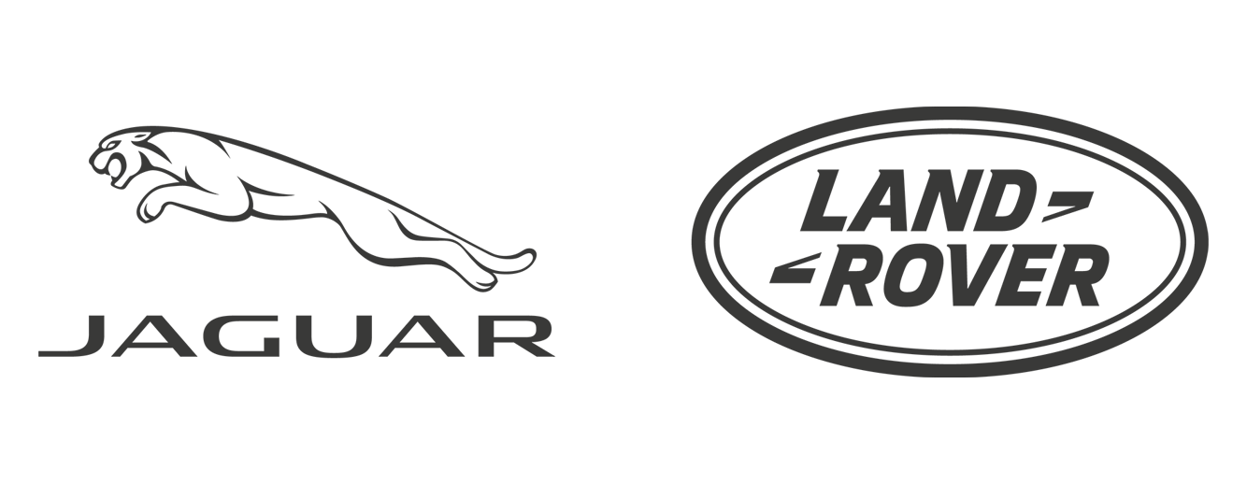
Figure 1: Jaguar Land Rover Logo (Beaury et al., 2020)

Environmental Analysis and Impact of Recent Disruptions

External Environmental Scan via PESTLE
JLR is subject to significant macroeconomic and regulatory forces that need to be constantly monitored, operating in the context of the UK and global automotive environment. The UK government has enacted stringent requirements to push businesses to net-zero carbon footprints, and changing timelines on restrictions to sales of new internal combustion engine vehicles, both politically and legislatively. Such regionalised legislative attacks imply that traditional luxury producers have to hastily abandon petrol and diesel platforms.
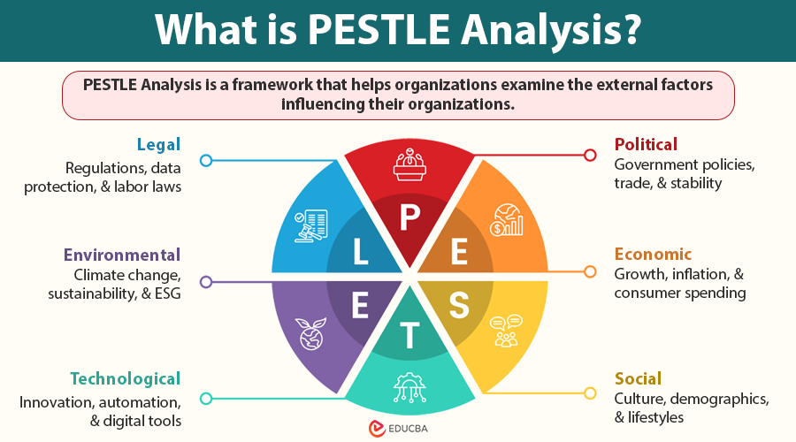
Figure 2: PESTLE Analysis (William et al., 2023)
Political Factor Analysis: The UK political environment is marked by post-Brexit trade dynamics and the changing schedule of carbon limitations. This dynamic approach to green industrial transitions by the UK government requires JLR to keep aligning its manufacturing roadmaps with the policy changes made by Westminster to access national investment subsidies and avoid strategic misalignment (JLR, 2023).
Economic Factor Analysis: Economically, JLR has high-friction barriers, such as endemic inflation, elevated interest rates, and erratic prices of raw materials, such as lithium, cobalt, and nickel vital to EV battery designs (Tata Motors, 2023). These internal forces are exacerbated by intense competition in the world of luxury, in terms of global aggressiveness, that is, by US and Asian manufacturers who have access to cheaper highly integrated battery supply chains.
Social Factor Analysis: Socially, high-end consumerism is changing at an extremely fast rate to sustainable luxury, circular manufacturing and zero-carbon branding (Alvesson and Sveningsson, 2024). Higher income groups are now more vigilant about brand ethics and carbon transparency and no longer regard mechanical status symbols as important unless they can be supported by a verifiable ecological responsibility and digital capability.
Technological Factor Analysis: Automotive is undergoing an unprecedented paradigm shift, which is characterised by Software-Defined Vehicles (SDVs), Cloud-integrated telemetry, and Over-The-Air (OTA) system updates (William et al., 2023). JLR must shift its historical core competencies to no longer focus on internal combustion engineering and shift to big data analytics, predictive maintenance AI, and cybersecurity.
Environmental Factor Analysis: Environmentally, JLR is subject to stringent sustainability policies, aiming to achieve net-zero carbon by 2039 throughout its whole value chain (JLR, 2023). This necessitates transformative structural modifications in the sourcing of raw materials, energy systems in factories, and closed-loop recycling systems to regulate Scope 3 lifetime vehicle emissions (Raut et al., 2019).
Legal Factor Analysis: Legal-wise, JLR is facing heavy statutory pressure due to the UK Zero Emission Vehicle (ZEV) Mandate that subjects the firm to harsh financial fines of £15,000 per vehicle that does not comply with stringent EV output requirements. Also, there are stringent GDPR limitations on connected vehicle systems, and post-Brexit rules of origin in international trade introduce trade tariffs in the case of battery assembly that is not localised in the UK (William et al., 2023).
Economically, JLR is experiencing stagnant growth trends which are typified by a saturation of global revenues and a decline in market share to fast moving electric vehicles producers who are both based in the United States and the Asian market. This issue is exacerbated by the extremely changeable supply-chain prices, with unstable prices of raw materials and world energy shocks swelling production costs. Socially, consumer behaviours are shifting rapidly towards environmentally friendly mobility offerings and city-centric lifestyle products, i.e., younger and richer consumers tend to care more about sustainability indicators than outdated mechanical luxuries. Putting these combined forces into academic perspective, they can be seen as a systemic environmental change in which organisations may not just be able to count on historic market power but must instead introduce active monitoring systems to adjust to the continuous ecological and market change (Beaury et al., 2020). In the case of JLR, the external factors provide a very dynamic environment which renders the status quo unachievable.
JLR will have to be very keen to how environmental changes will impact on its business in order to survive this tough times. These external issues cannot be viewed as individual problems by the company. Green energy is related to political choices, economic issues with international rivals and evolving social trends. Indicatively, any time the UK government alters its environmental timeframes, it will have a direct impact on consumer confidence and how much JLR will have to invest in creating new electric vehicle parts.
Also, the new post-Brexit economic reality has compelled JLR to rethink its overall parts sourcing paradigm. Since a significant part of the production process involves moving most of the important parts across the English Channel, any additional delays in customs can easily result in costly production halts. When this is added to the fact that the cost of transporting batteries and electrical parts is high, the financial argument that a stronger, more localised UK supply chain will be very apparent. Social changes also imply that the contemporary customers demand that the luxury brands should be complete open regarding their carbon emission.
A more in-depth analysis of the PESTLE landscape brings to light the operational and macro-frictions which JLR must face in implementing its strategic shift. Under Zero Emission Vehicle (ZEV) Mandate, the UK government is placing immediate statutory compliance pressure, with legally binding requirements for a 33% share of a manufacturer's new car sales to be zero emission, rising aggressively to 80% by 2030 and 100% by 2035, and a £15,000 fine per non-compliant vehicle. JLR is facing a 'tariff cliff edge' post-Brexit as the temporary extension of the EU-UK Trade and Cooperation Agreement (TCA) transitional rules ends on 2027, which would see the company face a 10% tax on any exports across the Channel if 55% of an EV's total value and 70% of its battery pack were produced in the UK. Sustainability and absolute transparency of Scope 3 lifetime emissions are required by premium consumer demographics from a socio-cultural and environmental point of view. At the same time, the challenges of localised technological change are compelling a radical paradigm shift in the direction of software-defined vehicle architecture, which in turn demands an urgent transformation within JLR of its own talent infrastructure from traditional mechanical engineering to complex cloud data management and predictive AI network management.

Digital Disruption, Industry 4.0, and Artificial Intelligence
The entire business landscape is shifting towards a paradigm shift that is being brought about by digital disruption and the instruments of Industry 4.0 that are transforming the administration of corporations on a fundamental level. To keep up with competitive trends and keep their workflows running smoothly, modern businesses are forced to employ large-scale automation methods, cloud computing systems, and secure blockchain registries (William et al., 2023). This, in the context of an automotive, implies that the factory floor control, supplier scheduling, and retail tracking should be completely embedded into a connected digital loop.
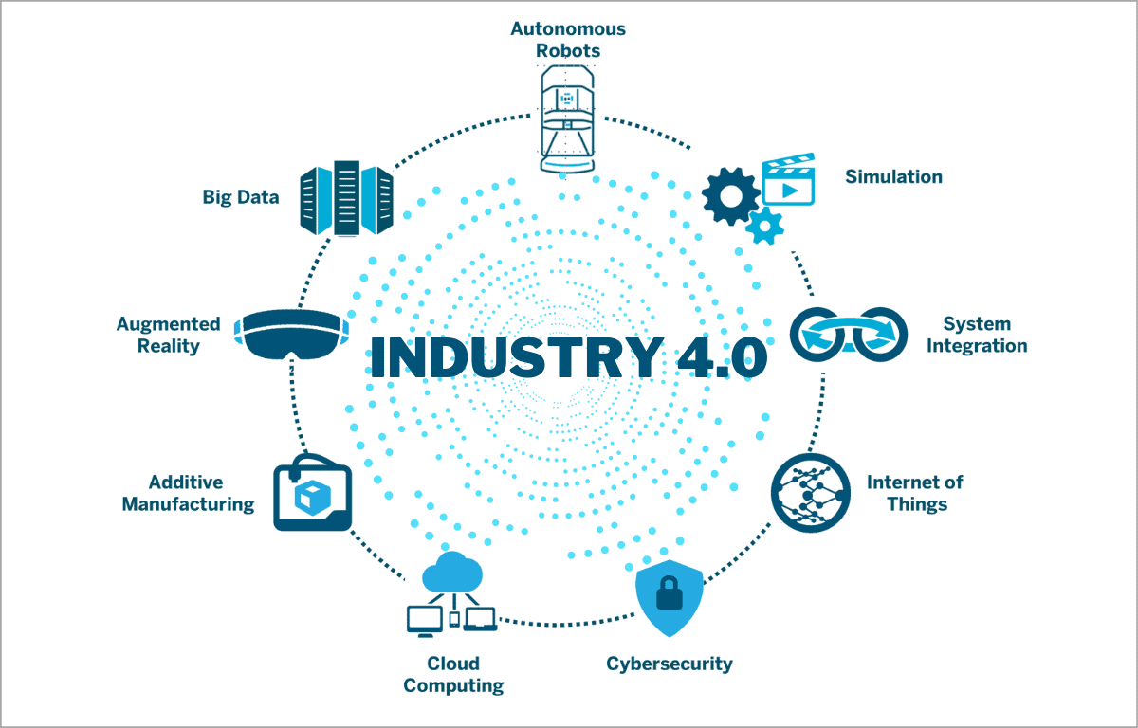
Figure 3: Understanding Industry 4.0 (Roetzel, 2019)
Nevertheless, the number of metrics available poses extremely dangerous corporate risks in the event that the company is not equipped with systems to manage that amount. The availability of huge amounts of data can effortlessly distort the decisions made by corporations to the detriment, introducing significant bottlenecks in operations where administrative personnel are victims to information overload on a systemic level (Roetzel, 2019). In the absence of adequate limits to analytical boundaries, managers might get paralysed due to inconsistent reports, which reduces the speed of response in a volatile market. In order to fight this and regain dwindling profit margins, strategic implementation of artificial intelligence needs to be directly embedded into the major business operations and daily financial actions (Pallathadka et al., 2023). By applying machine learning algorithms, companies can automate the draining reporting processes, predict market requirements, and eliminate human error in the supply chains. Therefore, the introduction of artificial intelligence into the core of the business management process ceases being a luxury option but an essential resource when it comes to saving costs and preserving business operations (Feuerriegel et al., 2022). In the case of JLR, the only solution to overcome the escalating cost of production and regain good health in its financial performance is to use these computational tools in all its global operations.
Cloud computing and blockchain technologies could be used to ensure that JLR develops a far more reliable supply chain network. With blockchain, the company will be able to trace the precise source of raw materials, including the cobalt and lithium in its electric vehicle batteries. Such a detail also ensures that JLR meets rigorous international sourcing regulations and provides eco-friendly consumers with the assurance that they are not endorsing unethical business practices. In the meantime, the cloud databases enable design engineers in Coventry to work in real-time with production teams in Solihull or Halewood.
Meanwhile, artificial intelligence can significantly contribute to the efficiency of the real-life factories of JLR. With installed smart sensors on the assembly lines, the company could apply predictive maintenance algorithms to predict when a robotic arm or stamping machine is going to break down. This enables maintenance people to repair the machinery during planned downtime as opposed to unforeseen, extremely costly failures during a busy production shift. Artificial intelligence can be used in the financial offices to analyse market trends to forecast changes in the prices of raw materials, and purchasing managers can buy metals and plastics at the most affordable times.

Technological Literacy and Organisational Capability Gaps
The internal capacity and willingness of the current workforce in JLR is critical in the successful adoption of digital tools. These broad technological trends must be linked to the real capacities of office places and assembly lines. Being both technologically literate and mindful of modern digitality is no longer a negotiable quality of both administrative staff and low-level operators in case an enterprise does not want to become obsolete in terms of its operations (Allen, 2020). When an organisation spends millions of dollars in state-of-the-art software and its workers are in the habit of using paper or fragmented habits and processes, the strategic worth of the technology is lost entirely.
In a more detailed analysis of the technical requirements, JLR has evident deficiencies in specialised data engineering and data analysis skills that are required to handle automated cloud operations and track predictive maintenance schedules (De Mauro et al., 2018). The company requires employees who are able to decode algorithmic recommendations and not simply check physical machinery. Nevertheless, the formation of a tech-oriented workforce generates an internal conflict between traditional engineering quality and the more human skills needed in order to navigate the staff members through significant digital changes (Ritter et al., 2018). Although technical mastery is needed in order to construct vehicles, soft skills such as emotional intelligence, effective communication, and cognitive flexibility are the ones that avoid employee resistance and burnout. Higher education institutions and contemporary companies should thus emphasise on equipping teams with a balance between the hard technical and soft managerial skills to prepare them to go digital (Goulart et al., 2022). JLR needs to proactively fill this talent gap, and long-term automotive professional should be upskilled so that they can succeed in a world of complicated automated systems.
To close this capability gap, JLR needs to change its internal training emphasis beyond mere, one-time software training. Rather, the company should develop an ongoing learning culture in which employees feel free to test new digital tools. Administrative personnel should be trained on how to employ sophisticated data visualisation tools in order to transform the raw operational data into intelligible actionable business plans. Mechanical technicians need to be trained on the assembly line to operate with automated guided vehicles and intelligent torque tools that save build data in real time.
Nevertheless, the management should also be aware that the technical training, in itself, is not sufficient to ensure successful transition. When workers are compelled to alter the way that they have been working decades, it may result in intense anxieties and frustrations. That is why it is of paramount importance to work on soft skills of team leaders and supervisors at this stage of transformation. Managers need to be trained to hear the concerns of employees, demonstrate the advantages of digital systems in a comprehensible way, and assist staff members who cannot cope up with the changes.

Critical Evaluation of Change Management Models

Theoretical Comparison: Lewin vs. Emerging Evidence-Based Frameworks
In order to execute the sweeping changes required by the overall Reimagine strategy at JLR, the management will have to critically analyse the developed change frameworks. The traditional Three-Step Model developed by Kurt Lewin based on the consecutive stages of unfreezing, changing, and refreezing is a simple approach to comprehend the realignment in corporations. During the unfreezing stage, JLR will need to dissolve the old habits of internal combustion engineering, and the changing stage will bring in the new electric architectures whereas the refreezing will instil these habits into daily routines. The paradigms of historical change such as those created by Lewin help to acknowledge that success in the long-term cannot be achieved without massive alignment of leadership and involvement of the employees in the change process throughout the entire initial stages to avoid the high level of internal resistance and fear of the unknown (Hussain et al., 2018). When the employees are not part of the vision, they will unconsciously oppose new goals.
Nevertheless, although it is clear, the linear model created by Lewin has been criticised as being overly simplistic in complex and fast-paced corporate settings. The current changes within organisations are hardly consistent, linear, with a refreezing destination. Rather, the latest trend in management thinking is multi-step, evidence-based change models that directly combine strict academic research with practical, daily corporate management practices (Stouten, Rousseau and De Cremer, 2018). These more sophisticated models view transformation as an iterative process that occurs continuously in which the leaders actively evaluate employee feedback, modify training approaches, and incorporate small experiments into the organisation processes.
By an evidence-based model that is current, JLR will be able to divide its massive electric transition into smaller manageable steps that can be tried and tweaked over time. As an illustration, rather than trying to initiate an update of all assembly lines simultaneously, the company can experiment with new automated workflows on a single production loop within a single facility. Through collecting the feedback of the operators on that particular line and the data on the build quality, managers may discover the technical defect and training inefficiencies and rectify them prior to the implementation of the systems in other factories. This scientific experimental method lowers the investment risk of huge investments and demonstrates to the sceptical employees that the new systems are viable and helpful in their daily work.
In addition, evidenced-based frameworks highlight the need to make decisions based on high-quality internal and external data as opposed to making decisions based on gut feelings or executive assumptions. JLR can make minor and proactive alterations to the change plan by continually surveying employees regarding their level of stress, monitoring the rate of software adoption, and assessing the specific time in seconds that production lines require after being updated. This is a constant feedback mechanism that will keep the company on its toes so as to avoid stumbling into a strict refrozen state that may turn outdated a few months later.

Institutional Change Dynamics and Success Determinants
The biggest, multi-location organisation tries to make an institutional-level pivot, it needs to grapple with the overwhelming issue of reorganising fundamental operations without bringing about a crunch in the current production or the quality of its vehicles. To manoeuvre through such institutional transformations, it is important to understand the workings of embedded habits, which is necessary to ensure that central strategies change without interrupting local lines of production (Kezar, 2018). In the case of JLR, it implies that, even though the transition to electric vehicles is planned at the central office, the real manufacturing plants in Solihull and Halewood will be the ones to finance the upgrade, through maintaining high standards of vehicle production.
According to academic sources, the success factors of large-scale corporate change revolve around operational and structural flexibility, as well as proactive prevention of employee exhaustion (Errida and Lotfi, 2021). There is change fatigue whereby employees get lost in repeated, ill-defined restructuring resulting in reduced morale and increased defects in production lines. In order to prevent this trap, the management should set up open communication lines, strong continuous learning platforms, and full transparency during the transition process (Lewis, 2025). The organisation can alleviate anxiety by explaining why the operation changes are made and offering clear training pipelines to employees.
The institutional change also involves JLR ensuring that the various departments within the company are in line with each other hence pulling towards the same direction. In many large manufacturing firms, design, purchasing, manufacturing, and marketing departments are often in remote silos and therefore they can create significant communication breakdowns. An example would be when the design team develops a very sophisticated electric motor without involving the plant engineers who would have to install it, the transition will be immediately delayed. The leaders should dismantle these departmental boundaries by forming cross functional transition teams that would have frequent meetings to exchange ideas, talk about the roadblocks and how to coordinate the schedules.
Also, to avoid change fatigue sabotaging the whole transformation process, JLR will have to rejoice in small, incremental wins in between. Electrification of a large automotive business is a gradual process that may take years, and workers can easily lose sight on the ultimate objectives when they feel that they are too far away. The management can keep the momentum and excitement high by establishing short-term and measurable goals, like training the first batch of battery technicians or finishing the first prototype of electric Defender.

Leadership Dynamics and Organisational Culture

Leadership Approaches in High-Volatility Environments
In times of extreme market upheaval, the top executive leadership should be a calming and stabilising presence in the entire corporate framework. The effectiveness with which an organisation responds to external challenges directly depends on the type of leadership style (Schermerhorn, Bachrach and Wright, 2020). Although an autocratic style can accelerate short-term decision-making in the face of a financial crisis, it can be very detrimental to morale in the long-term and can suppress innovation. Rather, JLR needs transformational and participative leadership approach that involves the different engineering and administrative groups in the decision-making process in an active way. This participative style fosters trust and helps workers to own the digital tools currently being implemented at the shop floor.
Moreover, the final outcome of any strategic change is grounded on the determination of a genuine desire to change on all levels of the workforce. But the willingness to change is not an executive order, it is a psychological agreement of the employees who are confident in their powers and ready to invest in the new business prospects (Weiner, 2020). Through participative methods used by top managers, they become the ones who make contributions towards this shared efficacy. In the case of JLR, this would be ensuring that the plant managers, line supervisors and engineers of their plants in the UK will all have a shared belief that the shift of electric luxury platforms was not only possible but a very big need that will give them a strong shield against the unpredictability of the external market.
To create this change preparedness, leaders should be very visible and accessible in the factory floor and in the design studios. Executive managers are not able to hide in boardrooms and give orders via corporate emails. They need to be involved in working with the employees, listening to the employees and showing an individual desire to participate in the retraining programs. When the employees realise that the top management is putting in its time and efforts to learn new digital systems, it creates a strong example to the other employees of the organisation to also do the same.
To top this, participative leadership assists to unlock the creative problem-solving ability, of the highly skilled engineering workforce of JLR. The individuals who operate on the assembly line or in the testing laboratory are in most instances much better acquainted with real-life issues of vehicle production than are executive managers. By asking such employees to take part in workshops and give their suggestions as to how the transition can be made more effective, the leaders will be able to discover significant tips that will save the company both time and money. Such a combined strategy will not only result in superior operational decisions but will also make the workers feel cherished and respected, which greatly diminishes the chances of union conflicts or active opposition to the change plan implementation.

Cultural Deconstruction and the Challenge of "Modern Luxury”
A major challenge confronting JLR is its engineering culture that is so deeply ingrained that it has decades to develop based on internal combustion engines and conservative high-end mechanical design. This rich history forms a clear institutional identity, but it also generates significant tension in attempting to transition to a more software-defined environment that is more digital-first. Changing a given corporate culture is an exceedingly slow and challenging process that cannot be handled easily by mere executive speech but has to be pursued on a daily basis (Alvesson and Sveningsson, 2024). Old customs and practices tend to be resistant to new data-driven practices because traditional teams might feel that automation poses a threat to their hard-earned skills in craft.
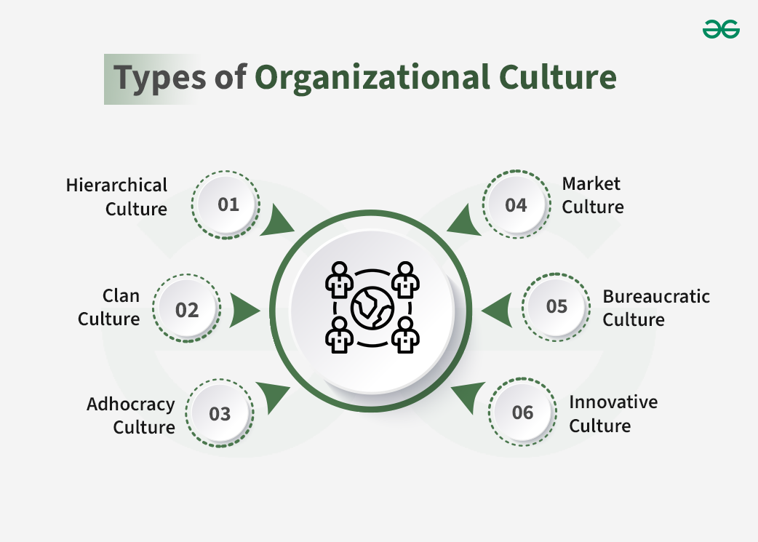
Figure 4: Different Types of Orgnaisational Culture (Lee, 2018)
Such cultural conflict is especially evident among certain sub-groups in various manufacturing facilities, e.g., the Solihull or Halewood manufacturing plant. Every facility possesses a local identity, union life and well-established means of operation that may result in different degrees of acceptance or simmerque resistance to new software architectures and automated workflows. Unless the shop floor teams perceive these digital changes as an unwarranted imposition by the head office as opposed to the means of enhancing the quality of vehicles being built, they might hold onto the old processes. Leaders have to work on transforming these specific sub-cultures by showing that software skills and data analytics can in fact make the British manufacturing prestigious, and she manages to rebrand the company to the new luxury customer segment.
The rebuilding of the JLR traditional culture should be done with a delicate and respectful treatment that will not render long-serving employees outdated. The management should stress that the transition to software-defined vehicles does not imply that JLR has renounced its traditions but is the next stage in its development. The traditional mastery that launched Range Rover and Jaguar into the limelight remains very applicable but now needs to be supplemented with the digital accuracy.
In order to sustain these cultural changes, JLR needs to also make its internal reward systems and promotion frameworks aligned to its new digital targets. In the past, status within the company was usually associated with knowledge of an engineer to design complicated mechanical gearboxes or high-powered petrol engines. In the future, the company should reward and encourage those who excel in the creation of effective battery cooling systems, writing clean vehicle control software, or data analytics helping to enhance the efficiency of factories. With the shift of internal icons of prestige and professional achievement, the management is able to promote the shift to the digital mentality to the rest of the workforce in a natural way, turning the switch to modern luxury into a real, cultural phenomenon.

Strategic Change Management Plan (The Proposal)

Objectives and Strategic Restructuring
The planned strategic change initiative will turn the declining market share of JLR around by strategically upskilling the current UK workforce and introducing big data analytics into daily manufacturing processes (Sousa and Rocha, 2019). The essence of the goal in the next 18 months is to transform forty percent of the old-school mechanical techs into certified electrification and data experts and reduce assembly mistakes by a quarter with real-time AI oversight. The association of sophisticated data analysis with sustainable operating strategies enables the company to address its environmental commitments and enhance the financial stability in the long term (Raut et al., 2019). In addition, JLR can save on the cost of third-party engineering contractors by actively building these high-tech capabilities in-house. This independence makes the company be able to respond to the changing needs of the market fast and retain high-value engineering jobs in the UK economy (Lee, 2018).

Financial and Investment Framework
This change will need a strict financial allocation plan led by the top management. The proposal will create a dedicated capital fund of forty-five million pounds in two financial years, which will be specifically divided into cloud data infrastructure, retooling of production lines at Halewood and expansion of the JLR Electrification Academy. This capital investment will be offset by a gradual decline in the budgets of legacy ICE development. The estimated payback period will be realised in twenty-four months with a thirty percent reduction in factory wastes and reduction in long-term warranty claims on vehicles through predictive AI diagnostics on the assembly line.

Stakeholder Communication Strategy
A multi-level communication system should be implemented at once to ensure internal resistance and avoid fatigue of change are minimised. The executive leaders will present monthly transparent video reports and have open Q&A sessions to explain how the House of Brands strategy cushions individual product lines such as Range Rover and Defender. Weekly team briefings in the plants by the line managers will be used to discuss the upcoming software changes and frequent consultation with labour unions will give direct assurances on the available retraining opportunities of the workforce. Such an open strategy decreases fears about automation and creates a sense of shared commitment throughout the organisation.

Evaluation, KPI Tracking and Feedback Loops
This change initiative will be evaluated on the basis of strict and measurable performance indicators that will be reviewed by the board of directors every quarter. These KPIs are the proportion of employees who have undergone digital upskilling programs, the rate of software integration within supply chains, and the mean cycle times of reconfigured assembly lines. Also, JLR will monitor the stabilisation of the retail margins within its UK dealership networks to make sure that operational changes are directly reflected in financial health. Constant feedback channels will enable supervisors in the plant to report any software glitches in real-time so that the transformation is flexible and responsive.

Conclusion
Overall, the high-pressure external stimuli of Jaguar Land Rover, such as stringent UK net-zero goals, digital threat, and the increase in electric vehicle competition, involve the need to radically transform the internal resources of the company. The old ways of manufacturing can no longer keep the profits afloat in a dynamic environment where revenues are becoming saturated and consumer behaviours are evolving. JLR can effectively fill its technological skills gap by critically implementing evidence-based change models and overcoming the cultural resistance that is ingrained in its culture. The review reveals that operational plans that are well laid and transformational leadership, which is inclusive is a necessity to safeguard corporate revenues and global market share. In conclusion, the strategic change plan contained in this report is an effective and realistic route to help JLR reestablish its operational groundwork. Making significant investments in internal technological literacy, effective stakeholder communication, and cutting-edge manufacturing analytics enables the organisation to get beyond complications in the legacy. This is a proactive measure that will make JLR House of Brands a success in the form of a highly innovative leader in the high-end electric vehicle segment that will be able to establish itself in the competitive UK economy in decades to come.

References
Allen, S.J. (2020) 'On the cutting edge or the chopping block? Fostering a digital mindset and tech literacy in business management education', Journal of Management Education, 44(3), pp. 362–393.
Alvesson, M. and Sveningsson, S. (2024) Changing organizational culture: cultural change work in progress. London: Routledge.
Beaury, E.M., Fusco, E.J., Jackson, M.R., Laginhas, B.B., Morelli, T.L., Allen, J.M., Pasquarella, V.J. and Bradley, B.A. (2020) 'Incorporating climate change into invasive species management: insights from managers', Biological Invasions, 22(2), pp. 233–252.
De Mauro, A., Greco, M., Grimaldi, M. and Ritala, P. (2018) 'Human resources for Big Data professions: a systematic classification of job roles and required skill sets', Information Processing & Management, 54(5), pp. 807–817.
Easterby-Smith, M., Valizade, D., Thorpe, R. and Jaspersen, L.J. (2021) Management and business research. 7th edn. London: SAGE Publications.
Errida, A. and Lotfi, B. (2021) 'The determinants of organizational change management success: literature review and case study', International Journal of Engineering Business Management, 13, pp. 1–13.
Feuerriegel, S., Shrestha, Y.R., Von Krogh, G. and Zhang, C. (2022) 'Bringing artificial intelligence to business management', Nature Machine Intelligence, 4(7), pp. 611–613.
Goulart, V.G., Liboni, L.B. and Cezarino, L.O. (2022) 'Balancing skills in the digital transformation era: the future of jobs and the role of higher education', Industry and Higher Education, 36(2), pp. 118–127.
Hussain, S.T., Lei, S., Akram, T., Haider, M.J., Hussain, S.H. and Ali, M. (2018) 'Kurt Lewin's change model: a critical review of the role of leadership and employee involvement in organizational change', Journal of Innovation & Knowledge, 3(3), pp. 123–127.
Jaguar Land Rover (JLR) (2023) Jaguar Land Rover Unveils New JLR Corporate Identity as it Accelerates Modern Luxury Vision. Available at: https://media.jaguarlandrover.com/ (Accessed: 26 June 2026).
Kezar, A. (2018) How colleges change: understanding, leading, and enacting change. 2nd edn. Routledge.
Lee, Y.S. (2018) 'Modern management and the demand for technical skill', Labour Economics, 55, pp. 328–343.
Lewis, L. (2025) 'Organizational change', in Origins, traditions, and trends of organizational communication. London: Routledge, pp. 415–436.
Pallathadka, H., Ramirez-Asis, E.H., Loli-Poma, T.P., Kaliyaperumal, K., Ventayen, R.J.M. and Naved, M. (2023) 'Applications of artificial intelligence in business management, e-commerce and finance', Materials Today: Proceedings, 80, pp. 2610–2613.
Raut, R.D., Mangla, S.K., Narwane, V.S., Gardas, B.B., Priyadarshinee, P. and Narkhede, B.E. (2019) 'Linking big data analytics and operational sustainability practices for sustainable business management', Journal of Cleaner Production, 224, pp. 10–24.
Ritter, B.A., Small, E.E., Mortimer, J.W. and Doll, J.L. (2018) 'Designing management curriculum for workplace readiness: developing students’ soft skills', Journal of Management Education, 42(1), pp. 80–103.
Roetzel, P.G. (2019) 'Information overload in the information age: a review of the literature from business administration, business psychology, and related disciplines with a bibliometric approach and framework development', Business Research, 12(2), pp. 479–522.
Schermerhorn Jr, J.R., Bachrach, D.G. and Wright, B. (2020) Management. 14th edn. Hoboken: John Wiley & Sons.
Sousa, M.J. and Rocha, Á. (2019) 'Skills for disruptive digital business', Journal of Business Research, 94, pp. 257–263.
Stouten, J., Rousseau, D.M. and De Cremer, D. (2018) 'Successful organizational change: integrating the management practice and scholarly literatures', Academy of Management Annals, 12(2), pp. 752–788.
Weiner, B.J. (2020) 'A theory of organizational readiness for change', in Handbook on implementation science. Cheltenham: Edward Elgar Publishing, pp. 215–232.
William, P., Sharma, G., Kapil, K., Srivastava, P., Shrivastava, A. and Kumar, R. (2023) 'Automation techniques using AI based cloud computing and blockchain for business management', 2023 4th International Conference on Computation, Automation and Knowledge Management (ICCAKM). Greater Noida,, 14-15 December. IEEE, pp. 1–6.

