1/06/2023
Benjamin Gaylard
2003557
Geographical Information Systems (ACCB5027)
Geodemographic analysis using GIS software

Table of Contents
What is a GIS system and their advantages and disadvantages of using the system? 4
What is an LSOA Area? 4
What is an MSOA Area? 4
What is an OAC Area? 5
What is UK data services? 5
What is InFuse 2011 Population Statistics? 5
What is Digimap? 5
Task One 6
Task Two 13
Hypothesis 1: 13
Hypothesis 2: 23
Hypothesis 3: 35
References 43

Figure 1 - UK Data Service Website 6
Figure 2 - Image of where I have saved the data too (E:) drive 6
Figure 3 - Infuse2011 Website 7
Figure 4 - Another infuse2011 image which I have selected the data needed 8
Figure 5 - Options tab from the infuse2011 website 9
Figure 6 - selected data from infuse2011 9
Figure 7 - Download screen 10
Figure 8 - Digimap website 10
Figure 9 - Digimap maps 11
Figure 10 - Thematic Map of Deprivation by LA for Wales 14
Figure 11 - Zoomed in for Newport of the Thematic Map of Deprivation 14
Figure 12 - Zoomed in for Swansea of the Thematic Map of Deprivation 15
Figure 13 - Thematic Map of Deprivation by LSOA for Newport 15
Figure 14 - Thematic Map of Deprivation by LSOA for Swansea 16
Figure 15 - Thematic Map of COVID-19 Infection Rates by LA for Wales 16
Figure 16 - Zoomed in of the Thematic Map of COVID-19 Infection Rates by LA for Swansea 17
Figure 17 - Zoomed in of the Thematic Map of COVID-19 Infection Rates by LA for Newport 17
Figure 18 - Thematic Map of COVID-19 Infection Rates by MSOA for Wales 18
Figure 19 - Thematic Map of COVID-19 Infection Rates by MSOA for Newport 18
Figure 20 - Thematic Map of COVID-19 Infection Rates by MSOA for Swansea 19
Figure 21 - Thematic Map Overlay for wales by LA 19
Figure 22 - Thematic Map Overlay by LA for Newport 20
Figure 23 - Thematic Map Overlay by LA for Swansea 20
Figure 24 - Thematic Map Overlay by LSOA and MSOA for Newport 21
Figure 25 - Thematic Map Overlay by LSOA and MSOA for Swansea 21
Figure 26 - Thematic Map of the Elderly Population by LA for Wales 24
Figure 27 - Thematic Map of the Elderly Population by LA for Newport 24
Figure 28 - Thematic Map of the Elderly Population by LA for Swansea 25
Figure 29 - Thematic Map of the Elderly Population by MSOA for Wales 26
Figure 30- Thematic Map of the Elderly Population by MSOA for Newport 27
Figure 31- Thematic Map of the Elderly Population by MSOA for Swansea 27
Figure 32 - Thematic Map of COVID-19 Death Rates by LA for Wales 28
Figure 33 - Thematic Map of COVID-19 Death Rates for Swansea 28
Figure 34 - Thematic Map of COVID-19 Death Rates by LA for Newport 29
Figure 35 - Thematic Map of COVID-19 Death Rates by MSOA for Wales 29
Figure 36- Thematic Map of COVID-19 Death Rates by MSOA for Swansea 30
Figure 37 - Thematic Map of COVID-19 Death Rates by MSOA for Newport 30
Figure 38 - Thematic Map Overlay by LA for Wales 31
Figure 39 - Thematic Map Overlay by LA for Newport 31
Figure 40 - Thematic Map Overlay by LA for Swansea 32
Figure 41 - Thematic Map Overlay by MSOA for Wales 32
Figure 42 - Thematic Map Overlay by MSOA for Newport 33
Figure 43 - Thematic Map Overlay by MSOA for Swansea 33
Figure 44 - Thematic Map of Vaccination Rates by LA for Wales 36
Figure 45 - Thematic Map of Vaccination Rates by LA for Newport 36
Figure 46 - Thematic Map of Vaccination Rates by LA for Swansea 37
Figure 47 - Thematic Map of Older Population by LA for Wales 37
Figure 48 - Thematic Map of Older Population by LA for Newport 38
Figure 49 - Thematic Map of Older Population by LA for Swansea 38
Figure 50 - Thematic Map of Vaccination Centre Locations by LA for Newport 39
Figure 51 - Thematic Map of Vaccination Centre Locations by LA for Swansea 39
Figure 52 - Thematic Map Overlay by LA for Wales without vaccination centres 40
Figure 53 - Thematic Map Overlay by LA for Newport 40
Figure 54 - Thematic Map Overlay by LA for Swansea 41

What is a GIS system and their advantages and disadvantages of using the system?
A GIS system, or Geographic Information System, is a computer-based system for storing, managing, analysing, and displaying spatial data. GIS systems can be used to create maps, analyse spatial relationships, and identify patterns and trends [1].

Advantages of using a GIS system: | Disadvantages of using a GIS system: | Examples of how GIS systems are used:
- GIS systems can be used to store and manage large amounts of spatial data. | - GIS systems can be expensive to purchase and maintain. | - Transportation: GIS systems can be used to plan and design transportation systems, such as roads, railways, and airports.
- GIS systems can be used to analyse spatial relationships, such as the distance between two points or the area of a polygon. | - GIS systems can be difficult to learn how to use. | - Environmental: GIS systems can be used to monitor and manage environmental resources, such as water quality and air quality.
- GIS systems can be used to identify patterns and trends in spatial data. | - GIS systems can be time-consuming to use. | - Business: GIS systems can be used to analyse market potential, plan store locations, and track shipments.
- GIS systems can be used to create maps that can be used to communicate spatial information. | - GIS systems can be inaccurate if the data is not properly entered or maintained. | - Government: GIS systems can be used to plan land use, manage emergency response, and track crime.

What is an LSOA Area?
Lower Layer Super Output Region, or LSOA as it is known in the UK, is a condensed statistical geographic area. The Office for National Statistics uses it to gather data for censuses and other purposes (ONS). Around 1,500 people live in LSOAs, which are utilised for a variety of tasks like crime mapping, education analysis, and health research. LSOAs are determined by a number of variables, such as social and economic traits, population density, and forms of housing [2].

What is an MSOA Area?
Middle Layer Super Output Areas, or MSOAs, are statistical geographic units similar to LSOAs that are used in the UK. A little more than 7,200 people live in MSOAs, which are bigger than LSOAs. They are used to provide a more thorough breakdown of census data and to analyse data for smaller geographic areas. Areas with comparable social and economic features, ethnic diversity, and housing styles are grouped together using MSOAs, which combine a number of LSOAs. MSOAs are employed for social planning, resource allocation, research, and policymaking [3].

What is an OAC Area?
Output Area Categorization, or OAC as it is known in the UK, is a geodemographic classification scheme. It is utilised to comprehend the social and economic traits of various regions. The OAC is based on a mix of socioeconomic and demographic factors, including household composition, type of dwelling, work status, and education [4].
Based on their social and economic features, the OAC system divides the UK Output Areas (OA) into a number of categories (often six or seven). OAs are little communities with a median population of roughly 300 people. The OAC categorization assists in identifying regional differences in socioeconomic circumstances, which may be helpful in informing local policy and service provision. It might be used, for instance, by companies wishing to target particular customer segments in particular locales or by health authorities wishing to comprehend disparities in health outcomes [4].

What is UK data services?
Researchers can access, analyse, and distribute census data with the support of a variety of resources and services offered by the UK Data Service Census Support team. To assist researchers in making the most of census data, the team also provides training and assistance. For people who are interested in exploiting census data, the team is a great resource [5].

What is InFuse 2011 Population Statistics?
InFuse 2011 Population Statistics includes compiled information from the 2011 UK Census. The UK Data Service website has a download link for it. Information on a range of subjects, including age, sex, ethnicity, education, employment, and housing, is included in the dataset. Researchers, companies, and other organisations can use it to find out more on the population and its features in the UK [6].

What is Digimap?
A variety of old and new maps of the United Kingdom may be seen on the website Digimap. It was created by the Ordnance Survey and is accessible to all users without charge. A broad variety of map formats, such as topographic maps, aerial pictures, and satellite images, are available on Digimap [7].

Task One
Collecting of Welsh Census Output Areas
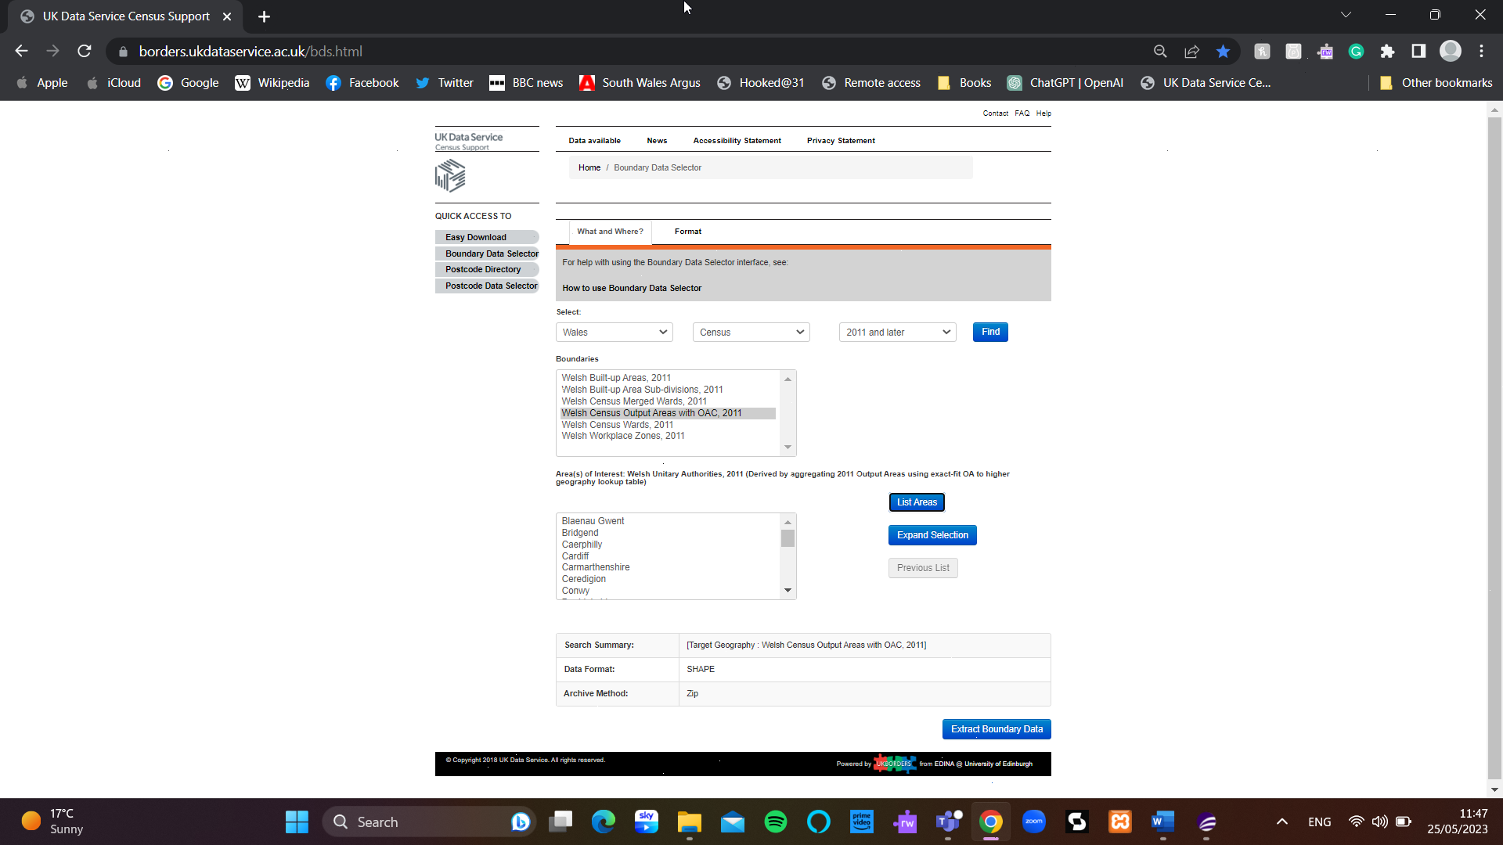
Figure 1 - UK Data Service Website
The first data collection is seen above. Wales has the choice of Welsh Census Output Areas, 2011, however, I'll get the ones for Newport and Swansea. This will be used in the GIS workspace for the case study. Due to the file type being a MAPINFO (native format), the map can be seen and used in MapInfo Pro 2021, the program that will be used in this case study. We will be able to present data topics for the neighborhood on this map. We may also get the LSOA and MSOA for the same locations on this website.
Storage of Documents and Downloads
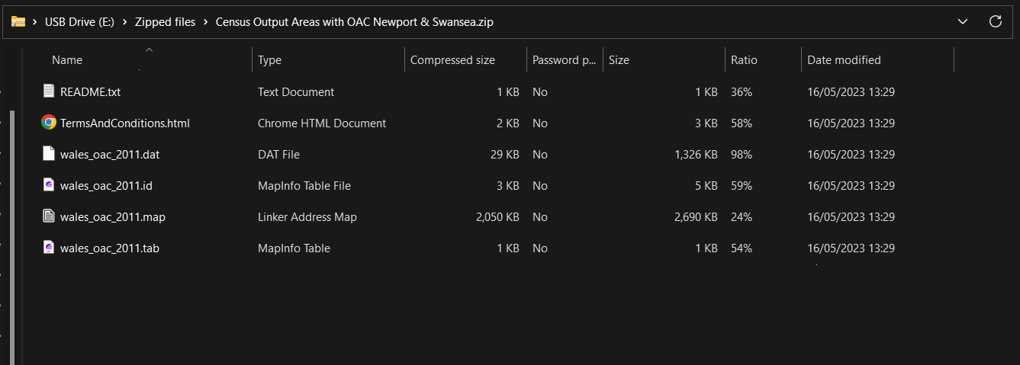
Figure 2 - Image of where I have saved the data too (E:) drive
The procedure of gathering the data was a methodical and effective way to get the data we need for this case study.
Collection of Data
These are only a few of the numerous data points that have been gathered.
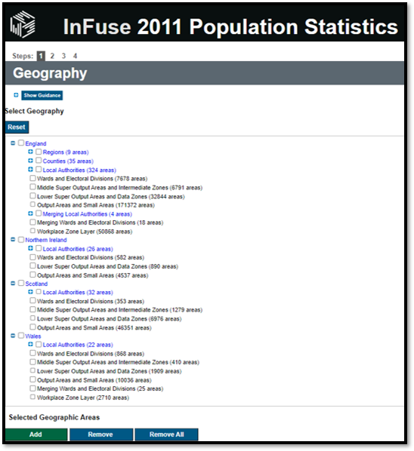
Figure 3 - Infuse2011 Website
Here, we may gather information on a variety of themes, including age, sex, deprivation, access to automobiles or vans, employment, and a great deal more. The option to choose the region from which you want to gather data is displayed above.
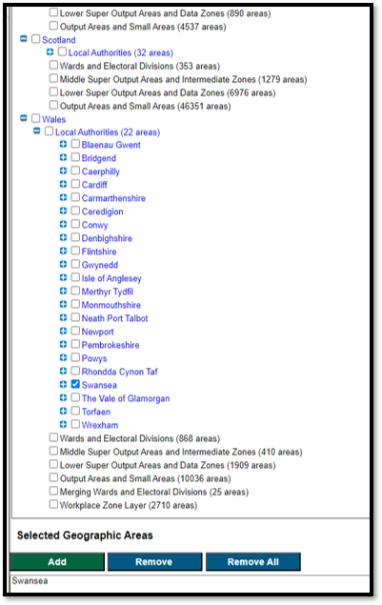
Figure 4 - Another infuse2011 image which I have selected the data needed
Swansea has been picked as the Local Authority, as well as the Output Areas and Small Areas (792 areas). However, given that the topic data within this selection may be chosen, I will obtain the data for all of Newport and Wales.
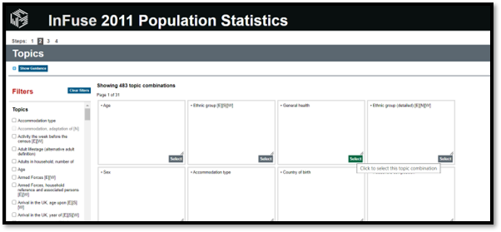
Figure 5 - Options tab from the infuse2011 website
Here, the issues are chosen, and those that fall under the heading "Deprivation, classification of household [E] [S] [W]" will be chosen.
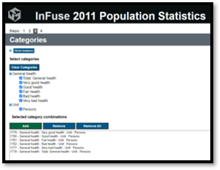
Figure 6 - selected data from infuse2011
All the chosen categories are listed here. For the data to be used, they must now be downloaded.
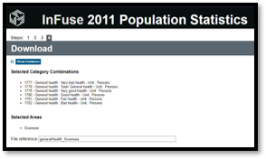
Figure 7 - Download screen
Now that the data is available for download, it can be removed from the.zip file and put in our designated folders, making it simpler to retrieve and lowering the possibility of future mistakes. To obtain all the information we need, this procedure will now be repeated.

Collection of Maps
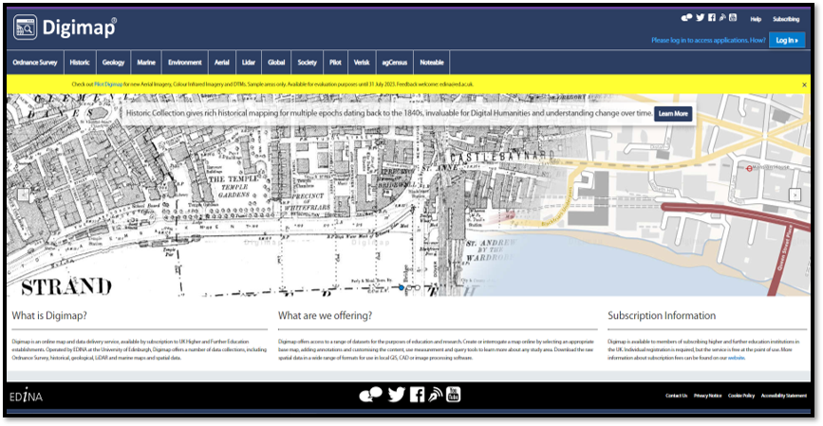
Figure 8 - Digimap website
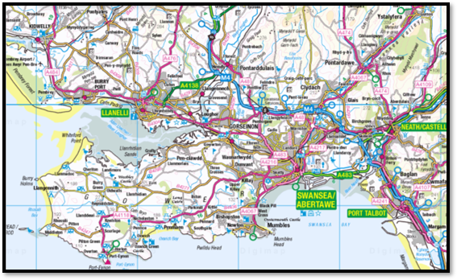
Figure 9 - Digimap maps
To collect data, we first chose a region of data to utilize and the layer of roads and infrastructure to use. After receiving the confirmation email, we downloaded the data and stored it with a suitable name.
Manipulation of Data
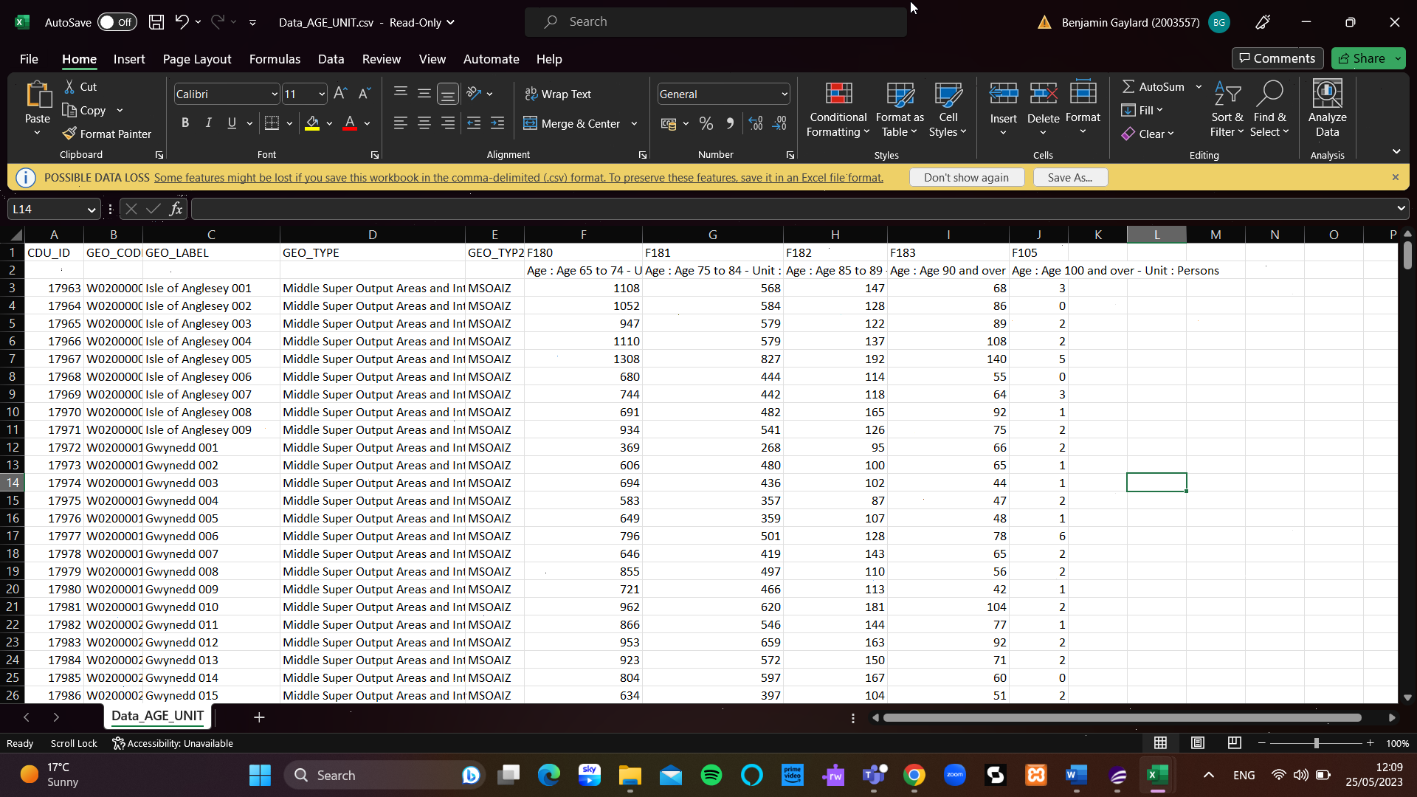
Now that we have access to the necessary data, we can change it such that it can be utilized in MapInfo Pro 2021. We may rename the headers to be more appropriate and intelligible, and we can eliminate any cells that we no longer need.
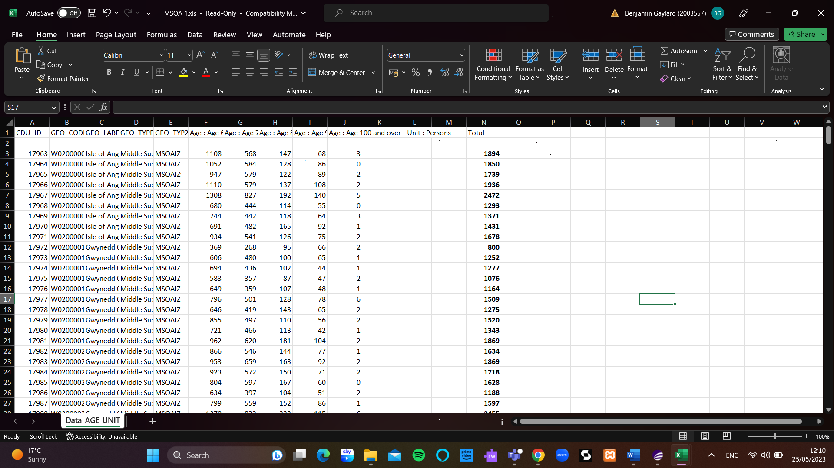
This information is now more valuable. This will be done for most of the data that will be used. The files will then be saved as Excel 97-2003 Workbook (*.xls) files, allowing the data to be utilized.

Task Two

Hypothesis 1:
Is there Correlation between Deprivation and COVID-19 Infection Rates in Newport and Swansea Regions

The purpose of this hypothesis is to ascertain if COVID-19 infection rates in the Newport and Swansea region as a whole correlate with degrees of deprivation as determined by the Townsend Deprivation Index. Deprivation levels and COVID-19 infection rates were shown using different thematic maps, which were then overlaid to look for any patterns or relationships. The evidence supports the theory by showing a direct relationship between higher levels of impoverishment and higher COVID-19 infection rates.

Methodology:
Data Collection
Multiple sources of information were gathered to support this idea. The levels of deprivation in the Newport and Swansea areas were calculated using the Townsend Deprivation Index. In order to study the virus's propagation, data on the COVID-19 infection rate was also gathered from Public Health Wales (PHW).

Townsend Deprivation Index
A frequently used indicator of deprivation, the Townsend Deprivation Index includes a number of socioeconomic characteristics, including income, job, education, and housing. For each geographic location, the index generates a composite score that represents the overall degree of deprivation.

COVID-19 Infection Rate Data
Public Health Wales (PHW) provided data on COVID-19 infection rates for the Newport and Swansea areas as cities; however, I was able to get infection rates per MSOA. Data on confirmed COVID-19 cases by local authority is included, enabling the estimation of infection rates.

Thematic Map Creation
MapInfo was used to produce thematic maps. Different hues or tones reflected various levels of deprivation and infection rates, respectively, using data from the Townsend Deprivation Index and COVID-19 infection rate.
Overlaying the Deprivation and COVID-19 Maps: Thematic maps showing deprivation and infection rates were superimposed in order to analyse the relationship between the two variables. The association between poverty and COVID-19 infection rates in the Newport and Swansea areas is visually shown by this overlay map.

Results:
Thematic Map of Deprivation
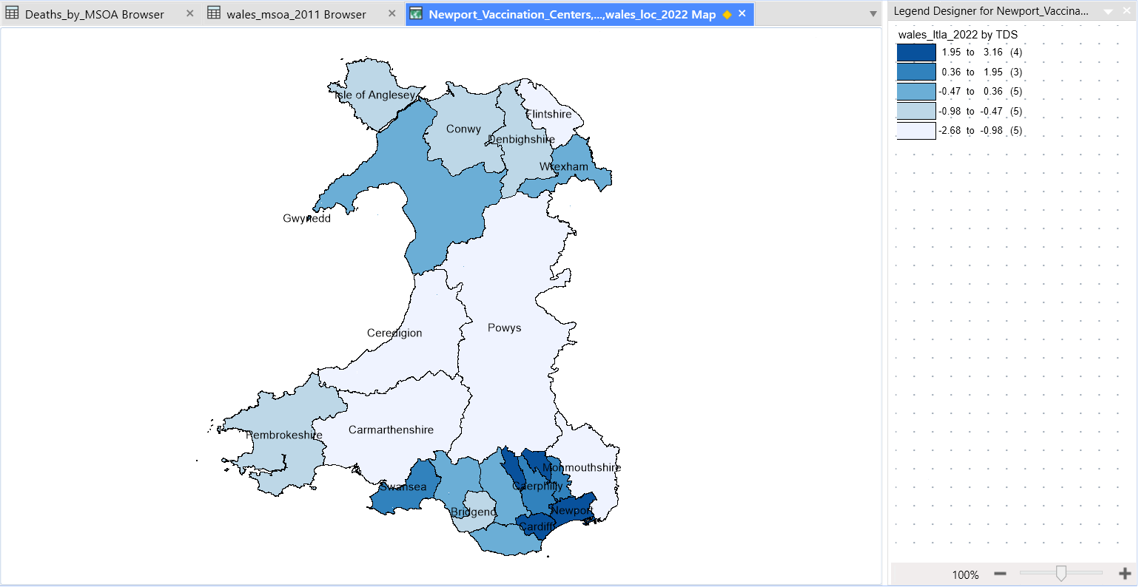
Figure 10 - Thematic Map of Deprivation by LA for Wales
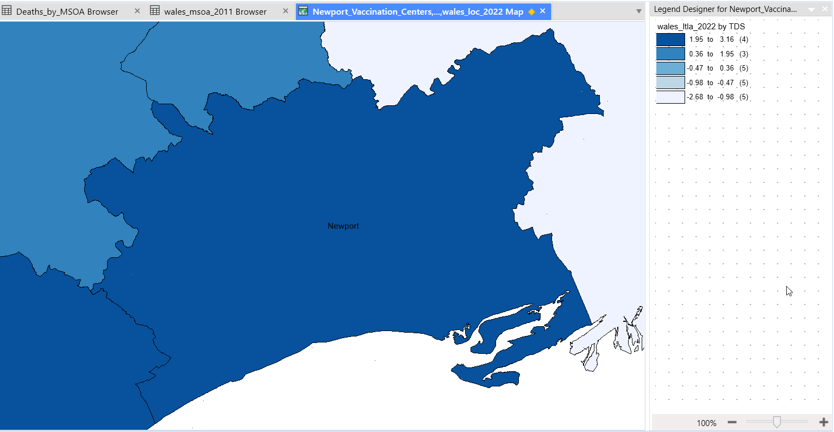
Figure 11 - Zoomed in for Newport of the Thematic Map of Deprivation
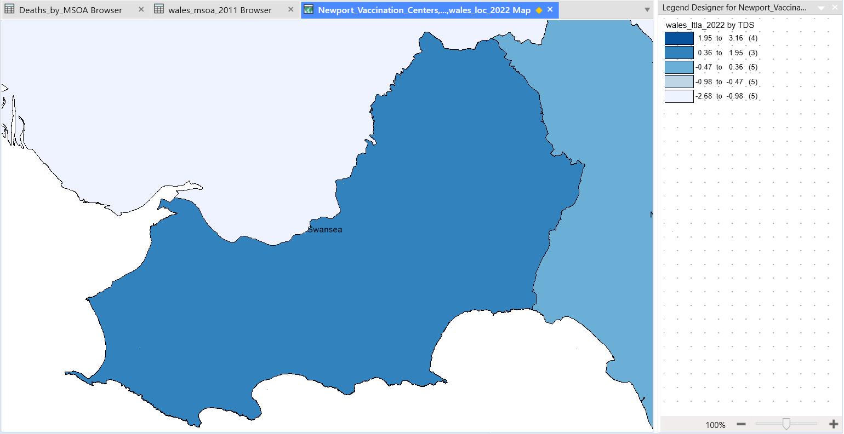
Figure 12 - Zoomed in for Swansea of the Thematic Map of Deprivation
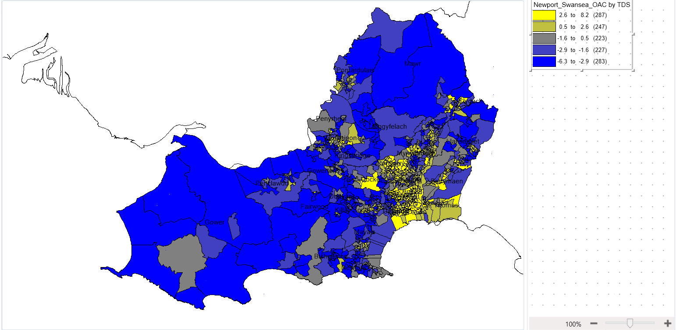
Figure 13 - Thematic Map of Deprivation by LSOA for Newport
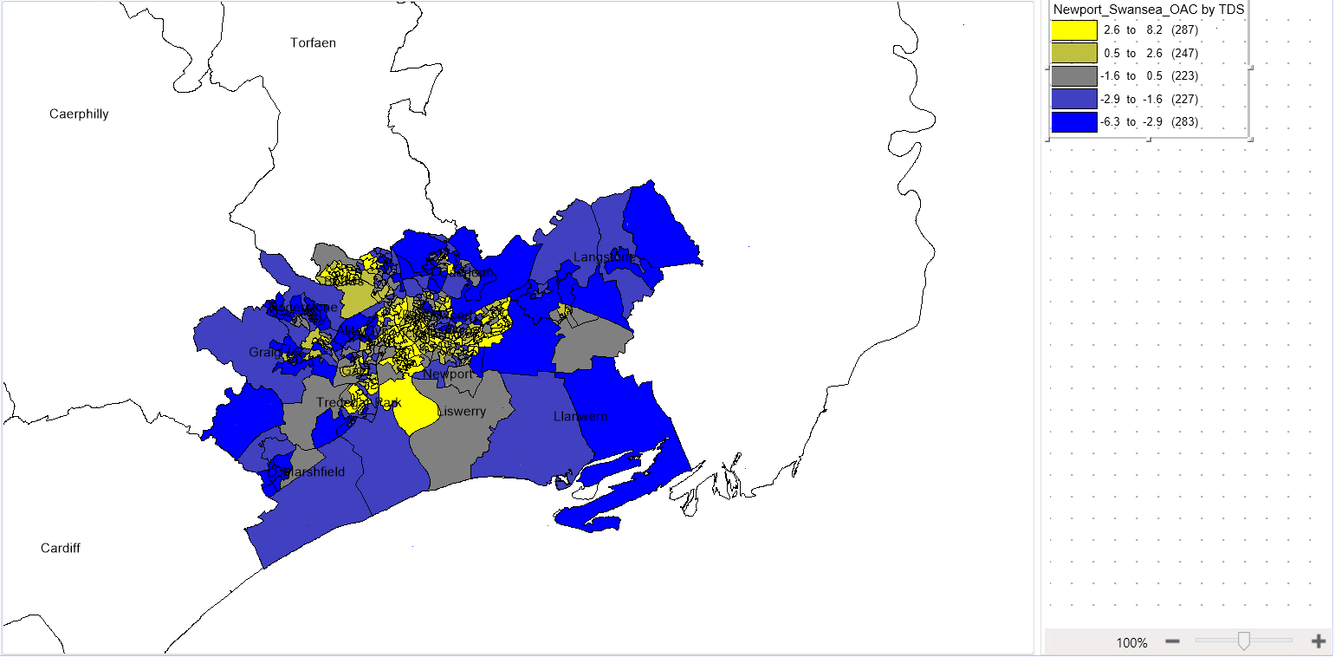
Figure 14 - Thematic Map of Deprivation by LSOA for Swansea
Description of the Map: The Townsend index by LSOA for Newport and Swansea is used to break down the levels of deprivation across Wales on the thematic map of deprivation. It uses a colour gradient to represent various densities of deprivation, from dark to bright. Lighter colours indicate lesser degrees of deprivation, whereas darker shades indicate higher levels.
Interpretation of Deprivation Levels: Darker colours on the theme map represent locations with greater degrees of impoverishment. Socioeconomic difficulties including poor income, restricted access to education, and substandard housing are likely to be present in these places.

Thematic Map of COVID-19 Infection Rates
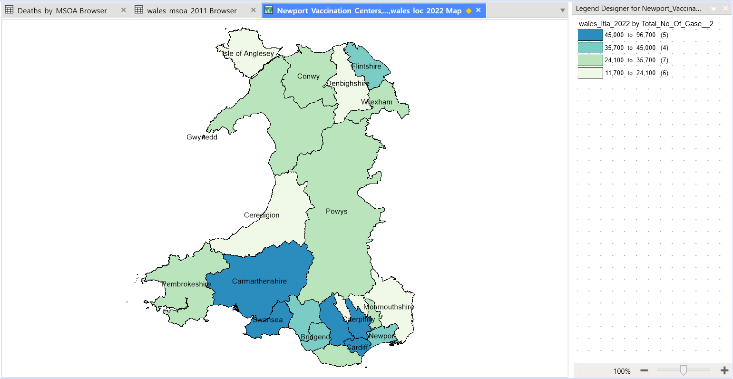
Figure 15 - Thematic Map of COVID-19 Infection Rates by LA for Wales
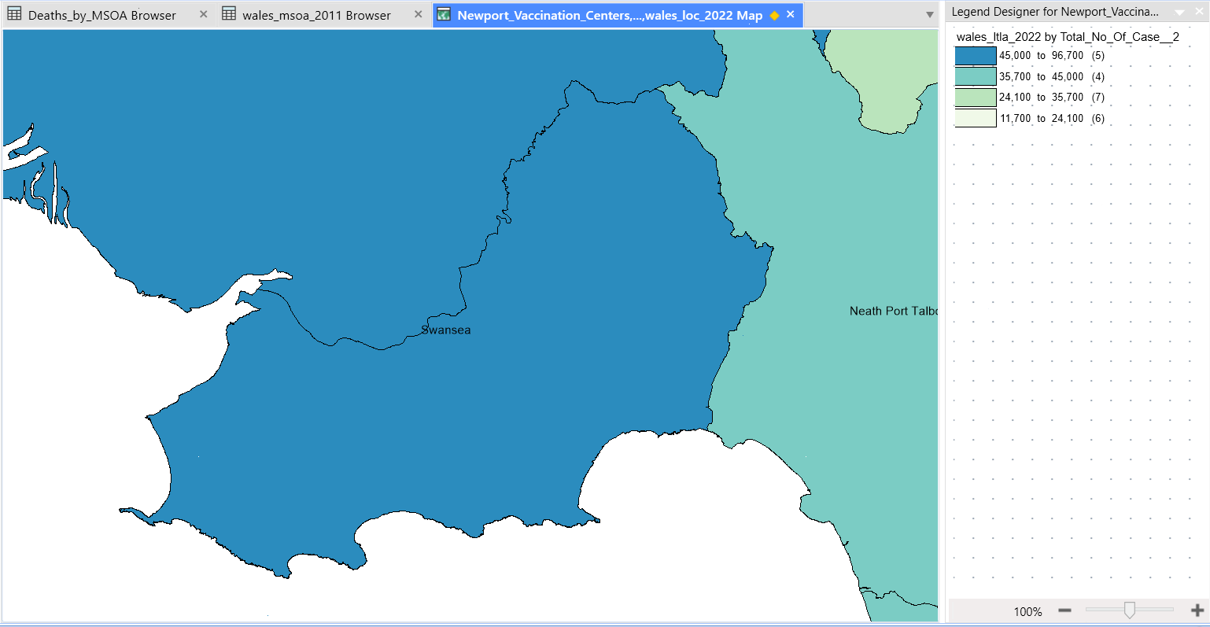
Figure 16 - Zoomed in of the Thematic Map of COVID-19 Infection Rates by LA for Swansea
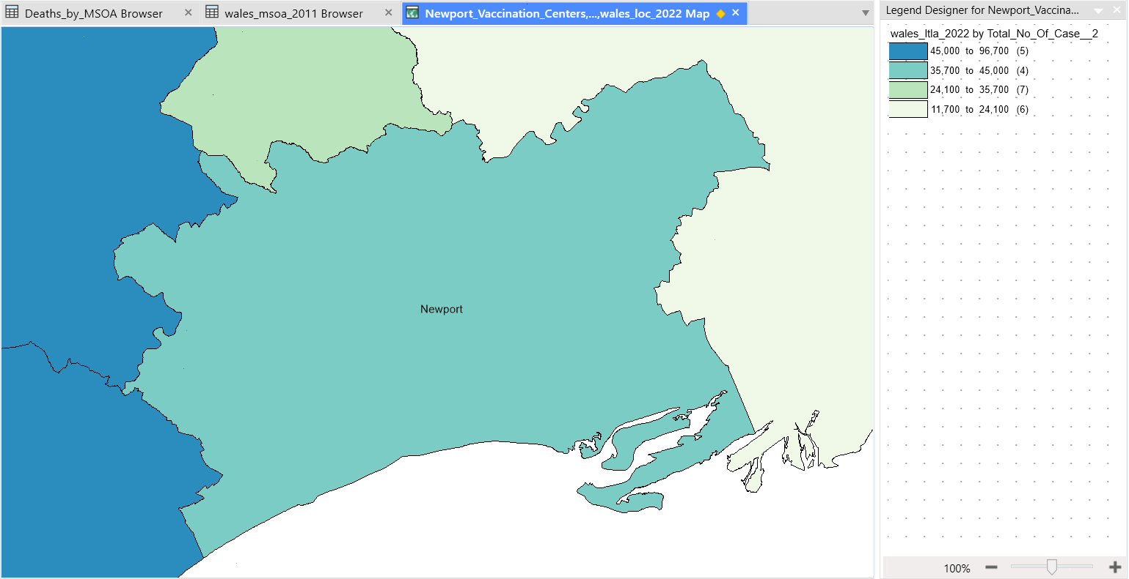
Figure 17 - Zoomed in of the Thematic Map of COVID-19 Infection Rates by LA for Newport
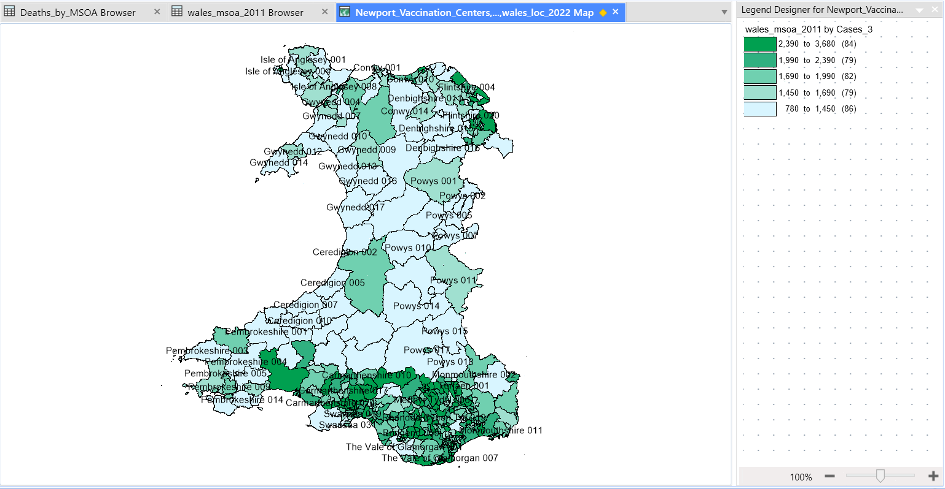
Figure 18 - Thematic Map of COVID-19 Infection Rates by MSOA for Wales
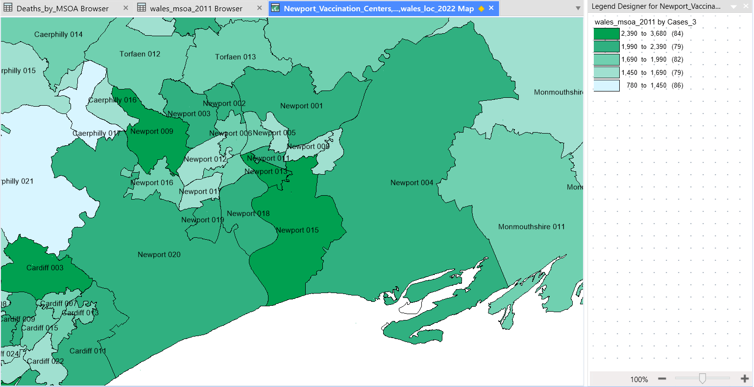
Figure 19 - Thematic Map of COVID-19 Infection Rates by MSOA for Newport
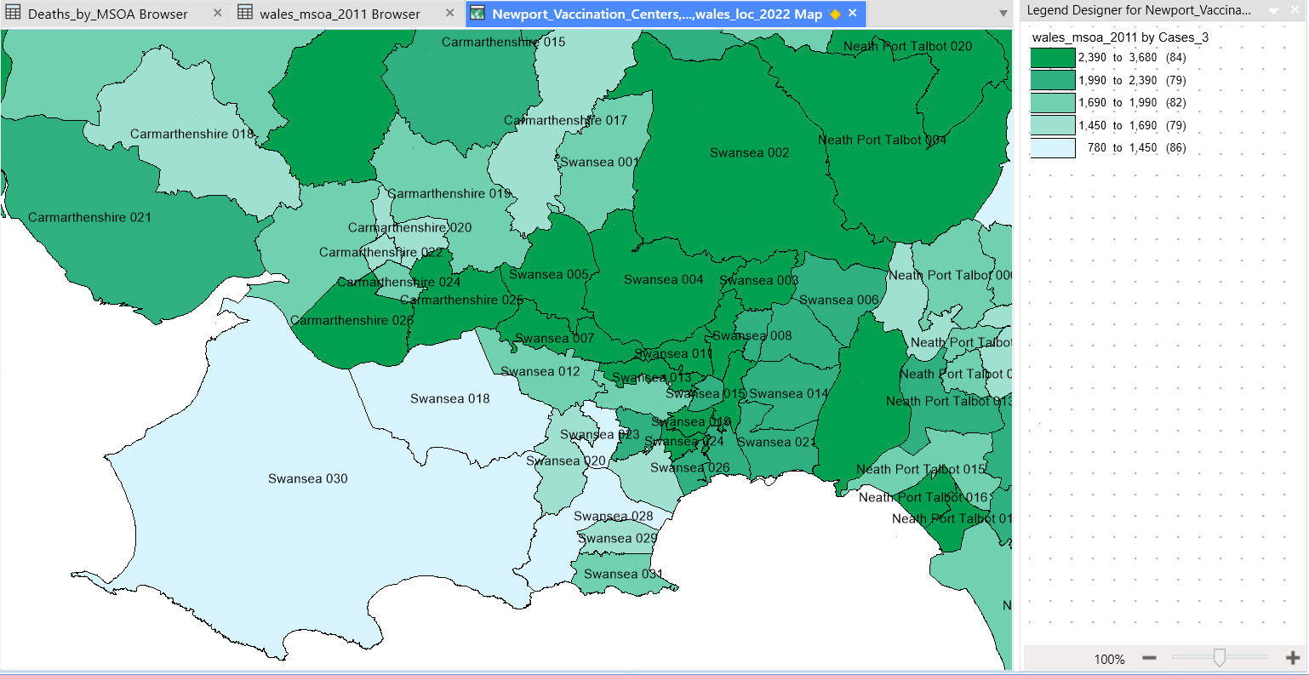
Figure 20 - Thematic Map of COVID-19 Infection Rates by MSOA for Swansea
Description of the Map: The distribution and intensity of COVID-19 cases across Wales are graphically represented by a thematic map of COVID-19 infection rates, which is then broken down by MSOA for Newport and Swansea. It employs a colour gradient to represent the various densities of infection rates, from low to high. Areas with greater infection rates are represented by lighter tints or colours.
Interpretation of Infection Rate Levels: Darker colours on the themed map denote locations with greater infection rates, which are organised by local authority and MSOA. These regions are probably where the virus spread most widely, possibly indicating greater risk factors and insufficient control methods.

Thematic Map Overlay
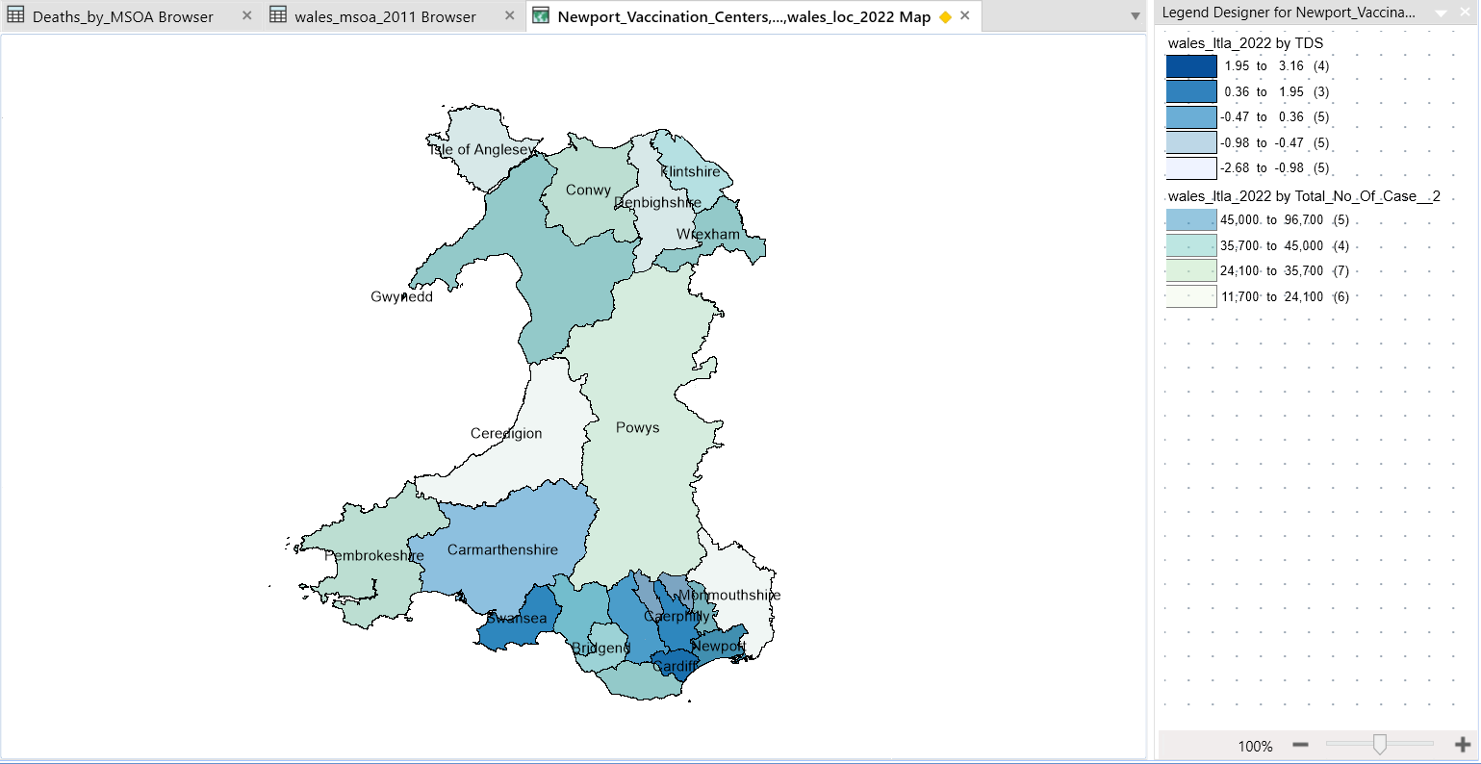
Figure 21 - Thematic Map Overlay for wales by LA
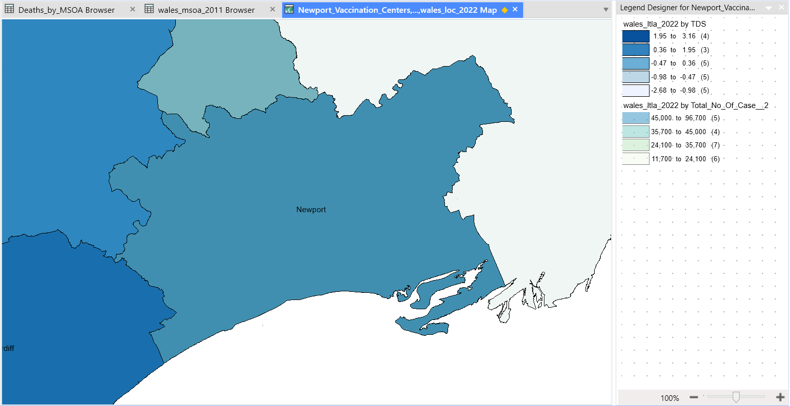
Figure 22 - Thematic Map Overlay by LA for Newport
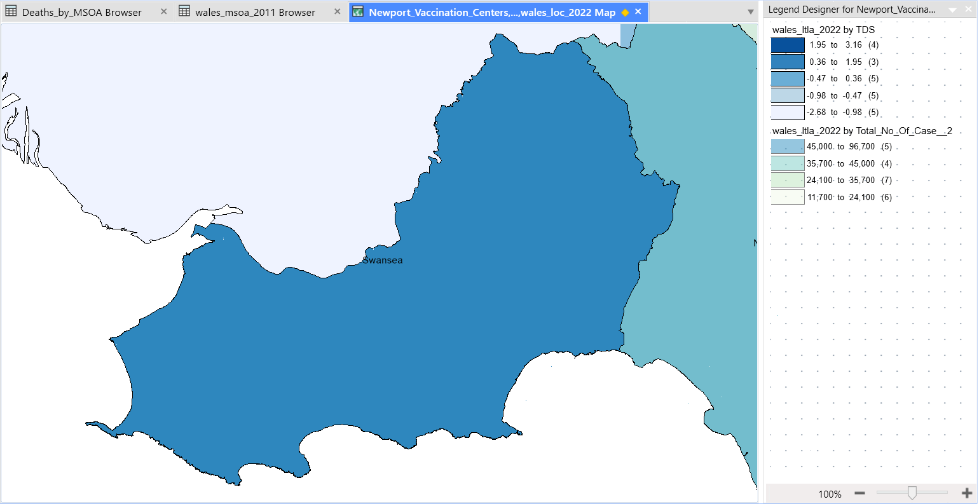
Figure 23 - Thematic Map Overlay by LA for Swansea
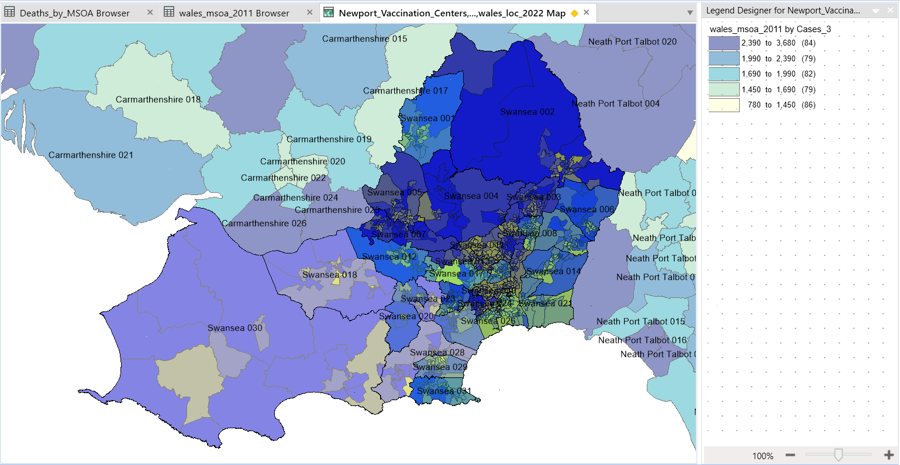
Figure 24 - Thematic Map Overlay by LSOA and MSOA for Newport
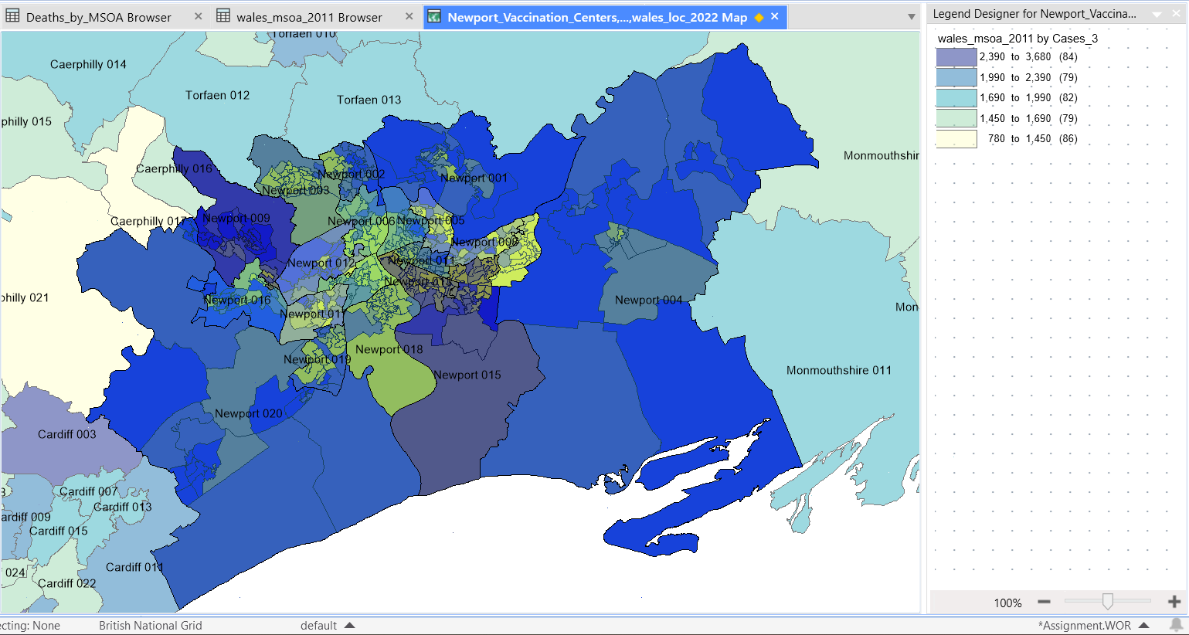
Figure 25 - Thematic Map Overlay by LSOA and MSOA for Swansea
Description of the Map Overlay: The destitution map and the COVID-19 infection rate map of Wales by LA are combined in the first two themed map overlays. The other two maps depict the deprivation according to the LSOA and Covid 19 MSOA statistics. presenting a visual representation of the relationship between poverty and infection rates. The two variables may be directly compared using this map, and any spatial patterns can be found. The second map can help us imagine what would have happened if we had the same datasets, but it does not accurately depict what has occurred as a result of LSOA or MSOA.
Analysis of the Correlation: It is clear from examining the overlay map that the locations with the greatest incidence of COVID-19 infection by local authority also have the highest levels of deprivation. Due to this geographical association, it appears that COVID-19 infection rates and deprivation levels are correlated.

Discussion:
Correlation between Deprivation and COVID-19 Infection Rates: The idea that locations with higher degrees of deprivation have higher infection rates is supported by the observed link between deprivation and COVID-19 infection rates. The overlay map offers compelling visual proof of this connection, demonstrating that socio-economic variables influence the propagation and effects of the virus.

Potential Explanations for the Correlation

Socioeconomic Factors: Limited access to healthcare, cramped living situations, and a higher frequency of comorbidities are frequently linked to higher degrees of deprivation. These elements may enhance people in underprivileged communities' susceptibility to COVID-19.

Living Conditions and Crowding: Greater population density and overcrowding in deprived regions can contribute to the fast spread of infectious illnesses. Social distance is difficult because of the close quarters and constrained personal space, which raises the danger of transmission.

Behavioural Factors: Socioeconomic disadvantage can affect people's behaviour, especially their willingness to follow safety precautions including wearing masks, washing their hands, and avoiding social contact. Lower adoption of these behaviours might be caused by a lack of resources and understanding, which would exacerbate the virus's transmission.

Conclusion:
Summary of Findings: Greater degrees of disadvantage are clearly correlated with higher infection rates, according to research on the association between deprivation and COVID-19 infection rates in the Newport and Swansea areas. This association is supported visually by the theme maps and the overlay map.
Confirmation of the Hypothesis: The findings support the basic theory that greater Townsend Deprivation Index-measured deprivation levels will correspond to higher frequencies of COVID-19 infection. The regional association between poverty and infection rates is vividly shown by the themed map overlay.

Hypothesis 2:
The Link between Elderly Population and Death Rates in Swansea and Newport
The purpose of this hypothesis is to look at the relationship between the COVID-19 death rates in the cities of Swansea and Newport and the percentage of the senior population. The distribution of the old population and the COVID-19 mortality rates were shown using different thematic maps, which were then overlaid to look for any patterns or relationships. The evidence strongly supports Hypothesis 2 by showing a connection between a larger percentage of older people and higher COVID-19 mortality rates.

Methodology:
Data Collection: This study's data came from a variety of sources. Data on the population's age distribution was taken from infuse2011 for the Swansea and Newport areas. To further analyse mortality rates, COVID-19 death rate data was obtained from government sources and PHW.
Population Proportion: Based on demographic information from Infuse UK Data Services 2011, the population proportion was calculated, considering the number of people 65 and older in each geographic region.
COVID-19 Death Rate Information: I was able to view Newport and Swansea when I zoomed into the map of Wales after obtaining COVID-19 death rate information from the Office for Nation Statistics (ONS) and public Health Wales. The data comprises the total number of COVID-19 fatalities that have been verified, allowing death rates to be calculated.

The percentage of the aged population and the COVID-19 mortality rate statistics were shown geographically on a thematic map, with various hues or tints denoting various percentages of the elderly population and death rates, respectively.
Elderly Population and COVID-19 Death Rate Maps Overlayed:
The thematic maps depicting the older population and death rates were superimposed in order to analyse the relationship between the fraction of the elderly population and COVID-19 mortality rates. The association between the old population and the COVID-19 death rates in the Swansea and Newport areas is visually shown by this overlay map.

Results:
Thematic Map of the Elderly Population:
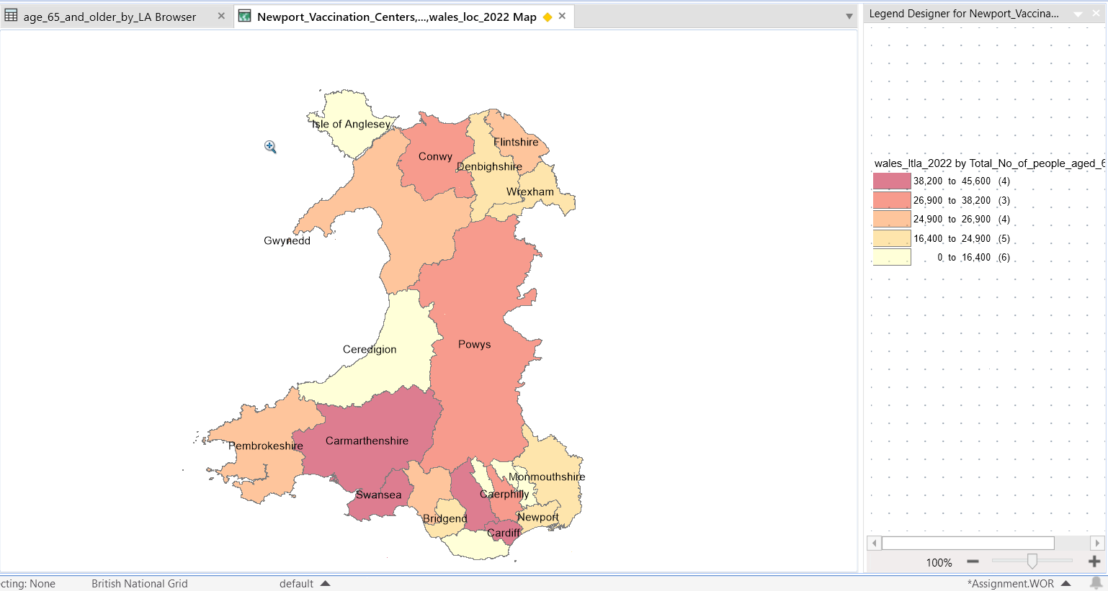
Figure 26 - Thematic Map of the Elderly Population by LA for Wales
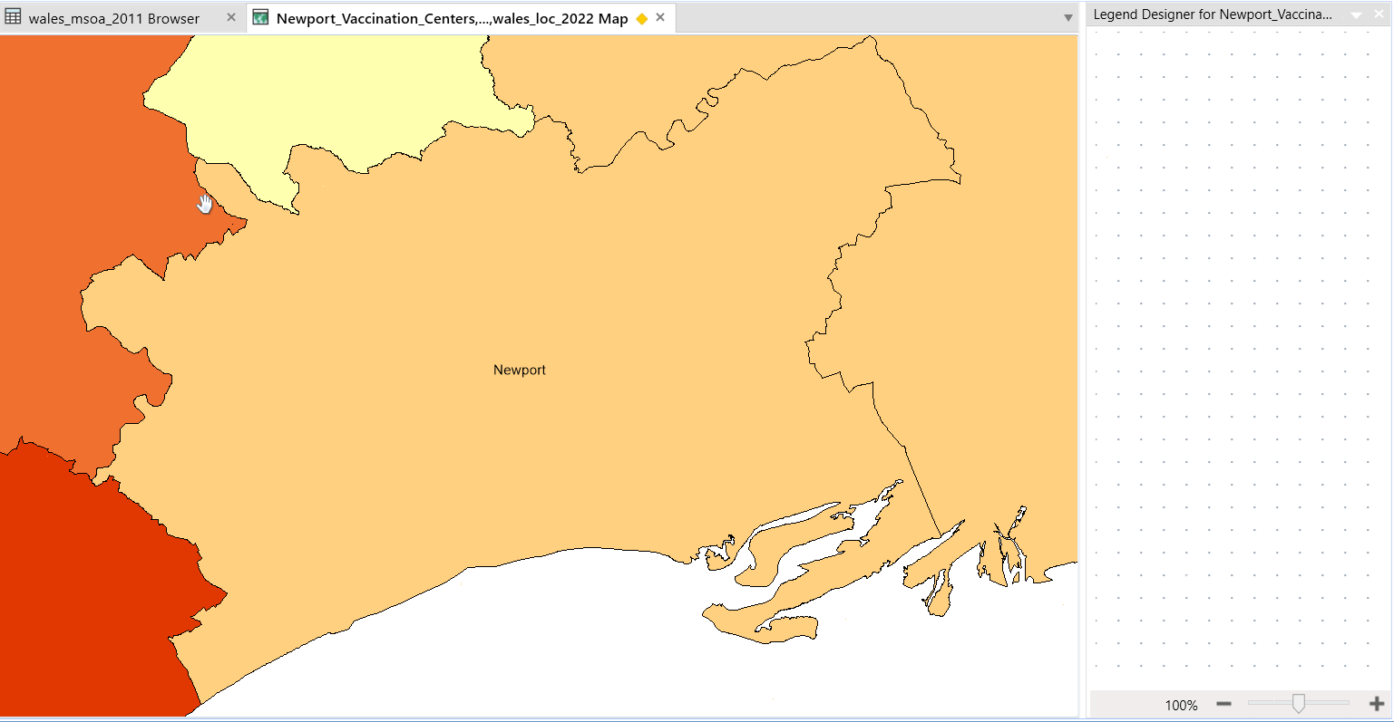
Figure 27 - Thematic Map of the Elderly Population by LA for Newport
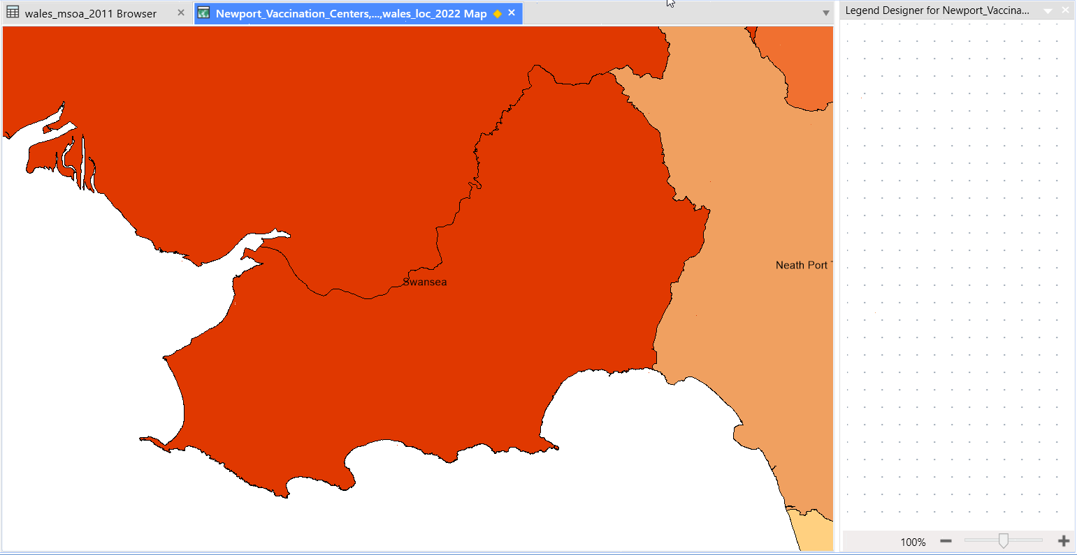
Figure 28 - Thematic Map of the Elderly Population by LA for Swansea
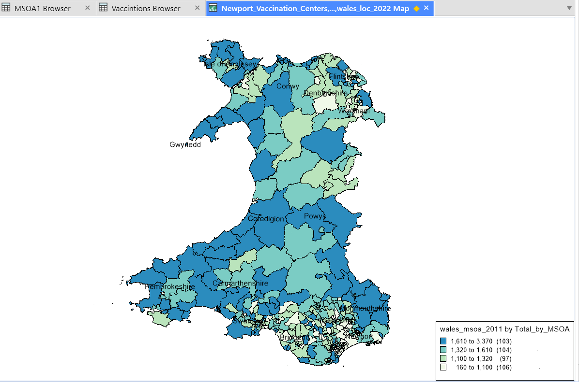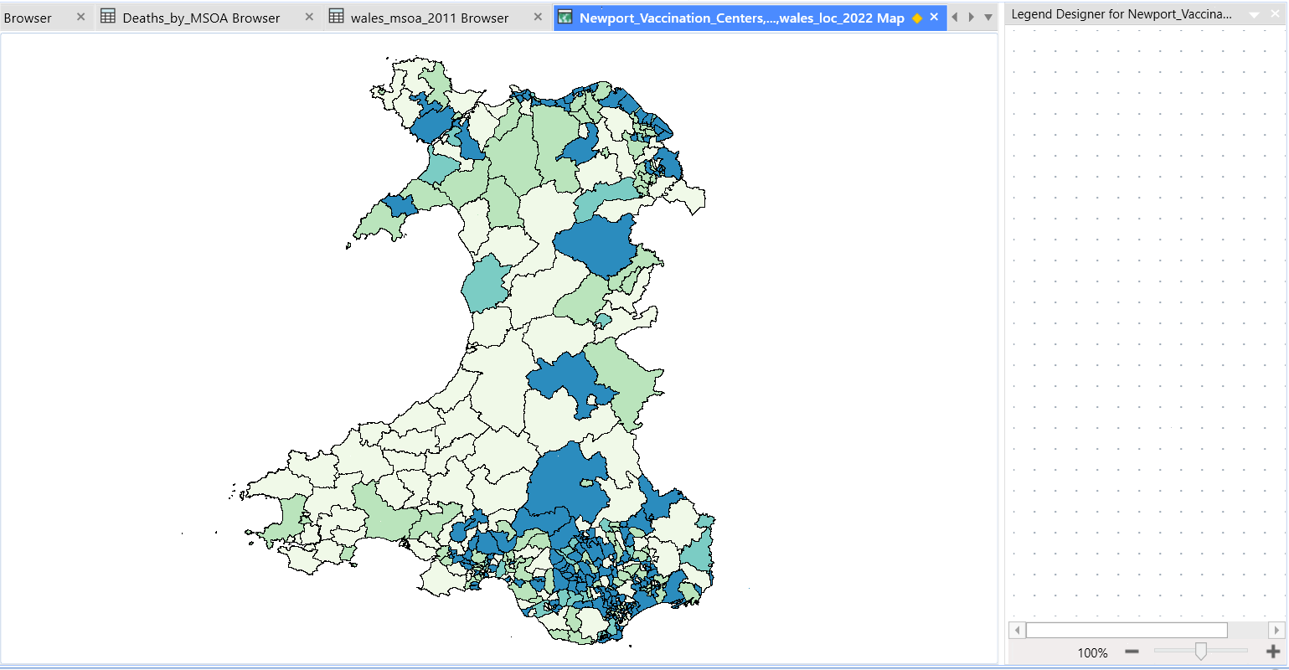
Figure 29 - Thematic Map of the Elderly Population by MSOA for Wales
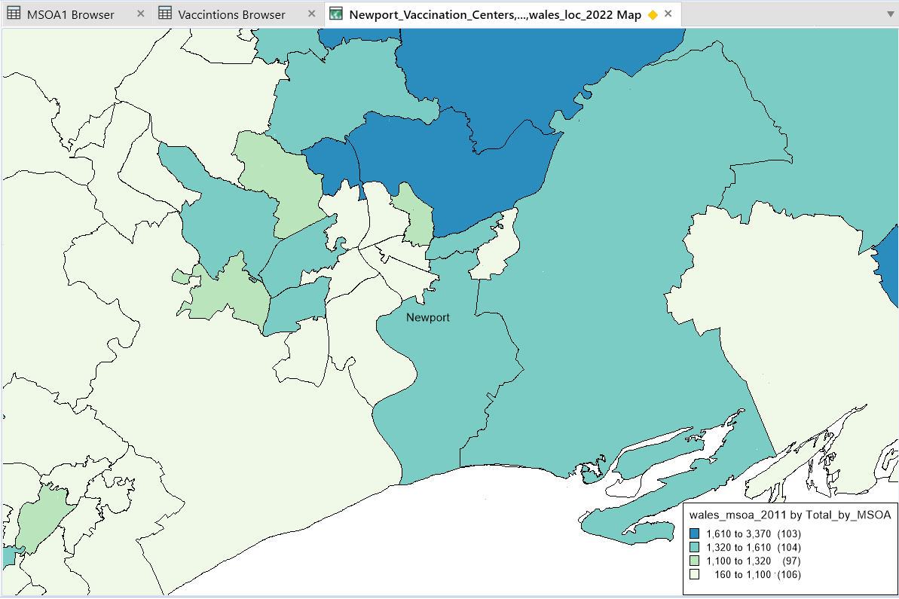
Figure 30- Thematic Map of the Elderly Population by MSOA for Newport
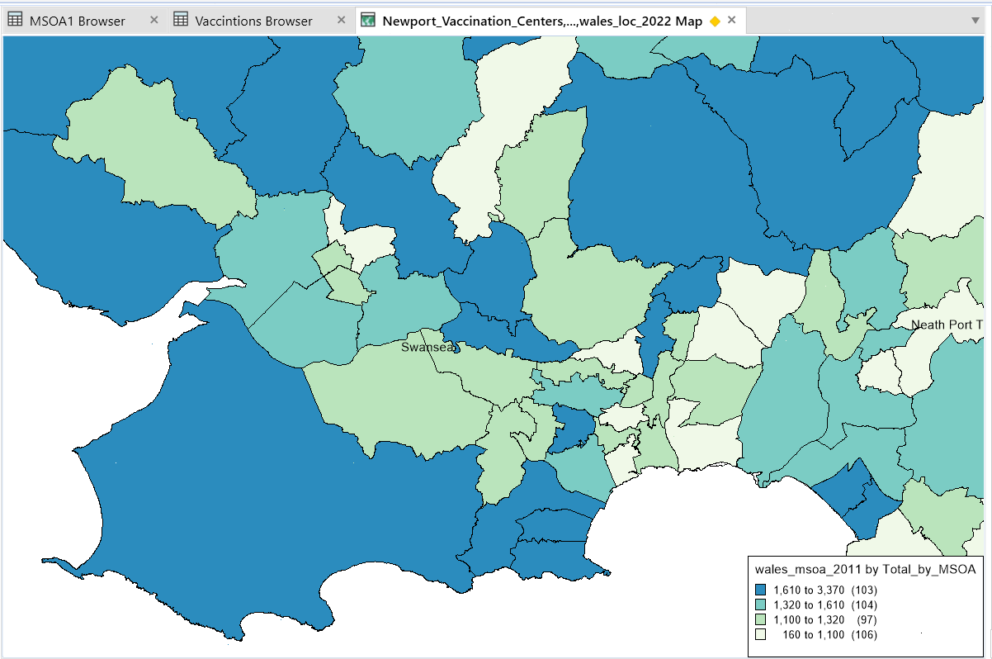
Figure 31- Thematic Map of the Elderly Population by MSOA for Swansea
Description of the Map: The distribution of people 65 and older in the Swansea and Newport areas is depicted visually on the thematic map of the senior population. It uses a colour gradient to represent the various densities of the senior population, from low to high. Greater tones indicate places where the elderly population is more prevalent.
Interpretation of Levels of the Elderly Population: According to the themed map, places with deeper colours have a larger percentage of older people living there. Compared to other communities in the region, these localities most likely have a higher proportion of elderly people.

Thematic Map of COVID-19 Death Rates:
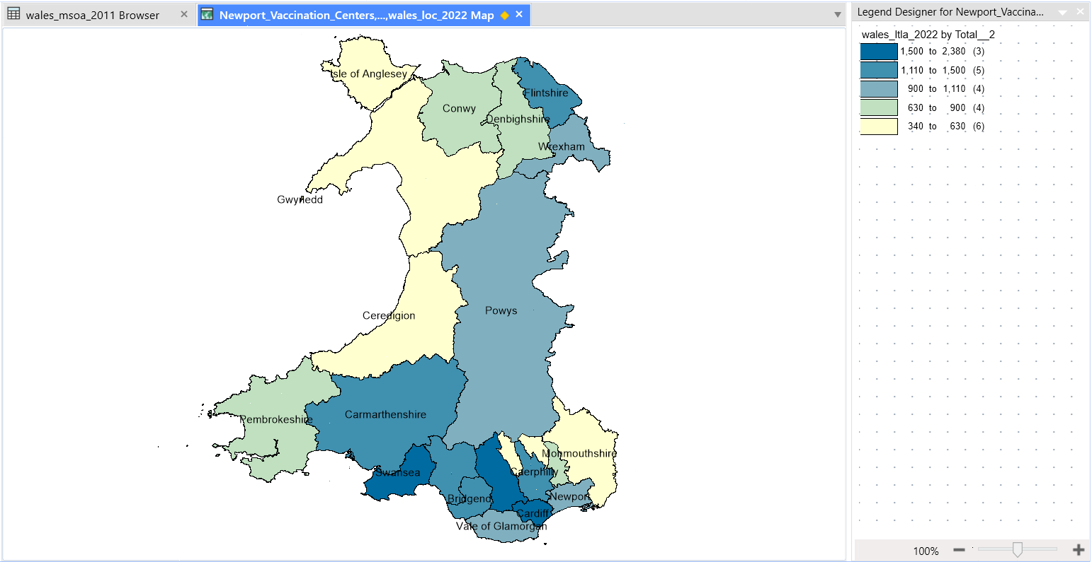
Figure 32 - Thematic Map of COVID-19 Death Rates by LA for Wales
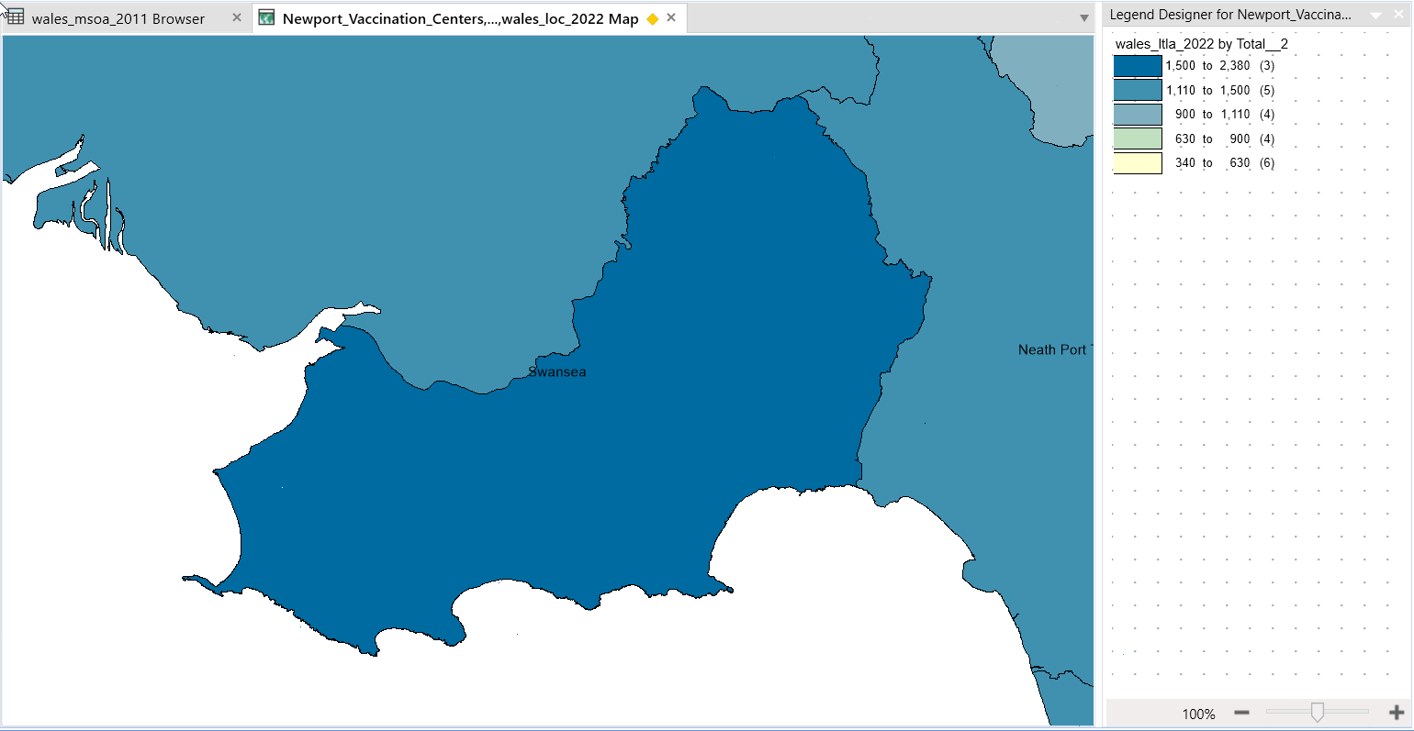
Figure 33 - Thematic Map of COVID-19 Death Rates for Swansea
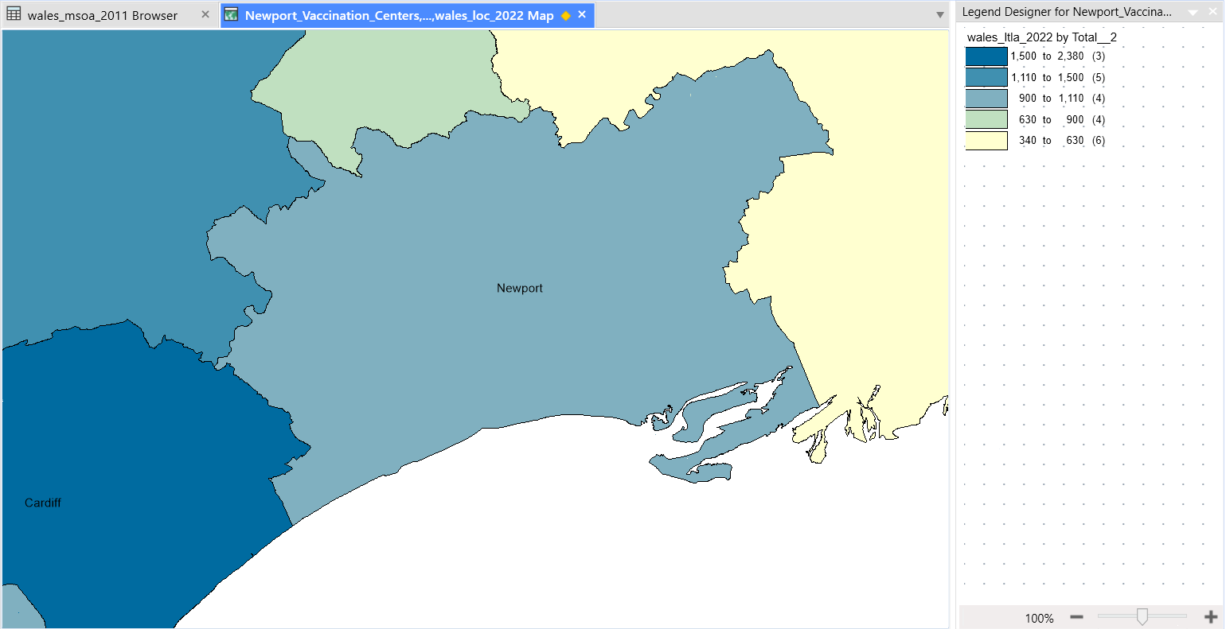
Figure 34 - Thematic Map of COVID-19 Death Rates by LA for Newport
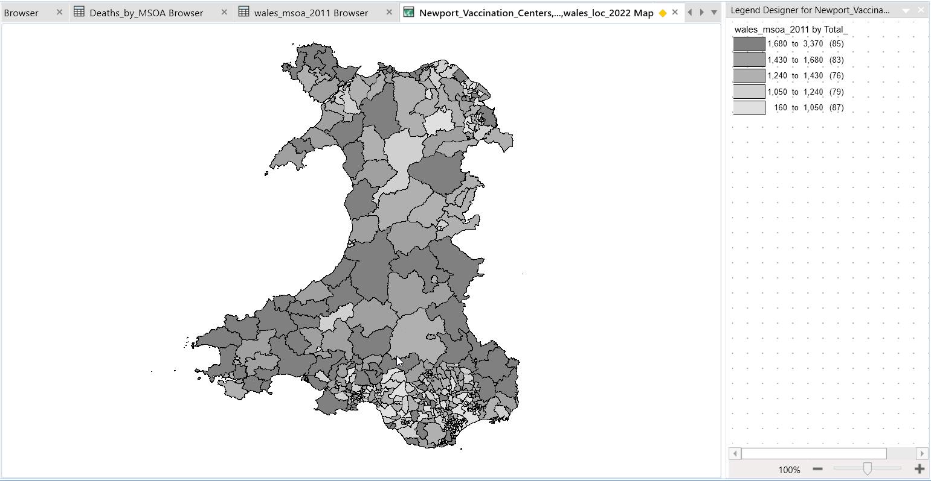
Figure 35 - Thematic Map of COVID-19 Death Rates by MSOA for Wales
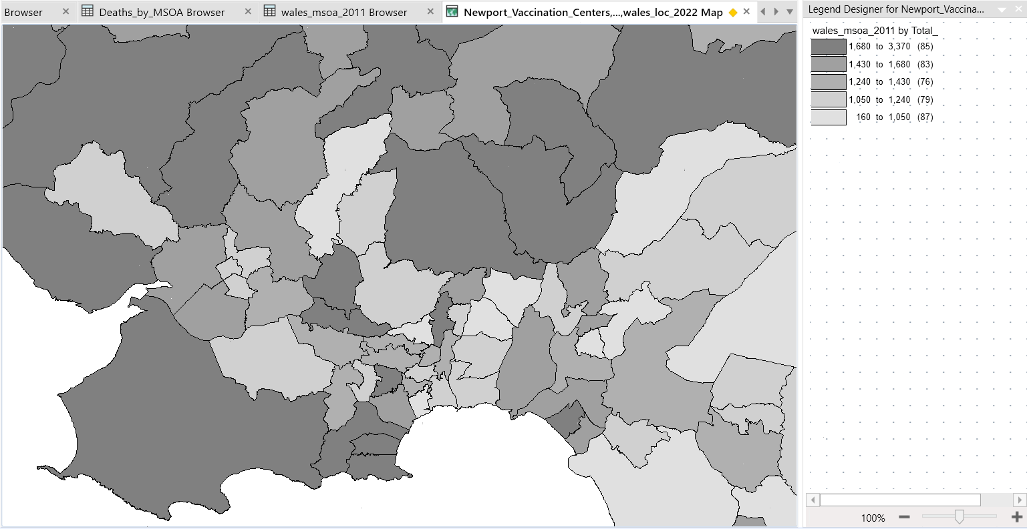
Figure 36- Thematic Map of COVID-19 Death Rates by MSOA for Swansea
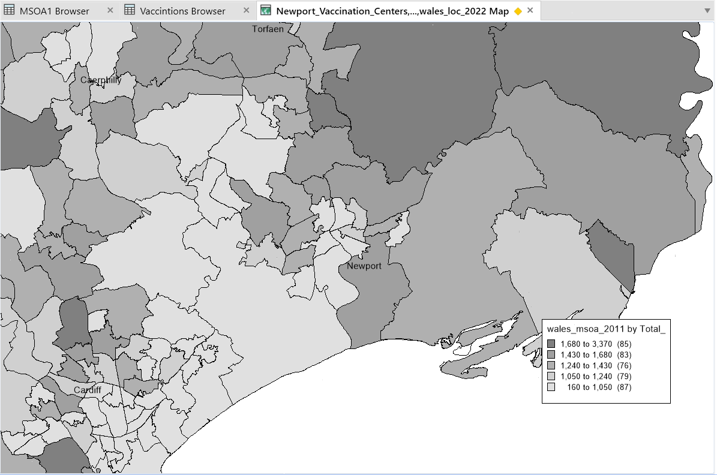
Figure 37 - Thematic Map of COVID-19 Death Rates by MSOA for Newport
Description of the Map: .The distribution and severity of COVID-19 mortality across the Swansea and Newport areas are depicted visually in the thematic map of COVID-19 death rates. It employs a colour gradient to represent the various densities of death rates, from low to high. Areas with greater death rates are represented by lighter tints or colours.
Interpretation of Levels of Death Rate: Darker colours on the themed map indicate locations with greater mortality rates as a result of COVID-19, and also shows areas with higher death rates by local authority. Because of their greater likelihood of COVID-19-related mortality, some regions may be more vulnerable or have other contributing variables.

Thematic Map Overlay:
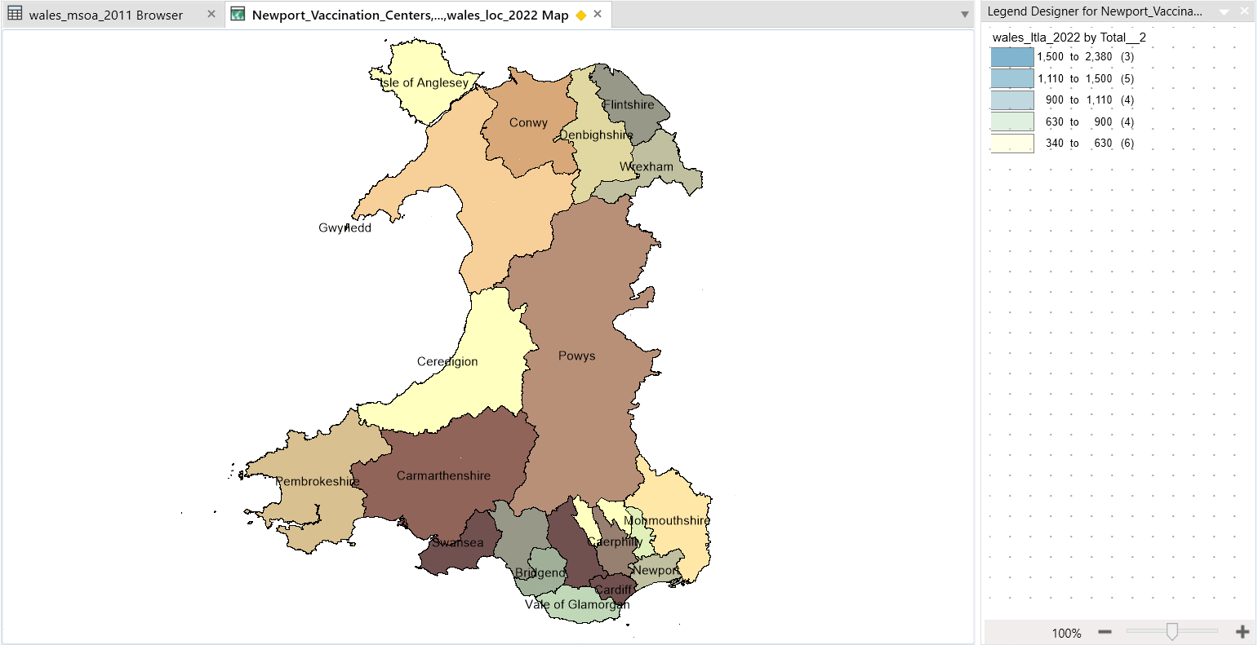
Figure 38 - Thematic Map Overlay by LA for Wales
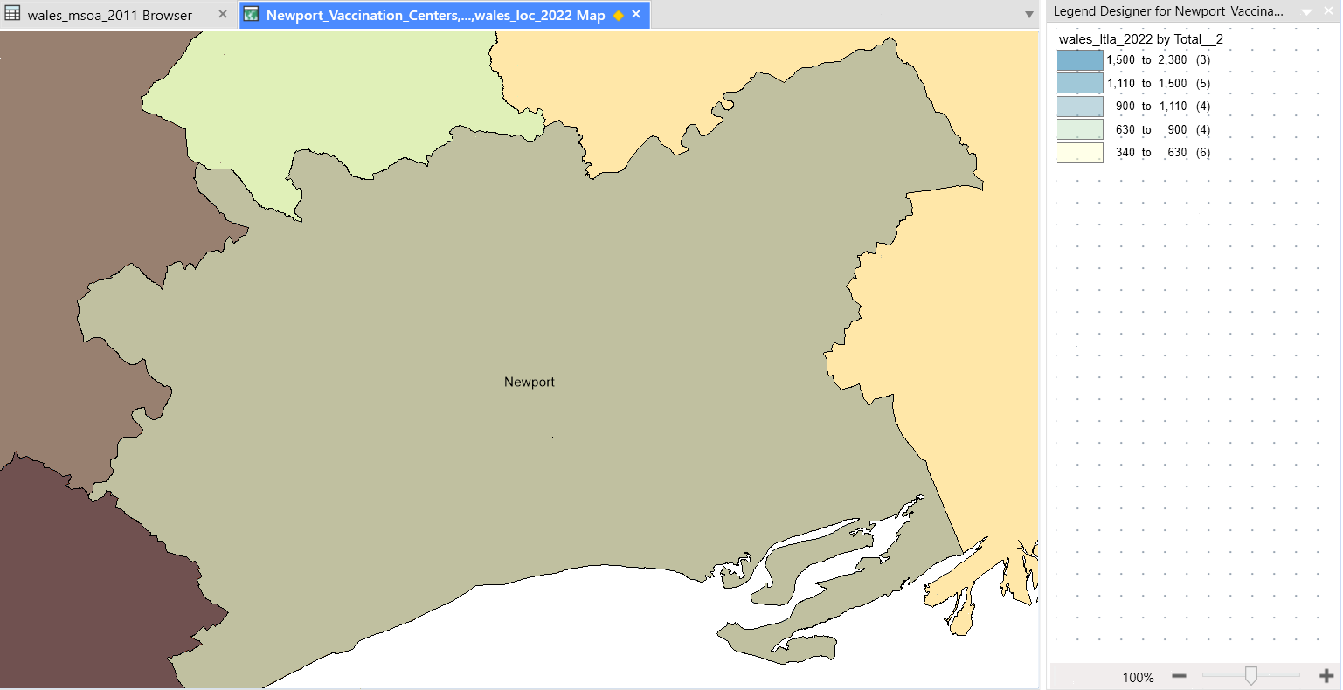
Figure 39 - Thematic Map Overlay by LA for Newport
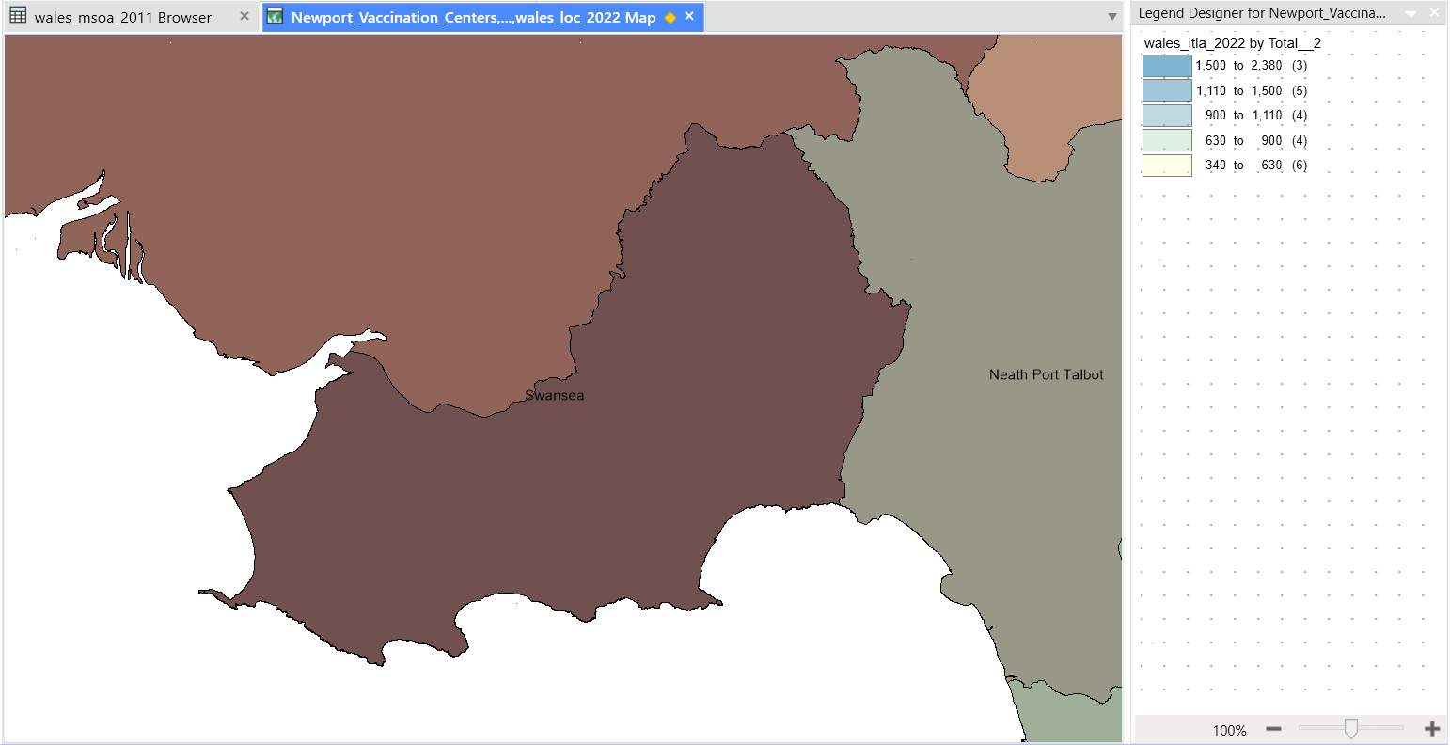
Figure 40 - Thematic Map Overlay by LA for Swansea
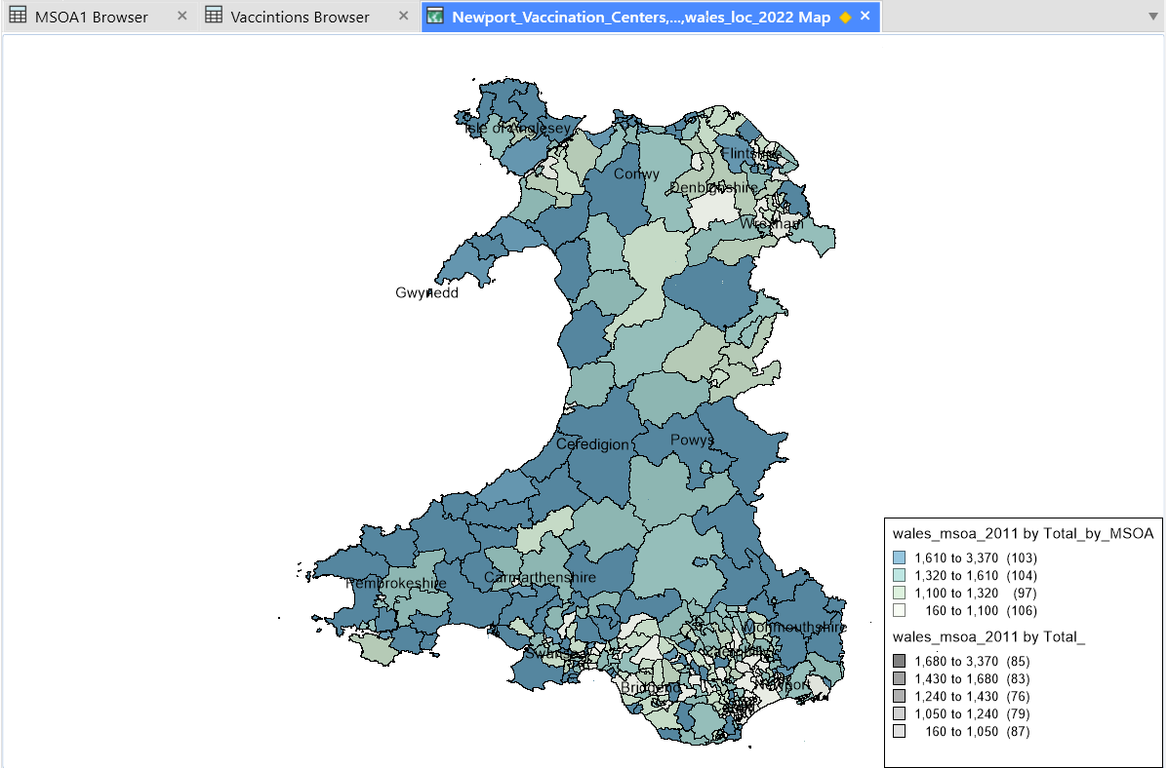
Figure 41 - Thematic Map Overlay by MSOA for Wales
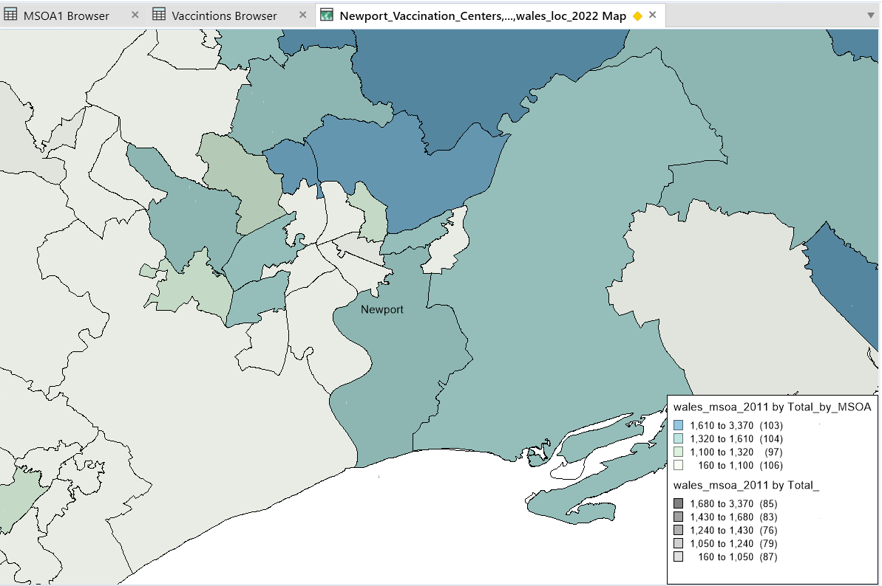
Figure 42 - Thematic Map Overlay by MSOA for Newport
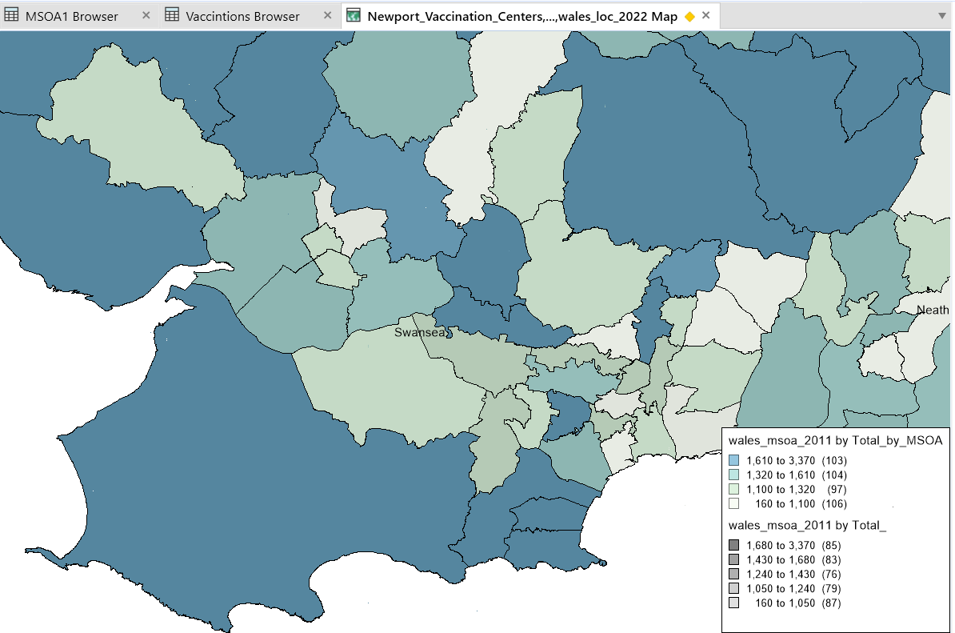
Figure 43 - Thematic Map Overlay by MSOA for Swansea
Description of the Map Overlay: The COVID-19 death rate map and the elderly population map are combined in a themed map overlay to show the relationship between death rates and the older population fraction. The two variables may be directly compared using this map, and any spatial patterns can be found.

Analysis of the Correlation: It is clear from examining the overlay map that regions with the highest local authority COVID-19 death rates also have larger proportions of older people living there. This geographical association implies a link between greater COVID-19 mortality rates and a higher percentage of old people in the population.

Discussion:
Correlation between Elderly Population and COVID-19 Death Rates:
Hypothesis 2 is supported by the observed association between COVID-19 mortality rates and the proportion of elderly population, which shows that locations with a larger number of senior people also have higher death rates. The overlay map offers compelling visual proof of this link, indicating that the age distribution of the population has a big impact on the virus's effects.
Potential Explanations for the Correlation:
Age-related Vulnerability: Due to age-related physiological changes and a larger frequency of underlying medical disorders, elderly people are more vulnerable to severe sickness and COVID-19 consequences. The higher death rates seen in locations with a higher percentage of older people can be attributed to this susceptibility.
Healthcare Accessibility: Areas having a larger percentage of senior citizens may experience problems with access to and availability of healthcare resources. The prompt discovery and management of COVID-19 cases may be impacted by limited access to healthcare services and specialised care for the elderly, thereby increasing death rates.
Community Settings and Care Facilities: Care facilities or communal living situations may be more prevalent in areas with a higher percentage of older residents. Such conditions can encourage the virus' quick transmission among weak people, increasing the fatality rate..
Conclusion:
Summary of Findings: According to an analysis of the association between COVID-19 death rates and the percentage of the old population in the Swansea and Newport areas, there is a direct correlation between the two. This association is supported visually by the theme maps and the overlay map.
Confirmation of Hypothesis 2: The analysis of the association between the percentage of the old population and the COVID-19 death rates in the Swansea and Newport areas shows a definite correlation between a larger percentage of the elderly population and a higher death rate. Thematic maps and an overlay map offer visual proof of this association.

Hypothesis 3:
Is there a correlation between vaccination rates, Elderly Population, and the availability of vaccination centres?
The purpose of this Hypothesis is to look at the relationship between vaccination rates, the elderly population, and the availability of vaccination centres. Separate thematic maps were generated to depict vaccination rates, the distribution of the elderly population, and the location of vaccination centres. The maps were then superimposed to look for patterns or relationships. The data show a clear link between greater vaccination rates and a higher share of the elderly population, as well as the availability of vaccination clinics in locations with higher vaccination rates. This lends credence to Hypothesis 3, which holds that vaccination rates are impacted by the elderly population and the availability of immunisation clinics.

Methodology:
Data Collection: Data for this study was gathered from a variety of sources. Data on vaccination rates were gathered from the appropriate health authorities or government organisations. Census data was used to obtain population statistics, especially the proportion of the elderly population (infuse2011). Both the Swansea Bay and Aneurin Bevan health boards provided information on vaccination clinic locations.

Vaccination Rates: Immunization rate statistics indicates the proportion of the population that has gotten at least one dose or has finished the whole vaccination regimen.

Older Population: The proportion of the senior population refers to the number of people in a given age group, often 65 and up. This demographic information aids in identifying places with a larger population of elderly people.

Vaccination Centre Locations: Understanding the accessibility and availability of vaccination services is dependent on the location of vaccination centres. Mapping the spread of these centres aids in determining the link between immunisation rates and the elderly population.

Thematic Map Creation: The vaccination rate data, older population distribution, and vaccination centre locations were spatially represented, using different colors or symbols to indicate variations in each variable.

Overlaying the Maps: Thematic maps depicting these data were superimposed to examine the relationship between vaccination rates, the elderly population, and the availability of vaccination centres. This overlay map depicts the link between vaccination rates, the older population, and the availability of vaccination centres in Newport and Swansea.

Results:
Thematic Map of Vaccination Rates:
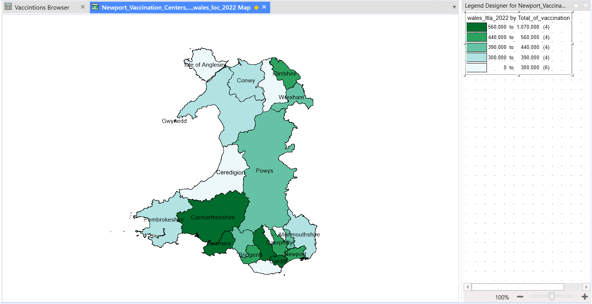
Figure 44 - Thematic Map of Vaccination Rates by LA for Wales
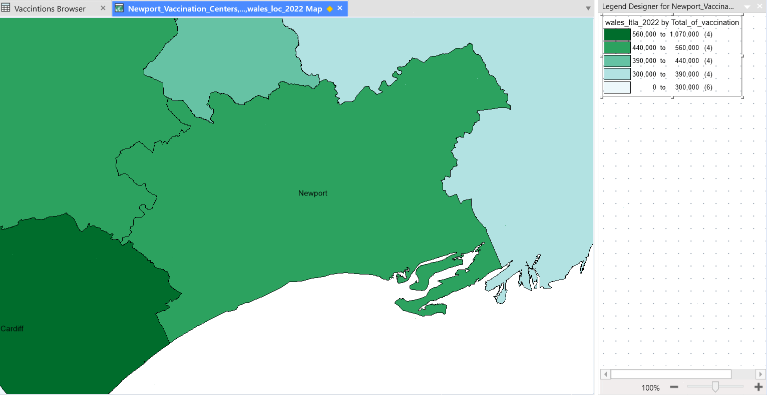
Figure 45 - Thematic Map of Vaccination Rates by LA for Newport
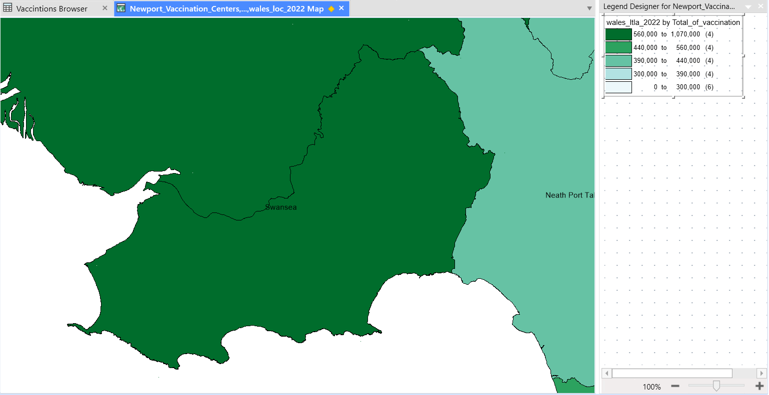
Figure 46 - Thematic Map of Vaccination Rates by LA for Swansea
Description of the Map: The vaccination rate thematic map depicts the distribution and intensity of immunisation rates in Newport and Swansea. It employs a colour gradient to represent differing degrees of vaccination rates. Greater-coloured zones have higher immunisation rates.
Vaccination Rate Levels Interpretation: Areas with brighter colours or represent places with better vaccination rates, according to the theme map. These places are more likely to have a higher proportion of vaccinated people, showing that vaccination efforts have been successful.

Thematic Map of Older Population:
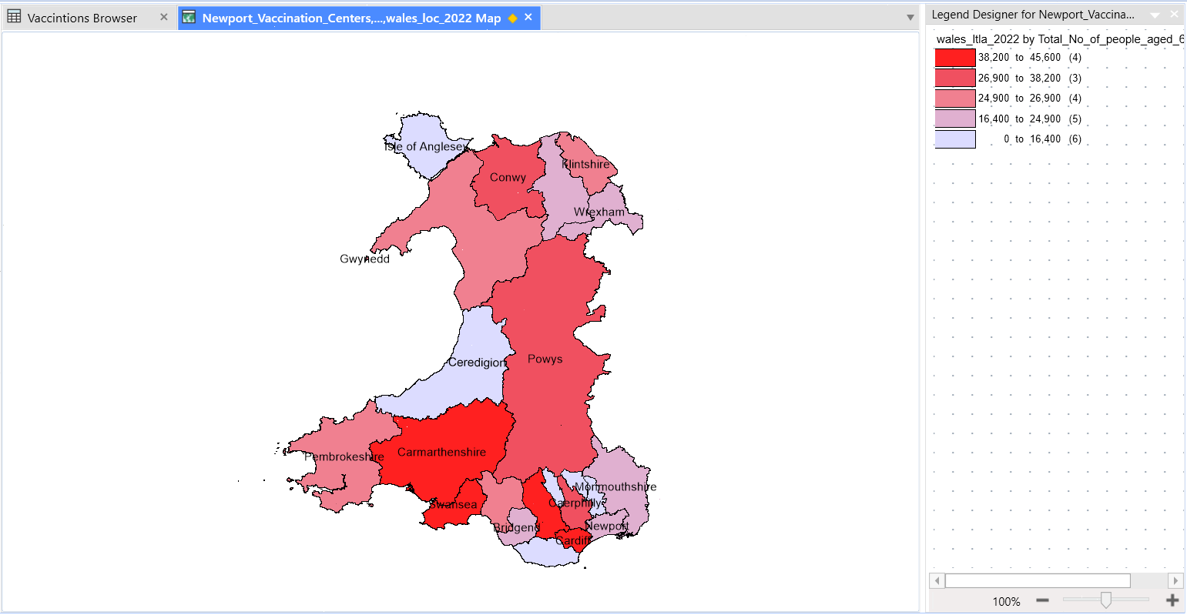
Figure 47 - Thematic Map of Older Population by LA for Wales
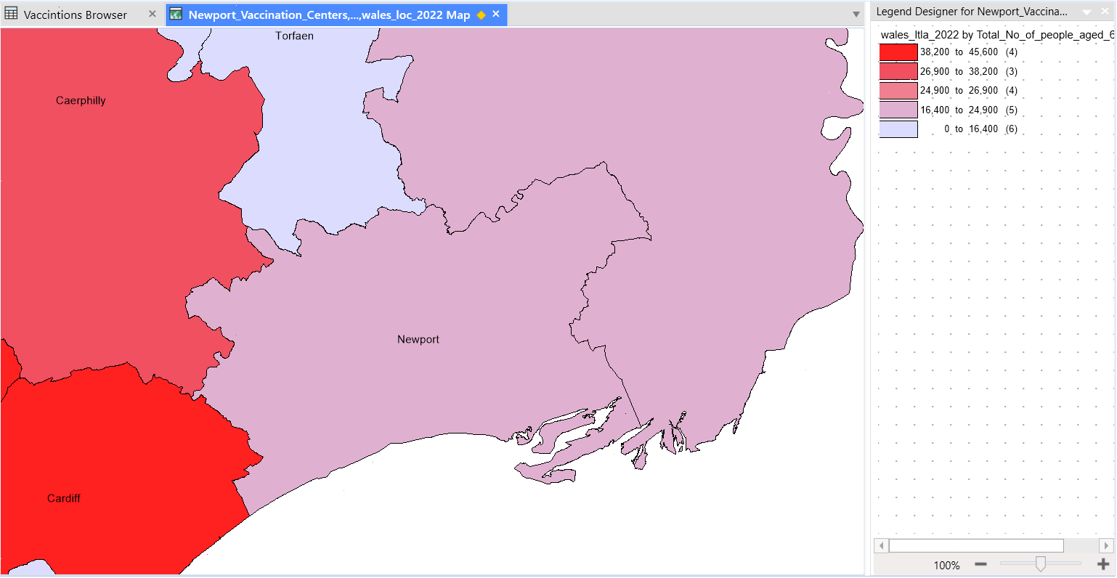
Figure 48 - Thematic Map of Older Population by LA for Newport
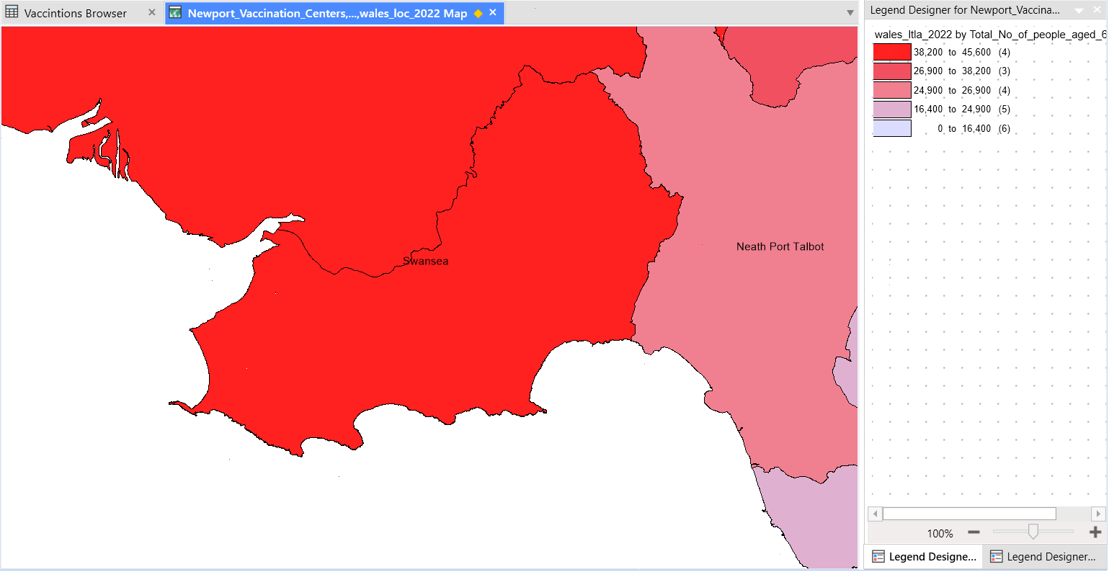
Figure 49 - Thematic Map of Older Population by LA for Swansea

Description of the Map: The thematic map of the older population depicts the distribution and concentration of older people in Newport and Swansea. It use colour gradients to represent the varied degrees of the elderly population. Larger-coloured locations have a higher proportion of senior people.
Levels of the Elderly: Interpretation The themed map shows areas with brighter colours suggesting places with a higher concentration of elderly people. These places are expected to have a higher proportion of elderly people.

Thematic Map of Vaccination Centre Locations:
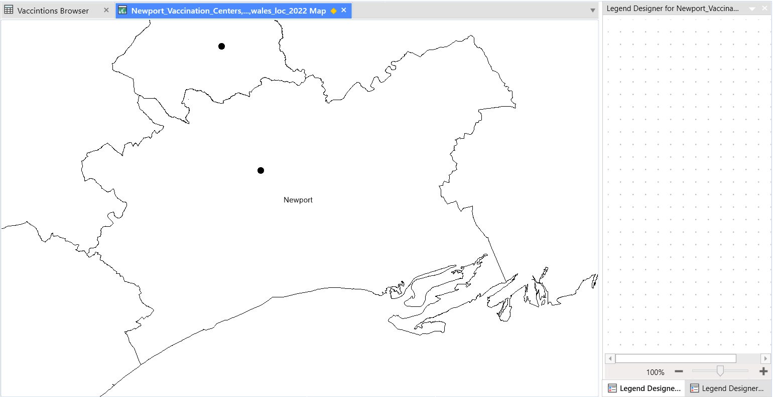
Figure 50 - Thematic Map of Vaccination Centre Locations by LA for Newport
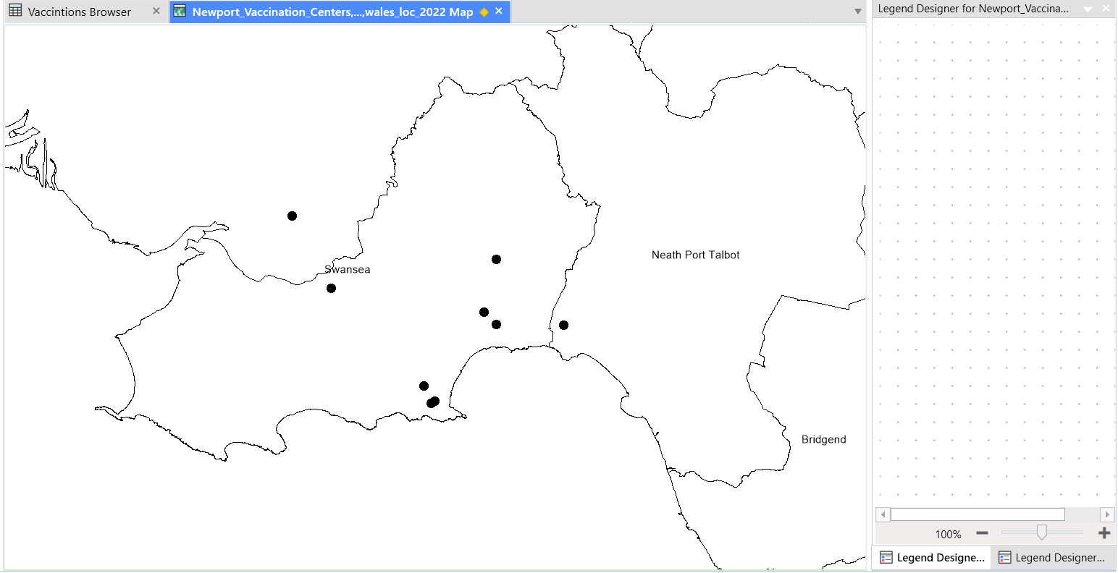
Figure 51 - Thematic Map of Vaccination Centre Locations by LA for Swansea
Description of the Map: The thematic map of vaccination centre sites depicts the geographic distribution of vaccination centres in Newport and Swansea. It employs coloured icons to pinpoint the exact position of each vaccination centre in the two locations I was comparing.
Locations of Vaccination Centres Interpretation: The thematic map depicts the geographic distribution of vaccination clinics, allowing for an assessment of their coverage and accessibility in various places.

Thematic Map Overlay:
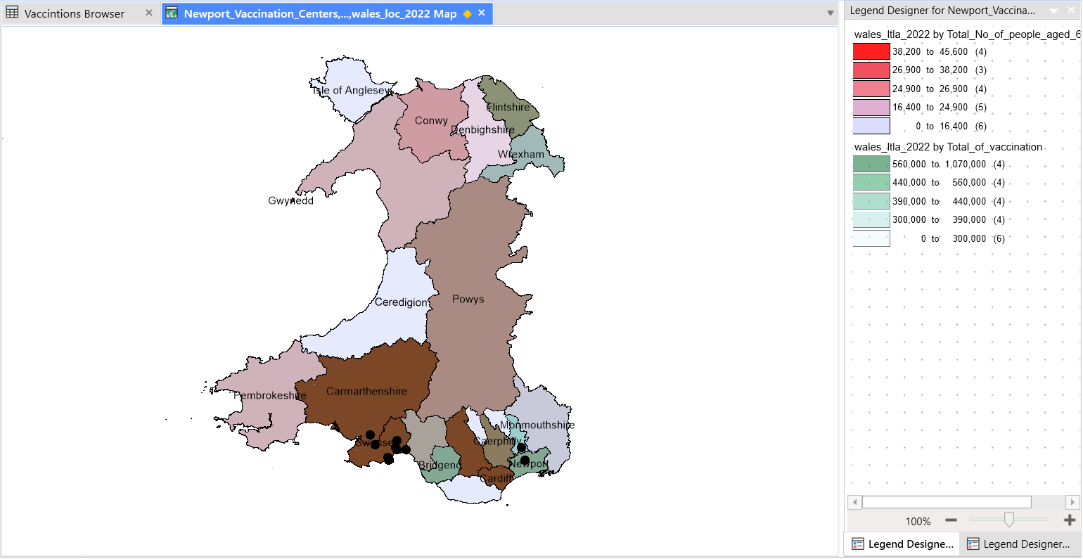
Figure 52 - Thematic Map Overlay by LA for Wales without vaccination centres
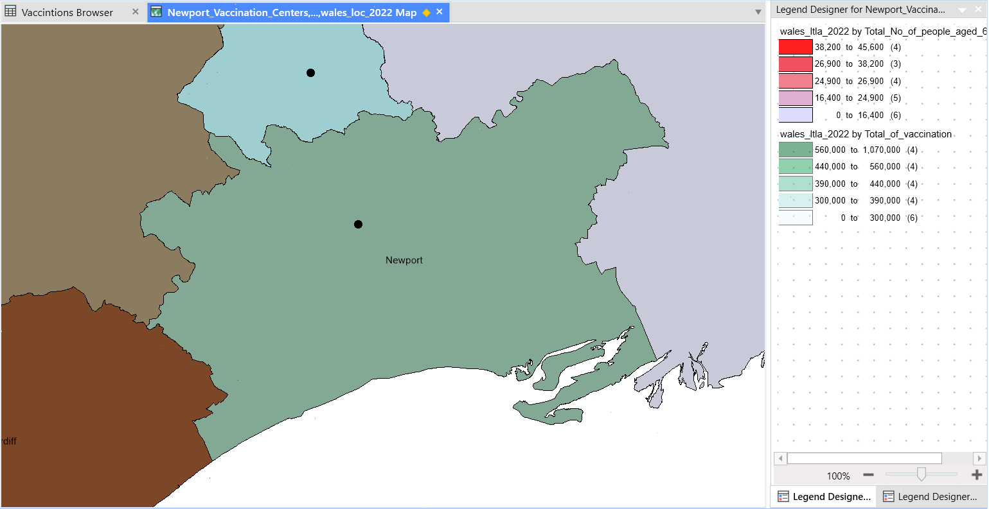
Figure 53 - Thematic Map Overlay by LA for Newport
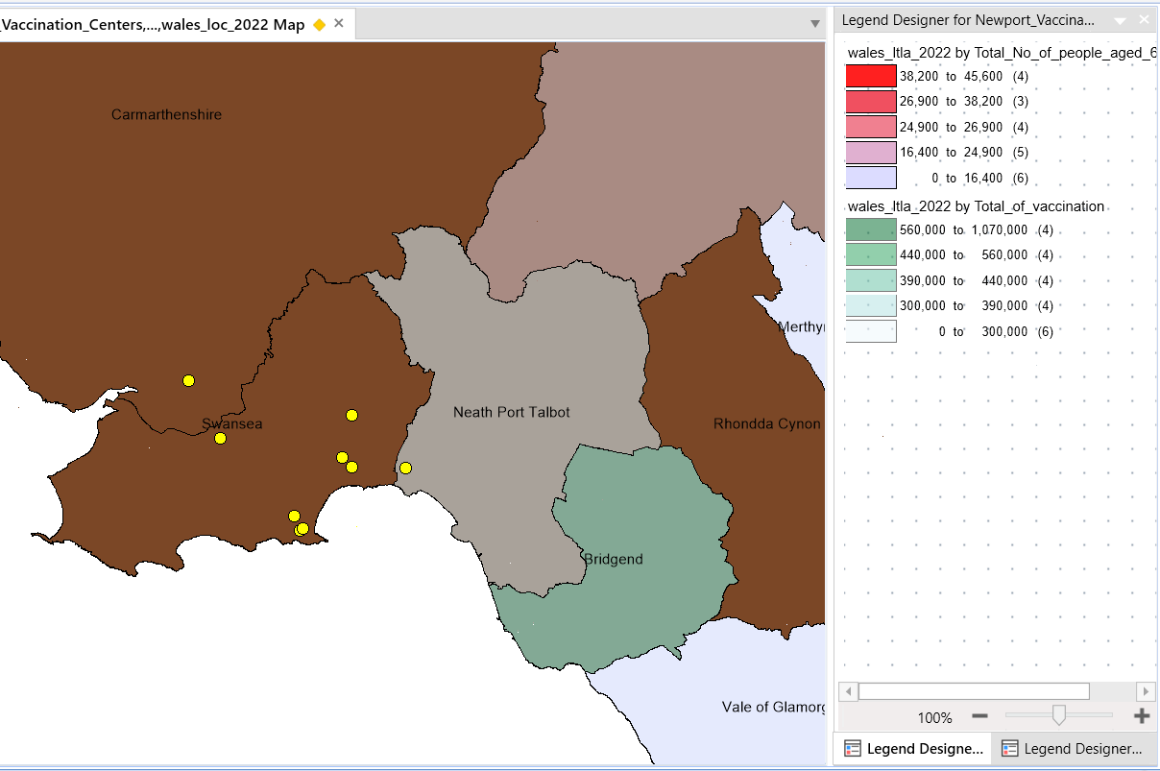
Figure 54 - Thematic Map Overlay by LA for Swansea
Description of the Map Overlay: The thematic map overlay includes the vaccination rate map, the older population map, and the vaccination centre placement map, graphically displaying the relationship between vaccination rates, the older population, and vaccination centre availability. This map enables direct comparison of data as well as discovery of any geographical trends.

Analysis of the Correlation: When the overlay map is compared, it is clear that places with greater vaccination rates correspond to regions with a higher number of elderly people. Furthermore, the availability of vaccination centres corresponds to locations with greater vaccination rates. This geographical association shows a link between vaccination rates, the elderly, and the availability of vaccination centres.

Discussion:
Correlation between Vaccination Rates, Older Population, and Vaccination Centre Availability:
The observed connections confirm Hypothesis 3, which states that greater vaccination rates are connected with a higher proportion of older people and the number of vaccination centres. The overlay map visualises these associations, implying that the older population and vaccination centre availability influence vaccination rates.

Potential Explanations for the Correlations:
Higher Vaccination Rates and Older Population: Because of their heightened sensitivity, the elderly are often prioritised for COVID-19 immunisation. As a result, localities with a higher number of elderly people are more likely to have higher vaccination rates, as vaccination efforts target these populations.
Availability of Vaccination Centres: The existence of vaccination centres in certain localities helps to increased immunisation rates in such areas. These centres provide individuals with accessible and convenient facilities to obtain immunizations, leading in higher uptake in certain areas.

Implications for Policy and Interventions:
The findings emphasise the need of directing vaccination efforts toward locations with a larger population of elderly people and guaranteeing the presence of vaccination centres in those areas. Immunization rates can be increased by prioritising the elderly and establishing vaccination centres in easily accessible areas.

Conclusion:
Summary of Findings: An examination of the relationship between vaccination rates, the elderly population, and the availability of vaccination centres indicates a definite link. The theme maps and overlay map give visual evidence to establish the link between greater vaccination rates, a higher share of the elderly population, and the number of vaccination centres.
Confirmation of Hypothesis 3: The findings support Hypothesis 3, which states that vaccination rates are related to the elderly population and the availability of vaccination centres. The geographical correlations between these variables are clearly illustrated by the overlay map.

References

[1] | Esri, “What is GIS?,” n.d.. [Online]. Available: https://www.esri.com/en-us/what-is-gis/overview. [Accessed 01 June 2023].
[2] | Office for National Statistics (ONS), “Lower Layer Super Output Areas (LSOAs),” n.d.. [Online]. Available: https://www.ons.gov.uk/methodology/geography/ukgeographies/censusgeographies/census2021geographies#:~:text=Lower%20layer%20Super%20Output%20Areas%20(LSOAs). [Accessed 01 June 2023].
[3] | Office for National Statistics (ONS). , “Middle layer Super Output Areas (MSOAs),” n.d.. [Online]. Available: https://www.ons.gov.uk/methodology/geography/ukgeographies/censusgeographies/census2021geographies#:~:text=Lower%20layer%20Super%20Output%20Areas%20(LSOAs). [Accessed 01 June 2023].
[4] | Consumer Data Research Centre , “Output Area Classification (2011),” n.d.. [Online]. Available: https://data.cdrc.ac.uk/dataset/output-area-classification-2011#:~:text=The%202011%20Classification%20for%20Output,the%20country%20with%20similar%20characteristics.. [Accessed 01 June 2023].
[5] | University of Sussex , “Statistics and datasets: UK Data Service,” n.d.. [Online]. Available: https://guides.lib.sussex.ac.uk/c.php?g=655580&p=4607014. [Accessed 01 June 2023].
[6] | UK Data Service , “Infuse,” n.d.. [Online]. Available: https://infuse.ukdataservice.ac.uk/#:~:text=InFuse%20is%20a%20free%20service,UK%202011%20and%202001%20censuses. [Accessed 01 June 2023].
[7] | University Of Bath, “What is DigiMap,” n.d.. [Online]. Available: https://library.bath.ac.uk/digimap. [Accessed 01 June 2023].

