Pamela Sillau Nunez (2306296)
Module code: ecps4018
january, 2024
E-PORTFOLIO FOR STUDY SKILLS IN PSYCHOLOGY

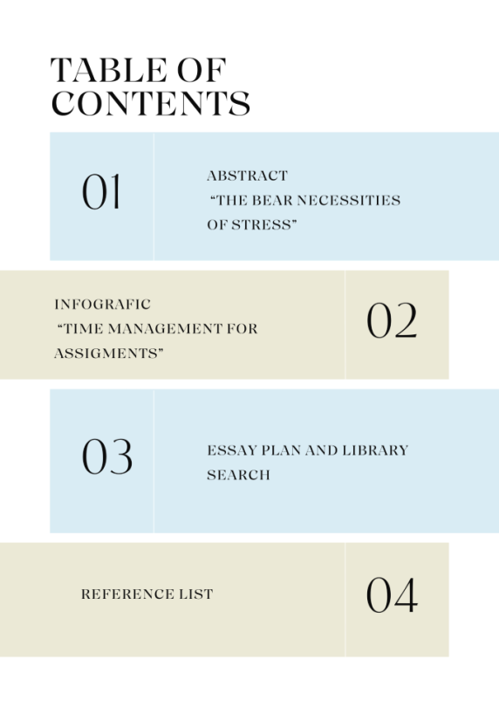 (Canva, 2023)
ABSTRACT OF ‘THE BEAR NECESSITIES OF STRESS’

In this article, Mark Wetherell (2022) explores the “fight, flight or freeze” response and the body's response to different stressors in different life scenarios, especially what makes the cortisol increase or decrease and showcases the impact stress has on physical and mental health in the long term.
Wetherell uses the scenario of the impact of suddenly coming front to front with a bear and the reaction internally and externally of a person; however, as ethics committees do not allow bringing bears into the laboratories, Wetherell and his colleagues must use alternative ways to study and understand stress mechanisms using different techniques in a controlled environment to stress people, such as physical challenges, unpleasant stimuli, making people do public speaking in front of an audience, mentally challenging tasks, and so on.
To explore everyday stressful experiences in more depth, Wetherell et al. studied people's stress with the challenge of multitasking by recreational users of cannabis and MDMA as well as people with the effects of a hangover after a heavy drinking session. The findings showcased how drugs and excessive alcohol consumption make these tasks more mentally demanding and frustrating.
Another approach in this article is measuring cortisol levels in people jumping out of aeroplanes, comparing novice jumpers with very experienced jumpers. Surprisingly, there was no difference in cortisol levels. However, there was a difference in the response; experienced jumpers obtained the necessary energy to act and think fast. The cortisol awakening response was measured in the sleep laboratory from when a person wakes up to when they go to sleep. This gives evidence of cortisol as the energizing hormone. These studies showcase how stress mechanisms respond to daily challenges and provide resources to deal with these.
In context, chronic stress is showcased with studies of parental caregivers giving evidence of significant levels of stress, anxiety, depression and an increase in health complaints and memory failures. Some evidence of how social support may ease or worsen stress levels is also showcased. ￼
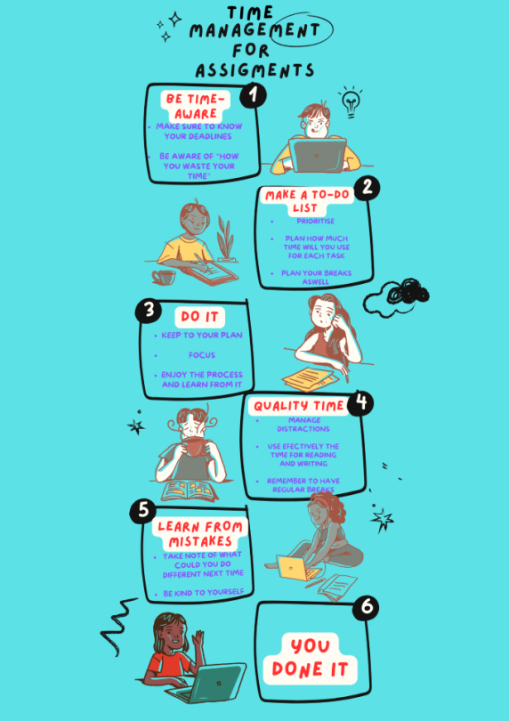( (Canva, 2023; Cottrell, 2019)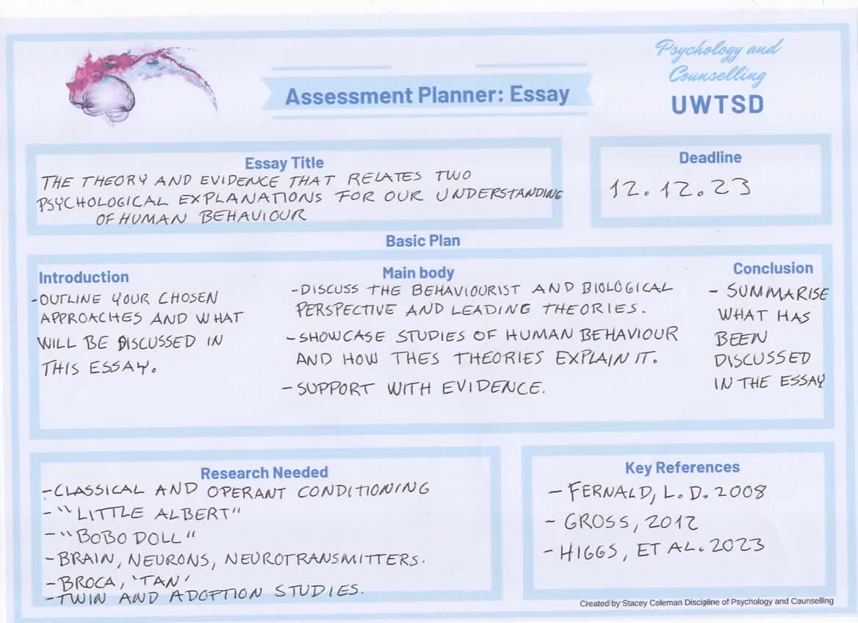
(Cooke & Jones, 2023)
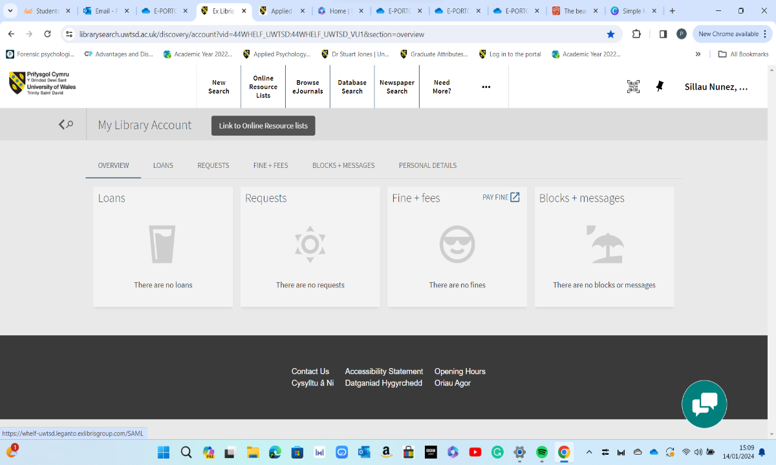
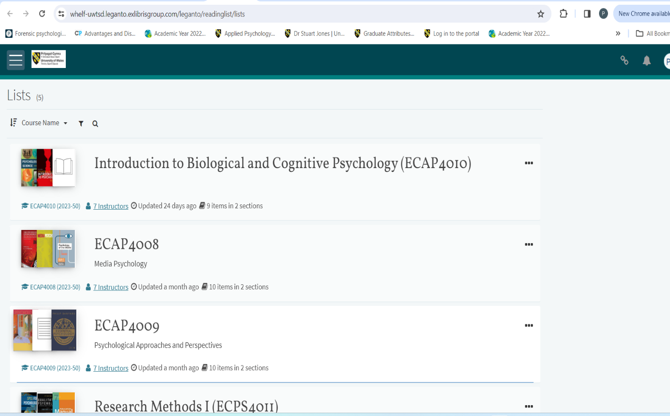
The best place to find all the resources needed for any assignment is the online library search, where clicking directly on the reading list provided by lectures makes it possible to find all recommended reading materials and do further research if needed. These are two pictures that show how to access the online resource list as well as the reading lists provided and recommended (Library Search, 2010)

References

American Psychological Association. (2020). Publication Manual of the American Psychological Association (7th ed.). American Psychological Association.

Canva. (2023). Canva. Canva.com; Canva. https://www.canva.com

Cooke, Z., & Jones, S. (2023, October 20). ECPS4018: Study skills for psychology. Moodle.uwtsd.ac.uk; University of Wales Trinity Saint David University . https://moodle.uwtsd.ac.uk/course/view.php?id=11582&section=2

Cottrell, S. (2019). The study skills handbook (5th ed.). Red Globe Press.

University of Wales Trinity Saint David University . (2010, November 18). Library search. uwtsd.ac.uk; University of Wales Trinity Saint David. https://librarysearch.uwtsd.ac.uk/

Wetherell, M. (2022, September 14). The bear necessities of stress. British Psychological Society. https://www.bps.org.uk/psychologist/bear-necessities-stress

