BSc HEALTH AND SOCIAL CARE

DON CASTRO SOLONZO
2408787
BMHP 5015
CHANGEMAKERS: BUILDING YOUR PERSONAL BRAND FOR SUSTAINABLE EMPLOYMENT
COMPONENT 2: ASSIGNMENT (REPORT)
NOUH ELMITWALLY
SUNDAY 19TH JULY 2026

CONTENT PAGE

INTRODUCTION----------------------------------------------------PAGE 3
MANAGER ROLE ADVERT-----------------------------------------PAGE 4
PERSONAL EMPLOYABILITY SKILLS----------------------------PAGES 5 & 6
EVALUATION OF MY SKILLS--------------------------------------PAGE 7
ACTION PLAN AND TIMELINE------------------------------------PAGES 8,9 & 10
BUILDING MY PERSONAL BRAND------------------------------PAGE 10
PROMOTING MY PERSONAL IDENTITY------------------------PAGE 11
BUILDING NETWORK FOR SUCCESSFUL EMPLOYMENT-PAGE 12
CONCLUSION------------------------------------------------------PAGE 13
REFERENCES-------------------------------------------------------PAGES 14 & 15

CARE MANAGER JOB ROLE
INTRODUCTION: The role of a care home manager in the UK is pivotal in ensuring the delivery of high-quality person-centred care and support to residents. Care home managers are responsible for the overall operation of the facility, including staff management, quality assurance, budget planning, and compliance with regulatory standards. Care managers play a crucial role in creating a safe, supportive, and nurturing environment for residents, many of whom may have complex health needs or disabilities (Kirkpatrick and Nyantanga).
In addition to managing day-to-day operations, care home managers are tasked with developing care plans tailored to individual residents, ensuring that their physical, emotional, and social needs are met. The importance of this role is underscored by the Care Quality Commission (CQC), which regulates care homes in England, setting standards that must be met to ensure the safety and dignity of residents. Research indicates that strong management leads to better outcomes for residents, including improved satisfaction and quality of life (Punnett et al, 2018).

RECENTLY ADVERTISED VACANCY FOR CARE MANAGER ROLE

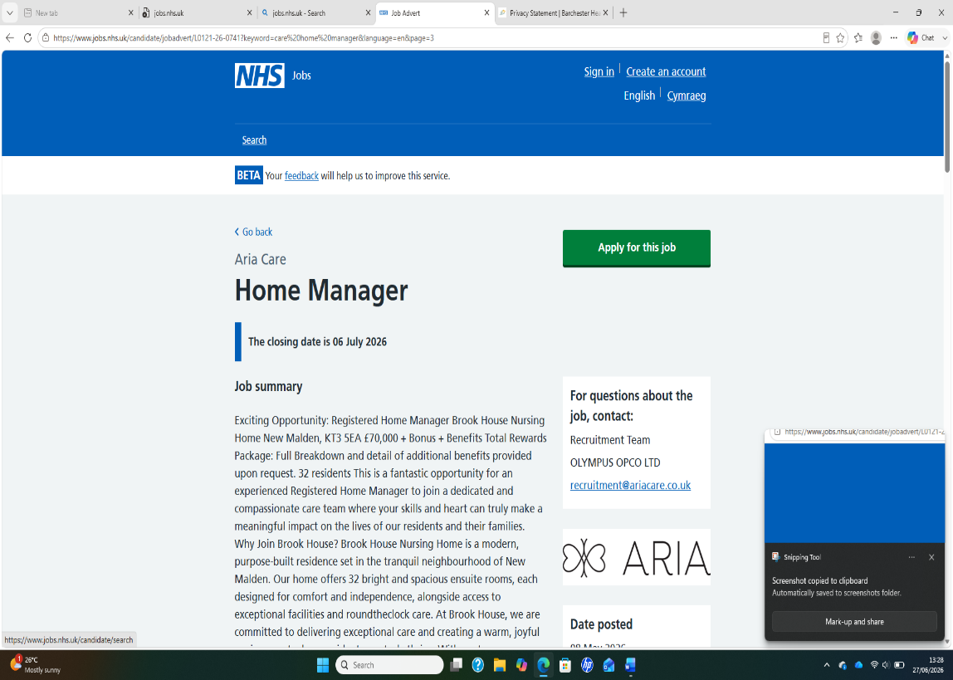
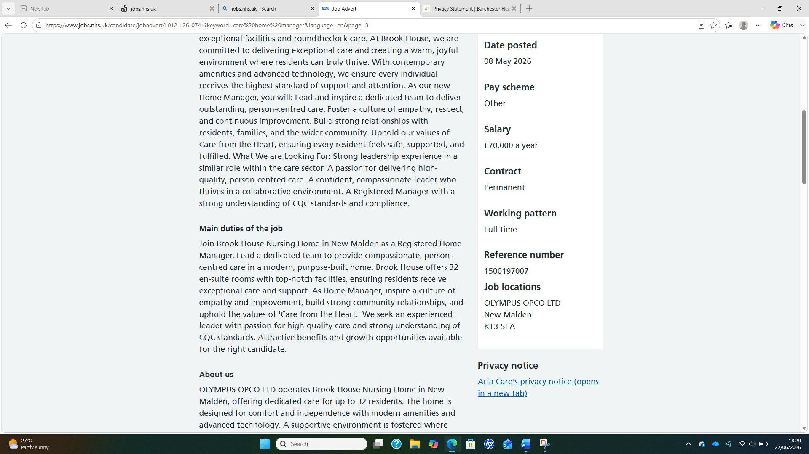
(NHS England, 2026)

PERSONAL EMPLOYABILITY SKILLS REQUIRED FOR THE JOB OF A CARE MANAGER

The position of a care manager is very important in a care home that is why it is paramount to employ a well-qualified, competent, and very experience person for the job. Below is the analysis of the personal employability skills for the role of a care manager.

- COMMUNICATION SKILLS: Communication is one of the most vital personal employability skills for a care manager. This position involves communicating or interacting with service users, families, regulatory bodies, social workers, healthcare professionals, and care staff on daily basis (Ratna, 2019). A care manager needs effective communication to explain care plans clearly, to resolve complaints and conflicts, to conduct staff meetings, and supervision sessions, and to write report, assessments, and for care documentation.

- TEAMWORK AND COLLABORATION SKILLS: Care managers work within multidisciplinary environments and with these skills, they can collaborate with Doctors, Nurses, Occupational Therapist, families, social workers, and
Regulatory inspectors. Without these skills, they can’t function effectively

- PROBLEM-SOLVING AND DECISION-MAKING SKILLS: Care homes often times involves complex and unpredictable situation. For these reasons, care managers need these skills to assess risk, respond to emergencies, make informed decisions, resolve staffing issues, and to handle complaints effectively (Almuna and Rahmi, 2023).

- ORGANISATIONAL AND TIME MANAGEMENT SKILLS: Care managers are simultaneously in charge of numerous responsibilities. These skills are of great importance to them to enable them to schedule staff effectively, help them manage multiple priorities, help them maintain accurate records, help them meet regulatory deadlines, and to coordinate care reviews.

Apart from these four key employability skills, other important employability skills for a care manager include empathy and compassion, leadership and management, problem solving and decision making, safeguarding awareness and ethical practice, digital and record keeping, resilience and stress management, professionalism and integrity, and financial and business management skills (Tushar and Sooraska,2023).

CONCLUSION: Care manager job role requires a lot of personal employability skills which includes leadership, empathy, safeguarding expertise, communication, organisation, and professional judgement. While qualification and technical knowledge are very important, employers increasingly value transferable personal skills such as problem solving, emotional intelligence, resilience, and teamwork. These skills empowered care managers to deliver safe, effective, and person-centred care while meeting regulatory and organizational requirements. Effective care managers do not only coordinate care but also lead teams, safeguard vulnerable people, and drive continuous improvement of services (Ledlow et al, 2023).

EVALUATING MY SKILLS AGAINST CARE MANAGER ROLE

If I evaluate my skills against a care manager job role, am convinced I will score very high on information-processing, documentation, coordination, and communication task, but may not perform too well when it comes to the aspect of direct human judgment, accountability, relationship-building, and real-world leadership. Below is the evaluation of my skills against the job.
COMMUNICATION: As a care manager, you are expected or required to communicate with patients, families, staff, and providers effectively. My skill in this area is very perfect. I can communicate with everyone perfectly and eloquently without stress (Sumaiya et al, 2022).
ASSESSMENT: A care manager is required to assess patients’ needs and risk as well. He can analyse and provide information but cannot directly observe patients. I think in this regard, I can perform moderately.
CARE COORDINATION: A care manager is required to coordinate multiple services and providers. He is also required to manage providers. My skill in this area is also moderate.
DOCUMENTATION: A care manager must possess the knowledge of maintaining records, reports, and case notes. In this area, I will perform very well because of my knowledge in understanding regulations, confidentiality, and standards, train and manage performance.
RELATIONSHIP BUILDING: A care manager is required to build trust with residents, families, and community partners. He or she is expected to advocate for patients and provide emotional support. Changes and make clinical decisions. Regulation outcomes are central to effective care management. In this area, I will do well also by putting my effective communication skills, empathy and compassion into practice (Stone, 2024).

12 MONTHS ACTION PLAN AND TIMELINE FOR DEVELOPING THE SKILLS REQUIRED FOR CARE MANAGER ROLE

Below are a 12-month action plan and timeline for developing the skills required for care manager role. This action plan and timeline is divided into 4 phases namely, Foundation (Months 1-3), Professional Practice Development (Months 4-6), Leadership Development (Months 7-9), and Care Manager Readiness (Months 10-12).
PHASE 1: FOUNDATION (Months 1-3): This is the stage of building core knowledge of care management and responsibilities and regulatory requirements.
Month 1: Review the standards and regulations of the Care Quality Commission (CQC). Read policies on safeguarding adults and mental capacity. Complete introductory training in safeguarding adults, Data Protection (GDPR), Equality and Diversity, and Mental Capacity Act.
Month 2: Shadow experienced care managers and observe care reviews, family meetings, incident investigations, and staff supervision sessions.
Month 3: Learn care planning and assessment processes, practice writing care plans and risk assessments using case studies and familiarize yourself with electronic care management systems. Upon the successful completion of these stages, I can now move to phase 2

PHASE 2: PROFESSIONAL PRACTICE DEVELOPMENT (Month 4-6): This is the stage to start developing operational and interpersonal skills.
Month 4: Attend advance communication training, practice active listening techniques, and lead small team discussions.
Month 5: This stage has to do with safeguarding and risk management. It is important at this stage to participate in safeguarding investigations, complete advanced safeguarding training, and review serious incident reports.
Month 6: This is the stage to start leadership foundation courses. At this stage, I will start to supervise new staff or volunteer, learn coaching techniques, and conduct staff one-to-one meetings. I can now move to phase 3 at the successful completion of phase 2.

PHASE3: LEADERSHIP DEVELOPMENT (Month 7-9): At this stage, I will start my transition from practitioner to manager.
Month 7: At this stage, I will start learning workforce planning and scheduling, participate in interviews, and understand recruitment and retention strategies.
Month 8: At this stage, I will start developing quality assurance technics or strategies. I will conducting internal audits, review medication records, and start analysing service quality indicators.
Month 9: This stage has to do with conflict resolution. At this stage, I will take active part complete mediation or conflict management training and also manage workplace disagreements under supervision. I will then proceed to the last phase which is phase 4 after the successful completion of phase 3.

PHASE 4: CARE MANAGER READINESS (Month 10-12): This is the stage to operate at a care manager level with supervision.
Month 10: At this stage, I will equip myself with knowledge about financial management. I will learn budgeting principles and understand staffing costs and resource allocation.
Month 11: This is the stage of regulatory compliance. At this stage, I will participate in mock inspections, review CQC key lines of enquiry and quality standards.
Month 12: This is the stage to gain acting care manager experience. At this stage, I will manage daily operations during supervised period, coordinate staff, residents, families, and external professionals. This successful completion of this phase will take me to the role of a full care manager.

BUILDING MY PERSONAL BRAND

Building a strong personal brand as a care manager involves several important steps that align with both personal values and professional goals. First, it is important to define your unique value proposition. This means identifying what sets you apart in the field of care management, such as specialized skills in geriatric care or expertise in mental health (Kromalcas and Kraujaliene, 2024).
Next, effective communication is a vital key. Utilize social media platforms like LinkedIn to share insight, articles, and personal stories related to care management, fostering engagement and showcasing your expertise. Networking with other professionals in healthcare sector can also enhance visibility and credibility.
Moreover, continues professional development is crucial. Attending workshops, obtaining certifications, and staying updated with the latest healthcare trends not only enhances your skills but also reinforces your brand as a knowledgeable and committed care manager (Talwelkar et al, 2024).
Finally, seeking feedback from colleagues and clients can provide insight into how others perceived your brand, allowing for adjustments as needed. Overall, a strong personal brand in care management is built through authenticity, expertise, and active engagement within the professional community.

Promoting your professional identity

Effectively communicating your skills and expertise to potential employers is crucial for a positive impression and securing job opportunities. Below are some detailed strategies that can help me convey my qualifications, skills, and expertise effectively:
- Tailor your resume and cover letter: This involves customizing for each job. I will highlight the skills and experiences I possess that align with the specific job description. I will use keywords from the job advertisement to demonstrate a match. I will use strong action verbs to start bullet point like managed, led, developed to showcase my contributions and achievements in my cover letter. I will make sure my CV is up to date and with the qualifications and skills that I have needed for the job role.

- Showcase soft and hard skills: Employers value both technical abilities (hard skills) and interpersonal qualities (soft skills) I will prepare myself to discuss both examples. When discussing my ex, I will structure my answer using the situation, task, action, and result format to clearly convey my contributions.

- Prepare for interviews: I will do some research about the company while preparing for my interview to understand the company’s mission, values, and recent developments. I will tailor my responses to show how my skills align with their goals (Plung, 2024). I will practise common questions. I will prepare for frequently asked interview questions and practise articulating my experience in a clear and confident manner.

BUILDING A NETWORK FOR SUCCESSFUL EMPLOYMENT

Networking is very important in health and social care sector because it helps professionals, organisations and services work together to provide safe, effective, and person-centred care. It involves building personal relationships, sharing information, and collaborating across different roles and organisations (Akkas, 2023).
Below are some of the reasons networking is important:
- It supports person-centred care: Individuals often have complex needs that require support from several professionals. Networking allows different services to work together to create care plans that meet the person's physical, emotional, and social needs.
- It promotes teamwork: Effective networking strengthens multidisciplinary teams. Team members understand each other’s roles and responsibilities, making it easier to deliver high-quality care.
- It improves communication: Networking enables health and social care professionals such as doctors, nurses, social workers, and care workers to communicate effectively (Isabirye et al, 2024). It also encourages knowledge sharing, supports safeguarding, builds professional development, encourages innovation, and improve efficiency.

To identify potential mentors, I will connect with influential figures in health and social care sector through platforms like LinkedIn and engage with their content and reach out for advice or insight. I will try to identify senior colleagues or managers who have the experience and knowledge I aspire to gain and approach them for informal mentorship.

CONCLUSION

In conclusion, a care manager plays a very important role in ensuring that individuals receive safe, high-quality, and person-centred care. By leading staff, coordinating services, and promoting effective communication, care managers help improve the well-being of service users while ensuring care is delivered in line with professional standards, legal requirements, and organisational policies.

REFERENCES
- Akkas, M.A., 2023. Role of networking skill to career success. Management Education for Achieving Sustainable Development Goals in the Context of Bangladesh, pp.13-39.
- Almulla, M.A. and Al-Rahmi, W.M., 2023. Integrated social cognitive theory with learning input factors: The effects of problem-solving skills and critical thinking skills on learning performance sustainability. Sustainability, 15(5), p.3978.
compassionate care in medicine: toward improving patients’ quality of care and satisfaction. Journal of Surgical Research, 289, pp.1-7.
- Isabirye, A.K., Moloi, K.C. and Lebelo, R.S., 2024. Enhancing networking skills for professional success: Strategies and tactics. Mitteilungen Klosterneuburg, 74(7), pp.1-35.
- Kirkpatrick, C. and Nyatanga, B., 2023. Exploring perceptions and approaches of registered managers regarding clinical safety in care homes in the UK. Journal of Long Term Care, (a), pp.45-53.
- Kromalcas, S., Kraujalienė, L. and Ževžikovas, G., 2024. The influence of personal brand communication on consumers. Business: Theory and Practice, 25(1), pp.95-107.
- Ledlow, G.J.R., Bosworth, M. and Maryon, T., 2023. Leadership for health professionals: Theory, skills, and applications. Jones & Bartlett Learning.
- Plaku-Alakbarova, B., Punnett, L., Gore, R.J. and Procare Research Team, 2018. Nursing home employee and resident satisfaction and resident care outcomes. Safety and health at work, 9(4), pp.408-415.
- Plung, D., 2024. Job interview preparation: A practical exercise in the rhetoric of oral argument. Business and Professional Communication Quarterly, 87(1), pp.177-193.
- Ratna, H., 2019. The importance of effective communication in healthcare practice. Harvard Public Health Review, 23, pp.1-6.
- Sinclair, S., Norris, J.M., McConnell, S.J., Chochinov, H.M., Hack, T.F., Hagen, N.A., McClement, S. and Bouchal, S.R., 2016. Compassion: a scoping review of the healthcare literature. BMC palliative care, 15(1), p.6.
- Stone, M., 2024. The Power of Trust and Relationship in the Implementation of Family Support Services: Learning from the Reaching Out, Supporting Families Programme. Child Care in Practice, 30(1), pp.62-70.
- Sumaiya, B., Srivastava, S., Jain, V. and Prakash, V., 2022. The role of effective communication skills in professional life. World Journal of English Language, 12(3), pp.134-140.
- Talwelkar, A.S., Uppal, A.G. and Thakarar, G., 2024, April. Importance of Continuous Professional Development and Ways and Means to Achieve It. In International Conference on Business and Technology (pp. 411-422). Cham: Springer Nature Switzerland.
- Tushar, H. and Sooraksa, N., 2023. Global employability skills in the 21st century workplace: A semi-systematic literature review. Heliyon, 9(11).
- Watts, E., Patel, H., Kostov, A., Kim, J. and Elkbuli, A., 2023. The role of

