TITLE

What is the most effective way to motivate staff?

Name: Andreea Nicoleta Micdan
ID: 2118517
Teacher Name: Doreen Nyaa Amundam
Academic and Employability Skills
BMSW4001

Table of Contents
Introduction 2
Different ways that staff can be motivated 2
Pay 2
Recognition and Awards 5
Additional holiday 6
Good working conditions 8
Conclusion 9
References 11

Introduction
The report will discuss the challenges of motivating employees in a workplace and will highlight different ways of improving such challenges faced by the firm. Additionally, a report will explore the pay process of the employee that should be hassle-free and flexible, which is significant for motivating the employee base in a workplace. Besides, the research report will explore that recognition and awards can be motivated employees to reflect on employee performances and even the organisation. In addition, the additional holiday will trigger an employee base in a workplace and good working conditions will encourage the employee base in performing better needed for the organisation and even the employees.

Different ways that staff can be motivated

Pay
Workforce satisfaction is determined as one of the most vital drivers of continuous enhancement within an organisation, which additionally assists the company in serving the clients related to the firm in an efficient manner (Armstrong and Brown, 2019). This procedure further ensures total quality management within any given company as the critic Galli (2020), has stated that the two most vital motivators for employees happen to be their individual satisfaction related to their designated assignments and job along with the salary structure. Pay permits the staff to remain motivated and productive further assisting in accomplishing the organisational objective. Moreover, the study by Criscuolo et al. (2020), has revealed that employee behaviour happens to be complex when it comes to money to perform as a motivator, which makes predicting workforce behaviour even more difficult, and the assessment shall explore these statements in detail.
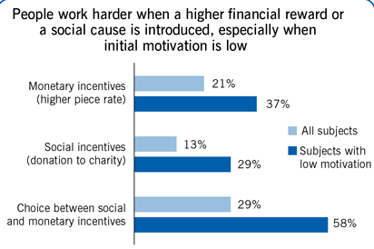
Figure 1: Pay benefits motivating the workforce
(Source: De Sousa Sabbagha et al., 2018)
Money is a vital incentive related to work motivation base pay management has been identified as the procedure of deciding on base pay levels with or without the formal assistance of pay structures (Pettinger, 2020). Staff salaries are generally paid on weekly, monthly or annually as identified by the case study. The base rate is vulnerable to fluctuations according to the competency of the staff and job evaluation is carried out in order to establish fair internal company policies with an establishment of a grade structure. Furthermore, market pricing determines the external relativities and informs the organisation with pay ranges concerning the grade structure. As viewed by Tekieli et al. (2018), variable pay is earned by employees by exceeding performance targets. All these factors collectively contribute to accomplishing workforce motivation.
According to Van der Kolk et al. (2019), performance management procedures permit companies to identify the individual performance of the staff as well as enable the management to monitor the contribution of the workforce. This performance management assessment allows evaluation of routine work against expectations involving regular constructive feedback aimed at the personal development of the dedicated staff. Reinforcement theory establishes that when payment is contingent on performance it encourages the workforce to maintain greater levels of effort, which is then compared to the perceived outputs, and inputs of the other teams present within the organisation (Van den Broeck et al., 2019). It can be determined from the above discussion that fair treatment at the workplace motivates the staff to exhibit fairness in their individual relationships with the co-workers besides the company itself.
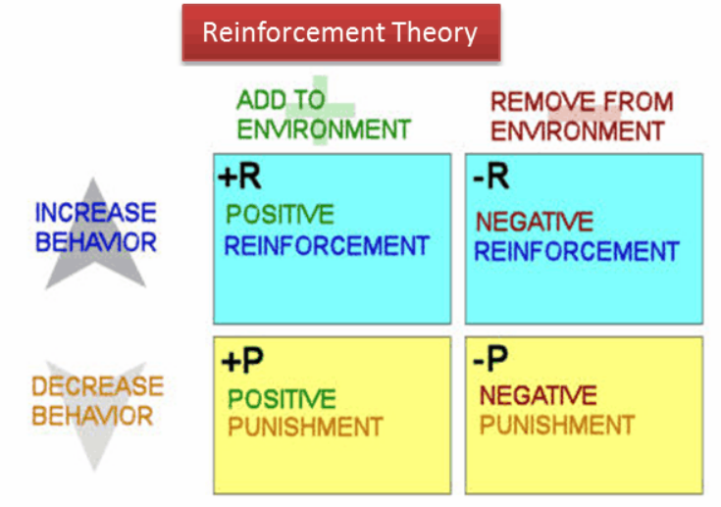

Figure 2: Reinforcement theory utilised to scrutinise workforce motivation concerning payments
(Source: Van den Broeck et al., 2019)
The study conducted with the aid of reinforcement theory has enabled us to observe when managers praise the employee. In the view of Alwaki (2018), it establishes positive reinforcement within the work base where positive behaviour is followed by positive outcome while negative enforcement is established when managers stop nagging the staff and therefore positive behaviour is followed by removal of negative consequences, which may include a reduction in the pay packages (De Sousa Sabbagha et al., 2018). Negative behaviour is followed by negative consequences in the punishment phase when the manager demotes the workforce. Extinction is that phase where negative behaviour is followed by the removal of positive consequences and it is observed when the manager ignores the positive behaviour of the staff by not providing them with timely increments (Shuck et al., 2018). Therefore, reward management has to be established by the human resource management team with establishing appropriate total remuneration packages in value of cash payments consisting of allowances and total earnings, pension benefits where the same rules shall be applicable for every employee without any discrimination.

Recognition and Awards
When rewards are equally distributed depending on objective data the staff are likely to observe the procedure as fair and are more likely to experience a concrete comprehension of what exactly is expected out of them in achieving the larger organisational objective. In the opinion of Holly et al. (2017), it is essential to assure that the workforce views the rewards as the significance of their dedication and managers must value the staff so that the motivated perform harder to achieve the rewards. It is essential to create a programme, which allows recognition programme motivates ever further. The article by Holly et al. (2017) has determined that Hershey Medical Center has implemented innovative staff recognition programmes inspiring involved staff through inspiring meetings and workshops. These programmes were highly accepted by staff when their appropriate code of conduct and performance related to work within the professional environment aided in achieving long-term goals (Malik et al., 2019). Employees become satisfied with incentives and additional holiday programmes when the pharmaceutical company rewards their cooperation and teamwork.
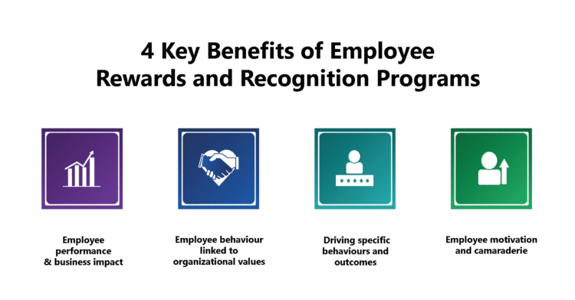
Figure 3: Major benefits of employee recognition and reward programmes
(Source: Van den Broeck et al., 2019)
The evaluation from the study has determined that when employers no longer pay the workers their due incentives related to dedication towards the organisation and ask them to remain as interns longer it may contribute towards lowering their motivational factor (Armstrong and Brown, 2019). The facility of being able to nominate someone for recognition happens to be an essential variable in developing a successful award programme as per the article. In-person feedback serves as a valuable way to recognise team efforts. Moreover, as stated by Hwang and Jung (2018), certain employee benefits that include insurance coverage along with pensions, sick pay, additional perquisites of remuneration, cash pay and annual holidays deliver staff with enough opportunity to rest their mind so that they can get back to work with double amount of dedication.

Additional holiday
The employee base is the pillar of an organisation that is responsible for organisational success and reputation. As denoted by Khoreva and Wechtler (2018), additional holiday acts as a key driver of enhancing employee performances and managing the challenges regulated in the organisation. Additionally, the organisation emphasised mitigating the challenges incorporated within the firm that highlighted the initiative. According to the case study of the neonatal intensive care unit of The George Washington University (GWU) Hospital expressed that Team-building interventions influenced employees that reflected in problem-solving efficiency and employee morale relevant for the organisation (Cohen, 2006). However, additional holidays minimised work stress and monotony effective for sustaining and retaining the employee within the organisation. As depicted by Narayanamurthy and Tortorella (2021), the employee base felt relaxed by attaining such facilities provided by the firm. The additional holiday retaining employees festive time necessary for strengthening employee skill and potentiality. This initiative evaluated employee relaxation essential for sustaining superior performances. The staff members work with immense hard work and dedication for which the management should provide monetary and non-monetary rewards to the employees. It is a common belief among the managers that giving money to the employees to appreciate their contribution to the organisation is the integral way. Furthermore, as denoted by Cohen (2006), the managers and leaders should try to understand the preferences and needs of the employees.
The employees need relaxation periods to manage their minds and get back to work with an approach that is more productive. The non-monetary rewards can be provided to the employees with the intent of recognising their accomplishments and appreciating their time and hard work. The employees need recognition and the fact that they are involved in the important work decisions. As opined by Phillips et al. (2017), the rewards such as prizes or certificates can also be provided to the employees to make them understand their value in the organisation and encourage them to work hard. The employees who actually work hard can be provided additional holidays to refresh their minds. According to Lappalainen et al. (2019), in some organisations such as HSBC Holdings, the management has implemented the rule of providing incentives in the form of holiday packages to the employees who have performed outstandingly in that specific month. The approach would be a non-monetary approach to appreciate the performance and importance of the employee for the growth and development of the organisation. As stated by Cohen (2006), the employees need appropriate motivation to improve their productivity level and learn new skills, which could help in their professional growth. The additional holidays would help the employees to feel motivated and maintain their work-life balance as well.

Good working conditions
Good working conditions triggers employee motivation and stimulated their performances necessary for personal and professional growth. As stated by Cattermole (2019), the authority of an organisation evaluated employee needs and aims that have to be fulfilled by formulating such relevant and essential practices within the firm functioning. The case study of The George Washington University (GWU) Hospital, explored that leaders initiated addressing issues of divisiveness and promoting positive interaction among the staff that encouraged them and evidenced good working conditions (Cohen, 2006). This initiative is relevant to increasing trust between employees and the leaders and generating reliability towards the brand. As opined by Lappalainen et al. (2018), the authority of the business emphasised addressing employee shortcomings and attaining their needs and objectives relevant for maintaining good working conditions in the workplace. Moreover, healthy communication enhanced connectivity between the employee and the leaders, which is reflected in employees and even the organisation's performances.
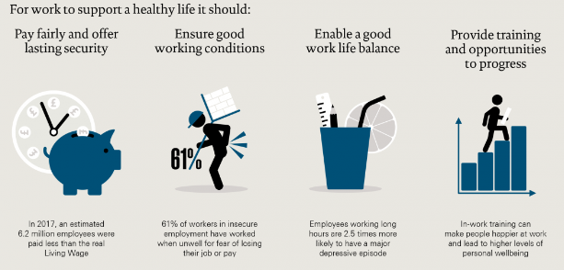
Figure 4: Working conditions and health
(Source: Wirth et al., 2019)
A key authority of an organisation insists on promoting effective working conditions within the workplace that aid in employee flexibility relevant for the business growth. In accordance with Malik and Singh (2019), leaders of a business are efficient in appointing talented employees sufficient for the business in enhancing business reputation and success. Besides, the management is reliable in changing the existent orientations relevant for enhancing employee motivation and managing the challenges further incorporated in the firm. According to the case study of the neonatal team of The George Washington University (GWU) Hospital, explained that management department promoted the Sunshine Committee responsible for setting the plan for implementing various social events and activities (Cohen, 2006). Moreover, leaders of an organisation emphasised implementing services excellence to the functioning of the business enhanced employee motivation and managing the challenges (Wirth et al., 2019). The authority of a business insists on implementing cultural changes relevant to managing the challenges in the organisation.
The management authority of an organisation insists on evaluating challenges generated in the functioning and highlights mitigating pathways of the challenges that increased employee motivation and morale. As depicted by Alblooshi et al. (2019), employee scrutinised organisational vision and values that is sufficient for attaining organisational goals and enhancing their core compatibilities. Moreover, leaders of an organisation emphasised promoting rewards and appreciations to the employee that is relevant for managing the challenges. According to the case study of Phillips, award programs that explored the culture of safety in the workplace that supporting the technical staff with enhancing their competency (Phillips et al., 2017). In this sense, The Dartmouth-Hitchcock Medical Center implementing an award defined Positive Recognition of Patient Safety (PROPS), encourages staff in producing superior performances and minimising error in the performances. Moreover, leaders of a business developed a relevant program that generalising ambience of comfort that employees should attend and felt valuable.

Conclusion
The report can be concluded by describing the challenges faced by the employee in the workplace and implementing relevant practices within the workplace. Besides, the case study of The George Washington University (GWU) Hospital, explained that Team-building interventions, which is influenced the employee base in producing superior performances and developed potentiality necessary for the organisation. Additionally, the report expressed that additional holidays enhanced employee relaxation and generated comfort by attaining the additional holiday. Moreover, good work plays as a key driver in enhancing employee motivation and managing the challenges incorporated within the firm. Besides, the authority of an organisation emphasised generating hassle-free payments that encouraged employees and retaining them in the organisation.

References
Alblooshi, M., Shamsuzzaman, M. and Haridy, S., (2020). “The relationship between leadership styles and organisational innovation: A systematic literature review and narrative synthesis”. European Journal of Innovation Management. Doi: 10.1108/EJIM-11-2019-0339
Alwaki, M.N., (2018). “An evaluation of the impact of remuneration on employee attitude and performance in organizations”. International Journal of Academic Research in Business and Social Sciences, 8(7), pp.410-420.
Armstrong, M. and Brown, D., (2019). Strategic Human Resource Management: back to the future. Institute for Employment Studies reports, pp.1-36.
Cattermole, G., (2019). “Developing the employee lifecycle to keep top talent”. Strategic HR review. Doi: 10.1108/SHR-05-2019-0042
Cohen, S., (2006). “Compliment your staff with nonmonetary rewards”. Nursing Management, 37(12), pp.10-14, doi: 10.1097/00006247-200612000-00004
Criscuolo, C., Hijzen, A., Schwellnus, C., Chen, W.H., Fabling, R., Fialho, P., Grabska, K., Kambayashi, R., Leidecker, T., Nordstrom Skans, O. and Riom, C., (2020). Workforce composition, productivity and pay: the role of firms in wage inequality.
De Sousa Sabbagha, M., Ledimo, O. and Martins, N., (2018). “Predicting staff retention from employee motivation and job satisfaction”. Journal of Psychology in Africa, 28(2), pp.136-140. DOI: 10.1080/14330237.2018.1454578
Galli, B.J., (2020). “Impact and role of motivation theories in continuous improvement environments: A reflection of literature”. International Journal of Service Science, Management, Engineering, and Technology (IJSSMET), 11(1), pp.1-13. DOI: 10.4018/IJSSMET.2020010101
Holly Phillips1, Ivana Bogdanich2, Kristen Carter3, Jacob Holler4, Trisha Smith2, Erin H. Ticehurst5, and Molly Wascher6 (2017) DOI: 10.1177/0018578717736242
Hwang, S. and Jung, H., (2018). “The interactive effects of motivation and contingent rewards on employee creativity”. The Journal of Industrial Distribution & Business, 9(7), pp.71-82. ISSN: 2233-5382
Khoreva, V. and Wechtler, H., (2018). “HR practices and employee performance: the mediating role of well-being”. Employee Relations. Doi: 10.1108/ER-08-2017-0191
Lappalainen, P., Saunila, M., Ukko, J., Rantala, T. and Rantanen, H., (2019). “Managing performance through employee attributes: implications for employee engagement”. International Journal of Productivity and Performance Management. Doi: 10.1108/IJPPM-10-2018-0356
Malik, A.R. and Singh, P., (2019). “The role of employee attributions in burnout of “talented” employees”. Personnel Review. Doi: 10.1108/PR-02-2018-0064
Malik, M.A.R., Choi, J.N. and Butt, A.N., (2019). “Distinct effects of intrinsic motivation and extrinsic rewards on radical and incremental creativity: The moderating role of goal orientations”. Journal of Organizational Behavior, 40(9-10), pp.1013-1026.
Narayanamurthy, G. and Tortorella, G., (2021). “Impact of COVID-19 outbreak on employee performance–moderating role of industry 4.0 base technologies”. International Journal of Production Economics, 234, p.108075. doi: 10.1016/j.ijpe.2021.108075
Pettinger, R., (2020). Managing the flexible workforce. Routledge.
Phillips, H., Bogdanich, I., Carter, K., Holler, J., Smith, T., Ticehurst, E.H. and Wascher, M., (2017). “Commentary: Exploring novel approaches to staff rewards and recognition”. Hospital pharmacy, 52(11), pp.729-731, doi: 10.1177/0018578717736242
Shuck, B., Peyton Roberts, T. and Zigarmi, D., (2018). “Employee perceptions of the work environment, motivational outlooks, and employee work intentions: An HR practitioner’s dream or nightmare?”. Advances in Developing Human Resources, 20(2), pp.197-213. DOI: 10.1177/1523422318757209
Tekieli, M., Festing, M. and Baeten, X., (2018). Centralization and effectiveness of reward management in multinational enterprises. Journal of Personnel Psychology. DOI: 10.1027/1866-5888/a000195
Van den Broeck, A., Carpini, J. and Diefendorff, J., (2019). “Work motivation: Where do the different perspectives lead us”. The Oxford handbook of human motivation, 2, pp.354-372. DOI: 10.1093/oxfordhb/9780190666453.013.27
Van der Kolk, B., van Veen-Dirks, P.M. and ter Bogt, H.J., (2019). “The impact of management control on employee motivation and performance in the public sector”. European Accounting Review, 28(5), pp.901-928. DOI: 10.1080/09638180.2018.1553728
Wirth, T., Mette, J., Prill, J., Harth, V. and Nienhaus, A., (2019). “Working conditions, mental health and coping of staff in social work with refugees and homeless individuals: A scoping review”. Health & Social care in the Community, 27(4), pp.e257-e269. Doi: 10.1111/hsc.12730

