Programme: BSc Health and Social Care
Module: Changemakers: Creativity and Value Creation
Module code: BMHP5014

Student ID: 2320536
Student Name: Codruta Alexandra Mican

Contents
Poster 3
Pitch - CareConnect AI: Enhancing Communication for Dementia Care 4
Introduction 4
The Problem: Why Communication Support Is Critical 4
The Innovation: What CareConnect AI Provides 5
Health and Wellbeing Impact 5
Policy, Law and Alignment to the professionals 6
Type of professional services 6
Community Involvement and Community Engagement 7
Conclusion 7
Reference list 9

Poster
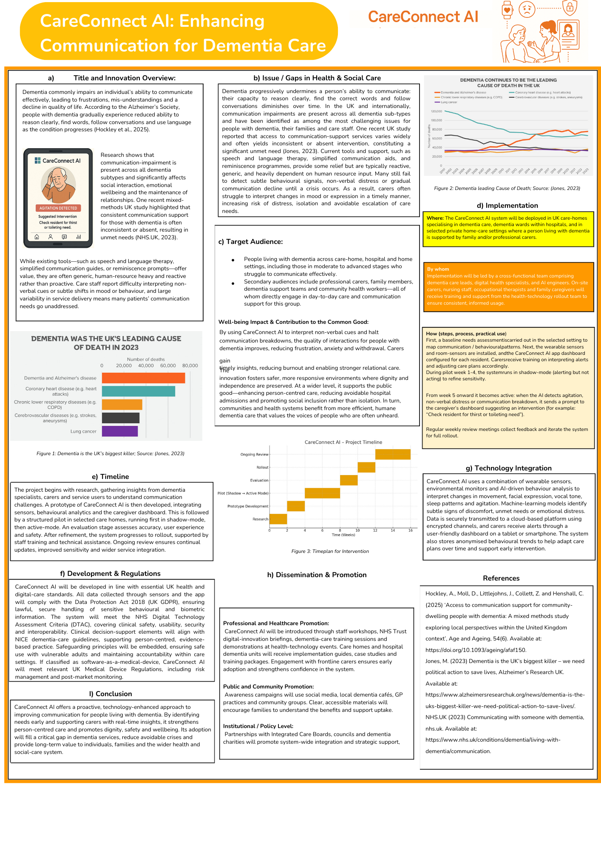

Pitch - CareConnect AI: Enhancing Communication for Dementia Care

Introduction
Dementia is one of the fastest-growing health burdens in the United Kingdom, and nearly 900,000 people are afflicted with the disease (LSE, 2024), with the figure likely to keep on rising in the coming decades at a high rate. Impairment of proper communication is among the most significant challenges dementia patients face (Jones, 2023). Not only does this deterioration affect the ability of the affected individual to express needs and emotions, but it also places considerable pressure on family members, caregivers, and health practitioners, who must now learn a great deal about subtle behavioural patterns without explicit guidance (Hockley et al., 2025). One of the new digital apps is CareConnect AI, which has the potential to seal this long-standing dementia care gap. Based on the principal ideas discussed in the poster, the pitch presents a more critical narrative about why this innovation is valuable, feasible, and transformative for the health and wellbeing of people with dementia and the health and social care system as a whole.
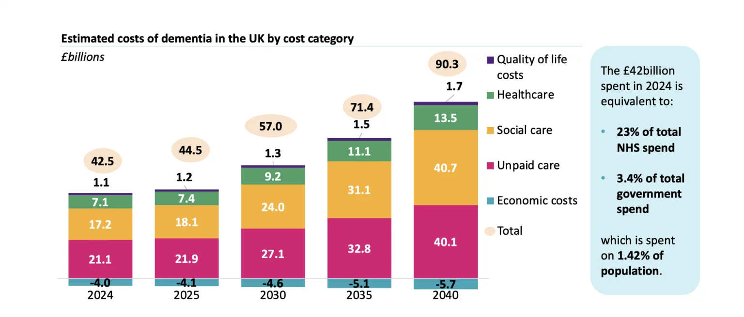
Figure: Estimated Costs of Dementia in UK; Source: (Baxter and Baxter, 2024)

The Problem: Why Communication Support Is Critical
Communication impairment is one of the significant barriers to offering safe, person-centred care to people with dementia (Wittenberg, Mann and Sullivan, 2024). They may have difficulty in expressing pain, anxiety, basic needs such as hunger, thirst or toileting as cognitive impairment progresses. Absence of recognition of distress signs may lead to agitation, behavioural problems, unnecessary hospitalisation and low quality of life. The carers (professional and informal) state that one of their most significant issues and a major cause of burnout is the interpretation of non-verbal cues.

The available tools, such as communication charts, speech and language therapy, or behavioural observation logs, are generally reactive, unequal, and very dependent on human resources. In the same vein, the majority of interventions are announced after the crisis occurs (Hockley et al., 2025). The health and social care industry requires a proactive, technology-based solution that provides real-time information on emotional or physical needs at a stage when the distress level is not too high. Much closer to this requirement, CareConnect AI is an artificial intelligence-based solution. It integrates behavioural analytics, wearable sensors, and machine learning to identify patterns and alert carers early enough to make evidence-based, compassionate decisions.

The Innovation: What CareConnect AI Provides
CareConnect AI will be developed as an online communication support tool for people with dementia. It is powered by AI behaviour recognition, in-wear or room sensors, and a user-friendly care dashboard. The system monitors facial expressions, body movements, alterations in vocal tone, agitation, sleep disorders, and physiological indicators. In case of any signs of discomfort or premature agitation, the AI alerts the carers' devices in real time, and the interventions offered follow established best practices. The system will warn you, e.g., by notifying: “Resident may be thirsty. Please check hydration” or “Indicators of emotional distress detected—consider offering reassurance or engaging in preferred activities.” Such an approach does not exclude human care; on the contrary, it improves it by providing personalised information at the right time.

Health and Wellbeing Impact
Farmers with dementia, particularly those at moderate and severe stages of the disease who experience communication difficulties, are the primary users of CareConnect AI. The system contributes to reducing distress and can identify unmet needs early, enhancing emotional wellbeing, dignity, and autonomy. Individuals are less likely to experience preventable crises, such as protracted agitation or behavioural outbursts, which can be traumatising and disorienting (NHS.UK, 2023).

The innovation provides relief and usefulness to the carers, whether they are professionals or relatives. It reduces the mental and physical pressure that involves guessing what an individual may be trying to say. There will be more confident, compassionate, and focused care, with carers providing more instructions. Better working conditions and healthier workers also lead to higher retention in the social care sector, which is already under pressure for staffing.

On a larger scale, safer service delivery, reduced unwarranted hospitalisation, and better community-based dementia services are the positive effects of the innovation on the common good. Regularly identified communication needs will help people stay independent a bit longer and reduce social isolation and the explosion of acute services (Wittenberg, Mann and Sullivan, 2024).

Policy, Law and Alignment to the professionals
CareConnect AI aligns with the current priorities of the UK health and social care system, such as the NHS Long-Term Plan. This emphasises the use of digital health technologies to provide more personalised care and improve outcomes for people with dementia (NHS.UK, 2023). The system follows the principles of NICE dementia care, which suggests person-centred needs-based approaches grounded in observational knowledge.

Because the innovation collects behavioural and biometric data, it fully adheres to the Data Protection Act 2018 (UK GDPR), which prioritises lawful processing, encryption, consent, and privacy protection. For example, professional accountability is cultivated through orientation to protection frameworks to ensure ethical use of vulnerable adults.

The AI component would also be checked against the NHS Digital Technology Assessment Criteria (DTAC) to ensure clinical safety, technical security, usability, and accessibility. If CareConnect AI is a software medical device, it would be in line with the relevant UK Medical Device Regulations, including risk management and post-market monitoring.

Type of professional services
CareConnect AI requires collaboration between multiple teams of professionals to be implemented. Experts also inform the behavioural models of dementia which are clinical in nature. Speech, language, and occupational therapists may provide knowledge of communication strategies to ensure that alerts and recommended interventions are based on best practice. Social workers and community dementia teams can help integrate the tool into care pathways so it is available beyond a clinical context.

Digital health teams facilitate installation, training and technical support. The primary participants in the system are carers, nurses, and family support workers, who can utilise real-time insights in their daily work. According to this model, multidisciplinary care for dementia is improved, and service users' experience guides innovation.

Community Involvement and Community Engagement
The stakeholders, that is, ordinary people, can play an essential role in the adoption of CareConnect AI. Research campaigns: Community members will participate in research campaigns to highlight the importance of early communication support for people with dementia and how technology can supplement human care rather than replace it. Families with loved ones at home may be particularly interested in the devices, which can comfort and guide them during challenging moments.

Community support groups, community hubs, GP practices, dementia cafes, and even advocacy organisations such as the Alzheimer Society are all critical solutions to building awareness. Given that dementia affects either directly or indirectly millions of people, the involvement of the people is not only normalising the use of the supportive technology but also improves cognitive awareness of the communication challenges within society. Empathy, inclusion, and a proactive care culture are also believed in through the promotion of community-level engagement (NHS.UK, 2023).

Conclusion
CareConnect AI is a creative, requirements-driven, visionary solution to a long-standing, massively problematic area of dementia care. The system enhances communication, promotes dignity, and wellbeing by using artificial intelligence to analyse behavioural indicators and alert carers when distress levels are beginning to rise. The technology helps strengthen professional practice, aid families, reduce unnecessary admissions, and address national policy priorities for digitally enabled person-centred care. As the condition of dementia becomes more widespread, CareConnect AI will deliver timely, transformative support, helping improve the lives of people, reduce the number of carers, and transform the health and social care system into a more caring, more resilient entity.

Reference list
Baxter, V. and Baxter, V. (2024) Investing in the Dementia Age - CF, CF. Available at: https://www.carnallfarrar.com/investing-in-the-dementia-age/.
Hockley, A., Moll, D., Littlejohns, J., Collett, Z. and Henshall, C. (2025) ‘Access to communication support for community-dwelling people with dementia: A mixed methods study exploring local perspectives within the United Kingdom context’, Age and Ageing, 54(6). Available at: https://doi.org/10.1093/ageing/afaf150.
Jones, M. (2023) Dementia is the UK’s biggest killer – we need political action to save lives, Alzheimer’s Research UK. Available at: https://www.alzheimersresearchuk.org/news/dementia-is-the-uks-biggest-killer-we-need-political-action-to-save-lives/.
LSE (2024) DEMENTIA AND INEQUALITY. Available at: https://www.lse.ac.uk/cpec/assets/documents/CPEC-briefing-1-Dementia-and-inequality.pdf.
NHS.UK (2023) Communicating with someone with dementia, nhs.uk. Available at: https://www.nhs.uk/conditions/dementia/living-with-dementia/communication.
Wittenberg, E., Mann, C. and Sullivan, S.S. (2024) ‘Exploring Communication Challenges in Dementia Care: Insights from Home Healthcare Nurses’, Patient Education and Counseling, 131, pp. 108590–108590. Available at: https://doi.org/10.1016/j.pec.2024.108590.

