A Comparison of The Marketing Methods of Two Multinational Hotel Brands

  - Ionel Babache
  - 2241659
  - Marketing Essentials BMIH4005
  - Gayathri Senanayake Mudiyanselge

In today's highly competitive global hospitality sector, multinational hotel corporations use a wide range of promotional methods to entice and keep customers with them. The focus of this research is on analysing and contrasting the marketing approaches utilised by two well-known international hotel chains, namely Six Senses and Holiday Inn, in order to draw conclusions and draw comparisons between them. Both Holiday Inn and Six Senses cater to separate yet complimentary demographics of customers. The purpose of this comparison is to shed light on the ways in which the marketing strategies of the two organisations are similar to one another as well as the ways in which they differ, including promotional techniques, brand positioning, target market selection, and overall marketing effectiveness.
Two of the most recognisable names in the hotel chain industry are Holiday Inn and Six Senses. Six Senses is able to provide luxurious lodgings in an unusual settings because of its commitment to preserving the environment, promoting health, and fostering innovation. As a result of their dedication to preserving the natural environment and maintaining excellent service standards, they have become the destination of choice for tourists who are looking for something that is really one of a kind (Stojanovic, Andreu, & Curras-Perez, 2018). On the other hand, Holiday Inn has been around for such a long time because of the exceptional quality and competitive prices of the lodgings it provides. The ideal consumer places a high value on both the cost and the convenience of the products and services they purchase. Despite having a Facebook rating that is far lower than average, Holiday Inn continues to bring in a significant number of customers. The hotel's success can most likely be attributed to its competitive rates while maintaining a consistently high level of quality (Syrdal & Briggs, 2018).
Product, pricing, location, and promotion are the four components that makeup Holiday Inn's marketing formula. Holiday Inn offers an outstanding product (rooms that are clean and priced affordably), pricing (rates that are affordable), location (many locations), and promotion (a new website, partnerships, and social media). The "product," "price," "place," and "promotion" (PPP) are the four pillars that comprise the marketing mix approach of Six Senses. Six Senses is a global hospitality firm that operates luxurious resorts for vacationers to stay at in remote areas of the world (Ray, 2019). The clientele that Six Senses caters to is rich individuals who are prepared to pay a higher price for luxurious and ethical vacations. Location is always a top priority for Six Senses, which is why all of its hotels are usually situated in very visible areas. Content marketing, social media, and strategic alliances are the promotional channels that Six Senses utilises to spread awareness of its brand and product offerings (Shanahan & Tran, 2019).
The PESTEL framework is a useful tool for conducting an assessment of an organization's susceptibility to the effects of environmental risks. Hotel Six Senses gives more consideration to nations that have well-established legal systems, healthy economy, innovative technologies, and pristine natural surroundings. In addition to complying with all necessary municipal, state, and federal standards, the hotel prioritises environmental responsibility, provides a safe and comfortable environment for guests, and takes advantage of advantageous political and economic situations (Hall, 2022). This examination focuses primarily on the political and economic stability of the Holiday Inn, as well as economic trends, social elements, and advancements in both technology and the law. (Peterdy, 2023).
The strengths and weaknesses of the scenario are taken into consideration in the SWOT analysis. The hotel offers a wide variety of perks, some of which include upscale branding, eco-friendly business practices, and individualised service. However, because there is no identifiable brand attached to it, the price is exorbitant (Shareef, Mukerji, Dwivedi, & Rana, 2019). Opportunities can be found in both the increasing number of people interested in ecotourism and the severe competition from other hotels. Holiday Inn offers several appealing qualities, such as affordable rates, a vast number of locations, and customer-loyalty programmes; on the other hand, it has a reputation for not being very opulent and there is a chance that the quality of its accommodations may vary. Catering to such a diversified customer base may be difficult due to changeable consumer tastes and pricing rivalry (Parsons, 2018).
Through articles and various social media platforms, Six Senses promotes both its brand and its products (Magno & Cassia, 2019). On the other side, Holiday Inn has invested in a new website and strategic alliances to bring in more customers. These hotels have begun providing training on diversity, equality, and inclusion to all of their employees as a direct response to the racial justice movement as well as new rules governing safety. This involves the deployment of contactless check-in as well as an increase in the frequency with which guest rooms are cleaned (McShane, Pancer, & Poole, 2019).
Both Six Senses and Holiday Inn attract the majority of their clients, who are tourists, through a variety of kinds of promotions. its consumers come from all over the world. This idea is depicted in "Bowman's Strategy Clock" (TH, 2023). Six Senses attracts individuals with more disposable income who are willing to splurge on unique, high-end, and environmentally conscious activities, whereas Holiday Inn targets those on a tighter budget who are looking for a straightforward and effective hotel. Holiday Inn targets high-spending consumers willing to spring for high-quality, upscale, and eco-friendly services. In their respective marketing strategies, both businesses put an emphasis on segmentation as well as targeting and positioning (Bowman & Faulkner, 2023).
The well-being of our guests is of the utmost importance to us, and act accordingly. The struggle for racial justice is one illustration of how these shifts were brought about in reaction to the problems of the modern era. Political difficulties, such as ever-changing rules and the aftermath of foreign conflicts, have impacted both Six Senses and Holiday Inn, leading to these negative outcomes. In order for these hotels to stay competitive and continue to deliver excellent experiences for their guests, they must negotiate political situations, adapt to newly enacted regulations, and handle disruptions (Quinn & Epstein, 2019).
Comparison and comparison should be done between the advertisements for Six Senses and Holiday Inn based on factors that are relevant to the audiences that each brand is trying to reach. According to Figure 2 in the appendix, Six Senses caters to rich people with disposable cash who have an interest in luxury experiences that are also cognizant of the environment. The company promotes its eco-friendly and healthy products through content marketing and social media. Holiday Inn, on the other hand, caters to budget-conscious, comfort- and convenience-oriented guests who place a premium on luxury. To attract more frugal customers, the company is investing in a new website and establishing partnerships with online travel agencies (Laurell, Sandström, Berthold, & Larsson, 2019).
Utilising SWOT analysis, every hotel chain has designed its very own one-of-a-kind strategy for the marketing of its brands. By utilising the perceptual map (see Diagram 2 in the appendix), we are able to observe that Six Senses pulls in wealthy customers by offering them services that are not only unique but also kind to the environment. This combination of benefits helps Six Senses stand out from its competitors. In the not-too-distant future, the corporation will utilise this as a promotional instrument. It presents itself as an improved option that is to the advantage of the world and the people who live in it. Because of its low prices and a good level of service, the Holiday Inn is a hotel that many tourists who are on a tight budget choose to stay at. The establishment of Six Senses' is a way of demonstrating its dedication to the responsible management of the environment (Kenton, 2023).
It has been stated that customers have been increasingly outspoken over the course of the past several years, prompting firms to take a stand on controversial matters. The advent of digital and social media marketing has had a significant impact on the manner in which businesses interact with their customers. Social media platforms such as Facebook, Twitter, Instagram, and LinkedIn have enabled businesses to engage in two-way conversations with the consumers they are attempting to persuade to purchase their products (Syrdal & Briggs, 2018).
If Six Senses desires to preserve its image as a provider of high-quality services, it is imperative that it places a high level of importance on content marketing and social media. If the company had deeper links to key persons in the tourist sector, it is feasible that the company's brand might enjoy a greater degree of market domination. Holiday Inn's website might be improved by making it simpler to use and by including visual representations of the brand's offerings. Tourists who are looking to negotiate lower costs may direct their attention to online travel firms (McShane, et al., 2019).
In conclusion, the digital marketing campaigns that were carried out by the two businesses were fruitful as a result of the unique strategies that were used in order to successfully target the demographics that were exclusive to each company. Despite the fact that each organisation used a different method, this outcome was nonetheless attained. Holiday Inn has not placed as much of a focus as Six Senses does on the use of social media and other forms of influencer marketing. Every piece of marketing collateral that companies use emphasises their care for the environment and commitment to preserving natural resources. According to the findings, Six Senses should proceed with the advertising plan it has been using up until now in order to continue growing its clientele. Either the firm may actively pursue prominent placement on trip registration systems or it could establish partnerships with airlines and travel providers.

References
Bowman, C. & Faulkner, D., 2023. Bowman’s Strategic Clock: Give Your Product the Market Position it deserves. [Online]
Available at: https://bstrategyhub.com/bowmans-strategic-clock-give-your-product-the-market-position-it-deserves/
Hall, M., 2022. Porter's 5 Forces vs. PESTLE Analysis: What's the Difference?. [Online]
Available at: https://www.investopedia.com/ask/answers/041015/whats-difference-between-porters-5-forces-and-pestle-analysis.asp
Kenton, W., 2023. SWOT Analysis: How To With Table and Example. [Online]
Available at: https://www.investopedia.com/contributors/53661/
Laurell, C., Sandström, C., Berthold, A. & Larsson, D., 2019. Exploring barriers to adoption of Virtual Reality through Social Media Analytics and Machine Learning - an assessment of technology, network, price and trialability. Journal of Business Research, pp. pp. 469-474.
Magno, F. & Cassia, F., 2019. Establishing thought leadership through social media in B2B settings. Effects on customer relationship performance Journal of Business and Industrial Marketing.
McShane, L., Pancer, E. & Poole, M., 2019. The influence of B to B social media message features on brand engagement: A fluency perspective. Journal of Business-to-Business Marketing, pp. pp. 1-18.
Parsons, A., 2018. Lepkowska-White Social media marketing management: A conceptual framework. Journal of Internet Commerce, pp. pp. 81-95.
Peterdy, K., 2023. PESTEL Analysis. [Online]
Available at: https://corporatefinanceinstitute.com/resources/management/pestel-analysis/
Quinn, K. & Epstein, D., 2019. #MyPrivacy: How users think about social media privacy. Proceedings of the International Conference on Social Media & Society, pp. pp. 360-364.
Ray, L., 2019. Google’s algorithm undergoes enormous shifts to prioritise content focused on expertise, authoritativeness and trustworthiness. Journal of Digital & Social Media Marketing, pp. pp. 128-136.
Shanahan, T. & Tran, T., 2019. Taylor Getting to know you: Social media personalization as a means of enhancing brand loyalty and perceived quality. Journal of Retailing and Consumer Services, pp. pp. 57-65.
Shareef, M., Mukerji, B., Dwivedi, Y. & Rana, N., 2019. Islam Social media marketing: Comparative effect of advertisement sources. Journal of Retailing and Consumer Services, 46 , pp. pp. 58-69.
Stojanovic, Andreu, L. & Curras-Perez, R., 2018. Effects of the intensity of use of social media on brand equity. European Journal of Management and Business Economics, pp. pp. 83-100.
Syrdal, H. & Briggs, E., 2018. Engagement with social media content. A qualitative exploration The Journal of Marketing Theory and Practice, pp. 26 (1-2), pp. 4-22.
TH, 2023. Bowman Strategy Clock. [Online]
Available at: https://www.toolshero.com/strategy/bowman-strategy-clock/

Appendix
      - 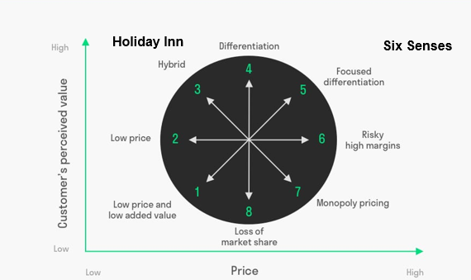
      - 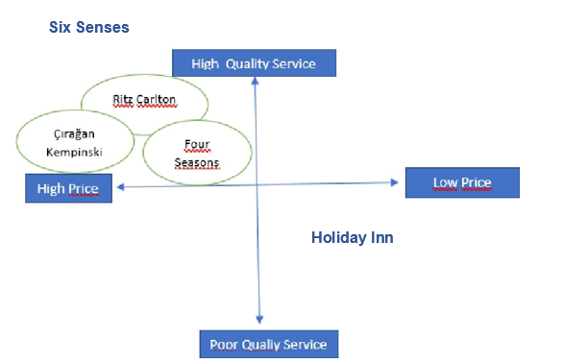
      - 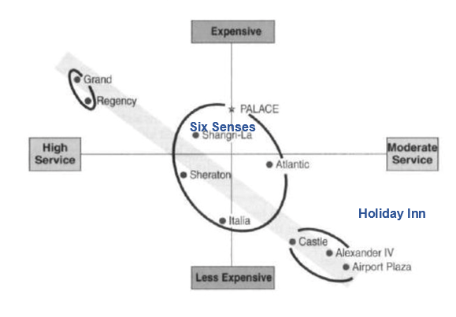

      - 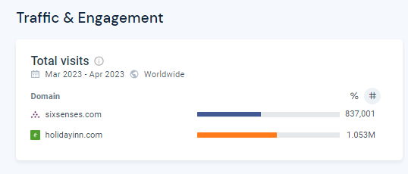

      - 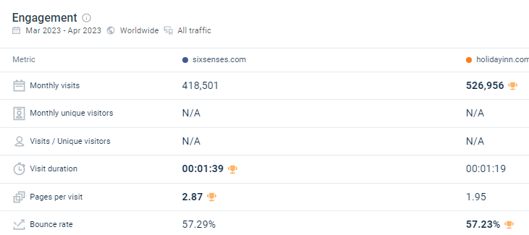

      - 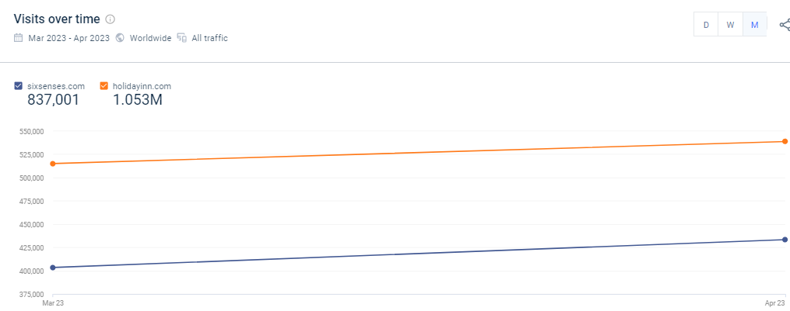

      - 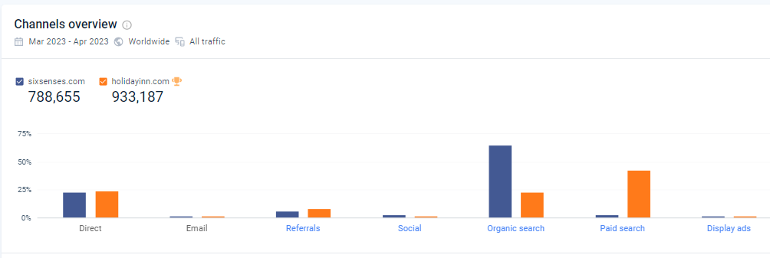

      - 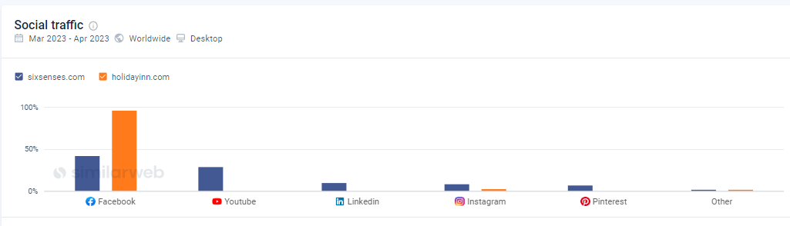

      - 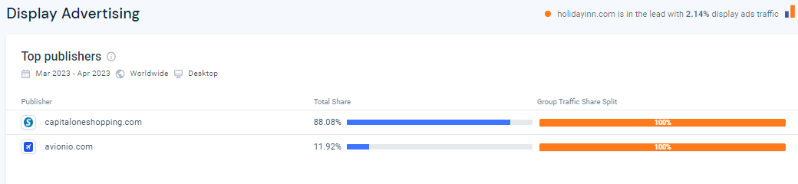

      - 
https://www.jetsetchristina.com/staying-at-the-six-senses-maldives-six-senses-laamu-hotel-review/
      - 
https://www.ihg.com/holidayinnexpress/hotels/us/en/price/pucut/hoteldetail

