Generating business data and analysis (BMSP4004)

George Parker

Dr. Roisin Mullins

4th May 2018
Content

Data analysis report 3
Abstract 3
Carbon usage survey 3
Prosumer survey 13
Swansea business school energy usage 17
Climate data survey 19
Conclusion 24
Bibliography 25

Assignment 2

Data analysis report

Abstract
This assignment begins with the analysis of data from an appliance carbon survey that contains a report on findings that where presented then following with another survey which contains various pieces of data on prosumer companies with analysis on the data found from the results of the survey. Following this there is a critical evaluation upon the data within a data spreadsheet used to show electricity data used on Swansea university campus then there was a comparison of weather data from two thousand and ten against two thousand and eighteen.

Carbon usage survey

This report begins with a carbon usage survey using data from nineteen individuals that took part within the survey on what household appliance they owned then using the data to draw conclusions. The house hold appliance survey is made up of two parts, the first is a data table containing a range of fifteen different common household appliances from microwave ovens to low energy lightbulbs. Then there is information on how often during a year the products are used as well as an assumption made about each household item, for example a microwave oven has a usage of ninety six times a year with the assumption of using 0.945 kilowatt hours per use. Following this there is cost per year and Co2 per year measured in kilograms and next to this there columns ranging from ‘s1’ to ‘s19’ there represent the nineteen students that took part in the survey, within these columns the data is shown as either a singular number or a zero with one representing a yes meaning that the participant in question owns a given number of the appliance in question and zero meaning that the participant does not own one of the household appliances. After being presented with this data the first step was to ‘scrub’ it meaning to organize that data into a way that was readable without containing any repeating data that was not required as well as the separation of both tables onto different sheets as to simplify the process further (Dasu & Johnson, 2003). With is data given there is much that can be done and achieved by using excel tools, the first was to calculate the total number of products owned per person. This was done using SUM followed by highlighting the range of data required then repeating for each participant as can be seen below (Ragsdale, n.d.).

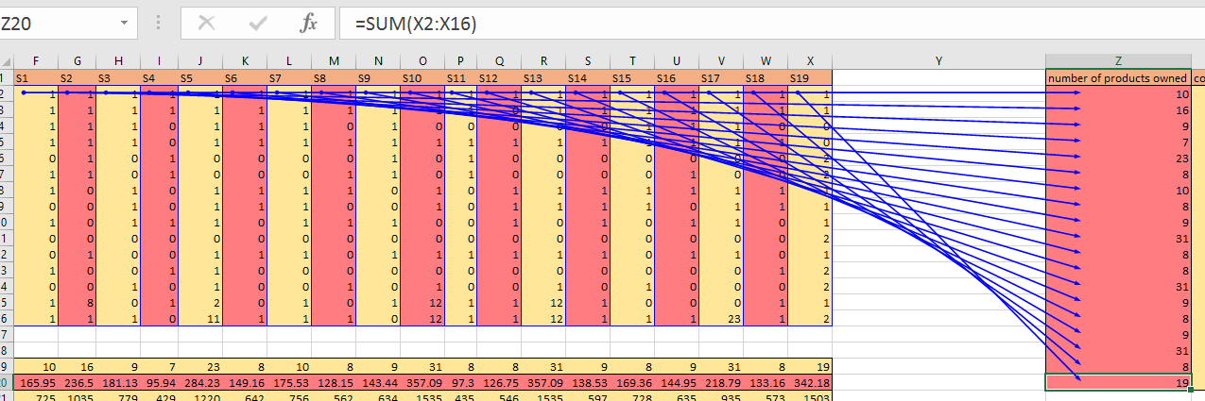

This data allows us to the work out other useful facts about the data sheet such as being able to calculate that the total number of products owned is two hundred and sixty two with an average of 13.79 products per person. The data also shows through filtering that the maximum number of products that a person within the survey owns is 31 and the minimum number of products is 7.
Following this, the cost per person was calculated using the cost given then times by the number of the product owned in most cases each person only owns one of each product apart from light bulbs where it is common for the participants to have multiple. Both of these methods can be seen bellow with the first only containing pluses as the participant only owned one of each product and the second shows a mixture of both pluses and times with the times sums within self-contained brackets (Evans, n.d.).
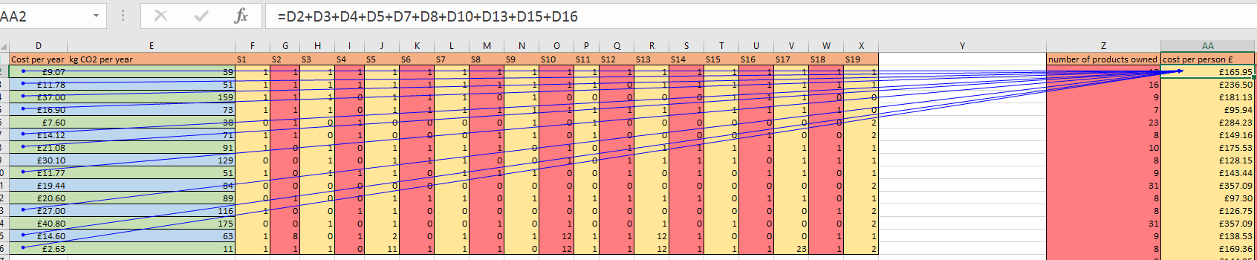
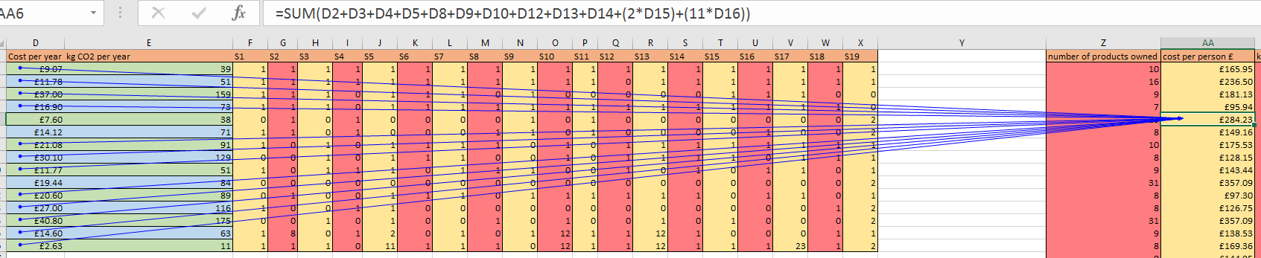
From this data it is now possible to work out the total cost of all devices which is £3,645.23 with an average cost per person of £191.85. Then from filtering the data it shows that the maximum cost of a person’s appliances is £357.09 and a minimum cost of £95.94.

The next step is to calculate the total number of kilograms of carbon per year this is done in the same way as calculating the total cost per person but instead of using cost per year this used kilograms of carbon per year and required the same functions to be used as seen bellow.
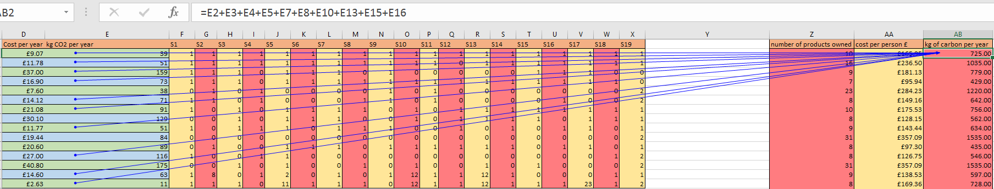
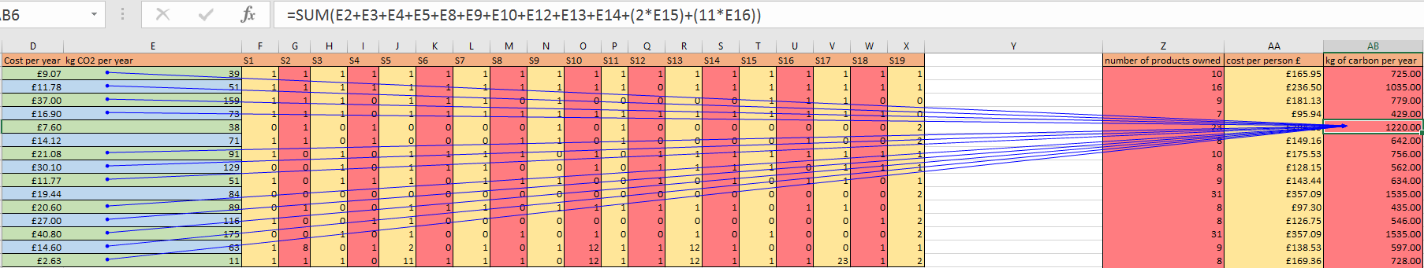

This data shows that the total number of kilograms of carbon dioxide produced is 15,804.00 kg by the participants whilst on average amount of carbon produced each individual produces 831.79kg a year with the largest amount of carbon produced by an individual in a year is 1535.00kg and the lowest amount of carbon produced by an individual in a year being 435.00kg of carbon. This can be seen in the image bellow along with the filters used to find the maximum and minimum.
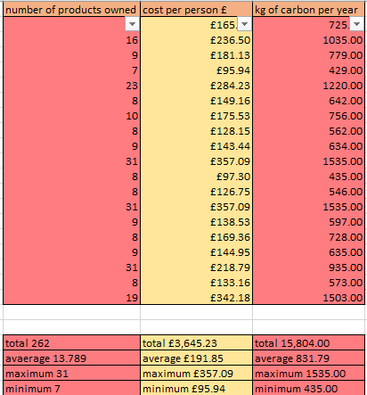

With the information collected it can be presented in a more visual format meaning that it will be easier to understand and read that extrapolating data from a spreadsheet, the first graph created is a graph to show number of products per person as seen below.

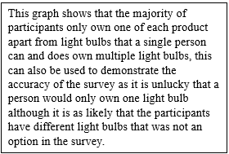
After this a graph was created another was made to show the relationship between the number of products a person owns and the amount spent on their products and another graph to show the relationship between the number of products a person owns and the about of Co2 produced by the products per year.

Even though the data on these graphs are simple to understand they help to confirm that the more products that you own the higher the cost and the higher the Co2 produced will be. This relationship is explored further in the final two graphs which both are scatter graphs to visually demonstrate the relationship between cost and Co2 (Evans, n.d.).

The first graph shows cost against Co2 per year in total and the second graph shows cost per year against Co2 per year per person to see if there is a difference between sets of data and if so what is the difference, the first graph has a R² value of 0.9964 which is incredibly accurate and close to an R² value of one. And the second graphs was found to have an R² value of 0.9993 which is even more accurate as it is only 0.0007 away from an R² value of one.
The second part of the carbon usage survey begins again with appliance although all of the appliances within this survey are different types of televisions, the next Colum shows the usage data for each appliance as to how only they are on each day as well as for how long each day they are on standby. Next to this there is energy used per use measured in watts then there is cost per year of each singular device and this is then followed by the amount of Co2 produced per year measured in kilograms, also following this there is a range of data from ‘s1’ to ‘s19’ with the range representing the number of students taking part in the survey as can be seen below.

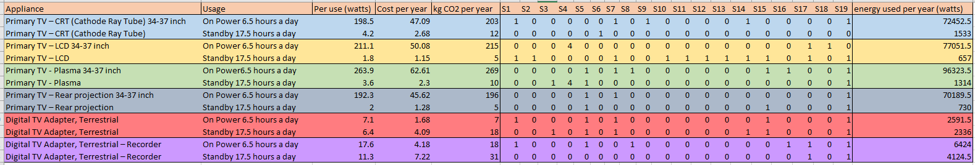

After scrubbing the data into a format that was easier to work with the first thing done was to calculate the energy used per year to find out how many watts of electricity where produced by each device each year.

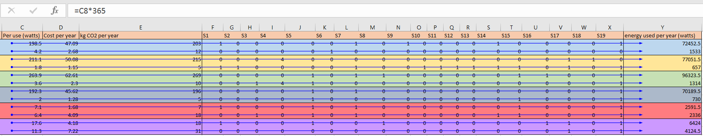

Finding the amount of energy used per year was done by multiplying electricity used per use (watts) by 365 as there are 365 days in a year to work out the total energy used per year from this the total number of watts from all device over a year can be calculated as well as the average, the total being 335,727 watts and the average being 27,977.25 watts as it can also been seen below.
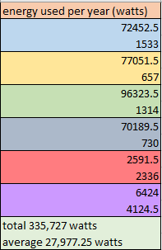
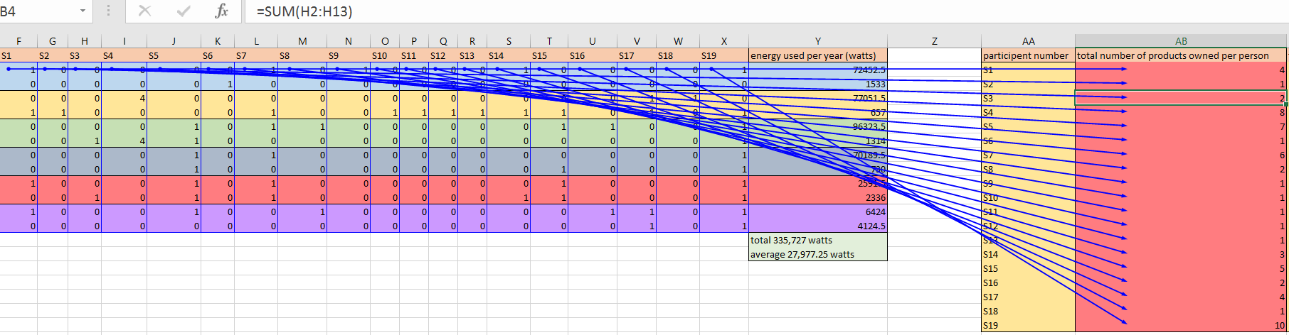

After this a simple cum was used to work out the number of products owned per person as it can be seen above, The next step taken was to calculate the total energy used per person per year in watts this was done using sum to add together the energy used per year for each of the devices that the participant owned and can be seen bellow.

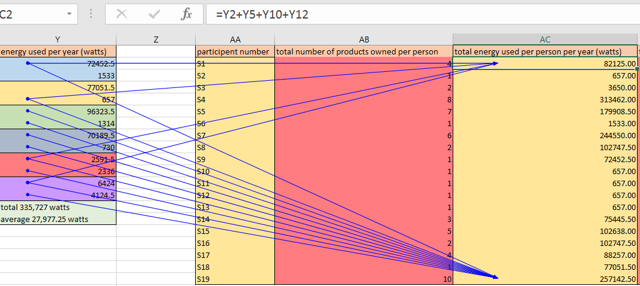
The next two steps are similar as they require an almost identical formula this first is to calculate the total cost per person per year and this was done adding the cost per year of each device that a participant had together as is seen in the first image below. The next step is to work out the total amount of Co2 per person in a year measured in kilograms, this is done by adding together all of the Co2 produced for each individual device that the participant owns together as can be seen in the second image below.
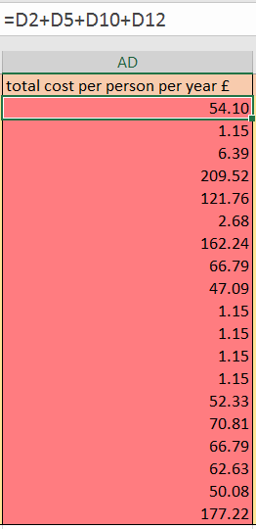
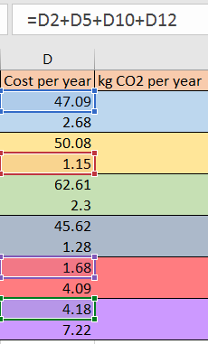

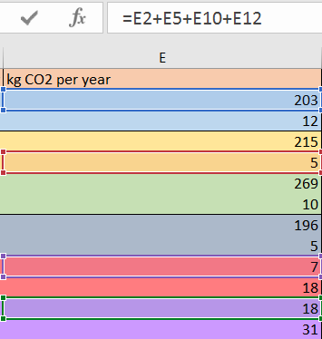
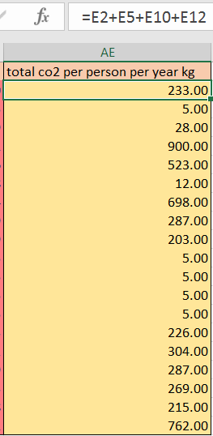

From the data gathered and crated above it allows us to extrapolate even more information such as the total figures for each data group as well as the average amount for each data group. Following this we can also calculate the maximum values as well as the minimum values as can be seen bellow.
Following this the next stage is to create graphs for a more visually simple version of information transfer beginning with the one bellow, the first graph shows the number of appliances owned by each participant of the survey. The graph shows that most survey participants only own one of each device except for a single person who owns four of two devices.

Secondly there is a bar graph to show the number of appliances owned per person and another to visually express the total cost per year per person, this graph can be compared and contrasted with another graph named total Co2 per person per year in kilograms to see the relationship between number of appliances owned and Co2 produced.

Finally there is a scatter graph to show another relationship this one being between cost per year and Co2 produced per year, the graph shows a liner relationship between the two variables meaning that as one increases so does the other. The graph has an R2 value that is exactly one and this has been further checked by using the equation y = 4.2978_{x} + 0.0496.

Prosumer survey

The prosumer survey relates to products that are designed with the assistance of users so that the product can better suit its desired propose which has a much larger benefit for the customer as it will work more efficiently and benefit the creator as sales will increase. The first stage to carry out for the survey is to ‘scrub’ and correct the provided data into a way that is easier for the reader to understand and read for analysing the data. This process is then repeated for the knowledge sharing sheet, incentives sheet and ICT sheet (Frayssé & O'Neil, n.d.).

Below is an image of how the data looks within its final scrubbed format.
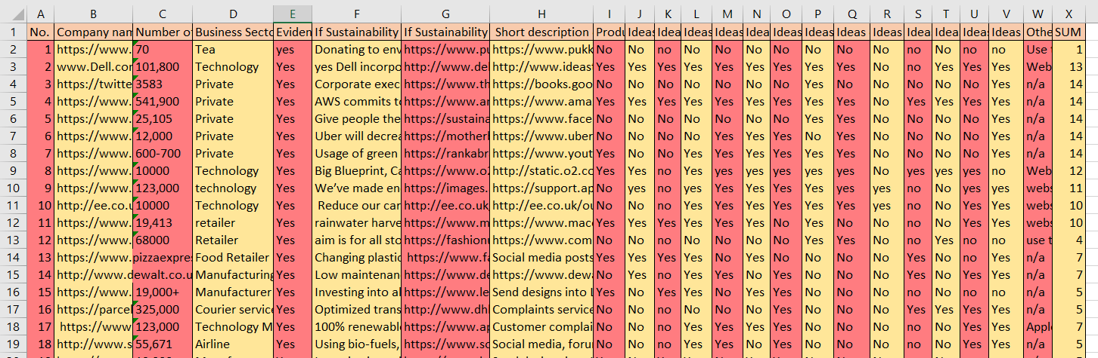

During this survey there where one hundred and twenty two companies analysed to see if and they are doing in relation to prosumers within their marker area (Pa?kowska, 2013). By collecting this data the first purpose of this survey has been reached. To identify which when prosumer knowledge is used in the creation of a product there has to be a filter applied allowing for the separation of data with and without prosumer considerations, this is done on the business processes sheet by applying filters to allow the separation of ‘yes’ and ‘no’ cells within a selected data range as seen below.

Filtering for only the ‘yes’ values in the range of products or its parts designed allows us to see which products or parts were designed with prosumerism in mind.

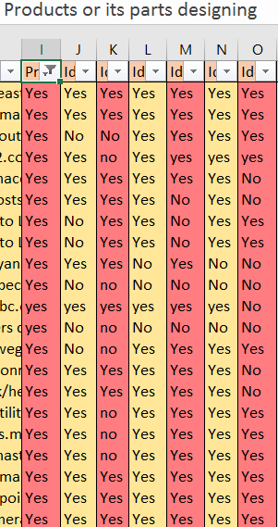
When companies and organisations are looking to improve their prosumer methods there are a range of shared processes that occur, the knowledge sharing sheet is where this data can be located. The processes of knowledge sharing include evaluating products by scoring them against others to see how well they are doing, commenting on products both positively and negatively to critically analyse them. Testing a product with consumers also allows for the product to evolve in a prosumerist way.
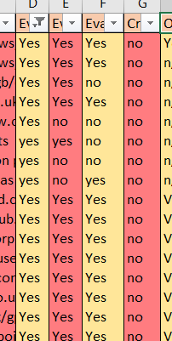
From filters the total can then be calculated from each data set allowing for the creation of graphs and other visual models, the totals for each page can be seen bellow.

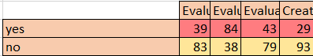

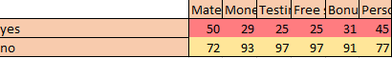

Below are two graphs the first shows total data for prosumer business processes in the form of a bar graph whilst the second graph is a line graph that shows the liner relation of the yes values of the business, the R² value of the graph is 0.0771 which is the most accurate R² value available and this has been checked using the equation y = -0.9187_{x} + 63.604.

The graphs below show the relationship between the yes and no vales for prosumer knowledge sharing, prosumer incentives and ICT used by different prosumers. Across all graphs it shows that the most common answer is no by most companies as to indicate that there is not enough focused by the businesses studied on prosumerism.

Swansea business school energy usage

The Swansea business school energy usage survey shows the energy data collected by Swansea business school campuses between the 31st of December two thousand and twelve the 14th of august two thousand and seventeen. The data itself is measured every thirty minutes beginning at 00:30 continuing on thirty minute intervals until 00:00 then repeating the next day. It is important to note that all energy is measured in Kilo Watt Hours or Kwh for short.
The first stage of the process was to remove the vast amounts of redundant data from the spreadsheet as can be seen below (Wang, Zaki & Toivonen, n.d.).

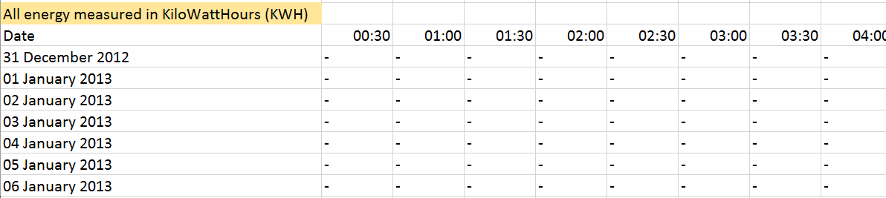

By doing this the amount of redundant data is vastly removed so now the spreadsheet looks as it does below.
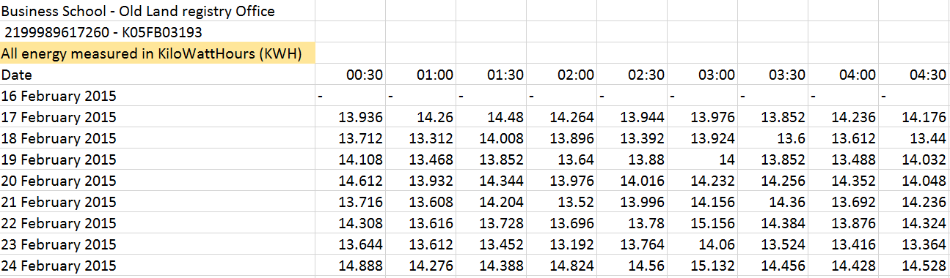
Resulting from the vast size of the data file it means that creating graphs from the raw data is incredibly difficult, to overcome this issue pivot tables are a necessity for organisation and extracting data. To show the usefulness of pivot tables there is a pivot table which compares the energy used at noon totalled into months then compared with all other months in the year, it if further possible to change the year to draw conclusions on how energy usage changes yearly as can be seen below.
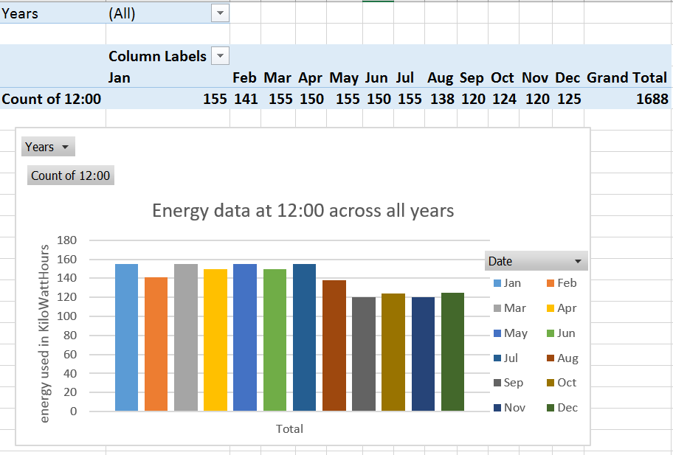
Pivot tables are easy to change and reformat as is evident by the following pivot table that is set to show 09:00 data across a year, this table also makes it easy to change between years for a cross comparison as well as showing the total amount of energy used across a year for further comparison.
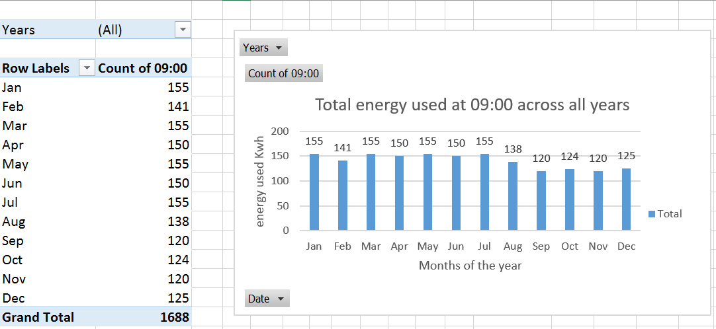

Climate data survey

The final part of the assignment is a survey comparison of weather data from 2010 and 2018 to find the relationship between the data between the two different years of data. The first step in this data file was to complete both sets of data by using the information provided to create the columns nightly air frost, grass growing conditions and state of precipitation. Nightly air frost was created using the formula =IF (Low temperature<=0, “night air frost”,””) to get the results shown below.
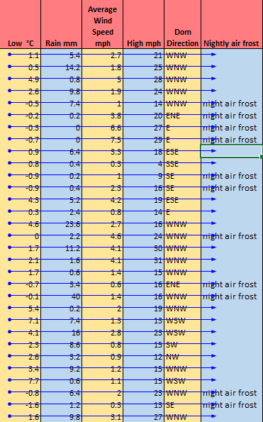
The column grass growing conditions is calculated using the formula of = IF(high temperature >=6,”grass will grow”,””) as it shows bellow.
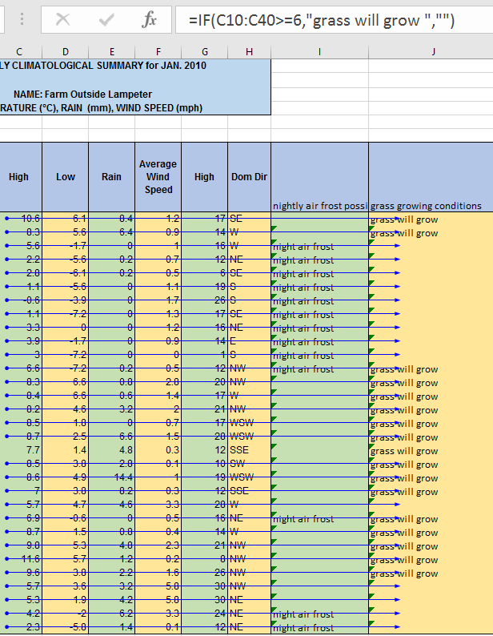
For the third column, state of precipitation a double IF function is used they expression of which is =IF (low temperature<=1, IF (rainfall >0,”snow”,”dry”), (“rain”)) and is shown below.
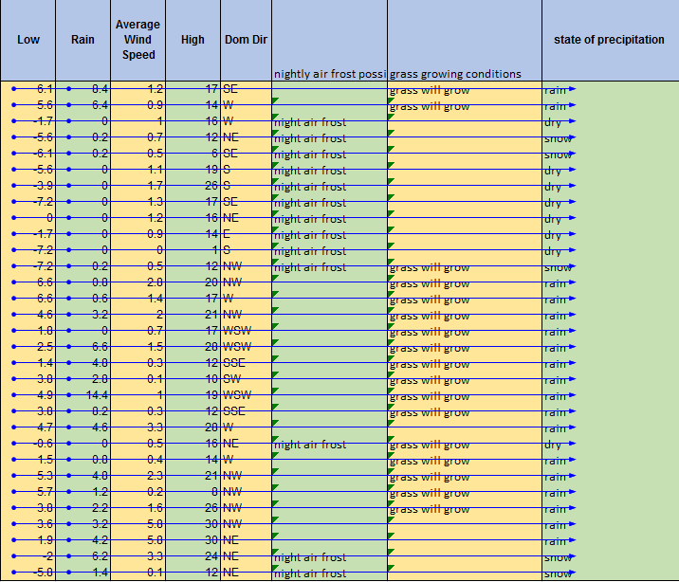

After this data was collected the totals, averages, maximums and minimums could be calculated for 2010 and 2018 as seen bellow.

Following the collection of this data the information from 2010 and 2018 where merged into one table for the creation of graphs and comparison of data.

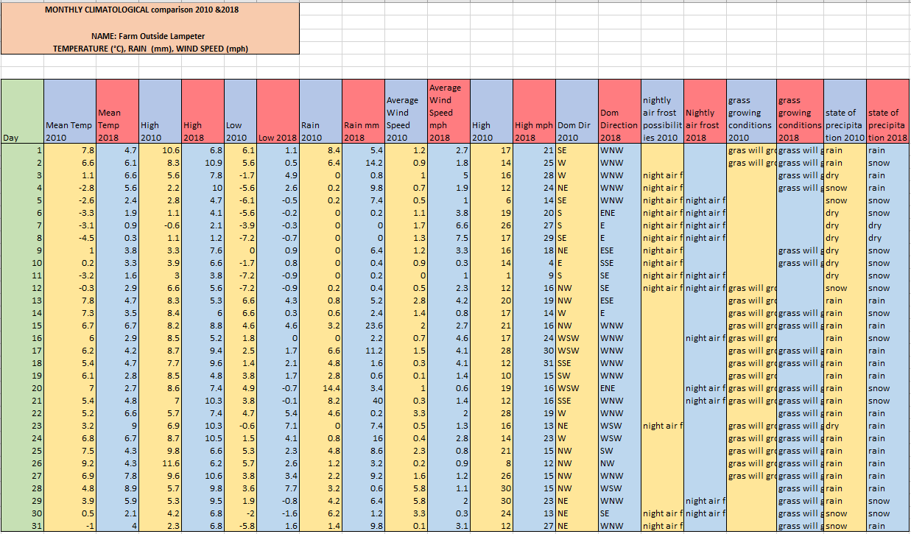

There is a wide range of information that can be drawn from this which has been presented in a graph format (Business Statistics for Competitive Advantage with Excel 2010, 2012) as can be seen below with the first three graphs showing the temperature difference between 2010 and 2018 and bellow that are graphs to show rainfall and wind speed from both 2010 and 2018.
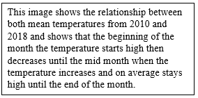

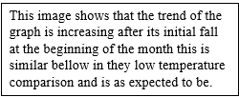

Conclusion

In conclusion from the analysis of the sets of data it proves that excel works well as a medium for data analysis because it allows for the removal of redundant data and sorting of required data into their necessary fields, this means that data becomes easy to manage, view and read for all parties using the excel program involved. Although excel can be difficult to come to grips with initially and requires time to formularise yourself with the functions of the spreadsheet, although the customisation allowed by the spreadsheet allows for this to be simplified dramatically.

Bibliography

Dasu, T., & Johnson, T. (2003). Exploratory data mining and data cleaning. Hoboken, NJ: John Wiley & Son.
Evans, J. Business analytics.
Frayssé, O., & O'Neil, M. Digital labour and prosumer capitalism.
Pa?kowska, M. (2013). Frameworks of IT Prosumption for Business Development. IGI Global.
Ragsdale, C. Spreadsheet modeling and decision analysis.
Springer US. (2012). Business Statistics for Competitive Advantage with Excel 2010. Boston, MA.
Wang, J., Zaki, M., & Toivonen, H. Data Mining in Bioinformatics.

