Beth Amie Lewis (2103104)
[Company Name]
Lake District
UK tourism and leisure industry

The focus of this essay is to illustrate what Lake District has to offer as well as it impacts and where it stands.
To categorically define general tourism and leisure provision within the United Kingdom may not be as simple as it may sound. As it is an industry that is known for its complexity.
From the perspective of the UK, From the perspective of The United Nations World Tourism Organisation otherwise known as the UNWTO states that tourism entails the movement of travellers to countries or places not in their usual environment for either business or personal purposes (VisitBritain). Tourism can fall into several categories.
Leisure being one of them, it can be defined as an umbrella principle whereby it is “time when one is not working or occupied: free time” ( Oxford Dictionary). To continue from this, George Torkidlsen suggests that it can be seen as an Activity, state of being, recreation, an all-embracing holistic concept.

As most people are aspiring to reach self- actualisation, Maslow’s Hierarchy of needs showcases this. It is a perfect example of how his idea of basic physiological needs such. As warmth, food etc can be satisfied and therefore allows you to move up the pyramid. All 5 needs are also shown in Appendix 1. As this is a need-based theory it means that travellers will then be motivated to understand and be able to predict future travel patterns and behaviour. It helps to meet the consumer needs; this can then lead to satisfaction which can then help with the future of the market. A theorist called (Freud, 1915) stated that “the conscious mind, which consists of all the mental processes of which we are aware”. He also compared the mind to an iceberg which can be seen in Appendix 2. This theory focuses on Self-gratification. It incorporates the conscience and ideal self. This has changed massively over the years.

Going back to the history of tourism, it can be seen as a global phenomenon. From as early as the 16th century. The grand tour which was undertaken through modern tourism with the offering of new structures.as well as broadening one’s education. Going back to the Victorian era and the grand tour, Lake District was an alternative destination in the 16th century and still to this day.

This is akin to one location in particular, The Lake District. It is a niche provision whereby those who want to travel to wide open areas rather than the confines of inner-city areas can retreat to. It is extremely adventure allocentric and home to explorers.
As Lake District is notorious for its mountains, forests and lakes as well as poet William Wordsworth and Beatrix Potter. Avid poets may want to visit for this reason. There are over 200 fell tops with the highest three being Scafell Pike at 978 metres, Scafell at 964 metres and Helvellyn at 950 metres. With 16 largest lakes, Windermere – 14.8 square kilometres, Ullswater 8.9 square kilometres. People who enjoy the outdoors and are one with nature may find the Lake District quite riveting to include families who enjoy this. (Lake District Gov.) Most touristic and historical attractions lie in the south half of the region like Windermere which is a popular destination as it offers water sports, sailing clubs, marinas, and both water and land bases activities. whereas the north offers more natural locations which can be much more appreciated by hikers. Places like Keswick which is a market town and hope to 5000 inhabitants and is centre to paths for serious walkers and climbers.

Lake District is known for its holiday homes and people will invest in property to let. Compared to longer-term lets, holiday lets can be much more profitable. A very rough rule of thumb might be that you can charge the same for a week’s holiday let when in-season as you can for a month’s long-term let” ( property let, Uk)

Lord Clark of Windermere led a campaign in which the goal was to claim the World heritage status for the Lake District. With protection of landscape and the people rather than new activities and facilities. He mentions how 18 million people don’t all come to visit a posh hotel, they would much rather visit the beauty of the place. “Cumbria Tourism has stated that 20% of businesses had already felt the benefit of the World Heritage Status. (BBC,2018)
It has joined the likes of Taj Mahal, Machu Picchu and the Grand Canyon by being awarded the UNESCO WH Status.

Tourism has already been identified as the main source of income for the Lake District Economy. With key locations mostly being National Trust, which is a voluntary conservation organisation. As it is widely known as a charity and being independent of government. it relies solely on income from fees and donations.

With the likes of the Coronavirus figures show that in 2020 there was a decrease in visitors with a loss of around £2bn. As a result of the virus the organisations within the National Park have willingly diversified, innovated and survived. Even though spending more time outdoors has been encouraged throughout the global pandemic, an influx of walkers has caused the natural beauty to become eroded with ecologists warning. Consequently, paths of as little as 300 metres can cost up to £45,000. The weather within the UK has drastically changed which also puts a strain on places like the Lake District which rely on tourists/ visitors. (Guardian,2021)
As there are many environmental issues in association with tourism, the biggest ones being footpath erosion, lakeside erosion and that of air pollution. There are path rangers who have been working incredibly hard in order to repair and build paths. “The National trust has repaired more over 200km of paths damaged by erosion in the past ten years - but we need to complete another 2,000m at a cost of £300,000 to keep the Lake District in good condition for years to come”. (National Trust, 2021)

As discussed earlier, Lake District has benefited over the years. The Butler model has 7 stages; Discovery, involvement, Development, Consolidation, Stagnation, Decline or Rejuvenation. With the investment over the years and the recent standstill with coronavirus. The Lake district in 2020 was in the consolidation and stagnation stage. Where there was a growth in numbers but also a decline. Currently the Lake District is at the stage of Rejuvenation. Whereby investment and modernisation might help improve visitor numbers (Butler, page 7)

The National Trust has 6 lake principles that all link with environmental factors. The first one being protecting the natural and cultural fabric of the lakes. With the responsibility being that of the people, water and wildlife etc. the second principle is working with nature rather than against it, it is about observing and understanding surroundings. Thirdly, adapting to the changing needs of society as the lakes have increasingly become important to people both locally but also nationally, this can include flood prevention. People playing their part within the community. Due to the national trusts aims; to help protect and adapt. The lakes appeal is to “help to look after the landscape, culture and wildlife of the Lakes, so people can find freedom, fresh air and the enriching experience of nature here forever.” (National Trust, 2021).

As previously mentioned, National Trust rely more so on the people such as farmers looking after 21,000 Herdwick sheep which is a native breed. Gifts in shops and legacies help to look after roughly 62,000 hectares of fields. With half a million pound spend on regularly countryside conservation a year.
Social impacts include more job opportunities, tourists can support the community more as it is charity led. By doing this money can go towards improving and conserving areas within the Lake District. To many positives there are always negatives. As previously mentioned by there being many tourists, it can result in footfall. With more people travelling to this destination. It also means there will be more pollution and litter as well as congestion and parking troubles.
In comparison to the Peak District on average there is 13.25 million visitors a year this is significantly lover than that of the lake district. Whilst people come to visit for both nature and adventure. Lake District is a lot more popular. Lake District is an hour away from Blackpool and can easily take away that urban feel.

Recommendations for the future could include promoting the use of public transport more. Making posters more visible when it comes to binning rubbish. Possibly by having more bins, this could help improve how people view this destination. To continue from this, sticking to the paths and not wandering off the beaten track is a perfect way to help keep the Lake District looking its best.

Bibliography

BBC, Call for Lake district protection rather than 'money making' goals. 9th July 2018
Butler, R. (2006) The Tourism Area Life Cycle, Volume 1. Page 7.
https://www.bbc.co.uk/news/uk-england-cumbria-44765903
Lake District, Learning. 2018 https://www.lakedistrict.gov.uk/learning/factsandfigures
National Trust, Lake Appeal https://www.nationaltrust.org.uk/lists/our-principles-for-looking-after-the-lakes
National Trust, lake district features. https://www.nationaltrust.org.uk/features/our-part-in-the-future-of-the-lake-district
The Guardian, Lake District in peril, August 2021. https://www.theguardian.com/uk-news/2021/aug/18/lake-district-climate-emergency-pandemic-walkers
Torkildsen, G. (2005) Leisure and Recreation Management, London : Routledge
Visit Britain, Tourism Introduction https://www.visitbritain.org/introduction-tourism
Investment UK , https://www.propertyinvestmentsuk.co.uk/holiday-lets/

Appendix 1
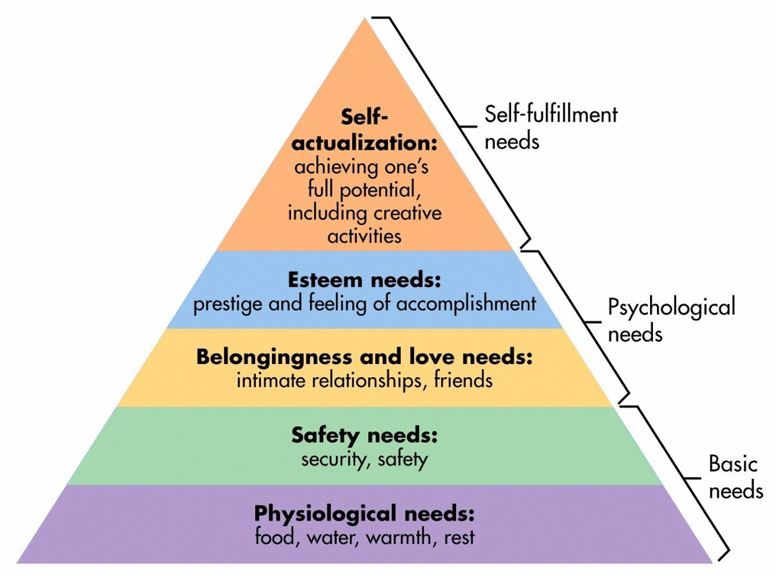

Appendix 2



