QUESTIONNAIRE DESIGN
MOVING MASALA – FOOD TRUCK

KATARZYNA KOLOWROCKA 1805961

Digital Skills and Research Methods BMSK4003
Christian Felices

2019
HP
HP
05.07.2019

The name of your team members:
- Shahidur Rahman 1805959, 1805959@student.uwtsd.ac.uk
- Sanu Miah 1806292, 1806292@student.uwtsd.ac.uk
- Abdul Islam 1806293, 1806293@student.uwtsd.ac.uk
- Mamasir Miah 1805953, 1805953@student.uwtsd.ac.uk
- Katarzyna Kolowrocka 1805961, 1805961@student.uwtsd.ac.uk
Url link to questionnaire:
https://forms.gle/MVQPw2BSEUEwd1638
Relevant password and User name:
Password: kaskol31 User name: 1805961kk@gmai.com

Business:
Moving Masala – food track
Location:
Business Imperial Park in Newport

Introduction

One of the best way to learn about the market and potential customers is by asking questions (McBurney, White, 2010). When market research questions are asked correctly, opportunities to improve market strategy and services can be identified.

The aim of this study was to create a questionnaire form and exam potential customer’s responses before Moving Masala entry on the market. This study is based on a primary research.

Findings

In our survey we have asked 10 questions, 9 of them were closed-ended questions. That gave respondents a fixed set of options to choose from. These closed-ended response choices were multiple choice options and one linear rating scales.
We have decided to ask closed - ended questions as open-ended questions require more effort and time to answer. This survey was conducted anonymously among students and 16 individuals responded to it.

Although this questionnaire was a team work effort and all questions were created together, I have contributed with greeting part of questionnaire.

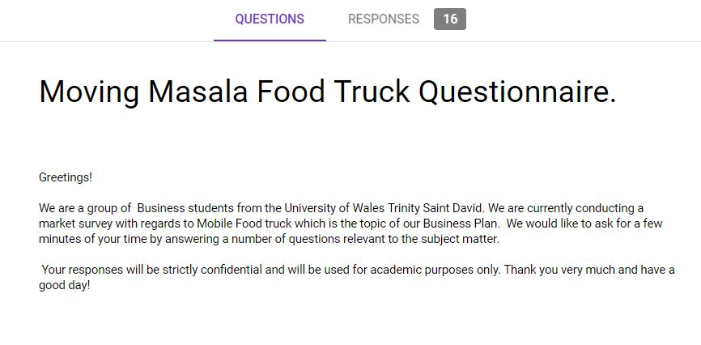

I have also designed response choices in a form that would be easier to understood by respondents.
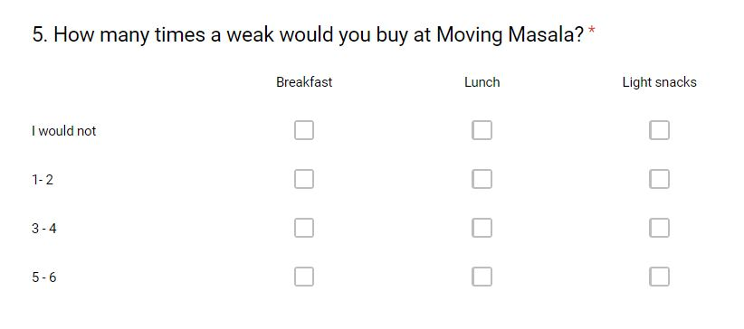

Questions from our survey.
Example 1

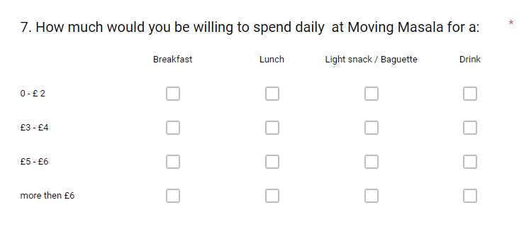

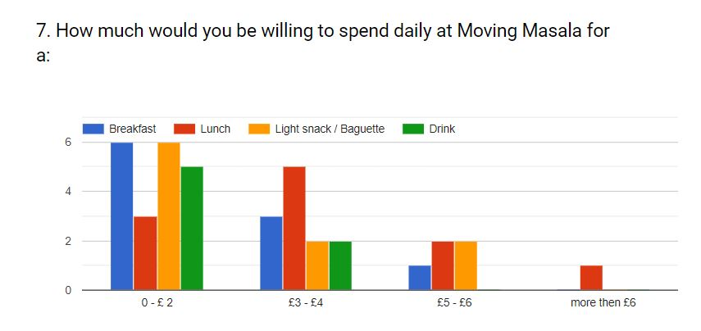

On the question “How much would you be willing to spend daily at Moving Masala”, the majority of the respondents stated that they intend to spend no more than £2 for breakfast, light snack and drinks. Much less potential customers would spent £3 to £4 on our services. Minority of respondents are willing to spend for lunch and snacks more than £5.I am a bit disappointed of the high number of individuals who would not spend more than £ 2 for a lunch. It should come as no surprise that daily spend on drink would not be higher than £4.
Based on responds on above question, enables us to establish sale forecast and monthly revenue, as Moving Masala is a new business.

Example 2

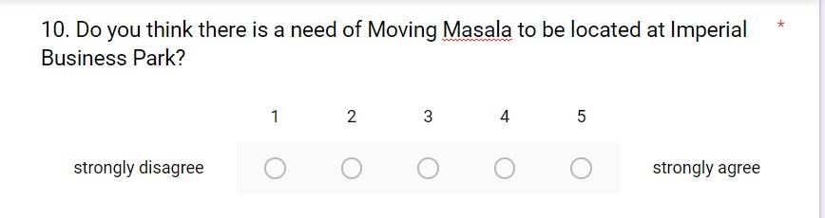
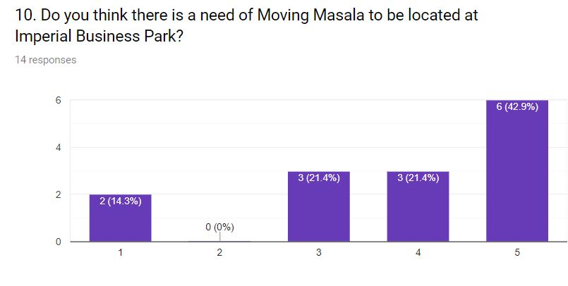

This question is a linear scale type of question.
Analysing the results on the above question over 60% of the respondents stated that it is a need of Moving Masala to be established in Imperial Park. My concern is that 14% respondents strongly disagreed to this question and 20% nether agreed or disagreed.

Conclusion

The survey results provide us with insight on how we can improve product and services and help us understand demand of potential customers.

References:

McBurney, D., H., White, T., L., (2010), Research Method, (8th Ed), Belmont: Cengage Learning

