Network Operating Systems and Services (ACCA5023)
Configure, and manage virtualised network
Sophie Meyrick-Vernon 2221762

Contents
Swansea Network Configuration 3
1.1 routing and remote access 3
1.2 Configure Site-to-Site VPN to London Network 7
1.3 Add Active Directory Domain Services (AD AS) 8
1.4 DNS Configuration 9
1.5 10
1.6 10
1.7 Mounting E: Drive 11
1.8 12

Swansea Network Configuration

1.1 routing and remote access
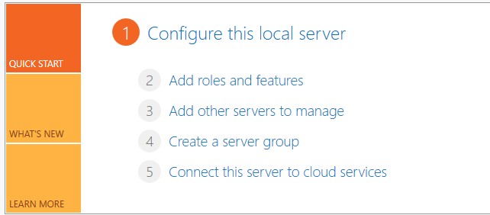Add roles and features

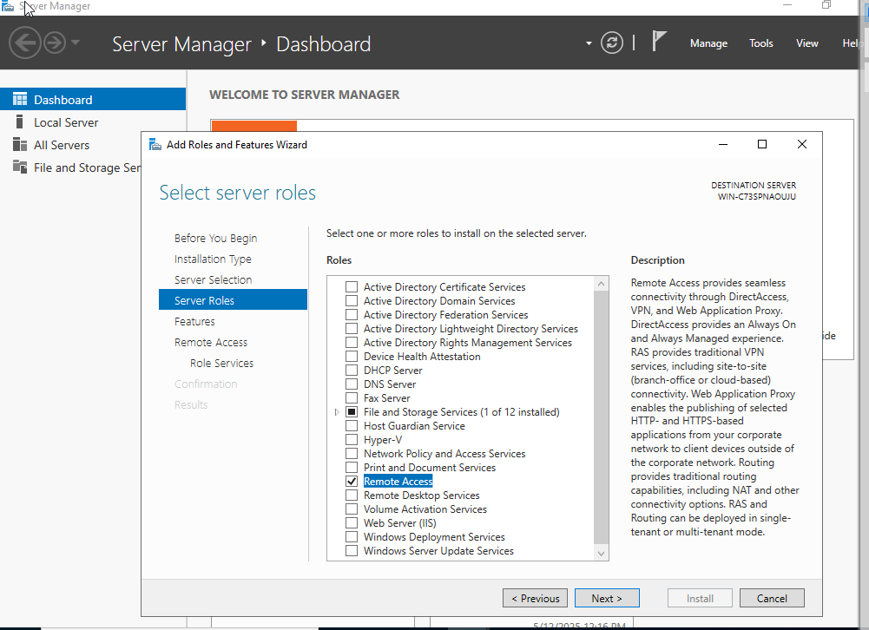
Remote access
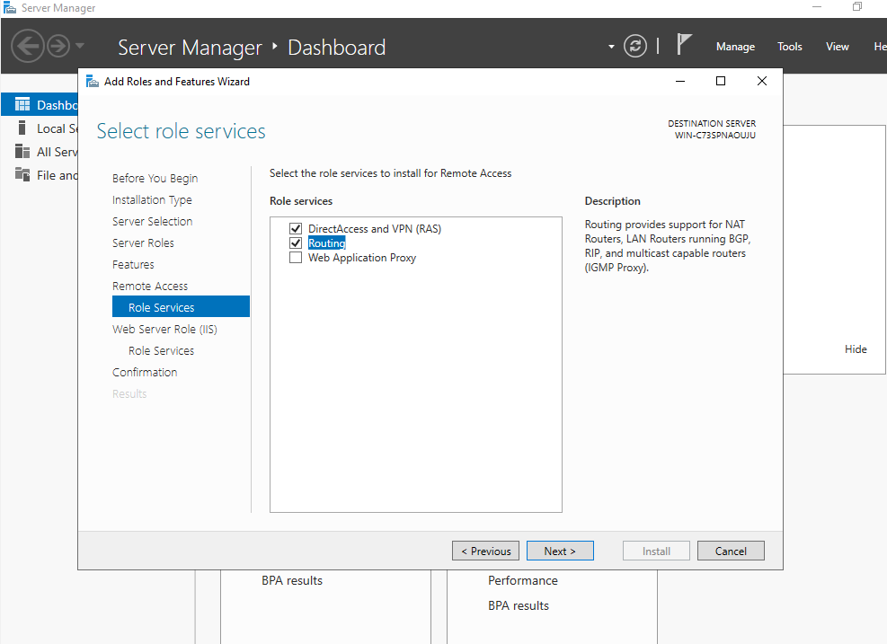Add routing and remote access server

Configuring Routing and RAS
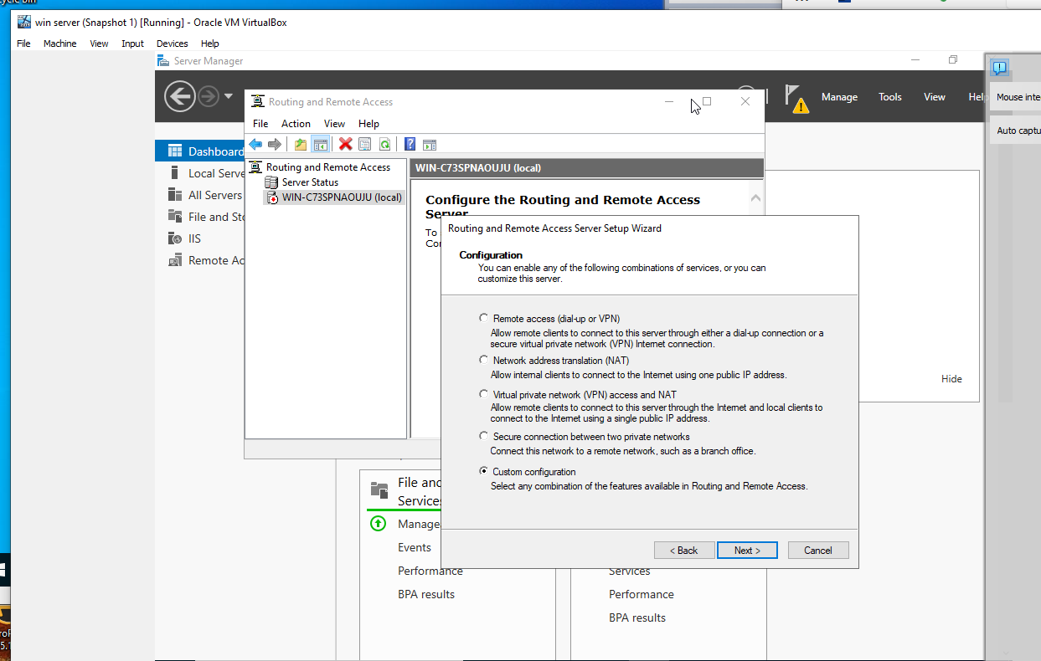
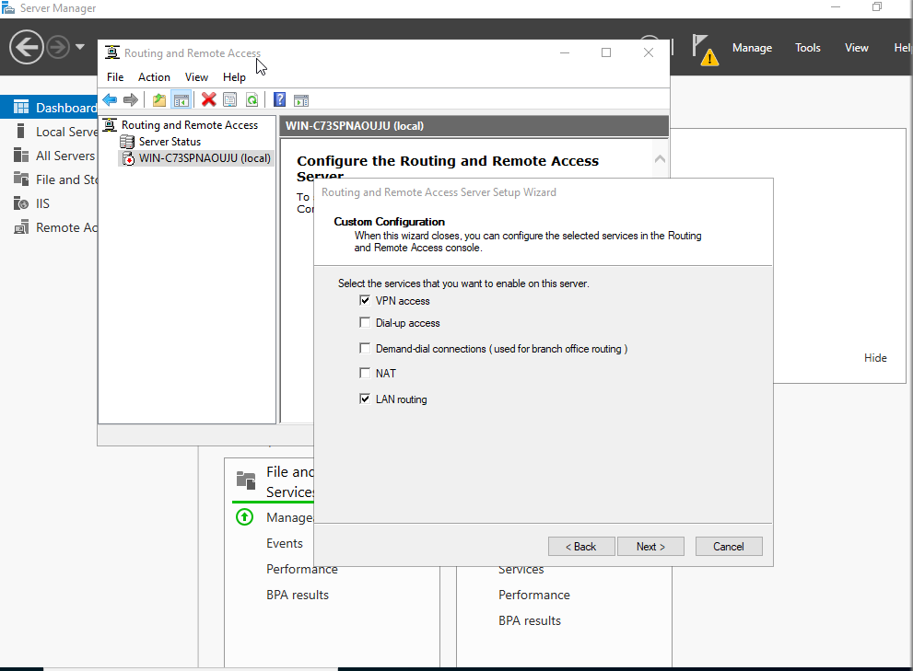
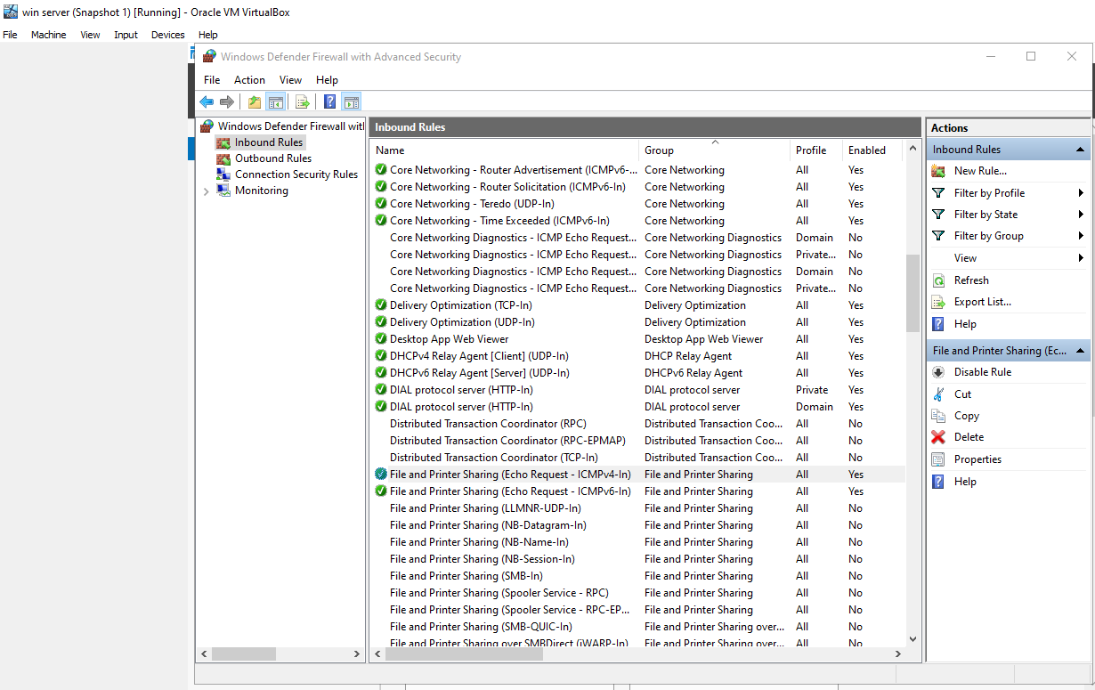Enabling rule in windows firewall to allow pings

1.2 Configure Site-to-Site VPN to London Network
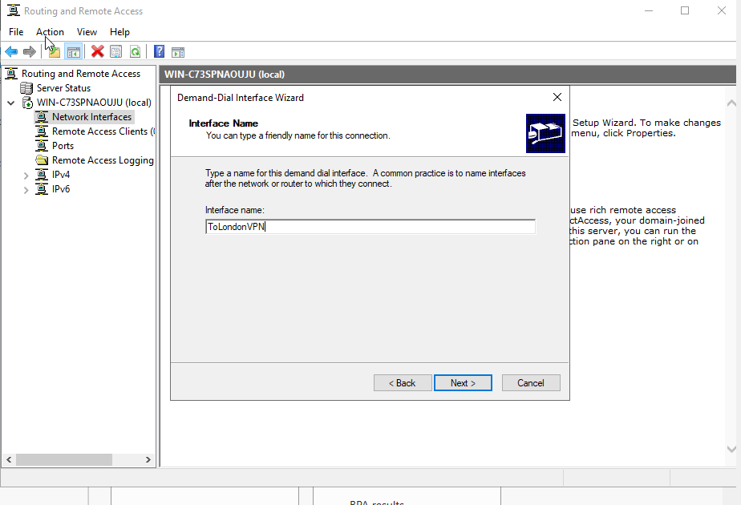

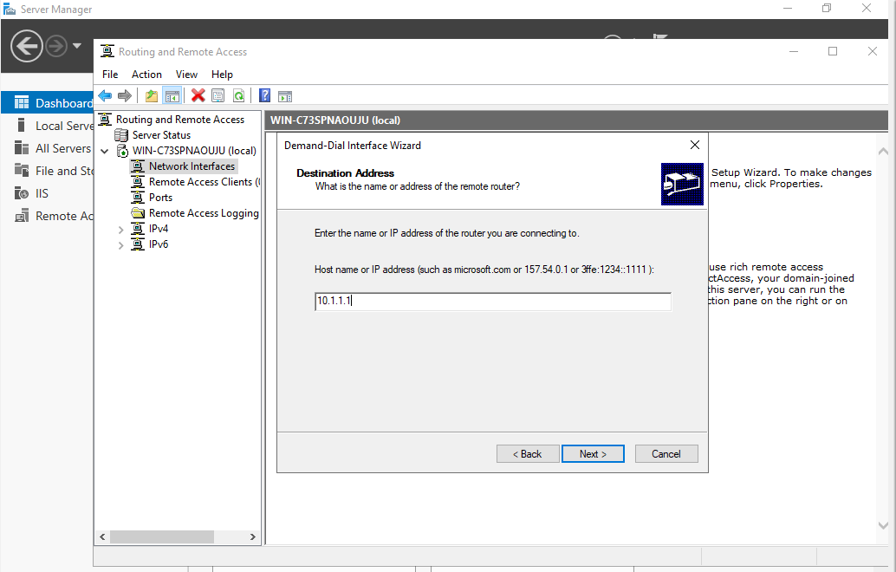Entering London endpoint ip

1.3 Add Active Directory Domain Services (AD AS)
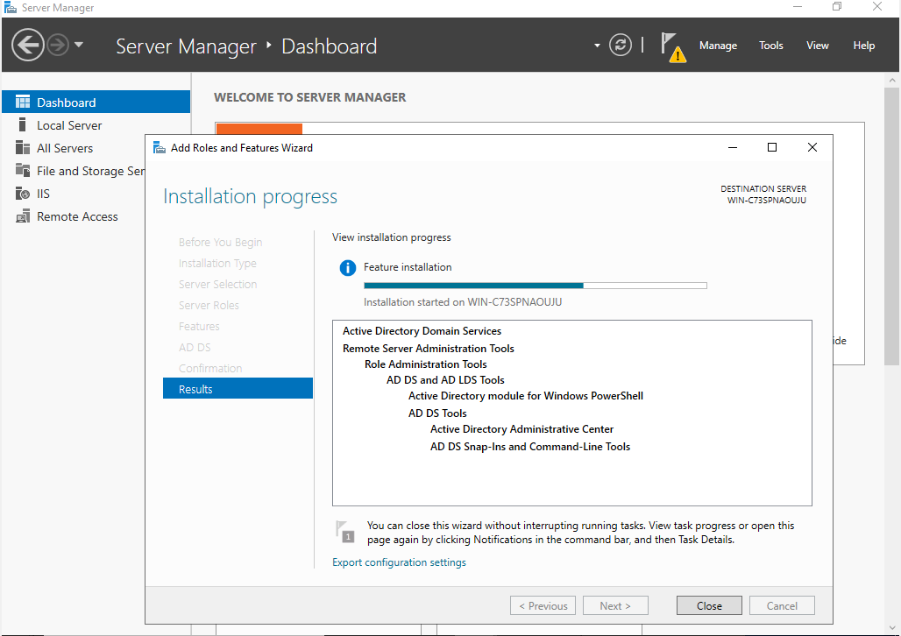
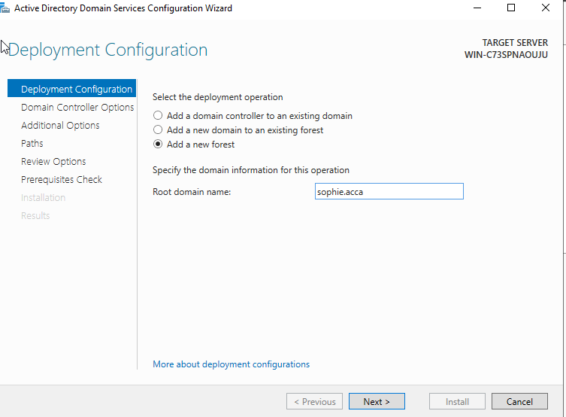

1.4 DNS Configuration
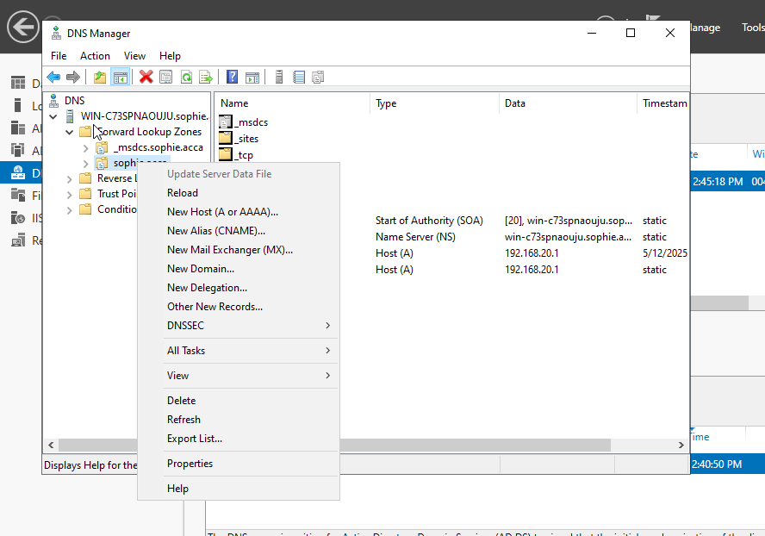Hosts

1.5
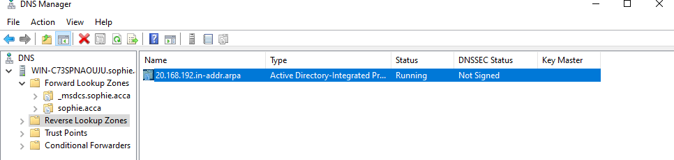

1.6

1.7 Mounting E: Drive
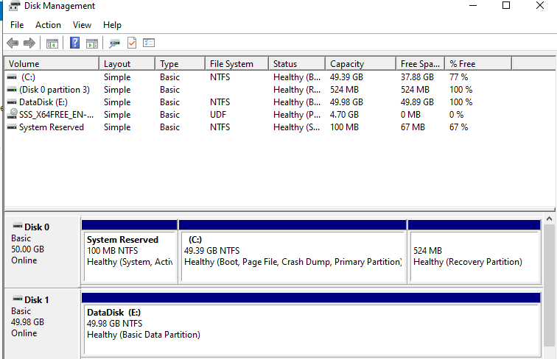
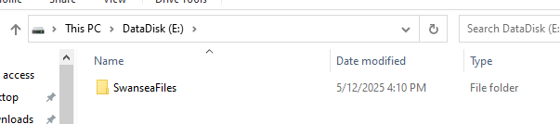
Mount second disk drive to D:\SwanseaFiles.

1.8


