Each activity based on the four stages of Rational Decision making presented on the lecture slides
Activity one – Define the problem
A problem must be clearly defined before you can expect to solve it. All problems, even simple ones, benefit from being clearly defined and stated, and a good test is:
Can you write it down?
Let’s look at an example of a problem which initially lacks definition, and then see how much it helps to define it on paper.
Bill supervises a team that repairs computer assemblies. He confides his problems to a friend over an after-work pint.
‘The work just keeps piling up. I have to divide the team’s time between repairing rejects sent over from Production and faulty items that are returned by customers. The boss is constantly telling me that this or that customer has complained about slow service, but he won’t let us have any more staff. He just says I should get better organized. Production keep sending me more and more rejects, and they’re always pressuring us too. Everyone’s fed up, I’m fed up, and it’s getting harder and harder to face it all.’
Question regarding above - Briefly define Bill’s problem, as he sees it. Try not to make too many assumptions, and don’t suggest solutions at this stage.
Answer
One way of defining Bill’s problem is like this
We will return to this case study – which we’ll call Bill’s problem – repeatedly during the remainder of this workbook.
- Bill’s team does not seem able to cope with its workload. This is resulting in low staff morale, unhappy customers, and an unhappy boss.
This definition is helpful, but we can improve on it by defining the problem in terms of the desired outcome. In practice, this might have more than one side to it.
- What does Bill want to achieve?
- What does the company want to achieve?
Activity two (Define problem)
Based on activity one
What would you say is the desired outcome to this problem:
a) from Bill’s point of view?
b) from the company’s point of view?
Possible answers
If we had asked Bill this question, he might have given one of the following answers.

- ‘I simply want my team to keep up with the workload. That way everyone will be happy.’
- ‘I’d like to prove to my boss, and everyone else, that they need to change the whole way of working around here.’
- ‘All I want is a quiet life.’
- ‘I want to reduce the amount of work they throw at my team.’
The company, on the other hand, will be concerned with ensuring the best possible mix of efficiency, service quality and productivity.
So while Bill is focusing on ‘Why is there too much work?’, the company is probably thinking in terms of ‘Why isn’t Bill delivering the goods?’
These are two very different views of the situation, and they imply that the solution is open to question. Bill wants a reduced workload, but for the company that will not be an acceptable solution.
Activity three - Stating the problem clearly (Define problem)
A good starting point is to draw up a ‘problem statement’.
Use the ‘problem statement grid’ (below) to identify the key issues in Bill’s problem. Tick the right-hand column if you think you need more information before you can answer this question.
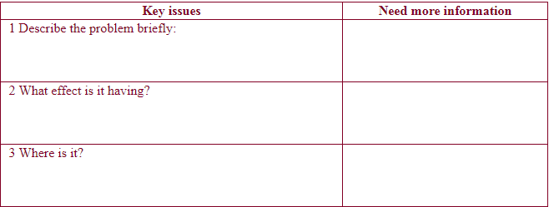
Answer
The problem is that Bill and the repair team are finding it difficult to meet the competing demands of the factory and the customers. This is creating stress among the team and damaging morale. It is probably also damaging relations with the customers. Note that this statement of the problem expresses it from both Bill’s point of view and that of the company.
The problem lies in the repair section. (We have no evidence that other parts of the company are overloaded.) However, this does not necessarily mean that the cause(s) and solution also lie in the repair section!
Activity four - Gathering information

To find the causes of a problem, you must gather information. (You must also gather information when generating possible solutions and establishing what the constraints – the restrictions – on the solution are.
Questions
a) What information have you been given about Bill’s problem? List each point separately.
b) What else do you need to know?
Answer
The information that we have about Bill’s problem consists of the following:
- Bill’s team is responsible for repairing both defective goods rejected from the factory and items returned from customers;
- Repaired goods are not being returned fast enough, either to the factory or to the customers; both have complained about this fact;
- Bill’s boss has rejected the idea of increasing staff as a solution to the problem.
The information that we need to know includes when the problem started, and whether there is anything special or distinctive about it.
In fact, although the team always had to work hard, the problem really began to surface in January; it is now March and there has been no improvement. On the other hand the problem doesn’t seem to have any unusual or distinctive features.
Activity five – Analyse the problem
Problem analysis consists of writing down a series of statements that will help locate the problem more precisely. The statements take the form of saying what the problem is and what it could be, but is not . . . Here’s an example of a problem analysis grid relating to the ‘carbon on the filaments’ that are not working on machines in a food factory.
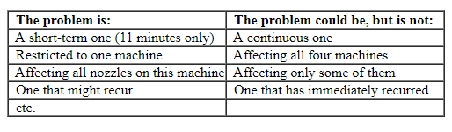
This helps to find a cause, and then a solution, by drawing attention to the specific location of the problem – in this case, for just 11 minutes, on all 480 nozzles of just one machine out of four. Any causes that are suggested must account for this specific pattern of events.
Question Analyse the problem you are working on, using the blank problem analysis grid or a separate sheet of paper.
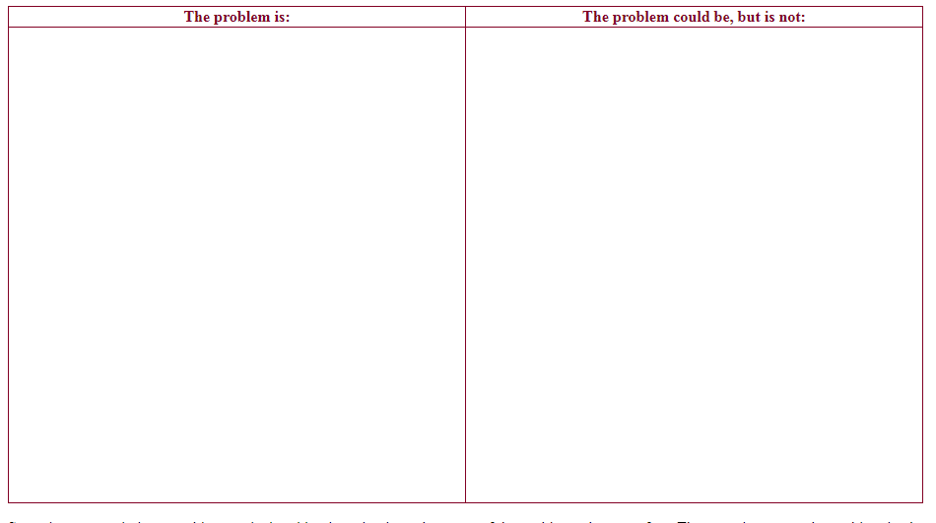
Sometimes, completing a problem analysis grid points clearly to the cause of the problem – but not often. The more important the problem is, the more it pays to take time to think.
Activity six - Identify possible causes
Before we attempt a solution, we must identify the cause or causes of the problem. This means more Sherlock Holmes work.
Question More information is needed to establish the causes of Bill’s problem. Where would you now concentrate your detective work?
Hint on how to tackle the above question - You need to concentrate on the point when the problem began – in January. Before January, there wasn’t a problem. From January on, there was. Something must have changed. If we can establish what it was, we’ll be a lot nearer a solution.
Question - List some of the things that might have changed in January, and so have possibly given rise to a problem
Answer to above question
Once you start thinking about this, you’ll realize that a lot of things may have changed within one or more of the following:
- the work itself;
- the working environment;
- the product;
- management;
- the make-up of the team;
- physical factors.
Sometimes the thing that changed will be obvious (for example, if a highly experienced technician left the team in January and was replaced by someone who is incompetent). Sometimes there are many possibilities, none of them obvious.
Activity seven
Images
Get together a group of colleagues (or your team) and try brainstorming the causes of Bill’s problem – that is, the things that may have changed in January.
Jot down your ideas on a separate piece of paper. When you’ve finished, sort your ideas into groups. Use the groups shown in the diagram below to group the ideas people come up with.

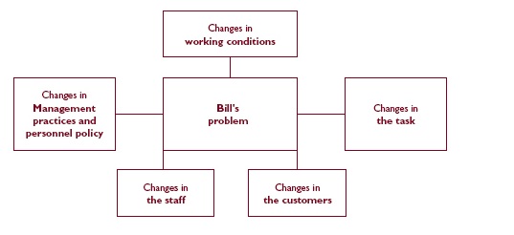
Answer
Below is just one possible outcome of a brainstorming session on Bill’s problem. The groups of causes selected are shown in the diagram (opposite). Your brainstorming session may well have come up with some different groups and lists of causes.
Brainstorming the possible causes of Bill’s problem

All the suggestions have been grouped under the five headings, but the ‘critical weeding’ stage of the process has not yet begun.
Changes in the working conditions:
- relocation to smaller space;
- worse conditions;
- heating not adequate – hard to work;
- overcrowding;
- bad smells (ventilation problem);
- tools and equipment worn out, inadequate.
Changes in the task:
- increase in number of jobs to do;
- individual jobs harder to do;
- more processes, so longer to complete;
- new kinds of jobs – not so familiar;
- bigger proportion of faults – production problems
- safety measures slowing down work.
Changes in the customers:
- getting more demanding;
- increased sales;
- different type of customers – don’t know how to use product;
- change in distribution structure – more direct sales, so complaints coming back to us rather than to dealers?
Changes in the staff:
- experienced people have left – new ones not so quick;
- fall in morale for some other reason – Pay cuts? Fear of redundancy? Change of management? New working practices?
- Bill is new to the job – hasn’t got leadership skills;
- jealousy over Bill’s appointment.
Changes in management practice/personnel policy:
- boss not setting priorities properly;
- too much meddling;
- different priorities set;
- more paperwork to complete;
- safety measures slowing down work;
- Bill and/or team given additional tasks not mentioned?

For further study and understanding in future lectures
We will later look at Fishbone diagrams later in the course - which can also be used to find the causes of problems


