* Kelly Rebeca Evans*  2220446 | Climate Change |  |  | *Module cide BMSP4012*
What is Climate Change?  Long-term changes in temperature and weather patterns are referred to as climate change. These changes could be caused by natural processes, such oscillations in the solar cycle. But since the 1800s, human activities—primarily the combustion of fossil fuels like coal, oil, and gas—have been the primary cause of climate change.  Fossil fuel combustion produces greenhouse gas emissions that serve as a blanket around the planet, trapping heat from the sun and increasing temperatures.  Carbon dioxide and methane are two examples of greenhouse gas emissions that are contributing to climate change. These are produced, for instance, while burning coal or gasoline to heat a building. Carbon dioxide can also be released during forest and land clearing. Methane emissions are primarily produced by waste landfills. Among the major emitters are energy, industry, transportation, buildings, ag riculture, and land use.  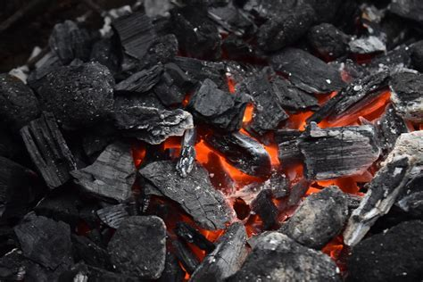  Coal  It is said that the United Kingdom consumes 41,459,830 tons of coal per year as of the year 2016.  The united kingdom is the 21st in the world for use of coal. Which accounts for 3.6% of the world’s total consumption of 1,139,471,430 tons.  The United Kingdom uses 625,356 cubic feet of coal per capita every year. This was based on the 2016 population of 66,297,944 people.  The United Kingdom produces 4,605,230.72 tons of coal per year and is ranked the 33rd country in the world for its coal production.  The United Kingdom imports 21% of its coal consumption |  |  | 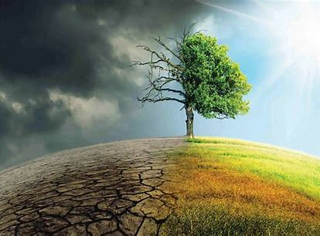  Climate change is a long term change in temperatures and weather patterns. These shifts can be natural. since around the 1800s human activities are a main cause for climate change, mainly due to burning fossil fuels such as coal, oil and gas.  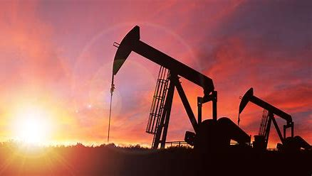  Oil  According to Certas energy the average Household {of 2 adults 2 children} in the United kingdom uses around 26,999 kWh of energy per year this roughly amounts to between 1,700 and 1,800 liters of heating oil per household.  As of 2016 the United Kingdom holds 2,754,685,000 barrels of proven oil reserve and the United Kingdom is ranked 30th in the world and accounts for 0.2% of the world’s total oil reserved which is a substantially large figure of 1,650,,585,140,000 barrels.  The United Kingdom reserves of oil are equal to 4.8 times its yearly consumption. Therefore without imports from countries such as Norway there would only be approximately 5 years of oil left at the current rate the United kingdom are consuming oil.  In 2016 the United kingdom accounted for roughly 1.6% of the world oil use.  How people are experiencing climate change?  Climate change affects us in diverse ways and here are examples of how it is affecting us:-  • Our health  • The ability to grow fresh food  • Our housing.  • Safety  • Work.

According to a website called on average, an average household in the United Kingdom uses 17,000 kilowatt of gas per year. And the average gas and electricity cost for a family in the United Kingdom is £1264 per year..
The average gas usage in the United Kingdom has decreased by 20% in the last 10 years .
The burning on the fossil fuels stated above produces greenhouse gas emissions. Greenhouse gasses act like a blanket wrapping itself around the earth, these greenhouse gasses trap the suns heat which then raises temperatures.
Two examples of greenhouse gas emissions that are causing this increase in climate change and carbon dioxide and methane. Yet it is very difficult to stop the use of these items that are having a bad impact on the globe, as these things are used in our everyday life, examples of these are fuel for driving a vehicle or the energy uses such as coal, oil and gas stated above for the use of heating households or business use. Landfill sites and the clearing of forests also produce carbon dioxide and methane emissions.
Greenhouse gasses are at their highest levels in 2 million years and there doesn’t seem to be a decrease in this. As a result in the rise in greenhouse gasses since the 1800s the earth is now approximately 1.1 degree Celsius warmer and the last decade has been the warmest on record.
Climate change is not just down to warmer temperatures, because the earth as one is a system where everything is connected changes that may happen in one area will more than likely lead on to another area.
Climate change has caused intense droughts, water becoming scarce, severe fires, a rise in sea levels, flooding, the melting of the polar ice, and fierce storms.

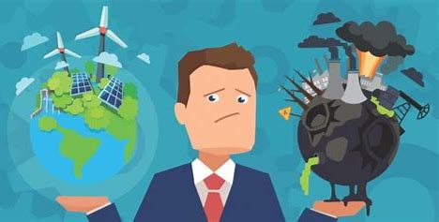

Effects climate change has on a business
The examples mentioned above can impact a business directly or indirectly.
Impacts that global warming have on a business that could impact it directly are physical damage from floods, which would lead to closures of business and potentially a loss of stock.
Impacts that global warming have on a business that could impact it indirectly are supply chains being affected by extreme weather, which would then lower income.
Depending on the size of the business climate change exposures differ and will depend on what industry your business is based. Some challenges that may happen are interruptions to supply change, changes in energy efficiency and the forever fluctuating costs. The health of a business’s employees are also impacted by global warming.
Industries such as the agricultural, forestry and fishing have a heightened risk of global warming affecting their business as their work relies massively on the natural environment and are climate sensitive. Some agricultural equipment has operating guidelines and requirements that climate change could affect the industry in a big way, flooding, excessive temperatures or stormy weather can cause damage to stock, equipment and/or have a total loss, therefore the agricultural industry loses money which will have a direct negative impact on the industries bottom line as stock and equipment will have to be reinvested putting the business at risk.
The weather due to climate change also has an effect on other business that many people might not think of and it is not just the environmental industries that suffer, the forever changing climate effects people for good and services and members of the working industry as it affects both working conditions inside and outside the climate could change beyond and acceptable threshold for workers.
Most businesses make great use of premises and the transport industries. Both premises and transport are at risk to weather related events such as storms, floods, snow etc.
Climate change affects the insurance industry as when the extreme weather increases, and premiums for flood and storm protection will more than likely rise the cost of insurance will get higher which for many businesses would create a negative impact on their bottom line.
Goods being transported from one country to another could result in habitat decline, and a rapid increase in emissions.
In 2008 29% of businesses said that there had been a disruption as a result of extreme weather and there had been a rise in costs for claims on business damages.
Some businesses will have a chance to expand their market and have great new opportunities given to them , some of these business opportunities may include outdoor leisure, summer food, drinks and events, the clothing retail companies will profit on new ranges and fashion and flood defense technologies will also profit.
Some industrial and agricultural industries could become better and more practicable and it is more than likely that winter heating costs will be lowered therefore saving the businesses money.
Global market businesses could be affected by climate change in other countries which could result in market opportunities for the agricultural economy for the UK food production. But many businesses based in the united kingdom rely on businesses and manufacturing operations in the east and south of Asia and unfortunately due to global warming and the forever changing climate change are expected to get tropical storms and water scarcity.

How climate change has effected the modern day farm

When i asked, young farmers said;
“Additional stresses on forage reserves during summer months, reducing grass growth increases the need to b uy in feed incurring additional costs on the business: both direct and indirect. The direct costs being losses in production, fertility and heat stress in the livestock themselves. With such extreme droughts like we’ve sufferd this year, our crops have sufferd tremendously.Some parts were down at least a third on avarage years. Along with other rising costs this year its been an additional chalange we don’t need. Fourtunately, there are varieties that are able tp cope with the dry weather, but then the harsh, wet weather we have in this part of the country its nearly impossible to have the perfect crop all year round” – Rhys Bevan

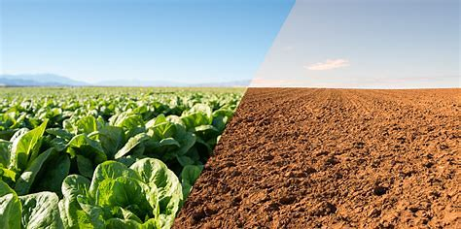

“it’s changed the time food lasts and the way the ground works so cant get enough crops off” – Dan Reeves

“It hasn’t really, there are different options for sourcing energy such as solar panels and wind turbines these days but only major effect climate change has had or ever will have is the weather, Obviously if the weather isn’t the best and raining then it spoils the crops, but also not enough rain won’t give the crops a chance to grow” – Emyr Evans

“not really affected our farm but for heavy rain or the hot weather last summer if we had livestock it would of affected the price of feed because of the shortage of grain and suger beet for making the feed or if we still milked cows they could have been short of water and grass” -Mark Evans

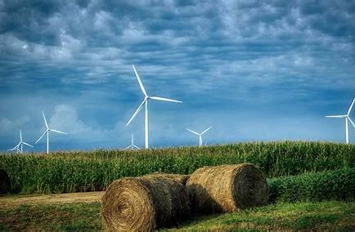

changes to the United kingdom’s climate will have many positive and negative impacts in the long term. For both agricultural and forestry industry productions.
For agriculture in the short term it might be that technology and socio-economic factors will continue to influence drivers of change.
the change in climate for the forestry industry will enable a long production cycle.
The united kingdom will have warmer drier summers which may have a negative impact on the production in the south and east than in wetter areas in the north and west. Upland areas of the farming industry will benefit from the warm dry weather while the production in the lower lands of farming may fall.
Eventually due to climate change the warmer weather which enables longer growing seasons for the farming crops will begin having a big negative impact as there will be less water availability to keep the crops hydrated.
The warmer weather will help increase the length of the growth season in the united kingdom, this will help the farmers have a longer growing period for the growth of crops such as sugar beet and leafy vegetables. Yet whilst the growth in crop will be a positive if they have livestock such as dairy cows the heat will stress the livestock and therefore reducing productivity such as milking.
Dried soil conditions will reduce growth of crops, pasture and trees especially in areas where water is already very scarce.
Summer drought will become more frequent.
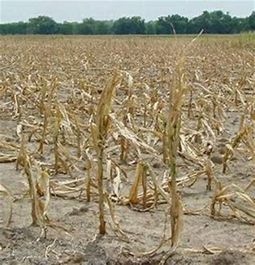
However the ever increasing concentration of carbon dioxide in the air will increase plant growth although the amount will vary depending on the water supply and temperature.
Due to an increased amount of rainfall and the rise in sea levels it could lead to a large loss of crops in the low-lying farming areas and may cause water logged land and erosion in soil.
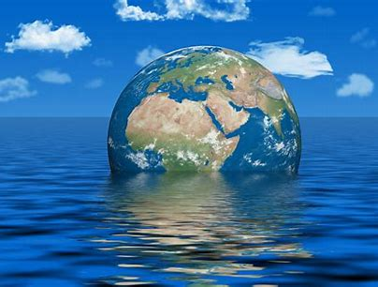
Sea levels around the united kingdom rose on average by 1-2mm/year in the 20th century and the rate has increased to 3mm/year during the past decade. High sea levels during storms appear to be rising at a similar rate.
2012 was a very difficult year for the farming agricultural community. It began the year with 3 very dry months the April and summer months where particularly dull although the duration of sun was near average it was recorded that it had a high rainfall and was the second wettest summer in the united kingdom since 1910. The growth in crops and feed such as fodder and maize were poor and the quality of the crops produced where the poorest since 1977. Due to the heavy rainfall the ground wasn’t prepared enough for the autumn sowing of crops and many farmers had to switch to spring sown crops.
Livestock farmers where hit the most during this year as there was an increase in feed costs and an increase in the feed use.
The United kingdom’s wheat yields were down by 14% due to disease pressure and low sunlight levels followed by poor harvest conditions. And lots of land became problematic due to the land being waterlogged and the damage it caused to grass areas.

https://www.un.org/en/climatechange/what-is-climate-change

United Kingdom Coal Reserves and Consumption Statistics - Worldometer (worldometers.info)

https://www.bing.com/search?q=how+much+oil+is+burned+per+year+in+the+uk&qs=n&form=QBRE&sp=-1&pq=how+much+oil+is+burned+per+year+in+the+uk&sc=3-41&sk=&cvid=20E723CE337146D0AE503F5F56DEFA5F&ghsh=0&ghacc=0&ghpl=

United Kingdom Oil Reserves, Production and Consumption Statistics - Worldometer (worldometers.info)

Average Gas Usage | Onaverage.co.uk

Climate change effects on business | AdaptNSW

7 Ways Climate Change Affects Global Businesses (hbs.edu)

UKCIP_Business.pdf

131221-NERC-LWEC-AgricultureForestryClimateChangeImpacts-ReportCard2016-English.pdf (ukri.org)

