John Jones - Essay question 4.
Discuss the issue of authenticity in relation to military memorials.
Introduction
This essay will discuss why authenticity is import in relation to military memorials by defining what constitutes a memorial, the different common types of memorials, and the differing aspects of what is authentic, by whom, how and where it is displayed and why it was erected. The essay will look at specific memorials and consider whether they are authentic, how they are authentic and the contribution they make to our heritage.
Memorials were originally set up as a means to remember the dead who died in battle. For the purpose of this essay, I will include wide referencing to memorials worldwide but in the main, I will concentrate on British memorials and battles in which British servicemen and women were involved and whenever possible I will work in my local area of Carmarthenshire. I will consider how we make a memorial authentic and relevant and representative of an event, or person, in order for future generations to understand the purpose of the memorial under review.
Different types of memorials.
Memorials are of such varied types that it is impossible to include every style and describe them, so a short overview will be provided to contextual the types of Memorial that is commonly seen in Britain.
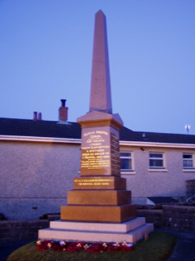
Obelisk
An obelisk such as the one at Llanybydder, in Carmarthenshire, Wales, is a memorial to the dead of the First and Second World Wars. This was erected following the collection of contributions from local people who wanted to pay respect to the friends, neighbours and local heroes who were killed during the First and Second World Wars, and strangely there is no separation of names by the war in which the person fought. This suggests that either the World War 1 memorial was replaced or that no memorial was made to either war until after 1945. The Llanybydder Memorial is a simple polished stone obelisk which is narrower at the top than the bottom and mounted on a series of plinths: The design of obelisks are based on an ancient Egyptian plan, with a small pyramid on top, and this may contribute as authenticity because on the Llanybydder obelisk, six of the twenty people named died in Egypt.

The Llanybydder Obelisk is well kept and is still valued by the local community as probably some of the people whose name appear still have relatives living in the vicinity today. At the annual November 11th Remembrance Day, a parade is followed from the church uphill to the Obelisk, and poppy wreaths and poppy crosses are laid by local groups. There is a woman named amongst all the men, she is Ann Joan Davies, Aircraftwoman 1st Class, 2076919, Women's Auxiliary Air Force. Ann was a local girl from Blaenpant, Llanllwni and she served with the Women’s Royal Auxiliary Air Force as an Aircraftswoman. Ann, aged just 19 years, died on 15 August 1942 on active service at Bristol and she is buried locally in Rhydybont Congregational Chapelyard where the inscription on her grave reads ‘Peacefully sleeping free from pain in God’s own way we shall meet again’ unfortunately how she died is not explained online and will require additional investigation to ascertain.

Statues
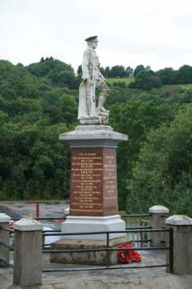 Pencader War Memorial
After the First World War the erection of a statue of a serviceman was a popular way of creating a memorial to the dead. Some statues were more authentic than others as they were sculpted to a custom specification. Some statues were less authentic because they were selected from catalogues of available designs to meet the budget available. A city, town or village may invest in an expensive one-off memorial or be more reserved in their spending and buy a statue which could be reproduced but also seen elsewhere, the fact that statues were reproduced brings question to their authenticity as although insufficient were made in any one style to make them a common sight, they were more regimented and less personal and as in many areas men signed up together and served in the same regiments. This would create a lack of authenticity as the uniform peculiarities of the local regiments would not necessarily be reflected in a catalogue-bought statue. Obviously, the list of names and dates engraved on to the memorial name plates would be unique as even if a catalogue-statues are representative of the dead of that given district because they usually provide date, name, regiment and location of death.
The Pencader statue shown above, was made by ‘Mr E. Jones’ at a cost of £400 and unveiled on 22 November 1922. It is unique in design and unique in content but the rules of the Commonwealth War Graves Commission were disregarded and the local people have added their own versions of names and dates as it was felt appropriate and many local fallen servicemen were commemorated elsewhere, but omitted on the Pencader statue, whether intentionally or not is not clear.
Memorial Edifices
Memorial Edifices are vvaried and may constitute Buildings of memorial, religious memorial, Plaques, Named Public Parks and street names
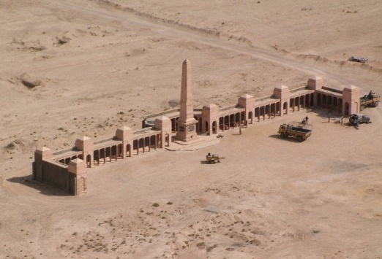 Memorial at Basra
An example of a local serviceman who did not have his name added to the local statue, but is noted elsewhere, is Thomas Ansell, Private, 14340, Welsh Regiment who died on 25 January 1917. Aged just 19 years old, he fought in Gallipoli, Suez Canal, Mesopotamia and died in in a battle against the Turks in Palestine. Private Ansell enlisted in Carmarthen, in August 1914, he is not remembered on the Pencader statue, but he is noted on the Basra War Memorial in Iraq on Panel 24 as ‘Private Ansell, Thomas, Service Number 14340 Died 25/01/1917 Aged 19, 8th Bn. Welsh Regiment. Son of John Ansell, of Cnecdu, Pencader, Carmarthenshire’. The war memorial at Basra now appears even more authentic as it has been renewed as a memorial and made current by the damage it received during the Iraq war 2003-2011 and conditions in the area are still not stable enough for engineers to visit and assess and repair the damage.

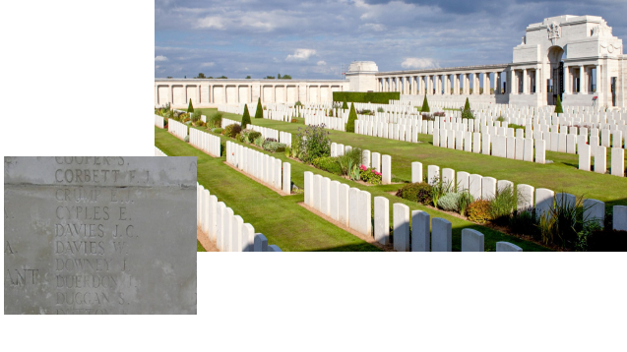
Memorial at Poziers
It is common for statues to be a point of local annual pilgrimage for all who wish to support them on Remembrance Day…….
Boards with lists of names
‘In Memorium’ boards in religious institutions, centres of education and public buildings are a local and frequently personalised marks of remembrance, as they list PALS regiments, favoured old boys who were lost or the nurses who served their country and died. These are highly varied in grandeur and size. Of the boards made by professionals, carpenters and sign writer, occasionally one will appear to have names added by an amateur after the main board is painted. These later additions can sometimes look as if they are added by relative or friend which makes their remembrance even more emotive and personal.
Plaques
There are many styles of plaque in remembrance to war dead. Some are generally commemorative of an event, some mark the spot of an action such as a plane crash or signpost the eye to a place where a ship was lost, others are to mark the recording of a medal winner or noteworthy person as having resided at a house. Frequently these are blue plaques which started to be seen for 1867 onwards and were originally erected by the Royal Society of Arts, although from 1984 they became the domain of English Heritage. English Heritage now site all new plaques and maintain the existing ones.
Buildings
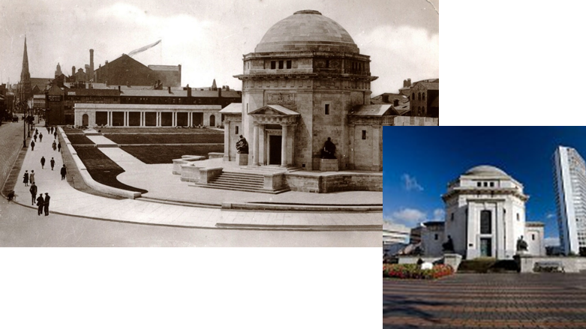
Hall of Memory, Birmingham
A clear example of a building that was created as an act of remembrance is the Hall of Memory in Birmingham. It was erected to remember over 12,000 local Birmingham men and women who served their country in the First and Second World Wars. Although when built, by local craftsmen in Portland Stone and with plaques, ornaments, statues and stained glass by Birmingham artists, Albert Toft, William Bloye and Richard Stubbington this was a very local and pertinent piece of impressively classical remembrance. Although well worth a visit it does not seem to attract many visitors and has the feel of being superfluous. The memorial cost £60,000 in 1923 and was built entirely from money raised by public subscription. This building has been beautifully reconstructed but perhaps it could have been kinder to lay it to rest as is busy only at the eleventh hour, on the eleventh day in the eleventh month of each year and otherwise stands empty. The building is perhaps tucked too far away from the homes whose families it represented.
Interesting and alternative memorials are made from the many streets that were named at the time of a battle or war. They were given the name of the event as an act of remembrance: Streets such as Mafeking Road in Cardiff and Waterloo Road in Llanelli are very authentic memorials because their name plates serve as a daily reminder of those who served and died in local regiments during a particular battle.
War Graves, War Cemeteries and Commonwealth War Graves seen in local church yards.
A lot of energy has been spent worldwide in the creation of war graves and despite many people viewing these as authentic memorials their true value must be at question. They are frequently buried out of the country to which the man or woman came from and the only link is that the place where they are buried is where they died, unless they are repatriated and even so they are buried as service men or woman and their personal identity, beliefs and wishes are not considered.
As questionable example of a religious memorial, The Grave of the unknown soldier is probably one of the most famous and most visited memorials of this type. The grave was moved from a makeshift graveyard in Armentieres in France to Westminster Abbey. As we do not know the religion of the soldier who died, it seems that a Church of England chaplain claimed a body without real consideration of whether the dead soldier wanted to be placed in a place where the worship has an English Protestant bias which could be viewed as inauthentic memorial.
Museum displays of medals.
The largest and most impressive of these is Lord Ashcroft Collection of Victoria Crosses which can be viewed at the Imperial War Museum in London but although the medals are authentic, that fact they have been collected be one person and put on show is like looking in as a spectator at a freak show. Brecon Military Museum, however, displays Victoria Crosses, and other medals, in a more casual way and to view them seems less invasive and more respectful. The notes which tell the tale of how the medal was won are often scribed by hand, and old notes produced on typewriters appear next to professionally printed documentation. It is very piecemeal, but somehow more welcoming and more appropriately reflects the event and the award. At Brecon it is often the families of the dead that contribute their medals for safe keeping and display and the collection, that is available for viewing, seems to increase every year which is very nice as when revisiting there is always something new to see. This method of remembrance is a comfortable one.
So far, we have considered whether memorials are authentic but there is a need to consider what memorial may represent the other side of the issue and be inauthentic. The visitor attraction, museum ‘experience’ and replica items all bring to question whether authenticity of memorial is real. Wax work images wearing stripped prison clothes that were made last year in China, photographs which have been touched up and have people removed or added to enhance the effect they provide, plastic food on army plates in displays of the trenches and Heather Morris’ romance set in a prison camp where a tattooist falls in love with a young female inmate that he was required to tattoo in order that her journey from camp to grave could be catalogued are all sad examples of remembrance and inauthentic examples of memorials.

To conclude – In this twenty-first century I hope that some may take the time to consider if there is a still a value, in the daily life of an average person, for a war memorial that commemorates an event that happened a hundred years ago. I have wondered if there should be a cut off time for the removal of old monuments to bring final closure and allow the future to evolve without fear of contamination for old and maybe irrelevant views, actions and politics. If such a principle was applied though where would it start and where could it stop? Perhaps there might not be an outcry at the loss of an obelisk or statue from a small Welsh village, perhaps the loss of a hall of remembrance or a grave attributed to an unknown soldier could be considered. But, when we come to the killing of grounds of millions of men, women and children at Auschwitz or Bergen Belson it would most probably create hue and cry worldwide. It is not because the closing of such sites prevent remembrance of victims lost, even though their families are dispersed worldwide and unable to maintain the memorial to their dead ancestors but perhaps more because society has found a use for these sites, people visit them to remember and feel the suffering and perhaps create their own dramas, coach loads of people are taken to ‘experience’ the desolation and sadness and the memorial becomes an alternative type of theatre-of-war .
It is difficult for me to remove my emotions when writing this essay as my patriotism and respect for the dead British servicemen and women was instilled into me by my father who served in the British Army in the second World War. I feel that perhaps the next generations will be colder and more able to separate emotion and judge the right and wrongs, and the suitability or otherwise of continuing to remember the dead of our various wars.

Steven John, Llanybydder War Memorial (2020) <https://www.wwwmp.co.uk/carmarthenshire-memorials/llanybydder-war-memorial/> [accessed 4 March 2020].
Commonwealth War Graves Commission, Commonwealth War Graves: Find Dead (2020) <https://www.cwgc.org/find/find-war-dead/ > [accessed 4 March 2020].
, War Memorials Register: Memorial Pencader (2020) <https://www.iwm.org.uk/memorials/item/memorial/6984> [accessed 4 March 2020].
, Basra Memorial Iraq: Roll of Honour: Listed by name (2020) <https://www.ww1cemeteries.com/iraq-basra-memorial.html> [accessed 4 March 2020].
Commonwealth War Graves Commission, Commonwealth War Graves: Find Dead (2020) <https://www.cwgc.org/find/find-war-dead/ > [accessed 4 March 2020].
, France - Pozieres British Cemetery & Memorial - 1 (2020) <http://www.euro-t-guide.com/See_Coun/France/F_NW/F_See_Pozieres_British_Cemetery_1-1.htm> [accessed 4 March 2020].
, Birmingham Hall of Memory (2020) <http://www.hallofmemory.co.uk/history.php> [accessed 4 March 2020].
, Birmingham Hall of Memory (2020) <http://www.hallofmemory.co.uk/history.php> [accessed 4 March 2020].
Dean and Chapter of Westminster, Unknown Warrior (2020) <https://www.westminster-abbey.org/abbey-commemorations/commemorations/unknown-warrior> [accessed 5 March 2020].

