Jac Thomas (2204038)
University of Wales Trinity St David
A Marketing Plan: McDonalds Entry to the meal kit INdustry

Executive Summary

This report covers the Objectives, Strategy, Tactics, Action and Control sections of a business plan, acting as a continuation from the situational analysis of McDonalds UK. Recognising that there is opportunity in the meal kit industry, the objective established in this report is that McDonalds should create their own meal kit service, aiming to achieve 100,000 members after a 6-month trial period between October 2025 and March 2026. The report advises that, following the model Segmentation, Targeting and Positioning (STP), McDonalds should segment to the health conscious and families, use Social media and SMS to target these demographics, and position themselves as the best cost option on the market, they should also use strategies such as diversification (Ansoff Matrix) and Cost and Differentiation Focus (Porters Generic Strategy). The tactics were laid out using the 7Ps model: the product is a meal box service aimed to be healthy, it will be priced based on competitive pricing, The promotion used will be the aforementioned Social Media advertising and SMS advertising, It will be ordered online and distributed from McDonalds distribution centres, the boxes used to package the items will be red and yellow and made from recyclable materials, The employees will require training and customers should be asked for feedback and The goods should be procured from farmers and the boxes will be prepared at the distribution centres. A Gantt chart can be used during implementation to ensure progress is monitored and achieved effectively. Lastly, KPIs like Cost per click, return on investment, click through rate and conversion rates will be used to measure the progress of this venture.

Contents Page

Contents

Executive Summary 1
Contents Page 2
1.0 Introduction 3
2.0 Main Findings 4
3.0 Situational Analysis 4
4.0 Objectives 5
4.1 The Objective 5
5.0 Strategy 6
5.1 S.T. P 7
5.2 Ansoff Matrix 8
5.3 Porters Generic Strategy 9
6.0 Tactics 10
7.0 Actions 13
9.0 Control 14
9.0 Recommendations 16
10.0 Conclusion 16
References 17

1.0 Introduction

As a continuation of the first assignment, this assessment is the second part of a Market analysis and business plan for McDonalds in the UK, using SOSTAC, the previous report was a Situational analysis, the first S of SOSTAC, this report will entail the remaining stages which are defined by Chaffey (2023):
Objectives: Where the business wants to be
Strategy: How the objectives will be achieved
Tactics: How objectives will be achieved, but this section is more detailed than strategy
Action - What is the organisations plan
Control – Measurement of Success
The report will cover a 12-month period between September 2025 to August 2026. A market plan will be helpful in this venture as explained by the Oxford College of Marketing (N.D) it will help to minimise risk and track the progress of a business venture.

2.0 Main Findings

The main strategic option will be for McDonalds to launch their own meal kit line, that is designed to compete with Hello Fresh and Gousto, who exist as a competitive threat in the form of an industry substitute to McDonalds, this is based on the previous situational analysis, this is looked at in more detail below.

3.0 Situational Analysis

The final findings of the situational analysis were as follows: McDonalds has a positive position within the UK as they remain market leaders, De Avezedo (2025) noted that they hold a lead on market share.
However, but do see threats from failing to adapt to technological change, the threat of new entrants and the meal kit industry. This report will focus exclusively dealing with the threat from the meal kit industry.
The TOWS model is explained by Chopra et al. (2025) to focus on Strengths, Weaknesses, Opportunities and Threats like SWOT but connects Opportunities to Strengths and Weaknesses to Threats. using this model, we could see that McDonalds UK are threatened by the growth of the meal kit industry, as these businesses have the advantage of being a healthier alternative, One of McDonalds weaknesses was its unhealthy menu, the larger health-conscious demographic found in assignment 1, will see little appeal in McDonalds current menu. However, McDonalds already has a strong network of suppliers and may wish to expand into the meal kit market, as highlighted in a Statista (2025) report “Revenue in the Meal Kit Delivery market is projected to reach US$1.50bn in 2025.” Which implies it could be a profitable venture for McDonalds. It was also established that competitors in this field would include Hello Fresh and Gousto.

4.0 Objectives

Cambridge Dictionary (2025) defines an objective as a plan to accomplish something; to provide some guidance for further action, the market plan will be given an objective to aim to work towards, Hinton (2023) explains that objectives create a sense of direction that enables a business to effectively carry out their efforts.
The objectives lined out for McDonalds in this report will be SMART objectives which are defined by Aldridge and Colvin (2024) as:
Specific – A clearly identified Goal
Measurable – Quantifiable measures
Achievable – The goal must realistically be reached
Relevant – Goals are aligned with company strategic goals
Time-bound – A time limit for achieving the objective is established.

4.1 The Objective

McDonalds should launch a Meal Kit Service offering healthier alternatives to their classic menu items as well as some new additions. McDonalds should aim to recruit 100,000 members by March 2026, this number should not be too hard to achieve given that Statista Research Department (2025) reported that competitor Hello Fresh had 6.64 million active customers by the end of 2023, giving some sense of the market size. McDonalds should recruit these customers in hopes to increase revenue to invest into their aims and values, which McDonalds (2025) state include contributions to climate protection, workplace inclusion and supporting people in their communities. This should be done over a period of 6 months, starting in October 2025, this is to determine whether the service is a success or not. The remaining 5 months after the trial period should then be used to act on the results of this objective. If successful, then McDonalds may want to expand upon the service or look at other demographics, if not they may wish to readapt their strategy.

5.0 Strategy

Boyles (2022) explains that strategy is a pursuit of creating value for stakeholders and that strategy can aid a business in gaining a competitive edge. Regarding McDonalds Strategy, Models that explore methods of growth such as Ansoff’s Matrix and Porter’s Generic Strategies will be used to help decide on how growth can be achieved.
Regarding general strategic direction, this will be looked at more through means of Segmentation, Targeting and Positioning (STP) will be used to help create a strategy for McDonalds to follow.

5.1 S.T. P
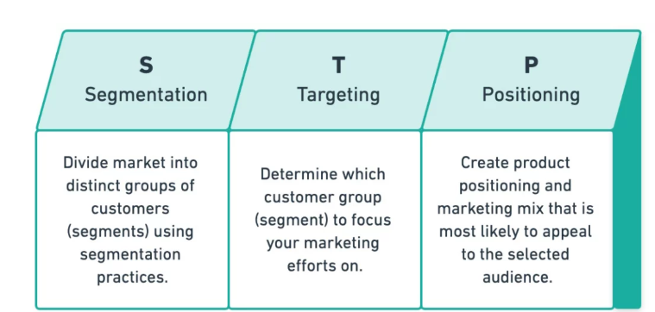
Figure 1: Segmentation, Targeting and Positioning (Yieldify, 2020)
The advantages of S.T.P. are explained by Warudkar (2020) as helping in identifying a target market and saving money that could have otherwise been wasted on unnecessary advertising.

5.1.1 Segmentation

McDonalds will be targeting potential customers who are health conscious and the method of segmentation they can use is psychographic segmentation, which Camilleri (2017) explains means to segment based on lifestyle and values, in this case McDonalds will be segmenting based on the social factors identified in the last report such as a greater interest in exercising, correlated with a greater interest in healthy eating, as they are also competing with Hello Fresh and Gousto they may want to expand their scope and aim for targeting families. Rollins (2021) Considers that families with kids will save time by using meal kits due to it cutting out the need for grocery shopping and it removes the need for collecting takeaways, so McDonalds new service could have great appeal here.

5.1.2 Targeting

McDonalds will use an differentiated strategy, Callimeri (2017) explains that this means establishing a plan to target each of their chosen segments, for McDonalds they will be using a different strategy for each segment, mainly with their promotion, by using Social Media to reach the younger, health conscious audiences, and SMS to reach the family demographic, this will be explored more in the tactics section below.

5.1.3 Positioning

McDonalds should aim to be perceived as the better choice alternative price wise in comparison to hello fresh and Gousto, this is explored more in tactics below.

5.2 Ansoff Matrix
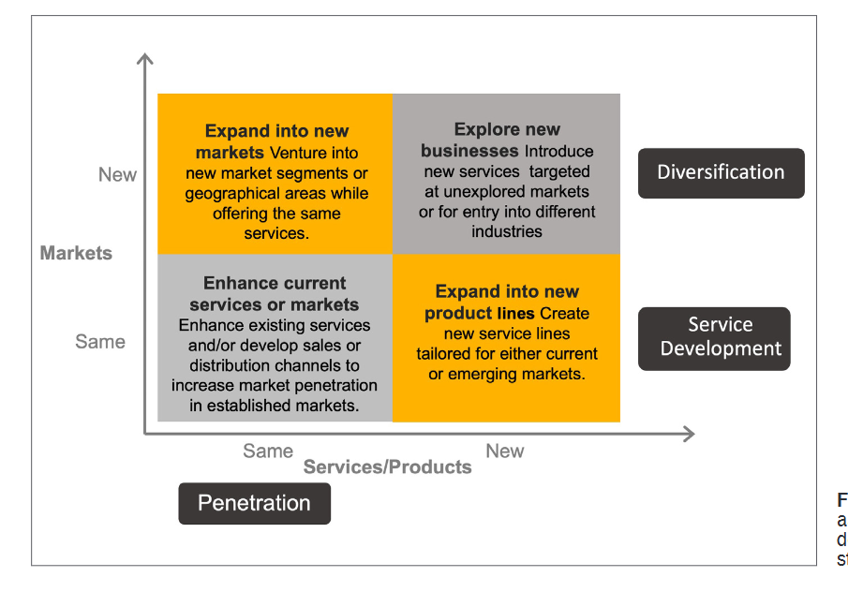…
Figure (2) – Ansoff Growth Matrix (Quaratana and Hui, 2024)
The Oxford College of Marketing (2016) explains that the Ansoff Matrix is a tool used to devise a growth strategy based on the items it sells and who it sells them to, they also explain that matrix helps in evaluating growth opportunities, shrinking risks and optimizing the allocation of resources.
Using Ansoff’s Matrix (see Figure 2), the strategy McDonalds could follow in this situation is diversification, the Meal Kit service will be new and will aim to capitalize on the health-conscious market that the current menu does not appeal to.

5.3 Porters Generic Strategy
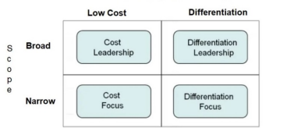
Figure (3) – Porters Generic Strategies (Bhat et al., 2024)
The University of Cambridge (2016) explains the stages of Porters Generic Strategies
- Cost Leadership: Aim to be producer in your industry with the lowest cost
- Differentiation – Aim to stand out from competitors by incorporating unique elements
- Focus – “The focuser selects a segment or group of segments in the industry and tailors its strategy to serving them to the exclusion of others.”:
- Cost focus – Achieve a cost advantage within the segment they have targeted
- Differentiation focus – aims to be a unique option to their target segment
This model has been chosen because, as explained by Stanke (2025) it is a clear framework, it provides a flexible approach for businesses, and it helps identify areas in need of improvement.
Applying this to McDonalds, McDonalds may engage in both Cost and Differentiation Focussed practices. It was established in the previous report that they were a lower cost alternative to some of their competitors, they may wish to achieve such a reputation in the new sector, this could help them attain some of Hello Fresh and Gousto market, Gonen et al. (2024) explains that businesses can attain a balance between early adopters and those who seek a bargain by understanding that they will respond to price reductions, where as a lower starting price is not a reduction, it is still confirmed that customers respond well to lower prices.

6.0 Tactics
Tactics are defined by Merriam-Webster (2025) as “the art or skill of employing available means to accomplish an end”, In this context, the 7Ps model will be used to explore how McDonalds UK can pursue their strategy. The 7Ps model is explained by Do and Vu (2020) as a tool used achieve the desired response a business wants from a target market. The 7 stages are listed and explained by Do and Vu (2020):
Product – what a business is selling.
Pricing – this involves the price of a product and other factors such as discounts.
Promotion – This involves efforts to raise brand awareness.
Place – This entails where from the businesses product is being distributed
Physical Evidence – makes a service palpable and gives it metrics.
People – Relates to the experience the customer has with staff
Process- Involves the delivery of a service and the attitudes of those people that deliver a service.

Product | McDonalds will offer these meal kit boxes which will contain make at home versions of their classic items with healthier ingredients, such as the ones McDonalds (2025) list like Chicken Selects. As well as this, McDonalds could add some new healthy meals. Good Food (2025) lists some healthy meal options that McDonalds could consider using alongside a range of healthy substitutes, such as Chinese chicken curry. The boxes could also include child portions to cater to the family demographic.
Pricing | McDonalds should use competitive pricing, Peppler (2022), explains that this means setting prices based on what competitors have set, offering lower prices can help boost sales and increase brand loyalty. Looking at the prices competitors are charging Cope (2024) notes that Hello Fresh charge £29.99 for three meals a week for two people, whereas Hannah (2025) notes that Gousto charge £31.75 for 3 recipes made for two people, McDonalds can set their price lower than their competitors so they can reap the advantages explained above.
Promotion | As said in Targeting, Social Media and SMS will be used in promotion.  Texas Health (2023) found that Millennials and Gen Z individuals are more likely to focus on eating healthy and exercising than older generations, which indicates that the growing health-conscious market will consist more so of younger audiences. The most popular way to promote to younger audiences is via social media as shown by Sheikh (2025), Instagram has 2 billion users of which 31.7% are 18-24, If McDonalds were to use a platform like Instagram, they would have more chance of reaching their target demographic. Macrotrends (2025) reports that “McDonald's annual revenue for 2024 was $25.92B, a 1.67% increase from 2023” and Airtasker (2024) reports that Instagram has a 50 per click charge, so it can be assumed that McDonalds will be able to afford social media advertisement for the 6-month test period.  Colwell (2022) finds it highly likely that parents will receive an SMS advertisement, stating there is a 98% open rate. The SMS works find these texts range in price between 2.99 pence to 10 pence plus VAT, again looking at McDonalds revenue, this should be a feature they can run for the duration of the 6-month trial.  Cnewton (2024) highlights that “Companies can still advertise healthier versions of products, and we encourage the food industry to change their recipes and think about providing healthier options.” So, restrictions mentioned in the previous report should not apply, however for certainty a legal expert should be consulted, Rothera Bray (2025) explains that legal advice should help present any breaches that could result in legal action against a company.
Place | Will be distributed from McDonalds distribution centres in the UK, McDonalds (2018) report 4 distribution centres in the UK and Ireland, “North Hampshire, Greater Manchester and Hertfordshire” as well as Dublin, these can be used to provide the service when it is started. Orders will be placed online through the McDonalds App, In the previous report it is mentioned by McDonalds (2022) that they have an App for rewards, this app could be given the additional purpose of being used to order the meal kits, After being ordered, the meal kits will be delivered to the customers home for them to prepare by following an instructional guide.
Physical Evidence | The boxes will feature McDonalds signature red and yellow colour palette, and the inside packaging will resemble that of which is seen in restaurants. The packaging will be made of recyclable materials in line with McDonalds goals of environmental protection.
People | Employees will need to be trained on how to prepare these meal kits, there may be a need for greater recruitment here. Customers should be given a QR code which will lead to a feedback page for the customers. As explained by Sokolovsky (2023), customer feedback is useful as it enables a business to gain an edge on competitors, establish customer loyalty and minimises the risk of product failure.
Process | It was mentioned in the previous report by The Sunday Times (2025) that McDonalds have goods for their restaurants supplied by British farmers, the ingredients used in these boxes can be sourced from these farmers. The boxes will be prepared at distribution centre and delivered to customers by van drivers; customers will be able to order a various quantity of food for various quantities of people.

7.0 Actions

Looking at an action plan for how McDonalds will carry out this new service, a Gantt Chart will be used. Gerald and Lechter (2012) explain that a Gantt Chart is used to organise current and future business operations, Ramos (2021) explains that Gantt charts help to improve efficiency and allows for tasks to be tracked with ease. In this report, it will be used to schedule the tasks required in carrying out this meal kit service, it can be seen below:

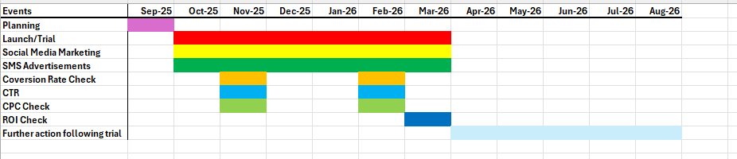
Figure 4 – Gantt Chart

Planning - Before the service is launched a month will be allocated for executive employees to lay out how this service will be provided. The Forbes Agency Council (2017) states that before a products launch, it may be important to have a definition of the target audience for the product, know the correct way to reach the audience and understand your competitors, in other words the executive team would use the data of this report to help launch the service.
Launch/Trial – When the actual service begins operations, customers will be able to order the boxes via app, they will be then prepared in the distribution centre and delivered to the customers who have ordered them. Wyatt (2024) states that over a third of employees need a new set of skills to carry out future roles, McDonalds corporate teams will need to design training exercises that will explain how these meal kits are to be prepared and delivered.
Social Media Marketing and SMS Advertisement will, as discussed above, run for the whole trial period. The conversion rate, CTR and CPC checks will occur in November and February, allowing executive McDonalds employees to see if the promotion strategies used have been effective or if altercations should be made.
Return on Investment will be analysed by executive employees to determine if the trial run was a successful venture.
Further Action will be taken in the remaining 5-month window, as explained above McDonalds may wish to readjust strategy if the venture is unsuccessful or pursue a new strategy for further growth if successful, It would be decided by higher ups in the company and would require some planning,

9.0 Control
To measure the effectiveness of the meal kit services promotions and success, Key performance indicators (KPIs) will be used. Parmenter (2015) defines KPIs: “Key performance indicators (KPIs) are those indicators that focus on the aspects of organizational performance that are the most critical for the current and future success of the organization” Pg 7.
Twin (2025) explains the usefulness of KPIs explaining that it provides an overview of how well a business is performing in a certain point of time.
Examples of some KPIs that businesses may use are provided by Gibson (2024), such as:
- Conversion rates – how many people perform a desired action (e.g. purchase an item) when visiting a webpage or digital platform – McDonalds can track the purchases made through the app
- Return on Investment (ROI) the cost of the marketing efforts will be subtracted from the generated revenue to determine the success of a venture – McDonalds can measure this at the end of the 6 months
- Cost per click – “considers the amount you pay each time a user clicks on your paid advertisement.” Airtasker (2024) explains above that the ads will be 50p per click, a high cost per click total would indicate to McDonalds that the advertisements are a success
- Click through rate – assesses the successfulness of an ad campaign by measuring how many people click on an advert. McDonalds can use this to measure the effectiveness of their SMS advertising.
Domo (2025) explains that KPIs will highlight areas for improvement, if any of the above KPIs are less than satisfactory McDonalds may choose to alter their strategy.
The CPC, CTR and conversion rates will be checked once in November 2025 and February 2026 as a means of checking the effectiveness of McDonalds Advertising campaign. Kyber (2024) says that when measuring customer engagement KPIs, they will need regular monitorisation, these scheduled checks should be sufficient.

9.0 Recommendations

To Summarise the findings of this report:
- McDonalds should pursue the objective of trying to reach 100,000 members by the end of the 6-month period, in hopes of competing in the mel kit growth market
- McDonald's should target the health conscious and family segments using social media advertisement and SMS advertisement, positioning themselves as the best value option.
- McDonalds should pursue strategies of diversification, cost and differentiation focus.
- Competitive Pricing should be used
- The McDonalds App should be used for customers to make orders
- Employees will need to be trained to make these boxes
- Customer feedback should be taken on board.
- Gantt Chart should be used for effective progress monitoring
- The KPIs should be used to monitor progress effectively.

10.0 Conclusion

Overall, in following this plan, McDonalds will hopefully be able to successfully enter and compete in the growth industry of meal kits. If McDonalds should fail, then it may be wise for them to devise a new strategy to help them reach their goals.

References

Airtasker (2024) “How much does social media advertising cost in the UK?” Available at: https://www.airtasker.com/uk/costs/social-media-marketing/social-media-advertising-cost/ Accessed: 13th May 2025
Aldridge, C.A. and Colvin, M.E. (2024) ‘Writing SMART objectives for natural resource and environmental management’, Ecological solutions and evidence, 5(1).
Bhat M., Agrawal A. and Barmpas M. V. (2024) ‘Differentiation, Cost Leadership, or Ending Up in the Middle? A Reflection on the Viability of Porter’s Generic Strategies through a Case Study Comparison of McDonalds and Starbucks’, Athens Journal of Business & Economics (online), 10(3), pp. 217–238
Boyles M. (2022) “What Is Business Strategy & Why Is It Important?” Available at: https://online.hbs.edu/blog/post/what-is-business-strategy Accessed: 17th May 2025
Cambridge Dictionary (2025) “Objective” Available at: https://dictionary.cambridge.org/dictionary/english/objective#google_vignette Accessed: 17th May
Camillieri M. A. (2017) ‘Market Segmentation, Targeting and Positioning’ Travel Marketing, Tourism Economics and the Airline Product: An Introduction to Theory and Practice Edition: 1 Chapter: 4 Publisher: Springer, Cham, Switzerland.
Chaffey D. (2023) “SOSTAC® marketing planning model guide and the RACE Growth System” Available at: https://www.smartinsights.com/digital-marketing-strategy/sostac-model/ Accessed: 4th May 2025
Chopra, A. et al. (2025) ‘A Comprehensive SWOT and TOWS analysis of transfusion medicine: Indian Perspective’, Transfusion and apheresis science, 64(1), pp. 104061–104061.
Cnewton (2024) “Here are the facts about our junk food advertising ban” Available at: h\ttps://healthmedia.blog.gov.uk/2024/12/06/here-are-the-facts-about-our-junk-food-ban/ Accessed: 10th May 2025
Colwell H. (2022) “Marketing to Parents: How to Get in Front of Busy Moms and Dads” Available at: https://www.heymarket.com/blog/marketing-to-parents/ Accessed: 15th May 2025
Cope R. (2024) “An honest HelloFresh recipe box review, written after a year of testing” Available at: https://www.glamourmagazine.co.uk/article/hello-fresh-review Accessed: 9th May 2025
De Azevedo A. (2025) “Takeaway & Fast-Food Restaurants in the UK - Market Research Report (2015-2030)” Available at: https://www.ibisworld.com/united-kingdom/industry/takeaway-fast-food-restaurants/3423/ Accessed: 17th February 2025
Do Q. H. and Vu T. H. A. (2020) ‘Understanding consumer satisfaction with railway transportation service: An application of 7Ps marketing mix’, Management science letters, 10(6), pp. 1341–1350.
Domo (2025) “How to use KPIs and metrics to boost business success” Available at: https://www.domo.com/learn/article/how-to-use-kpis-and-metrics-to-boost-business-success Accessed: 17th May 2025
Forbes Agency Council (2017) “17 Steps To Take Before You Launch A Product Or Service” Available at: https://www.forbes.com/sites/forbesagencycouncil/2017/10/24/18-steps-to-take-before-you-launch-a-product-or-service/ Accessed: 17th May 2025
Geraldi, J. and Lechter, T. (2012) ‘Gantt charts revisited: A critical analysis of its roots and implications to the management of projects today’, International journal of managing projects in business, 5(4), pp. 578–594.
Gibson K. (2024) “7 Marketing KPIs You Should Know & How to Measure Them” Available at: https://online.hbs.edu/blog/post/marketing-kpis Accessed: 8th March 2025
Gonen, L.D., Tavor, T. and Spiegel, U. (2024) ‘Unlocking Market Potential: Strategic Consumer Segmentation and Dynamic Pricing for Balancing Loyalty and Deal Seeking’, Mathematics (Basel), 12(21), pp. 3364-.
Good Food (2025) “Healthy dinner recipes” Available at: https://www.bbcgoodfood.com/recipes/collection/healthy-dinner-recipes Accessed: 10th May 2025
Hannah (2025) “Gousto prices – how much does a Gousto box cost?” Available at: https://www.gousto.co.uk/blog/gousto-prices-summary Accessed: 9th May 2025
Hinton J. (2023) “How Having Clear Objectives Benefits Your Business” Available at: https://www.ukbusinessmentoring.co.uk/news/how-an-objective-can-help-a-business Accessed: 15th May 2025
Kyber (2024) “How often should you revisit your KPIs?” Available at: https://kyber.consulting/how-often-should-you-revisit-your-kpis/ Accessed: 15th May 2025
Macrotrends (2025) “McDonald's Revenue 2010-2024 | MCD” Available at: https://www.macrotrends.net/stocks/charts/MCD/mcdonalds/revenue Accessed: 13th May 2025
McDonalds (2018) “How many distribution centres do you have in the country and where are they?” Available at: https://www.mcdonalds.com/gb/en-gb/help/faq/how-many-distribution-centres-do-you-have-in-the-country-and-where-are-they.html#:~:text=We%20use%20four%20Distribution%20Centres,Centre%20in%20the%20Dublin%20area. Accessed: 9th March 2025
McDonalds (2022) “Start earning on MyMcDonald’s Rewards!” Available at: https://www.mcdonalds.com/gb/en-gb/good-to-know/in-our-restaurants/my-mcdonalds-app/rewards.html Accessed: 10th May 2025
McDonalds (2025) “Discover Our Menu” Available at: https://www.mcdonalds.com/gb/en-gb/menu.html Accessed: 12th May 2025
McDonalds (2025) “Our Purpose & Impact” Available at: https://corporate.mcdonalds.com/corpmcd/our-purpose-and-impact.html Accessed: 9th May 2025
Merriam Webster (2025) “Tactics” Available at: https://www.merriam-webster.com/dictionary/tactics Accessed: 17th May
Oxford College of Marketing (2016) “Using The Ansoff Matrix to Develop Marketing Strategy” Available at: https://blog.oxfordcollegeofmarketing.com/2016/08/01/using-ansoff-matrix-develop-marketing-strategy/ Accessed: 3rd May 2025
Oxford College of Marketing (N.D.) “The Marketing Planning Processes” Available at: https://blog.oxfordcollegeofmarketing.com/2012/11/29/marketing-planning-the-importance-of-planning-and-the-planning-processes/ Accessed: 15th May 2025
Parmenter, D. (2015) Key performance indicators : developing, implementing, and using winning KPIs. Third edition. Hoboken, New Jersey: Wiley. Pg 7
Peppler S. (2022) “Competition-Based Pricing: Advantages & Disadvantages” Available at: https://www.flintfox.co.uk/resources/articles/competition-based-pricing-guide/ Accessed: 9th May 2025
Quaranta A. and Hui W. L. (2024) ‘The Application of the Ansoff Matrix in Dental Business Management’, Annali di stomatologia, 15(3), pp. 175–178.
Ramos D. (2025) “The Advantages and Limitations of Gantt Charts in Project Management” Available at: https://www.smartsheet.com/content/gantt-chart-pros-cons?srsltid=AfmBOoprnOkhLZp0j8EBqoNqeu223o2kKZt4DdL31jXt6if-u_2TJwnp Accessed: 14th May 2025
Rollins F. (2022) “Do Meal Kits Make Sense for a Family with Young Children?” Available at: https://magazine.joovy.com/do-meal-kits-make-sense-for-a-family-with-young-children/ Accessed: 14th May 2025
Rothera Bray (2025) “Advertising Law” Available at: https://rotherabray.co.uk/commercial-agreements-contracts/advertising-law/#:~:text=If%20your%20business%20is%20looking,against%20you%20by%20regulation%20authorities. Accessed: 15th May 2025
Sheikh M. (2025) “Social media demographics to inform your 2025 strategy” Available at: https://sproutsocial.com/insights/new-social-media-demographics/ Accessed: 9th May 2025
Sokolovsky D. (2023) “The Power Of Customer Feedback” Available at: https://www.forbes.com/councils/forbesbusinesscouncil/2023/06/30/the-power-of-customer-feedback/ Accessed at: 9th May 2025
Stanke B. (2025) “Porter's Generic Strategies: An Overview of Competitive Advantage” Available at: https://www.bobstanke.com/blog/porters-generic-strategies Accessed: 11th May 2025
Statista (2025) “Meal Kit Delivery - United Kingdom” Available at: https://www.statista.com/outlook/emo/online-food-delivery/grocery-delivery/meal-kit-delivery/united-kingdom Accessed: 3rd May 2025
Statista Research Department (2025) “Number of active customers of HelloFresh worldwide 2016-2023, by quarter” Available at: https://www.statista.com/statistics/948041/hellofresh-number-of-customers-worldwide-quarter/#:~:text=Number%20of%20active%20customers%20of%20HelloFresh%20worldwide%202016%2D2023%2C%20by%20quarter&text=In%20the%20three%20months%20ended,7.07%20million%20the%20previous%20quarter. Accessed: 17th May 2025
Texas Health (2023) “Study Shows Younger Generations Are More Health-Conscious Than Previous Generations” Available at: https://www.texashealth.org/areyouawellbeing/Health-and-Well-Being/Study-Shows-Younger-Generations-Are-More-Health-Conscious-Than-Previous-Generations Accessed: 9th May 2025
The Sunday Times (2025) “Quality Food – They’re Farming It” Available at: https://www.thetimes.com/static/farmers-potatoes-eggs-sustainable-mcdonalds-2/ Accessed: 12th May 2025
Twin A. (2025) “KPIs: What Are Key Performance Indicators? Types and Examples” Available at: https://www.investopedia.com/terms/k/kpi.asp#:~:text=Key%20performance%20indicators%20are%20used,a%20certain%20point%20in%20time. Accessed: 15th May 2025
University of Cambridge (2016) “Porter's Generic Competitive Strategies (ways of competing)” Available at: https://www.ifm.eng.cam.ac.uk/research/dstools/porters-generic-competitive-strategies/ Accessed: 3th May 2025
Wardukar H. (2020) “What is STP? The Importance of Customer Segmentation and STP Marketing” Available at: https://www.expressanalytics.com/blog/what-is-stp-in-marketing/ Accessed: 14th May 2025
Wyatt H. (2024) “Employees need new or better skills, say HR professionals” Available at: https://www.hrmagazine.co.uk/content/news/employees-need-new-or-better-skills-say-hr-professionals/ Accessed: 17th May 2025
Yieldify (2020) “The Complete Guide to STP Marketing: Segmentation, Targeting & Positioning” Available at: https://www.yieldify.com/blog/stp-marketing-model/ Accessed: 19th May 2025

