

Postgraduate/Distance Learning
Assignment coversheet & feedback form

THIS SHEET MUST BE THE FIRST PAGE OF THE ASSIGNMENT YOU ARE SUBMITTING (DO NOT SEND AS A SEPARATE FILE)

For completion by the student:
Student Name: Maayan Medzini

Student University Email: 1601934@student.uwtsd.ac.uk
Module code: AHAN7043  Module title: Skyscapes, Cosmology and Archeology | Student ID number:  1601934 |  |  | Educational support needs:  No
Assignment title: Is the Gezer ‘High Place’ a Venus Observatory?

Assignment due date: Jul. 30, 2018
This assignment is for the 1st ☐ 2nd ☐ 3rd ☐ 4th ☐ 5th ☒ 6th ☐ module of the degree
I confirm that this is my original work and that I have adhered to the University policy on plagiarism.
Signed …Mayan Medzini …………………………………
Email submission:if you are submitting this form via email, please tick this box ☒
(as a substitute for your signature) to confirm that you agree to the above declaration.
Assignment Mark
1st Marker’s Provisional mark
2nd Marker’s/Moderator’s provisional mark
External Examiner’s mark (if relevant)
Final Mark

NB. All marks are provisional until confirmed by the Final Examination Board.

For completion by Marker 1 :
Comments:

Marker’s signature: |  |  | Date:
For completion by Marker 2/Moderator:

Comments:

Marker’s Signature: |  | Date:
External Examiner’s comments (if relevant)

External Examiner’s Signature: |  | Date:
Is the 'high place' in Gezer a Venus observatory?
Word count: 3564

"Among the most spectacular discoveries of Robert Macalister at Gezer in 1902–1907 was an installation of 10 standing stones he called māssēbôt, he dubbed it a 'High Place'". Gezer was a thriving Canaanite city in the middle of the Bronze Age mentioned in the Bible, and in the Amarna letters. Now it is an Israeli national park featuring the 'high place' which turned out to be a mystery to modern scholars. The standing stones are unique, and there is no testimony to the existence of other similar installations in the world today: Ten standing stones placed in a small natural enclosure, a small depression, almost hidden from view. They are of different sizes, spaced unequally, with an altar in the middle. Their uniqueness makes it hard for researchers to understand their function, date of construction, and their ceremonial significance. They were clearly built for worship, but it is unclear, yet, to which deity/s, they were consecrated. "More than one hundred years later many aspects of this unique monument still remain enigmatic," sums up what we know about them. The purpose of this essay is to present the results of an archeoastronomy survey of a possible astronomical alignment of the stones, backed up by research into the culture that probably installed them. I will first introduce Gezer, and the archeological records of the excavations of the 'high place', followed by a presentation of the alignment of the stones to the horizon and the observed celestial phenomena. This research proposes that the 'high place' in Gezer is a Venus Observatory that still works, and a temple dedicated to Ashtoreth. The stones align with Venus (Ashtoreth) risings and setting on the horizon, accurately reflecting the phases of Venus synodic cycles, both as a morning star and as an evening star through the seasons.

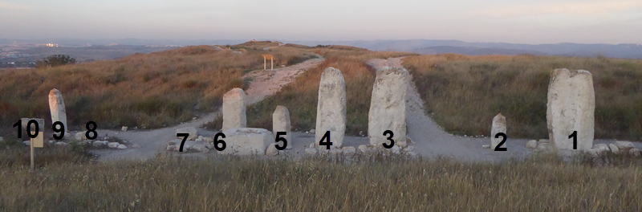
Figure 1, The Gezer 'high place' facing east, with Macalister's numbering (photo: Maayan Medzini)

Gezer and its 'high place':
Tel Gezer is an archaeological site in Israel, located right on the 'border' between the Judean Mountains and the coastal region, roughly midway between Jerusalem and Tel Aviv. The site has been populated since the Neolithic age (4th - 3rd millennium BCE) up to modern times. In ancient times it controlled important routes from Egypt to Damascus. The Tel is situated in an elevation, offering a good view of the surrounding area for many miles away. Gezer is first mentioned in the Bible in the book of Joshua, as a prominent city. In the book of 1 kings it is mentioned as a place the Pharaoh gave his daughter, King Solomon's wife. The Amarna letters from the 14-13 centuries BC, feature correspondence between the king of Gezer and the Egyptian pharaohs, attesting to the importance of the city. The city is next mentioned in the book 1 Maccabees, (circa 150 BC), as the chosen home of Simon Thassi. Over the centuries, Gezer lost its prominence, the 'high place' area served as dwellings, and was covered up by time, to be re-discovered in the 20th century. Nowadays, Tel Gezer is an Israeli national park open to the public. The archeological 'fame' of the place does not stem from the standing stones, but rather from a small inscription on a limestone tablet named The Gezer Calendar, which is the second oldest written record of the Hebrew language, with a probable date of the 10th century BCE.
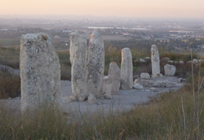
The 'high place' - meaning a place of idol worship, is NOT situated in the highest place of the Tel. Almost hidden from view, the stones cannot be seen from even a short distance and can be seen only upon approaching the edge of the small enclosure in which they stand, in a small natural depression. The tallest stones reach the top of the small hills of the enclosure. The stones are aligned in a wide crescent in a north-south direction. Between the two middle stones, there is a basin like square altar with a square cut in its middle. The stones are not the same size, some are tall, about 3 meters high, and some are short, about one meter high, two have been chopped off, one has fallen on the ground. Their widths are varied, and they are spaced unequally, some spaced narrowly, and two larger gaps, between them and the others. Archeological evidence suggest that even at the time of their installation, they were not the same size, and that they were never engraved. All these features are unique to the Gezer 'high place' with no known similar installation in the world.
Figure 2, The Gezer 'high place' facing north, The stones have been erected in a wide crescent (photo: Maayan Medzini)

The Archeological Records
Robert Macalister, an Irish 'Biblical Archeologist' excavated Gezer in 1902-3 and again in 1907-9. He was later heavily criticized by future archeologists and historians studying Tel Gezer for his method of work: "wholesale clearing without any emphasis on stratigraphic data or details, probably destroyed most of the crucial data which could have been most useful in any attempt to understand the character of the cultic site and to reconstruct its history". Macalister published his findings in a long three volume report, which offers no real clue as to the nature of the 'high place'. With non-reliable dating suggestions, the report serves more to confuse a modern researcher rather than provide clear cut information. Macalister termed the place a 'temple', made much of several burial jars for small infants he found nearby, mused about a nearby cave, and suggested cult worship practices depicted in the Bible.

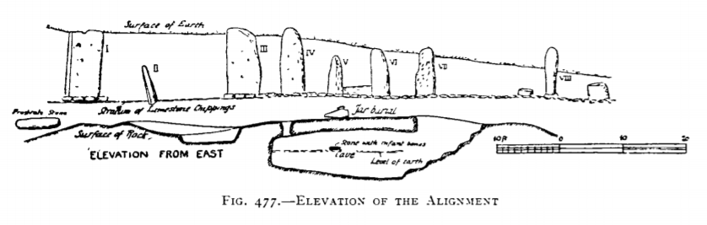
Figure 3, Macalister plan of the 'high place', published in 'The excavation at Gezer', Vol. II, p. 387

Macalister re-buried the standing stones to protect them, and in 1967 the standing stones were excavated again by William Dever leading a Hebrew Union College expedition. He did not add much to Macalister's suggestions, but concluded that the site was erected during Gezer's 'Golden Age' in MB IIC era (circa 1650-1500 BC). It was built all at once, the stones are in their original position, and they came from near-by, except for one which was probably brought from Jerusalem. Compelled to give an explanation, he concluded that the standing stones were "dedicated to covenant-renewal ceremonies" based on "Deuteronomy 27:2–8, where a māssēbāh is set up to commemorate Moses’ covenant with the 12 tribes of Israel". Yet, in the end of his report, Dever confessed to having no clue as to the symbolic significance of the 'high place' because it is so unique, and there is nothing to compare it to. In 2008, researcher Doron Ben-Ami claimed that research into 19th century archeological reports can identify other similar topographic sites: standing stones within a small depression, found in several sites in Jordan. Those were investigated by biblical archeologists touring the holy land at that time, but have vanished since. This paper is probably the first attempt to add a new angle to the archeological lens with an archeoastronomy research into a possible astronomical alignment of the standing stones.

Archeoastronomy
Archeoastronomy - the combination of archeology and astronomy is a growing field of science that adds astronomical data to archeological records. Astronomical events such as solstices, equinoxes, zenith passages, lunar standstills, heliacal risings and setting, etc. have been proposed, debated, and added an extra dimension into the interpretation of archeological findings. Archeoastronomy "investigate spatial patterning within the material record and its possible relationship to astronomical phenomena" says Clive Ruggles and emphasizes that analyzing structural orientations should start with broader cultural questions. The spatial patterning is calculated by determining the direction “indicated” by any structural orientation, measuring the azimuth, horizon altitude, and their calculated declination. An attempt is then made to identify consistent astronomical alignments that can then be correlated with the declinations of particular astronomical objects or phenomena". Beyond Solar and Lunar orientations, "Venus seems to be the only planet whose extremes exhibit easily observable patterns and long-term periodicity," says archeoastronomer Ivan Sprajc, in his discussion of alignments upon Venus. Gezer's 'high place' features a unique natural 'artificial' horizon upon which risings and settings can be easily observed. It also has historical and ethnographical records that can direct to intended astronomical phenomena.

Methodology:
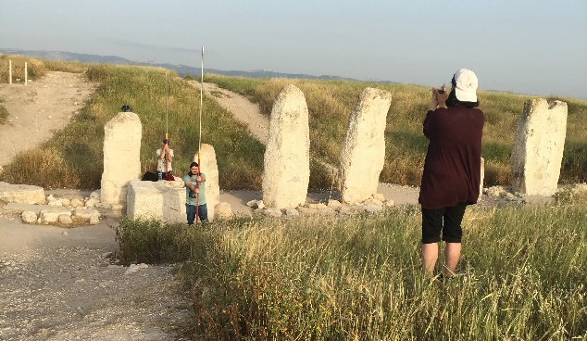
Fieldwork for the project took place during the spring of 2018, employing both a phenomenological visual experience with compass measurements for the data needed to compute the declinations. As was stated before the astronomical declination is a combination of azimuth and horizon altitude. Selecting the location for the azimuth measurements is of prime importance, and it was an uneasy task. The enclosure is not perfectly aligned east-west, nor north-south, the terrain's axial orientation changes as one walks through it. The site was buried and dug out more than once, with obvious changes of the topography. With all this in mind, I have decided to use the altar as my prime axis point, and take the measurements keeping it in the middle. The site also offers the opportunity to measure from both directions: the east and the west. Based on the altar location and moving in straight lines away and up from it (perpendicular to it), I have realized that standing near the top of the slopes, at exactly the same height as the top of the larger stones (stones 1, 3 and 4) brings into a straight line of view the top of the opposite hill as well, a natural 'makeshift' horizon. (fig. 8 and 9) . I used this 0° horizon altitude (top of the large stones converging with the horizon created by the small hill) for the smaller stones, the chopped stones and the fallen stone as well, measuring a point on the horizon on top of them. Therefore, I have taken measurements from measuring poles 'extending' the smaller stones to the same height as the larger stones/top of the hill/horizon's line. The slopes elevation is different, yet, it was easy to keep a straight line of view incorporating the stones and the horizon from both sides. The azimuth range for each stone was measured with Eyeskey Aluminum Slope/Height Measurement Compass. I have measured by hand, and therefore used the average azimuth taken on three different occasions (there were minimal variations) for the calculation of the declinations, those were corrected to true north and converted to declination by following the formula for conversion of horizontal to equatorial coordinates. ,
Figure 4, Azimuth measurements of the horizon marked by the stones. Photo: Tal Mor.

Results and Discussion

The data gathered revealed that the altar azimuth is 100/280, not exactly on the east/west axis. Solar and lunar risings and settings on solstices or equinoxes did not correspond to the declinations of the stones. More than that, the visual experience of the artificial horizon created by the hill, blocks much of the view of the rising/setting luminary. The stones stand in a wide crescent, which may correspond with many astronomical objects. Therefore, my method focused on identifying an overall consistent astronomical association as suggested by Ruggles. The overall declinations of the stones, led me to consider Venus as their intended 'target', both as a morning star and as an evening star. The declinations of Venus presented in fig. 7 and 8 are based on data obtained from JPL HORIZONS online ephemeris computation service, for circa 1600BC, based on Dever's conclusion. In addition the apparent visibility of Venus was reconstructed using Stellarium. However, before preceding to a detailed discussion of the stones' declinations in association with Venus, I would like to re-visit the material records, and their wider cultural connotations.

Ashtoreth/Venus
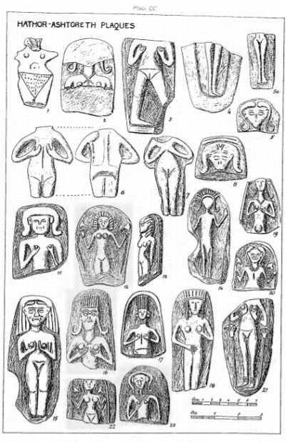
In Macalister's report, among the details of the religious objects he has uncovered in the 'high place', we find that "the most valuable figure in the excavation is the bronze statuette of the horned Ashtoreth (figure 5)". Dever maintained that the Ashtoreth statuette was found further west of the 'high place', may date to a later period. Nevertheless, Macalister's findings feature many Ashtoreth figurines, more than any other deity (fig. 4). Ashtoreth is the Biblical/Canaanite name for a goddess with many and varied names. In the Bible she is known as "Ashtoreth the goddess of the Zidonians". In the neighboring cultures she is known as Astarte, Athtar, Atartu, as Ishtar and Inanna, as Aphrodite, and sometimes simply as the Queen of the Heavens – a goddess equated with the planet Venus.
Figure 5, Macalister's Ashtoreth findings, published in 'The excavation at Gezer', Vol. III, p. 411
Ben Ami's proposal of considering the site's unique topographic features, in comparison with other similar sites brought forth a 1915 discussion of 'The Deity of the Crescent Venus' which described one of her temples as: "a double-peaked mountain with a temple in the hollow between the horns." With this notion that Venus is connected to Gezer based on the small statues, the topography, and the crescent shape installation, a further insight into its cultural significance is at hand.
The importance of helical risings and settings of Venus is evident in records from Babylon (circa 1500 BC) of the dates of the first and last visibility of Venus as morning star and as evening star. To that culture, Venus periodic 'disappearance' from the sky (when Venus is too close to the Sun to be observed) meant that she is in the underworld. Venus is the second brightest object in the night sky. Unlike other celestial bodies Venus does not rise, culminate and sets. Venus position between the earth and the Sun, dictates that it can be observed only before sunrise or after sunset, never too far from the Sun, never too high over the horizon. Venus visibility changes with her phases as demonstrated in Figure 6. In Gezer's latitude during its extreme phases it is visible for up to 3 hours before sunrise or after sunset. When it is close to the sun, before and after its 'visit to the underworld', it is visible for only few short minutes. Sparjc explains that the variations in Venus extremes are hard to determine by exact dates, but "the seasonality of extremes has likely been noted and considered significant in certain cultures." Orientations to Venus extremes have been found in Mesoamerica, and in Ashtoreth temples in Iberia., Yet, the following discussion suggests that we can validate a Venus alignment based upon its extremes in Gezer's 'high place', but add, that as a whole the site remarkably follows Venus risings and settings through its phases and all their possible variations at all the seasons.

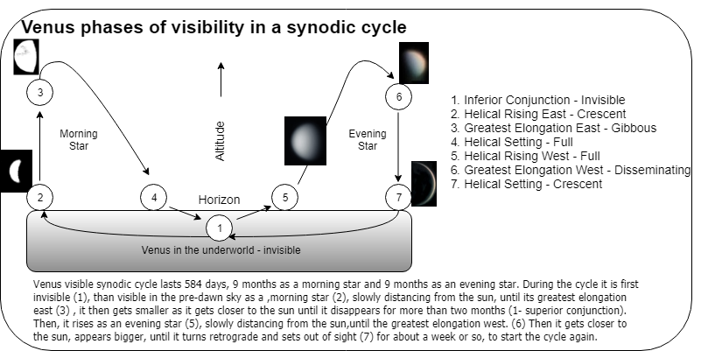
Figure 6, the phases of visibility of Venus in a synodic cycle. Images of Venus incorporated in the diagram were taken from Wikimedia commons.

Alignment upon Venus

As stated before, Venus is never too far from the sun, and therefore, its risings and settings follow the seasons: towards the north during the summer, towards the south during the winter. Venus synodic cycle span a year a half, each cycle's extreme points occur in a different season. Yet, after 5 synodic cycles, or roughly 8 years, Venus seems to be in the same place and phase at the same location, repeating itself with variations. This can explain why it is rather easy plotting the alignments to Venus over a period of time.

Figure 7, The declinations of the stones facing east | Figure 8, The declinations of the stones facing west

Fig. 7 and 8 detail the compass azimuths, and the calculation of the declinations (including true north corrections) of the stones. Fig 9 and 10 compare the stones' declination with Venus's, and demonstrate probable intentionality of the installation to observe Venus on the horizon. The slopes are a bit inclined, therefore, the stones marking Venus's seasonal paths are different from each side.

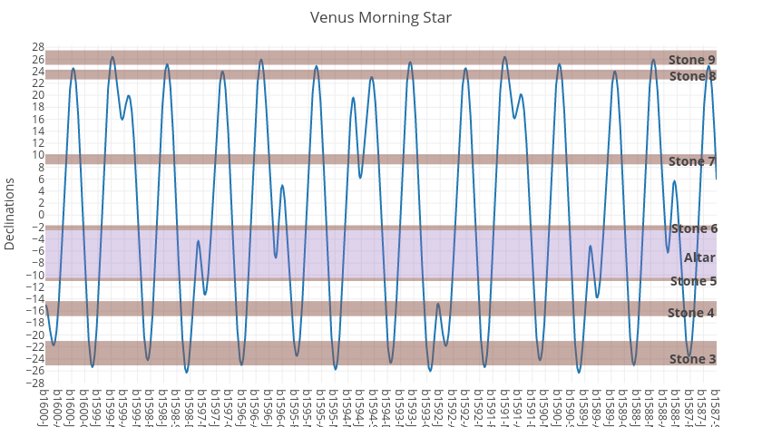
Venus Morning Star spans from stone 9 to stone 3: Standing on the western slopes, facing east, measurements reveal that stone 9 aligns with the rising Venus northern extreme, its greatest elongation east at summer solstice. Stone 8 aligns with summer risings of Venus, when it is not at its extreme elongation. Stones 7 and 6 follow the time between the summer solstice and the equinox. Near the equinox risings are marked by stones 6 and 5 with the altar in their midst. Those risings vary with Venus distance from the Sun. Stones 5 and 4 follow Venus from the equinox to the Winter solstice, with stone 3 marking the winter southern extreme of Venus morning star.
Figure 9, Venus morning star visible declinations plotted with the stones

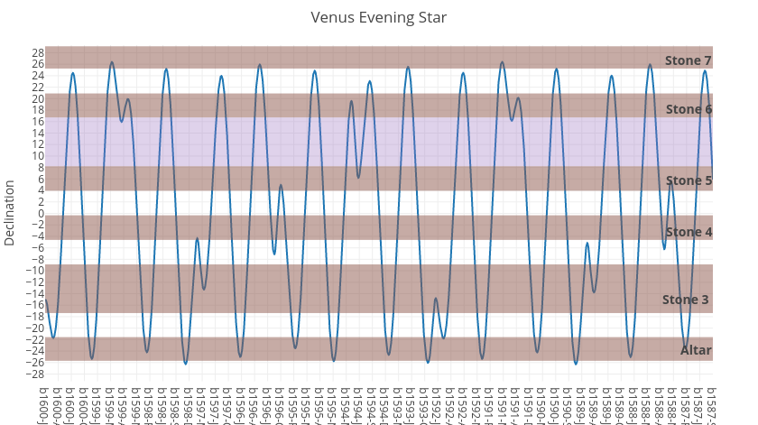
Venus Evening Star spans from stone 7 to stone 2: Standing on the eastern slope facing west, measurements reveal that stone 7 aligns with the setting Venus northern summer extreme, its greatest elongation west at summer solstice. The time between the summer solstice and the equinox is represented by stone 6. The equinox is represented by stone 5, with the attendant variations in distance from the sun marked by the altar and stone 4. Stone 3 marks the time between the equinox and the Winter solstice, with stone 2 marking the Venus evening star winter southern extreme.
Figure 10, Venus evening star visible declinations plotted with the stones

Stones 1 and 10 also mark extremes, but not those of the rising and settings, but rather, the furthest points in the sky where Venus is visible: During greatest elongation east around the time of the summer solstice, just before the Sun rises, Venus is at its highest and furthest north in the sky and can be seen shining above stone 10. The same holds for stone 1 which marks the visibility of Venus in the sky just after sunset at its extreme southern elongation around the time of the winter solstice.
The intentionality of an alignment to Venus can be demonstrated by the unequal spacing between the stones. There are two un-identical large gaps between the stones. those are explained by the different lines of visibility of the Venus extremes from either side. The gap between stones 7 and 8 is explained by Stone 7's alignment with Venus Evening star extreme settings, while stones 8 and 9 align with Venus morning star summer risings. The same is relevant for the gap between Stone 2 aligning with the Venus evening winter extreme, while stone 3 aligns with Venus morning winter extreme (Fig. 11 and 12).

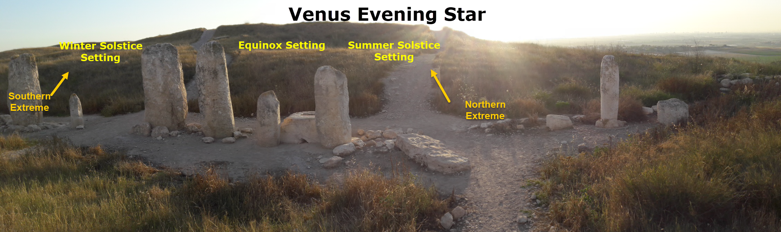
Figure 11, The seasonal path of Venus morning star (photo: Maayan Medzini).

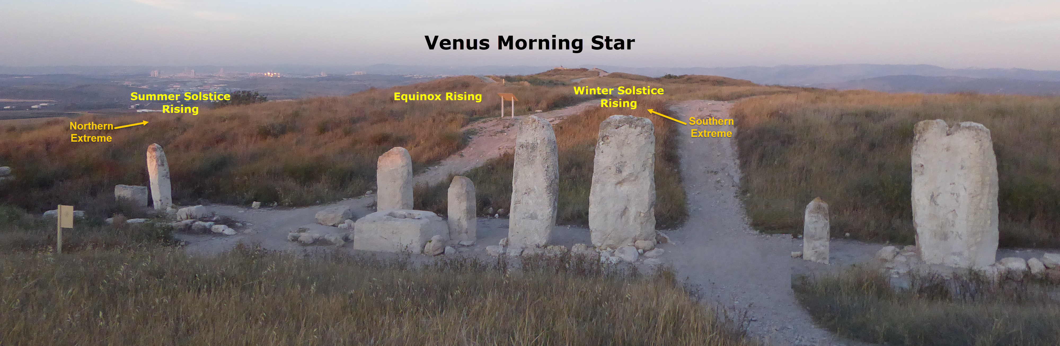
Figure 12, The seasonal path of Venus morning star (photo: Maayan Medzini).

Ruggles points to a problem of misusing the term ‘observatory’ to describe sites devoted exclusively to astronomical observations as if used by modern scientists. The 'high place' in Gezer may be a good example: it is a Venus observatory, yet, it was probably used for ritual, and used by many. The visual phenomena of Venus alignment with any stone can be seen over a large area from the slopes, down to the altar, and sideways. Possible rituals connected with the visibility of Venus are discussed in Appendix A, for now, I would like to concentrate on the visual phenomena of Venus on the horizon, and its ritual significance: The narrowly spaced stones 3 to 7 (and 8 only from the eastern side) are within the Sun's path, and therefore correspond with Venus's helical risings and settings. At these times the planet is visible for only few minutes before sunrise or after sunset. This leads to their consideration as visual aids helping a devotee to detect Venus, even when the sky is cloudy, by marking its rising/setting place on the horizon. Just by knowing the season, one would know where to locate Venus, and spot it in its short appearances. This can also explain why stones 2 and 9 are smaller, marking Venus alignments when it is high in the sky, at its best visibility. Overall, the alignment of the stones to Venus seems beyond coincidence, and fig.13 demonstrate that the observatory still works.
As with any suggestion such as this, there are still many open questions: Venus alignments cannot suggest a possible date of construction derived from the precession of the equinox. What I can suggest is that towards the west from the enclosure there is a high mound, covering a large structure Macalister dated to a later period. The stones were most likely installed before this structure was built, since it blocks parts of the visibility of Venus settings in the west.

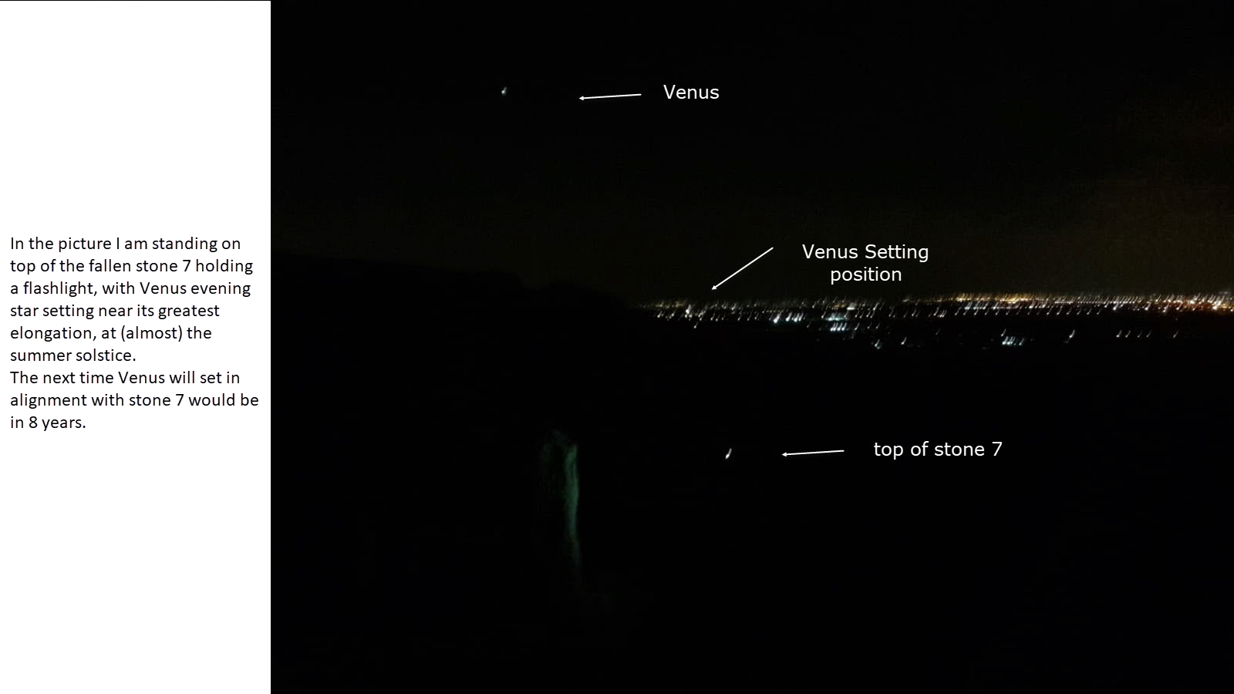
Figure 13, Picture taken at the Gezer 'high place' on June 29, 2018 at 21:30 (photo: Noam Yaffe)

Conclusion

The 'high place' in Gezer, comprised of ten standing stones and an altar installed in a small depression, puzzled archeologists and historians since they were discovered a century ago. The unique installation was regarded as a place for worship, but the specifics of deity and ceremony remained elusive. Gezer was a prominent city in the middle of the Bronze Age, 'Golden Age' dated to 1650-1500BC in which the 'high place' was probably installed. The site was excavated in the early 20th century using methods that destroyed many vital clues regarding its history. The 'high place' remained an enigma. The archeoastronomy research took into consideration material evidence such as statues, and the crescent shape formation of the stones as a possible link with Ashtoreth/Venus. Measurements of the declination of the stones demonstrated alignments to the Venus extremes, which also corresponded with the unequal gaps in their placements. The stones follow the overall seasonal path of Venus, both as a morning and an evening star. The stones were probably erected for ritual, highlighting just how important Venus observation was to those ancient people. The visual experience confirmed that the installation still works, making it is easier to observe the risings and settings of Venus over the horizon. The enigma of the 'high place' in Gezer, can be resolved with a suggested alternative name: Ashtoreth/Venus observatory temple.

Appendix A: The Queen of Heaven
Some ideas regarding the rituals connected with Ashtoreth performed at the 'high place' in Gezer can be found in two sources: the Ugarit tablets, and the Bible. Ugarit is a Phoenician city in modern day Syria. Its excavated texts, cuneiform inscriptions on clay tablets from the 14th-13th centuries B.C., contain the myths and rituals dedicated to the Canaanite deities. Those 'idol gods' so strongly opposed by the biblical prophets, were probably the deities of the Gezer people. Concentrating on the ritual tablets we find precession rituals involving moving statuettes of deities from one location to another on specific days (including Attartu (Ashtoreth)). We also find a ritual in an 'entry text' reading:

"A. (1) When Attartu-Hurri enters the “mound”(-room) (2) of the
palace: put on a feast in the temple of the (3) Star Gods.
B. As a taruμmatu-offering: (4) a garment and a tunic, a ušpgåt-garment,
(5) three shekels of gold (in the form of) a traveler’s (6)
scale.
C. A ram, a bull, and three (7) sheep/goats as a šlmm-sacrifice:
seven times (8) for the (Star?) Gods,
seven times for Kôtaru."

I would like to propose that this ritual is connected with Venus helical setting, when she enters a place where she is invisible. The above rituals were practiced in the king's palace at Ugarit, yet, there is little trace for them in the Gezer Altar which has no burning marks, and is not built as a sacrificial altar. Adding to the consideration, the cave adjacent to the stones, believed by Macalister to be connected to the rituals practiced. He suggested an oracle like ceremonies, going further to suggest that the site was chosen because of the cave. This emphasis on entering a dark space links to the well-known Sumerian myth of Inanna's Descent to the Underworld. Originally believed to depict the 'death' of the hot summer, recent scholarship on the myth presented by Jeff Cooley claim that "(the myth) at least in part, describes the setting of the planet Venus in the west followed by her journey through the underworld and eventual rising in the east". The myth has its correspondence in Ugarit's Ba'al Cycle, in which Anat, Ashtoreth's sister, goes to the underworld to save Ba'al. This may incorporate Macalister's notions of the installation near the cave representing the underworld, as part of a ritual depicting the myth.
Nevertheless, the Bible is the one source with a description that correspond to the site's unique features, depicting a possible ritual fit for the overall installation. The official KJ version of Jeremiah 7:18 translates the verse: "The children gather wood, and the fathers kindle the fire, and the women knead their dough, to make cakes to the queen of heaven, and to pour out drink offerings unto other gods." However, this translation is not an accurate one, and a direct translation from Hebrew is: "and the women knead their dough, to make DIRECTIONS to the queen of heaven, and pour out drink offerings." This verse which puzzled biblical commentators through the ages, and was not even translated to English properly, can be re-interpreted with the Gezer 'high place' in mind. With a basin like altar fit for drink offerings, and directions marked by the stones, this verse may describe the ritual intended by the culture that erected the stones.

Bibliography:
The Holy Bible, KJV (London: Oxford University Press, n.d.): Joshua 10:33, 1kings 9:16, 1 kings 11:5, Jeremiah 7:18
Dever, William G., 'The Middle Bronze Age “High Place” at Gezer', Bulletin of the American Schools of Oriental Research, No. 371, May 2014. pp. 17-57
Macalister Robert, The Excavation of Gezer, vols. I–III, (London: Committee of the Palestine Exploration Fund, 1912)

1 Maccabees, Good News Translation, (American Bible Society, 1967), ch. 13 vs. 43-48
Albright, W. F., 'The Gezer Calendar', Bulletin of the American Schools of Oriental Research,
no. 92 (Dec., 1943), pp. 16-26
Barton George A., 'The Levitical Cities of Israel in the Light of the Excavation at Gezer', The Biblical World, Vol. 24, No. 3 (Sep., 1904). pp. 167-179
Ben-Ami Doron, 'Monolithic Pillars in Canaan: Reconsidering the Date of the High Place at Gezer'. Levant 40 (2008). pp. 17-28
Cooley Jeffrey L. – Early Mesopotamian Astral Science and Divination in the Myth of Inana and Sukaletuda: in journal of ancient near eastern religions-vol.8 no.1 (2008)
Esteban César, Escacena Carrasco José Luis, 'Oriented for Prayer: Astronomical Orientations of Protohistoric Sacred Buildings of the South Iberian Peninsula', Anthropological Notebook 19 (supplement), (2013), p. 129-142
Offord Joseph, 'The Deity of the Crescent Venus in Ancient Western Asia', The Journal of the Royal Asiatic Society of Great Britain and Ireland, (Apr., 1915). pp. 197-203
Marcovich Miroslav, 'From Ishtar to Aphrodite', The Journal of Aesthetic Education, Vol. 30, No. 2, Special Issue: Distinguished Humanities Lectures II (1996), pp. 43-59
Pardee Dennis, Ritual and Cult at Ugarit, (Atlanta: Society of Biblical Literature, 2002)
Prendergast Frank, 'Techniques of Field Survey'. In Ruggles, Clive (ed), Handbook of Archaeoastronomy and Ethnoastronomy, (New York: Springer, 2015) pp. 3-14.
Ross James F., ' Gezer in the Tell el-Amarna Letters', The Biblical Archaeologist, Vol. 30, No. 2 (May, 1967), pp. 62-70
Ruggles Clive, 'Pushing back the frontiers or still running around the same circles? “Interpretative Archaeoastronomy” thirty years on'. In: Ruggles CLN (ed) Archaeoastronomy and ethnoastronomy: building bridges between cultures. (IAU symposium 278). (Cambridge University Press, 2012), Cambridge, pp 1–18
Ruggles Clive, 'Analyzing Orientations', in: Ruggles C. (eds) Handbook of Archaeoastronomy and Ethnoastronomy. (Springer: New York, 2015) p. 411-425
Ruggles Clive, 'Basic Concepts of Positional Astronomy', in: Ruggles C. (eds) Handbook of Archaeoastronomy and Ethnoastronomy. (New York: Springer, 2015) p. 459-472
Šprajc Ivan, 'Alignments upon Venus (and Other Planets) - Identification and Analysis. In: Ruggles C. (eds) Handbook of Archaeoastronomy and Ethnoastronomy. (New York: Springer, 2015). pp. 507-516
Sparjc Ivan, 'Governor’s Palace at Uxmal', in: Ruggles C. (eds) Handbook of Archaeoastronomy and Ethnoastronomy. (Springer: New York, 2015) p. 773-781
Ussishkin David, 'On The History Of The High Place at Gezer', In Studies in Honour of Manfred Bietak, E. Czerny et al. (eds.), Timelines:, vol. 2, (2006) pp. 409-416

Digital apps:
JPL HORIZONS online ephemeris computation service is provided by the Solar System Dynamics Group of the NASA Jet Propulsion Laboratory (http://ssd.jpl.nasa.gov/?horizons).
Stellarium is an open-source desktop planetarium simulating the visibility of the celestial bodies for any time and location on earth. (http://stellarium.org/)
Magnetic Field Calculators, NOAA: (http://www.ngdc.noaa.gov/geomagmodels/ Declination.jsp)

William G. Dever, 'The Middle Bronze Age “High Place” at Gezer', Bulletin of the American Schools of Oriental Research, No. 371, May 2014. P. 17
David Ussishkin, 'On The History Of The High Place at Gezer', In Studies in Honour of Manfred Bietak, E. Czerny et al. (eds.), Timelines:, vol. 2, (2006) p. 409
The Holy Bible, KJV (London: Oxford University Press, n.d.), Joshua 10:33.
The Holy Bible, KJV (London: Oxford University Press, n.d.), 1kings 9:16.
James F. Ross, ' Gezer in the Tell el-Amarna Letters', The Biblical Archaeologist, Vol. 30, No. 2 (May, 1967), pp. 62-70
1 Maccabees, Good News Translation, (American Bible Society, 1967), ch. 13 vs. 43-48
W. F. Albright, 'The Gezer Calendar', Bulletin of the American Schools of Oriental Research No. 92 (Dec., 1943), pp. 16-26
The direct translation for the word 'high place' meaning 'idol warship' from Hebrew is 'stage'. Example: 1kings 11:7 "Then did Solomon build a high place for Chemosh, the abomination of Moab, in the hill that is before Jerusalem" " אָז יִבְנֶה שְׁלֹמֹה בָּמָה, לִכְמוֹשׁ שִׁקֻּץ מוֹאָב, בָּהָר, אֲשֶׁר עַל-פְּנֵי יְרוּשָׁלִָם"-.
Dever, 'The Middle Bronze Age “High Place” at Gezer' p. 29
David Ussishkin, 'On The History Of The High Place at Gezer', In Studies in Honour of Manfred Bietak, E. Czerny et al. (eds.), Timelines:, vol. 2, (Leuven 2006) pp. 411-416 p. 409
Robert Macalister, The Excavation of Gezer, vols. I–III, (London: Committee of the Palestine Exploration Fund, 1912)
William G. Dever, The Middle Bronze Age “High Place” at Gezer, Bulletin of the American Schools of Oriental Research, No. 371 (May 2014). p. 52,
Doron Ben-Ami, 'Monolithic Pillars in Canaan: Reconsidering the Date of the High Place at Gezer'. Levant 40 (2008). pp. 17-28
Clive L.N. Ruggles, 'Pushing back the frontiers or still running around the same circles? “Interpretative Archaeoastronomy” thirty years on'. In: Ruggles CLN (ed) Archaeoastronomy and ethnoastronomy: building bridges between cultures. (IAU symposium 278). (Cambridge University Press, 2012). p. 1
Clive Ruggles, 'Analyzing Orientations', in: Ruggles C. (eds) Handbook of Archaeoastronomy and Ethnoastronomy. (Springer: New York, 2015) p. 411
Ivan Šprajc, 'Alignments upon Venus (and Other Planets) - Identification and Analysis. In: Ruggles C. (eds) Handbook of Archaeoastronomy and Ethnoastronomy. (Springer: New York, NY 2015) p. 507
Magnetic Field Calculation for the location was obtained from the National Center for Environmental Information, NOAA: (http://www.ngdc.noaa.gov/geomagmodels/ Declination.jsp)
Clive Ruggles, 'Basic Concepts of Positional Astronomy', in: Ruggles C. (eds) Handbook of Archaeoastronomy and Ethnoastronomy. (Springer: New York, 2015) p. 459
JPL HORIZONS online ephemeris computation service is provided by the Solar System Dynamics Group of the NASA Jet Propulsion Laboratory (http://ssd.jpl.nasa.gov/?horizons).
Stellarium is an open-source desktop planetarium simulating the visibility of the celestial bodies for any time and location on earth. (http://stellarium.org/)
Robert Macalister, The Excavation of Gezer, vols. II p. 403
William G. Dever, 'The Middle Bronze Age “High Place” at Gezer' p. 20
The Holy Bible, KJV (London: Oxford University Press, n.d.), 1 kings 11. 7.
Miroslav Marcovich, 'From Ishtar to Aphrodite', The Journal of Aesthetic Education, Vol. 30, No. 2, Special Issue: Distinguished Humanities Lectures II (1996), p. 45
Joseph Offord, 'The Deity of the Crescent Venus in Ancient Western Asia', The Journal of the Royal Asiatic Society of Great Britain and Ireland, (Apr., 1915),pp. 197-203 p. 201
A. Sachs, Absolute Dating from Mesopotamian Records, Philosophical Transactions of the Royal Society of London. Series A, Mathematical and Physical Sciences, Vol. 269, No. 1193, A Symposium on the Impact of the Natural Sciences on Archaeology (1970), pp. 19-22 p. 21
For example: The Sumerian tale of Inanna's Descent to the Underworld discussed in Appendix A.
Ivan Sparjc, 'Governor’s Palace at Uxmal', in: Ruggles C. (eds) Handbook of Archaeoastronomy and Ethnoastronomy. (Springer: New York, 2015) p. 773-781
César Esteban, José Luis Escacena Carrasco: 'Oriented for Prayer: Astronomical Orientations of Protohistoric Sacred Buildings of the South Iberian Peninsula', Anthropological Notebooks, XIX, Supplement (2013) p. 129-142
Clive L.N. Ruggles, 'Pushing back the frontiers or still running around the same circles? P. 3
Dennis Pardee, Ritual and Cult at Ugarit, (Atlanta: Society of Biblical Literature, 2002) p. 36
Pardee, Ritual and Cult at Ugarit p.71
Jeffrey L. Cooley – Early Mesopotamian Astral Science and Divination in the Myth of Inana and Sukaletuda: in journal of ancient near eastern religions-vol.8 no.1 (2008)
Mark S. Smith, The Ugaritic Baal Cycle: Volume I, Introduction with text, translation and commentary of KTU 1.1-1.2, (Brill: Leiden; NewYork; Koln, 1994)
Jeremiah 7:18 in Hebrew: הַבָּנִים מְלַקְּטִים עֵצִים, וְהָאָבוֹת מְבַעֲרִים אֶת-הָאֵשׁ, וְהַנָּשִׁים, לָשׁוֹת בָּצֵק: לַעֲשׂוֹת כַּוָּנִים לִמְלֶכֶת הַשָּׁמַיִם, וְהַסֵּךְ נְסָכִים לֵאלֹהִים אֲחֵרִים

