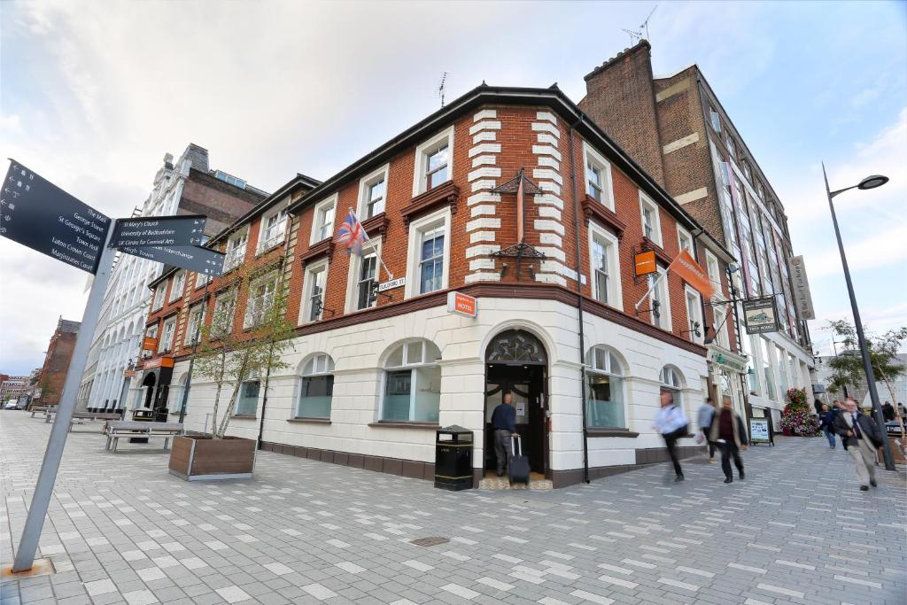
Trusted Consultancy Enterprise
Delivered on: 01.03.2023
Client’s Name: Lucs Drewes (Head of Marketing & Sales, easyHotel London Luton)
easyHotel London Luton
CONSULTANCY REPORT
2023
Student’s Name: Atikuz Zaman
Student’s No: 2019017

Table of Contents
Table of Contents
Executive summary 3
Introduction 8
Scope and analysis 9
Hotel Background 9
PESTEL Analysis 9
SWOT Analysis 12
Main Body 14
Analysis of the problems 15
Positive Aspects of EasyHotel Luton, London 19
Financial Performance Analysis 20
Findings and Results 21
The Housekeeping Department 21
The Front Office Department 23
Marketing department 24
Action Plan 25
Recommendations 28
Conclusion 29
References 30

Executive summary
The fundamental The Hotel London Luton is perfectly placed between Luton Rail Station (a 3-minute walk away) and London Luton Airport (a 20-minute drive away) (a 10-minute drive). By train, you can travel into the centre of London in around 40 minutes. There is free WiFi throughout the building, and public parking is just a minute's walk away. The comfortable Hypnos beds and flat-screen TVs in each room at the easyHotel London Luton will make you feel right at home. If you request one, we may give you with one. As an added convenience, you can buy some hot drinks and quick nibbles from the vending machine right here. Both the nearby mall and downtown Luton provide multiplex theatres, retail, and dining options (Werner, 2015). Bedfordshire University is about an 8-minute walk away. On the travel website Tripadvisor.com, the total rating was 2.7 out of 5(Tripadvisor.com, 2023). Visitors seem to enjoy the hotel's handy location, according to data. The organization is particularly good at providing practical services such as temperature control, accommodation, food, and catering.
The horrible customer service at the hotel far outweighs the many positive aspects of the property itself. This helps to explain why easyHotel had a rating of 4.7/10 from Booking.com yet only 2.7/5 from Tripadvisor. The hotel's services are of such poor quality that it is causing financial losses for the business. This study was commissioned by Trusted Consultancy Enterprise with the intention of conducting an exhaustive investigation of the data and providing the management of the hotel with actionable recommendations based on the findings.
However, extensive environmental analyses of the hotel's internal and outdoor surrounds were undertaken prior to the investigation trip. PESTEL study revealed the political motivations behind the Tax Rate Act, which led to its enactment. After the elections, the easyHotel Luton also feels the consequences of a change in government(Thams et al., 2020). There is now more competition than ever before. The third social factor impacting the hotel industry is consumers' growing preference for online hotel searches. easyHotel's long-term profitability is threatened by environmental challenges such as the industry trend toward reducing energy, water, and food waste, while customer use of social media and the internet is an example of technological growth. Finally, the day-to-day operations of the easyHotel Luton are governed by a slew of licenses and laws. An organization's internal environment may also be evaluated using the SWOT analysis (Wang, Chen & Chen, 2018). The hotel's strengths include its location, small, straightforward, and spotless rooms, budget-friendliness, convenient location, affordable pricing, and ease of accessibility from the airport, while its weaknesses include its low room turnover rate, poor customer service, long line at the front desk, and low customer satisfaction. easyHotel might be used to help with the hotel's expansion and renovation plans. Threats emanating from the broader hospitality sector, such as unfavourable coverage, guest complaints, and the introduction of new rivals, leave the hotel open to assault.
The hotel's extensive amenities aren't as much of an issue as the poor quality of its service to guests. The first issue is the lack of basic amenities like shampoo, soap, and tea and coffee. The second issue is that recent reviews of the easyHotel have shown widespread dissatisfaction with the hotel's conveniences, cleanliness, comfort, quality, services, and value (Whitaker, 2011). Last but not least, the room turnover rate is rather low at easyHotel. Since the hotel cannot keep up with the cleaning service owing to a shortage of workers, fewer guests are satisfied with their stay. Fourth, there will inevitably be a long wait in the lobby. Another problem is that easyHotel Luton isn't receiving good ratings from its customers. Finally, there is a critical lack of staff at the easyHotel in Luton.
The following table provides a weighted ranking of the various tasks:

- The issue of insufficient free resources may be easily remedied by simply stocking up on complimentary hotel supplies and storing them in closets and cleaning stations. This is a straightforward solution to the problem.
- Planning routine maintenance and buying new equipment in advance, say, 10 days, may help improve the effectiveness of room service. They might also check whether it helps to provide financial and non-financial incentives the hotel's employees (Uysal & Williams, 2013.
- Establishing Contactless Checkout technology and stocking all housekeeping stations with cleaning materials would help increase the hotel's room turnover rate, which is now too low.
- Guest-facing technology solutions that automate encounters with guests and give them more ability to act autonomously during their stay, as well as establishing a hotel employee recruiting plan, may help mitigate staff shortages (Turner & Hesford, 2019).
- By implementing Pre-arrival Contactless Check-In, you may decrease the number of people waiting in the lobby to check in, shorten the amount of time guests have to wait in line, and improve the overall guest experience.
- In order to mitigate the impact of negative feedback on the company's online image, management should create a plan that includes employing two digital marketers and increasing consumer participation (Sigala, 2018).
Soon after the problems were recognized, a strategy was devised to detail how each one would be fixed. Below is the proposed course of action:
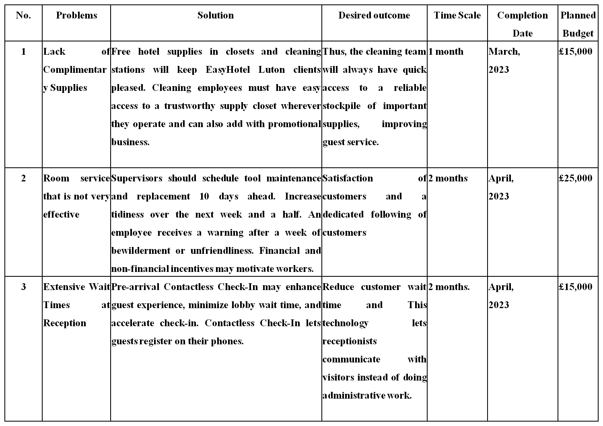
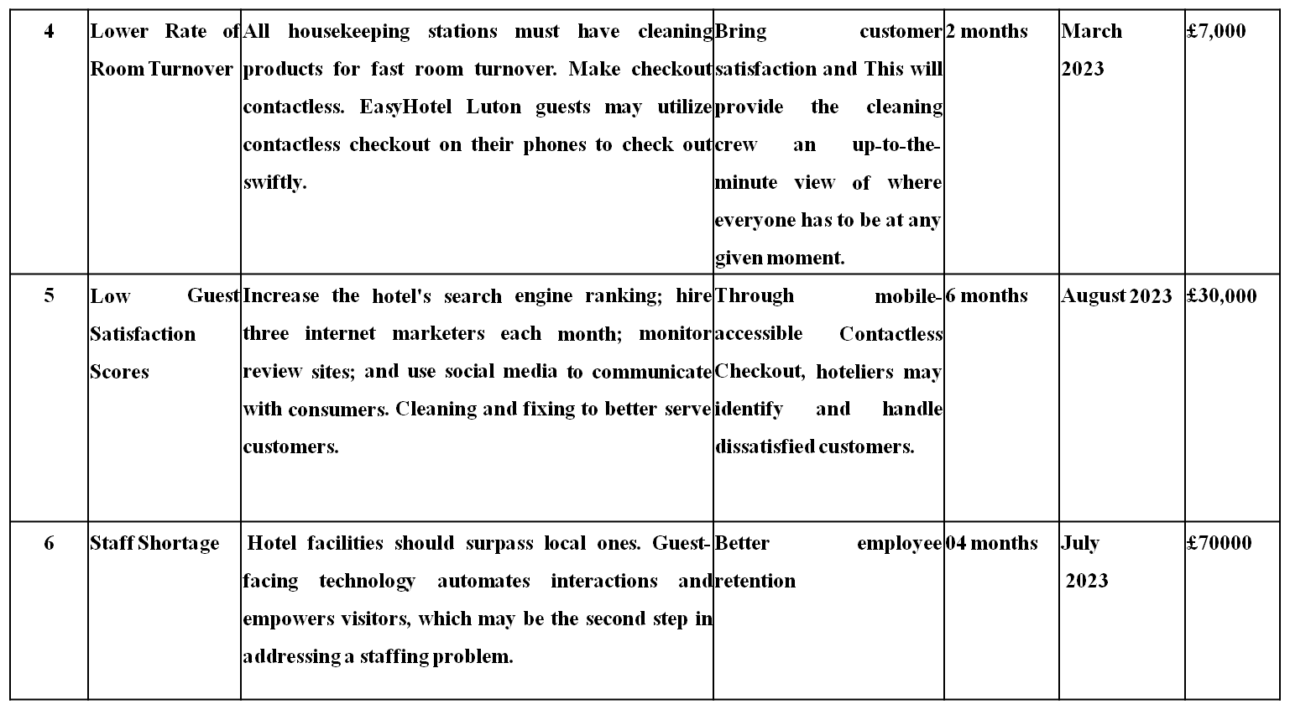
This technique uses one-month to one-year dates, depending on the complexity and urgency of the tasks. If the organization follows the strategy and motivates personnel, it will be easier to attract and retain visitors and improve consumers' negative opinions of the hotel.

Introduction
A hotel consultant is a specialist who employs a variety of strategies to raise the hotel's profile and attract more frequent visitors. The purpose of this study is to conduct a thorough examination of the available data and present the renowned EasyHotel Luton London with useful recommendations for enhancing hotel management. The first section of this report discusses the hotel's location, age, number of rooms, and client feedback. Additionally, it tackles any current management concerns. In addition, the present situation of the EasyHotel Luton has been analyzed using two distinct research methodologies. SWOT and PESTEL analyses are two prominent examples (Pelit & Katircioglu, 2022). The second part of the inquiry goes further into the operational changes of the hotel. The study finishes with a tabular summary of the results and recommendations for various hotel administration-related issues. This report will conclude with a thorough action plan that includes a timeframe, budget, and suggestions.

The EasyHotel in Luton has been experiencing some difficulties as of late. Common reasons for low customer satisfaction include unfavorable comments from customers, long wait times at the front desk, an insufficient number of personnel, cleanliness issues, and a general lack of appeal. These issues are driving customers away and costing the company money. These issues will be analyzed using the SWOT and PESTEL frameworks (Sriyam, 2017). You may assess your position in the market and the success of existing goods and services with the aid of a PESTEL analysis. This helps in comprehending the business, the market, and the customers. On the other hand, a SWOT analysis may help you figure out where your company is in terms of its own strengths, weaknesses, opportunities, and threats. This simple instrument may be used to evaluate the benefits and risks of the company's future.

Scope and analysis

Hotel Background
EasyHotel London Luton offers affordable airport lodging. Their central position is ideal for touring London and the UK. Before exploring the neighbourhood or city centre, visitors may rest in air-conditioned, well-appointed rooms. Outbound travellers may easily reach London Luton Airport in 10 minutes. Nearby WiFi and parking are free. EasyHotel London Luton offers Hypnos beds and flat-screen TVs (Sisley, 2017),. We have hairdryers. Nearby vending machines serve hot drinks and food. Downtown Luton has multiplexes, retailers, and restaurants. Bedfordshire University is 8 minutes away.
Even though the hotel advertises a wide range of services, guests often report difficulties with the hotel's customer support. First of all, there is a loack of complimentary supplies like shampoo, soap, coffee, tea etc. Second, Recent guest reviews for the EasyHotel have shown considerable discontent with the hotel's facilities, cleanliness, comfort, quality, services, and value.. Third, there is a low rate of room turnover. Forth, the hotel has staffing issues; it has shortage of staffs. Fifth, EasyHotel Luton takes extensive wait times at reception. Lastly, there is a low guest satisfaction scores on different online platform like Booking.com, Tripadvisor nad agoda.

PESTEL Analysis
To fully grasp the competitive landscape in which EasyHotel Luton finds itself, a PESTEL analysis is essential. The PESTEL study is shown below.
Factors | Impact
Political Factor | - In times of crisis, such as political unrest, the government may impose travel restrictions.  - The hotel industry might benefit or suffer from political shifts and elections (Riddle, 2022).  - The hotel's bottom line will be significantly impacted by the tax rate in effect.
Economic Factor | - There is a lot of rivalry among cheap hotels in the UK.  - More than one company offers competitively priced versions of the same service.
Social Factor | - Tourists span generations and social classes. Millennials pick hotels based on pricing and amenities.  - As a courtesy to its visitors, many hotels now provide opportunities to experience regional cuisine and activities (Sheehan Grant & Garavan, 2018).  - Many vacationers decide on a hotel after reading user reviews online. Or because they were highly recommended by someone you know and trust (Rosalina, Dupre & Wang, 2021).
Technological factor | - Hotel guests often read reviews before booking. You might have heard nice things from friends.  - Technology such as elevators, space warmers, and intercoms are used in hotels to better serve visitors.  - Because of the widespread use of social media, hotel advertisements may now reach more people (Oh, Kim & Shin, 2016).
Environmental factor | - Hotels can save food, water, and electricity. Renewable energy may reduce their carbon impact.  - Chemical cleansers have environmental impacts. Many hotels no longer utilize harmful materials (Peters, 2015).
Legal Factor | - In order to protect their visitors and their property, hotels must adhere to local innkeeper rules (Paul, 2021).  - EasyHotel, like other hotels, is subject to a number of regulations governing the hospitality industry as a whole.

Political factor analysis reveals political factors may affect EasyHotel Luton. Politics may restrict travel. This decision may damage EasyHotel Luton, which depends on overseas customers. Elections may benefit or suffer. Taxes determine the hotel. Inflation, unemployment, recession, and instability damage the hotel. (Portes, 2022). Stability and currency rates benefit the hotel. EasyHotel competes with other budget hotels in London, according to economic statistics. Famous businesses increase hotel service, complimentary meals, and more.
In the case of social factors, Hotels typically offer visitors local cuisine and culture. Traveling lets you appreciate the scenery and the culture. EasyHotel provides event packages to show guests the local culture (Pawirosumarto, Sarjana & Gunawan, 2017). New players are entering the competitive hotel business. Most hotel customers check reviews of the hotel before booking.
In the case of technological factors, the majority of hotels now provide online booking and payment. Customers like the safe app and AI-powered support system. In general, hotel reservations are a breeze for vacationers. Direct booking by foreign guests is beneficial to hotels. Hotels may improve their service quality by installing elevators, heating, and intercoms. Cameras and alarms keep them safe (Mody, Hanks & Cheng, 2021). The EasyHotel Luton, therefore, need to give greater thought to it.
Direct environmental influences on the hotel business are possible. Hotels can save food, water, and electricity. Renewable energy may reduce their carbon impact. By using more recyclables, they may cut plastic waste.
Chemical cleansers have environmental impacts. Many hotels no longer utilize harmful materials. Green cleansers protect the environment. So EasyHotel should focus more on these environmental factors.
At last, the regulations enforced by innkeepers are designed to safeguard visitors' possessions. In such circumstances, culpability and compensation are determined by these statutes (Oskam & Visser, 2022). For this reason, several countries keep an eye on lodgings to prevent any security lapses. It is essential for the survival of the hotel industry that data security regulations be followed. EasyHotel Luton must take all these things into account.

SWOT Analysis
SWOT analysis of EasyHotel Luton is given below:
Strengths | Weaknesses
- Every room at the EasyHotel Luton is compact, uncomplicated, and immaculate  - The EasyHotel is the best option for a cheap hotel close to Luton Airport.  - Pickup and drop-off service by Blue Circle Parking-affiliated transportation (Okumus & Hemmington, 2018).  - guests get unrestricted access to the in-room internet  - Convenient location, affordable pricing, and ease of accessibility from the airport. | - Lack of complimentary supplies  - Room service that is not very effective  - Low rate of room turnover  - There is a staff shortage  - Extensive wait times at reception  - Low guest satisfaction scores
Opportunities | Threats
- In the borough of Luton in London, there is an increase in the number of available hospitalization (Ozdemir et al., 2023).  - Foreign visitors may take advantage of the latest in commercial growth. | - The EasyHotel faces tough competition from some of the city's other leading hotel businesses ( Neupane, 2015).  - The bad press and user reviews on internet retailers.

Location, price, and convenience are EasyHotel Luton's SWOT strengths. The EasyHotel is the finest affordable Luton Airport hotel with comfort. Two EasyHotel parking packages: Airparks clients require less than ten minutes going from their hotel to the parking lot on departure day. They take the free airport shuttle. Blue Circle Parking-affiliated transit pick-up and drop-off. EasyHotel Luton clients must drive or pay to park since there is no parking. The Bewd Street garage, behind the hotel, offers free overnight parking from 6 p.m. to 8 a.m. EasyHotel Luton rooms are small, simple, and clean (Noone, McGuire & Rohlfs, 2019). Guests get unlimited in-room internet for the first 30 minutes. The hotel's location, price, and airport accessibility are all pluses. The hotel has drawbacks. Freebies are a bigger issue for EashyHotel Luton guests. All hotel guests get shampoo, soap, coffee, and tea. EasyHotel Luton may lose customers and ratings if its rooms don't meet these standards. The rooms, restrooms, bedding, towels, cannabis scent, and employees were all concerns. Any hotel needs regular customers to succeed. Understaffing and housekeeping issues may lower visitor happiness and income (Nasution& Mavondo, 2008). EasyHotel Luton staff struggled. Due to COVID-19 and labour market issues, Luton's EasyHotel can't meet demand. EasyHotel Luton's main issue is Booking.com, Tripadvisor, and Agoda reviews. Bad reviews deter appointments. Reviews may deter visitors. Hotel management worries they may appear anywhere. Foreign tourists may develop new business via everyday activities utilizing trained, productive workers and rising renovation investment (Manaktola& Jauhari, 2017). Competition and poor press are other concerns for the firm. Luton has more hospitalization. Hotel guests come from abroad. easyHotel rivals the city's top hotels. Finally, negative news and online reviews endanger the hotel.

Main Body
The Luton EasyHotelLuton London's association with the EasyHotel brand is reassuring. Tourists may now easily book hotels online. Tripadvisor frequently gives these place 2.7 stars. Statistics suggest hotel guests dislike the area. London Luton Airport is 10 minutes away by vehicle, and Luton Rail Station is 3 minutes from the hotel. Trains can take you to central London in under an hour. The motel has free WiFi and public parking a minute away. The EasyHotel London Luton provides Hypnos beds, flat-screen TVs, air conditioning, irons, heaters, and fans in each room. We may give a hair dryer if requested. If you're hungry, a vending machine nearby sells hot drinks and snacks (Marie, 2021). Downtown Luton and the neighbouring shopping district include multiplexes, shops, and restaurants. This is an 8-minute walk from Bedfordshire University. The business benefits from such high-quality services. Poor management and underinvestment can have detrimental impacts.
Despite the hotel's claims of providing a variety of amenities, customers have reported that they have not received the level of service that they were promised. The EasyHotel London Luton, although getting a 4.7 average rating on Booking.com, only has a 2.7 rating on Tripadvisor (2022).
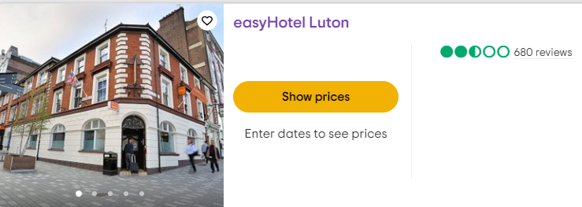
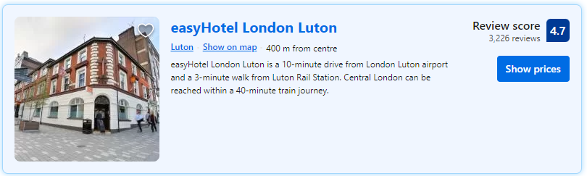
Picture 1: Customer ratings on Tripadvisor.com and Booking.com (2023)

Analysis of the problems
The following is a description and analysis of EasyHotel London Luton's issues:

First of all, Complaints from guests about the lack of freebies at the EashyHotel Luton have increased dramatically. Everyone is welcome at the EasyHotel Luton, and all guests are provided with the basics including free shampoo, soap, coffee, and tea. Luton EasyHotel might witness a decline in visitor satisfaction and poor online reviews if its rooms are lacking in these essentials.

Perhaps a wide variety of approaches can resolve this matter. For the comfort of their guests, EasyHotel Luton should stock up on freebies and disperse them liberally around the rooms and cleaning areas. This guarantees that the cleaning crew always has access to essential supplies, no matter where they are working on the property (Millar, 2021). As an added bonus, the EasyHotel Luton staff may investigate any discounts currently being offered by the companies that provide these amenities.
Second, guests have issues with the hotel's overall quality, service, value, and facilities. Visitors consented to removing the musty odour. The aging of the building makes routine upkeep more of a challenge. Long-term reservations are avoided at all costs. Tripadvisor users rated the hotel's cleanliness at 2.7 out of 5. The problem of seldom cleaning is significant. Hotels don't subject housekeeping to the same high service requirements as other departments. They're unmotivated because of the long hours, low salary, lousy managers, and lack of training. Numerous low-skilled individuals are employed at the EasyHotel Luton. This motel is in a sad state of disrepair.

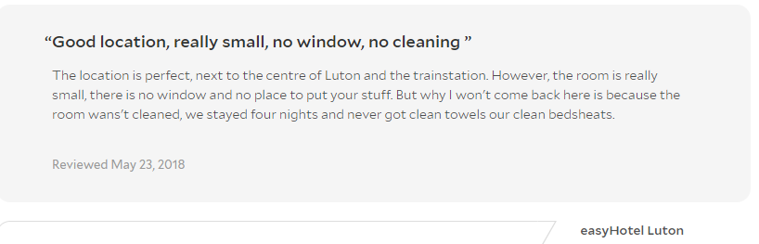
Picture 02: Guest review about cleanliness on agoda.com

The first and best option is to clean up the mess. The hotel has upgraded its cleaning operations, therefore maximizing productivity, making use of state-of-the-art equipment, and decreasing waste. A culture of cleanliness might be developed by consistent teaching. During training, employees are shown the best ways to use various pieces of cleaning equipment (Moreno& Tejada, 2019). Executives may utilize these evaluations as part of a pitch for novel methods of operation or pieces of equipment. The workers at hotels should benefit from learning more about their "ambassador" roles and the significance of providing guests with memorable stays. Third, we need to upgrade our restrooms and showers. A switch to modern home appliances may be in order. Things like brooms, dustpans, and mop buckets.

Third, not the least of the problems is the consistently lengthy queue that forms at reception. The wait for a bed at check-in at the EasyHotel in Luton is the most difficult aspect of the process since everyone there is in desperate need of a bed. When there are a lot of people waiting in line at the front desk of the hotel, the workers there could feel much greater strain.

EasyHotel Luton's Contactless Check-In solution allows visitors to take benefit of the hotel's simplified front desk operations, increased service quality, and decreased wait times even before they step foot inside the property. The hotel's use of mobile check-in technology enables all of these advantages. The hotel's innovative "Contactless Check-In" service enables guests to use their own smart phones to conduct the check-in process, which greatly simplifies the procedure for everyone involved (MIrza, 2017). Workers at the front desk may be able to spend less time on paperwork and more time interacting with customers as a consequence of this development.
Fourth, the next problem is that the EasyHotel London Luton has a very sluggish turnover rate for its guest rooms. The successful operation of hotels requires a high rate of room turnover. The hotel is losing both clients and money as a direct result of the fact that there are not enough staff working on the cleaning crew.

To solve this problem the way of solving is that if the EasyHotel Luton wants to maintain its impeccable reputation, its housekeeping staff must do everything in their power to keep the hotel spotless at all times. One of the tasks associated with this position could involve ensuring that all cleaning supplies are stocked at each housekeeping station. However, technological progress holds promise for future cleaning efficiency (Thams et al., 2020). Customers can choose to pay with any of the available contactless payment methods whenever it is most convenient for them (Liu, Wen & Huang, 2023). It's no surprise that guests are appreciative of these additions because they help them have a more pleasant and stress-free time at the hotel. When a guest checks out, they also inform the front desk staff about which rooms are available and which ones have already been vacated. This is like a real-time map for the cleaning staff, showing them exactly where they need to be at any given time.

Fifth, the main problem with EasyHotel Luton is the widespread criticism it has received on booking.com and review websites like Tripadvisor and Agoda. Bad ratings hurt the hotel since they discourage potential customers from booking a stay there. Some potential visitors could change their minds about staying at the hotel after reading these comments. Poor ratings are written by certain persons at times. Sadly, it has to be spoken. The worst case scenario for any hotel management, they might arise from an almost infinite variety of sources.
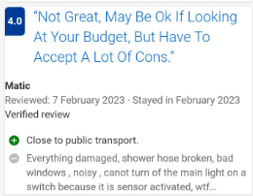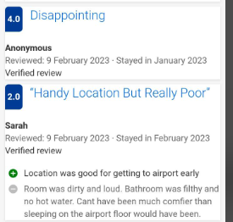
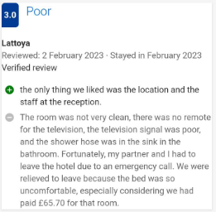
Picture 03: Low guest satisfaction scores on Booking.com

As such, it's prudent to avoid doing anything that might damage one's reputation. In order to improve a hotel's online image, management must first be aware of any complaints and take the appropriate actions to resolve them (Krishnan, 2022). It includes a wide range of responsibilities, such as keeping an eye on guest reviews, updating the hotel's social media pages, increasing traffic to the site, and more. Management at the hotel should respond individually to all reviews, positive and negative, since this is a simple yet successful strategy for controlling the brand's online reputation (Lu & Tabari, 2019). Second, in order to prevent unfavourable attention in the media, the hotel's management must prioritize improving the client experience. Facilities with state-of-the-art are conveniences, reasonable rates, friendly service staff, etc.

Lastly, At the EasyHotel located in Luton, there have been reports of staffing problems. The hotel has been experiencing difficulties due to a shortage of workers. The EasyHotel in Luton does not have enough employees to meet demand due to issues with the local labor market and the associated COVID-19 outbreak.

Two prongs of a solution are needed to address the problem of insufficient personnel. EasyHotel Luton's first order of business is to establish a system for screening applicants and selecting new hires. If the hotel wants to compete with other establishments in the area, it needs to find out what perks their rivals are offering their customers and try to beat those prices (Aladag et al., 2020). Employers can use the possibility of advancement as a selling point when trying to attract and retain talented employees (Kopp, 2022). The second method of dealing with the staffing shortage is to implement guest-facing technology solutions that automate messages to guests and grant them more freedom to do things on their own during their stay.

Positive Aspects of EasyHotel Luton, London
The EasyHotel is the best option for a cheap hotel close to Luton Airport that doesn't skimp on comfort.
EasyHotel offers two parking packages: To get from their hotel to the parking lot on the day of departure, Airparks customers need less than ten minutes. They then board the complimentary airport shuttle (Li& Tabari, 2019).
There is no parking available at the EasyHotel Luton, therefore guests should plan to either bring a car or pay to park nearby. Parking is available for free from 6 p.m. to 8 a.m., nightly, at the Bewd Street garage, which is conveniently located behind the hotel.
EasyHotel Luton rooms are small, simple, and clean. Guests have unlimited in-room internet for the first 30 minutes. A foyer vending machine sells coffee, tea, and other refreshments even if they're not in the rooms. The non-dining EasyHotel Luton is near several restaurants and coffee shops. A lobby vending machine sells drinks and snacks for lighter fare (Li et al., 2021).
The EasyHotel Luton Airport is the best option for travellers on a budget who want a comfortable night's stay without all the bells and whistles of a luxury brand while still being economical. Among the hotel's many positive qualities are its convenient location, affordable pricing, and ease of accessibility from the airport (Kilgore, 2020).

Financial Performance Analysis
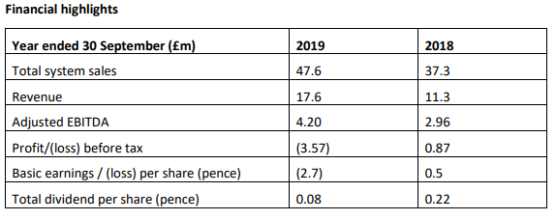
Table 01: Financial performance of EasyHotel (Source: Annual report of EasyHotel, 2019)
The hotel’s market dominance and ultra-low-cost product drove 42.1% adjusted EBITDA growth last year. Our Adjusted EBITDAR margin fell to 27.7% from 29.7% in 2018 due to investments in core resources and increased use of online travel agents (OTAs) to drive revenue and brand development. A £3.0 million non-cash impairment to our Ipswich hotel and £1.4 million in ownership structure-related expenses caused a £3.57 million loss before taxes (£0.87 million in 2018) (Jayaweera, 2015). Sales rose to £3.25 million from $2.86 million last year. The company's gross bank debt fell from £16.5 million in 2018 to £16.7 million in 2019, while cash and equivalents rose from £41.4 million to £11.7 million(Jones & Siag, 2016).
To grow its income, the hotel must also enhance its efficiency. As a result, EasyHotel must pay attention to consumer complaints and improve the hotel in response to the lower ratings that visitors have given it (Kaushal & Srivastava, 2021). The hotel values client input, reading and considering both good and negative comments in order to improve amenities and services.

Findings and Results
It is mentioned in the sections of the report pertaining to the scope and the major body that the easyHotel Luton possesses a number of positive qualities. On the other hand, it suffers from a significant lack of success in a number of the aforementioned areas. The following is a summary of the findings as well as the solutions regarding the different departments in the organization.

The Housekeeping Department
Problems and Findings | Solutions
Lack of Complimentary Supplies: EashyHotel Luton visitors are complaining about the absence of freebies more than before. Normally a hotel provides shampoo, soap, coffee, and tea to all guests. If its rooms lack these requirements, EasyHotel Luton may lose visitors and online ratings. | - EasyHotel Luton should stock up on complimentary room supplies and place them in closets and cleaning stations to keep visitors pleased.  - The housekeeping team should always have easy access to a dependable supply closet, no matter where they are on the premises.  - If the hotel believes there is a discount to be had from any of the firms for promotional providing these services, it may make the necessary inquiries (Jackson, 2018).
Room service that is not very effective: There were complaints with the rooms and bathrooms being dirty, there not being enough clean towels, the beds being uncomfortable, the smell of cannabis being present, and the staff being disrespectful. | - Supervisors should schedule routine maintenance and arrange for replacement equipment 10 days in advance.  - Within the next 10 days, raise the standard for cleanliness even higher.  - Recognizing disoriented or unfriendly workers within a week and issuing a warning to them  - Employees might be encouraged to perform better by offering both monetary and non-monetary incentives ( Justice, 2016).
Low Rate of Room Turnover: EasyHotel has a low rate of room turnover. As the hotel is understaffed and has trouble keeping up with the cleaning service, it causes a reduction in guest satisfaction and revenue. | - The hotel must provide all housekeeping stations with cleaning supplies to ensure fast room turnover  - Cleaning operations may be made more efficient with the use of technology (Jayawardena, 2019).  - Establish a Contactless Checkout technology  - If the guests are staying at the EasyHotel Luton, they can use their own mobile device to check out swiftly and conveniently using the hotel's contactless checkout technology (Hossain, 2017).
Staff Shortage: EasyHotel Luton staffs have had issues. The hotel has staffing issues. The EasyHotel in Luton is straining to meet visitor demand amid a COVID-19 pandemic and labour market issues. | - It's possible to approach the problem of a lack of available workers from two different angles. The first order of business is to design a hotel employee recruitment strategy. The hotel should research similar nearby establishments to see whether they offer any enticing perks, and if so, you should aim to equal or beat those (Gray & Liguori, 2011).  - The second stage in fixing a staffing issue may be to rely on guest-facing technology solutions, which automate contacts with guests and provide them greater freedom to act independently throughout their stay (Hassanien & Baum, 2018).

The Front Office Department
Problems and Findings | Solutions
Extensive Wait Times at Reception: Unavoidably, there will be a protracted line at the front desk. If someone is waiting for something they really need, like a bed in a beautiful room when they are staying at a hotel, they are less likely to be patient in a lengthy queue. When there are lengthy wait periods at the front desk, the hotel personnel often encounters furious and argumentative visitors. | - Pre-arrival Contactless Check-In may save time at the front desk, simplify the visitor experience, and reduce the likelihood of people waiting in the lobby to check in (Hesling, 2018).  - Guests may use their own smart phones to check in whenever it's convenient for them using Contactless Check-In (Garcia, 2019).

Marketing department
Problems and Findings | Solutions
Low Guest Satisfaction Score: EasyHotel Luton's main issue is its negative reviews on booking.com, Tripadvisor, and Agoda. Bad reviews deter guests from booking. These reviews may deter some guests. Some give low ratings. It's unfortunate. The worst-case scenario for hotel management is they could come from almost any source. | - Hiring three online marketers in a month.  - Keeping an eye on rating sites  - Using social media to spread content and engage with clients,  - Increasing the website of the hotel's accessibility via search,  - Putting an emphasis on maintenance, such as repairs and cleaning, in order to better serve customers (Hua, 2016).

It was found in the early phases of the study that managing a hotel is not an easy endeavour, and that a large amount of preparation is required. This was one of the key takeaways from those stages. If the hotel managers are well-prepared to deal with problems as they arise, there is a lesser likelihood that little problems may snowball into more serious problems in the future (Harris & Reynolds, 2014). The staff members working at the EasyHotel Luton will learn, in the case of a crisis, that it is very advantageous to have access to solid technological tools as well as well-laid plans of action in order to properly address the issue. In the event that the hotel staff is ready for anything may come their way, it is essential that certain items be maintained on hand at all times and be in a condition of preparedness (Denizci & Mohammed, 2015).

Action Plan
The EasyHotel Luton will use the following action plan going forward:
No. | Problems | Solution | Desired outcome | Time Scale | Completion Date | Planned Budget
1 | Lack of Complimentary Supplies | Free hotel supplies in closets and cleaning stations will keep EasyHotel Luton clients pleased. Cleaning employees must have easy access to a trustworthy supply closet wherever they operate and can also add with promotional business. | Thus, the cleaning team will always have quick access to a reliable stockpile of important supplies, improving guest service.  ‍ | 1 month | March,  2023 | £15,000
2 | Room service that is not very effective | Supervisors should schedule tool maintenance and replacement 10 days ahead. Increase tidiness over the next week and a half. An employee receives a warning after a week of bewilderment or unfriendliness. Financial and non-financial incentives may motivate workers. | Satisfaction of customers and a dedicated following of customers | 2 months | April,  2023 | £25,000
3 | Extensive Wait Times at Reception | Pre-arrival Contactless Check-In may enhance guest experience, minimize lobby wait time, and accelerate check-in. Contactless Check-In lets guests register on their phones. | Reduce customer wait time and This technology lets receptionists communicate with visitors instead of doing administrative work.  ‍ | 2 months. | April,  2023 | £15,000
4 | Lower Rate of Room Turnover | All housekeeping stations must have cleaning products for fast room turnover. Make checkout contactless. EasyHotel Luton guests may utilize contactless checkout on their phones to check out swiftly. | Bring customer satisfaction and This will provide the cleaning crew an up-to-the-minute view of where everyone has to be at any given moment. | 2 months | March  2023 | £7,000
5 | Low Guest Satisfaction Scores | Increase the hotel's search engine ranking; hire three internet marketers each month; monitor review sites; and use social media to communicate with consumers. Cleaning and fixing to better serve customers. | Through mobile-accessible Contactless Checkout, hoteliers may identify and handle dissatisfied customers. | 6 months | August 2023 | £30,000
6 | Staff Shortage | Hotel facilities should surpass local ones. Guest-facing technology automates interactions and empowers visitors, which may be the second step in addressing a staffing problem. | Better employee retention | 04 months | July  2023 | £70000

Recommendations
The previous study has led to the discovery of a number of problems as well as the answers to those problems. However, not every problem has the same level of significance. It is vital to give relative weight to each work since no two responsibilities are the same in and of themselves. In order to solve the issues that customers have with the establishment, the following are some potential solutions that the hotel might implement:
- The issue of insufficient free resources may be easily remedied by simply stocking up on complimentary hotel supplies and storing them in closets and cleaning stations. This is a straightforward solution to the problem (Djajasinga et al., 2021).
- Planning routine maintenance and buying new equipment in advance, say, 10 days, may help improve the effectiveness of room service. the might also check whether it helps to provide financial and non-financial incentives the hotel's employees.
- Establishing Contactless Checkout technology and stocking all housekeeping stations with cleaning materials would help increase the hotel's room turnover rate, which is now too low (Filimonau & Mika, 2019).
- Guest-facing technology solutions that automate encounters with guests and give them more ability to act autonomously during their stay, as well as establishing a hotel employee recruiting plan, may help mitigate staff shortages (Almeida& Silva, 2020).
- By implementing Pre-arrival Contactless Check-In, you may decrease the number of people waiting in the lobby to check in, shorten the amount of time guests have to wait in line, and improve the overall guest experience (French, 2018).
- In order to mitigate the impact of negative feedback on the company's online image, management should create a plan that includes employing two digital marketers and increasing consumer participation.

Conclusion
This consultant research was commissioned by the EasyHotel Luton, a popular establishment due to its convenient location, spacious event space, and high-quality dining and lodging options. The hotel has offered our Summit team the opportunity to serve as their consulting company, and we have already identified a number of issues that need to be fixed (Zainal et al., 2012). The company's expertise in event management and catering has been highly praised. Wasteful renovation expenses, low visitor satisfaction scores, long wait times at the front desk, a lack of complementary supplies, low room turnover, a paucity of employees, and unfavourable customer reviews have all contributed to the hotel's current predicament. Customers are defecting and sales are falling because of these issues.
The argument stated in this article is that janitors in all types of settings benefit from having easy access to a supply closet stocked with materials and the opportunity to earn extra money via promotional activities. Several tourists have complained about the hotel's lack of cleanliness and sanitary conditions, therefore staff members are working to fix these issues. Pre-arrival Contactless Check-In may enhance the passenger experience, as well as the time spent in the lobby and checking in (Zaba, 2019). The usage of a mobile device for the check-in process is one of the primary advantages of Contactless Check-In. Hiring personnel with the required abilities, attitude, and drive might help to overcome HR challenges. Plan for tool replacement and maintenance at least ten days in advance should be established. Attempt to be cleaner over the next two weeks (Altinay, Paraskevas & Ali, 2015). A warning is given after one week of workplace uncertainty or hostility. Employees may benefit from both monetary and nonmonetary incentives if they are used to increase productivity. The hotel must outperform its competitors in terms of facilities and services.

References
Aladag, O.F., Köseoglu, M.A., King, B. and Mehraliyev, F., 2020. Strategy implementation research in hospitality and tourism: Current status and future potential. International Journal of Hospitality Management, 88, p.102556.
Altinay, L., Paraskevas, A. and Ali, F., 2015. Planning research in hospitality and tourism. Routledge.
Almeida, F. and Silva, O., 2020. The impact of COVID-19 on tourism sustainability: Evidence from Portugal. Advances in Hospitality and Tourism Research (AHTR), 8(2), pp.440-446.
Denizci Guillet, B. and Mohammed, I., 2015. Revenue management research in hospitality and tourism: A critical review of current literature and suggestions for future research. International Journal of Contemporary Hospitality Management, 27(4), pp.526-560.
Djajasinga, N.D., Sulastri, L., Sudirman, A., Sari, A.L. and Rihardi, E.L., 2021, June. Practices in Human Resources and Employee Turnover in the Hospitality Industry. In 2nd Annual Conference on blended learning, educational technology and Innovation (ACBLETI 2020) (pp. 113-117). Atlantis Press.
Filimonau, V. and Mika, M., 2019. Return labour migration: an exploratory study of Polish migrant workers from the UK hospitality industry. Current Issues in Tourism, 22(3), pp.357-378.

French, S., 2018. Between globalisation and Brexit: Migration, pay and the road to modern slavery in the UK hospitality industry. Research in Hospitality Management, 8(1), pp.23-

Garcia, C. (2019) The Best Cheap Hotels in London from $39 - london cheap hotels: Expedia, Expedia.com. Available at: https://www.expedia.com/London-Hotels-Cheap-Hotels.0-0-d178279-tCheapHotels.Travel-Guide-Filter-Hotels (Accessed: November 21, 2022).
Gray, W.S. and Liguori, S.C. (2011) Hotel and Motel Management and Operations. Upper Saddle River, NJ: PH/PTR.
Halloran, R. (2021) The Changing Hotel Legal Environment: Being Aware and prepared: By Robert O'Halloran, Hospitality Net. Hospitality Net. Available at: https://www.hospitalitynet.org/opinion/4108245.html (Accessed: November 25, 2022).

Hua, N., 2016. E-commerce performance in hospitality and tourism. International Journal of Contemporary Hospitality Management.
Harris, L.C. and Reynolds, K.L., 2014. Jaycustomer behavior: an exploration of types and motives in the hospitality industry. Journal of Services Marketing, 18(5), pp.339-357.
Hassanien, A. and Baum, T., 2018. Hotel repositioning through property renovation. Tourism and Hospitality Research, 4(2), pp.144-157.
Hesling, D. (2019) Hotel Housekeeping: Tips, tricks & checklist, Little Hotelier. Available at: https://www.littlehotelier.com/blog/running-your-property/hotel-housekeeping-complete-guide/ (Accessed: November 25, 2022).
Hossain, H. (2017) Guest privacy, safety and security in the hotel industry, The National Law Review. Available at: https://www.natlawreview.com/article/guest-privacy-safety-and-security-hotel-industry (Accessed: November 25, 2022).
Jayawardena, C., 2019. What are the key innovative strategies needed for future tourism in the world?. Worldwide Hospitality and Tourism Themes, 11(2), pp.235-247.
Justice, K. (2016) The importance of Hotel Reputation Management - Texas Hotel and lodging, Texas Hotel and Lodging - Texas Hotel and Lodging. Available at: https://texaslodging.com/the-importance-of-hotel-reputation-management/ (Accessed: November 23, 2022).
Jackson, E. (2018) Hotel Management. New York, NY: Larsen & Keller.
Jayaweera, T., 2015. Impact of work environmental factors on job performance, mediating role of work motivation: A study of hotel sector in England. International journal of business and management, 10(3), p.271.
Jones, P. and Siag, A., 2016. A re-examination of the factors that influence productivity in hotels: A study of the housekeeping function. Tourism and Hospitality Research, 9(3), pp.224-234.
Kaushal, V. and Srivastava, S., 2021. Hospitality and tourism industry amid COVID-19 pandemic: Perspectives on challenges and learnings from India. International journal of hospitality management, 92, p.102707.
Kilgore, T. (2020) Covid-19 hit the hotel industry hard. here's how hotels are pivoting in the new reality, MarketWatch. MarketWatch. Available at: https://www.marketwatch.com/story/covid-19-turned-the-hotel-industry-upside-down-but-it-wont-change-what-people-want-2020-08-23 (Accessed: November 25, 2022).
Kopp, C.M. (2022) What is organizational behavior (OB), and why is it important?, Investopedia. Investopedia. Available at: https://www.investopedia.com/terms/o/organizational-behavior.asp (Accessed: November 25, 2022).
Krishnan, V. (2020) Hospitality and covid-19: How long until 'no vacancy' for us hotels?, McKinsey & Company. McKinsey & Company. Available at: https://www.mckinsey.com/industries/travel-logistics-and-infrastructure/our-insights/hospitality-and-covid-19-how-long-until-no-vacancy-for-us-hotels (Accessed: November 25, 2022).
Lu, L. and Tabari, S., 2019. Impact of Airbnb on customers' behavior in the UK hotel industry. Tourism Analysis, 24(1), pp.13-26.
Li, M., Yin, D., Qiu, H. and Bai, B., 2021. A systematic review of AI technology-based service encounters: Implications for hospitality and tourism operations. International Journal of Hospitality Management, 95, p.102930.
Liu-Lastres, B., Wen, H. and Huang, W.J., 2023. A reflection on the Great Resignation in the hospitality and tourism industry. International Journal of Contemporary Hospitality Management, 35(1), pp.235-249.
MIrza, F. (2017) Topic: Hotel industry in the United Kingdom (UK), Statista. Available at: https://www.statista.com/topics/3146/hotel-industry-in-the-united-kingdom-uk/ (Accessed: November 19, 2022).
Moreno, P. and Tejada, P., 2019. Reviewing the progress of information and communication technology in the restaurant industry. Journal of Hospitality and Tourism Technology.
Millar, A. (2021) How to keep hotels clean and hygienic during a pandemic, ISSA. Available at: https://www.issa.com/articles/how-to-keep-hotels-clean-and-hygienic-during-a-pandemic (Accessed: November 19, 2022).
Marie, C. (2021) Smokefree Policies Do Not Hurt The Hospitality Industry, Centers for Disease Control and Prevention. Centers for Disease Control and Prevention. Available at:https://www.cdc.gov/tobacco/data_statistics/fact_sheets/secondhand_smoke/protection/hospitality/index.htm (Accessed: November 25, 2022).
Manaktola, K. and Jauhari, V., 2017. Exploring consumer attitude and behaviour towards green practices in the lodging industry in India. International journal of contemporary hospitality management.
Nasution, H.N. and Mavondo, F.T., 2008. Customer value in the hotel industry: What managers believe they deliver and what customer experience. International Journal of Hospitality Management, 27(2), pp.204-213
Noone, B.M., McGuire, K.A. and Rohlfs, K.V., 2019. Social media meets hotel revenue management: Opportunities, issues and unanswered questions. Journal of Revenue and Pricing Management, 10(4), pp.293-305.
Neupane, R., 2015. Effects of coaching and mentoring on employee performance in the UK hotel industry. International Journal of Social Sciences and Management, 2(2), pp.123-138.
Ozdemir, O., Dogru, T., Kizildag, M. and Erkmen, E., 2023. A critical reflection on digitalization for the hospitality and tourism industry: value implications for stakeholders. International Journal of Contemporary Hospitality Management.
Okumus, F. and Hemmington, N., 2018. Barriers and resistance to change in hotel firms: an investigation at unit level. International Journal of Contemporary Hospitality Management.
Mody, M.A., Hanks, L. and Cheng, M., 2021. Sharing economy research in hospitality and tourism: a critical review using bibliometric analysis, content analysis and a quantitative systematic literature review. International Journal of Contemporary Hospitality Management, 33(5), pp.1711-1745.
Oskam, J.A. and De Visser-Amundson, A., 2022. A systematic review of ethical issues in hospitality and tourism innovation. Journal of Hospitality and Tourism Insights.
Oh, H., Kim, B.Y. and Shin, J.H., 2016. Hospitality and tourism marketing: recent developments in research and future directions. International Journal of Hospitality Management, 23(5), pp.425-447.
Peters, M., 20015. Innovation in hospitality and tourism. Routledge.
Paul, G. (2021) Achieving sustainability in the hotel industry, Asksuite. Available at: https://asksuite.com/blog/sustainability-in-hotel-industry/ (Accessed: November 25, 2022).
Portes, J., 2022. Immigration and the UK economy after Brexit. Oxford Review of Economic Policy, 38(1), pp.82-96.
Pawirosumarto, S., Sarjana, P.K. and Gunawan, R., 2017. The effect of work environment, leadership style, and organizational culture towards job satisfaction and its implication towards employee performance in Parador Hotels and Resorts, Indonesia. International journal of law and management.
Pelit, E. and Katircioglu, E., 2022. Human resource management studies in hospitality and tourism domain: a bibliometric analysis. International Journal of Contemporary Hospitality Management, 34(3), pp.1106-1134.
Rosalina, P.D., Dupre, K. and Wang, Y., 2021. Rural tourism: A systematic literature review on definitions and challenges. Journal of Hospitality and Tourism Management, 47, pp.134-149.
Riddle, H. (2020) 10 best economy and budget-friendly hotel brands and chains, The Vacationer. Available at: https://thevacationer.com/best-economy-and-budget-friendly-hotel-brands-and-chains/ (Accessed: November 25, 2022).
Sheehan, M., Grant, K. and Garavan, T., 2018. Strategic talent management: A macro and micro analysis of current issues in hospitality and tourism. Worldwide Hospitality and Tourism Themes.
Sriyam, A.L.I.N., 2017. Customer satisfaction towards service quality of front office staff at the hotel. Master Paper Of Arts Degree In Business English For International Communication.
Sisley, B. (2017) Hotel Management: Everything you need to know about managing a hotel, Revfine.com. Available at: https://www.revfine.com/hotel-management/ (Accessed: November 25, 2022).
Sigala, M., 2018. The information and communication technologies productivity impact on the UK hotel sector. International journal of operations & production management.
Thams, A., Zech, N., Rempel, D. and Ayia-Koi, A., 2020. An initial assessment of economic impacts and operational challenges for the tourism & hospitality industry due to COVID-19 (No. 2/2020). IUBH Discussion Papers-Tourismus & Hospitality.
Turner, M.J. and Hesford, J.W., 2019. The impact of renovation capital expenditure on hotel property performance. Cornell Hospitality Quarterly, 60(1), pp.25-39.
TripAdvisor (2023) EasyHotel Luton London - prices & reviews (London, England), Tripadvisor. Available at: https://www.tripadvisor.com/Hotel_Review-g186338-d195394-Reviews-Britannia_Hampstead_Hotel-London_England.html.
Uysal, M. and Williams, J.A., 2013. Current issues and development in hospitality and tourism satisfaction. Routledge.
Whitaker, M., 2011. Overcoming the barriers to successful implementation of information technology in the UK hotel industry. International Journal of Hospitality Management, 6(4), pp.229-235.
Wang, C.H., Chen, K.Y. and Chen, S.C., 2018. Total quality management, market orientation and hotel performance: The moderating effects of external environmental factors. International journal of hospitality management, 31(1), pp.119-129.
Werner, D. (2015) 5 Ways Hotel Consultant Agencies enhance the hospitality industry, Business First Family. Available at: https://businessfirstfamily.com/hotel-consultant-agencies-hospitality-industry/ (Accessed: November 25, 2022).
Zainal, A., Radzi, S.M., Hashim, R., Chik, C.T. and Abu, R. eds., 2012. Current issues in hospitality and tourism: Research and innovations. CRC Press.
Zaba, D. (2019) The importance of cleanliness in hotels: Beyond Housekeeping, ServiceMaster Restoration by Zaba. Available at: https://www.servicemasterbyzaba.com/blog/importance-of-cleanliness-in-hotels/ (Accessed: November 17, 2022).

