Name : Mubeen Rashid
Student No : 2126975
Lecturer : Ffion Cumberpatch
Module : Food & Beverage Operations

Hotel Trinity
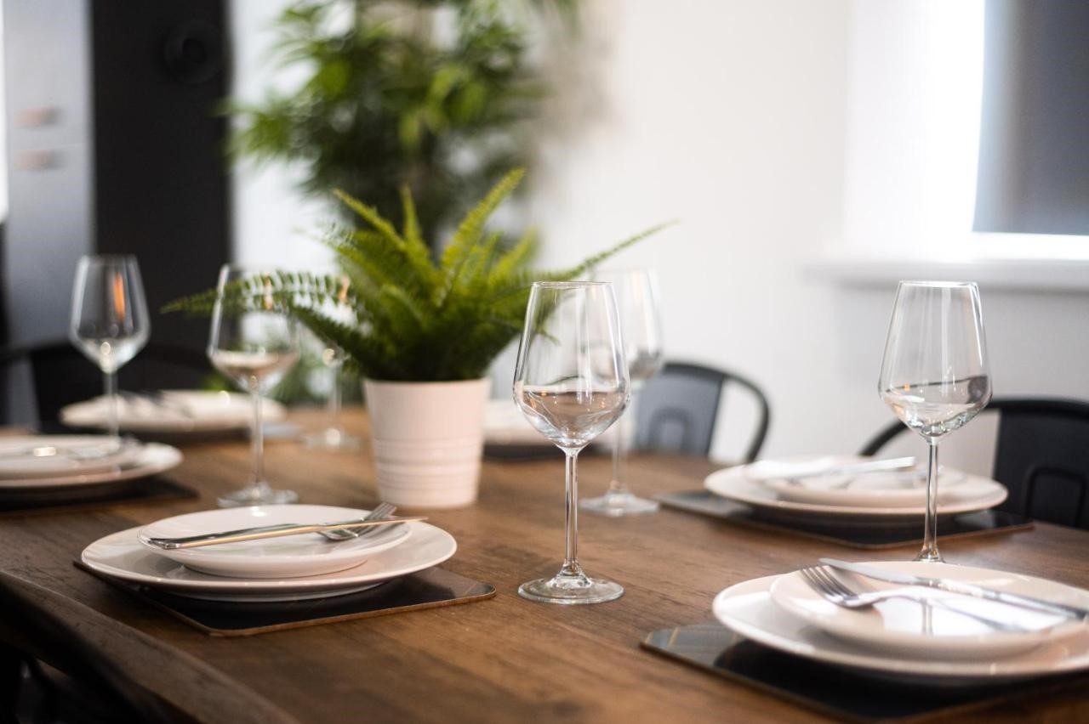
Christmas Special Offers
(Non-Veg)
To dine or not to dine

Located on the coast of Swansea,
South Wales



Hotel Trinity
Special Live Music 4pm to 9pm
“Make it a Combo in £40” special offer Available from 2pm to 9pm
Chicken Parmesan
Recommended pairing: Sangiovese
This dry wine complements the meal's rustic tomato sauce and crispy breadcrumb topping.
Price - £35
Mini Beef Tostada Cups
Recommended Pairing: Margarita
The subtle spice and savory components of the tostada cups are well balanced by the limey and somewhat sweet taste of a margarita.
Price - £36
Greek Island Shrimp with Pasta
Recommended Pairing: Agiorgitiko
This light and refreshing white wine complements the vibrant flavors of the shrimp pasta well.
Price - £34
Flank Steak Chimichurri
Recommended Pairing: Malbec
The fresh and strong chimichurri with fresh parsley, garlic, and chili flakes pairs nicely with the dry yet fruity wine.
Price - £35

References
Bohrer, S. (2021). Dinner Menu September 2021.
Maioli, F., Picchi, M., Guerrini, L., Parenti, A., Domizio, P., Andrenelli, L., ... & Canuti, V. (2022). Monitoring of Sangiovese Red Wine Chemical and Sensory Parameters along One-Year Aging in Different Tank Materials and Glass Bottle. ACS Food Science & Technology.

