Source Analysis 3, Tintern Abbey Grounds plan
An analysis of Tintern Abbey’s ground plan is a clear window into the world of Cistercian monasticism in Britain through the ages. From the introduction of Cistercianism into the island in the eleven twenties to the dissolution of the monasteries between 1536-1541, the Cistercians were a powerful monastic group in England and particularly in Wales, their abbeys were a reflection of their worldview, a reflection of their view of themselves and how they viewed the rule of St. Benedict. An Analysis of the ground plan of one of their earliest British Abbies, Tintern, will reveal much about them and their way of life.
Tintern Abbey is a Cistercian abbey in Wales, despite it not being as well-known as Fountains Abbey or Rievaulx Abbey in Yorkshire, the founding of Tintern was a significant event. Tintern Abbey was founded in 1131 by Walter Fitz Richard, a member of the notable and famous Marcher Lordship family the de Clares. He was Lord of Chepstow Castle on the Welsh Border. Tintern Abbey although less famous to a modern audience was a notable monastery in the 12th century, it was the second Cistercian Abbey founded in Britain after the founding of Waverly Abbey only three years earlier in 1128. Waverly Abbey was founded by the bishop of Winchester William Giffard.
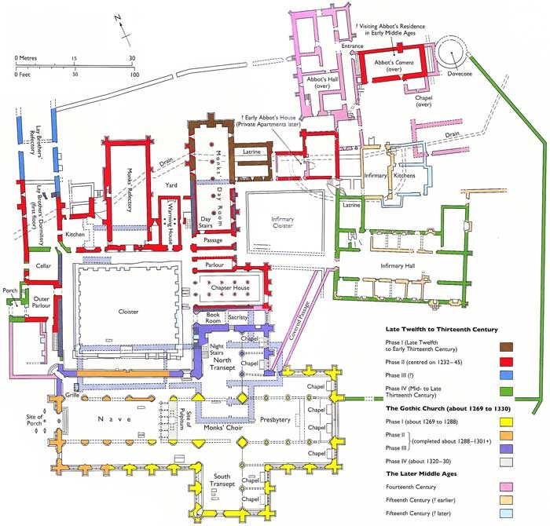
Figure 1 Tintern Abbey Ground plan provided by Dr Harriet Webster for HPHI5-6022

This map of the layout of Tintern Abbey is telling of the way that Cistercian abbeys are constructed, the ideal is that all abbey belonging to the Cistercian order are constructed the same way, this is because of the centrality of the rule of St. Benedict, and the ideal that each and every ‘White Monk’ would be able to follow the rule to the uttermost wherever he might find himself. However because of the realities of the local terrain, the Cistercians allowed the monasteries to vary their construction in subtle ways. Comparing two famous Welsh abbeys that of Strata Florida and Tintern, we see that the layout of the main buildings at Strata Florida are largely the same as those at Tinern. However in most of the monastic houses built to the Cistercian plan the Cloister and the main buildings are on the south side of the main Church Structure, this is how Strata Florida is built with its Cloister on the south side of its Nave. However, this is mirrored in Tintern Abbey where the cloister, a large open rectangular courtyard, is to the North of the main church and Nave buildings. This is because of the placement of the Abbey in relation to the watercourse to the north of it. This is one of the exceptions the Cistercians allowed in the construction of their abbeys, to follow local topography.
In the floor plan of Tintern Abbey in Figure 1, the image is colour-coded to represent the different phases of construction that the abbey went through. Tintern Abbey was distinct among the Welsh Cistercian Abbeys as it was almost entirely unaffected by the invasion of Wales in the 1280s by Edward the First
Other than the abbey being flipped in its construction, with the principal buildings being built to the North side of the nave, the buildings follow the typical Cistercian design. There is a square courtyard, called the Cloister where the monks would walk and do some of their manual labour. Beyond the Cloister is the refectory where the monks would eat in silence, in keeping with the rule of St. Benedict. The nave itself is cross-shaped and facing with the altar toward the East, this is because the altar of every church faces towards Jerusalem the shape of the church is cross-shaped specifically to remind the monks of Christ who is the centre of the Christian faith. As with every Cistercian house, the infirmary is separated from the main buildings and is away from the other structures. This is true of every Cistercian house, including Tintern and others such as Strata Florida, Fountains and Rievaulx Abbeys. The monks were acutely aware of the danger illnesses could pose to their communities, and although they were not aware of germ theory, they separated their sick from the main body of monks.
The layout of Tintern Abbey, and other abbeys like it shows a care for the physical space that the monks inhabited, as well as the importance of the spiritual space that the monastery reflected and represented. The Cistercians were aware of the image they wanted to project to the world, and being able to point out the uniformity of their monasteries would have been an excellent indicator of their uniformity and their adherence to the rule of St. Benedict.

Bibliography
Encyclopaedia Brittanica. [n.d.]. ‘Tintern Abbey | Ruin, Wales, United Kingdom’, Encyclopedia Britannica <https://www.britannica.com/topic/Tintern-Abbey>
Johnson, Ben. 2019. ‘Dissolution of the Monasteries’, Historic UK <https://www.historic-uk.com/HistoryUK/HistoryofEngland/Dissolution-of-the-Monasteries/>
Monastic Wales. [n.d.]. ‘Site Details: Tintern’, Www.monasticwales.org <https://www.monasticwales.org/site/34> [accessed 15 March 2024]
Keevill, G. (Graham), Michael Aston, and Teresa Hall, eds., Monastic Archaeology : Papers on the Study of Medieval Monasteries (Oxford, [England] ; Oxbow Books, 2017)

Robinson, David M. (David Martin), Tintern Abbey, 4th ed. (Cardiff: Cadw : Welsh Historic Monuments, 2002)

Robinson, David M. (David Martin), The Cistercians in Wales : Architecture and Archaeology, 1130-1540 (London: Society of Antiquaries of London, 2006)

Webster, Harriet. "Strata Florida Abbey: Field Trip" (lecture, The University of Wales Trinity St. David, March 4, 2024).

Ben Johnson, 2019. ‘Dissolution of the Monasteries’, Historic UK https://www.historic-uk.com/HistoryUK/HistoryofEngland/Dissolution-of-the-Monasteries/
Monastic Wales. [n.d.]. ‘Site Details: Tintern’, Www.monasticwales.org <https://www.monasticwales.org/site/34> [accessed 15 March 2024]
Monastic Wales. [n.d.]. ‘Site Details: Tintern’
David M Robinson, (David Martin), The Cistercians in Wales : Architecture and Archaeology, 1130-1540 (London: Society of Antiquaries of London, 2006) pp. 147
Webster, Harriet. "Strata Florida Abbey: Field Trip" (lecture, The University of Wales Trinity St. David, March 4, 2024).
Monastic Wales. [n.d.]. ‘Site Details: Tintern’
David M Robinson, The Cistercians in Wales (2006) pp. 150
Webster, Harriet. "Strata Florida Abbey: Field Trip" (2024).

