LCLM4001 Academic Skills
ACS assignment 3

Angela dias
Student ID: 2413809
Lecturer: Thomas Adeyemi

Table of Contents
1. Introduction………………………………………………………………….p.3
2. Note-taking skills 1………………………………………………….p.4
3. Paragraph Writing skills 2 ……………………………………p.5
4. Summarising skills3…………………………………………p.6
5. References…………………………………………………………………p.7

- Introduction
In this report I will talk on my learning and understanding on note taking, paraphrasing and summarizing “Effective note-taking strategies help students retain information and organize their learning in meaningful ways (Jones & Smith, 2020). How my skills have improved over the lessons and impact on my progress. All off these skills are vital for academic and professional, and I noticed I have been better in each of them. On note taking I started with little knowing about note taking as paraphrasing and summarizing, but with the lesson and with different techniques like Cornell method and mind mapping I notice some changes my notes wore clear and organised, improving my ability to review and gather more information. likewise, my paraphrasing my skills has improved as I learned to rephrase content correctly preserving the original meaning, this process has been vital to improve my academic writing. "Paraphrasing allows the writer to convey the original meaning of a text while using their own words, which is crucial for avoiding plagiarism (Brown, 2018)." Summarizing as helped me gather more information meaningful summaries.

2. Note-taking skills
"Effective note-taking techniques, such as using shorthand or visual aids, can significantly improve retention and understanding of lecture material" (Jones & Smith, 2020, p. 45). At first, I struggled and felt stressed, had difficulty capturing information and organization. My notes felt so unstructured and hard to understand later but with Cornell method, helped me be more organized on my notes. I could understand more. I still have some difficulties, sometimes I overwrite notes, but dividing my notes into section and summarizing key points makes it improve my process, I still have to keep practicing my note taking. "Note-taking, when done correctly, 'allows students to process and organize information as they hear it, resulting in deeper comprehension' (Parker, 2021, p. 78)."

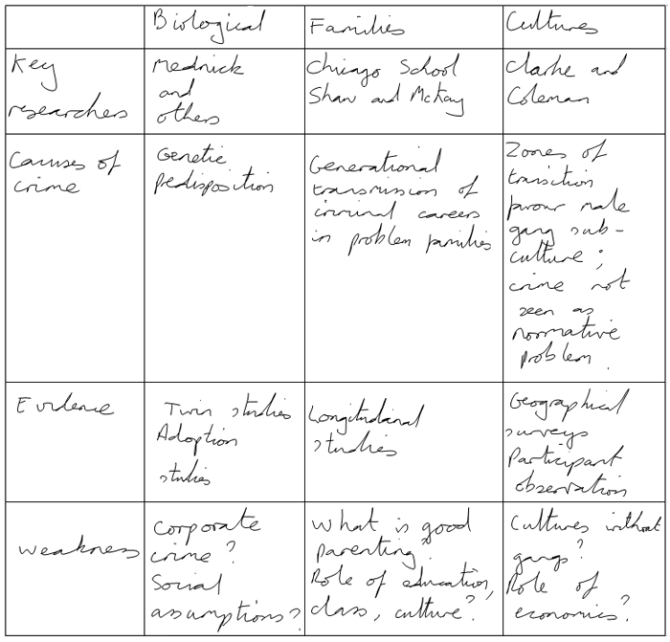

- Paragraph Writing
When, I learn about paraphrasing I found it so difficult; "Paraphrasing is 'an essential tool for avoiding plagiarism and demonstrating comprehension, as it allows writers to express ideas in their own unique voice' (Morris, 2021, p. 28)." I just change words with synonyms, that make my rewording so unclear and awkward, my attempts on replacing words rather than understanding the text. I understand a bit more on paraphrasing I know that I need to read and understand the reading and rephrasing them in my own words without changing the original text. I still struggle my paraphrasing can become unclear or disorganized, but I still practice on that. I will give some examples of activities form class. "As noted by Green (2019), 'Paraphrasing involves not only changing words but also altering the sentence structure, which helps writers to understand the content at a deeper level' (p. 45)."
- Ex; The increasing prevalence of social media platforms has fundamentally transformed the way individuals interact with one another, often blurring the lines between personal and public life.
The use of social media platforms has radically altered how people connect with each other, frequently blending personal and public aspects of life.
- Ex; Despite the complexity of the subject, the lecturer managed to explain the concepts clearly.
Although the subject was complex, the lecturer was able to explain the concepts in a clear manner
- Ex; University students can face unique pressures including living away from home for the first time, managing budgets, health and well-being and forming new friendships and facing new academic challenges, which is why it is important to understand these and find ways to manage them.
University students often experience unique pressures, such as living away from home, managing finances, maintaining health and well-being, forming new friendships, and adapting to academic challenges. Therefore, it is crucial to recognize these pressures and find effective ways to cope with them.

- Summarising skills
Like the others, summarizing was a challenge to, no understanding at all. I start summarising with too many details and long summaries. Losing all the main points. With time I realised summarizing involves key points , not including everything from the text I learn to focus on essential concepts arguments and findings. And gained more confidence, understanding, looking for the main ideas with different approach. Some examples from class.
Ex;
Integrity in student writing is essential because it fosters a culture of honesty and respect in academic environments. When students commit to integrity, they ensure that their work reflects their own understanding and effort, which enhances their learning experience. This practice not only helps students avoid plagiarism but also encourages them to acknowledge the contributions of others, thereby promoting a collaborative spirit. Upholding integrity allows students to build trust with their peers and instructors, which is crucial for a supportive learning community. Furthermore, when students take pride in their original work, they develop critical thinking and analytical skills, as they must engage deeply with the material rather than simply copying from sources. This deeper engagement leads to a more meaningful educational experience, where students can express their unique perspectives and insights. Ultimately, practicing integrity prepares students for ethical behaviour in their future careers, reinforcing the value of honesty and accountability in all aspects of life. By cultivating integrity in their writing, students not only contribute to their personal growth but also to the integrity of the academic community as a whole.
Summary; Integrity in student writing is vital for maintaining honesty and respect within academic environments. It ensures that students’ work represents their own effort and understanding, promoting a meaningful learning experience. By avoiding plagiarism and crediting others' contributions, students foster collaboration and trust with their peers and instructors. This commitment to integrity strengthens critical thinking and analytical skills, as students engage more deeply with the material. Moreover, it prepares students for ethical behaviour in their future careers, reinforcing the importance of accountability and honesty in all areas of life, benefiting both personal and academic growth.
Ex; Data democratization refers to the process of making digital information available and accessible to everyone within an organisation, regardless of their technical know-how. It means empowering employees to work with data, understand data and make faster data-informed decisions. According to Marr (2021), when staff members are given access to the organisation’s data, operations become more streamlined and efficient as those who know the business will not have to wait for data scientists to analyse the data for them. However, organisations who democratize data need to have a strong leadership in place to ensure the data is properly managed.

Note taking: Making digital information accessible to all employees, regardless of technical expertise. Empowers employees to understand data and make quicker, informed decisions. Streamlined and more efficient operations. Employees familiar with the business can access data directly, avoiding delays from data scientists. Strong leadership is essential to manage and oversee the proper use of democratized data.
Summary; Data democratization is the process of making digital information accessible to all employees, regardless of technical skills, empowering them to make faster, data-informed decisions. According to Marr (2021), this improves efficiency by allowing employees with business knowledge to directly access data, reducing dependence on data scientists. However, strong leadership is essential to ensure proper management of the data

References

- Adams, L., & Richards, P. (2018). Effective note-taking methods for students: A practical guide. Study Skills Publishing.
- Brown, A. (2018). Paraphrasing and academic writing: Best practices for students. Academic Writing Press.
- Green, J. (2019). Mastering paraphrasing: Techniques for effective writing. Writing Essentials Press.
- Johnson, R., & Thompson, H. (2017). The art of paraphrasing: Techniques for writing success. Writing Skills Publications.
- Jones, R., & Smith, T. (2020). The art of note-taking: Strategies for success. Educational Publishers.
.

