ACE Practical Portfolio (BMSW 4001_LON)
Name of the student: Iuliana Vines
Name of the University:University of Wales,Trinity Saint David
Student’s ID:2120470
Lecturer Anita Nan

Task 1
Slide 1:
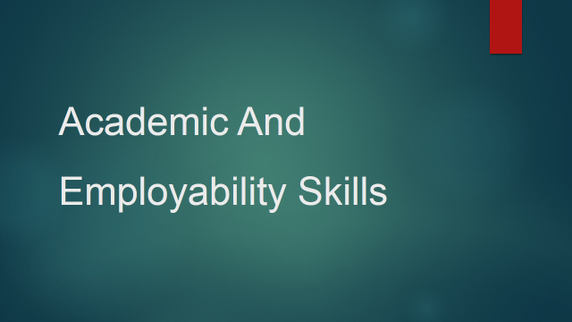
Slide 2: introduction
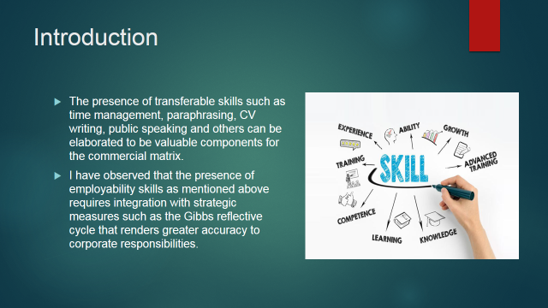The presence of valuable employable skills such as public speaking, time management and others can render a greater rate of aptitude to the individual thus inclining their vocational opportunities. The presence of modules such as the Gibbs cycle of reflection also renders accuracy in terms of skill assessment for employability.
Slide 3: SWOT Analysis
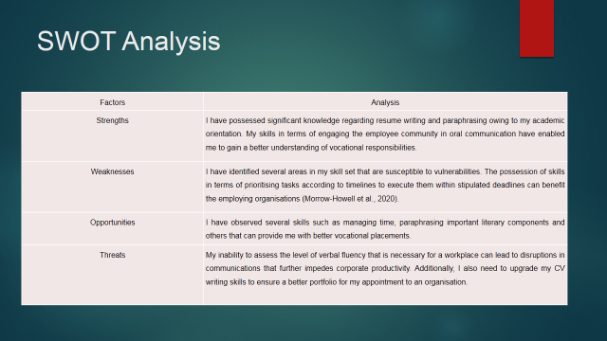
Table 1: SWOT analysis
(Source: by the Author)
The comprehensive analysis of my skills and aptitude in terms of resume writing, paraphrasing, time management and public speaking had informed me of the several positive and negative elements associated with the corporate spectrum.
Slide 4:Personal Development Plan:
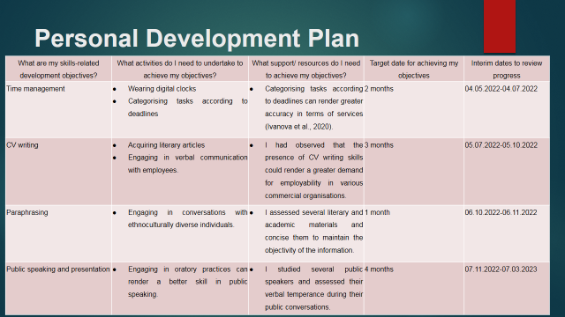
Table 2: Personal Development Plan
(Source: by the Author)
The categorisation and consequent assessment of my skills can render a greater efficacy in terms of my induction within an organisation.
Slide 5: Analysis of my skills
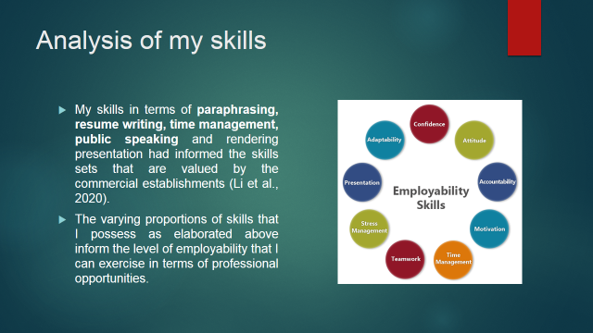
The presence of valuable skills that can increase an individual’s employability within an organisation can also render greater productivity to the enterprise. The incline in productivity can yield positive outcomes for the global economy as well.
Slide 6:Conclusion
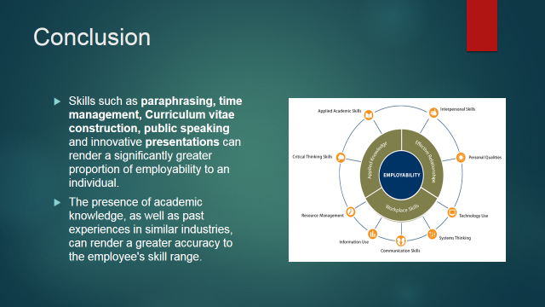The presence of transferable skills can be denoted to be crucial for executing the various corporate responsibilities that are designated to the employee demographic. Skills such as time management, CV writing, and public speaking, can be assessed to render a greater efficacy to the individual’s aptitude for executing tasks.
Slide 7: References
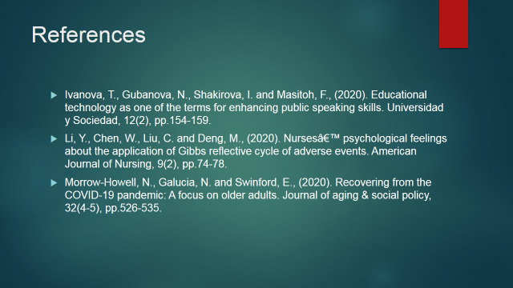
Slide 8: thank you

Task 2: Report
Introduction
This report focuses on the employability skills that I have acquired during my academic orientation. I had also acquired a concise understanding of the transferable skills that can render a greater rate of efficacy to my services. I had also employed strategic frameworks such as the Gibbs Reflective Cycle to better attune skills necessary for my workplace. The various skills in terms of time management, CV writing, paraphrasing skills and an aptitude for public speaking had rendered me a greater edge in terms of employability.My understanding of the skills and their consequent application in the vocational environment has been further scrutinised in the study for obtaining analytical insights.
Reflective analysis of academic and professional skills
I had acquired a multitude of necessary skills that can be denoted to be crucial for upholding the various commercial services that are rendered by an enterprise. The socioeconomic paradigm of the global institutions and financial establishments had undergone tumultuous changes owing to various adverse social challenges such as the Covid 19 pandemic among others. Consequently, I had assessed that the declining structure of the commercial establishments in terms of revenue generation had paved the way for gig economies to flourish at a commensurate pace. Skills such as time management, paraphrasing, and constructing curriculum vitae among others can be denoted to result in the betterment of annual corporate performance in the market trends (Morrow-Howell et al., 2020). The complete range of my skills and their deft application has been further elaborated in a comprehensive manner in the study.
- Time management
I have assessed that the presence of time management skills is one of the most crucial elements for executing the various tasks under an organisation's objectives and aims within a stipulated period. The execution of tasks within strict periods entails dissecting the responsibility into smaller sections (Ivanova et al., 2020). I have observed that the execution of the aforementioned endeavour is to be supported by the individuals appointed in the workplace that are divided into teams in terms of their skills.
Description: I had acquired scholastic knowledge regarding the various modes of time management such as establishing schedules for the workplace, establishing goals, and prioritising tasks with shorter deadlines or of higher importance to the company matrix that can yield beneficial outcomes for the enterprise. I also employed strategic frameworks such as the Gibbs cycle of reflection to analyse the efficiency of my understanding of time management skills.
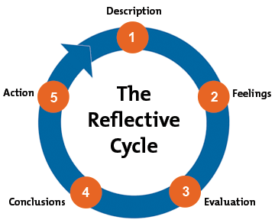
Figure 1: Gibbs Cycle of Reflection
(Source: Grieve et al., 2021)
I have employed the Gibbs reflective cycle to elaborate on the facets of time management and the proportion of positive outcomes that can yield on behalf of the corporations that assimilate the framework and its doctrines into diurnal elements. The primary stage of the reflective cycle elaborates on the descriptive treatment of a workplace and its imposed challenges (Grieve et al., 2021). The descriptive stage focuses on a corporate element and its diversification into smaller facets can be crucial for the execution of complicated tasks that are under the organisation’s objectives.
Feelings: The following stage of feelings contemplates the relay of emotional responses that I had undergone during the execution of corporate tasks. I had identified that this stage is highly important since it informs the mental outlook of the employee in terms of their rendered services in the corporate paradigm.
Evaluation: The following stage that has been identified me is an evaluationthat contemplates the proportion of time management and its contribution to the corporation's revenue generation efforts. As part of the evaluation process, I have also conducted analytical treatment of the positive and negative elements that can affect time management. I have also evaluated that the proportion of motivation that the employees possess in their vocational duties correlates with their contribution to the execution of corporate goals.
Analysis: I had observed that the presence of time management skills had enabled me to manage corporate tasks at a greater rate of efficacy. I have also obtained valuable insights into various measures for time management such as providing watches, wall clocks and others to ensure that the employees can execute their responsibilities on time.
Conclusion: The final stages of the strategic framework known as the Gibbs cycle are the conclusive stages that elaborate on the efficacy of time management that has been exhibited by the enterprises. The final stages enable the employed individuals to gather keen insight into the corporate impediments that can recur in the future.
Action: I observed that the concluding stages also lead to the formulation of an action plan. The long-term goals of an organisation entail a greater focus on strategic measures as well as the areas within an organisation that is in ardent need of renovation to secure them from external intrusions. I have assessed that accurate time management in terms of executing corporate goals is crucial for upholding the enterprise's performance in the market trends. My skills in terms of time management have been assessed to be benefitted by the incorporation of strategic frameworks that have been concisely expressed in the study.
- CV writing
I have assessed that a curriculum vitae of an employee is a compendium of their knowledge and skills that can be crucial to an enterprise. The integration of skills such as the construction of CVs can render a greater level of authenticity to the information provided to an organisation regarding employability in the corporate matrix (Chong and Clohisey, 2021). My aptitude in terms of curating curriculum vitae that are specific to corporate paradigms has enabled me to gain greater relevance in terms of contributions to company objectives. The skills necessary for constructing CVs also necessitate a legitimacy of the information provided to ensure the authenticity of the employee's skill range.
Description: The Gibbs reflective cycle has informed the course of action to abide by in terms of writing CVs that are intrinsic to the organisation. My job role in my previous professional engagements had informed me of the importance of describing the skills of the employee in a comprehensive manner on a formal document. The description stage of the framework is followed by the feelings stage that analyses the mental temperance of an individual before employing them into the company matrix.
Evaluation: I have observed that the evaluation step of the framework has been crucial for verifying the legitimacy of the information provided on professional resumes. The evaluative stage also assesses the employability of an individual within a corporation in terms of the need of their skillset among others (Choudhuri et al., 2020).
Analysis: The presence of skills in terms of writing curriculum vitae had informed me of the importance of providing apt and accurate information to a corporation regarding academic qualifications and professional skills. I had also understood that constructing resumes had provided me with valuable insights regarding the skills that are prioritised by commercial enterprises.
Conclusion: The conclusion stage informed me of the skills that are in higher demand in the corporate spectrum and hence, prioritised by enterprises during their employee induction procedures. The final element of the framework informs of the actions that are necessary for upholding the legitimacy of the resumes constructed for obtaining vocational opportunities (Martin et al., 2020).
Action: The skill of innovating curriculum vitae that are concise, relevant and convincing in terms of the employee's skills had rendered me greater efficacy in my job role in my previous professional engagements. My observation of CV writing skills has also informed me of the need for maintaining transparency and honesty in terms of the information provided on resumes to ensure apt integration into the company matrix as employees under its wage structure.
- Paraphrasing
I have expended a significant proportion of time studying scholastic articles and literary materials to understand the importance of paraphrasing skills in the workplace. The concept of paraphrasing involves consisting a great deal of information into smaller portions by objectifying the information acquired.
Description: The descriptive stage of the skill involves incorporating academic materials that can relay the information in a collected manner. The descriptive stage can be assessed as an instrumental element of the Gibbs reflective cycle since it comprises the majority of the scholastic information that is required to be paraphrased comprehensively.
Feelings: I have perceived that the following stages of the cycle namely the feelings stage elaborate on the individual and their mental outlook regarding the paraphrased content. The detachment of personal biases during the composition of paraphrased articles and literary information can render an efficacy to the acquired information (Ruslan et al., 2020). It can be expressed that paraphrasing skills necessitate a strictly objective perception of the employee to ensure the infallibility of the paraphrased materials.
Evaluation: I have observed that the evaluation stage of the framework attempts to assess the proportion of paraphrasing skills that are possessed by me in terms of concise sensitive corporate documentation. My employment in previous professional engagements has informed me of the importance of aptly evaluating paraphrased materials to ensure their objectivity of information.
Analysis: My understanding of paraphrasing skills has informed me of the importance of shortening academic materials and literary concepts to increase their efficacy in terms of identifying valuable sets of information. The paraphrasing skills are complementary to reading aptitude that enables the retentive treatment of several sets of information that are sensitive.
Conclusion: The concluding stages of the framework inform of the need to upgrade the facets associated with the paraphrasing skills of an individual. I had identified that my paraphrasing skills also require reading aptitude that can be benefitted from my internalisation of several academic concepts. I have also understood the importance of paraphrasing materials by conducting scrutiny of the provided literary content to ensure the security of sensitive information in the corporate context.
Action: The action stage informs me of the necessary steps that can modify my paraphrasing skills. An aptitude for reading, as well as memorising aptitude for valuable information can render better paraphrasing skills in the future that can benefit various enterprises (Manobanda Herrera, 2021). Interacting with individuals belonging to ethnoculturally diverse communities can also incline my aptitude for verbal skills that benefit my paraphrasing prowess.
- Public speaking and presentation
Description: My public speaking skills have been instrumental in the corporate matrix owing to the ability to inform important subsets of information to the employed demographic. Public speaking skills can be observed to be one of the skills that work in accordance with presentation skills. The ability of an employee to instil changes can be speculated to be relatively reliant on their aptitude for public speaking. Public speaking is also crucial to inform of the corporate changes as well as mitigating communicative disputes that can regress an organisation's services.
Feelings: I had understood the importance of engaging in public speaking and its necessity in the corporate paradigm. The ability to inform others regarding changes within an enterprise or informing an enterprise's decisions in terms of their commercial performances to the employed demographic entails mature public speaking skills (Li et al., 2020). I had understood the importance of possessing vast oration skills that can lead to the betterment of engaging in public conversations.
Evaluation: The evaluation of my public speaking skills informed me of the importance of possessing verbal fluency. I had also observed that my aptitude in conversations with employees belonging to ethnically diverse communities requires sensitivity training to better understand the employee feedback.
Analysis: I have attempted to modify my skills in terms of public speaking to encourage a greater range of communication between the employees demographic. My public speaking skills also mandate a notable grasp on my ability to produce presentations that exhibit corporate elements comprehensively. The presence of skills in terms of public speaking and presentation can be expressed as integral elements for maintaining coherent communication with the employee demographic (Adeani et al., 2020).
Conclusion: I had learnt the importance of possessing an aptitude for oration as well as vernacular skills that can render a greater efficacy of communicative discords. I had also assessed that the presence of verbal fluency can lead to a better grade in public speaking.
Action plan: I have identified the need to possess a concise notion of foreign languages as well as oral skills to better attune myself to the public speaking roles. I also understood the importance of acknowledging the needs of the employed demographic that provides greater efficiency in the public speaking practices.
Conclusion
I have assessed that the presence of several skills such as time management, Curriculum vitae construction, paraphrasing aptitude and others can render a greater rate of efficiency to the execution of corporate responsibilities. I have also employed Gibbs's reflective cycle as one of the strategic frameworks to analyse the proportion of skills and aptitude that can benefit an establishment. My possession and understanding of skills in terms of public speaking and presentation have also enabled me to gain a better grasp on the skills that are prioritised in the global economic paradigm as elaborated in the report.
References
Adeani, I.S., Febriani, R.B. and Syafryadin, S., (2020). USING GIBBS’REFLECTIVE CYCLE IN MAKING REFLECTIONS OF LITERARY ANALYSIS. Indonesian EFL Journal, 6(2), pp.139-148.
Chong, Z.S. and Clohisey, S., (2021). How to build a well‐rounded CV and get hired after your PhD. The FEBS Journal, 288(10), pp.3072-3081.
Choudhuri, A., Seal, S. and Chatterjee, A.K., (2020). Impediments to the Art of Public Speaking. International Journal of English Learning & Teaching Skills, 3(1), pp.1751-1763.
Grieve, R., Woodley, J., Hunt, S.E. and McKay, A., (2021). Student fears of oral presentations and public speaking in higher education: a qualitative survey. Journal of Further and Higher Education, 45(9), pp.1281-1293.
Ivanova, T., Gubanova, N., Shakirova, I. and Masitoh, F., (2020). Educational technology as one of the terms for enhancing public speaking skills. Universidad y Sociedad, 12(2), pp.154-159.
Li, Y., Chen, W., Liu, C. and Deng, M., (2020). Nursesâ€™ psychological feelings about the application of Gibbs reflective cycle of adverse events. American Journal of Nursing, 9(2), pp.74-78.
Manobanda Herrera, V.L., (2021). The paraphrasing strategy and the English-speaking skills (Bachelor's thesis, Carrera de Idiomas).
Martin, F., Stamper, B. and Flowers, C., (2020). Examining Student Perception of Readiness for Online Learning: Importance and Confidence. Online Learning, 24(2), pp.38-58.
Morrow-Howell, N., Galucia, N. and Swinford, E., (2020). Recovering from the COVID-19 pandemic: A focus on older adults. Journal of aging & social policy, 32(4-5), pp.526-535.
Ruslan, I., Sunubi, A.H., Halidin, A. and Kaharuddin, A., (2020). Paraphrasing Technique To Develop Skill for English Writing Among Indonesian College Students of English. Sys Rev Pharm, 11(11), pp.291-297.

