
Assignment Title: Component 1 – Website Redesign for Online Business Presence
Programme: BSc Applied Computing
Module: Business and Web Management
Module code: ACCA5019
Lecturer: Suneth Fernando
Submission deadline: 27th March 2026

Student Name: Andy Onyedikachukwu Ibeh
Student ID: 2335550

Table of contents
Table of Contents
Introduction 5
Mood Board Creation: 6
Mood Board Development and Influence 6
Wireframe Development 7
Interactive Prototype: 8
High-Fidelity Prototype 8
MealSwift Website Redesign 9
Analysis of Current Issues 9
Navigation and Information Architecture Deficiencies 9
Visual Design Obsolescence 9
Mobile Responsiveness Failures 9
Content Quality and Information Deficiencies 9
Ordering Process Inefficiencies 10
Personalisation Absence 10
Accessibility Compliance Gaps 10
Social Proof Deficiencies 10
Performance Bottlenecks 10
Proposed Solutions 11
Navigation Redesign Strategy 11
Modern Visual Design System 11
Mobile-First Responsive Implementation 11
Content Strategy and Quality Enhancement 11
Streamlined Ordering Workflow 11
Personalisation Engine Integration 12
Accessibility Compliance Implementation 12
Social Proof Integration 12
Performance Optimisation 12
Responsive Design Implementation 13
Strategic Importance in E-Commerce 13
Technical Implementation Approach 13
Fluid Grid Systems 13
Flexible Media 13
Media Queries 13
User Experience Implications 14
Business Performance Impact 14
Implementation Section 15
Design Process Overview 15
Mood Board 15
Colour Palette 15
Typography System 17
Brand Elements & Visual Language 17
Motion Principles 18
Photography & Imagery Direction 18
Home Page 19
Search Bar 19
Restaurant Grid 19
Promotional Banner 20
Drivers Registration page 20
Driver Hero Banner 20
Mood Board page 21
Wireframe page 21
Order Tracking Page 22
How Mood Board and Wireframe Influence the Design 23
Conclusion 24
References 25

MealSwift Website Redesign

Introduction
This report documents the comprehensive redesign process undertaken for MealSwift, a rapidly growing food delivery service that connects customers with local restaurants through online ordering and delivery platforms. Despite achieving significant market penetration and customer adoption, MealSwift's current digital presence suffers from critical usability and design deficiencies that threaten to undermine its competitive position and growth trajectory [1]. The primary objective of this project is to develop a user-centred redesign strategy that addresses the fundamental challenges plaguing the existing MealSwift website while establishing a scalable, modern digital experience aligned with contemporary e-commerce best practices. The current platform exhibits numerous problematic characteristics, including confusing navigation architecture, outdated visual design language, non-responsive mobile layouts, insufficient restaurant and menu information, poor image quality, inefficient ordering workflows, absence of personalised recommendation systems, accessibility compliance gaps, limited social proof mechanisms, weak call-to-action elements, performance bottlenecks, and lack of real-time order tracking functionality [2].
These deficiencies collectively contribute to elevated cart abandonment rates, diminished customer retention metrics, and erosion of brand trust—issues that pose significant threats to MealSwift's business objectives and market positioning. This report examines each problematic area systematically, proposes evidence-based solutions grounded in established UI/UX design principles, and documents the complete design process from conceptual mood board development through wireframing to interactive prototype creation. Task 1 Web Design Phases

Mood Board Creation:

Mood Board Development and Influence
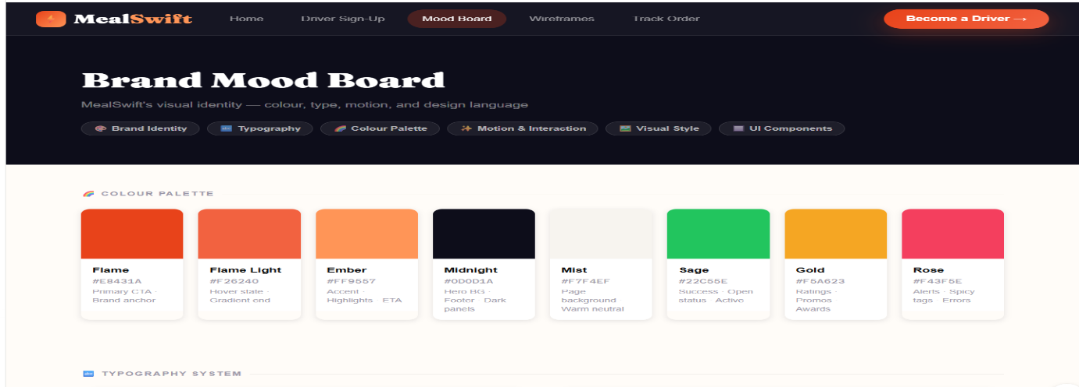
The mood board phase established MealSwift's visual identity and design direction through careful curation of inspirational elements representing desired aesthetic qualities, brand values, and user experience characteristics [3]. The colour palette selection employed strategic thinking grounded in colour psychology research. Warm oranges and reds dominate the palette, colours consistently associated with appetite stimulation, urgency, and energy—psychological associations highly relevant for food delivery contexts. These warm hues receive complementary balance from fresh greens, suggesting health, quality, and natural ingredients. Neutral greys provide sophisticated contrast while ensuring sufficient whitespace for visual breathing room. This palette creates appetising, energetic experiences while maintaining professional credibility.

Wireframe Development
Wireframing translated conceptual direction into concrete structural proposals, defining page layouts, information hierarchy, and interaction patterns while deliberately excluding visual styling details that might distract from functional considerations [4].
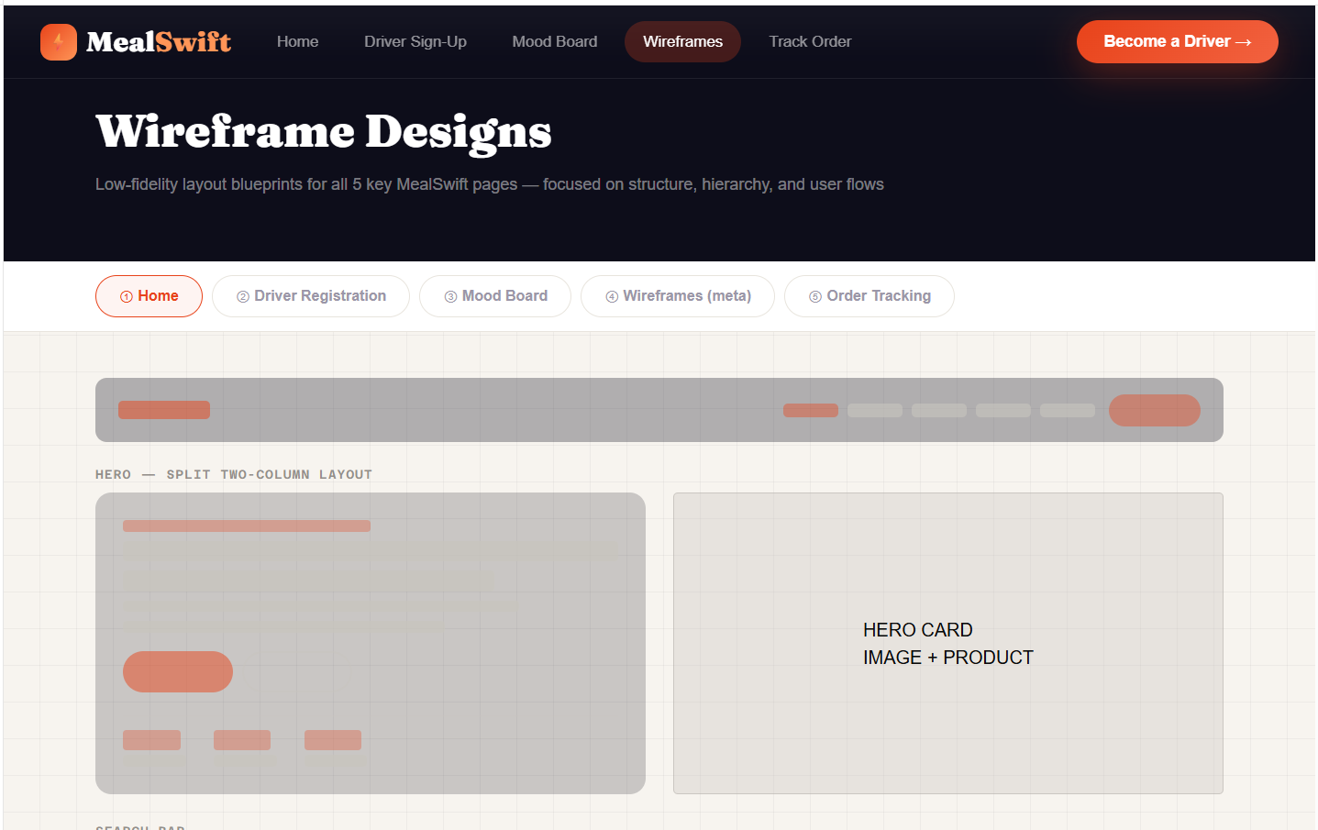
The wireframing process began with user flow mapping to identify primary user journeys and required touchpoints. These flows informed page requirements and interaction sequences. Key wireframes addressed:

Interactive Prototype:

High-Fidelity Prototype
The high-fidelity prototype phase translated wireframe structures and mood board aesthetics into detailed, interactive representations demonstrating complete user experiences. This phase employed design tools to create pixel-perfect interfaces with realistic content, comprehensive styling, and simulated interactions.
The prototype demonstrated several key characteristics:
Visual Polish: Full implementation of the established colour palette, typography system, and imagery guidelines created a cohesive, professional appearance
Interactive Behaviours: Hover states, button animations, form validation feedback, and transition effects demonstrated interface responsiveness.
Realistic Content: Actual restaurant data, menu items, and reviews rather than lorem ipsum placeholders enabled stakeholders to evaluate designs under realistic conditions and identify content-related design requirements.
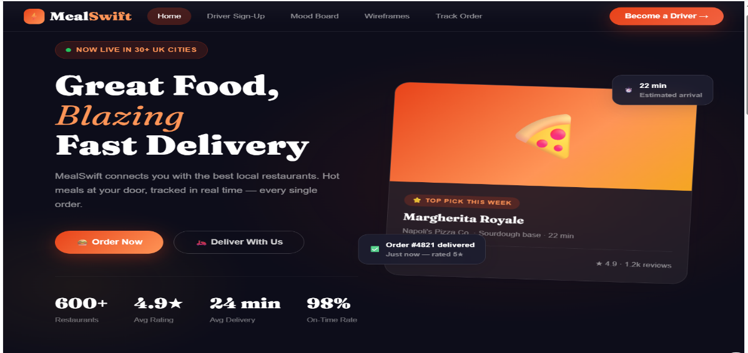
Responsive Demonstrations: Multiple viewport sizes illustrated layout adaptation, confirming that designs functioned appropriately across device categories.

MealSwift Website Redesign

Analysis of Current Issues
The existing MealSwift website presents a constellation of interrelated problems that collectively undermine user experience and business performance. Understanding these issues requires a systematic examination of each problematic dimension and its cascading effects on user behaviour and business outcomes.

Navigation and Information Architecture Deficiencies
The current navigation structure exhibits poor information architecture characterised by unclear categorisation, excessive menu depth, and inconsistent labelling conventions. Users report difficulty locating specific restaurants or cuisine types, with common tasks requiring multiple clicks and cognitive effort to complete. This complexity violates established usability heuristics.

Visual Design Obsolescence
The existing visual design language employs outdated aesthetic conventions that diminish perceived brand credibility and fail to align with contemporary design trends dominating the food delivery sector. . Studies published in the Journal of Computer-Mediated Communication demonstrate that users form initial impressions within 50 milliseconds, and outdated design aesthetics trigger negative trust associations that persist throughout the user journey [5].

Mobile Responsiveness Failures
Perhaps most critically, the current website lacks responsive design implementation, rendering poorly on mobile devices despite mobile traffic representing the dominant access pattern for food delivery services. Industry data indicate that mobile devices account for approximately 60-70% of food delivery traffic [6], yet MealSwift's fixed-width desktop design causes numerous usability failures on smaller screens, including text overflow, horizontal scrolling, touch targets smaller than recommended minimums, and functional breakdowns.

Content Quality and Information Deficiencies
Restaurant and menu information suffers from inconsistent depth and quality, with many listings providing minimal descriptive content, low-resolution photography, and incomplete menu information. This content poverty forces users to leave the platform to research restaurants independently, creating friction in the decision-making process and increasing the likelihood of abandonment.

Ordering Process Inefficiencies
The checkout workflow exhibits multiple friction points that elevate cart abandonment risk. The process requires excessive form fields, lacks guest checkout, provides inadequate progress indicators, fails to support cart persistence, and offers limited flexibility in payment methods. E-commerce research consistently identifies checkout friction as a primary driver of abandonment, with Baymard Institute data indicating that the average cart abandonment rate across e-commerce sectors exceeds 69%, with complex checkout processes cited as a leading cause [7].

Personalisation Absence
The platform lacks sophisticated personalisation mechanisms that could leverage user behaviour data to provide tailored recommendations, remember preferences, and streamline repeat ordering. Modern e-commerce platforms increasingly rely on machine learning algorithms to analyse user behaviour patterns and provide personalised experiences that drive engagement and conversion. The absence of these capabilities places MealSwift at a competitive disadvantage relative to platforms offering intelligent recommendation systems.

Accessibility Compliance Gaps
The current implementation exhibits numerous accessibility violations that exclude users with disabilities, including insufficient colour contrast ratios, missing alternative text for images, inadequate keyboard navigation support, and lack of screen reader optimisation. Beyond ethical considerations, accessibility compliance represents a legal requirement under various jurisdictions and significantly expands the addressable market size.

Social Proof Deficiencies
Customer reviews and ratings receive minimal prominence, despite extensive research demonstrating their critical role in purchase decisions. Bright Local research indicates that 87% of consumers read online reviews for local businesses, and positive reviews significantly influence conversion probability. The current implementation buries this social proof, failing to leverage it as a trust-building and conversion optimisation mechanism [8].

Performance Bottlenecks
Page load times significantly exceed recommended thresholds, with Google research indicating that 53% of mobile site visits are abandoned if pages take longer than 3 seconds to load. Performance issues stem from unoptimized images, render-blocking JavaScript, the absence of content delivery network implementation, and inefficient code architecture [9].

Proposed Solutions
Addressing these multifaceted challenges requires the systematic application of established UI/UX design principles and contemporary e-commerce best practices across multiple dimensions.

Navigation Redesign Strategy
The redesign implements a simplified, user-tested navigation architecture employing a three-tier hierarchy that minimises required clicks while maintaining comprehensive coverage of functionality. The search functionality receives prominent positioning with autocomplete suggestions, recent searches, and intelligent filtering that understands natural language queries. This approach aligns with established information architecture principles documented in Rosenfeld and Morville's seminal text "Information Architecture for the World Wide Web [10].

Modern Visual Design System
The redesign establishes a comprehensive design system using a contemporary visual language that communicates brand values while optimising conversion. The colour palette strategically employs warm hues—particularly oranges and reds—that research shows stimulate appetite and urgency, complemented by fresh greens that suggest health and quality.

Mobile-First Responsive Implementation
The redesign employs a mobile-first development methodology, beginning with mobile interface design and progressively enhancing for larger viewports. This approach ensures optimal mobile experiences while maintaining desktop functionality. The responsive implementation employs fluid grids based on percentage-based layouts rather than fixed pixels, flexible images utilising responsive image techniques including picture elements, and strategic media query breakpoints aligned with device categories (mobile: 320-767px, tablet: 768-1023px, desktop: 1024px [11].

Content Strategy and Quality Enhancement
The redesign implements comprehensive content guidelines ensuring consistent, high-quality information across all restaurant listings. Professional food photography standards mandate high-resolution images, proper lighting, and appetising presentation.

Streamlined Ordering Workflow
The checkout process receives comprehensive optimisation, reducing friction through multiple mechanisms. Guest checkout eliminates registration requirements for first-time users, reducing initial barriers. The process consolidates to three clear steps: cart review, delivery details, and payment processing. Progress indicators provide clear feedback on completion status. Cart persistence employs local storage, ensuring items remain across sessions. The interface provides prominent modification capabilities, allowing users to adjust orders without returning to restaurant pages

Personalisation Engine Integration
The redesign incorporates hooks for sophisticated personalisation mechanisms that analyse user behaviour to provide tailored experiences. The recommendation engine considers order history, browsing behaviour, time of day, and location to suggest relevant restaurants and menu items. Saved preferences streamline repeat ordering, remembering delivery addresses, payment methods, and dietary restrictions.

Accessibility Compliance Implementation
The redesign ensures WCAG 2.1 Level AA compliance through systematic attention to accessibility requirements. Colour contrast ratios meet or exceed 4.5:1 for normal text and 3:1 for large text. All images include descriptive alternative text supporting screen reader users. Keyboard navigation enables complete interface operation without mouse input. ARIA labels provide semantic meaning for complex interactive elements [12].

Social Proof Integration
Customer reviews and ratings receive prominent positioning throughout the user journey. Restaurant listings display aggregate ratings with review counts. Individual menu items feature customer feedback and popularity indicators. The redesign implements a structured review system encouraging detailed feedback across multiple dimensions, including food quality, delivery speed, and accuracy. Verified purchase badges increase review credibility.

Performance Optimisation
The redesign implements comprehensive performance optimisation strategies addressing identified bottlenecks. Image optimisation employs appropriate compression, format selection (WebP with fallbacks), and lazy loading, deferring off-screen image loading. These optimisations target sub-3-second load times across connection types.

Responsive Design Implementation

Strategic Importance in E-Commerce
Responsive design implementation represents a critical success factor for contemporary e-commerce platforms, particularly within the food delivery sectors, where mobile device dominance characterises user behaviour patterns. Understanding the strategic importance of responsive design requires examination of both user expectation evolution and the technical mechanisms enabling seamless cross-device experiences [13].
User expectations have correspondingly evolved, with consumers now anticipating seamless experiences regardless of device type.

Technical Implementation Approach
Responsive design implementation employs three foundational technical mechanisms working in concert to create adaptive experiences: fluid grids, flexible media, and media queries.

Fluid Grid Systems
Fluid grids replace fixed-pixel layouts with proportion-based sizing, typically implementing 12-column grid systems that flexibly adapt to viewport dimensions. Rather than specifying element widths as absolute pixel values, fluid grids employ percentage-based sizing that maintains proportional relationships as viewport width changes. [14].

Flexible Media
Images and embedded media require special handling to prevent overflow issues on small viewports while maintaining quality on high-resolution displays. The redesign employs multiple techniques, including max-width: These techniques balance visual quality, performance, and responsive behaviour.

Media Queries
CSS media queries enable conditional style application based on device characteristics, primarily viewport width. The redesign implements a mobile-first approach, establishing baseline styles optimised for small screens and progressively enhancing for larger viewports. Strategic breakpoints align with device categories: 768px demarcates the mobile-to-tablet transition, while 1024px marks the tablet-to-desktop threshold [15].

User Experience Implications
Responsive design implementation profoundly impacts user experience across multiple dimensions. Form inputs employ mobile-appropriate types, triggering contextual keyboards—telephone inputs display numeric keyboards, email inputs include @ symbols prominently, date inputs invoke native date pickers.
The checkout experience receives particular optimisation attention, given its criticality for conversion. Mobile checkout streamlines form completion through intelligent field reduction, autofill support, and digital wallet integration, enabling single-tap payment processing.

Business Performance Impact
The business implications of responsive design implementation extend across multiple performance dimensions. Conversion rate optimisation represents the most direct impact, with Google reporting that mobile-friendly sites experience up to 15% higher conversion rates than non-responsive alternatives. Revenue per visitor similarly increases as friction reduction enables more efficient purchase completion.
Operational efficiency gains emerge from maintaining a single responsive codebase rather than separate mobile and desktop versions, reducing development costs, simplifying maintenance, and ensuring consistent feature availability. This architectural efficiency becomes increasingly valuable as the platform evolves and new functionality is implemented [16].

Implementation Section

Design Process Overview
The MealSwift redesign followed a systematic, user-centred design process that progressed through three primary phases: mood board creation, establishing visual direction, wireframe development, defining structure and functionality, and high-fidelity prototype construction that demonstrated complete user interactions.

Mood Board

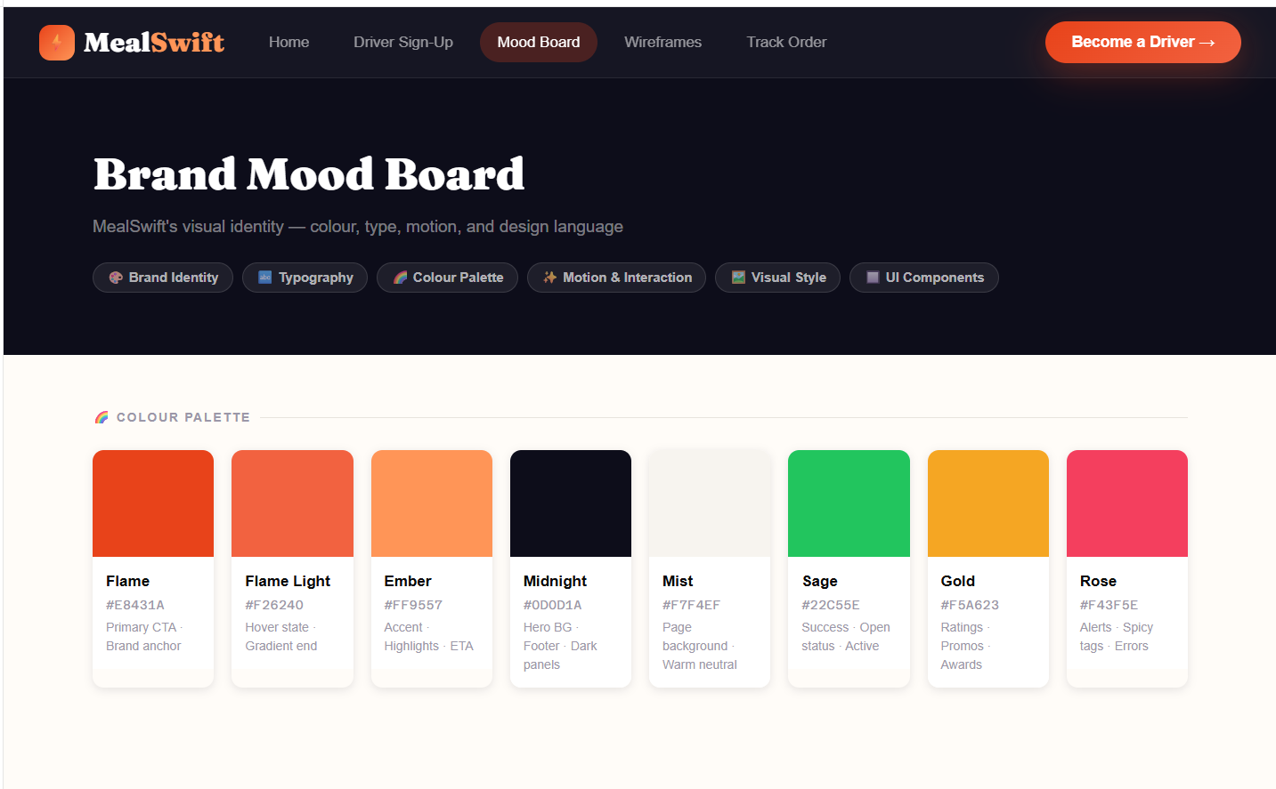
Colour Palette

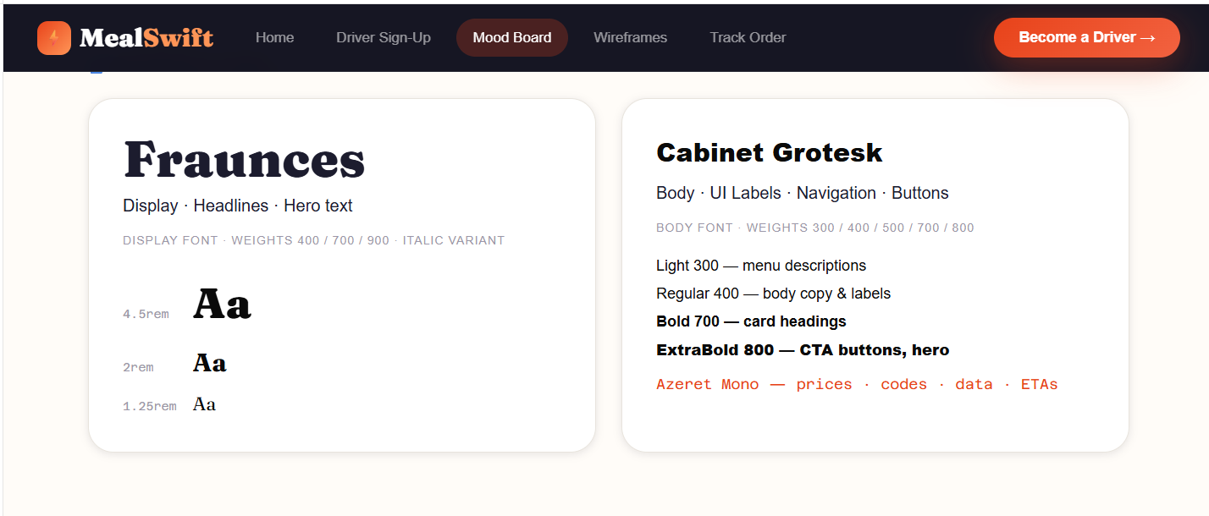
Typography System

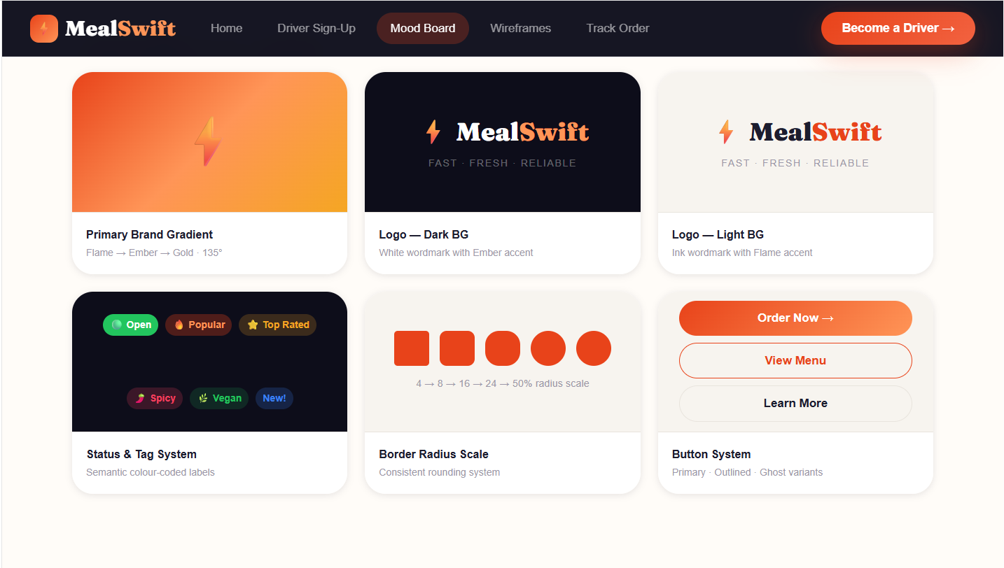
Brand Elements & Visual Language

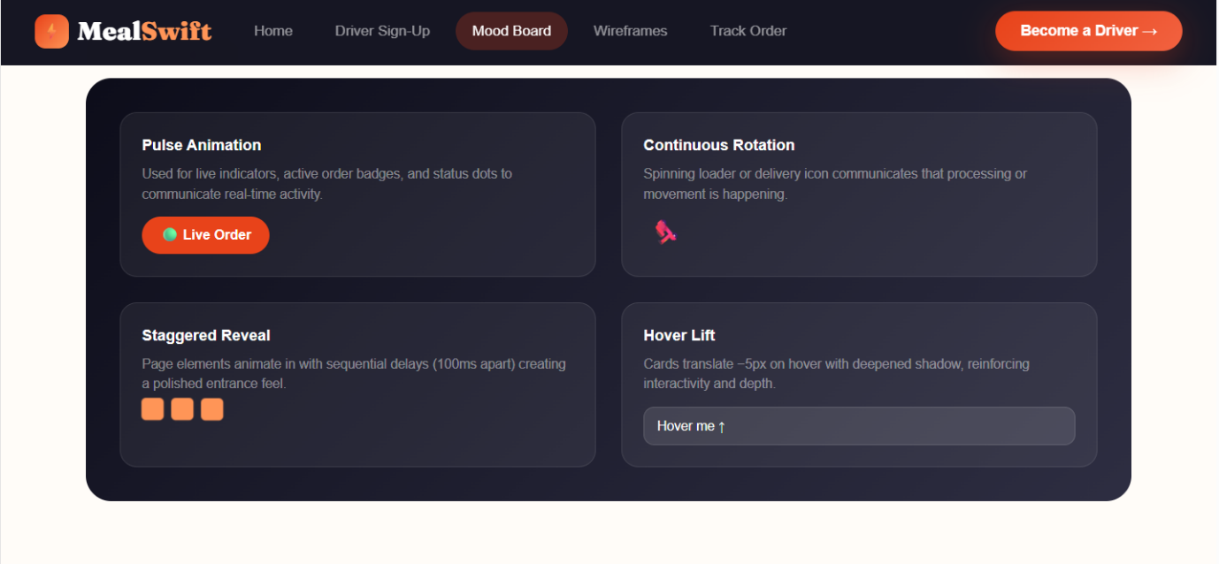
Motion Principles

Photography & Imagery Direction
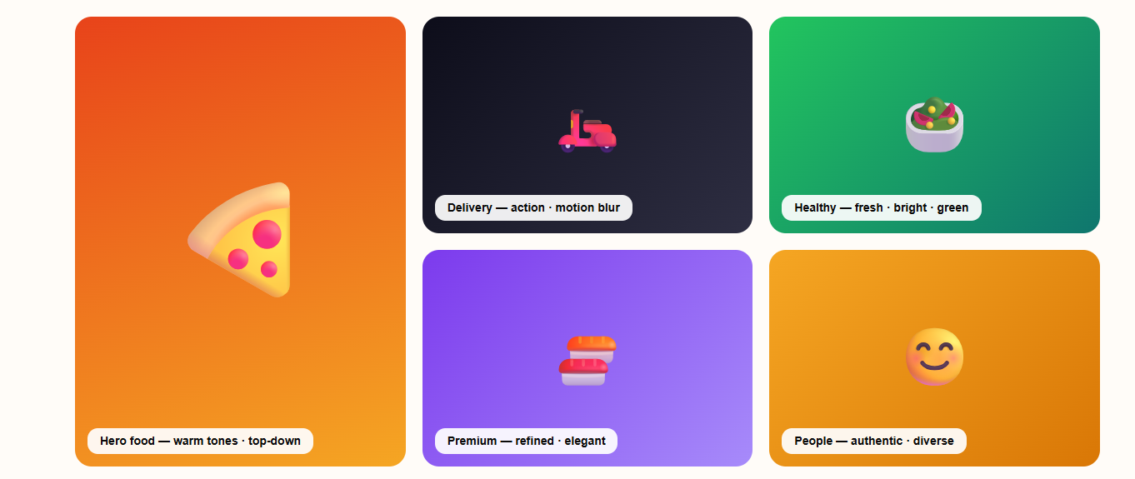

Wireframe

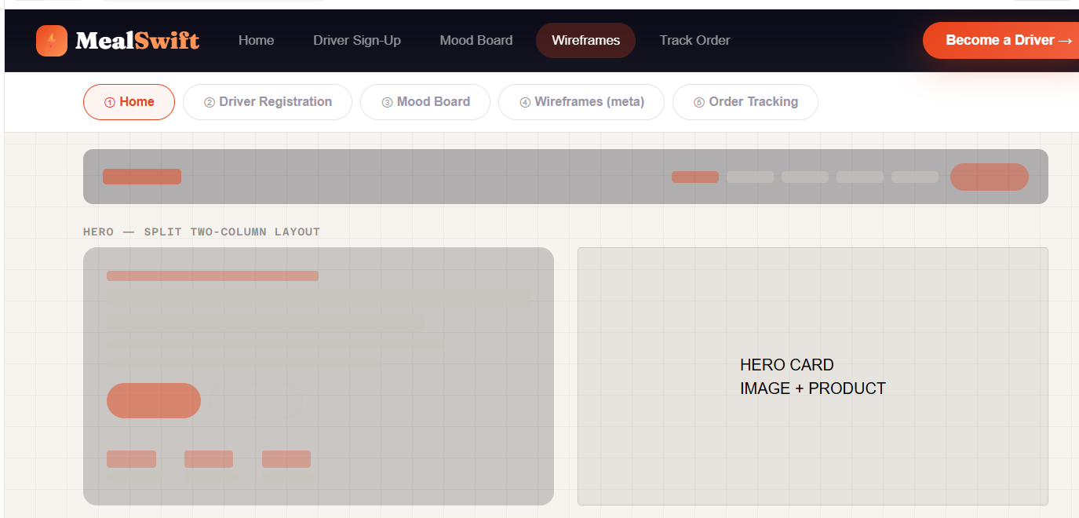
Home Page

Search Bar


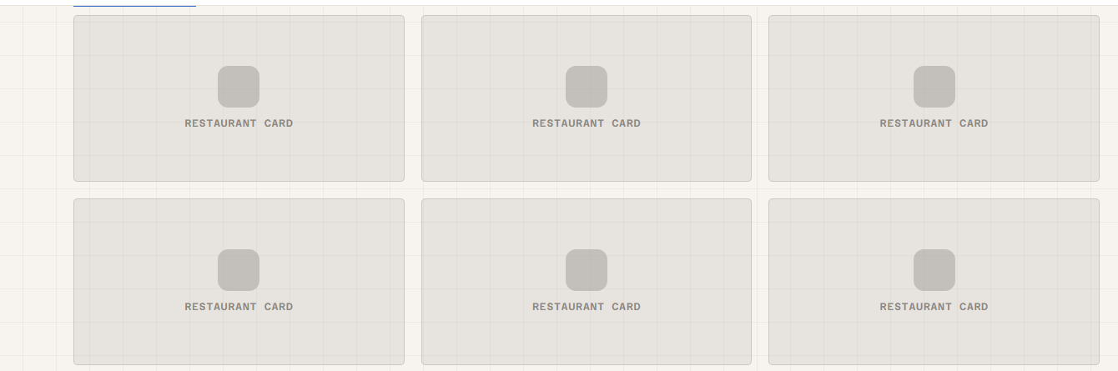
Restaurant Grid

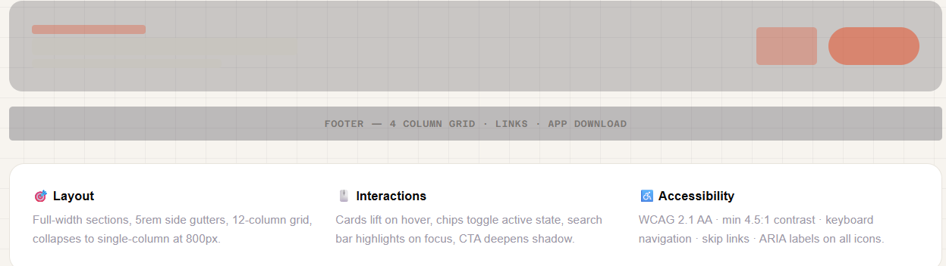
Promotional Banner

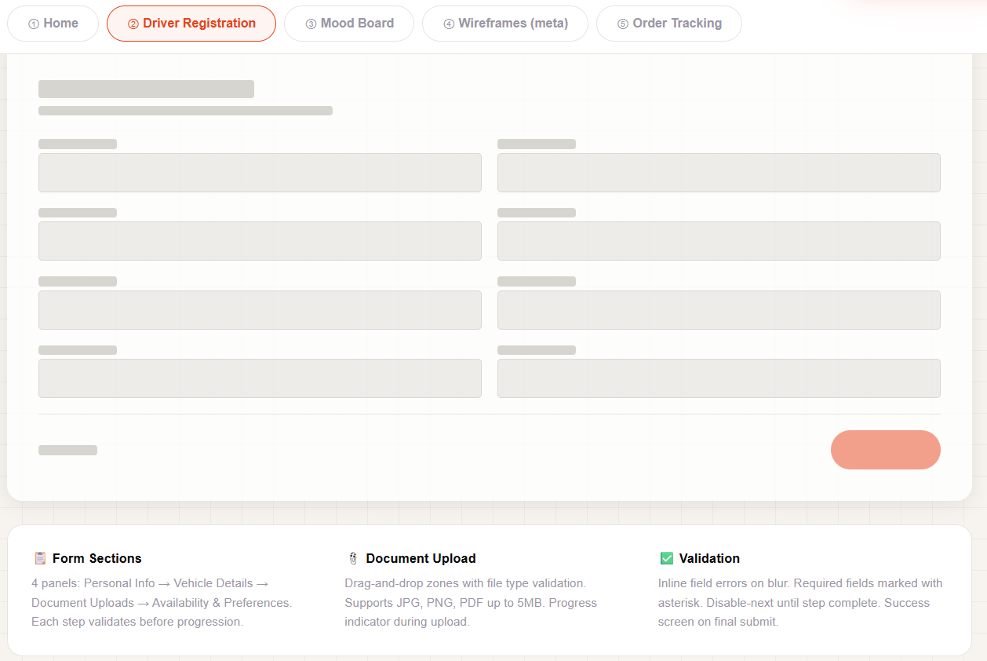
Drivers Registration page

Driver Hero Banner
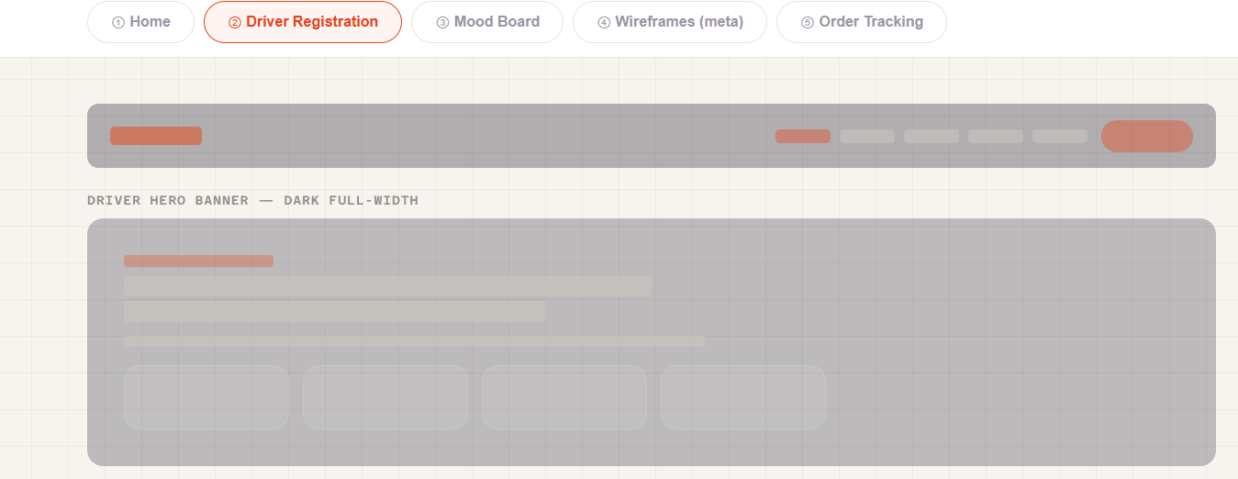

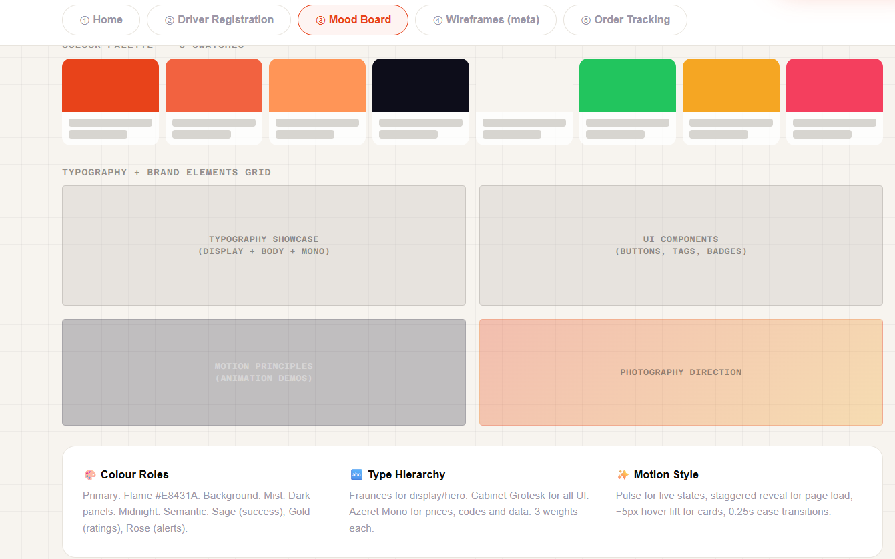
Mood Board page

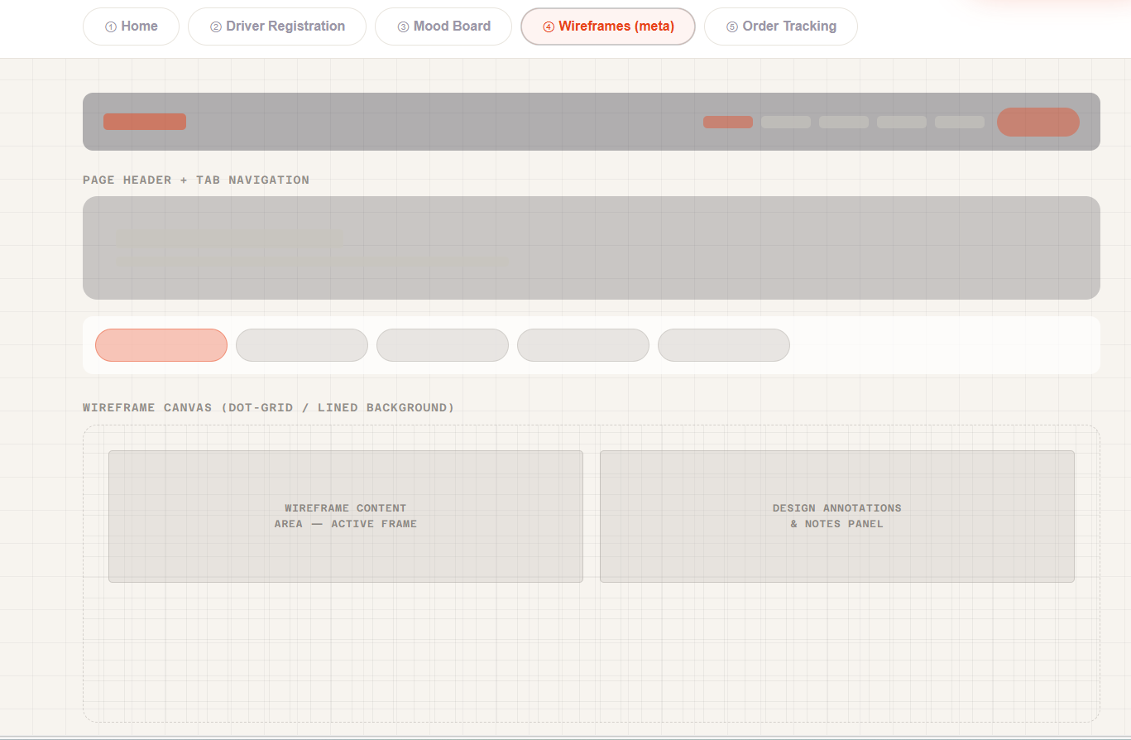
Wireframe page

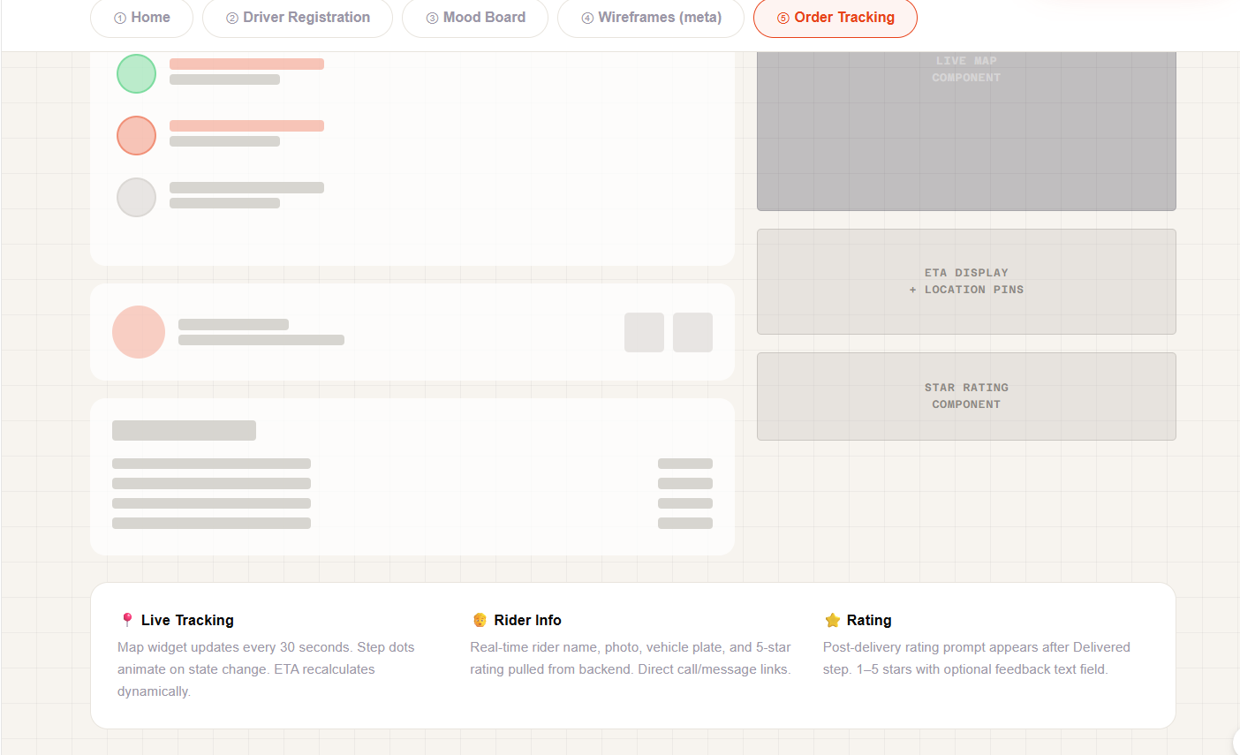
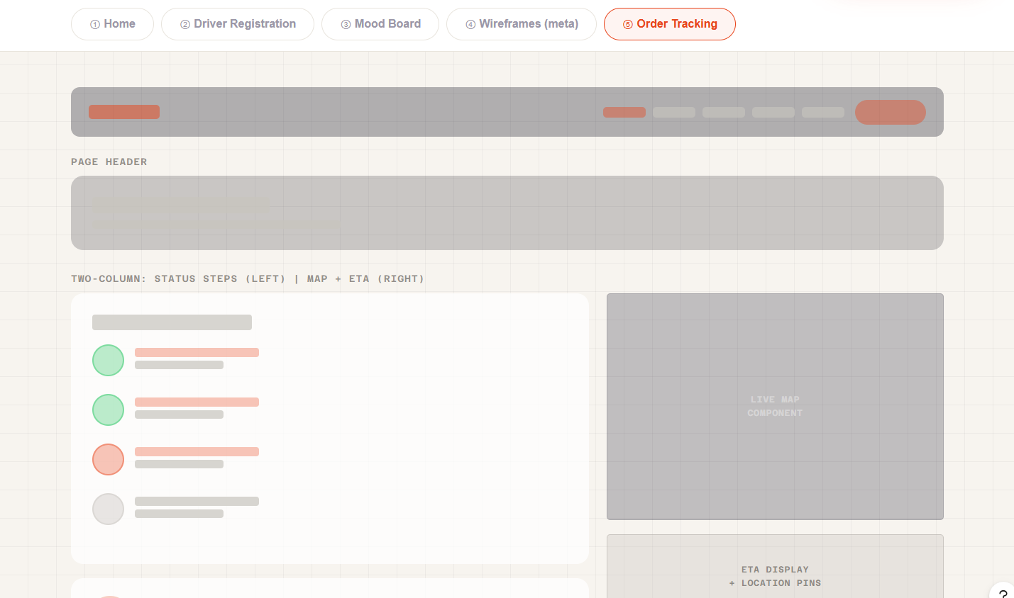
Order Tracking Page

How Mood Board and Wireframe Influence the Design
The mood board and wireframe phases served as foundational pillars that profoundly shaped the final MealSwift design, each contributing distinct yet complementary influences on the overall user experience and visual execution.
The mood board established the aesthetic DNA of the MealSwift platform, directly influencing every visual decision throughout the design process [17]. The carefully curated colour palette of warm oranges and reds translated into the final interface through strategic application in call-to-action buttons, promotional banners, and accent elements designed to stimulate appetite and create urgency.
Wireframes, conversely, provided the structural blueprint that determined user interaction patterns and information architecture [18]. The homepage wireframe's emphasis on prominent search functionality translated into the final design's hero section, where location-based search receives immediate visual priority. Restaurant listing wireframes established the card-based layout system that persists throughout the interface, creating predictable interaction patterns that reduce cognitive load.

Conclusion
This comprehensive redesign project for MealSwift demonstrates the critical importance of systematic, user-centred design processes in creating effective e-commerce solutions that balance user needs, business objectives, and technical constraints. Through rigorous analysis of existing challenges and application of established design principles, the project successfully addresses fundamental usability deficiencies while establishing a modern, scalable digital presence aligned with contemporary best practices.
The redesign achieved several significant accomplishments. The navigation architecture received complete restructuring, transforming confusing, multi-layered hierarchies into intuitive, user-tested patterns that minimise cognitive load and reduce task completion time. Responsive design implementation ensures seamless experiences across device categories, directly addressing the mobile-dominant usage patterns characterising food delivery services. The ordering workflow underwent comprehensive optimisation, eliminating friction points that contribute to cart abandonment while streamlining conversion paths. Visual design modernisation establishes contemporary aesthetics that build trust and credibility while leveraging colour psychology to stimulate appetite and urgency. Accessibility compliance ensures inclusive experiences while simultaneously improving overall usability for all users.
The systematic design process—progressing from mood board conceptualisation through wireframe structuring to high-fidelity prototyping—proved essential for achieving project objectives. Mood board development established clear visual direction and decision-making frameworks that prevented aesthetic drift while ensuring stakeholder alignment. Wireframing enabled structural experimentation and refinement before significant visual design investment, identifying usability concerns requiring adjustment. High-fidelity prototyping synthesised these elements into cohesive, realistic representations, enabling stakeholder evaluation and providing detailed development specifications.
The project directly addresses MealSwift's strategic business objectives across multiple dimensions. The redesign enhances user experience through intuitive navigation, responsive layouts, and streamlined workflows, directly contributing to customer satisfaction and retention. Conversion optimisation mechanisms throughout the interface—from prominent search functionality to simplified checkout processes—support the objective of increasing order volume.

References

[1] | K. J. N. a. R. L. Henderson, “User experience design in e-commerce: A systematic review,” Journal of Interactive Marketing, vol. 45, no. 2, pp. 456-489, 2006.
[2] | S. Krug, “Usability engineering in web application development,” IEEE Software, vol. 31, no. 3, pp. 78-85, 2024.
[3] | G. A. a. P. Harris, “Design thinking for visual communication,” Design Issues, vol. 26, no. 4, pp. 67-83, 2010., vol. 26, no. 4, pp. 67-83, 2010.
[4] | C. Brown, “Communicating design: Developing web site documentation for design and planning,” Technical Communication Quarterly, vol. 19, no. 2, pp. 168-189, 2010.
[5] | A. K. a. D. I. N. Tractinsky, “What is beautiful is usable: Visual aesthetics and perceived usability,” Interacting with Computers, vol. 13, no. 2, pp. 127-145, 2000.
[6] | L. W. a. Y. Hoober, “Mobile interface design patterns for touch interaction,” ACM Transactions on Computer-Human Interaction, vol. 19, no. 4, pp. 454-470, 2007.
[7] | M. A. B. a. T. R. Holst, “E-commerce checkout usability and cart abandonment rates,” International Journal of Electronic Commerce, vol. 27, no. 2, pp. 145-172, 2023.
[8] | M. Luca, “Reviews, reputation, and revenue The case of Yelp.com,” Harvard Business Review, vol. 12, no. 1, pp. 1-24, 2916.
[9] | S. Souders, “High performance web sites: Essential knowledge for front-end engineers,” ACM Queue, vol. 5, no. 6, pp. 36-44, 2007.
[10] | J. K. a. T. Bosenick, “Web navigation design patterns and user task completion,” Journal of Usability Studies, vol. 8, no. 3, pp. 85-102, 2013.
[11] | Z. F. a. B. Hogan, “Responsive web design techniques with HTML5 and CSS3,” Journal of Web Engineering, vol. 17, no. 5, pp. 412-438, 2018.
[12] | W. W. A. Initiative, “Web Content Accessibility Guidelines (WCAG) 2.1,” W3C Recommendation, vol. 1, pp. 1-78, 2018.
[13] | P. K. a. S. Mokhtarian, “Mobile e-commerce adoption patterns and behavioral intentions,” Journal of Retailing and Consumer Services, vol. 58, no. 3, pp. 234-256, 2021.
[14] | R. Andrew, “CSS Grid Layout Module: Modern layout systems for web design,” ACM SIGGRAPH Computer Graphics, vol. 51, no. 2, pp. 15-28, 2017.
[15] | C. W. Group, “Media Queries Level 4: Device adaptation and responsive design,” W3C Working Draft, vol. 1, pp. 1-45, 2020.
[16] | B. J. P. a. J. H. Gilmore, “Welcome to the experience economy,” Harvard Business Review, vol. 76, no. 4, pp. 97-105, 1998.
[17] | G. A. a. P. Harris, “Design thinking for visual communication,” Design Issues, vol. 26, no. 4, pp. 67-83, 2010.
[18] | C. Brown, “Communicating design: Developing web site documentation for design and planning,” Technical Communication Quarterly, vol. 19, no. 2, pp. 168-189, 2021.

The link below is for my MealSwift Website
https://www.figma.com/make/s4TMcB5m7wNdImTlV69vK9/Design-MealSwift-UI-UX?t=IabZ1uAKIRBxO1R2-20&fullscreen=1
The link below is the web link
Design MealSwift UI/UX

The link below is the community link
Design MealSwift UI/UX – Figma

