Photography in the Arts
Dissertation Proposal
Creative Research

Alexandra Smith

1702583
Module Code: ADAD5001
Lecturer: Paul Duerinckx

Word Count: 2281

Three Key Words: Anthropocene, Reverence for Life, The Sublime
Key Thinkers: Edward Burtynsky, Albert Schweitzer, Edmund Burke
Introduction
During this proposal I plan to explore environmental concerns through philosophical concepts including the Anthropocene, Reverence for Life and The Sublime. These subjects will be looked at and supported by key thinkers Edward Burtynsky, Albert Schweitzer and Edmund Burke amongst others. I chose this theme to explore in my dissertation due to the relevance to our contemporary condition. This is a big issue for everyone on a global scale and is a theme close to my heart, being a surfer and an avid lover of everything outdoors, the deterioration of our planet is an issue I will continue to address whether it be through my theory or my photography work.
Chapter 1 will look at the Anthropocene and the work of photographer Edward Burtynsky who has based one of his projects on this subject, looking at humans’ negative impact on our planet and how we are causing it to deteriorate. This then leads me on to Chapter 2 which contemplates Albert Schweitzer’s theory Reverence for Life looking at how our aspiration and love for life comes from everything with in nature and the vast beauty of the natural world. Finally ending on Chapter 3 The Sublime, in particular the natural sublime focusing on philosophical theories of Edmund Burke studying feelings of awe and terror from nature.
Anthropocene
The Anthropocene is our current period which human activity has had a vast impact on earth’s climate change, scientists have declared that we are living in a new geological epoch, called the Anthropocene. (Merriam – Webster, 2019)
One of the main factors by humans influencing climate change include Co2 emissions, deterioration in the biosphere/atmosphere, changes in weather patterns, rising sea temperatures caused by melting ice caps, destruction of natural habitats and industrialisation. The changes to the world are happening at such a fast rate that we don’t give the earth enough time to regenerate that we will eventually destroy everything.
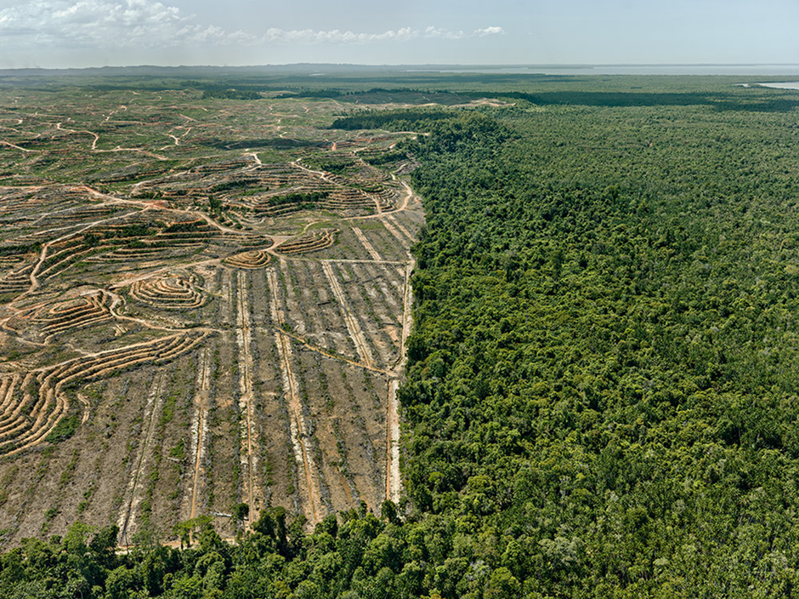
An image from Edward Burtynsky’s collection Anthropocene

I took this image from Edward Burtynsky’s (1955- Present) collection The Anthropocene where he looks at humans vast impact on the natural world. His large scale landscape shots put into perspective and give viewers a fist hand look at how we are destroying the planet. He touches upon mans greed for much more than we need to survive and how our destructive selfish tendencies are now impacting the environment. The Anthropocene project by Edward Burtynsky is a collaborative project combining fine art photography, film, virtual reality, augmented reality, and scientific research to investigate human influence on the state, dynamic and future of the planet earth. (Burtynsky, 2018) When discussing the environment Burtynsky commented to the Canadian news journal something that we should all be thinking about when it comes to excessive waste and greed we as humans have in our everyday lives: “Its about extracting what we need without destroying the places we take it from”, this quote reflects well with Burtynsky’s art work and his personal philosophies on the subject. This makes us as viewers think are we taking more than is actually required based on pure selfish greed. (Burtynsky, 2007)
Environmental concerns are a very current topic amongst artists and photographers in the last century due to the relevance of it in our contemporary condition. Although some would argue the environment has been under threat since the industrial revolution first started in the 18th century. Many artists including filmmakers, authors, painters and poets have explored this subject through different approaches, from Sebatio Salgado’s Genesis to Cormac McCarthy’s Post-apocalyptic novel The Road. For the purpose of my dissertation I will predominantly looking at photographers, some artists and film makers will be mentioned but my main focus will be on photographers and how they highlight our current concerns within the environment.
While Looking into moral theories that have been concerned with the environment it has been suggested that our rationalistic and materialistic ways of living are causing anxiety about the consequences of our actions. If humans weren’t so concerned with short term pleasure or excessive greed for products we don’t need, then it would be less likely that the environment would suffer. As Belshaw states: “Wetlands will be drained and turned into theme parks, deserts will offer scope for retirement homes, plants an animal will become extinct, whenever their survival conflicts with our pleasure”. (Belshaw, 2001)
Even though human impact is the predominant factor that is undeniably affecting the environment in today’s society, environmental concerns has always been an issue independently of humans. Going back to dinosaur extinctions, volcanoes and natural disasters all have effectively always happened throughout history with or without human influence. But the global crisis is worse now than ever before because of human impact. “Nature once determined how we survive, now we determine how nature survives” (David Attenborough, Our Planet, 2019)
Much of my own practice is linked to the Anthropocene focusing on global warming and rising sea levels. This has been a subject of most of my work throughout my time at university and I will continue to explore these themes as an artist. So, I feel it would be appropriate to write my dissertation on this by exploring the subject further and linking theory to my creative practice as it is a subject I am most passionate about.
While researching into the Anthropocene it led me onto Baruch Spinoza’s (1632-1677) philosophical theory of Natura Naturata meaning nature nurtured his work discusses God and nature as one entity and takes environmental concerns to a higher metaphysical state. ‘God is the infinite, necessarily existing (that is, uncaused), unique substance of the universe. There is only one substance in the universe; it is God; and everything else that is, is in God. ‘(Shand, 2005) The quote itself proposes Spinoza’s links between nature and god and how they are in fact one being. Looking at nature from a religious view which then led me onto considering the theory reverence for life and how this thinks with the Anthropocene.
There are many artists who work with nature, famous Land Artist Andy Goldsworthy comments on his relationship to nature: ‘we often forget that we are nature, nature is not something separate from us so whenever we say we have lost our connection to nature we have lost our connection to ourselves.’ (Goldsworthy, 2017)

Reverence for Life
Reverence for Life comes from the vast size of nature and the inextricable hold that is has over us. The strong emotions we get from witnessing the beauty of nature. The reverence for nature has an inevitable hold over us, we as a race should want to preserve and admire not poison and destroy. We will never feel this unique and fulfilling feeling from any other powerful source on earth so why are we destroying it.
Reverence for life within my personal work symbolises an emotional connection to the landscape whilst highlighting the lack of respect we as a race have towards the outside world.
Firstly, I looked at Albert Schweitzer (he was a German/French philosopher who is best known for his theories on the Reverence for Life, which proposes an ethical way of living. Schweitzer’s theory on the Reverence for Life suggest that we as humans show no morality for anything other than ourselves. We make no exclusions through rationality, sentence, usefulness or see the beauty or protection needed for those living things. He insists that we should have “a reverence for life”. (Belshaw, 2001)
Schweitzer also discusses misuse of power within humans and how this affects our relationship to nature he refers to our treatment and misuse of animals and believed that injuring or killing is permitted when necessary but unnecessary harm is objectionable. Linking this to the Anthropocene, humans selfish greed is the frontal cause for the deterioration of the earth. There are many theorists that have considered this moral dilemma including Paul Taylor who wrote the book Respect for Nature. The book discusses what is a non-moral thesis about the character of humans and their relationship to living things. In the book he goes onto discuss humans as a member of a bigger community on earth not the only living being and we can’t survive as a species independently, but no one species is greater than the other. “Nature has implanted in our souls, an unconquerable passion for all, that is great and for all that is more, divine than ourselves” (Longinus). [1st Century AD Roman-era Greek]
In my dissertation I would like to propose Do photographers try and portray a reverence for life in their work and how do they do this?
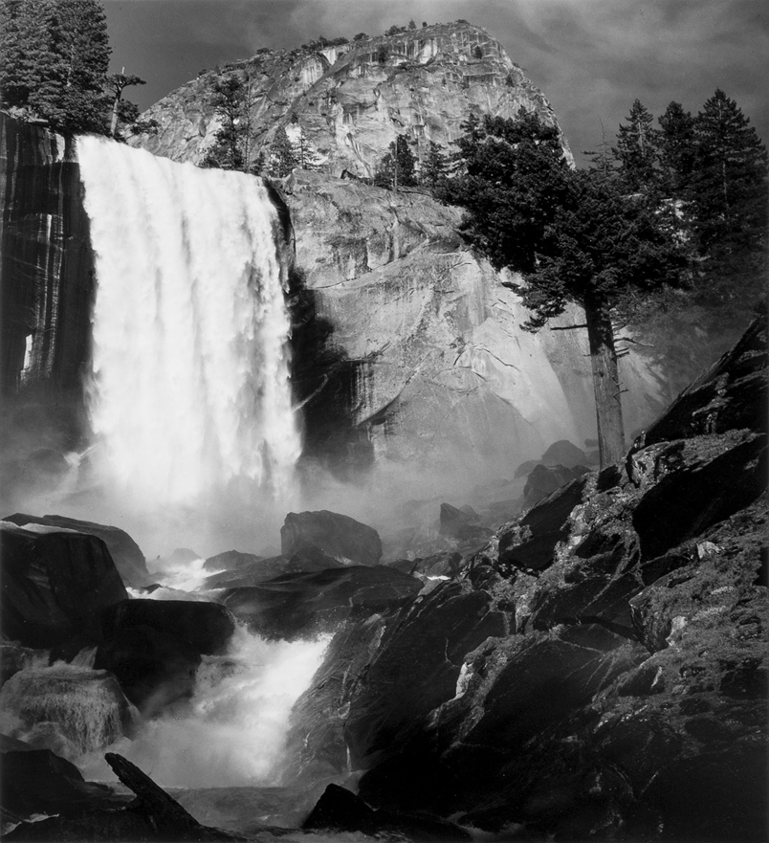

Image taken from an Ansel Adams Exhibition entitled Reverence for life
Ansel Adams images look at preservation of the landscape, respect to the environment and awareness of our influence over it.
Both the grand and the intimate aspects of nature can be revealed in the expressive photograph. Both can stir enduring affirmations and discoveries, and can surely help the spectator in his search for identification with the vast world of natural beauty and wonder surrounding him – and help him comprehend man’s continuing need for that world.

Adams explains how the essence of nature can be identified through nature. This represents the power of photography as a medium.

Sublime
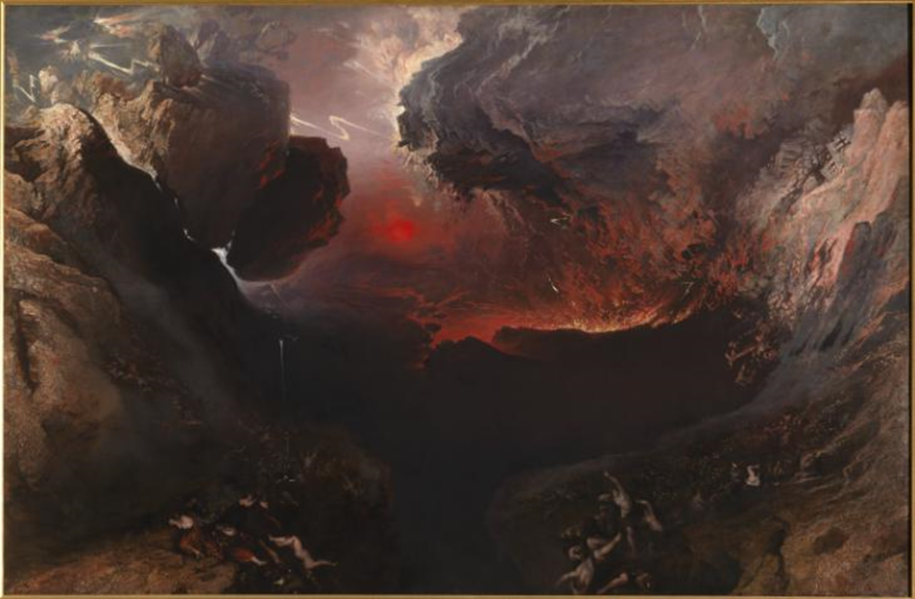
John Martin The Great Day of His Wrath 1851
There are many different interpretations of The Sublime some of which include; terror, finitude, scale, timelessness and the contemporary sublime. Through my understanding of these theories I have singled out the area of the sublime I am keenest to explore, which is the natural sublime.
The ‘natural Sublime’ regards sublimity as a quality inherent in the external world. Theorists, of the natural sublime in other words, are engaged on a quest for the origins of the sublime. Rhetorical theory, however, is not averse to such speculation. According to Longinus, although rhetoric, the primary determinate of the sublime, is that nature seeds the idea of greatness in man and that inclines us to admire the grandeur of the Nile, the Rhine or still more the ocean. (Shaw, 2006, p. 28)
The Natural sublime is a topic many Artists have represented through their work from Joseph Mallord William Turner ‘Snow Storm - Steam-Boat off a Harbour's Mouth’ and William Williams’s ‘Thunderstorm with the Death of Amelia’. But from a more contemporary perspective photographers such as Edward Burtynsky and Andreas Gursky have explored the sublime through their vast landscape shots.
Edmund Burk (1729-1797) talks about the sublime as a concept of making humans feel small, he talks about the vast scale of nature against and the violent process nature can endure and juxtaposes this against us and our thoughts and feelings. He uses the term of being made to feel small and describes it as a positive process allowing us to manifest our thoughts and realise the vast scale of the universe and how unimportant we are in it. This is something I have previously explored through my art; I have represented these ideas though visuals but would now like to explore them through writing in my dissertation. “Whilst Longinus stresses sublimity as a rhetorical phenomenon Burnett and his followers play close attention to the vast and grand in nature” (Shaw, 2006)
Thomas Burnett’s a theorist of the natural sublime believed that the oceans would eventually flood the world this theory linked to biblical texts (genesis 7:11 the fountains of the great deep) that stated a subterranean with water volume of 9 oceans would eventually break and flood the world. (Cox, 1997)
Conclusion
Looking into these theories surrounding nature and the environment has helped me to understand some of the ways in which we as humans observe nature, and the many aspects it can be perceived from. We have gone from observing the beauty within the natural world to controlling and destroying the environment, and some of the photographers mentioned throughout the proposal have demonstrated these different ways we respond and try to capture some of these big issues.
I have discussed different points of view when looking at the environments. Whether it be the terrifying vast size of the landscape and feelings of awe within the sublime or the love, admiration and fascination one can perceive from the landscape, it helps us put things into perspectives as people and realise we are just tiny specs within this vast universe. Photography that deals with themes such as mass production like Andreas Gursky’s “99 cent” to Burtynsky’s large vast landscape shots even though they are both very different subjects they link together to tell a visual narrative of how we as humans are destroying our home. My dissertation aims to explore these responses to the natural world in a more in-depth synopsis and link it within my final year visual work. I have been looking at themes within my work of the Anthropocene and environmental concerns these theories can help educate me and give me a better understanding when making my visual work through looking at different processes when developing work to what to photograph to correspond with my theory research.
This proposal has given me a good platform to begin researching this area. Exploring these theories has broadened my understanding and has helped define my subject knowledge working towards a dissertation question. At this point there are still a few lines of enquiry that I may take, but I am undecided as to which one to pursue. However, having a better understanding of key theories that are connected to nature they have broadened my knowledge so that I can now continue and formulate a question to pursue into my dissertation.

Bibliography
Books
Shand, J., (2005). Central Works of Philosophy v2: Seventeenth and Eighteenth Centuries. New York: Acumen.
Shaw, P., (2006). The Sublime. New York: Routledge .
Websites
The Ansel Adams Gallery (2019) Ansel Adams Portfolio Three – An Intimate Look. Available at: http://anseladams.com/ansel-adams-portfolio-three/ [Accessed May 10th]
Burtynsky, E. (2018, September 23rd). The Anthroposcene Project. Retrieved May 8th, 2019, from Edward Burtynsky: www.edwardburtynsky.com/projects/the-anthropocene-project
Burtynsky, E. ‘Extraction’ (July 2007), Available at http://walrusmagazine.com/articles/2007.07-detail-extraction/2/, (Accessed: 13th May 2019)
Cox, D. E., 1997. Thomas Burnet and The Sacred Theory of the Earth. [Online] Available at: https://creationconcept.info/burnet.html [Accessed 24 April 2019].
Goldsworthy, A. Sacred Ecology. Available at: https://sacredecology.com/andygoldsworthy/ (Accessed: May 12th 2019)
Philosophy, S. E. o., 2016. Baruch Spinoza. [Online] Available at: https://plato.stanford.edu/entries/spinoza/ (Accessed: May 12th 2019)
Merriam Webster (2019) Definition of Anthropocene Available at: www. Merriam - wester.com/dictionary/Anthropocene (Accessed: 30th April, 2019)

Films
Our Planet. (2019) Netflix, 5th April

Figure List
Figure 1- Edward Burtynsky from Anthropocene taken from: https://www.edwardburtynsky.com/projects/photographs/anthropocene
Figure 2- Vernal Fall, Yosemite Valley, California, circa 1948:
https://www.npca.org/articles/1307-a-silent-but-most-effective-voice-ansel-adams-and-advocacy
Figure 3 - John Martin The Great Day of His Wrath 1851
https://www.tate.org.uk/art/art-terms/s/sublime

