

LCBB6000 Dissertation Assignment Component 1 Coursework – A Written Research Proposal

Proposed Research Title:

Effectiveness of Social Media Advertisement (Ad) Vs Traditional Online Ads: A Comparative Study Among Small Businesses

Research Method: Secondary Qualitative

Tutor’s Name: Akshay Narayanan

Student Name: Davinder Singh

Student ID: 2221905

TABLE OF CONTENTS
1 CHAPTER ONE: INTRODUCTION AND FORWARD PLANNING 6
1.1 Background of the Study 6
1.2 Research Problem 6
1.3 Research Aim and Objectives 7
1.3.1 Aim 7
1.3.2 Research Objectives 7
1.4 Research Questions 7
1.5 Research Rationale 7
1.6 The Scope and Context Of The Study. 8
1.7 Significance of the Study 8
1.8 Structure of the Dissertation 9
1.9 Chapter Summary 9
2 CHAPTER TWO: LITERATURE REVIEW 10
2.1 Chapter Overview 10
2.2 Social Media Advertising and Consumer Engagement (RO1) 10
2.3 Social Media Advertising and Purchasing Behaviour (RO1) 10
2.4 Traditional Online Advertising and Brand Visibility (RO2) 10
2.5 Traditional Online Advertising and Conversion Rates (RO2) 11
2.6 Cost-Effectiveness of Social Media Advertising (RO3) 11
2.7 Cost-Effectiveness of Traditional Online Advertising (RO3) 11
2.8 Alignment with Marketing Objectives (RO4) 12
2.9 Comparative Effectiveness of Advertising Methods 12
2.10 Challenges and Limitations of Social Media and Traditional Online Advertising 12
2.11 Theoretical Foundations. 13
2.11.1 AIDA Model in Advertising Effectiveness 13
2.11.2 Technology Acceptance Model (TAM) and Consumer Behaviour 13
2.12 Research Gap 14
2.13 Conclusion 14
3 CHAPTER THREE: METHODOLOGY 15
3.1 Chapter Overview 15
3.2 Research Philosophy 15
3.3 Research Approach: Inductive 16
3.4 Research Design 16
3.5 Eligibility of Secondary Data Collection. 16
3.6 Secondary Data Collection 17
3.6.1 Search Strategy 17
3.6.2 Key Terms and SPIDER Framework. 17
3.7 Secondary Data Sampling. 18
3.8 Thematic Analysis 19
3.9 Ethical Considerations 19
3.10 Methodology Limitations. 20
3.11 Chapter Summary 20
4 CHAPTER FOUR: DATA ANALYSIS AND DISCUSSIONS 21
4.1 Data Analysis (Thematic Analysis) 21
4.1.1 Theme 1: Social media advertising generates significantly higher customer engagement and interactive reach compared to traditional online advertising among small businesses. 21
4.1.2 Theme 2: Traditional online advertising demonstrates stronger conversion rates and purchase-driven outcomes compared to social media advertising. 21
4.1.3 Theme 3: Social media advertising is more cost-effective and accessible for small businesses compared to traditional online advertising. 22
4.1.4 Theme 4: Social media advertising offers greater advantages in brand building and customer relationships, whereas traditional online advertising provides more structured and measurable outcomes. 23
4.1.5 Theme 5 The effectiveness of advertising strategies depends on their alignment with specific marketing goals, with social media supporting long-term branding and traditional online advertising driving short-term sales. 23
4.2 Discussion 26
4.2.1 Discussion Linked with Research Objectives 26
4.2.2 Discussion Linked with Research Question 28
4.2.3 Findings Link with Theoretical Framework 29
5 CHAPTER FIVE: CONCLUSION, LIMITATIONS, AND RECOMMENDATIONS. 30
5.1 Conclusion 30
5.2 Study Limitations. 30
5.3 Recommendations 31
REFERENCES 32

Abstract
This research discusses the efficacy of social media advertising over traditional online advertising, with a special emphasis on small businesses. In the current digital world, small businesses tend to be at cross roads in regards to the type of advertising strategy that best suits them, particularly when they have limited budgets and resources. Thus, the primary goal of the research is to learn how both advertising strategies impact the key factors, including customer engagement, conversion rates, cost-effectiveness, and overall marketing objectives. The research is founded on a secondary qualitative research approach, where a variety of peer-reviewed studies published between 2015 and 2025 will be analysed to determine common trends and insights. The results show that social media advertising tends to be more effective in terms of establishing customer engagement, brand awareness, and long-term relationships with customers. This can be attributed to the fact that the social media platforms enable the businesses to engage the audience directly in a more personalized and cost-effective manner. Conversely, the traditional online advertising, including display ads and search-based ads, is likely to work better in the case of generating immediate sales and providing measurable results, specifically when it comes to short-term marketing objectives. In general, the study indicates that no one advertising technique can be deemed the most effective in every case. Rather, the success of every strategy is determined by the objectives of the business in particular.

CHAPTER ONE: INTRODUCTION AND FORWARD PLANNING

Background of the Study
Advertisements (ad) are essential for small businesses in the digital economy, but different types serve distinct purposes. Social media advertising on platforms like Facebook, Instagram, and TikTok enables real-time, personalized engagement with potential customers, helping increase brand awareness and find new clients on limited budgets (Cole et al., 2017). In contrast, conventional online ads, such as Google display ads and email marketing, provide broader, more stable reach but may lack the interactivity of social media formats (Bhatnagar & Asnani, 2013). Automation drives much of today's ad industry, and by 2025, 85 percent of global ad spending is forecasted to be programmatic (Statista, 2025). Small and medium enterprises struggle to choose which type of ad interactive social media or stable, far-reaching conventional ads, best suits their needs as consumer behaviors change. Comparative research is necessary to clarify which advertising methods offer more advantages for SMEs.

Research Problem
The current digital environment of small businesses is very competitive and saturated. Although advertising is one of the most important marketing tools, there is always the issue of choosing the most cost-effective and effective medium. Even though social media advertising has more chances to be more engaging and personalized, and interactive content, it is also prone to changes in algorithms and content saturation on the audience (Tuten, 2023). On the other hand, the conventional forms of online ads, such as banners, pay-per-click (PPC) promotions, and email advertising, can offer a measurable targeting capability but, in most cases, lack emotional appeal and interactivity (Pfeiffer & Zinnbauer, 2010). Academic and industry literature present contrasting evidence that makes it hard to make informed marketing decisions as a small business owner. In addition, empirical comparative studies on the SME context are lacking, and it is uncertain to determine the long-term benefits and the return on investment (ROI) of each type of advertising. This research paper fills this gap by undertaking a comparative analysis of social media and conventional online ads in relation to small business performance. The study will determine the impact of every ad plan on significant marketing performance, including customer response, brand recognition, sales, and cost efficiency. The knowledge of these relations will help SMEs to implement data-driven and sustainable marketing.

Research Aim and Objectives

Aim
The aim of this research is to evaluate the comparative effectiveness of social media advertisement and traditional online advertisement in helping small businesses enhance customer reach, boost sales, and build brand awareness.

Research Objectives
- RO1: To assess how social media advertisement influences customer engagement and purchasing behaviour.
- RO2: To evaluate the impact of traditional online advertisement on brand visibility and conversion rates.
- RO3: To compare the cost-effectiveness of social media ads versus traditional online ads for small businesses.
- RO4: To identify which advertisement strategy aligns better with the marketing goals of small businesses.

Research Questions
RQ1: Which form of advertisement (social media or traditional online) is more effective in reaching and engaging customers?
RQ2: How do conversion rates and return on investment differ between the two ad types?
RQ3: What are the key advantages and limitations of each advertisement method for small businesses?
RQ4: Which advertisement strategy better aligns with the overall marketing goals of small businesses?

Research Rationale
The rationale behind this study is that there are still some debates on the nature of online advertisement social media or traditional that has more effective outcomes on small businesses. Although ads in social media are known to be targeting and interactive (Kaplan & Haenlein, 2010), the performance and consistency of the advertisements are subject to change because the online trends change rapidly (Dwivedi et al., 2021). The traditional advertisements are not so innovative, but the stable and measurable outcomes make them more appreciated (Bhatnagar & Asnani, 2013). The absence of consensus signifies that there is a need to do further comparative analysis. This research will explain why a particular approach of advertising is more effective in SMEs in certain situations, both to make real-life marketing choices and to contribute to the existing body of knowledge.

The Scope and Context Of The Study.
The comparative analysis of the social media advertisement (Facebook, Instagram, and Tik Tok) and traditional online advertisement (Google display advertising, banners, and email marketing) is conducted in the study. The contextual focus is limited to small enterprises that tend to have low marketing resources and rely on online platforms to market their brands and communicate with clients.

Significance of the Study
The study has a theoretical and practical implication. Theoretically, it helps to add to the existing body of knowledge concerning how advertising models such as AIDA model (Hassan et al., 2015), Hierarchy of Effects (Barry & Howard, 1990), and Technology Acceptance Model (Davis, 1989) can be used to test the current advertisement strategies. In a real sense, it offers small business owners and marketers with fact on the ground to make informed decisions on advertising basing the decisions on cost-effectiveness, customer engagement, and brand growth. The results can also help the marketing teachers, consultants, and policy makers to devise training and support interventions to enhance the digital marketing competence of SMEs.

Structure of the Dissertation
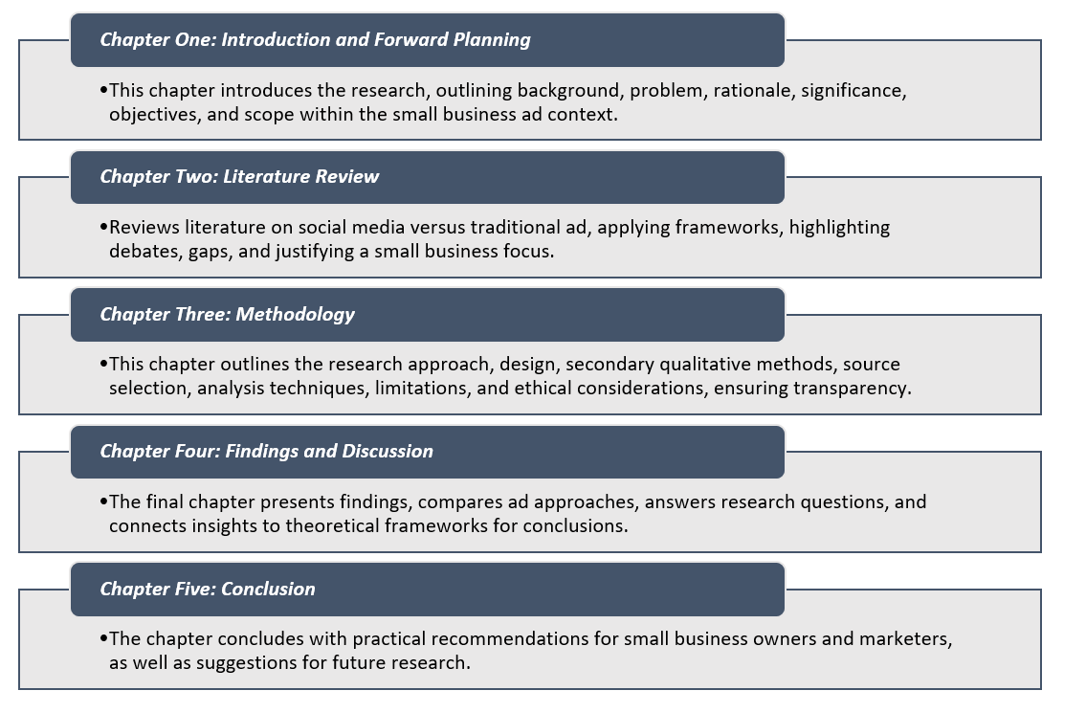

Chapter Summary
This introductory chapter explains the reason and objective behind selection of this research. The following chapters will build on this foundation. The next section will present a literature review, followed by a qualitative analysis. These chapters will help draw meaningful conclusions that address the stated research goals.

CHAPTER TWO: LITERATURE REVIEW

Chapter Overview
The increasing trend of digitalization has changed the advertising approach, especially for small businesses that want to focus on cost-efficient and effective advertising techniques. Therefore, this review critically evaluates the existing literature to address the research aim of comparing advertisement effectiveness and to answer the research questions.

Social Media Advertising and Consumer Engagement (RO1)
Social media advertising has long been noted for its ability to improve customer engagement. De Vries et al. (2012) proved that interactive brand posts enhance user engagement in a profound manner, whereas Ashley & Tuten (2015) emphasized creative content strategies as one of the essential motifs. In addition, Duffett (2017) found that social media advertisements have a positive impact on consumer attitudes in younger demographics. Nevertheless, Voorveld et al. (2018) found that levels across different platforms would not be limiting or restrictive for generalization. Such unequivocity implies that the result of engagement is platform-specific. So, social media advertising, as a concept, is important for customer communication, though its effectiveness depends on the situation in relation to RO1 and RQ1 regarding engagement performance.

Social Media Advertising and Purchasing Behaviour (RO1)
The association between social media advertising and purchasing behaviour has become of great interest. Kumar et al. (2016) claimed that firm-generated content has a direct impact on customer buying decision whereas Stephen (2016) emphasized the influence of peer influence on buying behaviour. Nevertheless, as Dwivedi et al. (2021) noted, there are various external issues that affect behavioural outcomes and include trust and privacy concerns. This implies that, as much as social media advertising influences purchasing intentions, it is not effective on all people. Hence, social media advertisements are adding to behavioural performances but must be implemented strategically, which contributes to the research objective and RQ2, requiring a conversion difference.

Traditional Online Advertising and Brand Visibility (RO2)
Conventional web advertising, such as display advertisement and search engine advertising, continues to play an important role with regard to brand exposure. Claiming that retargeting strategy enhances ad relevance and visibility, Lambrecht & Tucker (2013) also argued that traditional advertising can strengthen the brand's online presence. Nonetheless, Tiago & Verissimo (2014) observed that such techniques are usually not interactive and therefore there are low levels of engagement. This weakness means that though conventional advertisements increase publicity, they might not prolong consumer attention. Thus, the conventional online advertisement leads to brand recognition, but it does not provide an in-depth engagement, which answers RO2 and RQ1.

Traditional Online Advertising and Conversion Rates (RO2)
An important measure of advertising performance is the conversion rate. Lambrecht & Tucker (2013) discovered that in personalization, the conversion rates are significantly higher. On the same note, Bhatnagar & Asnani (2013) opined that a systematic online campaign gives quantifiable results. Nevertheless, Cole et al. (2017) pointed out that small businesses are not always able to optimize such resource constraints. This implies that traditional online advertisements can drive conversions, but their effectiveness depends on technical skills and budget constraints. Thus, conventional online advertising has quantifiable advantages in conversions, but with the limitation of operational difficulty, which fits RO2 and RQ2.

Cost-Effectiveness of Social Media Advertising (RO3)
Price is important for small businesses that have a tight budget. According to Taiminen & Karjaluoto (2015), the low entry and high reach are afforded through social media marketing. Kaplan & Haenlein (2010) contended that user-generated content lowers marketing costs. Nevertheless, Dwivedi et al. (2021) pointed to hidden expenses like content development and management of the platform. This means that the social media advertising may seem cost-effective, but it must be supported with a constant effort in strategy and creativity. Thus, social media advertisements are also affordable, yet not free, which responds to RO3 and RQ2.

Cost-Effectiveness of Traditional Online Advertising (RO3)
Ordinary internet advertisements can be more expensive than social media sites. Reports by Statista (2025) indicated that there was ever-growing digital spending on advertisements globally and thus, many competitors and costs. According to Bhatnagar & Asnani (2013), traditional advertisements can be seen only when the company invests a lot of money. But Lambrecht & Tucker (2013) also postulated that this can be done through targeted advertising, and this can enhance the return on investment. Nevertheless, Cole et al. (2017) have indicated that small businesses might have problems with cost efficiency. Thus, the standard Web-based advertising can provide potential ROI advantages but is not likely to be survival-friendly for smaller companies, which is also in line with RO3 and RQ2.

Alignment with Marketing Objectives (RO4)
To be effective, the advertising strategies need to be aligned with business goals. Tiago & Verissimo (2014) pointed out that digital marketing opens goal-oriented, flexible strategies. Tuten (2023) stated that social media enables the company to customize campaigns to meet certain goals, including engagement or brand awareness. Nevertheless, Cole et al. (2017) observed that small businesses do not have strategic planning capacity in many cases. This implies that the alignment is a factor of managerial knowledge and not just a platform selection. Thus, both means of advertisement can match the business objectives when working with them efficiently to cover RO4 and RQ4.

Comparative Effectiveness of Advertising Methods
Comparative research has given conflicting reports on the effectiveness of advertising. Bhatnagar & Asnani (2013) stated that online advertisement is more effective in reaching and targeting as compared to traditional methods. Conversely, Pfeiffer & Zinnbauer (2010) noted that conventional advertisements can be used to complement digital ones. According to Stephen (2016), both methods should be combined in order to provide the best results. Nevertheless, Dwivedi et al. (2021) added that success is relative to circumstances and structure. This means that there is no best way. Thus, comparative effectiveness situational, as it is, directly addresses the aim of research and RQ1.

Challenges and Limitations of Social Media and Traditional Online Advertising
In addition to its benefits, there are various challenges associated with social media advertising. The platform fragmentation was emphasized by Voorveld et al. (2018) as one of the limitations, and Duffett (2017) noted the problem of users being overly exposed to advertisements. Also, Dwivedi et al. (2021) expressed the issue of information privacy and reliance on algorithms. Nonetheless, Kaplan & Haenlein (2010) believed that such challenges could be addressed with the help of strategic content management. This is an indication that social media advertising does not lack risks. Consequently, its weaknesses should be taken into consideration during the measurement of effectiveness, RQ3.
There are also restrictions on traditional online advertising. Tiago & Verissimo (2014) concluded that, regardless of the type of interaction, an absence of interactivity lowers consumer engagement, and Cole et al (2017) found that resource allocation is a challenge to most small businesses. Moreover, Lambrecht & Tucker (2013) outlined the problem of ad blindness, in which they overlook frequent adverts. Pfeiffer & Zinnbauer (2010), however, proposed that these limitations could be avoided by using traditional and digital strategies interchangeably. This means that standard online advertising cannot be enough. Thus, it is limited in its effectiveness, which responds to RQ3.

Theoretical Foundations.

AIDA Model in Advertising Effectiveness
The AIDA model still forms a basic theory in analyzing the influence of advertising. Based on this, Lavidge & Steiner (1961) suggested that advertisement takes consumers through stages of awareness to action. In the same vein, Hassan et al. (2015) have also emphasized its use in advertising small businesses on social media. Pramita & Manafe (2022) also supported it in the relevance to comprehend customer response. Barry & Howard (1990), however, criticized the model as being too simplistic and linear. Conversely, the researchers of today profess that digital environments form non-linear consumer experiences. This criticism proposes that although AIDA is a useful tool, it needs to be modified, which is the goal of the research to compare the effectiveness of advertisements.

Technology Acceptance Model (TAM) and Consumer Behaviour
The TAM can be used to understand how users interact with online advertisements. Davis (1989) claimed that technology adoption depends on perceived usefulness and ease of use. Taiminen & Karjaluoto (2015) supported this idea by pointing out that SMEs use digital marketing tools depending on such perceptions. Nevertheless, Cole et al. (2017) also indicated that small businesses do not always have the competencies and abilities to use digital platforms to their full potential. On the contrary, Dwivedi et al. (2021) found that these issues do not stop adoption because of the ongoing technological progress. This shows that user perception is a determinant factor which is connected to RO1 and RQ3 on references to benefits and constraints.

Research Gap
The current literature provides a detailed discussion of social media and traditional online advertisement on their own; thus, there is little work that compares these two categories of advertisement with special emphasis on small businesses. Although Stephen (2016) and Dwivedi et al. (2021) addressed the topic of digital trends, they did not focus on the cost-effectiveness of these changes to SMEs. In a similar way, Bhatnagar & Asnani (2013) opposed the advertising techniques, but they did not provide the latest empirical evidence. Furthermore, research works like Taiminen & Karjaluoto (2015) did not examine the effectiveness, but instead the use of the channel. Consequently, the gap in knowledge regarding which advertising plan is more aligned with the objectives of a small business is evident, which is why the research purpose was selected and answering all research questions was achieved.

Conclusion
The research gap identified further points to the necessity of a small business-oriented comparative analysis. As such, the proposed study will fill this gap and offer practical insights in accordance with the research objectives and research questions.

CHAPTER THREE: METHODOLOGY

Chapter Overview
This chapter outlines the methodology of investigating the comparative effectiveness of social media advertisement and traditional online advertisement among small businesses. The importance of methodology lies in providing a systematic pathway to answer the research questions and fulfil the research aim. Since this paper relies on secondary qualitative data, the research onion model is used to organise the discussion based on philosophy, approach, design, data collection, sampling, analysis and ethics (Saunders, Lewis & Thornhill, 2009). This methodology chapter follows the Research Methods for Business Students research onion model, covering research philosophy, inductive approach, qualitative design, secondary data collection, inclusion criteria, sampling (PRISMA), thematic analysis, and ethical considerations. The motive behind is to ensure a systematic and reliable comparison of advertising effectiveness.
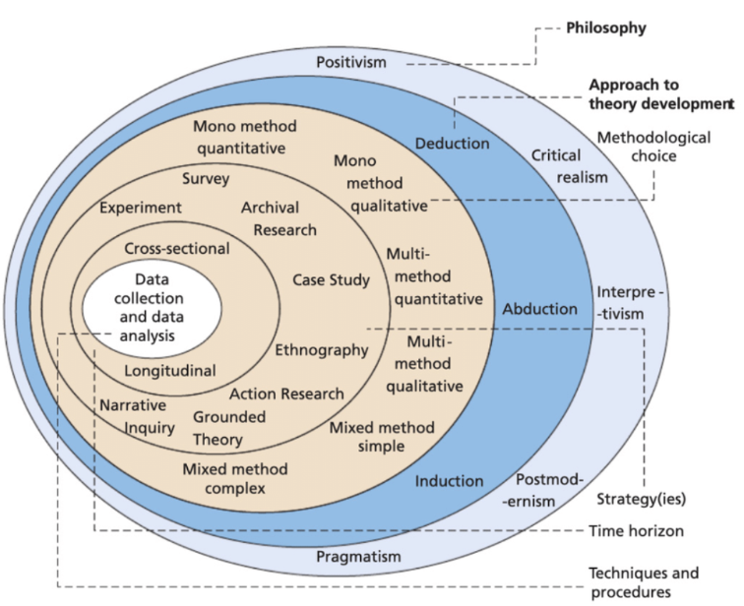
Figure 1. Research Onion
Source: (Salmons, 2024)

Research Philosophy
This research takes an interpretivist philosophy. Research philosophy can be defined as those beliefs which lead to knowledge, understanding, and interpretation of a study. Such common philosophies are positivism, interpretivism, realism and pragmatism. Interpretivism is suitable in this case since the research focuses on explaining the advertising effectiveness that has been discussed in the past qualitative research, but not quantifying a single objective reality. As secondary qualitative research is interested in meaning, context, and interpretation, interpretivism contributes to a better understanding of how social media and traditional online advertisements can impact customer engagement, conversion, and marketing objectives (Fossey et al., 2002; Pathak, Jena & Kalra, 2013). The paradigm suits the study since it enables the researcher to analyse the trends in the published findings and relate them to the goals of small businesses.

Research Approach: Inductive
The research adopts an inductive method. The approaches to research are mostly inductive or deductive. The deductive approach is used to test existing theories, whereas the inductive approach is used to make patterns and themes based on the data. The study is inductive as it has started with secondary qualitative evidence and enables the themes to be developed based on the chosen literature. It is appropriate in comparative advertising studies as it assists in detecting similar problems in studies like engagement, visibility, cost-effectiveness, and strategic fit, as opposed to applying rigid assumptions to the data. Inductive reasoning is thus very consistent with secondary qualitative analysis (Heaton, 2008).

Research Design
The study is a systematic qualitative review with the help of thematic analysis. Research design gives the general outline of how to gather and analyse the data. The most popular are exploratory, descriptive, explanatory, and case study designs, yet in this case, the best choice would be a systematic qualitative review as the study will compare and synthesise the available evidence regarding two advertising strategies. This design will allow the researcher to examine the pertinent peer-reviewed literature in a clear and systematic way, whereas thematic analysis will be used to determine the primary trends that are associated with customer engagement, conversion, and cost-effectiveness (Lochmiller, 2021).

Eligibility of Secondary Data Collection.
Relevance and quality were ensured by having clear inclusion and exclusion criteria. Peer-reviewed written English works published since 2015 and up to 2025 were given preference, as recent studies are more up-to-date with the latest evidence on digital advertising trends and platform changes, as well as SME marketing practices. The reason to use peer-reviewed articles is based on the fact that they are more academically reliable than editorials, opinion articles and non-scholarly documents. Any articles that were published earlier than 2015 were eliminated as a way to remain up to date and reflect on the present-day situation in online advertising. The use of non-English sources was also restricted because of language constraints.
Table 1. Inclusion and Exclusion Criteria for Secondary Data
Inclusion Criteria | Exclusion Criteria
Peer-reviewed journal articles | Editorials, opinion pieces, blogs
Published 2015–2025 | Published before 2015
English language | Non-English studies
Relevant to SMEs, social media ads, or online ads | Irrelevant to the research topic

Secondary Data Collection

Search Strategy
Google Scholar, Scopus, and JSTOR were searched using a structured search strategy to collect secondary data. This was significant towards credibility, breadth and transparency of the review process.

Key Terms and SPIDER Framework.
The search was guided by the SPIDER framework since it is applicable in qualitative systematic review and provides the ability to obtain narrow search terms (Amir-Behghadami, 2021).
Table 2. SPIDER Model
SPIDER Component | Description | Search Terms
Sample | Small businesses/SMEs | small business, SME
Phenomenon of Interest | Advertising effectiveness | social media advertising, online advertising
Design | Qualitative review | qualitative, thematic review
Evaluation | Engagement, ROI, visibility | customer engagement, conversion rate, cost-effectiveness
Research Type | Secondary qualitative | systematic review, secondary analysis

Alternative terms such as "digital marketing," "online promotion," "paid social media," "display advertising," and "email marketing" were also used to widen the search. Boolean operators such as AND, OR, and NOT refined the search and reduced irrelevant results.

Secondary Data Sampling.
The method of purposive sampling was used to choose studies that were in line with the research aim and objectives (Taherdoost, 2016). Initially, 90 articles were found. Following the elimination of duplicates, there were 70 individual records. The screening process eliminated irrelevant and non-peer-reviewed articles, and 30 full-text articles remained to be assessed in terms of eligibility. Following additional quality and relevancy screening, 10 studies were incorporated in the analysis. This was facilitated by the PRISMA model and enhanced transparency (Moher et al., 2009).
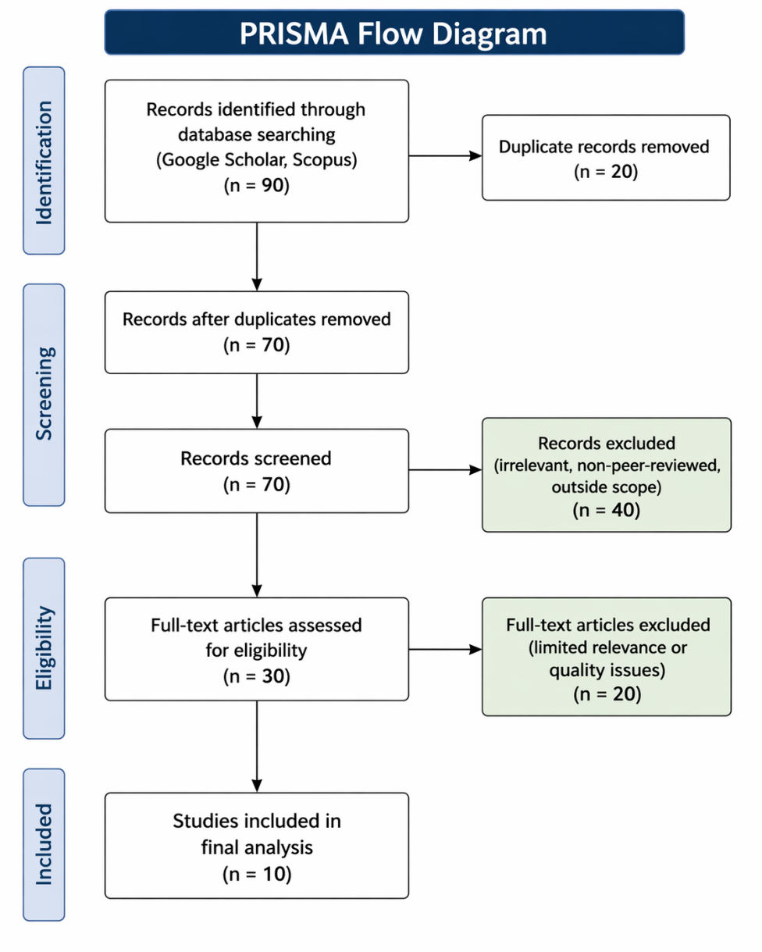
Figure 2. PRISMA Flow Diagram

Thematic Analysis
The research employed manual thematic analysis since it is appropriate for the arrangement of qualitative evidence into significant patterns. The analysis had five phases: familiarisation with the data, first coding, theme generation, theme review, and final reporting. Manual thematic analysis was chosen due to its ability to enable the researcher to interact with the studies in a more intimate manner and compare the results across the sources in a more flexible manner (Lochmiller, 2021).

Ethical Considerations
There were no immediate human subjects in this study since secondary published data will be used. Thus, there were limited risks. Nevertheless, the ethical practice still demanded proper references, fair representation of findings made by the authors and prevention of plagiarism. Only authoritative peer-reviewed materials were discussed, and all evidence was analysed according to university academic standards (Irwin, 2013).

Methodology Limitations.
There are a number of limitations in this methodology. To begin with, it is solely based on the secondary sources; the results will depend on the quality of the available research. Second, English-language studies were only utilised. Third, it was restricted to 2015-2025, potentially omitting previous background work. Lastly, the last dataset of 10 studies is quite small, and it might restrict the scope of conclusions.

Chapter Summary
This chapter described the interpretivist philosophy, inductive approach, systematic qualitative review design, eligibility criteria, search strategy, sampling process, thematic analysis, ethics, and limitations. The research aim and the objectives can be well addressed using the methodology since it facilitates a systematic comparison of social media and traditional online advertising among small businesses. The findings and analysis are presented in the next chapter.

CHAPTER FOUR: DATA ANALYSIS AND DISCUSSIONS
This chapter presents the findings derived from the qualitative analysis of peer-reviewed literature.

Data Analysis (Thematic Analysis)

Theme 1: Social media advertising generates significantly higher customer engagement and interactive reach compared to traditional online advertising among small businesses.
The literature reviewed shows a consistent pattern of social media advertisement being more effective in creating customer engagement and reach than traditional online advertisement. Indicatively, Yousef et al. (2021) show in their A/B test that the advertisements posted on social media can generate measurable indicators of engagement, i.e., likes, shares, and clicks, and thus can be characterised as interactive. Similarly, Bakshy et al. (2012) discovered that the use of social cues in advertisements significantly enhances responses of the users, which supports the importance of social influence in boosting engagement. Moreover, Hervet & Guitart (2022) present experimental evidence from large-scale field experiments that demonstrates that executional properties of social media display advertisements, including message framing and repetition, have a significant positive effect on the click-through rate, which in turn reinforces the results of engagement.
On the other hand, the conventional online advertising systems, like banner and display advertisements, are mainly based on passive exposure, which does not allow user engagement. Soriaga et al. (2023) also believe that using social media platforms helps small businesses to engage more people at a reduced cost. Nonetheless, even with the increased level of engagement, the literature reveals that such interactions do not necessarily turn into purchasing behaviour. Thus, concerning RQ1 and RO1, social media advertisement is more efficient in terms of engagement, but its effectiveness in conversion is context-specific.

Theme 2: Traditional online advertising demonstrates stronger conversion rates and purchase-driven outcomes compared to social media advertising.
Although social media advertising may be more effective at engagement, traditional online advertising can be more effective at achieving conversions and sales. Empirical data in Ntousi et al. (2025) reveal that the advertisement strategies guided by performance through structured content and quantifiable results lead to increased conversion rates and the return on ad spend (ROAS). Further, Hail (2025) discovered that paid advertising campaigns, especially those related to organised online platforms, are more efficient in providing small businesses with immediate and quantifiable sales results. Even though social media campaigns may create high traffic, the conversion rates are not always consistent, as user behaviour is exploratory. Conversely, conventional online advertising, especially search-based ads, focuses on consumers who have higher purchase intent, and more dependable conversion results are achieved. This point outlines that the traditional online advertisement is more aligned with the transactional goals, and the social media advertisement is more aligned with the awareness and engagement. Consequently, answering RQ2 and RO2, online advertising is more effective in turning customer interest into real purchases, especially in short-term sales situations.

Theme 3: Social media advertising is more cost-effective and accessible for small businesses compared to traditional online advertising.
Affordability of social media advertising is one of the strongest arguments that have been presented in the literature, that cost-effectiveness is a decisive factor in advertising among small businesses. Using a large-scale dataset of more than 79,000 businesses, Lee et al. (2025) find that social media advertising is an important part of improving business resilience, especially in times of economic turmoil, because the cost is relatively low, and the reach is extensive. Equally, Soriaga et al. (2023) emphasise that social media can enable the business to advertise products without huge investments of money and at the same time, awareness will be created among many individuals. Conversely, conventional online advertisement is sometimes more expensive, such as pay-per-click (CPC) and bidding, which might not be viable for small enterprises with limited resources. However, Hail (2025) observes that social media advertising is cost-efficient, but when it comes to returns on investment, the returns are often seen as moderate and long-term in comparison to the traditional paid advertising, which provides faster financial returns. Consequently, regarding RQ2 and RO3, social media advertising will be more cost-effective, whereas traditional online advertising can offer better financial opportunities in the short term, even at increased costs.

Theme 4: Social media advertising offers greater advantages in brand building and customer relationships, whereas traditional online advertising provides more structured and measurable outcomes.
In the comparative analysis, there are specific benefits and drawbacks of each advertising strategy. The personalised and interactive content enables social media advertising to promote brand awareness, customer interaction, and relationship building. Efendioğlu & Durmaz (2022) show that social media ads have a critical impact on brand awareness and brand associations, especially in younger consumers. Also, Musa et al. (2016) discovered that social media engagement has a positive relationship with small business performance, which suggests that it can be used to promote brand reputation. Nevertheless, some of the drawbacks of social media advertising include the impossibility of easily measuring performance, exposure to negative reviews, and reliance on the algorithms of platforms (Soriaga et al., 2023). However, conventional online advertising offers more precise performance measures, organisation of targeting and quantifiable results, and thus is more dependable in performance assessment. However, it has the drawbacks of ad fatigue, increased cost, and reduced engagement. Thus, answering RQ3, the two methods of advertising have their own advantages and disadvantages and imply that their success may vary based on the context of the specific situation and goals of the small businesses.

Theme 5 The effectiveness of advertising strategies depends on their alignment with specific marketing goals, with social media supporting long-term branding and traditional online advertising driving short-term sales.
The results show that there is no one type of advertising that is most effective in all situations, but effectiveness relies on the compatibility between the advertising approach and business goals. Social media advertisement works best with long-term objectives like brand awareness, customer engagement and relationship development. As an illustration, Hotkar et al. (2023) show that careful sequencing of social media advertisements can greatly boost their engagement and lower their advertising expenses, suitable for long-term marketing. In contrast, the traditional online advertising is more suitable in terms of short-term goals like the generation of leads and making instant sales because it is more focused on high-intent consumers and provides measurable results (Hail, 2025). The difference implies that small companies must apply a strategic thinking approach by combining the two strategies to optimise the overall effectiveness. Answering RQ4 and RO4, the study concludes that a hybrid type of advertising that integrates the merits of both strategies is best applicable to meet various marketing objectives.
Table 3. Summary of key findings

Author(s) & Year | Study Focus | Key Method/Context | Key Findings | Relevance to Research Objectives
Lee et al. (2025) | Social media advertising & SME resilience | Large dataset (79,000+ firms, 49 countries) | Social media ads reduce business failure risk during crises and improve survival under lockdowns. | Supports RO1 & RO4: SM ads enhance resilience, engagement, and long-term sustainability
Yousef et al. (2021) | Advertising appeals in social media | A/B testing experiment (21,000+ users) | Negative ads generate higher engagement (likes, clicks, shares) than positive/coactive ads. | Supports RO1: SM ads strongly influence engagement and behavioural response
Ntousi et al. (2025) | Consumer-generated content vs traditional ads | Field experiment (social media campaigns) | DCGC produces higher conversion rates and ROAS than brand-created ads | Supports RO2: social media ads can outperform in conversion when user-generated content is used
Hotkar et al. (2023) | Sequential social media advertising | Randomised field experiments | Sequential targeting increases clicks by 23% and improves efficiency | Supports RO1 & RO3: SM ads are more cost-efficient and strategically optimisable
Hail (2025) | ROI of organic vs paid social media ads | Survey + analytics (SMEs on Meta platforms) | Paid ads generate faster sales; organic builds long-term engagement | Supports RO3: social media ads are cost-effective but long-term ROI-driven
Musa et al. (2016) | Social media marketing & SME performance | Quantitative SME study (Malaysia) | Customer engagement and brand image significantly improve performance | Supports RO1 & RO4: SM ads enhance engagement and brand development
Soriaga et al. (2023) | Effectiveness of social media marketing | Descriptive quantitative study | SM ads are low-cost, high-reach, but difficult to measure and may harm the brand via negative feedback. | Supports RO3: highlights cost advantage but also limitations
Efendioğlu & Durmaz (2022) | Perception of Instagram ads | Survey (665 users, Gen Y) | SM ads increase brand awareness and influence consumer decision-making | Supports RO1 & RO4: strong impact on awareness and branding
Hervet & Guitart (2022) | Effectiveness of displaying social media ads | Startup-based field experiment | Ad repetition increases CTR; overly complex ads reduce engagement | Supports RO1 & RO2: optimisation improves SM ad performance
Bakshy et al. (2012) | Social influence in advertising | Large-scale field experiments | Social cues and peer influence significantly increase ad clicks and engagement. | Supports RO1: social influence enhances engagement in SM advertising

Discussion

Discussion Linked with Research Objectives

RO1
The results are in line with previous researchers who noted that social media advertising is very effective in terms of customer engagement, like De Vries et al. (2012), and Ashley & Tuten (2015), who highlighted the interactive quality of the social media sites. The findings by Yousef et al. (2021) and Bakshy et al. (2012) also reinforce this claim by showing that the rates of likes, shares, and clicks are much greater when it comes to social media because of social influence and interactive content. This is in line with the TAM framework, whereby the perceived usefulness and ease of interaction enhance user engagement.
Nevertheless, the results also indicate that increased engagement does not always lead to purchase behaviour, which corroborates the evidence of Dwivedi et al. (2021) and Stephen (2016), who declared that purchase decisions are mediated by other external factors like trust and peer influence. It implies that there is a disconnect between engagement and conversion, implying that social media is good at raising awareness but less effective at prompting people to make purchases. Thus, the results partially justify RO1, which proves the high level of engagement, yet the unstable behavioural results.

RO2
The findings prove that the conventional online advertisements are more successful in creating conversions and quantifiable results, which is consistent with Lambrecht & Tucker (2013), who emphasised the importance of targeted advertising to boost the conversion rates. This is supported by empirical results of Ntousi et al. (2025) and Hail (2025), who reveal superior return on ad spend (ROAS) and greater short-term sales performance within a structured advertising context. Also, Tiago & Verissimo (2014) found that traditional online advertising has the benefit of improving brand visibility and is not that interactive. The present results build on this by demonstrating that even with reduced engagement, traditional advertisements work better in reaching consumers with high intent, leading to increased conversion rates. This conforms to the AIDA model, where conventional advertisements are better in the Action phase, transforming the awareness into the purchase. Nevertheless, other limitations that are included in the discussion are increased costs and technical expertise, as determined by Cole et al. (2017). Thus, traditional advertising is effective in terms of conversion; however, its availability to small businesses is limited.

RO3
The results are a solid point in favour of the idea that advertising on social media is less expensive, which is in line with the claims of Taiminen & Karjaluoto (2015), who focused on the aspect of low entry barriers and high reach. This is further confirmed by Lee et al. (2025), who show that social media advertising strengthens a business, especially in times of economic upheaval, because it is relatively cheap and readily available. Nevertheless, it also emerges in the discussion that the low cost is not the only determinant of cost-effectiveness. Hidden costs like content creation and platform management as an issue , which is also supported by Dwivedi et al. (2021). Hail (2025) supports this by determining that, although social media has long-term ROI, traditional online advertising has faster financial returns. Therefore, the results indicate a compromise between low costs and short-term: social media advertising is cheap when it comes to long-term growth, whereas traditional advertising would be more expensive but would yield more immediate returns. This subtle insight goes straight to RO3.

RO4
The results show that advertising strategies are more likely to be effective when they are based on a particular business goal, which confirms Tiago and Verissimo (2014) and Tuten (2023), who pointed out the significance of strategic alignment in online marketing. Long-term objectives like brand awareness and customer engagement demand social media advertising, and short-term objectives like sales and lead generation demand traditional online advertising. Hotkar et al. (2023) also prove this by showing that strategic sequencing of social media campaigns can enhance engagement and save money, thereby being the best in long-term marketing. On the other hand, traditional advertising is in harmony with performance-oriented goals because of quantifiable results. The results also support the idea presented by Stephen (2016) and Dwivedi et al. (2021), according to which a mix of advertising tools is the most effective one. Thus, RO4 is completely taken care of by concluding that the hybrid approach is the best in the case of small businesses.

Discussion Linked with Research Question

RQ1
The findings mentioned that engaging the customers, which is aligned with the studies of De Vries et al. (2012) and Duffett (2017). Social media platforms have interactive capabilities that allow businesses to interact directly with their customers, which increases the level of engagement. Nonetheless, the discussion also reveals that there is a difference in the level of engagement on different platforms (Voorveld et al., 2018), implying that effectiveness is relative.

RQ2
The results indicate that conventional online advertising is better in terms of rate of conversion and instant ROI, as it supports Lambrecht & Tucker (2013) and Bhatnagar & Asnani (2013). Conversely, social media advertising has a long-term ROI based on brand building and interaction (as reported by Hail, 2025). This shows that traditional advertising is more effective in short-term benefits, whereas social media helps in creating long-term value.

RQ3
The discussion reveals that the benefits of social media advertising include cost-effectiveness, engagement, and brand building, but it has challenges, including dependence on the algorithm and difficulties in measurement. These results corroborate those concluded by Kaplan & Haenlein (2010) and Dwivedi et al. (2021). Conversely, conventional online advertisement has quantifiable results and increased conversion rates but is characterised by high prices and low interactions, which is in line with Tiago & Verissimo (2014).

RQ4
The results affirm that there is no one superior strategy. Rather, it relies on the correspondence to marketing objectives, which is indicative of the situational viewpoint as emphasised by Stephen (2016). An integrated method that incorporates both methods is singled out as the best solution.

Findings Link with Theoretical Framework
The results are highly consistent with the AIDA model, which describes the advertising effects on consumer decision-making processes. Advertising on social media is especially useful to capture attention and interest due to interactive and engaging content, and the arguments presented by Hassan et al. (2015) support this. By contrast, more classic forms of online advertising would be more efficient in eliciting desire and action because they appeal to consumers with a better purchase intent and offer quantifiable results, which aligns with Lavidge & Steiner (1961). Additionally, the Technology Acceptance Model (TAM) also offers further explanation of the identified differences. The use of social media is viewed as interactive and easy to use, increasing user engagement (Davis, 1989; Taiminen & Karjaluoto, 2015). On the other hand, the conventional online advertising correlates with perceived usefulness because of its capability to offer concrete performance indicators and conversion. As such, the combination of the AIDA and TAM implies that the two means of advertising act at distinct yet complementary points of the customer experience, indicating that the two should not be opposed to each other but instead employed strategically.

CHAPTER FIVE: CONCLUSION, LIMITATIONS, AND RECOMMENDATIONS.

Conclusion
The purpose of this study was to determine the relative effectiveness of social media advertising and traditional online advertising among small businesses regarding their ability to engage customers, convert them, be cost-effective, and achieve their marketing goals. The results show that the two advertising strategies have different yet complementary purposes. Social media advertising is more efficient in creating customer interaction, brand familiarity and long-term relationships because it is interactive and low-cost. It confirms the previous literature that emphasises its power in terms of communication and reach to the audience (Yousef et al., 2021; Bakshy et al., 2012).
Conversely, conventional online advertising proves to be more effective in facilitating conversions, measurable results, and immediate ROI, especially using search-based and structured ad structures (Ntousi et al., 2025; Hail, 2025). The research finds that there is no universal best method, but that the effectiveness of the approaches is determined by business goals. The social media advertising will be more in line with long-term branding objectives, whereas the traditional online advertising will be more in line with short-term sales and performance-based outcomes. Thus, the hybrid model of advertising is the most appropriate when small businesses are interested in getting moderate results in terms of marketing.

Study Limitations.
This study has various limitations, even though it has contributed to the same. To start with, the research is founded on secondary qualitative information, that is, the conclusions are made applying the existing peer-reviewed research as opposed to the primary empirical information of small businesses. This restricts capturing real-time experiences that are business-specific. Second, it is a general study of small businesses without breaking down the industries, which can influence the overall generalisability of the results. Third, the geographical and platform-specific contexts of the literature reviewed might affect the consistency of the results. Lastly, a lack of quantitative statistical testing limits the possibility of quantifying precise differences in performance measures like ROI and conversion rates.

Recommendations
According to the results, several recommendations are drawn up for small businesses. To begin with, companies ought to have a hybrid approach to advertising that incorporates social media advertising as a means of engaging and building brands, and traditional online advertising as a means of conversion-oriented campaigns. Second, small businesses ought to invest in data analytics software to enhance the process of advertising performance measurement and decrease the use of subjective ROI measurements. Third, companies must enable content strategies by personalising advertisements based on platform-specific user behaviour to achieve maximum effectiveness. Lastly, policymakers and online platforms ought to offer affordable advertising options and market training to enable small businesses to enhance digital marketing skills and minimise operational challenges.

REFERENCES
Amir-Behghadami, M. (2021). SPIDER as a framework to formulate eligibility criteria in qualitative systematic reviews. BMJ Supportive & Palliative Care, 14(e1), e312–e313. https://doi.org/10.1136/bmjspcare-2021-003044
Ashley, C., & Tuten, T. (2015). Creative strategies in social media marketing: An exploratory study of branded social content and consumer engagement. Psychology & Marketing, 32(1), 15–27. https://onlinelibrary.wiley.com/doi/abs/10.1002/mar.20761
Bakshy, E., Eckles, D., Yan, R., & Rosenn, I. (2012). Social influence in social advertising. Proceedings of the 13th ACM Conference on Electronic Commerce, 146–161. https://doi.org/10.1145/2229012.2229027
Barry, T. E., & Howard, D. J. (1990). A review and critique of the hierarchy of effects in advertising. International Journal of Advertising, 9(2), 121–135. https://doi.org/10.1080/02650487.1990.11107138
Bhatnagar, H., & Asnani, K. (2013). Online vs traditional advertisement media – A comparative analysis. Pacific Business Review International, 6(4), 23–31.
Cole, H. S., DeNardin, T., & Clow, K. E. (2017). Small service businesses: Advertising attitudes and the use of digital and social media marketing. Services Marketing Quarterly, 38(4), 203–212. https://doi.org/10.1080/15332969.2017.1394026
Davis, F. D. (1989). Perceived usefulness, perceived ease of use, and user acceptance of information technology. MIS Quarterly, 13(3), 319–340. https://doi.org/10.2307/249008
De Vries, L., Gensler, S., & Leeflang, P. S. H. (2012). Popularity of brand posts on brand fan pages: An investigation of the effects of social media marketing. Journal of Interactive Marketing, 26(2), 83–91. https://journals.sagepub.com/doi/abs/10.1016/j.intmar.2012.01.003
Duffett, R. G. (2017). Influence of social media marketing communications on young consumers’ attitudes. Young Consumers, 18(1), 19–39. https://www.emerald.com/yc/article/18/1/19/389482
Dwivedi, Y. K., Ismagilova, E., Hughes, D. L., Carlson, J., Filieri, R., Jacobson, J., ... & Wang, Y. (2021). Setting the future of digital and social media marketing research: Perspectives and research propositions. International Journal of Information Management, 59, 102168. https://doi.org/10.1016/j.ijinfomgt.2020.102168
Efendioğlu, İ. H., & Durmaz, Y. (2022). The impact of perceptions of social media advertisements on advertising value, brand awareness and brand associations: Research on Generation Y Instagram users. Transnational Marketing Journal, 10(2), 251–275. https://doi.org/10.33182/tmj.v10i2.1606
Fossey, E., Harvey, C., McDermott, F., & Davidson, L. (2002). Understanding and evaluating qualitative research. Australian and New Zealand Journal of Psychiatry, 36(6), 717–732. https://doi.org/10.1046/j.1440-1614.2002.01100.x
Hail, K. M. S. (2025). Impact of meta platforms on organic and paid ROI in small businesses. Review of Management, Accounting, and Business Studies, 6(2), 103–114. https://doi.org/10.38043/revenue.v6i2.6747
Hassan, S., Nadzim, S. Z. A., & Shiratuddin, N. (2015). Strategic use of social media for small businesses based on the AIDA model. Procedia – Social and Behavioral Sciences, 172, 262–269. https://doi.org/10.1016/j.sbspro.2015.01.363
Heaton, J. (2008). Secondary analysis of qualitative data: An overview. Historical Social Research / Historische Sozialforschung, 33, 33–45.
Hervet, G., & Guitart, I. A. (2022). Increasing the effectiveness of display social media ads for startups: The role of different claims and executional characteristics. Journal of Business Research, 153, 467–478. https://doi.org/10.1016/j.jbusres.2022.08.052
Hotkar, P., Garg, R., & Sussman, K. L. (2023). Strategic social media marketing: An empirical analysis of sequential advertising. Production and Operations Management, 32(12). https://doi.org/10.1111/poms.14075
Irwin, S. (2013). Qualitative secondary data analysis: Ethics, epistemology and context. Progress in Development Studies, 13(4), 295–306. https://doi.org/10.1177/1464993413490479
Kaplan, A. M., & Haenlein, M. (2010). Users of the world, unite! The challenges and opportunities of social media. Business Horizons, 53(1), 59–68.
Kumar, A., Bezawada, R., Rishika, R., Janakiraman, R., & Kannan, P. K. (2016). From social to sale: The effects of firm-generated content in social media on customer behavior. Journal of Marketing, 80(1), 7–25. https://journals.sagepub.com/doi/abs/10.1509/jm.14.0249
Lambrecht, A., & Tucker, C. (2013). When does retargeting work? Information specificity in online advertising. Journal of Marketing Research, 50(5), 561–576. https://journals.sagepub.com/doi/abs/10.1509/jmr.11.0503
Lavidge, R. J., & Steiner, G. A. (1961). A model for predictive measurements of advertising effectiveness. Journal of Marketing, 25(6), 59–62. https://journals.sagepub.com/doi/abs/10.1177/002224296102500611
Lee, S.-Y., Runge, J., Yoo, D., Bart, Y., Gyurak, A., & Schneider, J. W. (2025). EXPRESS: Social media advertising’s role in small business resilience amid lockdowns. Journal of Interactive Marketing. https://doi.org/10.1177/10949968251336683
Lochmiller, C. R. (2021). Conducting thematic analysis with qualitative data. The Qualitative Report, 26(6), 2029–2044. https://doi.org/10.46743/2160-3715/2021.5008
Moher, D., Liberati, A., Tetzlaff, J., & Altman, D. G. (2009). Preferred reporting items for systematic reviews and meta-analyses: The PRISMA statement. BMJ, 339, b2535. https://doi.org/10.1136/bmj.b2535
Musa, H., Ab Rahim, N., Azmi, F. R., Shibghatullah, A. S., & Othman, N. A. (2016). Social media marketing and online small and medium enterprises performance: Perspective of Malaysian small and medium enterprises. International Review of Management and Marketing, 6(7), 1–5.
Ntousi, E., Lazaris, C., Katiaj, P., & Koukopoulos, A. (2025). Directed consumer-generated content (DCGC) for social media marketing: Analyzing performance metrics from a field experiment in the publishing industry. Systems, 13(2), 124. https://doi.org/10.3390/systems13020124
Pathak, V., Jena, B., & Kalra, S. (2013). Qualitative research. Perspectives in Clinical Research, 4(3), 192–196. https://doi.org/10.4103/2229-3485.115389
Pfeiffer, M., & Zinnbauer, M. (2010). Can old media enhance new media? How traditional advertising pays off for an online social network. Journal of Advertising Research, 50(1), 42–49. https://doi.org/10.2501/S0021849910091166
Pramita, K., & Manafe, L. A. (2022). Personal selling implementation and AIDA model: Attention, interest, desire, action. International Journal of Entrepreneurship and Business Development, 5(3), 487–494.
Salmons, J. (2024) Topics, problems, and methodologies. Sage Research Methods Community. Available at: https://researchmethodscommunity.sagepub.com/blog/topics-problems-methodologies (Accessed: 1 May 2026)
Saunders, M., Lewis, P., & Thornhill, A. (2009). Research methods for business students (5th ed.). Pearson Education.
Soriaga, T. P., Pangilinan, K. A., Flores, J. D., Martinez, A., Mercado, A., Santiago, P. A., & Javate, I. J. (2023). Effectiveness of social media as a marketing tool for advertising small businesses. Ascendens Asia Journal of Multidisciplinary Research Abstracts, 5(2), 34. https://ojs.aaresearchindex.com/index.php/AAJMRA/article/view/12420
Statista. (2025). Advertising – Worldwide | Statista Market Forecast. https://www.statista.com/outlook/amo/advertising/worldwide
Stephen, A. T. (2016). The role of digital and social media marketing in consumer behavior. Current Opinion in Psychology, 10, 17–21. https://www.sciencedirect.com/science/article/pii/S2352250X15300014
Taherdoost, H. (2016). Sampling methods in research methodology: How to choose a sampling technique for research. International Journal of Academic Research in Management, 5(2), 18–27.
Taiminen, H. M., & Karjaluoto, H. (2015). The usage of digital marketing channels in SMEs. Journal of Small Business and Enterprise Development, 22(4), 633–651. https://www.emerald.com/insight/content/doi/10.1108/JSBED-05-2013-0073/full/pdf
Tiago, M. T. P. M. B., & Veríssimo, J. M. C. (2014). Digital marketing and social media: Why bother? Business Horizons, 57(6), 703–708. https://www.sciencedirect.com/science/article/pii/S0007681314000949
Tuten, T. L. (2023). Social media marketing (4th ed.). SAGE Publications. http://www.uibesummer.com/userfiles/upload/course/201703222156479432.pdf
Voorveld, H. A. M., Van Noort, G., Muntinga, D. G., & Bronner, F. (2018). Engagement with social media and social media advertising: The differentiating role of platform type. Journal of Advertising, 47(1), 38–54. https://www.tandfonline.com/doi/abs/10.1080/00913367.2017.1405754
Yousef, M., Dietrich, T., & Rundle-Thiele, S. (2021). Social advertising effectiveness in driving action: A study of positive, negative and coactive appeals on social media. International Journal of Environmental Research and Public Health, 18(11), 5954. https://www.mdpi.com/1660-4601/18/11/5954

