Analysis of Quality Assurance in the RaDonda Vaught Medication Error Case

Student name: Limbachiya Jaimin

Student id: 2527056

Module: Quality Assurance and Service and Improvement

Module code: LCHS7006

Programme: MSc Public Health ans Social Care in Practice

Contents

Analysis of Quality Assurance in RaDonda Vaught medication Error 1
1. Introduction 4
1.1 Brief Description of the RaDonda Vaught Case 4
2. Main Body 4
2.1 Case Study Analysis: The RaDonda Vaught Medication Error 4
2.2 Application of the Donabedian Model 5
Critical Evaluation of the Donabedian Model 7
2.3 Fishbone Diagram Analysis 8
Critical Evaluation of the Fishbone Diagram 9
2.4 Five Whys Analysis 10
Critical Evaluation of the Five Whys Analysis 11
2.5 SWOT Analysis 11
Critical Evaluation of the SWOT Analysis 13
2.6 Kurt Lewin’s Three-Stage Change Model 13
Unfreeze 14
Change (Move) 14
Refreeze 14
Critical Evaluation of Lewin’s Change Model 15
3. Recommendations 15
Recommendation 1: Strengthen Medication Safety and Clinical Governance 15
Recommendation 2: Improve Medication Technology and Barcode Medication Administration (BCMA) 16
Recommendation 3: Enhance Workforce Development and Medication Safety Training 16
Recommendation 4: Promote a Just Culture and Improve Patient Safety Culture 16
Recommendation 5: Implement Digital Quality Monitoring and Continuous Risk Surveillance 17
Recommendation 6: Adopt the Plan–Do–Study–Act (PDSA) Cycle for Continuous Quality Improvement 17
4. Conclusion 18
References 19

1. Introduction

1.1 Brief Description of the RaDonda Vaught Case
The RaDonda Vaught case is one of the most widely discussed patient safety incidents in modern healthcare because it raised important questions about medication safety, organisational accountability, and the balance between individual responsibility and system failure. In December 2017, RaDonda Vaught, a registered nurse at Vanderbilt University Medical Center in Tennessee, accidentally administered vecuronium, a powerful neuromuscular blocking agent, instead of the prescribed sedative midazolam (Versed) to a 75-year-old patient, Charlene Murphey, who was undergoing a PET scan. The medication error resulted in respiratory arrest and subsequent death (Centers for Medicare & Medicaid Services (CMS), 2019).
Investigations identified several contributing factors, including the use of medication overrides within the automated dispensing cabinet, inadequate barcode medication administration processes, communication failures, workload pressures, insufficient safety checks, and weaknesses in organisational safety culture. Although Vaught accepted responsibility for her actions, the incident generated significant debate regarding whether the tragedy resulted primarily from individual negligence or from multiple latent failures within the healthcare system. In 2022, Vaught was convicted of criminally negligent homicide and gross neglect of an impaired adult, prompting widespread concern among healthcare professionals about the potential impact of criminal prosecution on error reporting and patient safety culture (Institute for Safe Medication Practices (ISMP), 2022).
Consequently, the RaDonda Vaught case has become an important example for examining quality assurance, systems thinking, human factors, and service improvement within healthcare organisations.

2. Main Body

2.1 Case Study Analysis: The RaDonda Vaught Medication Error
The RaDonda Vaught case is a significant patient safety incident demonstrating how human error combined with organisational and system failures can result in serious patient harm. In December 2017, registered nurse RaDonda Vaught accidentally administered vecuronium, a neuromuscular blocking agent, instead of the prescribed sedative midazolam to 75-year-old Charlene Murphey before a PET scan. The patient experienced respiratory arrest and subsequently died (CMS, 2019).
The error occurred after Vaught used the override function on the automated dispensing cabinet (ADC) because of delays in the electronic medication system. Barcode medication administration (BCMA), medication verification, and continuous patient monitoring were not completed, allowing multiple safety barriers to fail.
The incident highlighted organisational weaknesses including frequent use of ADC overrides, inadequate leadership oversight, poor clinical governance, and a culture in which unsafe workarounds had become normal practice (ISMP, 2022). Furthermore, Vanderbilt University Medical Center initially failed to disclose the medication error, limiting opportunities for organisational learning.
The prosecution of Vaught generated widespread debate about balancing individual accountability with system responsibility. Patient safety experts argued that criminalising unintentional errors could discourage incident reporting and undermine a Just Culture, where organisations learn from errors rather than focusing solely on blame (Marx, 2001).
Overall, the case demonstrates that patient safety depends upon effective technology, leadership, governance, and organisational learning rather than individual performance alone.

2.2 Application of the Donabedian Model
The Donabedian Model evaluates healthcare quality through Structure, Process and Outcomes (Donabedian, 1988).

Structure
Vanderbilt University Medical Center possessed medication safety systems including electronic health records (EHRs), automated dispensing cabinets and barcode medication administration. However, frequent system failures resulted in routine use of ADC overrides, while leadership failed to monitor these unsafe practices effectively.

Process
Several medication safety procedures were not followed. The incorrect medication was selected, barcode scanning was bypassed, medication verification was incomplete and the patient was not adequately monitored. These failures represented significant deviations from accepted medication safety standards (AHRQ, 2022).

Outcomes
The outcome was the preventable death of Charlene Murphey, psychological distress among staff, criminal prosecution of the nurse, reputational damage to the organisation and reduced public confidence in healthcare. The case also prompted international discussion regarding medication safety and Just Culture.
Critical evaluation
The Donabedian Model effectively links organisational resources with clinical practice and patient outcomes. However, it assumes a linear relationship between these elements and gives limited attention to organisational culture and human factors influencing healthcare quality.

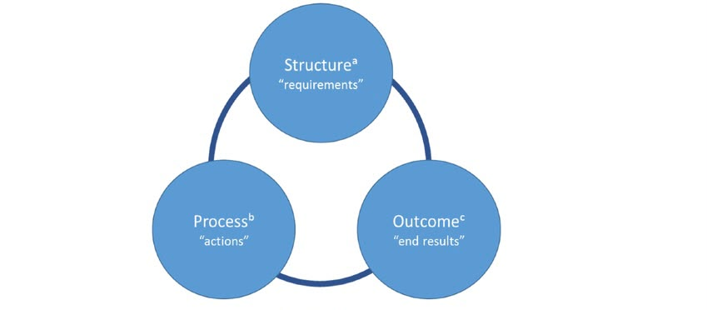

2.3 Fishbone Diagram Analysis
The Fishbone Diagram identifies multiple causes contributing to adverse events (Ishikawa, 1986).

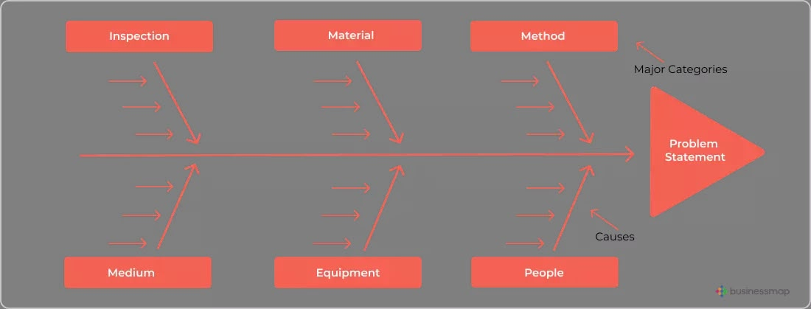

Category | Critical Causes Identified
People | Human error, confirmation bias, distraction during medication preparation, failure to verify medication, inadequate adherence to the Five Rights of medication administration, and insufficient supervision.
Methods | Routine use of automated dispensing cabinet (ADC) overrides, failure to follow barcode medication administration (BCMA) procedures, incomplete medication verification, and inadequate compliance with medication safety protocols (ISMP, 2022).
Technology (Equipment) | Electronic health record (EHR) implementation problems, malfunctioning or inefficient medication retrieval systems, reliance on override functions, and failure to utilise barcode scanning technology effectively (CMS, 2019).
Environment | Busy clinical environment, high workload, interruptions during medication administration, time pressures, and competing clinical priorities that increased cognitive workload and reduced situational awareness (AHRQ, 2022).
Management | Weak clinical governance, insufficient leadership oversight, inadequate risk management, failure to identify unsafe workarounds, poor incident reporting systems, and limited organisational learning following previous safety concerns.
Policies | Inconsistent implementation of medication safety policies, inadequate monitoring of compliance, limited reinforcement of safety protocols, and insufficient promotion of a Just Culture that encourages reporting and learning from errors (Marx, 2001).
The analysis demonstrates that the medication error resulted from interacting organisational failures rather than one individual mistake. Frequent medication overrides became normal practice because staff were attempting to compensate for technology problems. Leadership failed to identify these unsafe behaviours through effective quality assurance.
Critical evaluation
The Fishbone Diagram is valuable because it considers multiple contributing factors and supports system-wide improvement. However, it does not prioritise causes or explain relationships between them and should therefore be combined with Root Cause Analysis.

2.4 Five Whys Analysis
The Five Whys technique identifies root causes by repeatedly asking why an incident occurred (IHI, 2023).

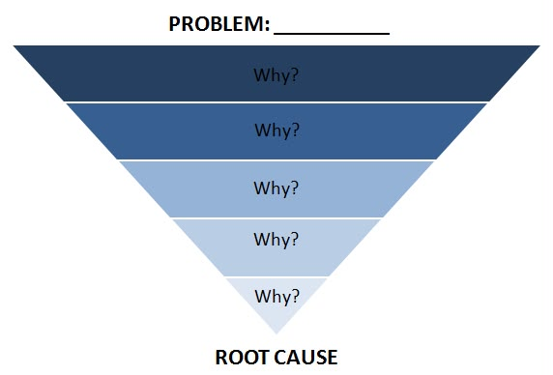
Problem | Critical Explanation
Patient died after receiving the wrong medication. | Charlene Murphey received vecuronium instead of the prescribed sedative midazolam, resulting in respiratory arrest and death (CMS, 2019).
Why 1: Why was the wrong medication administered? | The nurse selected vecuronium from the automated dispensing cabinet instead of midazolam and administered it without recognising the error.
Why 2: Why was the incorrect medication selected? | The automated dispensing cabinet override function was used, allowing access to medications without the usual electronic verification process. Barcode medication administration was also not utilised (ISMP, 2022).
Why 3: Why were medication safety procedures bypassed? | Technical problems with the electronic medication system had led nurses to routinely use overrides, making unsafe workarounds part of everyday clinical practice.
Why 4: Why had unsafe workarounds become normal practice? | Organisational leadership failed to identify and address repeated medication safety risks through effective monitoring, clinical governance, and quality assurance processes.
Why 5: Why did organisational systems fail to prevent the incident? | Weak patient safety culture, inadequate risk management, insufficient leadership oversight, and poor organisational learning allowed unsafe practices to continue without corrective action (AHRQ, 2022).
The analysis shows that the fatal error resulted from organisational weaknesses rather than solely individual negligence. Technology failures, inadequate governance and poor safety culture created conditions in which human error reached the patient.
Critical evaluation
The Five Whys encourages organisations to investigate system failures rather than assigning blame. However, healthcare incidents are often complex, meaning the technique should be used alongside broader quality improvement methods.

2.5 SWOT Analysis
SWOT analysis evaluates organisational strengths, weaknesses, opportunities and threats (Gürel and Tat, 2017).

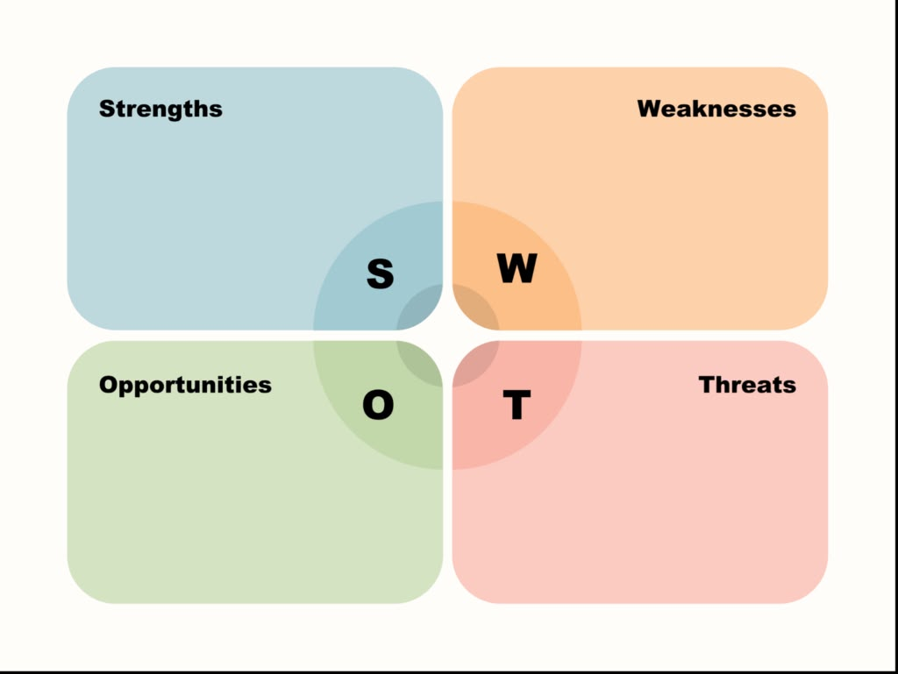
Element | Critical Analysis
Strengths | Vanderbilt University Medical Center (VUMC) had established medication safety policies, electronic health records, automated dispensing cabinets (ADCs), barcode medication administration (BCMA), and trained healthcare professionals. These systems were designed to reduce medication errors and improve patient safety. However, their effectiveness depended on consistent implementation and organisational compliance (AHRQ, 2022).
Weaknesses | Significant weaknesses included routine use of ADC override functions, inadequate medication verification, failure to utilise barcode scanning, insufficient patient monitoring, weak clinical governance, ineffective leadership oversight, and poor organisational learning. These deficiencies reduced the effectiveness of multiple safety barriers and increased the likelihood of human error (CMS, 2019).
Opportunities | The incident provides an opportunity to strengthen medication safety through improved staff education, enhanced clinical governance, better utilisation of digital technologies, stronger medication administration protocols, regular safety audits, simulation-based training, and development of a Just Culture that promotes transparency and learning from adverse events (ISMP, 2022).
Threats | Continuing reliance on unsafe workarounds, increasing workload pressures, staff shortages, technological failures, fear of criminal prosecution following medical errors, reputational damage, litigation, and declining public trust may discourage incident reporting and hinder continuous quality improvement efforts (Marx, 2001).
Although Vanderbilt possessed advanced medication safety systems, ineffective implementation reduced their effectiveness. The incident provides opportunities to improve leadership, digital systems and organisational learning. However, criminal prosecution may discourage future error reporting and weaken patient safety culture.
Critical evaluation
SWOT provides a useful strategic overview but does not explain causal relationships. It is therefore most effective when used with root cause analysis tools.

2.6 Kurt Lewin’s Three-Stage Change Model
Lewin’s Change Model (1947) provides a framework for implementing sustainable organisational improvement.

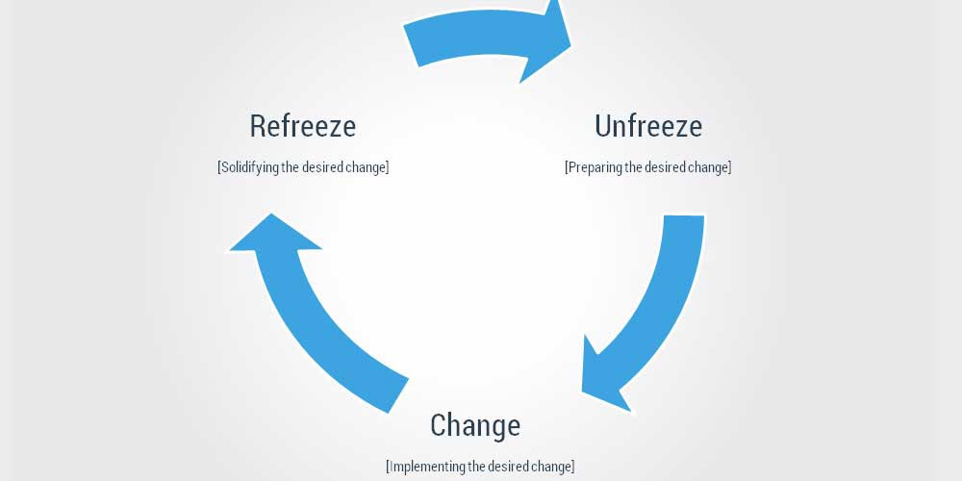

Unfreeze
Leadership should acknowledge failures within medication management, communicate lessons from the incident and encourage open reporting through a Just Culture. Unsafe practices such as routine ADC overrides must be recognised as unacceptable.

Change
Medication safety should be strengthened by restricting override use, enforcing barcode medication administration, improving staff training, conducting regular competency assessments and increasing leadership monitoring through audits and medication safety reviews (ISMP, 2022).

Refreeze
Improved practices should become standard through continuous education, clinical audits, incident reporting, performance monitoring and regular review of medication safety indicators. Embedding these changes within organisational culture supports long-term patient safety.
Critical evaluation
Lewin’s model provides a clear and practical approach for implementing healthcare improvement. However, it assumes change occurs in fixed stages, whereas healthcare organisations often experience continuous and dynamic change. Despite this limitation, it remains useful for guiding sustainable medication safety improvements following adverse events.

3. Recommendations
The RaDonda Vaught case demonstrates that patient safety failures rarely result from a single individual’s actions. Instead, they arise from weaknesses in organisational systems, leadership, technology, communication, and governance. Sustainable improvement therefore requires a systems-based approach that addresses both human and organisational factors. The following recommendations are informed by current patient safety evidence and quality improvement principles

Recommendation 1: Strengthen Medication Safety and Clinical Governance
Healthcare organisations should strengthen clinical governance by implementing robust medication safety policies, regular audits, and multidisciplinary governance committees to monitor medication-related incidents. Medication errors and near misses should be reviewed routinely to identify trends and implement corrective actions. Organisations should ensure compliance with the Five Rights of Medication Administration (right patient, medication, dose, route, and time) through regular monitoring and governance reviews. Strong governance enhances organisational accountability, improves oversight, and supports continuous quality improvement (AHRQ, 2022).

Recommendation 2: Improve Medication Technology and Barcode Medication Administration (BCMA)
Electronic medication management systems should be optimised to reduce opportunities for human error. Barcode Medication Administration (BCMA) should be mandatory for all routine medication administration to verify medicines before they reach patients. Automated Dispensing Cabinet (ADC) override functions should be limited to genuine emergencies, with override activity regularly monitored to identify unsafe practices. Healthcare organisations should also improve Electronic Health Record (EHR) integration to minimise delays that encourage staff to adopt unsafe workarounds. These technological improvements strengthen safety barriers and reduce medication administration errors (ISMP, 2022).

Recommendation 3: Enhance Workforce Development and Medication Safety Training
Healthcare organisations should provide mandatory annual training on medication safety, human factors, and the safe use of electronic medication systems. Simulation-based learning should allow healthcare professionals to practise managing high-risk medication scenarios in a safe environment, while competency assessments should evaluate medication administration skills and technology use. Leadership development programmes should also prepare nurse managers to identify safety risks and lead quality improvement initiatives. Continuous education strengthens staff competence, confidence, and patient safety.

Recommendation 4: Promote a Just Culture and Improve Patient Safety Culture
Healthcare organisations should foster a Just Culture in which staff feel able to report errors and near misses without fear of unfair punishment. Incident investigations should focus on identifying system failures rather than assigning individual blame (Marx, 2001). Leaders should encourage open communication, provide feedback on lessons learned, and promote psychological safety so that staff are comfortable raising concerns. Regular multidisciplinary safety briefings and reflective practice sessions can strengthen organisational learning and improve teamwork, ultimately reducing the risk of future medication errors.

Recommendation 5: Implement Digital Quality Monitoring and Continuous Risk Surveillance
Digital quality monitoring systems should be used to provide real-time surveillance of medication safety. Electronic dashboards can monitor indicators such as medication error rates, BCMA compliance, ADC override frequency, and incident reporting trends. Clinical governance teams should review these data regularly to identify emerging risks and evaluate improvement initiatives. Automated alerts can support early intervention when abnormal safety patterns occur. Continuous monitoring enables organisations to make evidence-based decisions while strengthening proactive risk management (WHO, 2021).

Recommendation 6: Adopt the Plan–Do–Study–Act (PDSA) Cycle for Continuous Quality Improvement
Healthcare organisations should adopt the Plan–Do–Study–Act (PDSA) cycle as a framework for continuous quality improvement. The planning stage should identify medication safety issues using incident reports and audits before targeted interventions are implemented. These may include enhanced staff training, improved barcode scanning compliance, revised medication policies, and strengthened governance processes. Performance should then be evaluated using indicators such as medication error rates, staff compliance, and patient outcomes before successful interventions are standardised across the organisation. The PDSA cycle promotes continuous evaluation, organisational learning, and sustainable improvements in patient safety (Institute for Healthcare Improvement, 2023).

Overall, preventing incidents similar to the RaDonda Vaught case requires healthcare organisations to move beyond individual accountability and strengthen the systems that support safe clinical practice. Enhancing governance, investing in technology, improving workforce capability, promoting a Just Culture, implementing digital monitoring, and embedding continuous quality improvement can significantly reduce medication errors and improve patient safety.

4. Conclusion
The RaDonda Vaught medication error case is one of the most significant patient safety incidents in contemporary healthcare because it demonstrates how multiple organisational failures can combine to produce catastrophic patient harm. This report has shown that the incident was not solely the result of an individual nurse’s actions but reflected broader weaknesses in quality assurance systems, clinical governance, leadership, medication safety processes, and organisational culture. The routine use of automated dispensing cabinet overrides, inadequate medication verification, failure to utilise barcode medication administration, insufficient patient monitoring, and ineffective organisational learning collectively weakened the healthcare system’s ability to prevent medication errors.
The application of the Swiss Cheese Model illustrated how multiple safety barriers failed simultaneously, allowing the medication error to reach the patient. The Fishbone Diagram and Five Whys Analysis identified interconnected human, technological, environmental, managerial, and organisational factors that contributed to the adverse event. Furthermore, the SWOT Analysis highlighted both the strengths and weaknesses of existing medication safety systems while identifying opportunities for organisational improvement. Finally, Kurt Lewin’s Three-Stage Change Model demonstrated how sustainable organisational change can be achieved through structured implementation of evidence-based quality improvement initiatives.
The recommendations proposed in this report—including strengthening clinical governance, improving medication technology, enhancing workforce education, promoting a Just Culture, implementing digital quality monitoring, and adopting the Plan–Do–Study–Act (PDSA) cycle—provide practical strategies for reducing medication errors and improving patient safety. These interventions emphasise continuous organisational learning, multidisciplinary collaboration, and leadership accountability as essential components of effective quality assurance.
In conclusion, the RaDonda Vaught case reinforces the principle that patient safety is a shared organisational responsibility rather than the responsibility of individual healthcare professionals alone. Healthcare organisations must foster robust quality assurance systems, transparent leadership, and a culture of continuous improvement to prevent similar incidents in the future. By learning from adverse events and implementing evidence-based service improvements, healthcare providers can enhance patient outcomes, strengthen public trust, and deliver safer, higher-quality care.

References
- Agency for Healthcare Research and Quality (AHRQ) (2022) Patient Safety Primer: Medication Errors. Rockville, MD: AHRQ. Available at: https://psnet.ahrq.gov (Accessed: 26 July 2026).
- Centers for Medicare & Medicaid Services (CMS) (2019) Statement of Deficiencies and Plan of Correction: Vanderbilt University Medical Center. Baltimore, MD: CMS.
- Gürel, E. and Tat, M. (2017) ‘SWOT analysis: A theoretical review’, The Journal of International Social Research, 10(51), pp. 994–1006.
- Institute for Healthcare Improvement (IHI) (2023) Science of Improvement: How to Improve. Boston, MA: Institute for Healthcare Improvement. Available at: https://www.ihi.org (Accessed: 26 July 2026).
- Institute for Safe Medication Practices (ISMP) (2022) Criminalization of Human Error and Its Impact on Patient Safety. Horsham, PA: ISMP. Available at: https://www.ismp.org (Accessed: 26 July 2026).
- Ishikawa, K. (1986) Guide to Quality Control. 2nd rev. edn. Tokyo: Asian Productivity Organization.
- Joint Commission (2024) National Patient Safety Goals: Hospital Program. Oakbrook Terrace, IL: The Joint Commission. Available at: https://www.jointcommission.org (Accessed: 26 July 2026).
- Kohn, L.T., Corrigan, J.M. and Donaldson, M.S. (2000) To Err Is Human: Building a Safer Health System. Washington, DC: National Academy Press.
- Lewin, K. (1947) ‘Frontiers in group dynamics’, Human Relations, 1(1), pp. 5–41.
- Marx, D. (2001) Patient Safety and the “Just Culture”: A Primer for Health Care Executives. New York: Columbia University.
- NHS England (2023) Patient Safety Incident Response Framework (PSIRF). London: NHS England. Available at: https://www.england.nhs.uk/patient-safety (Accessed: 26 July 2026).
- Reason, J. (2000) ‘Human error: Models and management’, BMJ, 320(7237), pp. 768–770.
- Rodziewicz, T.L., Houseman, B. and Hipskind, J.E. (2024) ‘Medical Error Reduction and Prevention’, StatPearls. Treasure Island, FL: StatPearls Publishing.
- Rodziewicz, T.L., Houseman, B. and Hipskind, J.E. (2025) ‘Patient Safety’, StatPearls. Treasure Island, FL: StatPearls Publishing.
- Spath, P.L. (2022) Introduction to Healthcare Quality Management. 4th edn. Chicago: Health Administration Press.
- The Joint Commission (2024) Sentinel Event Policy and Procedures. Oakbrook Terrace, IL: The Joint Commission.
- Vincent, C. and Amalberti, R. (2016) Safer Healthcare: Strategies for the Real World. Cham: Springer.
- World Health Organization (WHO) (2021) Global Patient Safety Action Plan 2021–2030: Towards Eliminating Avoidable Harm in Health Care. Geneva: World Health Organization.
- World Health Organization (WHO) (2024) Patient Safety Factsheet. Geneva: World Health Organization. Available at: https://www.who.int (Accessed: 26 July 2026).
- World Health Organization (WHO) (2025) Medication Without Harm: Global Patient Safety Challenge. Geneva: World Health Organization.

