ECGE4002P – ACADEMIC STUDY SKILLS

A portfolio of tasks reflecting the Skills, Knowledge and Dispositions needed for Higher Education study.
  - Yasmin Scrine Student number: 1902590 November 2019

Contents
Portfolio Task 1 2
Developing your skills: vision of success as a student-teacher 2
Creating a digital mind-map of all the resources available to me as a university student. 2
Portfolio Task 1 3
Current Skills Audit 3
3
Portfolio Task 1 4
What does success look like for me? 4
Portfolio Task 2 5
Developing Critical Thinking 5
Summary of Chapter 1 – Developing Critical Thinking skills by Stella Cottrell 5
Portfolio Task 3 7
Developing Critical Writing 7
What I think about Education in Wales 7
Referencing 9

Task 1

Developing your skills: vision of success as a student-teacher

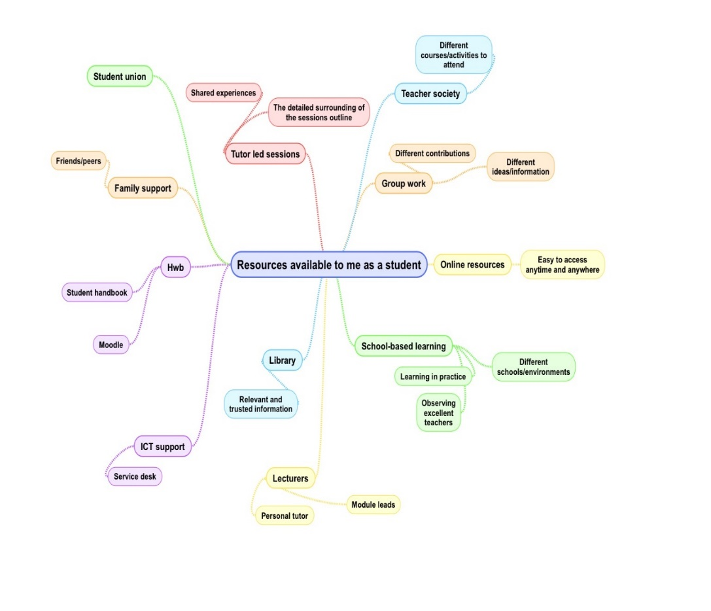
Creating a digital mind-map of all the resources available to me as a university student.

Task 1

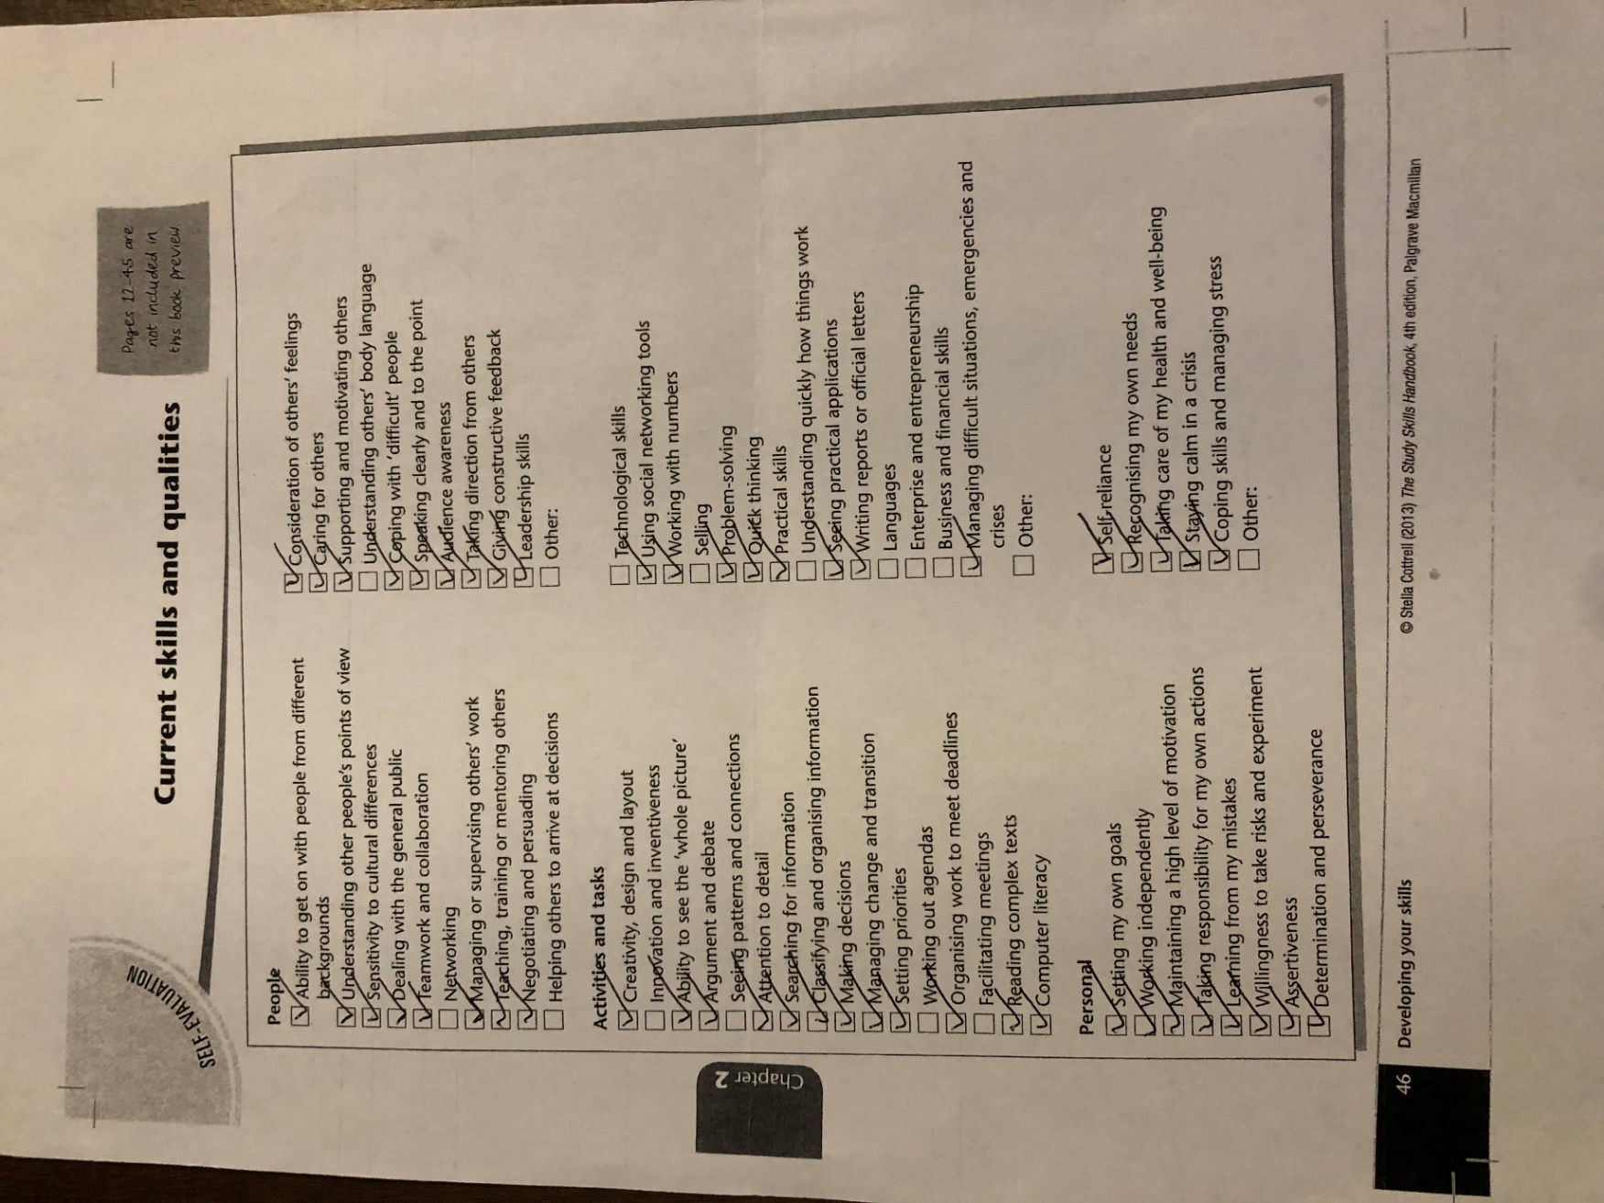
Current Skills Audit

Task 1

What does success look like for me?

Everybody’s success is unique, in my opinion it’s an accomplishment of an aim or goal within my personal life and career. My goal is to learn how to understand others’ body languages and to become more self-confident as I develop into becoming an effective primary school teacher. I am aiming to make my life-long dream a reality, as I currently strive towards achieving the highest qualification in my degree which is a first-class honour. Furthermore, the experiences involved will engage me to quickly understand how things work and allow me to pursue the role of helping children become as confident as possible academically and personally. This achievement means a significant personal growth as I will have a stable and professional career to give me security and happiness in everyday life. There are many resources available that I will make use of such as experiences, peers, friends and tutors that can support me throughout my journey to achievement. Transformational experiences also share a sign of success which can be life changing as they can challenge your own assumptions and beliefs. Although this can affect how you understand yourself, I believe this is an important aspect of an experience because it allows you to learn different capabilities and consider a whole range of beliefs and values you may not have thought about previously. “Living life with a sense of purpose and meaning is ultimately what makes you feel fulfilled” (Price and Price, 2011, p.20). I agree with Price as for me success isn’t just about the result; it’s about embracing the journey that leads you there. Overall, accomplishing my visions by using my abilities and resources to become a well-rounded individual both professionally and personally is fulfilment and success.

Task 2

Developing Critical Thinking

Summary of Chapter 1 – Developing Critical Thinking skills by Stella Cottrell

According to Cottrell (2005) critical thinking is associated with the mind involving cognition. It uses four mental processes: attention, categorisation, selection and judgement, as well as a wide range of skills and attitudes. “Critical thinking gives you the tools to use scepticism and doubt constructively so that you can analyse what is before you” (Cottrell, 2005, pg.2). This supports that, it helps to work out whether we believe what we see or hear. Critical thinking is, a complex approach, improved with practice and by understanding exactly what is required. Furthermore, to understand the message being conveyed alongside the construction of the argument, it is important to develop these skills.
There are many benefits associated with the developments:
- improved attention and observation
- more focused reading
- improved ability to identify key points in a text
- improved ability to respond to appropriate points in a message.
Therefore, when you acquire good skills you can identify the key information accurately but also quickly; saving time benefits professional and everyday life. It also encourages growth within your ancillary skills because you must observe something before you can analyse it and then use reasoning as evidence for your judgement, which involves decision-making. All these skills are also personal qualities which is another factor associated. Cottrell (2005) said people who are more self-aware are usually outstanding at critical thinking. This is because they reflect and evaluate the evidence used to support their point of view and have courage to argue it against an alternative view. However, emotional self-management can engage emotions and passionate responses which can arouse anxiety and frustration if the evidence contradicts your own beliefs. Nevertheless, you can still argue your point convincingly if you remain calm and speak logically. In saying this, critical thinking is not easy for everyone and can come with different barriers.
Firstly, emotional content can add power to your view but as a barrier it can also undermine it. There is also sometimes a misunderstanding of the word ‘criticism’ whereby people believe it is just negative comments; constructive criticism can help people to excel from a situation. You may not feel comfortable to give criticism due to the way it can be misperceived and because there is a natural anxiety, about critically analysing work by people you respect. On the other hand, over-estimating your own reasoning abilities can also cause a barrier as we tend to believe our own beliefs are the best, but even if you win an argument it does not mean you have the best points. Although, it is not saying to disregard your important beliefs; give more thought to evidence that justifies them. Lastly, people do not always know how to develop further as some strategies they know, may not be relevant for the type of development needed. Even though there are developmental activities, they require good attention to detail with no other distractions. Despite that, students mistake information for understanding; they would prefer facts and answers than to learn and practice the skills to become a grounded justified individual.
Ultimately, by personally evaluating throughout this chapter, I now recognise my own underlying skills, attitudes and barriers and how I can deal with these to improve my critical thinking skills. Cottrell (2005) stresses the importance of this throughout and why developing this skill is fundamental.

Task 3

Developing Critical Writing

What I think about Education in Wales

It was stated in a report that the education curriculum and assessment should support each child to meet their needs and prepare them for their future lives (Donaldson, 2015, p.5). However, the current National Curriculum is a framework of subject knowledge being taught and assessed, which Donaldson believes was devised to reflect a world before advanced technology transformed our way of living and working (Donaldson, 2015). Therefore, I believe there is a need for change in how children learn during education; to prepare them for a successful future in the twenty-first century.
Graham Donaldson has proposed a redesign of the curriculum called “Successful Futures” which is organised into Areas of Learning and Experience that will build towards his main purposes. The Welsh Government (Education Wales 2019), state that Donaldson’s curriculum involves four purposes; “setting out the aspirations for all children and young people by the age of 16, enabling them to be successful learners, who play an active part in their community and wider society, and who are prepared to thrive in an increasingly complex world”. For instance, by focusing on equipping young people with literacy, numeracy, digital competency skills and welsh values and cultures; they will lead a successful personal and professional life within this modern day. Donaldson (2017) believes that the current curriculum and assessment arrays no longer benefit the young people of Wales because society is now different; due to the significant technological and economical changes since the last curriculum formed. Supporting this, the Welsh Government (Education Wales) 2019, also said that evaluations from the education and training inspectorate for Wales (Estyn) have shown that children are currently achieving lower than they should be. Therefore, I agree that there is a need to change the way children are taught; the teachers focus should be free enough to adapt to the individuals needs which contributes to their flourishing futures. Currently, I do not trust that the curriculum is preparing children to succeed in a world which is continuously changing. As stated in Donaldson’s (2017) report the current key stages restrain the learning and growth, which is why Donaldson proposes to move away from discrete subjects and introduce the six Areas of Learning and Experience:
- “Expressive arts
- Health and well-being
- Humanities
- Languages, literacy and communication
- Mathematics and numeracy
- Science and technology” (Donaldson, 2015, p.39).
However, skills and knowledge remain crucial to a child’s development and will continue to be a focus throughout the new curriculum. In saying this, the Welsh Government (Education Wales) 2019 state it is also crucial that children have a blend of skills, experiences and knowledge to prepare them for a future that involves digital skills, creativity and adaptability. Personally, it is a positive change in education because it proposes to prepare and shape young people to lead a fulfilling life as an adult and become a valued member of their society.
All things considered, I favour Donaldson’s proposal for educational change because it is important to realise that our world is rapidly changing. The rearrangement is needed for the way education is taught in order to reflect a modern society. Currently, the curriculum does not have any main focuses, it is outdated and limited for the ways of learning.

Referencing

Cottrell, S. (2005) Critical thinking skills: developing effective analysis and argument. Basingstoke: Palgrave Macmillan
Donaldson, G. (2015) Successful Futures. Independent Review of Curriculum and Assessment Arrangements in Wales. Illustrations: Scarlett Design International Ltd 2015.
Donaldson, G. (2017) ‘A Systematic Approach to Curriculum Reform in Wales’, Wales Journal of Education, 19(1), pp. 7-20.
Education Wales (2019) A guide to Curriculum for Wales 2022. Available at: https://hwb.gov.wales/storage/f8f9760c-64a1-48ea-80fd-db130ad9050b/a-guide-to-curriculum-for-wales-2022.pdf (Accessed: 1 November 2019).
Education Wales (2019) Education is changing. Available at: https://gov.wales/education-changing (Accessed: 3 November 2019).
Price, A and Price, D. (2011) Psychology of success: a practical guide. London: Icon.

