

EXAMINATION PAPER
MARKS AND COMMENTS SHEET

PROGRAMME | OME Degree Apprenticeship
LEVEL | 4
MODULE | ACDB4011 Chemistry
STUDENT I.D. | 2414411
EXAMINER | Ewa Kazimierska | INTERNAL VERIFIER
Once completed marks only should be transferred onto the front of the examination paper (no comments other than ticks or crosses on the examination paper)

Question  Number | Comments | Marks available | Marks awarded | 2nd marker (sample) | 3rd marker (where necessary)
1 | 7/10 True/False correct. Good grasp of bonding and structure, but some key gaps remain. | 15 | 10.5
2 | Some confusion between protons and neutrons. Lewis diagram attempted but incomplete; relevance to explosives not addressed. | 11 | 5
3 | Correct answers for parts b and c. In part a, unit conversion error and missing units led to loss of marks. | 11 | 10
4 | Only the combustion reaction was answered correctly. No attempts at gas law calculations. | 16 | 2
5 | Limited effort overall. Incomplete answer to a; remaining parts missing or contain major conceptual errors. | 14 | 0
6 | Reaction profile missing quantitative detail; activation energy not correctly assessed. | 7 | 2
7 | Phase diagram structure incorrect. Physical state regions misplaced; no attempt at final question. | 11 | 2
8 | No work shown on titration problem or net ionic equation. | 5 | 0
9 | No response provided. | 5 | 0
10 | Concepts of oxidation/reduction understood, but oxidation states not calculated; no answer in part b. | 5 | 0.5
 |  |  | 32

1st Marker Name | Ewa Kazimierska | 1st Marker Signature | 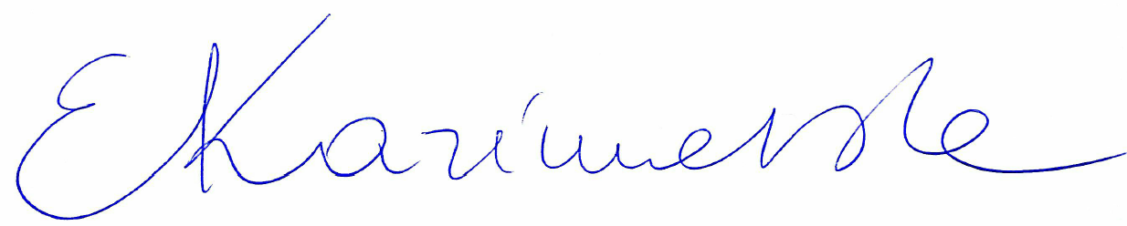
2nd Marker Name |  | 2nd Marker Signature
3rd Marker Name |  | 3rd Marker Signature
Reasons for awarding the final mark where there is more than one marker
Notes:
- The 3rd marker may be used where there is more than a 10 percentage point difference (in the TOTAL mark) between markers 1 and 2 OR when it is not possible to get agreement between markers 1 and 2. Reasons must be given where an agreed mark is given.
- This form is for internal use only and is NOT to be returned to the student. The final agreed marks must be transferred to the student feedback sheet in the assignment specification.
- The external examiner MUST be shown this form.

