

Programme: BSc Health and Social Care
Student Name: Sophia Pitter
Student number: 2409134
Module title: Changemakers: Building your Personal Brand for Sustainable Employment
Module code: BMHP5015
Assignment title: Component 2: Assignment (Report)
Lecturer Name: Olufemi Oluranti

Introduction
Social work is a specialised career that efforts on enhancing the wellbeing of persons, families and societies by safeguarding vulnerable persons, encouraging social justice and supporting autonomy. Social workers work with children, adults, elder persons and people facing mental health problems, disability or safeguarding worries. They work together with healthcare specialists, schools, police and community groups to make sure of suitable care and support is delivered (National Careers Service, 2025).
I selected the role of Social Worker since I like assisting persons overcome challenges and enhancing their quality of life. This report examines the employability skills compulsory for the job role, appraises my existing skills, develops an action plan for development, and clarifies how I will be building my professional individuality, individual brand and professional system to realise effective employment.
Job Advertisement
Use a current NHS or Local Authority advertisement.
Example:
Job Title: Social Worker
Employer: NHS Jobs
Advertisement: https://www.jobs.nhs.uk/candidate/jobadvert/C9236-25-0648
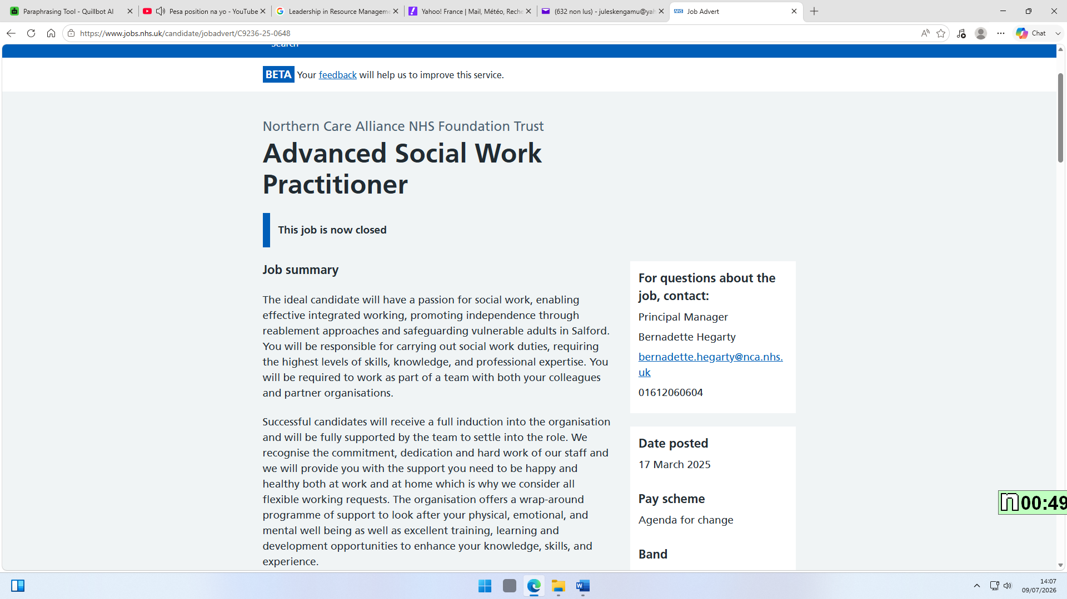
Figure 1: NHS Social Worker Job Advertisement (NHS Jobs, 2025).

Job Role Employability Skills
Conferring to the Social Worker job description and person specification, social workers need a blend of professional abilities, interpersonal skills and ethical values to deliver efficient support to persons, families and groups. The key duties of a social worker comprise evaluating needs of service users, safeguarding vulnerable persons, developing care plans, keeping correct records and working jointly with other specialists (National Careers Service, 2025; Skills for Care, 2024).
Among the main employability skills needed for this role is examination and analytical decision-making. Social workers need to collect data regarding situations of people, categorise threats and strengths, and make evidence-based decisions regarding suitable interventions (BASW, 2021). This skill is vital since social workers frequently deal with multifaceted circumstances including protection concerns, mental health problems, disability or family issues. Effective evaluation allows specialists to deliver person-centred support while guaranteeing that rights and wellbeing of service users are protected (Social Work England, 2023).
Communication skills are additional important need for social workers. The role includes communicating with clients, relatives, healthcare specialists, local authorities and legal specialists. Social workers need to determine active listening, sympathy and the capability to clarify multifaceted information evidently (National Careers Service, 2025). Solid communication aids establish trust and promote service users to contribute dynamically in decisions concerning their lives (Trevithick, 2012).
Social workers as well need solid collaboration and partnership-working skills since they often work together with multidisciplinary teams, counting doctors, nurses, psychologists, teachers and community groups (Skills for Care, 2024). Efficient teamwork guarantees that people receive coordinated and holistic support somewhat than lonely facilities.
Alternative significant skill is safeguarding knowledge and professional decision. Social workers have a lawful and ethical duty to safeguard children and adults at risk of harm, misuse or negligence. Understanding law for example the Care Act 2014 and the Children Act 1989 allows social workers to make legal and ethical choices (Department of Health and Social Care, 2014; HM Government, 1989).
Lastly, emotional resilience, expertise and ethical mindfulness are important employability skills. Social workers often meeting worrying circumstances and need to manage emotional burdens while keeping professional limitations and privacy (Social Work England, 2023). These skills support safe practice, promote service-user trust and subsidise to efficient provision of health and social care facilities.

Evaluation of Own Skills
To effectively follow a career as a social worker, it is significant to assess my existing employability skills contrary to the needs of the vocation. Self-assessment enables me to categorise my current strengths, know areas that need improvement and develop approaches to improve my professional willingness. Social work needs a mixture of interpersonal skills, professional understanding, emotional resilience and dedication to continuous learning (Social Work England, 2023).
Among my key strengths is communication and interpersonal skills. I am capable to listen actively, interconnect deferentially and shape positive relations with persons from varied backgrounds. These skills are vital since social workers must create trust with service users who might be facing difficult individual situations. Effective communication supports joint decision-making and allows social workers to comprehend persons’ demands more precisely (Trevithick, 2012). Over classroom debates, group events and presentations, I have improved self-assurance in articulating thoughts and working with others.
Additional strength is my sympathy and readiness to support others. I comprehend the significance of treating persons with self-respect, esteem and sympathy. Social workers need to utilise compassion to comprehend service users’ experiences while keeping professional limitations (BASW, 2021). My capability to keep on patient and non-judgemental will support my growth as a person-centred physician.
Though, I have recognised areas where additional development is needed. One area for development is my understanding of social work law and safeguarding measures. While I have improved a comprehension of health and social care principles over my learnings, I must strengthen my understanding of law for example the Care Act 2014, Mental Capacity Act 2005 and safeguarding contexts. Legal understanding is vital since social workers make decisions that immediately impact safety of people and their rights (Department of Health and Social Care, 2014).
Additional area for development is professional self-assurance in decision-making. Social workers often manage multifaceted circumstances where they need to balance diverse viewpoints and make evidence-based decisions. I aim to enhance this skill by obtaining practical experience over volunteering, work experiences and engaging with case studies. Reflective practice will as well assist me assess my decisions and learn from professional knowledge (Thompson, 2016).
To support my growth, I may search for guidance from university speakers, placement managers, skilled social workers and professional groups for example British Association of Social Workers. Mentors may offer guidance around practice prospects, career development and professional growth opportunities. Feedback from these specialists will help me recognise additional strengths and areas for improvement.

Action Plan and Timeline
Evolving the skills need to become a competent social worker needs an organised action plan with clear goals, assets and timescales. Continuous professional development is a main prospect in social work since physicians need to keep ability and reply to shifting social care demands (Social Work England, 2023).
Area for Development | Action Needed | Resources/Support | Timeline
Enhance understanding of protection and social work law | Achieve extra learning on safeguarding measures, the Care Act 2014, Mental Capacity Act 2005 and child protection law | University units, online training, government direction and professional assets | 5 months
Improve practical experience | Search for volunteering opportunities or work experiences roles in social care environments to obtain experience working with vulnerable groups | University jobs service, local charities, social care groups and placement managers | 10 months
Enhance communication and interviewing abilities | Perform professional discussions, active listening and report-writing skills over role plays and academic events | Lecturers, peers, placement tutors and reflective practice exercises | Ongoing
Create self-assurance in professional decision-making | Examine social work case studies and contribute in debates around ethical dilemmas | Academic lecturers, qualified practitioners and professional workshops | 4 months
Improve professional networking skills | Join social care sessions, career activities and professional consultations | BASW, university interacting activities and local authority staffing events | In 10 months

In the immediate future (0–6 months), my focus will be on enhancing my theoretical understanding of social work practice and legislation. I will undertake pertinent online courses and consistently consult professional directives from Social Work England. This will enhance my comprehension of the obligations and ethical standards of the profession.
In the medium term (6–12 months), I will concentrate on acquiring practical experience through volunteering, placements, or support roles in health and social care settings. Practical experience will enable me to apply theoretical information to real-world scenarios and enhance my confidence in engaging with service users and professionals.
My long-term objective (12–24 months) is to fulfil my qualification requirements and apply for entry-level roles in social work. I will further cultivate my professional identity by lifelong learning, participation in professional development opportunities, and remaining cognisant of advancements in social care practice.
By adhering to this action plan, I will cultivate the employability skills necessary for social work and exhibit dedication to becoming a compassionate, informed, and ethical practitioner.

Building Your Personal Brand
Establishing a robust personal brand is essential for attaining success in the social work profession, as it conveys my beliefs, talents, expertise, and dedication to assisting vulnerable individuals. A professional personal brand must exhibit attributes esteemed by employers, such as compassion, reliability, ethical conduct, and a dedication to ongoing development (Social Work England, 2023).
To establish my own brand, I will initially ascertain my professional abilities and the attributes that characterise me as an aspiring social worker. My personal brand will emphasise empathy, respect, and responsibility, with a dedication to advancing welfare and social justice. I will exemplify these values through my academic endeavours, volunteer experiences, internships, and professional engagements.
I will utilise several resources to enhance my professional identification, including creating a LinkedIn profile, attending career events, and engaging in social care programs. My web presence will encompass my education, pertinent skills, volunteer activities, and accomplishments, while upholding professional norms and confidentiality (BASW, 2021).
The content I disseminate online will concentrate on health and social care subjects, insights on professional development, and knowledge of social issues impacting communities. Producing substantive professional content will illustrate my dedication to social work and enable prospective employers to acknowledge my devotion to the field.
Moreover, I will guarantee that my personal brand is uniform across my CV, cover letters, digital presence, and professional dialogues. An unequivocal and genuine professional identity can enhance employability by elucidating my appropriateness for a social work position (Tench and Yeomans, 2017).

Promoting My Professional Identity
Advancing my professional identity necessitates the efficient communication of my competencies, experiences, and career objectives to prospective employers. In the competitive health and social care business, employers seek people who possess not only academic qualifications but also exhibit professional values, practical skills, and a dedication to service consumers (Skills for Care, 2024).
I will create a customised CV and cover letter for each social work application. My CV will emphasise pertinent abilities such as communication, collaboration, safeguarding awareness, problem-solving, and empathy. I will provide examples from academic projects, volunteer activities, and professional experience to illustrate how I have implemented these abilities in practice. My cover letter will elucidate my reason for pursuing a career in social work and how my own values correspond with the organisation's objectives.
I will also preserve a professional internet presence. Platforms like LinkedIn facilitate career advancement by enabling connections with social care experts, tracking industry advancements, and displaying my accomplishments. I will ensure that my online conduct adheres to professional ethical standards, especially with confidentiality and respect for service users (Social Work England, 2023).
A further approach to enhancing my professional identity is via reflective practice. By documenting my learning experiences and highlighting areas for improvement, I may exhibit self-awareness and commitment to professional advancement. Reflective practice is crucial in social work as it enhances practitioners' decision-making and improves support for service users (Thompson, 2016).

Building a Network for Successful Employment
Networking is a crucial element of career advancement in health and social care, since it facilitates learning from seasoned professionals, uncovers job prospects, and fosters professional relationships. Social work necessitates collaboration among several agencies; thus, establishing a professional network is crucial for efficient practice and career advancement (Skills for Care, 2024).
I will expand my professional network by interacting with social workers, placement supervisors, university instructors, and healthcare experts. Seasoned social workers can offer essential insights regarding employment expectations, interview readiness, and professional advancement chances. Establishing mentoring ties will provide me with insights into practical social work applications.
I will also collaborate with professional bodies such as the British Association of Social Workers and Social Work England. These associations offer professional resources, assistance, and chances for ongoing education (Social Work England, 2023).
Participating in networking events, career fairs, social care conferences and university employment workshops will enable me to engage with employers and professionals in the field. These activities can enhance awareness of available positions and facilitate my comprehension of current requirements in social work recruitment.

Conclusion
This study has examined the employability skills necessary to attain my selected career objective of becoming a social worker in the UK health and social care sector. The investigation revealed that proficient social workers necessitate a diverse array of competencies, encompassing communication, empathy, safeguarding expertise, collaboration, decision-making, resilience, and ethical awareness. These competencies are crucial for assisting vulnerable individuals and providing secure, individualised care.
The self-evaluation process revealed that I possess strengths in communication, empathy, and relationship-building, which establish a robust foundation for social work practice. Nonetheless, I acknowledge the necessity to enhance my understanding of legislation, safeguarding protocols, and professional self-assurance. This report's action plan offers a systematic strategy for enhancing these domains via education, practical experience, mentoring, and professional development.
Establishing my personal brand, enhancing my professional identity, and cultivating a professional network will substantially aid in attaining successful employment. By cultivating a professional web presence, developing focused applications, and networking with seasoned practitioners, I may enhance my exposure within the social care field.
I am driven to seek a profession in social work due to my commitment to assisting individuals, safeguarding vulnerable populations, and making a constructive impact on society.

References
BASW (British Association of Social Workers) (2021) Professional Capabilities Framework (PCF) for Social Workers. Available at: https://www.basw.co.uk/professional-development/professional-capabilities-framework-pcf (Accessed: 8 July 2026).
Department of Health and Social Care (2014) Care Act 2014: Statutory Guidance. Available at: https://www.gov.uk/government/publications/care-act-statutory-guidance (Accessed: 8 July 2026).
Department of Health and Social Care (2023) Care and Support Statutory Guidance: Issued under the Care Act 2014. Available at: https://www.gov.uk/government/publications/care-act-statutory-guidance/care-and-support-statutory-guidance (Accessed: 8 July 2026).
HM Government (1989) Children Act 1989. Available at: https://www.legislation.gov.uk/ukpga/1989/41/contents (Accessed: 8 July 2026).
HM Government (2005) Mental Capacity Act 2005. Available at: https://www.legislation.gov.uk/ukpga/2005/9/contents (Accessed: 8 July 2026).
National Careers Service (2025) Social Worker: Job Profile. Available at: https://nationalcareers.service.gov.uk/job-profiles/social-worker (Accessed: 8 July 2026).
NHS Jobs (2025) Social Worker Job Advertisement. Available at: https://www.jobs.nhs.uk (Accessed: 8 July 2026).
Skills for Care (2024) Social Worker: Role and Career Information. Available at: https://www.skillsforcare.org.uk/Careers-in-care/Job-roles/Roles/Social-worker.aspx (Accessed: 8 July 2026).
Social Work England (2023) Professional Standards. Available at: https://www.socialworkengland.org.uk/standards/professional-standards/ (Accessed: 8 July 2026).
Social Work England (2023) Continuing Professional Development (CPD) Guidance. Available at: https://www.socialworkengland.org.uk/cpd/ (Accessed: 8 July 2026).
Tench, R. and Yeomans, L. (2017) Exploring Public Relations. 4th edn. Harlow: Pearson Education. Available at: https://www.pearson.com (Accessed: 8 July 2026).
Thompson, N. (2016) People Skills. 4th edn. London: Palgrave Macmillan. Available at: https://www.macmillaneducation.com (Accessed: 8 July 2026).
Trevithick, P. (2012) Social Work Skills and Knowledge: A Practice Handbook. 3rd edn. Maidenhead: Open University Press. Available at: https://www.mheducation.co.uk (Accessed: 8 July 2026).

