Radostina Avgustinova 1913408
Slide 3.
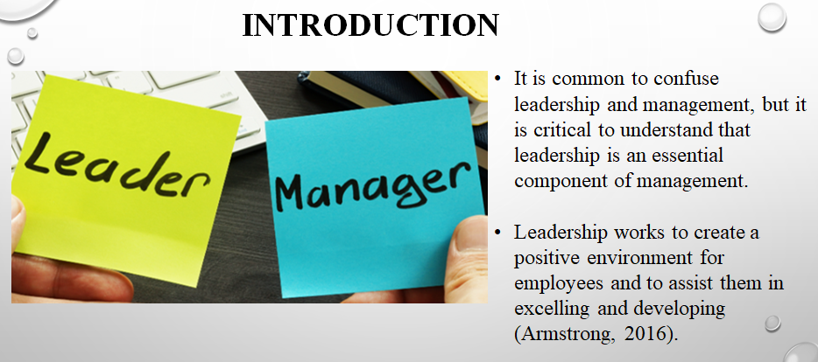
It is common to confuse leadership and management, but it is critical to understand that leadership is an essential component of management. Leadership works to create a positive environment for employees and to assist them in excelling and developing (Armstrong, 2016). In this presentation, we will go over more leadership and management theory and practices. We will also discuss Jeff Bezos's leadership skills who is the Amazon's founder and former CEO. Jeff Bezos is best known for his success in online retail stores after the launch of Amazon.

Slide 4.
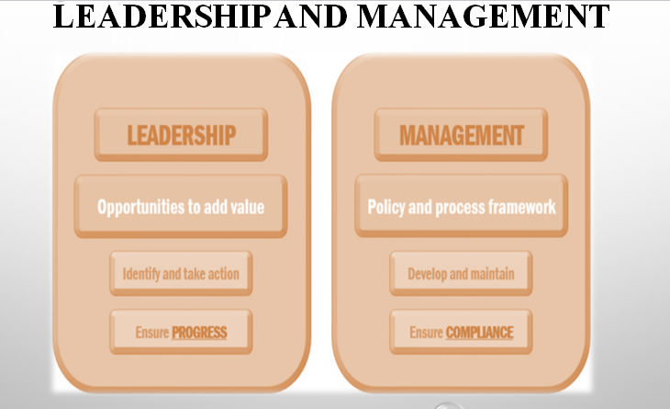

Even though leadership is an older phenomenon, and much has been published on the subject since the 20th century (Almutairi, 2015), the role of a leader is so vital and an element of powerful role to the organisation that every component, connection, and characteristic requires further additional context and investigations.
Leadership is described by multiple writers according to their own attire and knowledge, in a variety of manners, but interaction of the leader may indeed perform a significant role as everything needs to be passed into the spirit of individuals through dialogue and creates the long-term impact of personality, which is how excellent and efficient leaders gain the certainty and faith of their audience, establishing the path to infuse one's perspective.
Management and leadership are essential for providing high-quality services. Despite being similar in some ways, they might entail various sorts of perspectives, capabilities, and attitudes.
Managers should aim to be leaders, but they must also possess management know-how in order to be successful.
Leaders see what is feasible and communicate it to everyone else, as well as design techniques for reaching the goal. They motivate people and can provide reserves and other help to assist them in attaining their objectives.
Managers have to make sure that working capital is correctly organised and utilised to get the best results (Wajdi, 2017). A manager must also function as a leader in a source of energy and challenging environment with multiple intermediary areas in order to get the best feasible outcomes.
Slide 5.
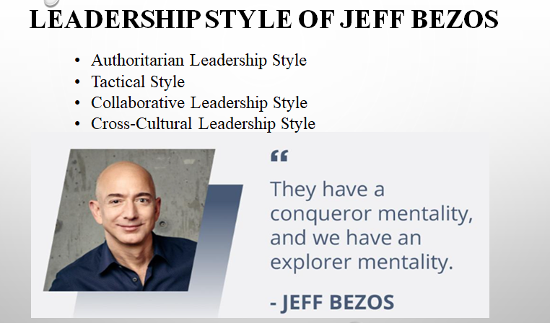
Jeff Bezos is widely regarded as a transformational and mission leader. He sought and continues to seek ways to innovate and reinvent his company.
He is an innovative leader well-known for achieving accomplishments. To better help customers, a bond is formed between Bezos' short- or medium-term goals and the majority's wants and wishes.
He was able to help his business grow and prosper throughout time because of his aptitude for thinking creatively and intellectually explore (Financhill, 2019).
When we look at Bezos' leadership style, we can see that it is different and distinctive. His leadership style is based on the Authoritarian Leadership Style since he aggressively watches and supervises everything. He also has a Tactical Style, which helps him to create fantastic ideas and creative approaches that assist his firm and employees. I nfrequently, Jeff Bezos implements the Collaborative Leadership Style. He may establish the company's future direction and set the standards and aspirations using this leadership style. Because he has a large workforce, he employs a Cross-Cultural Leadership Style in which he inspires everyone by his personality, thoughts, and actions. As a result, his leadership styles differ depending on the circumstances (Bohatala, 2021).

