Donna Morgan - 1051704
Word Count – 13,001
ECDE7013 Research Report

AI Acknowledgement

I acknowledge the use of Chat GPT from January 2026 to October 2026 to find relevant research articles. I used the prompt(s):
1. Please find up to date articles, research papers, or other academic or professional publications relating to either ‘gender bias within nursing education’ or ‘men in nurse education’.
2. Please send me an update of new publications every Friday

I acknowledge the use of Chat GPT on 4th October 2026 to create 3 x tables (Appendix 7). I used the prompt(s):
1. Please put all open-text responses for Q14, Q16 and Q18 of the following spreadsheet into tables. Please make 1 table per question and export these to a word document.

I acknowledge the use of Chat GPT on 5th October to proofread the main body of my report. I used the prompt(s):
1. Please check the following text for UK spelling, grammar, readability, and syntax.

I confirm that I have not presented any AI generated text as my own work.
I confirm that I have copies of my drafts, notes, and other resources I used before and after the use of AI tools which I may be asked to provide in evidence.

Contents

Chapter 1: Introduction 6
1.1 Rationale 7
1.2 Institutional and Local Context 7
1.3 Researcher Position 8
1.4 Purpose of the Study and Research Questions 8
Chapter 2: Literature Review 9
2.1 Theme 1: Gender and Men’s Entry into Nursing 10
2.1.1 Historical Construction of Nursing 10
2.1.2 Sociocultural and Gender Stereotypes 11
2.1.3 Exposure, Representation and Career Consideration 13
2.1.4 Motivations for Men Entering Nursing 13
2.2 Theme 2: Gender and the Nursing Education Experience 14
2.2.1 Gendered Experiences Within Nursing Education 14
2.2.2 Gender, Learning and the Educational Environment 16
2.2.3 Barriers to Successful Completion and Attrition 18
2.3 Literature Review Synthesis, Research Gap and Justification 20
Chapter 3:Research Design and Methodology 22
3.1 Research Design 23
3.1.1 Epistemology, Ontology and Theoretical Framework 23
3.1.2 Researcher Positionality 23
3.2 Methodology 24
3.2.1 Sampling Strategy 24
3.2.2 Data Collection Methods 26
3.2.3 Data Analysis Methods 30
3.2.4 Ethical Considerations 32
Chapter 4: Findings and Discussions 34
4.1 Questionnaire Findings and Discussion 35
4.1.1 Respondent Characteristics 35
4.1.2 Gender Representation within Nursing Education 36
4.1.3 Gender Representation within Learning Resources 37
4.1.4 Gender, Inclusivity and Belonging 38
4.1.5 Barriers within Nursing Education 41
4.2 Interview Findings and Discussions 43
4.2.1 Development of Interview Themes 43
4.2.2 - Exposure and Awareness Influence Men's Entry into Nursing 44
4.2.3 Gender Stereotypes Continue to Shape Perceptions of Nursing 46
4.2.4 Men Are Motivated by Personal Values and Career Opportunities 49
4.2.5 Gender Shapes Educational Experience but Not Necessarily Successful Completion 51
Chapter 5: Conclusions and Recommendations 54
5.1 Conclusions and Contribution 55
5.2 Limitations and Reflections 55
5.3 Recommendations and Future Research 56
References 57
Appendices 69
Appendix 1 – Blank Copy of Questionnaire 70
Appendix 2 - Semi-Structured Interview Questions 80
Appendix 3 - Initial Coding and Theme Development Tables 81
Table A. Initial Coding 81
Table B. Theme Development 87
Appendix 4 – Ethical Approval 89
Appendix 5 - Interview Participant Information and Consent Sheet 114
Appendix 6 – Graphs: Questionnaire Results 117
Appendix 7 - Questionnaire Open-Text Responses 126
Question 14: Open-Text Responses 126
Question 16: Open-Text Responses 132
Question 18: Open-Text Responses 135

Contents: Tables and Figures

Tables

Table 1. Demographic characteristics of questionnaire respondents…………………………………………….. | 35
Figures

Figure 1. Respondents’ perceptions of the representation of men’s historical contribution n=101……………………………………………………………………………………………………………………………………………………… | 37
Figure 2. Respondents’ perceptions of gender and belonging within nursing education n=101……………………………………………………………………………………………………………………………………………………… | 39
Figure 3. Male respondents’ perceptions of gender and belonging within nursing education n=6…………………………………………………………………………………………………………………………………………………………. | 40
Figure 4. Respondents’ perceived gender-related barriers within nursing education n=101…………………………………………………………………………………………………………………………………………………….... | 42
Figure 5. Male respondents’ perceived gender-related barriers within nursing education n=6………………………………………………………………………………………………………………………………………………………….. | 42

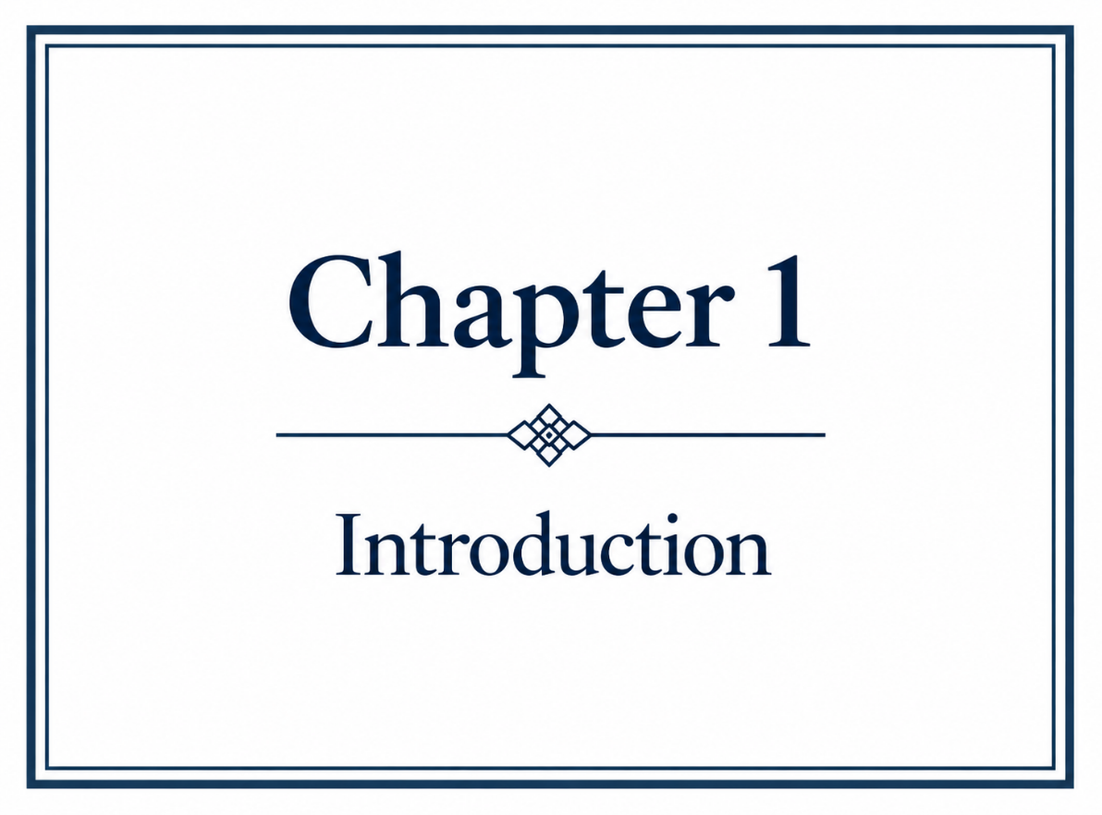

1.1 Rationale
Nursing continues to experience a significant gender imbalance, both internationally and within the United Kingdom (UK) (World Health Organization, 2026), where men remain substantially underrepresented within the profession, comprising approximately 11% of nurses on the UK NMC register and 9.5% of those registered in Wales (Nursing and Midwifery Council, 2026). This imbalance exists alongside continuing nursing workforce shortages within the UK and Wales (RCN, 2026; Wattret, 2026), strengthening the importance of recruiting future nurses from across the population. Effective recruitment into nurse education has consequently been identified as an important component of sustaining the future nursing workforce (Stanley et al., 2017; Teresa-Morales et al., 2022).
Gender imbalance, however, is also evident within this educational pipeline. Longstanding literature has identified the persistent underrepresentation of men within nurse education (Villaneuve, 1994; Anthony, 2004; Folami, 2017; Kearns and Mahon, 2021; Andina-Diaz et al., 2023; Shim and Park, 2024), while more recent UK data demonstrate that this disparity remains substantial, with Universities and Colleges Admissions Service (UCAS) (2025a) data showing that just 8.5% of applicants to nursing programmes are men. The disparity is even greater in Wales, where approximately 5% of nursing graduates are male (UCAS, 2025b).
Existing research identifies several factors that may contribute to men’s underrepresentation, including gender stereotypes, exposure to nursing as a career and the visibility of men within the profession (Carter et al., 2025; Ng et al., 2024; Liu et al., 2022; Yip et al., 2021; Stewart, 2026). Questions have also been raised regarding how men experience nurse education and whether aspects of the educational environment may be perceived differently according to gender (Yip, Yip and Tsui, 2021; Grimshaw et al., 2024; Prosen, 2022). The persistence of the imbalance, together with comparatively limited research examining male nursing students specifically within Wales, provided the rationale for investigating factors influencing men’s entry into nursing, their motivations for choosing the profession and their perceived barriers during nurse education.

1.2 Institutional and Local Context
The research was undertaken within a university in South Wales, providing pre-registration nursing education across Adult, Mental Health, Child and Learning Disability nursing; participants were drawn from students enrolled across three years of these programmes. Locating the study within Wales enables the wider issue of male underrepresentation to be investigated within a context in which men remain markedly underrepresented among nursing graduates.

1.3 Researcher Position
The researcher is both a registered nurse and a university lecturer within nursing and healthcare education. These professional roles have provided first-hand experience of gender imbalance within clinical practice and higher education and contributed to the development of the research interest. Professional experience within nursing and education also provided contextual understanding of the issues explored within the study, while creating the potential for existing knowledge, experiences and assumptions to influence the research process. The researcher’s positionality and the reflexive consideration of these influences are examined further within the methodology chapter.

1.4 Purpose of the Study and Research Questions
The purpose of this study was to investigate the underrepresentation of men within nursing education in Wales, with particular consideration of the factors influencing men’s entry into nursing, their motivations for choosing the profession and the barriers they perceived during their nursing education. The study was guided by the following research questions:
RQ1 - Why are men less likely than women to undertake study on a nursing degree programme in Wales?
RQ2 - What are the motivational factors for males to undertake studies on a nursing degree programme in Wales?
RQ3 - What, according to male nursing students, are their perceived barriers to successful completion of studies on a nursing degree programme in Wales?



2.1 Theme 1: Gender and Men’s Entry into Nursing

2.1.1 Historical Construction of Nursing
There is a substantial documented history of men’s contribution to nursing which predates the development of modern professional nursing, including caregiving within religious and military settings (Brown and Stone, 1973; Verger, 1986; Jezuit et al., 2020). The professionalisation of nursing during the nineteenth century nevertheless coincided with changing constructions of femininity, masculinity and the nursing role, contributing to nursing becoming increasingly associated with women (Brown, Nolan and Crawford, 2000; MackIntosh, 1997). This gendered construction was subsequently reflected institutionally through female-only admission policies within some nursing schools (Hardy, 1986; Mellish, 1984; Carnevale and Priode, 2018). Christensen (2017) argues that, despite more than 2,000 years of male participation, conventional nursing histories have predominantly presented nursing from a female perspective. More recently, Fernández-Delgado et al. (2025), in a narrative review of 27 studies, similarly identified substantial male participation across different historical periods while associating men’s subsequent marginalisation with sociocultural change, professionalisation and gender stereotyping. The historical evidence therefore challenges perceptions of nursing as inherently ‘women’s work’, positioning its contemporary association with femininity as historically and socially constructed.
The under-recognition of men’s historical contribution is also evident within literature examining nursing education. Grady et al. (2008) identified limited consideration of men within teaching concerning nursing history, while Hodges et al. (2017) identified limited knowledge of men’s nursing history alongside role strain, gender discrimination, isolation and lack of role models as potential barriers within nursing education. O’Lynn and Tranbarger (2007) similarly connect limited historical visibility with wider issues of gendered representation, education, recruitment and retention, while greater recognition of men’s historical contribution has been proposed as supporting professional identity and providing male students with historical and contemporary role models (Anthony, 2004; Wildman and Hewison, 2009). Empirical support for this proposed relationship remains limited; historical invisibility does not demonstrate that increasing students’ historical knowledge improves recruitment, inclusion or continuation. Furthermore, little contemporary UK evidence appears to establish either the representation of men’s history within current preregistration nursing curricula or whether such knowledge influences students’ professional identity and perceptions of belonging.

2.1.2 Sociocultural and Gender Stereotypes
Despite the historical involvement of men in nursing, contemporary literature continues to identify sociocultural and gender stereotypes that construct nursing as a predominantly feminine occupation. Terry et al. (2020), in a systematic review and integrated synthesis of 24 publications, identified recurring influences upon men’s navigation of nursing including role misconceptions, marginalisation and gender bias, while nursing continues to be associated with characteristics traditionally constructed as feminine, including caring, nurturing and emotional sensitivity (Prosen, 2022; Teresa-Morales et al., 2022). Men entering nursing may therefore experience tensions between their professional identity and socially constructed expectations of masculinity (Connell and Messerschmidt, 2005; Terry et al., 2020), including stereotypes concerning male nurses’ sexuality and the appropriateness of men providing intimate care (Harding, 2007; Baker, Fisher and Pryor, 2022). Importantly, such stereotypes are not confined to men’s accounts of their own experiences. Kaur, Ricciardelli and Clow (2023) identified gendered assumptions within responses from 117 female nursing and non-nursing students in Canada, although this sample cannot establish the prevalence of these perceptions or their influence upon men’s career decisions. Overall, the literature provides stronger evidence for the existence and experience of gender stereotypes than for their influence upon nursing applications, particularly as much of the evidence concerns men who have already entered the profession.
Evidence examining career consideration provides some support for the proposition that gendered perceptions may deter men from nursing, although their relative importance remains contested. Whitford et al. (2020), in a mixed-methods Scottish study involving male preregistration nursing students, nursing lecturers and schoolteachers, found that nursing could simultaneously be recognised as secure and worthwhile while being perceived as ‘not a career for men’. Meadus and Twomey (2011) similarly identified societal perceptions of nursing as an inappropriate career for men among male nursing students in Canada. These findings suggest that recognising nursing as an attractive occupation does not necessarily mean that it is perceived as a personally relevant career. Conversely, Wang, Lin and Wang (2022) and Kulkarni and Nithyanand (2012) identify personal career preferences as potentially more influential than societal attitudes, while Flynn, Brenock and Saab (2025) found contact with nurses and previous healthcare experience among the strongest reported influences upon choosing nursing. Linden et al. (2022) further demonstrated that exposing school pupils in Northern Ireland to realistic accounts of contemporary nursing could influence perceptions of the profession, although subsequent application or programme entry was not established. The evidence consequently suggests that gendered perceptions may influence career consideration but cannot readily be separated from personal preference, familiarity, previous healthcare experience and direct exposure to nursing.
The relationship between gender stereotypes and career choice is further complicated by the conceptualisation of masculinity. Connell and Messerschmidt’s (2005) hegemonic masculinity provides a theoretical framework through which caring occupations may be understood as potentially inconsistent with dominant constructions of male identity, while recognising that masculinities vary between individuals and social contexts. Nursing-specific evidence supports some relevance of this tension; Terry et al.’s (2020) systematic review identified societal, individual and collective influences through which men negotiated nursing and masculine identities, while Harding’s (2007) study of 18 heterosexual male nursing students and registered nurses in New Zealand identified homophobic stereotyping and strategies to affirm heterosexual and masculine identities. Harding’s (2007) deliberately heterosexual sample limits these findings to those participants and cannot represent gay or bisexual men. More recent evidence cautions against presenting masculinity as a uniform constraint. Prosen (2022) identified broadly shared motivations among 72 male and female Slovenian nursing students, despite some differences in anticipated professional roles, while Prosen and Čekada (2025) identified generally positive attitudes towards men in nursing alongside continuing gender biases and professional-identity challenges. The variation across the studies supports consideration of masculinity as one possible social influence rather than a characteristic all men possess or perform similarly; consequently, the present study did not assume masculinity to be explanatory in advance, recognising that differences may also reflect individual, social, cultural, educational or experiential influences.

2.1.3 Exposure, Representation and Career Consideration
Alongside gendered barriers, exposure and familiarity with nursing recur as influences upon career consideration. Yi and Keogh’s (2016) systematic review identified early exposure to nursing and healthcare professionals as one of four influences upon men’s decisions to enter nursing, while Whitford et al. (2020) identified knowing nurses, encouragement and positive role models as facilitators within their Scottish study. Similarly, Flynn, Brenock and Saab (2025) found contact with nurses and previous healthcare experience among the strongest reported influences upon choosing nursing, with gender stereotypes and media portrayals less influential among participants who had entered the profession. Earlier exposure may also be important; Linden et al. (2022) found that a nursing careers intervention involving pupils from all-boys, all-girls and mixed-gender schools in Northern Ireland could influence perceptions of nursing, although subsequent applications or programme entry were not established. Evidence concerning familiarity should, however, be distinguished from the more specific proposition that men require male role models. Hodges et al. (2017) identify limited male role modelling as a potential barrier, while Ghimire and Qiu’s (2025) Australian study suggests that male role models may also shape perceptions of particular nursing specialties. The significance of male representation may therefore extend beyond simple visibility; the areas of nursing in which male role models are visible may influence perceptions of where men belong within the profession. Male representation could consequently challenge the broader construction of nursing as feminine while simultaneously reinforcing gendered assumptions that men are more suited to particular specialties. Current evidence does not establish that specifically male role models increase men’s applications to nursing; exposure, familiarity and representation are therefore better understood as related but distinct influences upon career consideration.

2.1.4 Motivations for Men Entering Nursing
Men’s motivations for entering nursing are characterised within the literature as multifactorial rather than exclusively gender-specific. Yi and Keogh’s (2016) systematic review identified early exposure to nursing and healthcare professionals, chance, extrinsic motivation and intrinsic motivation as recurring influences. Prosen’s (2022) study of 72 male and female Slovenian nursing students similarly identified altruism, perceived opportunities and organisational factors among both genders, although female participants additionally identified family and social incentives. Prosen (2022) also identified differences in anticipated professional roles, with male participants more frequently envisaging management, leadership and technical aspects of nursing. These findings demonstrate some gender differences within participants’ accounts but should not be conflated with motivations for entering nursing, as anticipated career destinations may reflect influences operating after the initial career decision. Whitford et al. (2020) found that employment security, varied career opportunities, encouragement and knowing nurses could facilitate men’s consideration of nursing, despite concurrent perceptions that nursing was not a career for men. Flynn, Brenock and Saab (2025) additionally identified contact with nurses and previous healthcare experience as influential among men who had chosen or were considering nursing. The range of motivations identified suggests that men enter nursing through combinations of altruistic, practical, interpersonal and experiential influences rather than through a specifically male motivational pathway. Evidence directly comparing male and female motivations remains comparatively limited, making it difficult to determine which influences, if any, are distinctive to men. This distinction is particularly important to the present study because explaining the motivations of men who have already chosen nursing cannot, in isolation, explain why substantially fewer men than women consider or enter the profession.
Theme 1 identified that men’s entry into nursing is situated within interacting historical, sociocultural and representational influences. Gender stereotypes, limited exposure and perceptions of nursing as a feminine occupation may constrain career consideration, while men who enter nursing report varied motivations that are not necessarily gender-specific. These provide plausible explanations for male underrepresentation, but do not establish why fewer men enter nursing education in Wales.

2.2 Theme 2: Gender and the Nursing Education Experience

2.2.1 Gendered Experiences Within Nursing Education
Gender-related differences within nursing education have been identified across literature examining male students’ educational, social and clinical experiences (O’Lynn, 2004; Meadus and Twomey, 2011; Chan et al., 2014; Hodges et al., 2017; Terry et al., 2020; Taylor et al., 2022; Ng, See and Ignacio, 2024). O’Lynn (2004) identified gender-related barriers within preregistration nursing education, while Meadus and Twomey’s (2011) phenomenological study of 27 male nursing students identified gender bias and stereotyping within participants’ educational experiences. More recent UK evidence provides some convergence; Taylor et al. (2022), in a qualitative study across four Scottish universities, identified isolation and marginalisation, stereotyping concerning masculinity, reluctance to seek help and difficulties accessing learning opportunities among male participants. Similar experiences are evident within international systematic literature. Chan et al.’s (2014) systematic review of 55 studies identified distinctive negative experiences for male students within some clinical environments, while Ng, See and Ignacio’s (2024) qualitative systematic review and meta-synthesis of 23 studies identified stereotyping, discrimination, reduced clinical opportunities and psychological and social stress. Importantly, Chan et al. (2014) also found broadly comparable academic performance between male and female nursing students, demonstrating that differences in educational experience should not be assumed to result in differences in academic performance.
Evidence concerning inclusion and belonging is not, however, consistent. Christensen et al. (2021) found that first-year male nursing students in England generally felt welcomed, supported and included and demonstrated no overall gender-role conflict. Although the small, male-only, first-year sample limits wider conclusions, the findings provide important UK counter-evidence to accounts of marginalisation. Prosen and Čekada’s (2025) Slovenian study similarly identified generally positive attitudes towards men in nursing alongside continuing concerns relating to societal gender bias, mentorship and professional identity. Amin et al. (2025), studying 308 male nursing students in Egypt, found significant relationships between gender misconceptions, occupational stigma and professional identity, although the cross-sectional design cannot establish the direction of these relationships and the cultural context limits transferability to Wales. The experiences of men within nursing therefore appear neither homogeneous nor invariably negative.
Representation may provide an additional dimension to these experiences. Earlier literature identified concerns regarding limited male representation within curricula, mentorship and educational environments (Grady et al., 2008; Loughrey, 2008; McLaughlin and Muldoon, 2010), while Hodges et al. (2017) identified limited male role models among barriers encountered by male nursing students. Taylor et al. (2022) subsequently recommended greater visibility of male role models within academic and clinical environments, and Prosen and Čekada (2025) identified continuing difficulties surrounding mentorship and professional identity. The influence of representation may nevertheless be complex. Ghimire and Qiu (2025) found that male role models influenced final-year male students’ aspirations towards critical-care nursing, suggesting that male representation may challenge the broader construction of nursing as female while potentially reinforcing perceptions that particular specialties are more appropriate for men. Evidence concerning representation and mentorship therefore provides a reasonable basis for exploring belonging and professional identity but does not establish that a predominantly female academic workforce teaches in ways that advantage female students. The literature supports gender as relevant to some men’s experiences of nursing education, while the inconsistency of those experiences and limited contemporary UK evidence leave the nature and extent of that influence unresolved.

2.2.2 Gender, Learning and the Educational Environment
The potential relationship between gender and learning within nursing education has received considerable attention, although both the nature and significance of this relationship remain contested. Earlier literature identified differences in the learning preferences of men and women (Lachenmayer, 1997; Heffler, 2001; Kolb and Kolb, 2005), while subsequent nursing literature suggested that elements of nursing education may correspond more closely with learning approaches reportedly preferred by women. Lamiri et al. (2020), for example, associated women with preferences for experiential, hands-on learning, while Ibrahim and Hussein (2016) identified reflection, collaborative problem-solving and understanding interpersonal behaviour as approaches frequently employed within nursing education. Conversely, Li, Chen and Tsai (2008) associated male learners more strongly with analytical approaches, particularly within science, technology, engineering and mathematics. The evidence underpinning some of these gendered distinctions is, however, problematic. Li, Chen and Tsai (2008) draw upon earlier literature including Sherrod (2003), whose explanation of male learning invokes the concept of a more ‘logical brain’; Sherrod’s argument itself draws upon considerably older work, including Belenky et al. (1986). Such accounts risk presenting socially constructed and historically situated assumptions about masculinity and femininity as inherent cognitive differences. More contemporary research by Nancekivell, Shah and Gelman (2020) challenges assumptions that abilities and preferences traditionally associated with gender are innate, instead emphasising the role of learning and experience. Consequently, literature reporting gender differences in learning provides a legitimate basis for investigating whether male and female nursing students experience or prefer different approaches to learning but provides a much weaker basis for assuming that such differences are biologically determined or fixed.
The question of whether the nursing educational environment itself may favour particular approaches to learning is similarly difficult to establish. Dyck et al. (2009), using classroom observations and interviews with six male nursing students and six female instructors across two Canadian nursing schools, identified an incongruity between some male students’ educational preferences and techniques prevalent within their nursing programmes. Their findings are consistent with the possibility that some male students may experience aspects of nursing education as less congruent with their preferred ways of learning. The study cannot, however, demonstrate that these approaches favoured female students because no female students were included for comparison; its small qualitative sample, Canadian setting and age further limit transferability to contemporary nursing education in Wales. Mangold et al. (2018) also reported that nurse educators tended to employ teaching strategies reflecting their own preferred approaches to learning. Although this raises a legitimate question concerning the relationship between educator preferences and teaching practices, it does not establish that female educators employ specifically female-preferred pedagogies or that male students are consequently educationally disadvantaged. The distinction is important because evidence that educators favour familiar teaching approaches cannot independently demonstrate a causal pathway between educator gender, teaching methodology and student outcomes.
More recent evidence also challenges the conceptualisation of learning styles as stable categories to which teaching should be matched. Brannan, White and Long (2016), using the Felder-Soloman Index of Learning Styles with nursing students, found that knowledge and confidence did not differ significantly according to learning-style classification in either traditional classroom or high-fidelity simulation conditions. Hattie and O’Leary (2025), drawing upon evidence from 17 meta-analyses, make a particularly important distinction between learning styles, preferences and strategies. Studies specifically testing whether educational outcomes improve when teaching is matched to an identified learning style produced a negligible effect, whereas the broader correlational evidence concerning learning preferences and strategies produced a stronger relationship. Hattie and O’Leary (2025) consequently advocate adaptable learning strategies appropriate to particular tasks and learning goals rather than matching instruction to supposedly fixed styles. This contemporary evidence substantially weakens the proposition that male and female nursing students possess distinct learning styles requiring gender-specific teaching. It does not negate the relevance of examining how students experience different teaching approaches, since preferences, strategies, engagement and perceptions of the educational environment remain distinct from claims of fixed gendered learning styles. The literature therefore supports investigation of whether male nursing students perceive aspects of their learning environment differently, while requiring considerable caution before attributing those perceptions to inherent gender differences or assuming that they translate into differences in academic ability or attainment.

2.2.3 Barriers to Successful Completion and Attrition
The gender-related experiences identified within nursing education raise a further question concerning whether they present barriers to successful programme completion. Earlier literature associated male student retention with gender bias, stereotyping and limited male role models (Cudé and Winfrey, 2007; Meadus and Twomey, 2011; Adeniji et al., 2015; Drennan et al., 2016; Stanley et al., 2017), although the extent to which these factors directly contribute to withdrawal remains unclear. This distinction is important because evidence that male students encounter gender-related difficulties does not demonstrate that those difficulties cause attrition. Students may withdraw from nursing programmes for numerous interacting academic, financial, placement, personal and wellbeing-related reasons, making gender difficult to isolate as an independent explanation.
Taylor et al. (2022) provide particularly relevant UK evidence through their four-phase qualitative investigation across four Scottish universities. Their study incorporated male and female nursing students, nurse lecturers and men who had withdrawn from preregistration nursing programmes. Male participants described isolation and marginalisation, gender stereotyping, communication difficulties, reluctance to seek help, financial pressures and difficulties accessing learning opportunities, while resilience and maturity were identified as factors assisting students to navigate these experiences. The inclusion of withdrawn students strengthens the study’s relevance to attrition; nevertheless, only three participants had actually withdrawn. Most of the evidence therefore concerns students who remained enrolled, and the qualitative design cannot determine the relative contribution of gendered experiences compared with other reasons for withdrawal or establish that students experiencing greater gender-related difficulties were subsequently more likely to leave.
Similar caution is required when interpreting wider evidence. Ng, See and Ignacio’s (2024) qualitative systematic review and meta-synthesis identified discrimination, missed clinical opportunities and psychological and social stressors associated with potential difficulties retaining men within nursing. The inclusion of both students and registered nurses, however, limits conclusions concerning withdrawal from nurse education. Amin et al. (2025) identified significant relationships between gender misconceptions, occupational stigma and professional identity among male nursing students, suggesting a possible pathway through which gendered experiences could affect belonging or engagement. Their cross-sectional study measured professional identity rather than programme withdrawal and cannot establish that this pathway results in attrition. Existing research consequently provides stronger evidence that some male nursing students experience gender-related barriers than that these barriers independently cause programme withdrawal. This distinction is particularly relevant to the present study, which explores perceived barriers to successful completion but cannot determine the causes of attrition.
Theme 2 identified that gender can shape aspects of men’s nursing education experiences, particularly through stereotyping, representation, belonging and some clinical experiences. Evidence is considerably weaker for fixed gender differences in learning or a causal relationship between gender-related barriers and attrition. Male students’ experiences are also heterogeneous, leaving uncertainty regarding these issues within contemporary nursing education in Wales.

2.3 Literature Review Synthesis, Research Gap and Justification
Theme 1 focused upon gender and men’s entry into nursing, identifying a range of historical, sociocultural and representational influences that may contribute to nursing being less readily considered by some men. Theme 2 examined gender and the nursing education experience, identifying evidence that gender may shape aspects of students’ educational and clinical experiences, while challenging stronger assumptions concerning gendered learning styles and the causal relationship between gender-related barriers and attrition. Across both themes, the literature therefore provides considerably stronger evidence for the existence of gendered perceptions and experiences than it does for their direct effects upon entry, learning outcomes or programme completion.
Important limitations within the evidence base remain. Research concerning men in nursing spans different countries, cultures, educational systems and stages of professional development, with evidence concerning registered nurses sometimes used to illuminate preregistration education. Much of the research is qualitative or based upon relatively small male-only samples, while some influential studies are now considerably dated. More recent UK research provides valuable evidence concerning recruitment and educational experience, but little empirical research identified within this review examines these issues specifically within Welsh preregistration nursing education. International and wider UK findings therefore provide an important basis for investigation but cannot be assumed to explain the participation or experiences of male nursing students in Wales.
These limitations provide the justification for the three research questions underpinning the present study. RQ1 examines why men may be less likely than women to undertake nursing degree study in Wales, addressing uncertainty concerning whether explanations for underrepresentation identified within the wider literature are reflected within the Welsh context. RQ2 examines the motivations of men who have entered nursing education, providing a counterpoint to the predominantly barrier-focused literature and exploring whether previously identified motivations are evident among male students studying in Wales. RQ3 examines male nursing students’ perceived barriers to successful completion, responding to evidence of gender-related educational difficulties while avoiding the unsupported assumption that these experiences necessarily cause programme withdrawal. The three questions therefore address complementary dimensions of male participation in nursing education: underrepresentation at entry, motivations for choosing nursing and perceived barriers to successful completion within a context for which the existing evidence remains limited.



3.1 Research Design

3.1.1 Epistemology, Ontology and Theoretical Framework
This study adopted a pragmatic philosophical position, informed by social constructionism. Pragmatism supports the use of different research methods according to the questions being investigated, rather than requiring a study to follow one methodological approach (Morgan, 2014; Kaushik and Walsh, 2019). This was particularly relevant to the present study, as the research questions required both an exploration of patterns within a wider group of nursing students and a deeper understanding of the motivations, perceptions and experiences underlying their responses.
A social constructionist perspective was also relevant, recognising that meaning and understanding are shaped through individual and collective experiences within wider social and cultural contexts (Berger and Luckmann, 1966; Andrews, 2012; Burns et al., 2022). This is particularly pertinent when investigating gender within nursing education, where perceptions of nursing, masculinity and gender stereotypes may be influenced by historical narratives and wider cultural and social expectations. Participants’ accounts were therefore understood as individual interpretations of their experiences rather than representations of a single objective reality.
A mixed-methods approach was consequently adopted, utilising quantitative and qualitative data through an online questionnaire and semi-structured interviews. Combining these approaches enabled broader patterns within the questionnaire responses to be explored (Creswell and Plano-Clark, 2017) alongside more detailed accounts of participants’ motivations, perceptions and experiences (Regnault, Willgoss and Barbic, 2018; Creswell, 2015). This provided the breadth required to examine responses across a larger sample whilst allowing greater exploration of the complexity underpinning them.

3.1.2 Researcher Positionality
My positionality as both a practising registered nurse and nurse educator provided contextual and professional knowledge relevant to the phenomenon under investigation. Insider researchers can possess an understanding of the environment and experiences being explored that may not be readily accessible to those external to that setting (Dwyer and Buckle, 2009; Attia and Edge, 2017). My clinical experience and longstanding involvement in nursing education have consequently shaped both my interest in male underrepresentation and my understanding of the educational and professional contexts within which participants’ experiences were situated.
Insider status is not, however, absolute (Dwyer and Buckle, 2009). Although I possessed professional and educational knowledge of the context, I did not personally know any of the students who participated in the interviews. My insider position was therefore based on professional and educational experience rather than personal familiarity with the participants. This distinction did not remove the potential influence of my positionality; familiarity with nursing education and previous engagement with the literature risked creating assumptions about the experiences of male nursing students or influencing how participant accounts were interpreted. Both Mercer (2007) and Chavez (2008) caution that familiarity can result in researchers overlooking aspects of a setting that may be more apparent to an outsider, whilst Berger (2015) and Greene (2014) identify reflexivity as important in recognising how the researcher and research process may mutually influence one another.
Reflexivity was therefore important throughout the study. Rather than attempting to remove my existing knowledge and assumptions, these required continued critical consideration during data collection and interpretation (Berger, 2015; Olmos-Vega et al., 2023). This became particularly pertinent where findings challenged expectations developed from previous literature; for example, the anticipated relationship between gender and learning preferences was not strongly reflected within the data. Recognition of such discrepancies provided an important means of questioning, rather than simply confirming, my existing assumptions.

3.2 Methodology

3.2.1 Sampling Strategy
The population for this study comprised pre-registration nursing students studying Adult, Children’s, Mental Health and Learning Disabilities Nursing across all three year groups at one Welsh university. Approximately 600 students were potentially eligible to participate, although an exact institutional population figure was unavailable. Access to potential participants was facilitated through a gatekeeper, who placed the questionnaire link on the university Virtual Learning Environment (VLE). This enabled students across the eligible population to participate without direct recruitment by the researcher.
A total of 101 students completed the questionnaire. Although this represented only a proportion of the potentially eligible population, a conventional response rate could not be reliably calculated because the number of students who actually encountered the invitation was unknown. The possibility of non-response and self-selection bias must therefore be recognised, as students choosing to participate may have differed from those who did not (Bryman, 2016). Maslovskaya et al. (2025) advises against interpreting response rate alone as an indicator of survey quality, noting that non-response bias depends upon differences between respondents and non-respondents rather than solely upon the proportion responding. Consequently, the questionnaire findings cannot be assumed to represent the wider eligible student population.
Interview participants were selected purposively from questionnaire respondents who volunteered for further participation. Purposive sampling facilitates the selection of participants with characteristics or experiences directly relevant to the research question (Ames, Glenton and Lewin, 2019; Campbell et al., 2020). Twenty respondents volunteered for interview: six men, thirteen women and one non-binary participant, with all six male questionnaire respondents volunteering. Seven students were subsequently interviewed: three men, three women and the non-binary participant. The non-binary participant later withdrew their interview data within the permitted withdrawal period, leaving six interviews for qualitative analysis; their questionnaire response remained within the quantitative dataset. Male participants were selected from Mental Health, Adult and Learning Disability Nursing, while female participants were selected from the corresponding fields and across different years of study. Where more than one female volunteer met the required characteristics, the first eligible participant identified within the recruitment spreadsheet was selected.
The interview sample exceeded the four participants originally anticipated within the research proposal, reflecting the greater availability of volunteers than expected. The decision to interview three men rather than all six male volunteers was influenced by previous experience of ethical review, which had reinforced an assumption that equal gender representation within the interview sample was necessary to minimise sampling bias. Retrospectively, this assumption required greater critical consideration because all three research questions specifically concerned men’s entry into, motivations for, or experiences of nursing education. Interviewing all six male volunteers may have provided greater depth and diversity among the male students who were central to the research questions. Maintaining equivalent male and female samples would, however, have substantially increased the volume of qualitative data collection and analysis within an already mixed-methods study. Although purposive selection enabled variation within a small interview sample, the accounts obtained should therefore be understood as detailed individual perspectives rather than representative of the experiences of male nursing students more widely.

3.2.2 Data Collection Methods

Online Questionnaire
An online questionnaire was selected to obtain data from a broader proportion of the eligible student population than could feasibly be reached through individual interviews. Online questionnaires can facilitate efficient and cost-effective collection of data from comparatively large and geographically dispersed samples (Regmi et al., 2016; Hlatshwako et al., 2021). The standardised format also enabled comparison of responses across participants, while providing quantitative data relating to students’ perceptions and experiences. This breadth was important within the mixed-methods design, although questionnaire data alone could not provide the depth required to understand the motivations and experiences underpinning participants’ responses.
The questionnaire was developed using Microsoft Forms and comprised 19 questions across six sections: About You; Teaching and Learning Environment; Learning Resources; Gender Representation within Nursing Education; Gendered Language; and Educational Barriers and Student Experience. Multiple-choice questions and Likert-type statement clusters were used alongside free-text questions that enabled participants to provide examples or elaborate upon their experiences. Likert scales provide a means of quantifying attitudes and perceptions, although their structured format can oversimplify complex perspectives and may be susceptible to response biases including acquiescence (Bishop and Herron, 2015; Fink, 2017). Similarly, closed questions facilitate comparison but restrict participants to researcher-defined response categories (Brace, 2022), potentially limiting the depth and nuance of the data obtained (Ponto, 2015). The inclusion of free-text questions provided some opportunity for participants to elaborate beyond these predefined categories.
Prior to distribution, the questionnaire was informally pre-tested with students to establish whether the questions were understandable and whether Microsoft Forms functioned appropriately. A formal pilot was not undertaken due to the timeframe available. Although informal pre-testing provided some indication of comprehensibility and functionality, it did not adequately evaluate whether questions consistently represented the intended concepts or would generate sufficiently detailed data to address the research questions. This became apparent during analysis; for example, separate questions referring to ‘learning materials’ and ‘teaching methods’ did not provide examples or sufficiently define these terms, potentially allowing different interpretations. Greater use of free-text opportunities and more rigorous pre-testing may therefore have strengthened the questionnaire’s capacity to elicit the intended data (Brace, 2022; Bryman, 2016).
The questionnaire link was provided to the institutional gatekeeper in December but was not placed on the VLE until late February and remained available until approximately mid-April. Recruitment was mediated through the gatekeeper and no subsequent reminder invitations were distributed. This, in line with caution from both Clark (2011) and Crowhurst (2013), limited the researcher’s control over both the timing and frequency of recruitment. Distribution also coincided with a period in which students across different year groups were undertaking academic assessments and clinical placements, including final assessments and management placements for some third-year students. Although these circumstances may have affected engagement, their influence upon participation cannot be established. Reliance upon VLE recruitment also meant that the number of eligible students who actually encountered the invitation was unknown. These factors limited the ability to evaluate recruitment reach and reinforced the potential for self-selection and non-response within the questionnaire sample.
A blank copy of the questionnaire can be found in Appendix 1.

Semi-Structured Interviews
Semi-structured interviews were undertaken to explore participants’ motivations, perceptions and experiences in greater depth than was possible through the questionnaire; their flexible structure enables researchers to use a consistent set of core questions whilst probing responses that warrant further exploration (DeJonckheere and Vaughn, 2019; Brinkmann and Kvale, 2018). This was particularly appropriate for research questions concerned with participants’ perceptions of gender-related barriers and motivations for entering nursing, where restricting responses to predetermined questionnaire categories risked overlooking individual experiences and meanings. Semi-structured interviews can, suggests Kallio et al. (2016), consequently generate rich and nuanced qualitative data, although the interaction between researcher and participant also contributes to the data produced and requires reflexive consideration.
Seven interviews were conducted online using Microsoft Teams, guided by nine loosely structured core questions. Interviews lasted between approximately 22 and 36 minutes, with an average duration of approximately 28 minutes. The semi-structured format, according to Busetto, Wick and Gumbinger (2020), enabled additional questions and prompts to be used where participants raised issues relevant to the research questions. This flexibility was valuable because probing enabled participants to clarify or elaborate upon initial responses, rather than restricting the interview to the predetermined schedule. Existing methodological literature (McGrath, Palmgren and Liljedahl, 2019; Braun and Clarke, 2022) identifies this capacity for probing as a particular strength of semi-structured interviewing, although interviewer questioning and behaviour can also influence the direction and content of participants’ responses (DeJonckheere and Vaughn, 2019; Rubin and Rubin, 2012).
The interview process developed as data collection progressed. Although all participants were asked the same core questions, in accordance with DeJonckheere and Vaughn’s (2019) recommendations, increased interviewer confidence led to greater use of probing and encouragement of participants to elaborate through examples and personal accounts during later interviews. A more conversational approach appeared to support greater rapport, with some participants expanding upon initially brief responses; this was particularly noticeable during some interviews with male participants, where initial responses to questions concerning gender stereotypes and perceptions appeared guarded but became more detailed following further discussion. These observations cannot establish that increased rapport caused greater disclosure, and longer or more detailed interviews cannot automatically be considered better quality. They do, however, demonstrate that the interaction between participant and researcher influenced how the interview developed.
Conducting interviews through Microsoft Teams enabled remote participation without requiring participants and the researcher to be physically co-located. Automated Teams transcription, however, did not consistently represent some sections of conversation accurately. Transcripts were therefore checked against the original interview recordings and corrected where necessary shortly after each interview. Listening to the recordings provided a more reliable basis for correction than recollection alone. Transcription nevertheless involves decisions concerning how spoken accounts are represented and can influence subsequent analysis (Cassell and Bishop, 2019; Vanover, 2021). Transcripts were subsequently cleaned to remove pauses, hesitations and verbal fillers that were not analytically relevant. As the study explored participants’ perceptions and experiences rather than the mechanics of speech, this enhanced readability and supported coding while preserving the substantive meaning of participants’ accounts (Bailey, 2008; Braun and Clarke, 2022).
A copy of the interview questions is provided in Appendix 2.

Focus Groups
Focus groups were also considered as an alternative qualitative data collection method. Their interactive nature can encourage participants to respond to and develop one another’s contributions, potentially generating perspectives that may not arise during individual interviews (Nyumba et al., 2018; Luke and Goodrich, 2019). They were ultimately rejected because group dynamics can also inhibit individual expression, particularly where participants hold differing views, while dominant voices may influence the direction of discussion (Flick, 2020). Individual semi-structured interviews were therefore considered more appropriate for exploring personal perceptions and experiences of gender within nursing education. In retrospect, the initially guarded responses observed among some male interview participants raise the possibility that interaction with other male students might have encouraged further discussion; equally, Kreuger and Casey (2022) note that a group setting may increase self-consciousness or conformity. Focus groups may therefore provide a useful complementary method in future research rather than representing an inherently preferable alternative to individual interviews.

3.2.3 Data Analysis Methods
Quantitative and qualitative data were initially analysed separately using methods appropriate to each dataset before being considered together during interpretation. Questionnaire data collected through Microsoft Forms were exported into Microsoft Excel and analysed descriptively using frequencies and percentages. Descriptive statistics enabled the characteristics of the sample and patterns within questionnaire responses to be summarised and compared (Field, 2018); graphical representations were also used where these facilitated clear presentation of the findings. Although the original research proposal anticipated the use of SPSS, the exploratory nature of the study and the data generated did not require the inferential statistical procedures available within specialist statistical software. Microsoft Forms and Excel provided the functionality required for the descriptive analysis undertaken.
Restricting the quantitative analysis to descriptive statistics also placed important limits upon interpretation. Frequencies and percentages could identify patterns within the respondents’ answers but could not establish statistical relationships, causation or whether observed differences were likely to exist within the wider student population; this was particularly important when comparing responses by gender because only six questionnaire respondents identified as male. Percentages within this subgroup were therefore interpreted alongside the corresponding frequencies, recognising that a single response represented a substantial proportion of the male sample. Inferential testing was not subsequently added because the small and unequal gender groups would have restricted the meaningful conclusions that could be drawn from such analysis. This differed from the analysis originally proposed but was considered more appropriate for the data obtained than applying statistical tests that would add little meaningful interpretation.
Qualitative interview data were analysed thematically, informed by Braun and Clarke’s approach to thematic analysis (Braun and Clarke, 2006). The interview material was read repeatedly to develop familiarity with participants’ accounts and identify statements and ideas relevant to the research questions. These were initially organised into tables in Microsoft Word, allowing similarities and differences across participants’ accounts to be compared. Related ideas were grouped and reconsidered as the analysis progressed, eventually contributing to four themes: ‘Exposure and Awareness Influence Men's Entry into Nursing’; ‘Gender Stereotypes Continue to Shape Perceptions of Nursing’; ‘Men Are Motivated by Personal Values and Career Opportunities’; and ‘Gender Shapes Educational Experience but Not Necessarily Successful Completion’. This process broadly reflected Braun and Clarke’s (2006) stages of familiarisation, coding and developing and refining themes.
The initial coding and theme-development tables are provided in Appendix 3.
Although Braun and Clarke (2006) provided a framework to guide the analysis, the process was not treated as a rigid sequence of six separate steps. Later development of their approach emphasises the active role of the researcher in interpreting qualitative data and developing themes, rather than suggesting that themes are simply discovered within the data (Braun and Clarke, 2019). This distinction was important within the present study because decisions about which participant responses were related, which patterns were significant and how these should be organised into broader themes involved researcher interpretation. This approach was also consistent with the social constructionist position underpinning the study, which recognises that meaning is interpreted and constructed rather than representing a single objective reality.
Integration of the quantitative and qualitative strands occurred primarily during interpretation rather than through a planned sequential process. Questionnaire patterns were compared with interview accounts, with qualitative data sometimes providing context or further explanation for responses identified quantitatively. The two datasets were therefore used to complement one another rather than assuming that agreement between them automatically established the validity of a finding. Mixed-methods integration can occur at different stages of a study, although meaningful integration requires more than the separate collection and presentation of quantitative and qualitative results (Creswell and Plano Clark, 2017; Almalki, 2016). With hindsight, analysing the questionnaire data before conducting the interviews could have enabled emerging patterns to inform subsequent interview questions and potentially generated more explanatory qualitative data. This would, however, have constituted a more deliberately sequential design than that undertaken within the present study and should not be assumed to have produced better findings.

3.2.4 Ethical Considerations
Ethical approval was obtained prior to commencement of the study (Appendix 4), with the research conducted in accordance with UWTSD ethical requirements, the British Educational Research Association (BERA, 2024) guidelines and the NMC Code (2018). Gatekeeper permission was obtained from the School of Nursing and Midwifery before recruitment. The use of a gatekeeper was particularly important given the researcher’s professional role as a nurse educator, as recruitment without direct researcher contact reduced the potential for students to perceive participation as an expectation associated with an educational relationship. This approach supported the voluntary nature of participation and helped minimise the potential influence of perceived power differentials between the researcher and students (Clark, 2011; BERA, 2024).
Participation was voluntary and informed consent was obtained prior to data collection. Questionnaire participants were provided with study information and were required to actively confirm consent before proceeding. Interview participants provided written consent via a response email to an information sheet (Appendix 5), with verbal consent additionally confirmed before audio recording commenced. Participants were informed of their right to withdraw without providing a reason; interview data could be withdrawn for two weeks following participation, after which anonymisation and analysis prevented individual data from being readily identified.
Protection of confidentiality and participant identity was particularly important because the study involved students discussing their educational experiences and perceptions of gender. The questionnaire avoided collection of directly identifying information, while the six participants included in the final interview analysis were identified as Participants 1–6, and identifying details were removed from reporting. Data, including interview recordings and transcripts, were stored securely on password-protected university systems in accordance with the approved data-management arrangements.
Potential psychological discomfort was also considered because participants were invited to discuss personal motivations, experiences and perceived barriers relating to nursing and nursing education. Although the topic was not considered highly sensitive, reflecting on personal experiences or challenging situations had the potential to cause temporary discomfort for some participants. To minimise this risk, participants were informed that they were free to decline to answer any question, pause the interview, or withdraw from the study at any stage without consequence. This approach was consistent with the ethical principles of respect for autonomy, voluntary participation and protection from harm (British Educational Research Association, 2024; Nursing and Midwifery Council, 2018).

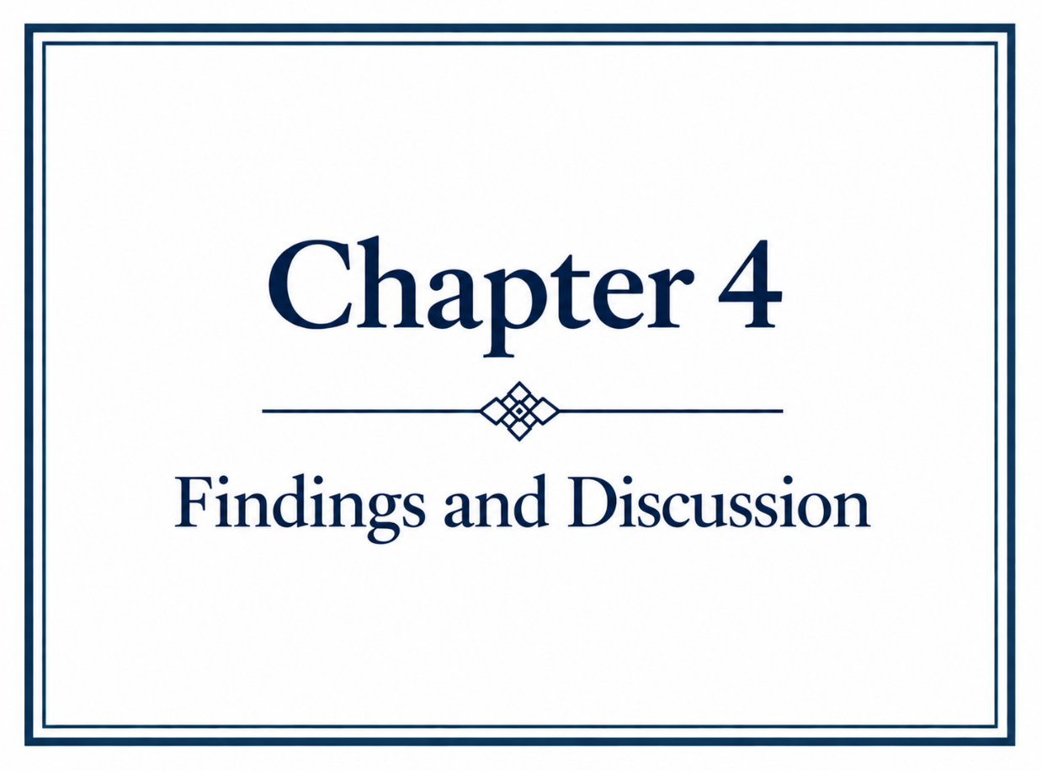

4.1 Questionnaire Findings and Discussion
Complete questionnaire graphs are provided in Appendix 6.

4.1.1 Respondent Characteristics
A total of 101 students completed the questionnaire, representing all four fields of pre-registration nursing and all three years of the programme (Table 1). Six respondents (5.9%) identified as male. Although this low proportion is consistent with the wider underrepresentation of men within nursing education (NMC, 2026; RCN, 2026), it should not be interpreted as evidence that the sample was representative of the wider student population because the gender composition of students who received or viewed the questionnaire invitation could not be established. Findings from the six male respondents are therefore presented descriptively.

Table 1. Demographic characteristics of questionnaire respondents (n = 101)

Characteristic | Category | n | %
Gender | Female | 91 | 90.1
 | Male | 6 | 5.9
 | Non-binary | 1 | 1.0
 | Prefer not to say | 3 | 3.0
Year of study | Year 1 | 37 | 36.6
 | Year 2 | 39 | 38.6
 | Year 3 | 23 | 22.8
 | None | 2 | 2.0
Field of nursing | Adult Nursing | 44 | 43.6
 | Mental Health Nursing | 25 | 24.8
 | Child Nursing | 19 | 18.8
 | Learning Disability | 13 | 12.9

Note. Percentages may not total 100% because of rounding.

4.1.2 Gender Representation within Nursing Education
Male representation was perceived to be limited within the educational environment. Fifty respondents (49.5%) believed that fewer than half of their nurse educators were male and 44 (43.6%) reported that very few were male; no respondent perceived men to constitute more than half. Although this measured perception rather than the actual composition of the teaching workforce, it is consistent with literature identifying limited visibility of male academics and role models within nursing education (Carter et al., 2025; Stewart, 2026). Male role models have been associated with professional identity and men's perceptions of nursing (Yip et al., 2021; Liu et al., 2022), although neither the literature nor the present findings establish that increasing male educator numbers would itself improve recruitment or educational outcomes.
Limited representation was also evident in respondents’ awareness of men's historical contribution to nursing. More than half (n=54, 53.5%) reported no prior awareness of this history, 35 (34.7%) reported partial awareness and six (5.9%) reported being aware. Within the programme, 86 respondents (85.1%) disagreed or strongly disagreed that their understanding of men's historical contribution had increased, 89 (88.1%) disagreed or strongly disagreed that the programme included discussion of this contribution, and 84 (83.2%) disagreed or strongly disagreed that it was visible within their education. These findings correspond with Christensen's (2017) argument that men's contribution has received comparatively limited attention within dominant accounts of nursing history and Hodges et al. (2017), who identify inadequate knowledge of men's nursing history as a potential gender-related educational barrier.

Figure 1. Respondents’ perceptions of the representation of men’s historical contribution within nursing education (n=101)

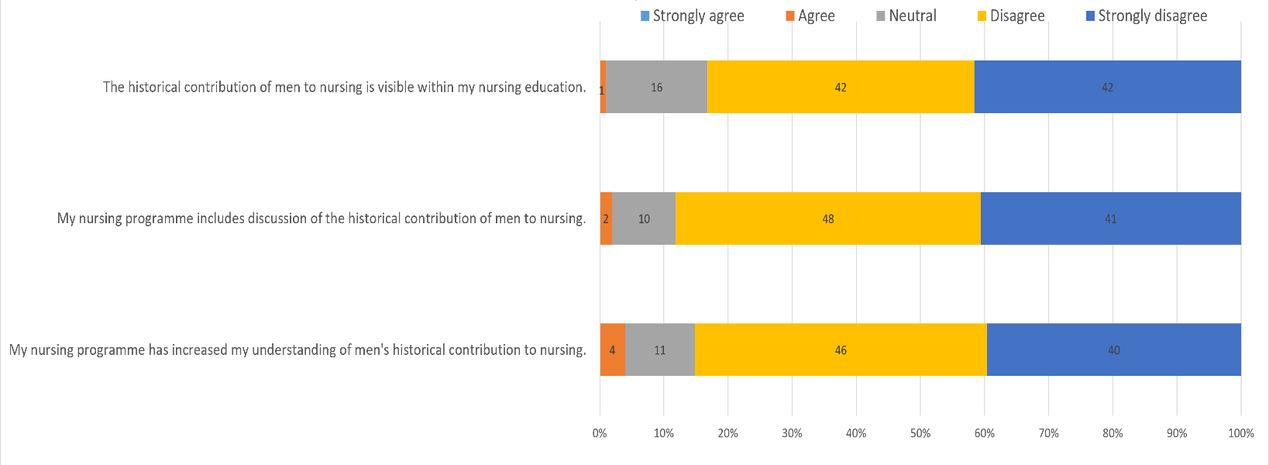
Importantly, this pattern occurred across the wider sample rather than being confined to male respondents, suggesting a broader perceived absence from the curriculum. The findings cannot establish whether greater historical representation would influence recruitment, professional identity or belonging, but identify an aspect of nursing history that respondents perceived to have limited visibility within their education.

4.1.3 Gender Representation within Learning Resources
Responses concerning learning resources presented a mixed picture. Most respondents agreed or strongly agreed that resources were accessible and easy to use (n=84, 83.2%) and relevant to students of all genders (n=79, 78.2%). Responses were less positive when specifically addressing gender representation. Fifty respondents (49.5%) agreed or strongly agreed that nursing was portrayed as suitable for all genders, while 33 (32.7%) disagreed or strongly disagreed. Similarly, 43 (42.6%) agreed or strongly agreed that resources challenged traditional gender stereotypes, compared with 44 (43.6%) who disagreed or strongly disagreed. This suggests a distinction between the functional accessibility of educational resources and gender inclusivity within their content.
This distinction was also apparent in the language respondents encountered. Fifty-five (54.5%) reported that learning resources most commonly referred to nurses as female, 22 (21.8%) perceived male and female nurses to be represented equally and 24 (23.8%) were unsure; no respondent reported predominantly male representation. Forty-nine respondents (48.5%) agreed or strongly agreed that gendered language was common within nursing education, while 54 (53.5%) agreed or strongly agreed that such language influenced how nursing was portrayed. These findings correspond with recent literature (Kuzma and Yingling, 2025; Prosen and Čekada, 2025) identifying continued associations between nursing and femininity and female-centred representations within nursing discourse, but do not establish that gendered language influences men's educational outcomes.
Gendered representation was particularly noticeable among the six male respondents; five perceived nurses to be represented predominantly as female, five agreed that gendered language was common, and five agreed or strongly agreed that it influenced how nursing was portrayed. Responses were less uniform concerning whether nursing was portrayed as suitable for all genders or whether resources challenged stereotypes. Although the subgroup is too small to support wider conclusions, the overall pattern suggests that resources can be perceived as accessible and relevant while not necessarily challenging the enduring representation of nursing as a predominantly female profession. Differences in field, year of study, teaching exposure or individual perceptions provide possible alternative explanations that were not examined.

4.1.4 Gender, Inclusivity and Belonging
Across the whole sample, 84 respondents (83.2%) agreed or strongly agreed that they felt a sense of belonging within their nursing programme, while 63 (62.4%) agreed or strongly agreed that students of all genders were treated equally. Views were more divided regarding whether gender influenced educational experience: 37 (36.6%) agreed or strongly agreed, compared with 52 (51.5%) who disagreed or strongly disagreed. For the wider sample, therefore, perceiving gender as relevant to educational experience did not necessarily correspond with an absence of belonging or perceived inequality.
A different pattern was evident among the six male respondents. All agreed or strongly agreed that gender had influenced their educational experience, while none agreed that students of all genders were treated equally; four disagreed and two were neutral. Belonging was more mixed, with two agreeing, three responding neutrally and one disagreeing. None agreed that teaching methods were inclusive of all genders or that they felt respected regardless of gender, with responses to both statements divided between neutral and disagreement. Although these findings cannot be generalised beyond this small subgroup, gender was clearly salient within these respondents’ reported educational experiences.

Figure 2. Respondents’ perceptions of gender and belonging within nursing education (n=101)
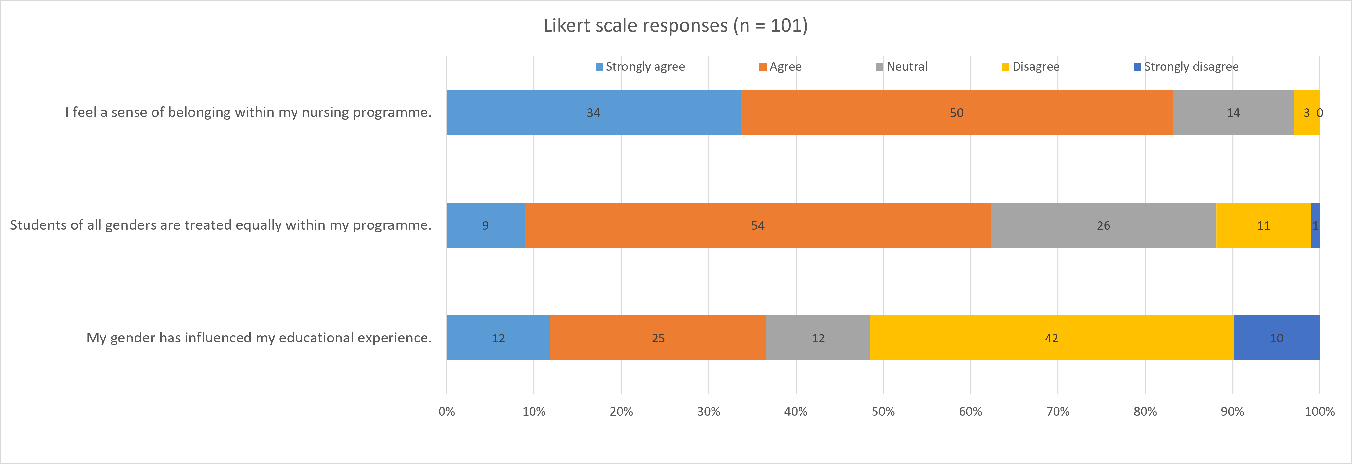

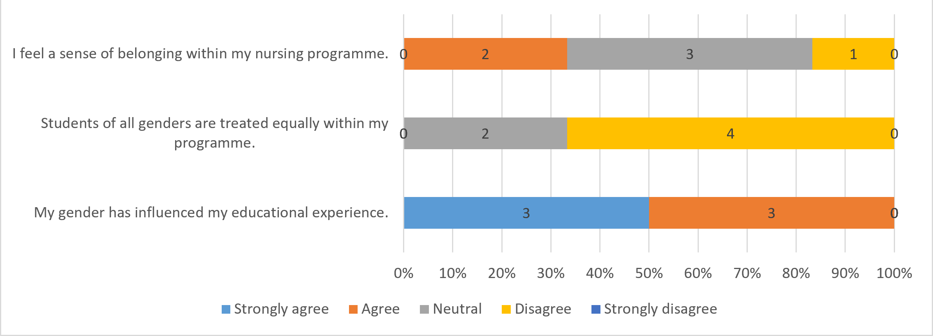
Figure 3. Male respondents’ perceptions of gender and belonging within nursing education (n=6)

Open-text responses provide important context (Appendix 7). Male respondents described feeling accepted while also reporting experiences that heightened their visibility, including standing out within the classroom, being repeatedly asked to provide a male perspective and perceiving that their contributions were received differently; this demonstrates an important distinction between minority visibility and perceived gender bias. Being one of few men and consequently feeling conspicuous does not itself demonstrate bias, whereas accounts of being singled out or treated differently specifically because of gender can more appropriately be interpreted as perceived gender bias. The two may coexist without necessarily removing a sense of belonging.
This complexity is reflected in the literature. Some studies report isolation, marginalisation and heightened visibility among male nursing students (Grimshaw et al., 2024; Yip et al., 2021), whereas Christensen et al. (2021) found that first-year male students generally felt accepted and supported. Chan et al. (2014) similarly found broadly comparable academic and clinical performance between male and female nursing students despite some gender-specific differences in educational experience. Experiencing nursing education differently because of gender should therefore be distinguished from experiencing perceived gender bias and, importantly, from gender presenting a barrier to educational success. The present questionnaire findings establish the first two among some respondents but do not demonstrate that these experiences threatened successful completion.

4.1.5 Barriers within Nursing Education
Respondents reported a range of barriers during nursing education. On a scale from 1 to 10, ratings extended across the full scale, with a median of 6. All six male respondents selected scores between 6 and 10. The questionnaire did not define ‘barrier’ and provided examples including financial pressures, academic workload, placements and personal circumstances; consequently, these ratings indicate perceived difficulties rather than necessarily identifying threats to programme completion.
Open-text responses identified financial pressures, employment, childcare and family responsibilities, travel, placement commitments, workload, confidence and returning to education. Male respondents reported similar difficulties, including balancing study with night shifts and family responsibilities, adjustment from practical employment to academic study and significant financial commitments; one reported having nearly left the programme because of financial pressures. These findings indicate that difficulties experienced by male students cannot be understood solely through gender.
When asked specifically about gender-related barriers, 67 respondents (66.3%) reported experiencing none. In contrast, all six male respondents selected either ‘moderately’ (n=2) or ‘quite a lot’ (n=4). This contrast is notable within the sample but cannot support wider conclusions about male nursing students. Importantly, the question asked whether barriers were experienced because of gender, not whether those barriers affected successful completion.
Male open-text responses included perceptions that their views were not taken seriously, being asked to provide a male perspective, limited representation within resources, teasing about studying nursing and gender-related interactions during clinical placements. Responses were not uniform; one respondent reported no gender-related barriers in the open-text question despite selecting a gender-related barrier category in the preceding closed question, while another stated that he was “not sure if it’s a barrier” before describing limited male representation. These inconsistencies suggest that respondents may have interpreted ‘barrier’ differently and expose a limitation created by not defining the construct within the questionnaire.
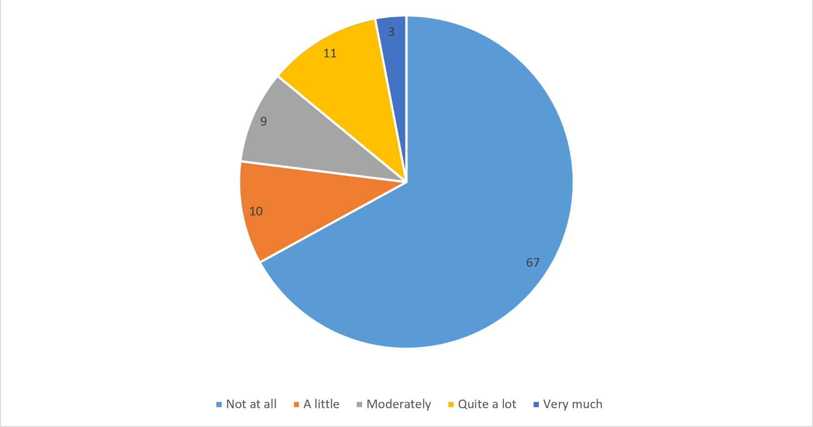

Figure 4. Respondents’ perceived gender-related barriers within nursing education (n=101)

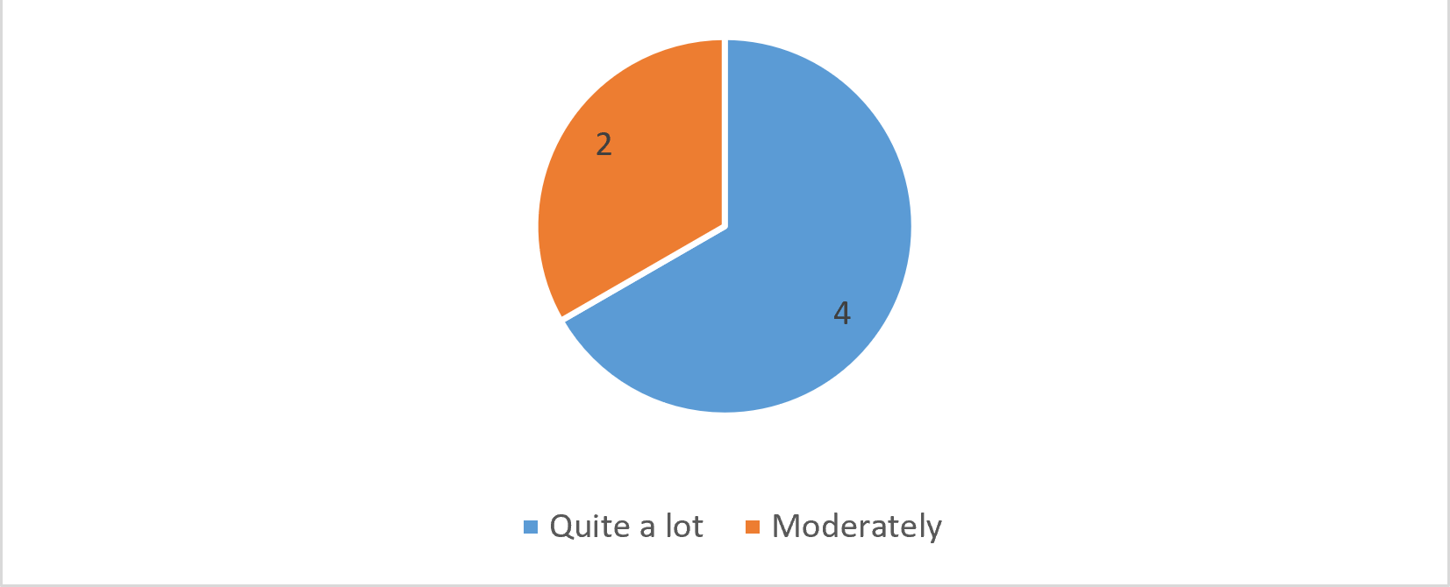
Figure 5. Male respondents’ perceived gender-related barriers within nursing education (n=6)

Taylor et al. (2022), examining male attrition across four Scottish universities, similarly identified gender-related experiences including isolation, marginalisation and stereotyping alongside financial pressures, communication difficulties and access to learning opportunities. Only three participants had actually withdrawn, however, limiting causal conclusions about attrition. Hodges et al. (2017) and Ng, See and Ignacio (2024) also identify gender discrimination, isolation and limited male representation as potential barriers within nursing education. The present findings similarly suggest that gender-related and wider practical, academic and personal difficulties can coexist, but do not establish that gender-related experiences present a greater threat to successful completion.
This distinction is central to RQ3. All six male respondents reported some degree of gender-related barrier in the closed question, yet their open-text responses suggest that some experiences may be more accurately understood as minority visibility, perceived gender bias or educational friction than direct threats to completion. This relationship is explored further within the interview findings.

4.2 Interview Findings and Discussions

4.2.1 Development of Interview Themes
Analysis of the six semi-structured interviews involved repeated engagement with the transcripts, followed by initial coding and the grouping of related codes into broader categories. Participants 1–3 were female and Participants 4–6 were male; these identifiers are used throughout the findings to support interpretation of participants’ accounts by gender. Initial categories included early exposure to nursing, motivations for entering nursing, career opportunities and advancement, gendered perceptions of careers, masculinity and nursing identity, belonging within nurse education, and academic and personal barriers. Comparison across participants allowed related patterns to be developed and refined while retaining differences between individual accounts.
Four themes were developed from this process: ‘Exposure and Awareness Influence Men's Entry into Nursing’; ‘Gender Stereotypes Continue to Shape Perceptions of Nursing’; ‘Men Are Motivated by Personal Values and Career Opportunities’; and ‘Gender Shapes Educational Experience but Not Necessarily Successful Completion’. The themes addressed recurring patterns relevant to the research questions while retaining divergent accounts. For example, Participant 4 described experiencing gender and sexuality-based stereotypes after entering nursing but had not regarded nursing as an inappropriate career for a man. This challenged a simple interpretation that experiencing gender stereotypes necessarily deterred men from entering the profession. A summary of the progression from initial coding to categories and final themes is provided in Appendix 7.

4.2.2 - Exposure and Awareness Influence Men's Entry into Nursing
Exposure to nursing was a recurring influence within the male participants’ accounts of career choice, although the nature and timing of that exposure differed. Participant 4 had grown up with a mother and sister who were nurses and therefore had longstanding familiarity with the profession. He described hearing about their work, understanding the variety within nursing and being able to ask questions about its realities before applying. This appeared to make nursing an established career possibility rather than an unfamiliar occupation:
“Because I'd seen nursing through my family, I never questioned whether it was something a man could do. It was just a career that interested me.”
Participant 6 described a contrasting route. Nursing had not been discussed as a career within his social environment and was not something he initially considered after leaving the military. Later contact with healthcare professionals and nurses changed his understanding of the profession, particularly when he recognised similarities between nursing and skills developed through military service, including teamwork, responsibility, communication and resilience. Reflecting on his earlier lack of awareness, he stated:
“It's difficult to choose a career that you've never seriously considered.”
Participant 5 provided a further perspective, having actively researched nursing before applying to his studies. His account emphasised awareness of the breadth of the profession, including specialist practice, leadership, advanced practice and other progression opportunities.
These accounts illustrate different routes through which nursing became a conceivable career. Exposure was therefore not simply about seeing nurses, but about developing sufficient understanding of the profession for it to become a realistic and potentially attractive career option.
This interpretation is consistent with research identifying familiarity with nursing as an influence upon career consideration. Yi and Keogh's (2016) systematic review identified early exposure to nursing and healthcare professionals among the influences upon men's decisions to enter nursing, while Whitford et al. (2020) identified knowing nurses, encouragement and positive role models as factors facilitating consideration of the profession. Flynn, Brenock and Saab (2025) similarly identified contact with nurses and previous healthcare-related experience among important, reported influences upon choosing nursing. These findings support the relevance of exposure, but do not establish how it operates or whether its absence prevents men from considering nursing.
The distinction between occupational attractiveness and career consideration is particularly relevant. Whitford et al. (2020) found that nursing could be recognised as worthwhile and offering employment security and varied opportunities while simultaneously being perceived as ‘not a career for men’. The present findings suggest that career consideration may therefore occur before an individual evaluates the specific advantages and disadvantages of nursing. Participant 4's familiarity meant that nursing was already within his range of possible careers, whereas Participant 6 described nursing becoming conceivable only after later exposure changed his understanding of the profession. Participant 5's account further suggests that awareness of nursing's professional breadth and progression opportunities may influence what individuals believe a nursing career can offer. Together, these accounts raise the possibility that some men may not actively reject nursing; rather, the profession may not enter their range of careers for serious consideration.
Evidence from earlier stages of career formation provides some support for this interpretation. Linden et al. (2022) found that exposing school pupils in Northern Ireland to realistic accounts of contemporary nursing could influence their perceptions of the profession; the study did not, however, establish whether changed perceptions subsequently resulted in applications or entry to nursing programmes. A similar limitation applies to the present study, as all three male participants had ultimately chosen nursing and were retrospectively identifying influences upon their decisions. Their accounts cannot establish whether men who never consider nursing have less exposure to the profession, or whether increasing awareness would increase male applications.
Exposure was also not exclusive to the male participants, as female participants described previous caring, family and healthcare experiences as influences upon their own decisions to enter nursing. Familiarity with nursing may therefore influence career choice irrespective of gender; its possible relevance to male underrepresentation should consequently be considered within the wider social context in which nursing continues to be associated predominantly with women, rather than interpreted as a specifically male requirement. Similarly, the findings do not demonstrate that men require male role models; family members, healthcare professionals, occupational experience and access to accurate information may provide different routes through which nursing becomes familiar.
In relation to RQ1, these findings suggest that men's lower participation in nursing may involve influences operating before an active decision to accept or reject nursing is made. Within this small group, exposure contributed to whether nursing was perceived as a conceivable career and to awareness of the opportunities it could provide. The findings do not establish a causal relationship between exposure and entry into nursing but indicate that limited career consideration warrants attention alongside more explicit barriers to entry. How this may interact with gendered perceptions of nursing is considered within the following theme.

4.2.3 Gender Stereotypes Continue to Shape Perceptions of Nursing
Gender stereotypes were evident within participants’ accounts of how nursing and male nurses are perceived. Male participants described assumptions concerning caring, masculinity and, in some cases, sexuality, while female participants also identified gendered expectations surrounding career choice. These accounts suggest that nursing continues to carry gendered meanings, although the extent to which these influence men's decisions to enter the profession is less certain.
Participant 4 described experiencing assumptions about his sexuality because he was training to become a nurse; he reported being questioned about this by patients, students and colleagues and linked these experiences to wider assumptions about men working within caring professions. He also challenged the idea that caring was inconsistent with masculinity, arguing that supporting vulnerable people and families through difficult circumstances required resilience and strength:
“The problem isn't nursing. The problem is some of the outdated assumptions that people still have about men who choose nursing.”
Participant 6 similarly questioned the separation of caring and masculinity; drawing upon his military experience, he described trust, loyalty and responsibility for others as forms of caring that had been integral to environments traditionally associated with masculinity. He therefore did not perceive nursing and masculinity as incompatible, rather, he considered society's understanding of masculinity to be too narrow. These accounts are important because neither participant simply accepted the gendered construction of caring; instead, both interpreted caring, resilience and responsibility as compatible with their own understanding of male identity.
This reflects wider literature from Candelaria et al. (2025) and Liu et al. (2025) identifying nursing as a profession that remains culturally associated with women and with characteristics traditionally constructed as feminine. Terry et al. (2020), in a systematic review and integrated synthesis of 24 publications, identified societal, individual and collective influences affecting how men negotiate nursing and male identity. Harding's (2007) study of 18 heterosexual male nursing students and registered nurses in New Zealand similarly identified homophobic stereotyping and strategies used by participants to negotiate assumptions concerning sexuality and masculinity. Harding's (2007) deliberately heterosexual sample limits the wider application of these findings, but the identification of sexuality-based stereotyping corresponds with Participant 4's account of being questioned about his sexuality because of his career choice.
The findings do not support the assumption that masculinity operates uniformly among men entering nursing. Participant 6's military background challenges a simple opposition between caring and masculine identity, as characteristics he associated with military life were also those he valued within nursing. Prosen (2022) similarly identified broadly shared motivations among male and female nursing students, while Prosen and Čekada (2025) reported generally positive attitudes towards men in nursing alongside continuing gender biases and professional identity challenges. Gender stereotypes can therefore remain present without determining how individual men understand either themselves or nursing.
Female participants provided further evidence that gendered career expectations were recognised within the wider participant group. Participants 2 and 3 discussed boys receiving different career messages and the possible influence of childhood expectations and peer judgement; these accounts cannot establish how prospective male applicants themselves perceive nursing, but they demonstrate that gendered career expectations were not identified solely by the male participants. This was also reflected within the questionnaire, where respondents reported gendered language and gendered portrayals within nursing education. As these respondents had already entered nursing, their responses provide evidence of perceived gendered representation rather than evidence that stereotypes prevented entry.
The distinction between experiencing stereotypes and demonstrating their effect upon career choice is therefore important. Whitford et al. (2020) found that nursing could be viewed as secure and worthwhile while also being perceived as ‘not a career for men’, while Meadus and Twomey (2011) identified perceptions of nursing as an inappropriate career for men among male nursing students in Canada. Conversely, Wang, Lin and Wang (2022) and Kulkarni and Nithyanand (2012) suggest that personal career preferences may be more influential than societal attitudes, while Flynn, Brenock and Saab (2025) found stereotypes and media portrayals to be less influential than contact with nurses and previous healthcare experience among people who had chosen or considered nursing. The literature therefore provides stronger evidence that gender stereotypes exist and are experienced than that they directly determine men's application behaviour.
The present findings reflect this distinction. Participants 4 and 6 recognised or experienced gendered assumptions, but neither regarded caring or nursing as incompatible with male identity. Their experiences demonstrate the continuing presence of stereotypes but cannot establish that those stereotypes explain why other men do not enter nursing.
In relation to RQ1, gendered assumptions concerning caring, masculinity and appropriate career choices remain part of the social context within which men encounter nursing. They may influence whether nursing appears appropriate or personally relevant, but the present study cannot establish their relative influence upon men's career decisions. Gender stereotypes therefore provide one possible influence upon men's underrepresentation rather than a sufficient explanation for it.

4.2.4 Men Are Motivated by Personal Values and Career Opportunities
The male participants described varied motivations for entering nursing, combining personal values with practical and career-related considerations. Participant 4 was attracted by work that was challenging, varied and practical, while also wanting a career in which he could make a meaningful contribution. Participant 6 similarly described helping others as important, linking nursing with his previous experience of teamwork, responsibility and service within the military. Participant 5 placed greater emphasis upon long-term professional development, including specialisation, leadership, management, research and advanced clinical practice.
Participant 5's account was particularly focused upon what nursing could provide throughout a career rather than qualification alone. He had initially considered a business-related career and became more interested in nursing as he discovered the range of professional pathways available:
“For me, it wasn't just about becoming a nurse. It was about what nursing could lead to in the future.”
Participant 5 also identified stability and continued development as attractive, while Participants 4 and 6 placed greater emphasis upon meaningful work, challenge, variety and purpose. Even within this small group, motivations were therefore varied rather than representing a single pathway into nursing.
This variation corresponds with the wider literature. Yi and Keogh's (2016) systematic review identified a range of intrinsic and extrinsic influences upon men's decisions to enter nursing. Whitford et al. (2020) similarly identified practical attractions including job security and varied career opportunities alongside interpersonal and experiential influences. The present findings reflect this mixture, with meaningful work and helping others sitting alongside challenge, stability, professional development and career flexibility.
Comparison with the female participants revealed considerable overlap alongside some differences in emphasis. Both male and female participants described influences including previous exposure to care, significant personal relationships and the desire to undertake meaningful work. Male participants, however, more frequently articulated the attractions of nursing through challenge, progression, specialisation, transferable skills and occupational opportunity, whereas female participants more often located their decisions within caring experiences, personal relationships and personal fulfilment. This suggests that similar underlying motivations may have been conceptualised or articulated differently across participants according to gender.
Prosen (2022) provides some support for this distinction, identifying shared motivations including altruism and perceived opportunities among male and female nursing students, while male participants more frequently anticipated management, leadership and technical roles. Such differences should not automatically be attributed to gender. Participant 6's emphasis upon teamwork and transferable skills was closely connected to his military background, while Participant 5 had an established interest in business and progression. Individual biography and career aspirations may therefore have contributed to the apparent gender pattern. Future career aspirations should also be distinguished from initial motivation; Participant 5's interest in progression does not establish that leadership ambitions generally explain why men enter nursing.
In relation to RQ2, the male participants identified meaningful work, helping others, challenge, variety, stability and professional development as motivations for entering nursing. Many were shared with female participants, although differences were apparent in how they were articulated and prioritised. The findings do not support a wholly distinctive male motivational pathway but suggest that individual experience and career aspirations may shape how participants conceptualise the attractions of nursing.

4.2.5 Gender Shapes Educational Experience but Not Necessarily Successful Completion
Participants described a range of barriers during nursing education, but the difficulties most directly associated with successful completion were not predominantly gender-specific. Male participants identified time management, employment, financial pressures, academic writing and adjustment to higher education alongside experiences related to being a numerical minority. Female participants similarly described competing responsibilities, childcare, financial pressures and academic confidence. Across the interviews, practical and personal circumstances therefore appeared more consistently connected with progression through the programme than gender alone.
Participant 4 identified balancing employment, placement and academic requirements as his principal challenge and also described difficulty with academic writing; he nevertheless distinguished these difficulties from gender-related assumptions:
“I wouldn't say these experiences have stopped me progressing, but they can become tiring after a while.”
Participant 5 similarly emphasised time management, employment and financial pressures and questioned whether many of the challenges experienced by students could be explained primarily through gender. He noted that students differed in their family responsibilities, employment, commuting and previous educational experience, concluding that these circumstances could have a greater impact than gender. Both accounts suggest a distinction between experiencing nursing education differently because of gender and experiencing a barrier that threatens successful completion.
Participant 6 provided a more explicit account of minority status and belonging. He described becoming aware of the small number of men on the programme and sometimes finding it difficult to relate socially to other students; he nevertheless stated that he had not been deliberately excluded:
“That doesn't necessarily stop you succeeding, but it can affect how comfortable you feel initially.”
Participant 6 also described occasions when he felt expected to provide “the male perspective”, which could make him feel that he was representing men generally rather than expressing an individual view. The account suggests that numerical minority status can create visibility and discomfort without necessarily producing exclusion or preventing academic progression; his academic challenges, particularly rebuilding confidence after time away from formal education, were not described as gender-specific.
The interview findings provide further context for the questionnaire results, in which male respondents described gender influencing their educational experience alongside experiences of minority visibility, being expected to represent a male viewpoint and gender-related interactions during placement. Considered alongside the interviews, these findings suggest that gender can shape educational experience without necessarily presenting a threat to successful completion.
This distinction is reflected within the wider literature. Taylor et al. (2022), examining male attrition across four Scottish universities, identified isolation, marginalisation and gender stereotyping alongside financial pressures, communication difficulties and difficulties accessing learning opportunities. The inclusion of men who had withdrawn makes the study particularly relevant to RQ3, although only three withdrawn students participated. Taylor et al. (2022) therefore provide evidence that gender-related experiences can occur alongside factors associated with persistence but cannot establish their relative contribution to withdrawal. Similarly, Ng, See and Ignacio's (2024) qualitative systematic review identified discrimination, missed clinical opportunities and psychological and social stressors among male nurses and nursing students, but its mixed professional and international evidence base limits direct application to programme completion within Welsh preregistration education.
Evidence concerning educational outcomes provides further reason for caution. Chan et al. (2014) found broadly similar academic and clinical performance between male and female undergraduate nursing students across the studies included in their systematic review, despite identifying some distinctive negative experiences among men. Although the review is older and internationally heterogeneous, it reinforces an important distinction within the present findings: experiencing nursing education differently does not necessarily result in poorer educational attainment or unsuccessful completion.
The female participants also provide an important counterpoint; their accounts described substantial pressures involving childcare, caring responsibilities, employment, finances and academic confidence. These experiences demonstrate that barriers capable of affecting progression are not confined to male students and may arise from circumstances unrelated to gender. The findings therefore do not support a simple division in which male students encounter gender barriers while female students experience nursing education without comparable difficulties.
In relation to RQ3, gender shaped aspects of male participants' educational experiences through minority visibility, gendered assumptions and expectations to represent a male perspective. These experiences could affect comfort and belonging but were not generally described as preventing successful progression. Barriers more directly connected with completion involved competing demands, finances, employment and academic adjustment, many of which were also experienced by female participants. The findings therefore provide stronger evidence that gender can influence how nursing education is experienced than that gender-related barriers independently threaten successful completion.

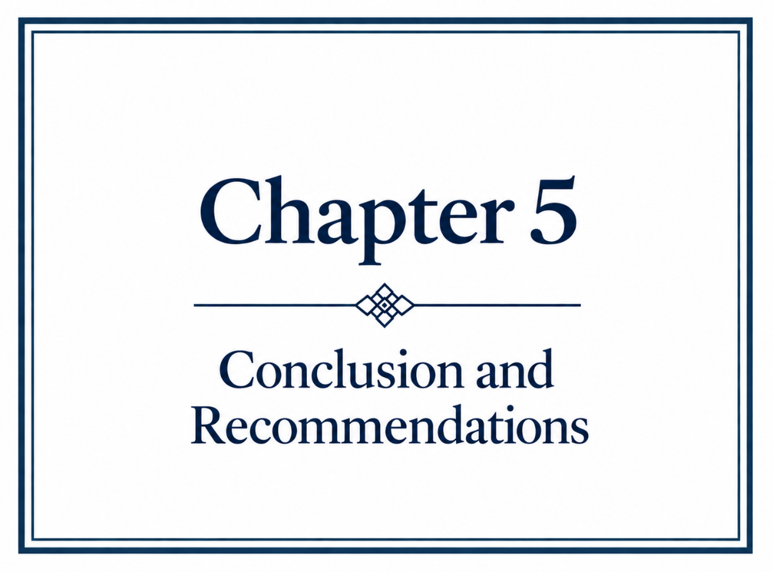

5.1 Conclusions and Contribution
This study identified that gender continues to shape experiences within nurse education, although not predominantly in the ways initially anticipated. The findings did not provide sufficient evidence that differences in learning preferences or teaching approaches disadvantaged male students. Instead, gender was more apparent through minority visibility, gendered assumptions and stereotypes, including male participants describing standing out within a predominantly female environment and being expected to provide a male perspective. These experiences demonstrate that gender can influence how nurse education is experienced but should not automatically be interpreted as evidence of disadvantage or as barriers to successful completion.
The findings also suggest that men's underrepresentation cannot be explained by a single gender-related influence. Exposure and awareness appeared relevant to whether nursing became a conceivable career, while participants described motivations including meaningful work, helping others, challenge, stability and professional development. Gender stereotypes remained evident, but their presence did not establish that they determined career choice. Similarly, barriers more directly associated with progression included financial pressures, employment, competing responsibilities and academic adjustment, many of which were not gender-specific. The study therefore contributes a more nuanced understanding of gender within nurse education, distinguishing gendered experience from disadvantage and perceived barriers from threats to successful completion.

5.2 Limitations and Reflections
Reflection on the research process identified limitations within both the sample and questionnaire design. Although 101 students completed the questionnaire, only six were male, with three subsequently participating in interviews, limiting the extent to which findings can represent male nursing students more broadly. Furthermore, investigating why men are less likely to enter nursing through participants who had already chosen the profession restricted exploration of those who had never considered or had rejected nursing as a career. Greater distinction was also required within the questionnaire between gendered experiences, perceived difficulties and barriers that might threaten successful completion. Refining these constructs would have strengthened the alignment between the data collected and the research questions.

5.3 Recommendations and Future Research
The findings support consideration of gender-inclusive approaches to the representation of nursing. Recruitment materials should represent men and women equally while communicating the breadth of nursing roles, skills and career opportunities, rather than presenting nursing differently to men. This is consistent with evidence that exposure to realistic accounts of contemporary nursing can influence perceptions of the profession (Linden et al., 2022), although evidence that such approaches increase applications remains limited.
Within nurse education, greater recognition of the historical contributions of both men and women could broaden traditional gendered narratives of nursing, while an audit of learning resources and recommended reading could identify gendered language or representation. These recommendations respond to participants’ perceptions of limited male representation but should not be interpreted as interventions demonstrated by this study to improve recruitment, belonging or completion.
Future research should prioritise young people before key educational and career decisions are made. The present study could identify retrospectively what influenced students who ultimately entered nursing but could not explain why other men never considered or rejected the profession. Research with school-aged young people could therefore examine when gendered perceptions of nursing develop, whether nursing enters the range of careers considered by boys, and what influences its inclusion or rejection.



Adeniji, O., Akanni, A., Owkulaemi, R. and Ekundayo, O. (2015) ‘Gender difference in emotional labour among nurses’ Gender and Behaviour, 13(2), pp 6789–6794.
Almalki, S. (2016) ‘Integrating Quantitative and Qualitative Data in Mixed Methods Research—Challenges and Benefits’, Journal of Education and Learning, 5(3), pp. 288–296. Available at:doi.org/10.5539/jel.v5n3p288.
Ames, H., Glenton, C. and Lewin, S. (2019) ‘Purposive sampling in a qualitative evidence synthesis: a worked example from a synthesis on parental perceptions of vaccination communication’, Bio Med Central Journal of Medical Research and Methodology, 19(26). Available at:/doi.org/10.1186/s12874-019-0665-4.
Amin, S. M., Demerdash, D. E., Othman, A. A., Zoromba, M. A., El-Gazar, H.E., Atta, M. A., Albzia, A., Abdelrahman, A. M., Alasqah, I. and Abdallah, H. M. (2025) ‘The mediating role of professional identity in the relationship between gender misconceptions and occupational stigma among male nursing students’, BMC Nursing, 24, pp. 930. Available at:10.1186/s12912-025-03552-5.
Andina-Díaz, E., Ventura-Miranda, M. I., Quiroga-Sánchez, E., Ortega-Galán, Á. M., Fernández-Medina, I. M. and Ruiz-Fernández, M. D. (2023) ‘Nursing Students' Perception about Gender Inequalities Presented on Social Networks: A Qualitative Study’, International Journal of Environmental Research and Public Health, 20(3), pp. 1962-1967. doi: 10.3390/ijerph20031962.
Andrews, T. (2012) ‘What is Social Constructionism?’, The Grounded Theory Review, 11(1), pp. 39-46.
Anthony, A. (2004) ‘Gender Bias and Discrimination in Nursing Education: Can we change it?’, Nurse Educator, 29(3), pp. 121-125. Available at: https://doi.org/10.1097/00006223-200405000-00009.
Attia, M. and Edge, J. (2017) ‘Be(com)ing a reflexive researcher: a developmental approach to research methodology’, Open Review of Educational Research, 4(1), pp. 33–45. https://doi.org/10.1080/23265507.2017.1300068.
Bailey, J. (2008) ‘First steps in qualitative data analysis: transcribing’, Family Practice, 25(2), 127-131. Available at: https://doi.org/10.1093/fampra/cmn003.
Baker, M. J., Fisher, M. and Pryor, J. (2021) ‘Potential for misinterpretation: An everyday problem male nurses encounter in inpatient rehabilitation’, International Journal of Nursing Practice, 28(1). Available at: https://doi.org/10.1111/ijn.12985.
Berger, P. L. and Luckmann, T. (1966) The Social Construction of Reality: A Treatise in the Sociology of Knowledge. New York: Doubleday and Company.
Berger, R. (2015) 'Now I see it, now I don't: Researcher's position and reflexivity in qualitative research', Qualitative Research, 15(2), pp. 219-234. Available at: https://doi.org/10.1177/1468794112468475.
Bishop, P. A. and Herron, R. L. (2015) ‘Use and Misuse of the Likert Item Responses and Other Ordinal Measures’, International Journal of Exercise Science, 8(3), pp. 297-302. Available at:doi: 10.70252/LANZ1453.
Brace, I. (2022) Questionnaire design: How to plan, structure and write survey material for effective market research. 5th edn. London: Kogan Page.
Brannan, J. D., White, A. and Long, J. (2016) ‘Learning styles: impact on knowledge and confidence in nursing students in simulation and classroom’, International Journal of Nursing Education Scholarship, 13(1). Available at: 10.1515/ijnes-2015-0052.
Braun, V. and Clarke, V. (2006) ‘Using Thematic Analysis in Psychology’, Qualitative Research in Psychology, 3(2), pp. 77-101. Available at:doi.org/10.1191/1478088706qp063oa.
Braun, V. and Clarke, V. (2019) ‘Reflecting on Reflexive Thematic Analysis’, Qualitative Research in Sport, Exercise and Health, 11(4), pp. 589-597. Available at: doi.org/10.1080/2159676X.2019.1628806.
Braun, V. and Clarke, V. (2022) Thematic analysis: A practical guide. London: Sage.
Brinkmann, S. and Kvale, S. (2018) Epistemological issues of interviewing. Thousand Oaks: Sage Publications Inc.
British Educational Research Association (2024) Ethical guidelines for educational research. 5th edn. London: BERA.
Brown, B., Nolan, P. and Crawford, P. (2000) ‘Men in nursing, ambivalence in care, gender and masculinity’, International History Nursing Journal, 2000, 5(3), pp. 4-13.
Brown, R. G. and Stone, R. W. (1973) The Male Nurse. Birkenhead: Wilmer Brothers.
Bryman, A. (2016) Social Research Methods. 5th edn. Oxford: Oxford University Press.
Burns, M., Bally, J., Burles, M., Holtslander, L. and Peacock, S. (2022) ‘Constructivist Grounded Theory or Interpretive Phenomenology? Methodological Choices Within Specific Study Contexts’, International Journal of Qualitative Methods, 21, pp. 1-13. Available at: https://doi.org/10.1177/16094069221077758.
Busetto, L., Wick, W. and Gumbinger, C. (2020) 'How to use and assess qualitative research methods', Neurological Research and Practice, 2(14). Available at: https://doi.org/10.1186/s42466-020-00059-z.

Campbell, R., Goodman-Williams, R., Feeney, H. and Fehler-Cabral, G. (2020) ‘Assessing Triangulation Across Methodologies, Methods, and Stakeholder Groups: The Joys, Woes, and Politics of Interpreting Convergent and Divergent Data’, American Journal of Evaluation, 41(1), pp. 125-144. Available at: https://doi.org/10.1177/1098214018804195.
Candelaria, D., River, J., Gallagher, R. and McCormack, B. (2025) 'Harnessing the collective power of gender equity and diversity in nursing', Journal of Advanced Nursing, 82, pp. 4059-4061. Available at: https://doi.org/10.1111/jan.16835.
Carnevale, T.D. and Priode, K. (2018) ‘The Good Ole’ Girls’ Nursing Club: The Male Student Perspective’, Journal of Transcultural Nursing, 29(3), pp. 285–291. Available at: https://doi.org/10.1177/1043659617703163.
Carter, D., Milasan, L. H., Clifton, A., McGill, G., Stribling, J. and De Vries, K. (2025) 'The perceptions of male accessibility to the fields of nursing practice by those studying or teaching nursing in England: Cross-sectional survey', Journal of Advanced Nursing, 5(81), pp. 6452–6467. Available at: https://doi.org/10.1111/jan.16789.
Cassell, C. and Bishop, V. (2019) ‘Qualitative data analysis: Exploring themes, metaphors and stories’, European Management Review, 16, pp. 195-207. Available at: https://doi.org/10.1111/emre.12176.
Chan, Z. C. Y., Cheng, Q. Q., Ling, C. C. Y. and Lui, A. M. H (2014) ‘Gender differences in the academic and clinical performances of undergraduate nursing students: a systematic review’, Nurse Education Today, 34(3), pp. 377–388. Available at: 10.1016/j.nedt.2013.06.011.
Chavez, C. (2008) 'Conceptualizing from the inside: Advantages, complications and demands on insider positionality', The Qualitative Report, 13(3), pp. 474-494. Available at: https://doi.org/10.46743/2160-3715/2008.1589.
Christensen, M. (2017) ‘Men in nursing: The early years’, Journal of Nursing Education and Practice, 7(5), pp. 94–103. Available at: 10.5430/jnep.v7n5p94.
Christensen, M., Purkis, N., Morgan, R. and Allen, C. (2021) ‘Does the nursing curriculum influence feelings of gender-role conflict in a cohort of nursing degree male students?’, British Journal of Nursing, 30(17), pp. 1024–1030. Available at: 10.12968/bjon.2021.30.17.1024.
Clark, T. (2011) 'Gaining and maintaining access: Exploring the mechanisms that support and challenge the relationship between gatekeepers and researchers', Qualitative Social Work, 10(4), pp. 485-502. Available at: https://doi.org/10.1177/1473325010369028
Connell, R. W. and Messerschmidt, J. W. (2005) ‘Hegemonic Masculinity: Rethinking the Concept’, Gender Society, 19(6), pp. 829-859. https://doi.org/10.1177/0891243205278639.
Creswell, J. (2015) Research Design: Qualitative, Quantitative and Mixed Methods Approaches. London: Pearson Education Inc.
Creswell, J. W. and Plano-Clark, V. L. (2017) Designing and Conducting Mixed Methods Research. 3rd edn. Thousand Oaks: Sage.
Crowhurst, I. (2013) 'The fallacy of the instrumental gate? Contextualising the process of gaining access through gatekeepers', International Journal of Social Research Methodology, 16(6), pp. 463-475. Available at: https://doi.org/10.1080/13645579.2013.823282.
Cudé, G, and Winfrey, K. (2007) ‘The hidden barrier: gender bias: fact or fiction?’ Nursing for Women's Health, 11(3), pp. 254-265. Available at: https://doi.org/10.1111/j.1751-486X.2007.00165.x.
DeJonckheere, M. and Vaughn, L. M. (2019) ‘Semi-structured interviewing in primary care research: a balance of relationship and rigour’, Journal of Family Medicine and Community Health, 7(2), e000057. doi: 10.1136/fmch-2018-000057.
Drennan, V., Halter, M., Gale, J. and Harris, R. (2016) ‘Retaining nurses in metropolitan areas: insights from senior nurse and human resource managers’, Journal of Nursing Management, 24(8) pp 1041–1048. Available at: https://doi.org/10.1111/jonm.12402.
Dwyer, S. C. and Buckle, J. L. (2009) 'The space between: On being an insider-outsider in qualitative research', International Journal of Qualitative Methods, 8(1), pp. 54-63. Available at: https://doi.org/10.1177/160940690900800105
Dyck, J.M., Oliffe, J., Phinney, A. and Garrett, B. (2009) ‘Nursing instructors’ and male nursing students’ perceptions of undergraduate, classroom nursing education’, Nurse Education Today, 29(6), pp. 649–653. DOI: 10.1016/j.nedt.2009.02.003.
Fernández-Delgado, J. C. M., Fernández-Sanchez, H., Sharif, L. S. and Canova-Barrios, C. (2025) ‘The evolution of the male role in nursing: a narrative review study’, Khyber Medical University Journal, 17(4), pp. 484-492. Available at: DOI: 10.35845/kmuj.2025.23904.
Field, A. (2018) Discovering Statistics Using IBM SPSS Statistics. 5th edn. London: Sage Publications.
Fink, A. (2017) How to Conduct Surveys: A Step-by-Step Guide. 6th edn. Thousand Oaks: Sage Publications Inc.
Flick, U. (2020) An Introduction to Qualitative Research. 6th edn. London: SAGE.
Flynn, A. V., Brenock, O. and Saab, M. M. (2025) ‘Factors influencing men's decisions about a career in nursing’, PLOS ONE, 20(12), e0337360. Available at:10.1371/journal.pone.0337360.
Folami, F. (2017) ‘Gender Inequality and Role-strain among Male Nursing Students in Selected Nursing Institution, Lagos, Nigeria’, Journal of Education and Training Studies, 5(16), pp. 214–219. Available at: https://doi.org/10.11114/jets.v5i6.2435.

Ghimire, A. and Qiu, Y. (2025) ‘Navigating masculinity in nursing: Unpacking the 'critical care only' career aspirations of male undergraduate nursing students’, Nurse Education in Practice, 84. Available at: https://doi.org/10.1016/j.nepr.2025.104332.
Grady, C., Stewardson, G., Mitchell, F. and Hall, J. (2008) ‘Faculty notions regarding caring in male nursing students’, Journal of Nursing Education, 47(7), pp. 314-323. Available at: https://doi.org/10.3928/01484834-20080701-05.
Greene, M. J. (2014) 'On the inside looking in: Methodological insights and challenges in conducting qualitative insider research', The Qualitative Report, 19(29), pp. 1-13. Available at: https://doi.org/10.46743/2160-3715/2014.1106
Grimshaw, L., Jackson, S., Littlefair, D. and Melling, A. (2024) 'Experiences of men in the minority: understanding men's sense of belonging studying primary education, nursing and social work in higher education', Journal of Further and Higher Education, 48(1), pp. 81-96. Available at: https://doi.org/10.1080/0309877X.2023.2263384.
Harding, T. (2007) ‘The construction of men who are nurses as gay’, Jan Leading Global Nursing Research, 60(6), pp. 636-644. Available at: https://doi.org/10.1111/j.1365-2648.2007.04447.x.
Hardy, L. K. (1986) Career Politics: The case of career histories of selected leading female and male nurses. Chichester: Wiley and Sons.
Hattie, J. and O’Leary, T. (2025) ‘Learning styles, preferences, or strategies? An explanation for the resurgence of styles across many meta-analyses’, Educational Psychology Review, 37(2), Article 31. Available at: 10.1007/s10648-025-10002-w.
Heffler, B. (2001) ‘Individual learning style and the learning style inventory’, Educational Studies, 27(3), pp. 307-316. Available at: https://doi.org/10.1080/03055690120076583.
Hlatshwako, T. G., Shah, S. J., Kosana, P., Adebayo, E., Hendriks, J., Larsson, E. C., Hensel, D. J., Erausquin, J. T., Marks, M., Michielsen, K., Saltis, H., Francis, J. M., Wouters, E. and Tucker, J. D. (2021) ‘Online health survey research during COVID-19’, Lancet Digital Health, 3(2), pp. 76–77. Available at: https://doi.org/10.1016/S2589-7500(21)00009-0.
Hodges, E. A., Rowsey, P. J., Gray, T. F., Kneipp, S. M., Giscombe, C. W., Foster, B. B., Alexander, G. R. and Kowlowitz, V. (2017) ‘Bridging the Gender Divide: Facilitating the Educational Path for Men in Nursing’, Journal of Nursing Education, 56(5), pp. 295–299. Available at: 10.3928/01484834-20170421-08.
Ibrahim, R. H. and Hussein, D. (2016) ‘Assessment of visual, auditory, and kinesthetic learning style among undergraduate nursing students’, International Journal of Advanced Nursing Studies, 5(1), pp. 1-4. Available at: https://doi.org/10.14419/ijans.v5i1.5124.

Jezuit, D., Carter-Richey, M., Ridge, A. and Ritt, E. (2020) ‘Advancing the Synergy of Benedictine Values and Caring in Online Graduate Nursing Education’, International Journal for Human Caring, 22(2), pp. 20–25. Available at: https://doi.org/10.20467/1091-5710.22.2.20.
Kallio, H., Pietilä, A. M., Johnson, M. and Kangasniemi, M. (2016) 'Systematic methodological review: Developing a framework for a qualitative semi-structured interview guide', Journal of Advanced Nursing, 72(12), pp. 2954–2965. Available at: https://doi.org/10.1111/jan.13031.
Kaur, N., Ricciardelli, R. and Clow, K. (2023) ‘Men in Nursing: A Qualitative Examination of Students’ Stereotypes of Male Nurses through the Framework of Social Role Theory and Stereotype Content Model’, The Journal of Men’s Studies, 31(1), pp. 157–178. Available at: 10.1177/10608265221108209.
Kaushik, V. and Walsh, A. (2019) ‘Pragmatism as a Research Paradigm and Its Implications for Social Work Research’, Journal of Social Sciences, 8(9), Article 255. Available at: https://doi.org/10.3390/socsci8090255.
Kearns, T. and Mahon, P. (2021) ‘How to attain gender equality in nursing—an essay’, British Medical Journal, 373, pp. 1232-1323. Available at: https://doi.org/10.1136/bmj.n1232.
Kolb, A. Y. and Kolb, D. A. (2005) ‘Learning styles and learning spaces: Enhancing the experimental learning in higher education’, Academy of Management, Learning and Education, 4(2), pp. 193-212. Available at: https://doi.org/10.5465/AMLE.2005.17268566.
Krueger, R. A. and Casey, M. A. (2015) Focus Groups: A Practical Guide for Applied Research. 5th edn. Thousand Oaks: Sage Publications.
Kulkarni, M. and Nithyanand, S. (2012) ‘Social influence and job choice decisions’, Journal of Employee Relations, 35(2). Available at: doi:10.1108/01425451311287844.
Kuzma, E. K. and Yingling, C. (2025) ‘Gender diversity in nursing: time to erode the social fallacy of gender norms to create an inclusive nursing workforce’, Evidence-Based Nursing, 28(1), pp. 22-23. Available at: https://doi.org/10.1136/ebnurs-2023-103908.
Lachenmayer, D. (1997) Learning Styles: A handbook for teachers to identify and teach to all learning styles. London: Merriam Webster.
Lamiri, A., Qaisar, R., Khoaja, D., Abidi, O., Bouzoubaa, H. and Khyati, A. (2020) ‘Descriptive Study of Nursing Students' Learning Styles. Case Study of the Professional Bachelor's Degree Cycle in Nursing of the Higher Institute of Nursing Professions and Health Techniques of Casablanca, Morocco’, The Open Nursing Journal, 14(3), pp. 309-316. Available at: https://doi.org/10.2174/1874434602014010309.

Li, Y., Chen, P. and Tsai, S. (2008) ‘A comparison of the learning styles among different nursing programs in Taiwan: Implications for nursing education’, Nurse Education Today, 28(1), pp. 70-76. Available at: https://doi.org/10.1016/j.nedt.2007.03.006.
Linden, M. A., Cannon, M., Comiskey, C. M., McPherson, S., McMurray, A., Hartin, P. J., Carter, B., Cree, C., McKinley, Y., Neill, A., Lowe, B., Begley, T. and Hunter, R. F. (2022) ‘Recruiting males to the nursing profession: acceptability testing of the “Make a Difference with Nursing” intervention for post-primary school students’, BMC Nursing, 21, Article 173. Available at: https://doi.org/10.1186/s12912-022-00956-5.
Liu, H. Y., Han, H. M., Chao, C. Y., Chen, H. F. and Wu, S. M. (2022a) 'Performative masculinity: A meta-ethnography of experiences of men in academic and clinical nursing', International Journal of Environmental Research and Public Health, 19(22), 14813. Available at: https://doi.org/10.3390/ijerph192214813.
Liu, Y., Yao, C., Zhao, S., Han, P., Jiang, J. and Duan, X. (2022b) ‘Perspective and experience of male nursing students in 3-year vocational college during their clinical practicum: A qualitative study in Shanghai, China’, Frontiers in Public Health, 10, Article 905200. Available at: https://doi.org/10.3389/fpubh.2022.905200.
Loughry, M. (2008) ‘Just how male are male nurses…?’, Journal of Clinical Nursing, 17(10), pp. 1327-1334. Available at: doi10.1111/j.1365-2702.2007.02250.x.
Luke, M. and Goodrich, K. M. (2019) ‘Focus Group Research: An Intentional Strategy for Applied Group Research?’, The Journal for Specialists in Group Work, 44(2), pp. 77-81. Available at: https://doi.org/10.1080/01933922.2019.1603741.
Mackintosh, C. (1997) ‘A historical study of men in nursing’, Journal of Advanced Nursing, 26(2), pp. 232–236. Available at: https://doi.org/10.1046/j.1365-2648.1997.1997026232.x
Mangold, K., Kunze, K. L., Quinonez, M. M., Taylor, L. M. and Tenison, A. J. (2018) ’Learning Style Preferences of Practicing Nurses’, Journal for nurses in professional development, 34(4), pp. 212–218. Available at: https://doi.org/10.1097/NND.0000000000000462.
Maslovskaya, O., Lynn, P., Calderwood, L., Durrant, G., Fitzgerald, R., Nicolaas, G. and Williams, J. (2025) Survey Futures position statement on response rates. Survey Futures. Available at: Response-Rates-Posititon-Statement_Survey-Futures.pdf (Accessed on 5 September 2026).
McGrath, C., Palmgren, P. J. and Liljedahl, M. (2019) 'Twelve tips for conducting qualitative research interviews', Medical Teacher, 41(9), pp. 1002-1006. Available at: https://doi.org/10.1080/0142159X.2018.1497149.
McLaughlin, K. and Muldoon, O. (2010) ‘Gender, gender roles and completion of nursing education: a longitudinal study’, Nurse Education Today, 30(4), pp 303–307. Available at: https://doi.org/10.1016/j.nedt.2009.08.005.
McMullan, J., Thompson, D. R., Dixon, A., Palumbo, A., Dickinson, T., Jourdain, P., Monaghan, C. and Quinn, B. (2025) 'Exploring perceptions of what increased gender diversity might bring to the nursing profession', Journal of Advanced Nursing, 81(1), pp. 450-462. Available at: https://doi.org/10.1111/jan.16246.
Meadus, R. and Twomey, J. (2011) ‘Men student nurses: the nursing education experience’ Nursing Forum, 46(4), pp. 269-279. Available at: https://doi.org/10.1111/j.1744-6198.2011.00239.x
Mellish, J. M. (1984) A Basic History of Nursing. Durban: Butterworth.
Mercer, J. (2007) ‘The challenges of insider research in educational institutions: wielding a double‐edged sword and resolving delicate dilemmas’, Oxford Review of Education, 33(1), pp. 10–27. Available at: https://doi.org/10.1080/03054980601094651.
Morgan, D. L. (2014) Integrating Qualitative and Quantitative Methods: A Pragmatic Approach. Thousand Oaks: Sage.
Nancekivell, S. G., Shah, P. and Gelman, S. A. (2020) ‘Maybe They’re Born With It, or Maybe It’s Experience: Toward a Deeper Understanding of the Learning Style Myth’, Journal of Educational Psychology, 112(2), pp. 221-235. Available at: https://doi.org/10.1037/edu0000366.
Ng, M., See, C. and Ignacio, J. (2024) 'Qualitative systematic review: The lived experiences of males in the nursing profession on gender discrimination encounters', International Nursing Review, 71(3), pp. 468-483. Available at: https://doi.org/10.1111/inr.12921.
Nursing and Midwifery Council (2018) The Code: Professional standards of practice and behaviour for nurses, midwives and nursing associates. London: Nursing Midwifery Council.
Nursing and Midwifery Council (2026) The NMC Register Wales: 1 April 2025 – 31 March 2026. London: Nursing and Midwifery Council.
Nyumba, T. O., Wilson, K., Derrick, C. J. and Mukherjee, N. (2018) ‘The use of focus group discussion methodology: Insights from two decades of application in conservation’, Methods in Ecology and Evolution, 9(1), pp. 20-32. Available at: https://doi.org/10.1111/2041-210X.12860.
O’Lynn, C. E. and Tranbarger, R. E. (2007) Men In Nursing: History, challenges and Opportunities. New York: Springer Publishing Company.
Olmos-Vega, F. M., Stalmeijer, R. E., Varpio, L. and Kahlke, R. (2023) ‘A practical guide to reflexivity in qualitative research: AMEE Guide No. 149’, Medical Teacher, 45(3), pp. 241–251. Available at: https://doi.org/10.1080/0142159X.2022.2057287.
O'Lynn, C. E. (2004) ‘Gender-based barriers for male students in nursing education programs: prevalence and perceived importance’, Journal of Nursing Education, 43(5), pp. 229–236. Available at: 10.3928/01484834-20040501-08.
Ponto J. (2015) ‘Understanding and Evaluating Survey Research’, Journal of Advanced Practice in Oncology, 6(2), pp. 168-71. Available at: https://doi.org/10.6004/JADPRO.2015.6.2.9.
Prosen, M. (2022) 'Nursing students' perception of gender-defined roles in nursing: a qualitative descriptive study', BMC Nursing, 21, 123. Available at: https://doi.org/10.1186/s12912-022-00876-4.
Prosen, M. and Čekada, T. (2025) 'Nursing students' views on men in nursing: a gender diversity challenge in the healthcare workforce', BMC Nursing, 24(1), 820. Available at: https://doi.org/10.1186/s12912-025-03521-y.
Regmi, P. R., Waithaka, E., Paudyal, A., Simkhada, P. and van Teijlingen E. (2016) ‘Guide to the design and application of online questionnaire surveys’, Nepal Journal of Epidemiology, 6(4), pp. 640-644. Available at: 10.3126/nje.v6i4.17258.
Regnault, A., Willgoss, T. and Barbic, S. (2018) ‘Towards the use of mixed methods inquiry as best practice in health outcomes research’, Journal of Patient Reported Outcomes 2(19). https://doi.org/10.1186/s41687-018-0043-8.
Royal College of Nursing (2026) Nurse Shortage Far Worse Than First Thought, RCN Analysis Shows. Available at rcn.org.uk/news-and-events/news/uk-nurse-shortage-far-worse-than-first-thought-rcn-analysis-shows-220926 (Accessed on 22nd September 2026).
Rubin, H. J. and Rubin, I. S. (2012) Qualitative Interviewing: The Art of Hearing Data. 3rd edn. Thousand Oaks: Sage Publications.
Sherrod, D. (2003) ‘Reach out to the best and the brightest’, Journal of Nursing Practice, 33(3), pp. 43-44.
Shim, J., Park, D. I. (2023) ‘The Influence of Gender Equity in Nursing Education Programs on Nurse Job Satisfaction’, Healthcare, 11(9), pp. 13-18. Available at: 10.3390/healthcare11091318.
Stanley, D., Beament, T., Falconer, D., Haigh, M., Saunders, R., Stanley, K., Wall, P. and Nielson, S. (2017) ‘Why can’t they stay? A study of male retention in undergraduate nursing programmes’, Journal of Advanced Nursing, 73(12), pp. 3055–3065. Available at: https://doi.org/10.1111/jan.13350.
Stewart, T. (2026) ‘The dual burden of visibility: A qualitative exploration of the experiences of male faculty in nursing education programs’, Nurse Education Today, 167:107327. Available at: doi: 10.1016/j.nedt.2026.107327.
Taylor, J., Marland, G., Whitford, H., Carson, M. and Leece, R. (2022) ‘Isolation and marginalization: exploring attrition of men in preregistration nursing programs’, Journal of Nursing Education, 61(4), pp. 179–186. Available at: 10.3928/01484834-20220209-02.
Teresa-Morales, C., Rodríguez-Pérez, M., Araujo-Hernández, M. and Feria-Ramírez, C. (2022) ‘Current Stereotypes Associated with Nursing and Nursing Professionals: An Integrative Review’, International Journal of Environmental Research and Public Health, 19(13), pp. 7640. Available at: 10.3390/ijerph19137640.
Terry, D., Peck, B., Carden, C., Perkins, A. J. and Smith, A. (2020) ‘Traversing the Funambulist’s Fine Line between Nursing and Male Identity: A Systematic Review of the Factors that Influence Men as They Seek to Navigate the Nursing Profession’, European Journal of Investigation in Health Psychology and Education, 10, pp. 691–703. Available at:10.3390/ejihpe10030051.
Universities and Colleges Admissions Service (2025a) New UCAS Insight Shows Health and Social Care Professions Among the Most Diverse and Welcoming. Available at ucas.com/corporate/news-and-key-documents/news-ucas-insight-health-and-care-statistics (Accessed on 17th September 2026).
University and College Admissions Service (2025b) UCAS End of Cycle Report: Chapter 2 – Nursing: Summary of applicants and acceptances. Cheltenham: UCAS.
Vanover, C. (2021) Analyzing and interpreting qualitative data: After the interview. Thousand Oaks: Sage Publications Inc.
Verger, J. (1986) Different Values and Authorities. Cambridge: Cambridge University Press.
Villanueve, M. J. (1994) ‘Recruiting and Retaining Men in Nursing: A review of literature’, Journal of Professional Nursing, 10(4), pp. 217-228. Available at: https://doi.org/10.1016/8755-7223(94)90023-X.
Wang, R., Lin, X. and Wang, L. (2022) ‘The paradoxical effects of social class on career adaptability: The role of intolerance of uncertainty’, Frontiers in Psychology, 6(13). Available at: 10.3389/fpsyg.2022.1064603.
Wattret, M. (2026) ‘NHS ‘Underestimates’ Nurse Shortages as Workforce Lags Behind Medics’’, Nursing Times. Available at: Nursing-Times/.29200020 (Accessed on 15th October 2026).
Whitford, H. M., Marland, G. R., Carson, M. N., Bain, H., Eccles, J., Lee, J. and Taylor, J. (2020) ‘An exploration of the influences on under-representation of male pre-registration nursing students’, Nurse Education Today, 84, 104234. Available at: 10.1016/j.nedt.2019.104234.
Wildman, S. and Hewison, A. (2009) ‘Rediscovering a history of nursing management: From Nightingale to the modern matron’, International Journal of Nursing Studies, 46(12), pp. 1650-1661. Available at: https://doi.org/10.1016/j.ijnurstu.2009.06.008.
World Health Organization (2026) Nursing and Midwifery. Available at: who.int/news/fact-sheets/detail/nursing-and-midwifery (Accessed on 14th September 2026).
Yi, M. and Keogh, B. (2016) ‘What motivates men to choose nursing as a profession? A systematic review of qualitative studies’, Contemporary Nurse, 52(1), pp. 95–105. Available at: https://doi.org/10.1080/10376178.2016.1192952.
Yip, Y. C., Yip, K. H. and Tsui, W. K. (2021) 'Exploring the gender-related perceptions of male nursing students in clinical placement in the Asian context: A qualitative study', Nursing Reports, 11(4), pp. 881-890. Available at: https://doi.org/10.3390/nursrep11040081.



Appendix 1 – Blank Copy of Questionnaire

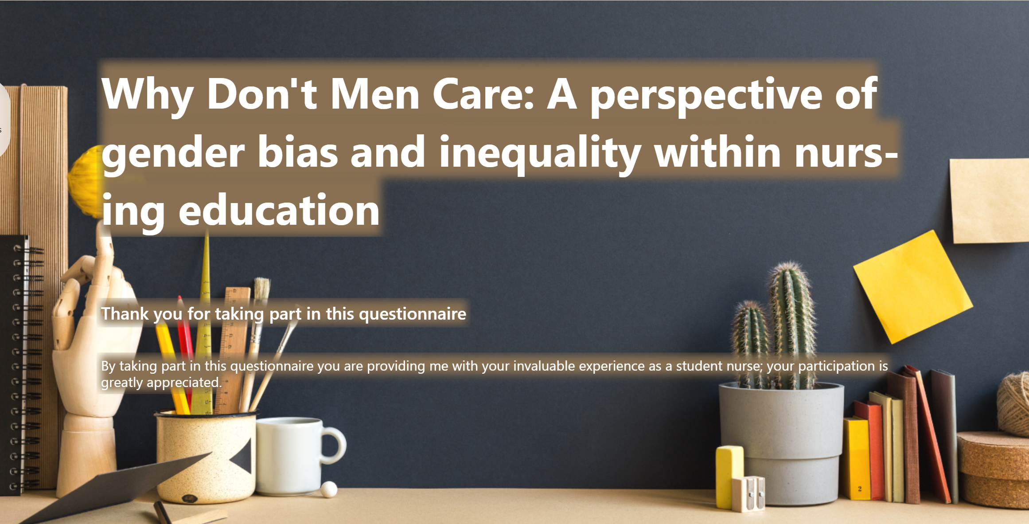

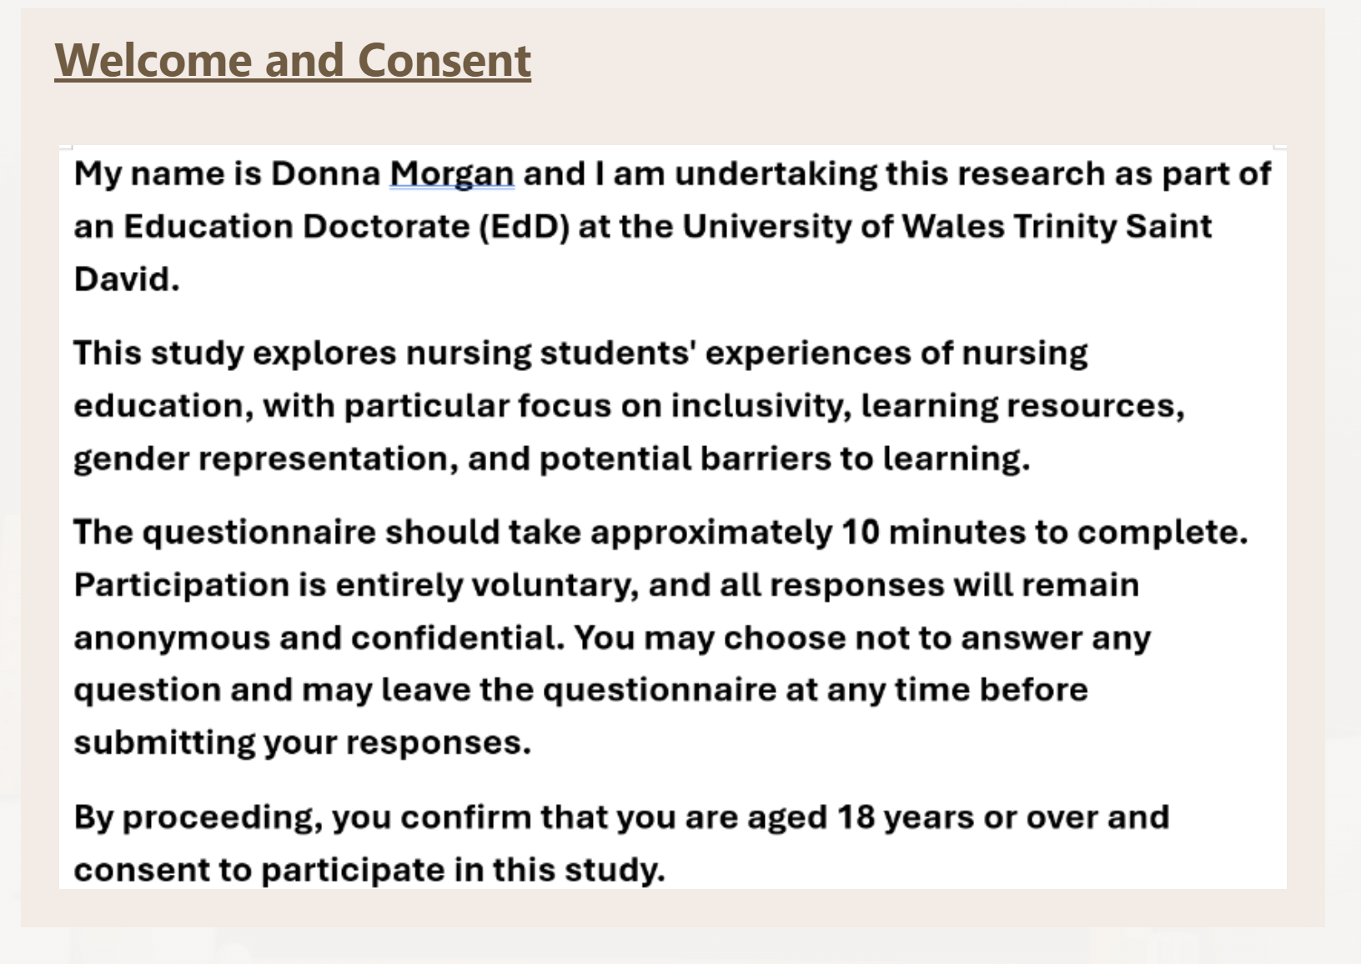
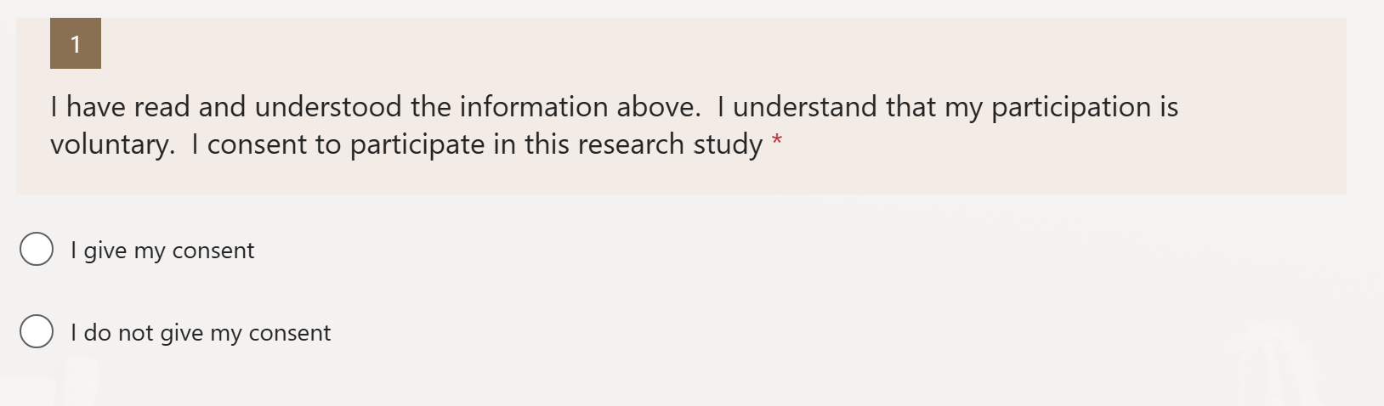

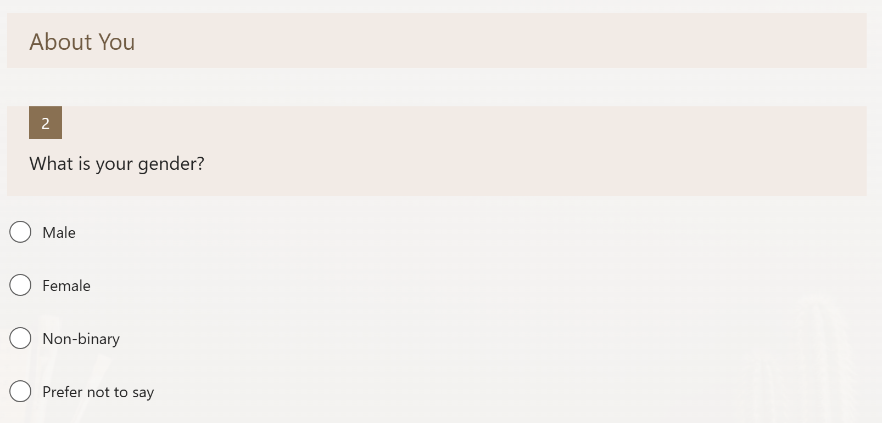
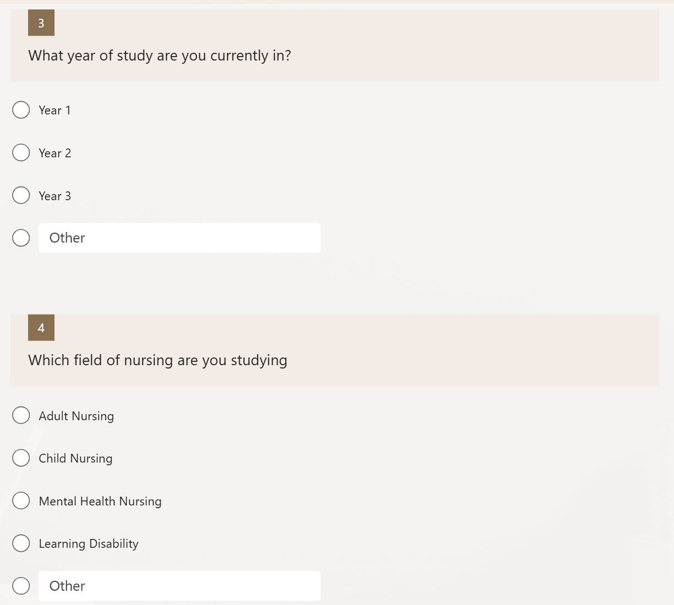
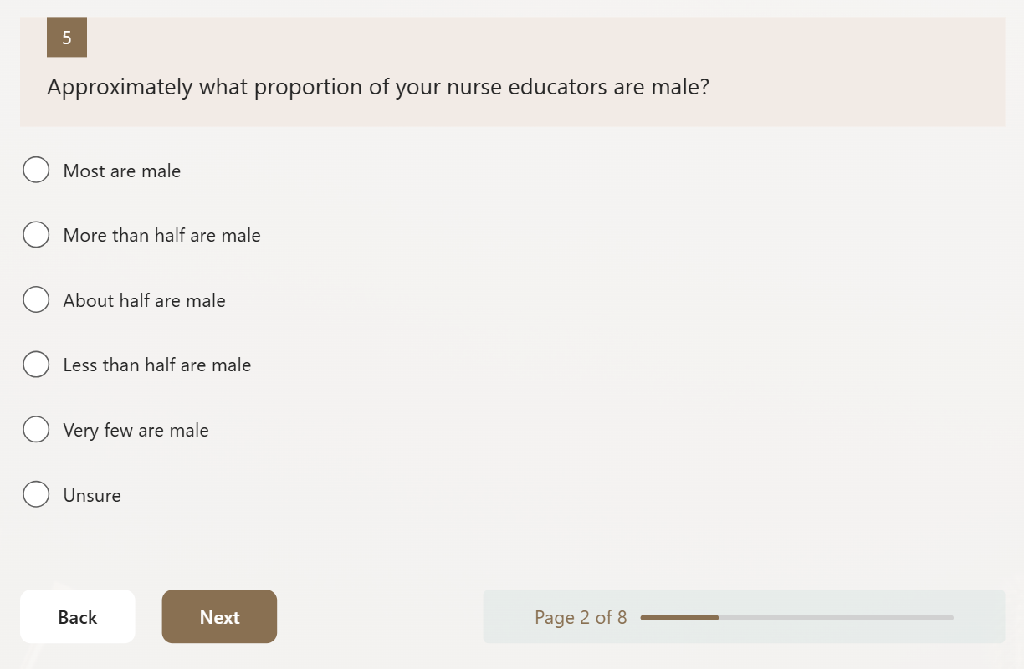
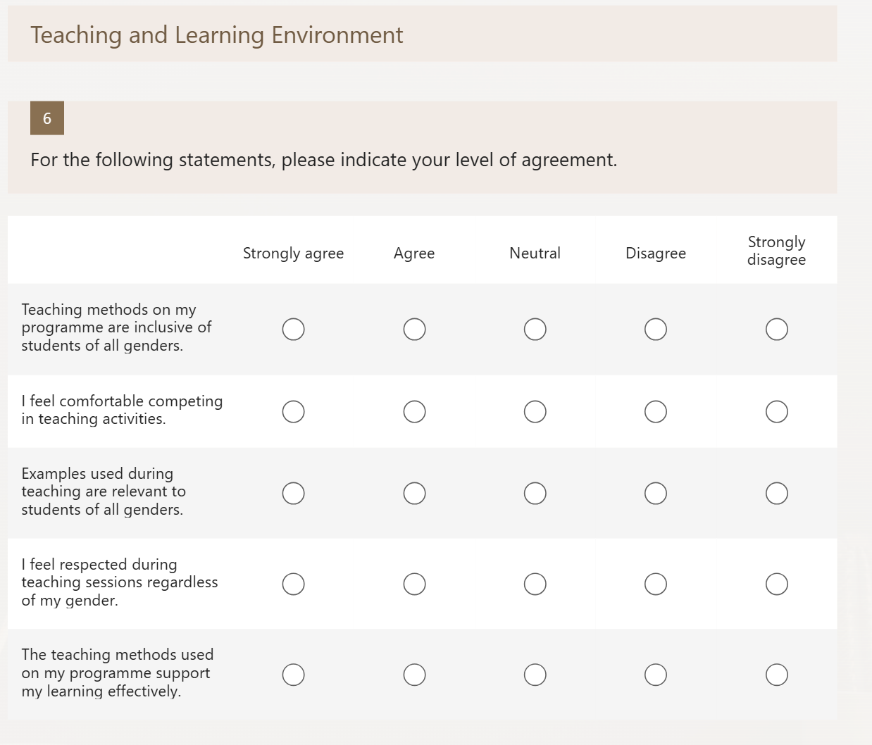
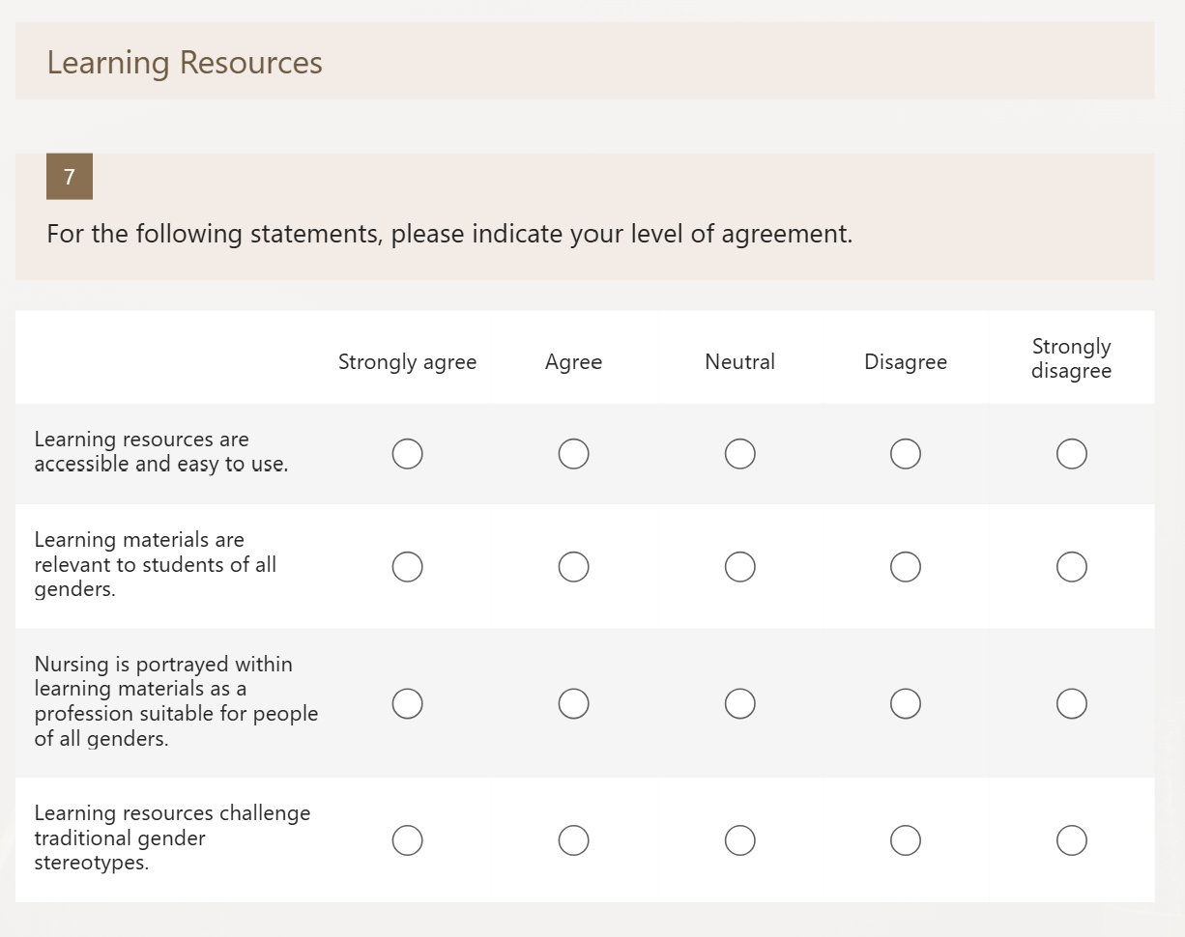
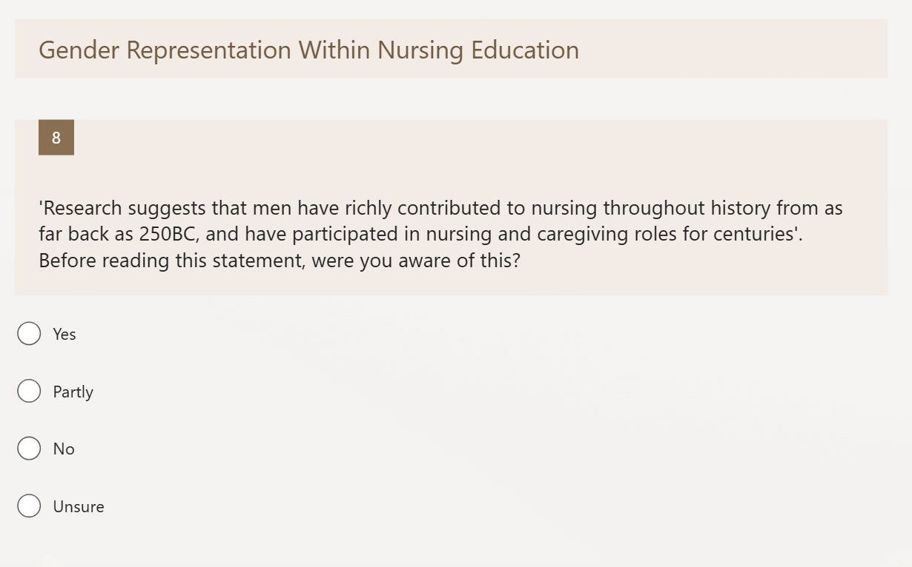
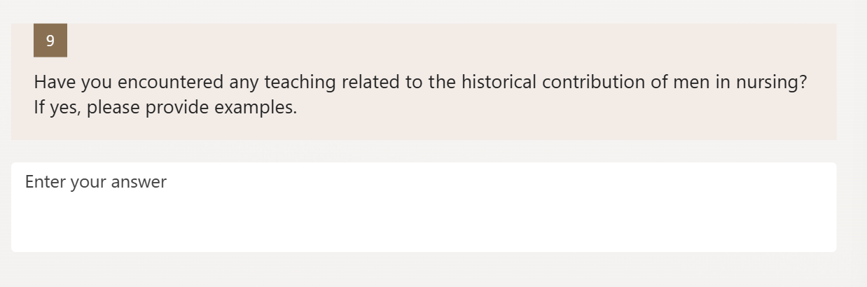
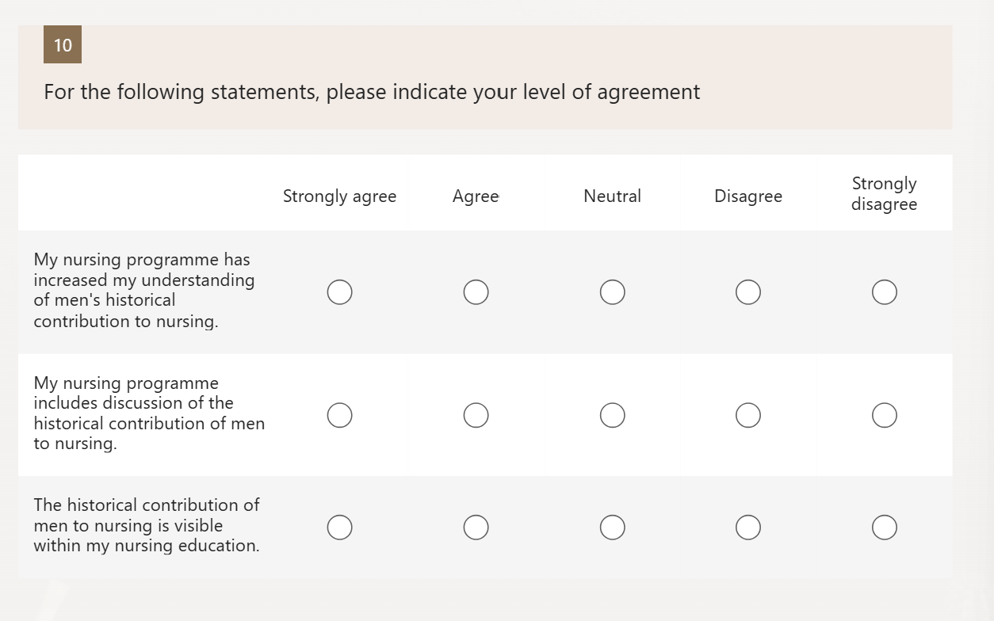
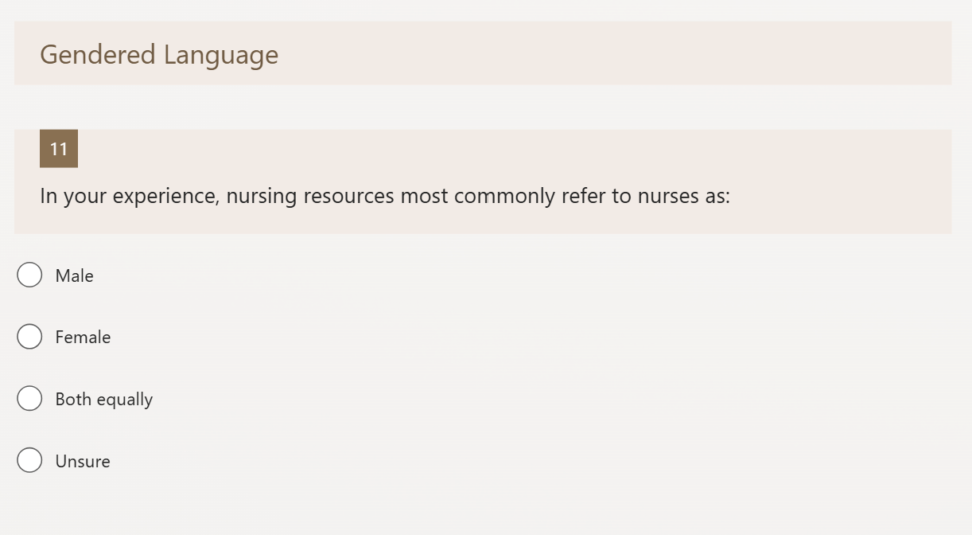
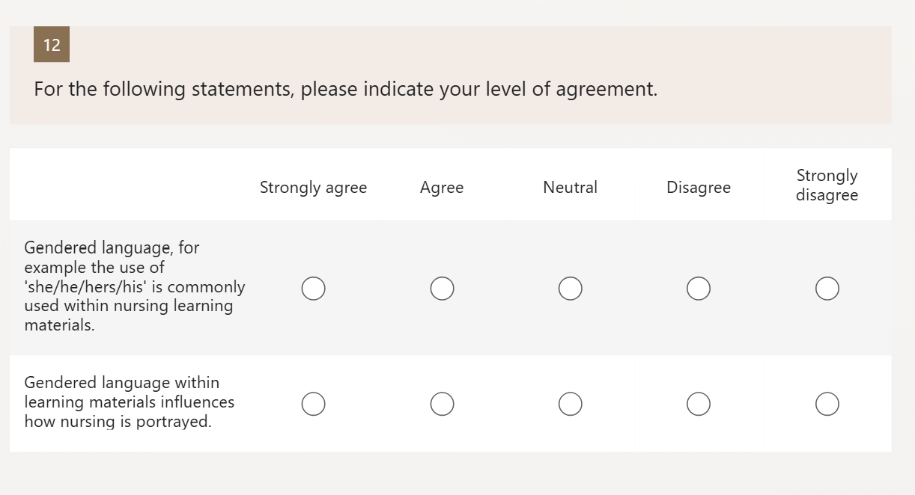
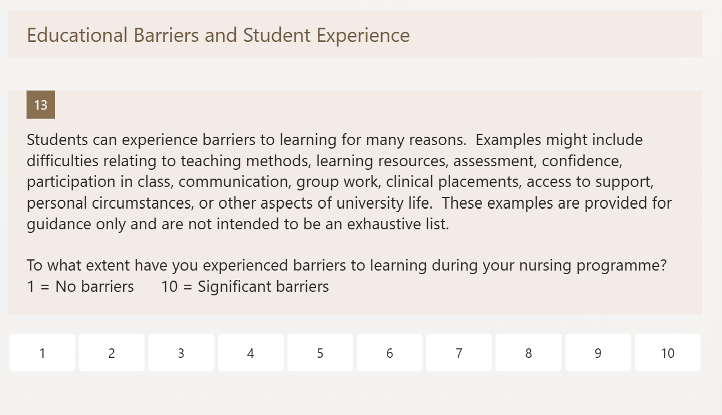
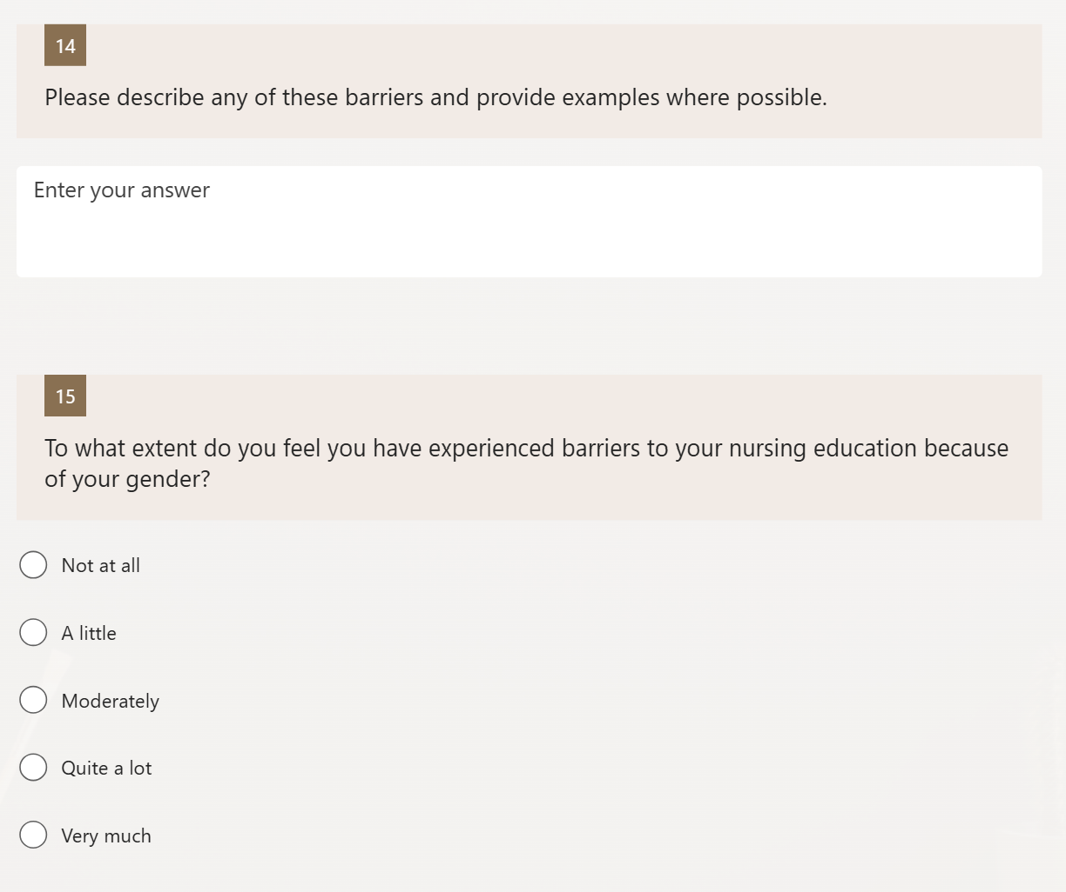
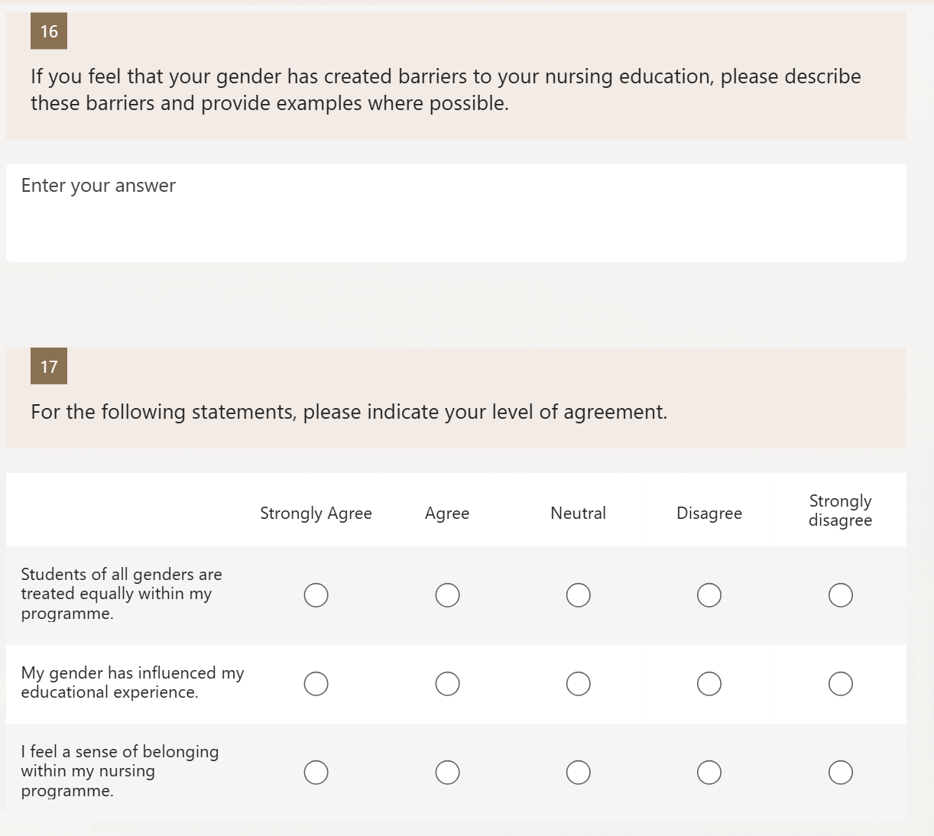
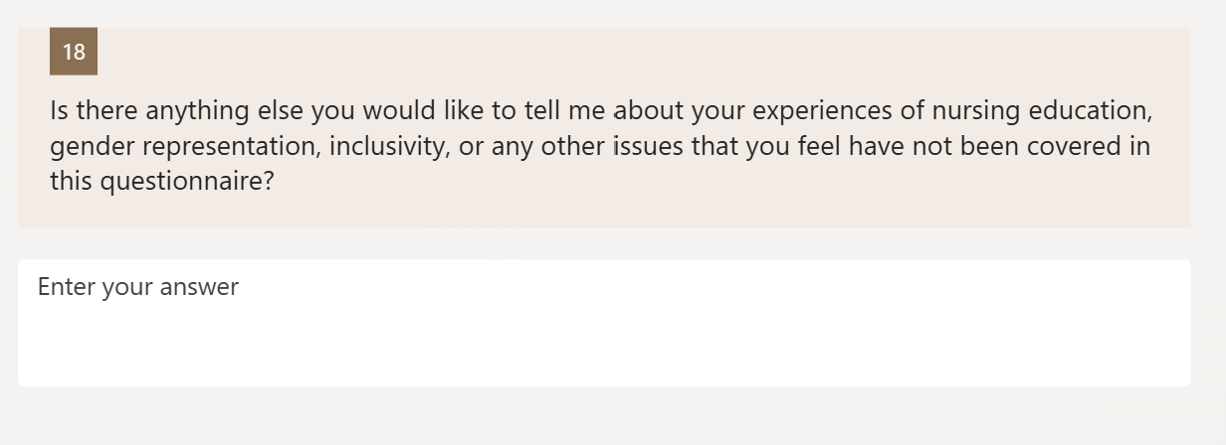
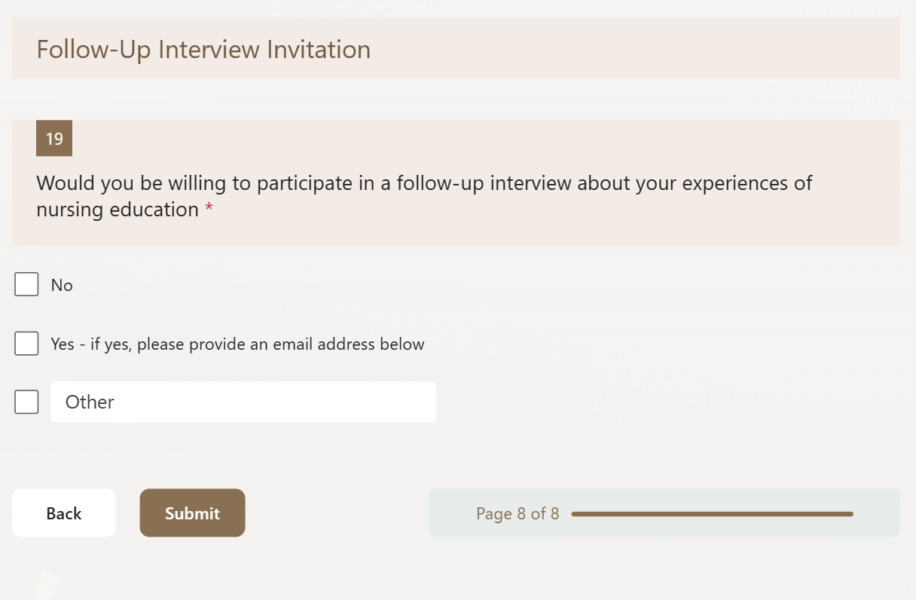

Appendix 2 - Semi-Structured Interview Questions

Q1. Can you tell me about your decision to study nursing and what influenced that decision?

Q2. What factors do you think encourage men to consider nursing as a career?

Q3. What factors do you think discourage men from applying to study nursing?

Q4. In your opinion, how do societal views about men and women influence decisions to enter nursing?

Q5. What role, if any, do male nurses or male role models play in encouraging men to enter nursing?

Q6. What barriers, if any, have you personally experienced during your nursing education?

Q7. Do you think male and female nursing students experience different challenges during their studies? Why or why not?

Q8. What factors do you think help nursing students successfully complete their studies?

Q9. What changes, if any, do you think could encourage more men to enter nursing and support them to complete their studies?

Appendix 3 - Initial Coding and Theme Development Tables
These tables provide an audit trail showing the movement from initial coding of the six interview transcripts to broader analytical categories and the four final themes reported in Chapter 4. The initial coding table retains codes developed from the participant accounts. The theme-development table demonstrates how related codes were grouped and refined; the process was iterative rather than strictly linear, and some codes informed more than one area of interpretation.

Table A. Initial Coding

Participant 1 (Female)
Transcript Extract | Initial Code
Worked in nursing home before applying | Previous Care Experience
Wanted to progress beyond healthcare assistant role | Career Advancement
Observed male colleague experiencing stereotypes | Observed Gender Stereotyping
Balancing study, work and caring responsibilities | Competing Responsibilities
Child with additional needs affects studies | Caring Responsibilities
Concerns about academic ability | Academic Self-Doubt
Male nurses visiting schools suggested | School-Based Role Modelling
Men represented in recruitment materials | Visible Representation

Participant 2 (Female)
Transcript Extract | Initial Code
Caring for disabled sibling influenced career choice | Family Caregiving Experience
Nursing viewed as meaningful work | Purpose-Driven Career Choice
Boys not encouraged towards nursing | Gendered Career Messaging
Careers associated with gender | Gendered Career Expectations
Need for diversity initiatives in both directions | Reciprocal Workforce Diversity
Public misunderstanding of nursing | Public Misunderstanding of Nursing
Nursing achievements under-recognised | Professional Visibility
Male students highly visible due to low numbers | Minority Visibility

Participant 3 (Female)
Transcript Extract | Initial Code
Delayed nursing career due to family commitments | Interrupted Career Aspiration
Wanted children to be proud | Role Modelling for Children
Boys may fear peer ridicule | Peer Judgement
Childhood expectations influence careers | Early Gender Socialisation
Confidence affects educational experience | Low Academic Confidence
Childcare affects study time | Childcare Pressures
Determination required to complete programme | Personal Resilience
Parents influence career perceptions | Family Influence on Career Choice

Participant 4 (Male)
Transcript Extract | Initial Code
Mother and sister are nurses | Family Nursing Role Models
Saw nursing as normal career for men | Normalised Exposure to Nursing
Nursing viewed as varied and challenging | Challenging Career
Asked about sexuality because he is a nurse | Sexuality Assumptions
Caring viewed as strength not weakness | Alternative Masculinity
Society misunderstands male nurses | Occupational Stereotypes
Family provided accurate understanding of nursing | Authentic Career Exposure
Wants misconceptions challenged | Stereotype Reduction

Participant 5 (Male)
Transcript Extract | Initial Code
Researched nursing opportunities before applying | Career Exploration
Attracted by leadership opportunities | Leadership Aspirations
Interested in progression pathways | Career Progression
Nursing offers multiple directions | Career Flexibility
Men unaware of nursing opportunities | Opportunity Awareness Deficit
Nursing underestimated as profession | Professional Undervaluation
Long-term goals support success | Goal-Oriented Motivation
Recruitment should highlight development opportunities | Progression-Focused Recruitment

Participant 6 (Male)
Transcript Extract | Initial Code
Military background influenced nursing decision | Military Influence
Humanitarian work sparked interest in care | Service-Oriented Motivation
Military and nursing share skills | Transferable Military Skills
Boys often never consider nursing | Limited Early Exposure
Caring compatible with masculinity | Alternative Masculinity
Few men on programme affects belonging | Minority Experience
Asked to provide male perspective | Gender Tokenism
Recruitment should start in schools | Early Career Intervention
Ex-military personnel suitable for nursing | Alternative Recruitment Pathway

Table B. Theme Development
Final Theme | Broader Categories | Contributing Initial Codes | Link to Participant Accounts | Related RQ
Exposure and Awareness Influence Men's Entry into Nursing | Exposure and familiarity with nursing; limited early consideration; understanding of the profession and its opportunities | Previous Care Experience; Family Caregiving Experience; Family Nursing Role Models; Normalised Exposure to Nursing; Authentic Career Exposure; Career Exploration; Opportunity Awareness Deficit; Limited Early Exposure; School-Based Role Modelling; Visible Representation; Early Career Intervention | P1 described prior care work; P2 described lifelong family/healthcare exposure; P4 described nursing as normal because his mother and sister were nurses; P5 only appreciated nursing after researching its breadth; P6 said nursing was not discussed as a career for boys and became conceivable after healthcare exposure. | RQ1
Gender Stereotypes Continue to Shape Perceptions of Nursing | Gendered career expectations and socialisation; stereotypes about male nurses; masculinity and caring; assumptions about who belongs in nursing | Observed Gender Stereotyping; Gendered Career Messaging; Gendered Career Expectations; Peer Judgement; Early Gender Socialisation; Sexuality Assumptions; Occupational Stereotypes; Alternative Masculinity; Stereotype Reduction | P1 described stereotypes experienced by a male nurse; P2 discussed boys not being actively encouraged towards nursing; P3 discussed peer judgement and childhood expectations; P4 described sexuality assumptions while rejecting the idea that caring is incompatible with masculinity; P6 similarly framed caring and strength as compatible. | RQ1
Men Are Motivated by Personal Values and Career Opportunities | Meaningful and purposeful work; challenge and variety; stability; career progression, flexibility and leadership | Purpose-Driven Career Choice; Career Advancement; Challenging Career; Leadership Aspirations; Career Progression; Career Flexibility; Professional Visibility; Professional Undervaluation; Goal-Oriented Motivation; Service-Oriented Motivation; Transferable Military Skills; Progression-Focused Recruitment | P4 valued challenge and variety; P5 emphasised progression, leadership, flexibility and long-term development; P6 described service, teamwork, challenge and transferable skills. Female accounts also identified meaningful work, stability and progression, indicating that these motivations were not wholly gender-specific. | RQ2
Gender Shapes Educational Experience but Not Necessarily Successful Completion | Minority visibility and belonging; being positioned as representative of men; gendered educational experience; practical, financial, caring and academic pressures affecting progression | Minority Visibility; Minority Experience; Gender Tokenism; Competing Responsibilities; Caring Responsibilities; Childcare Pressures; Academic Self-Doubt; Low Academic Confidence; Personal Resilience; Goal-Oriented Motivation | P6 described awareness of being one of few men, initial discomfort and being asked for 'the male perspective'; P5 also noted that male students were noticeable because of their low numbers. Across male and female accounts, barriers more directly connected with progression included work, finances, caring responsibilities, time management and academic adjustment, rather than gender alone. | RQ3

Appendix 4 – Ethical Approval

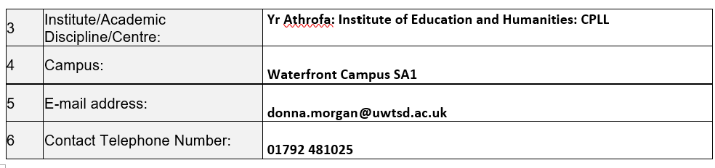

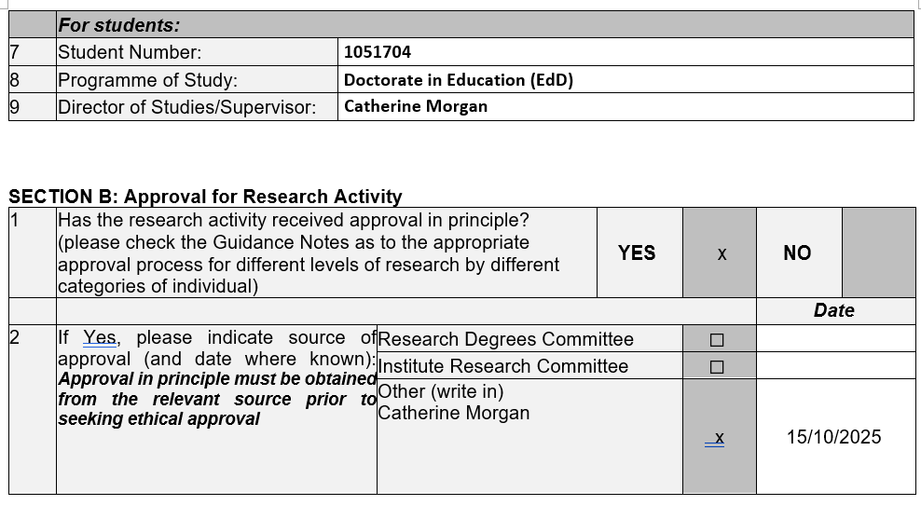
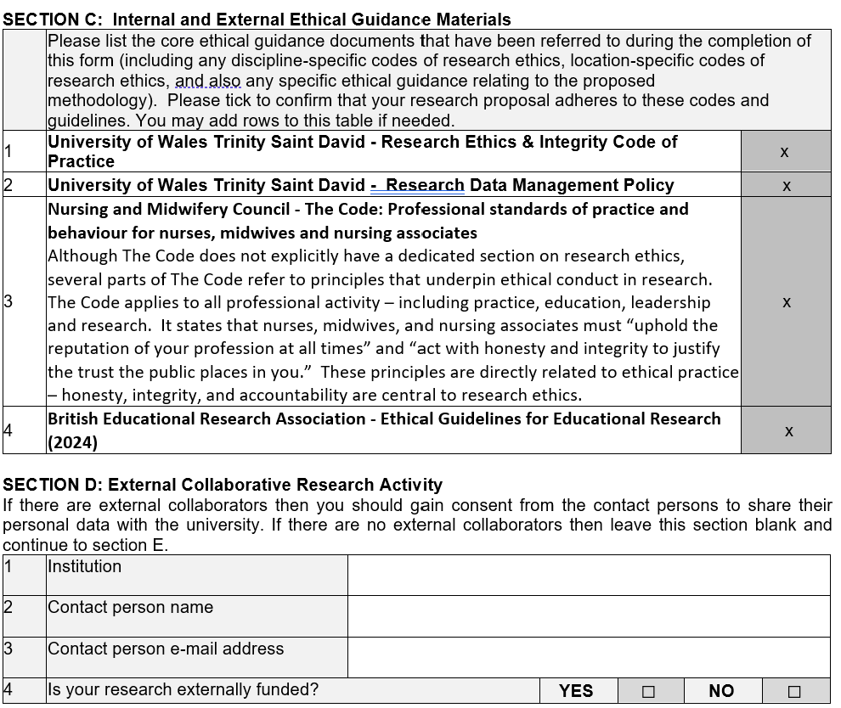

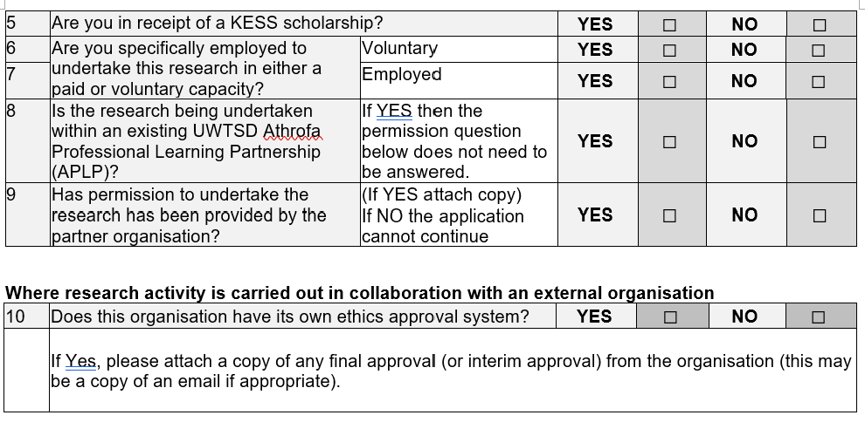
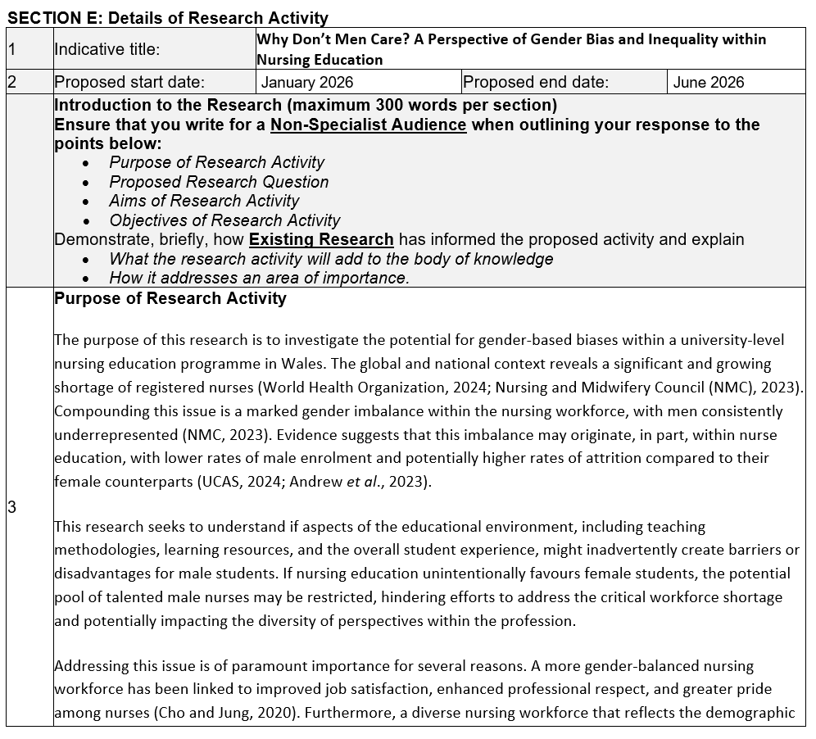

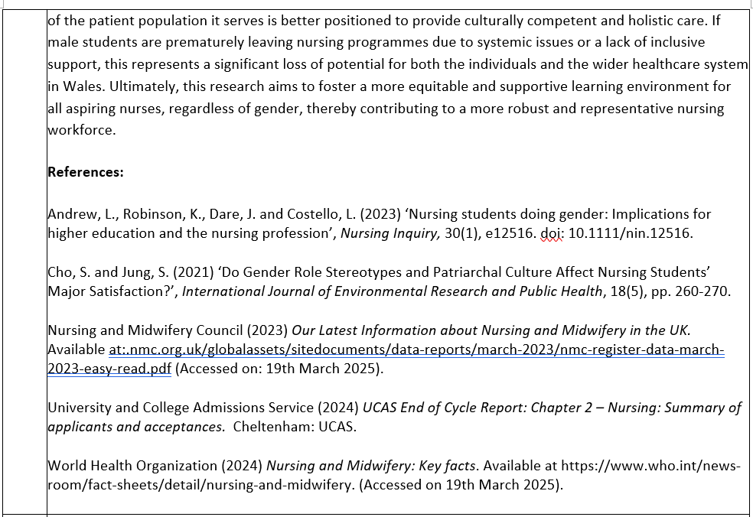
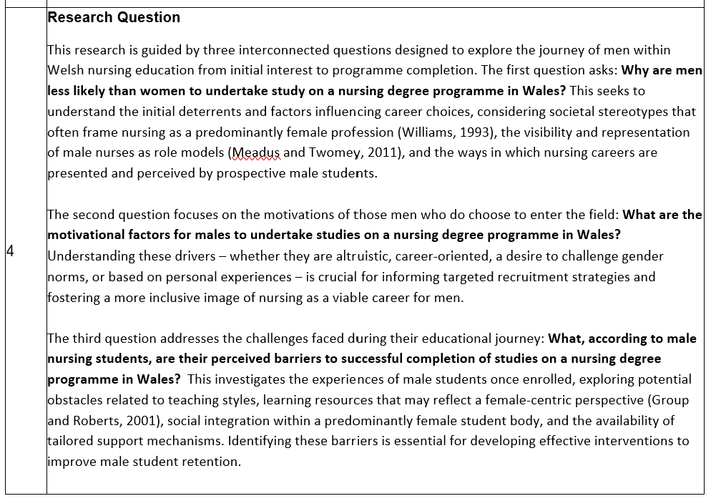

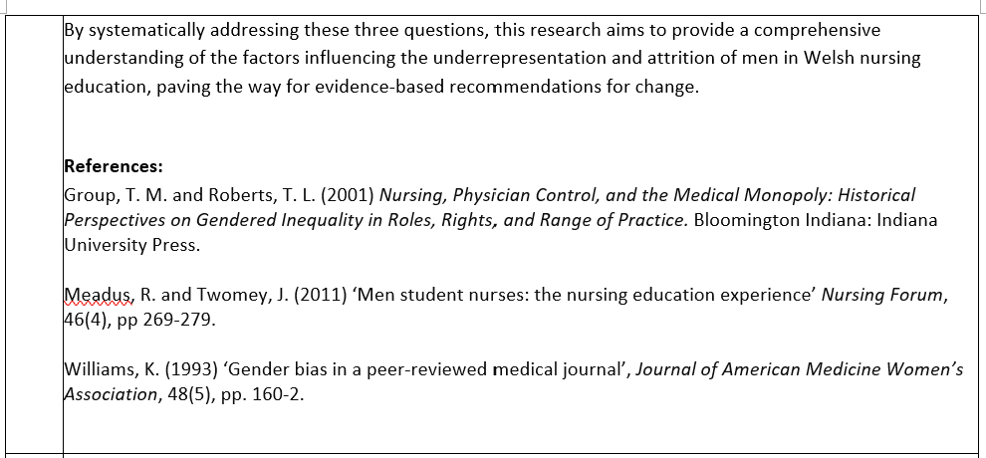
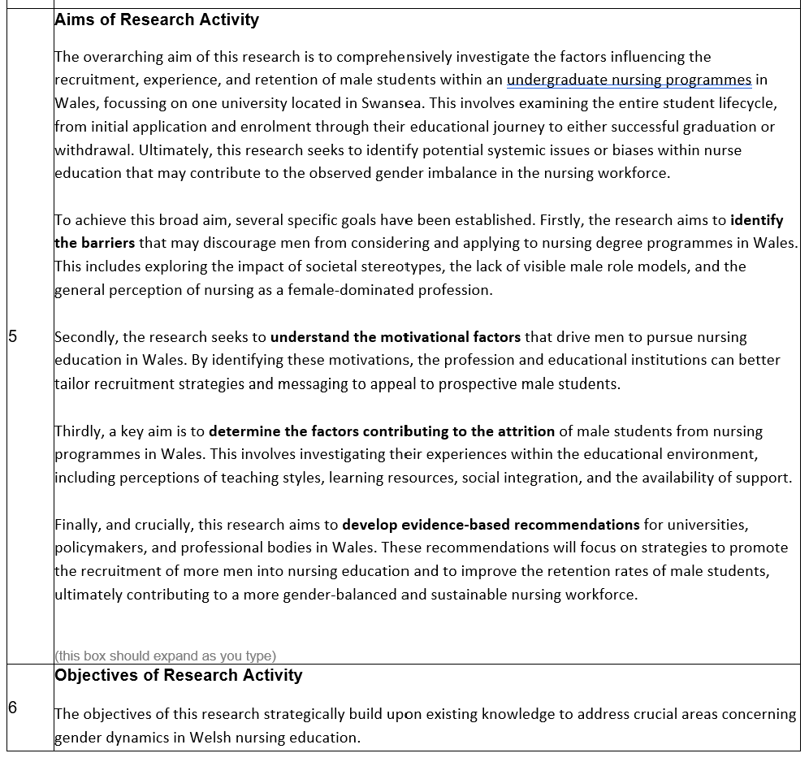

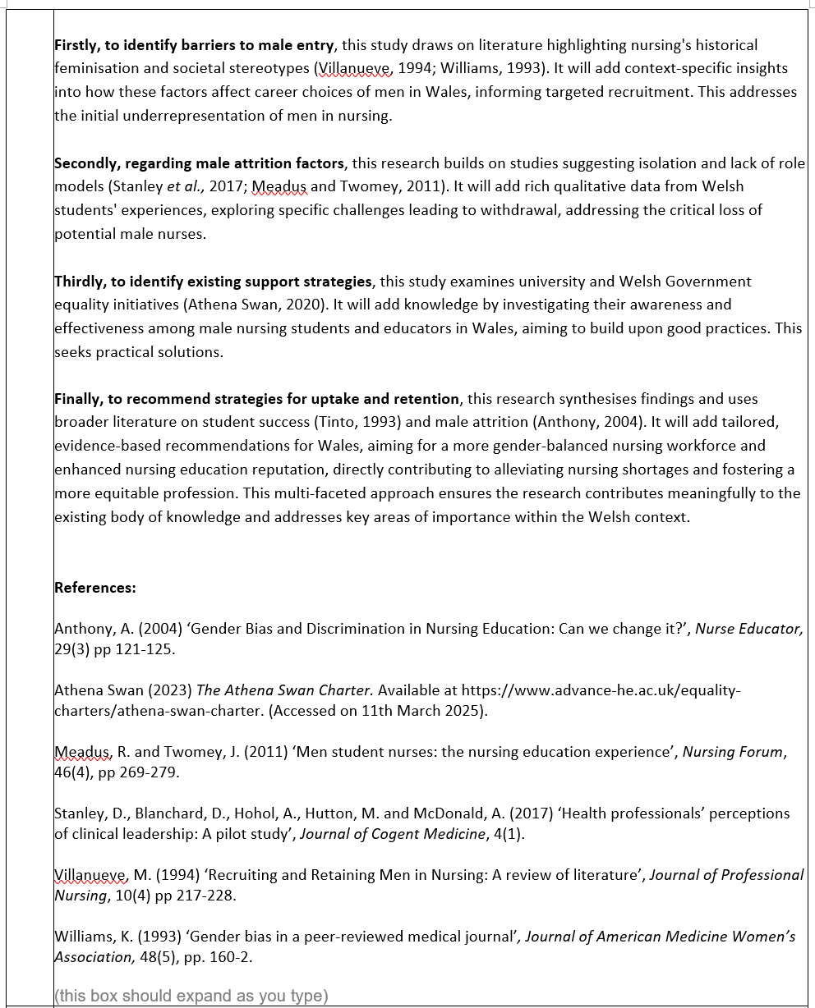
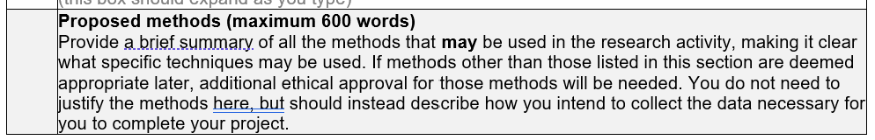

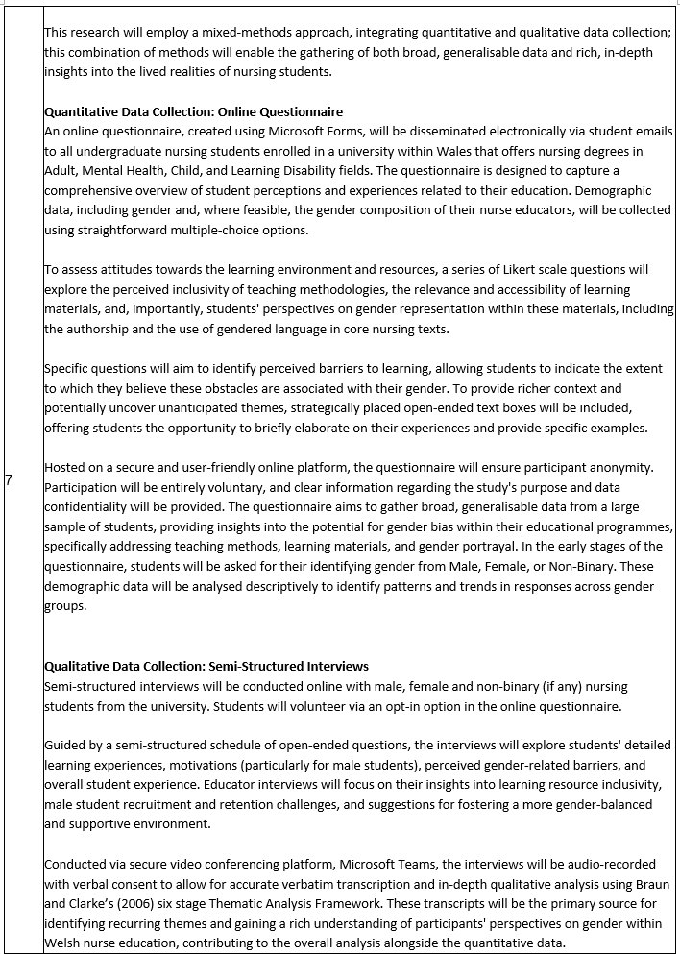

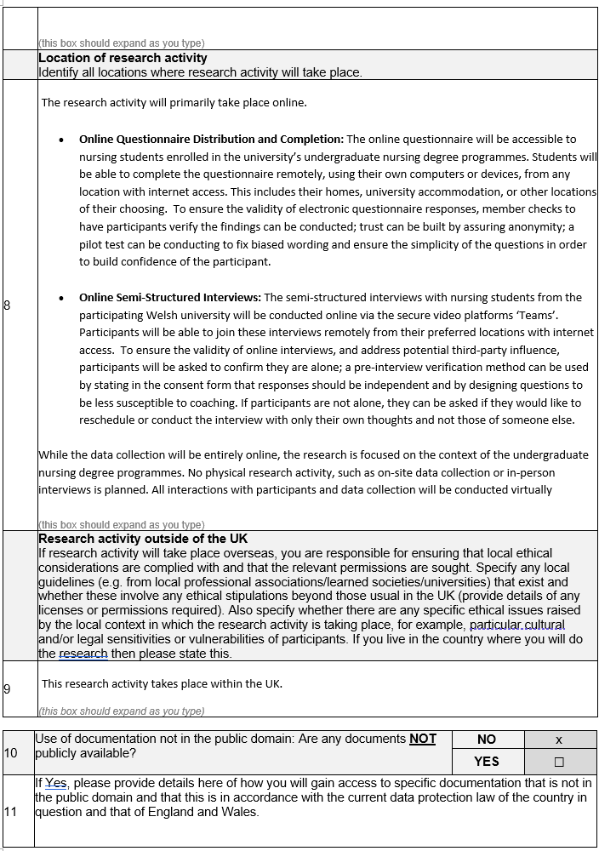

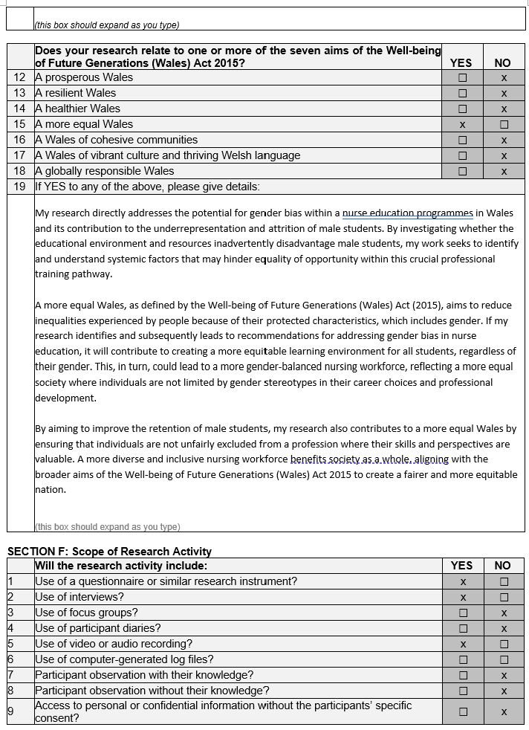

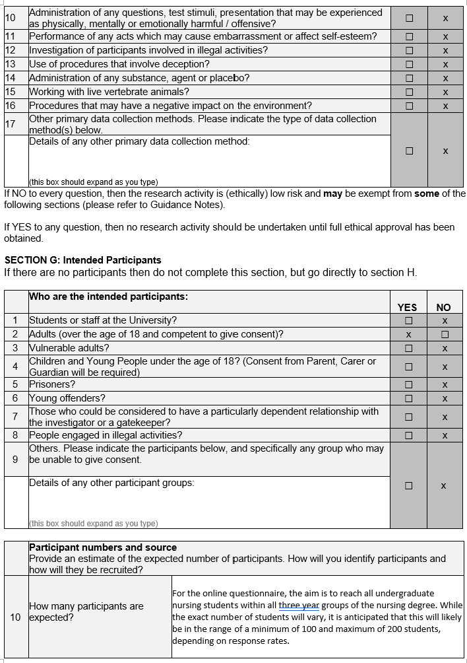

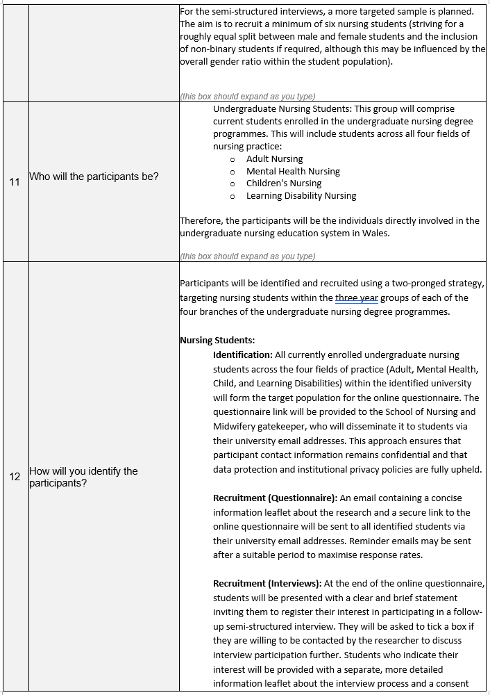

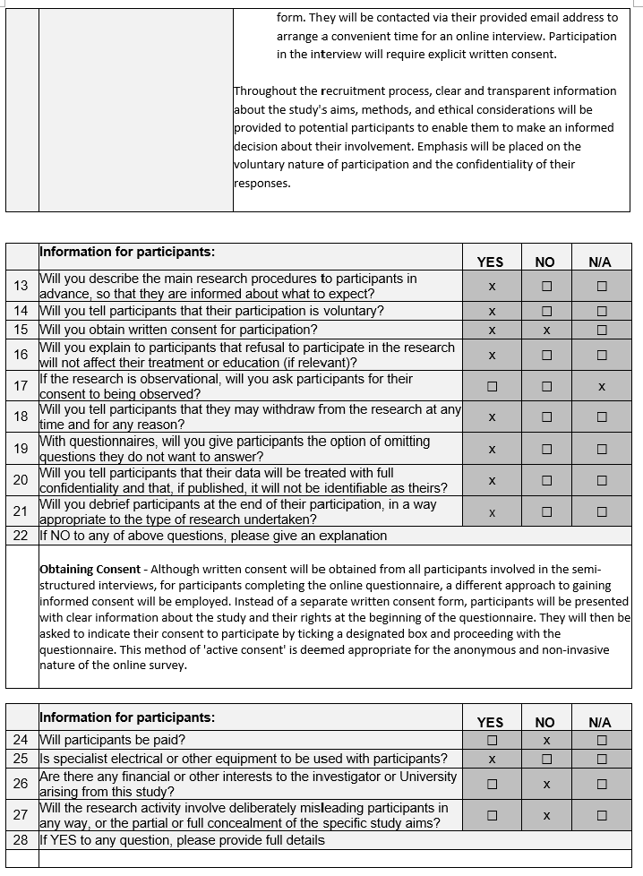

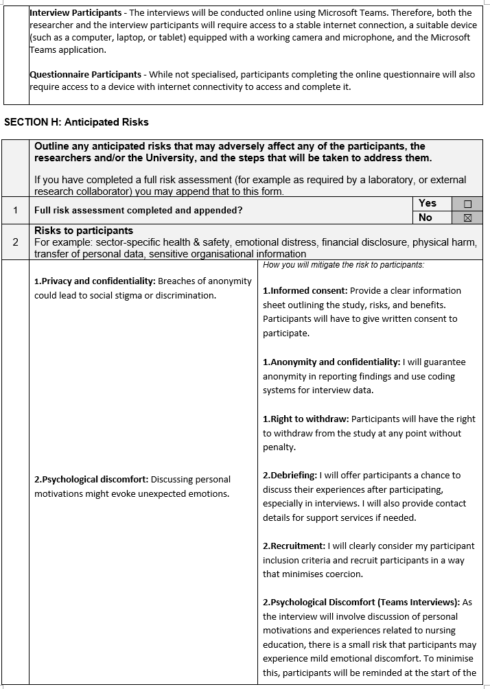

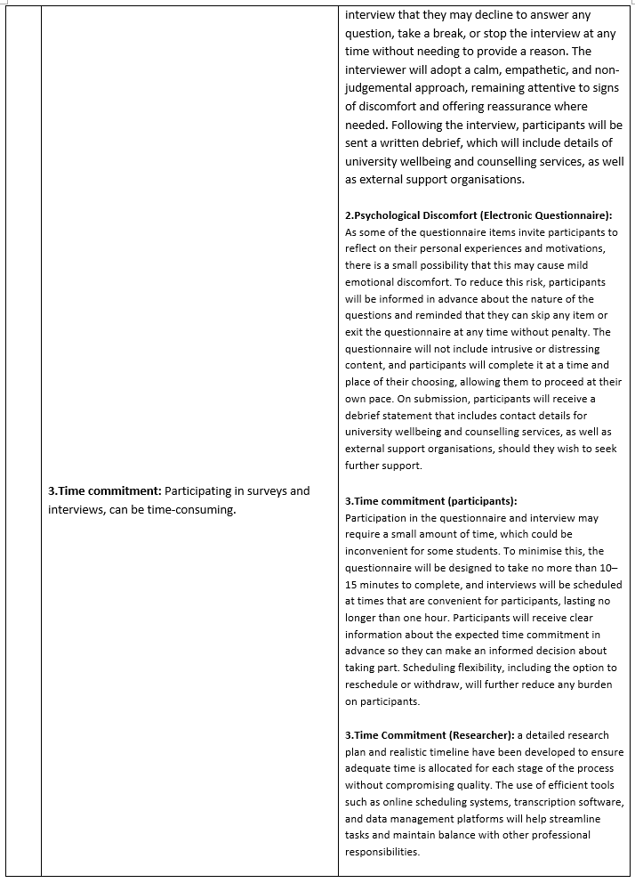

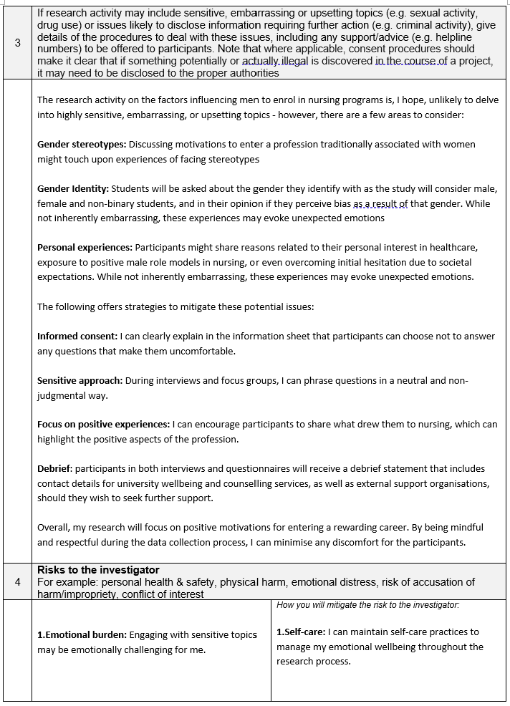

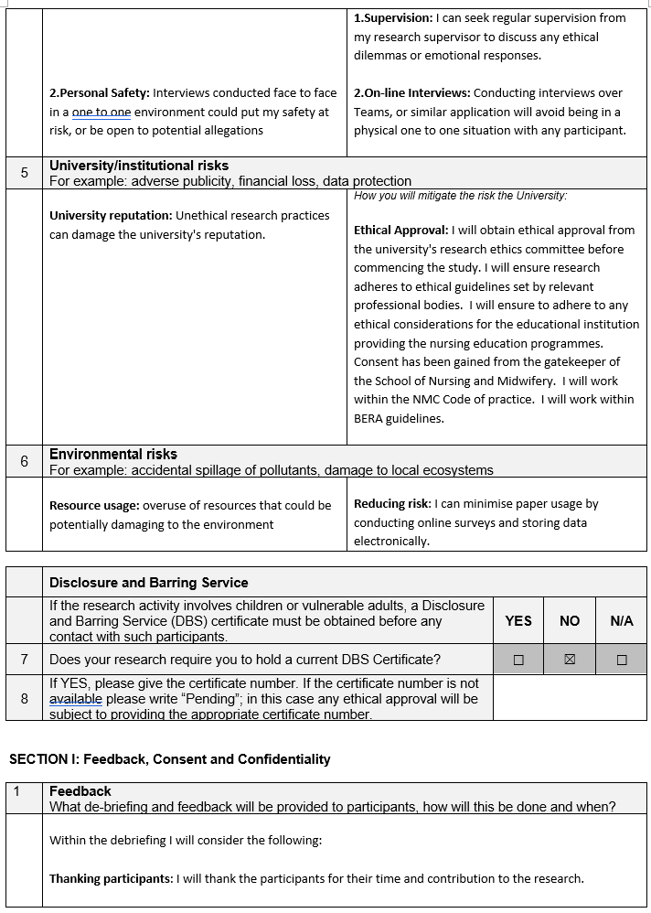

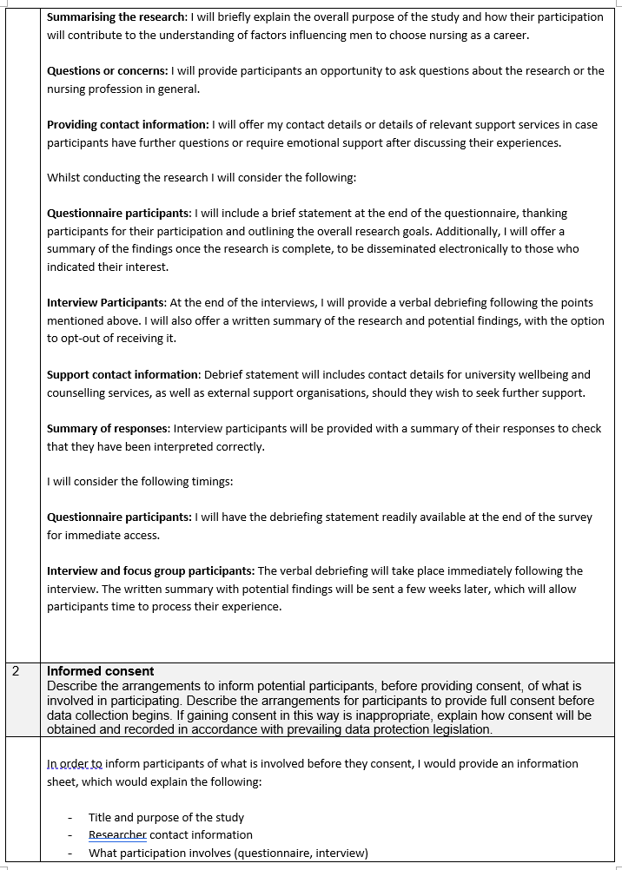

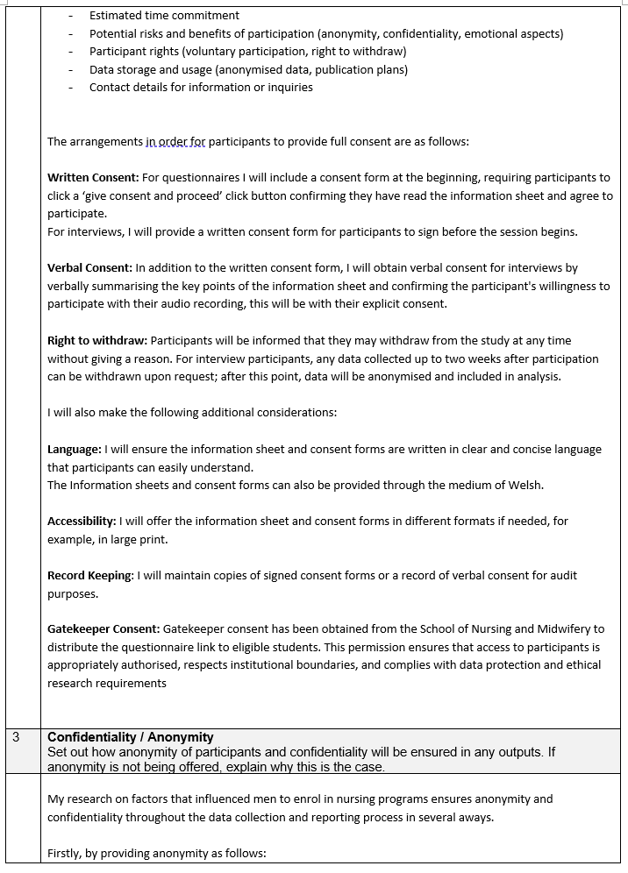

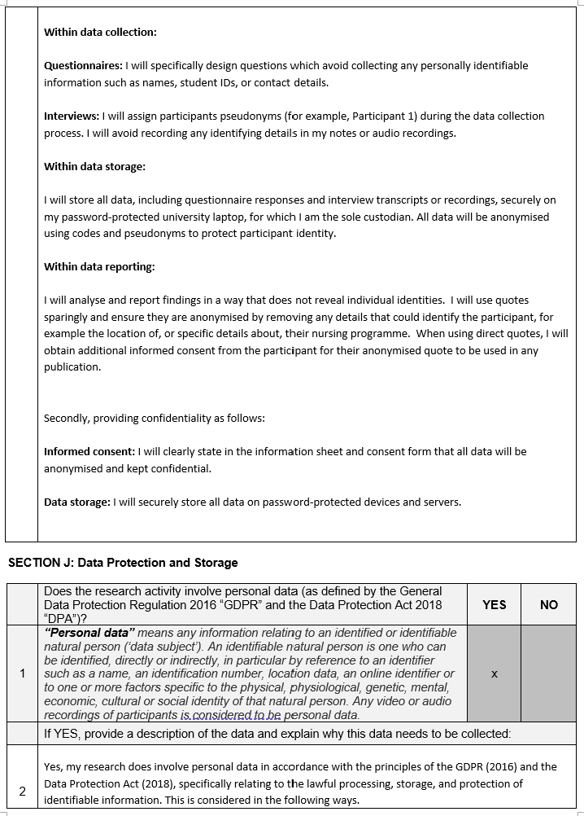

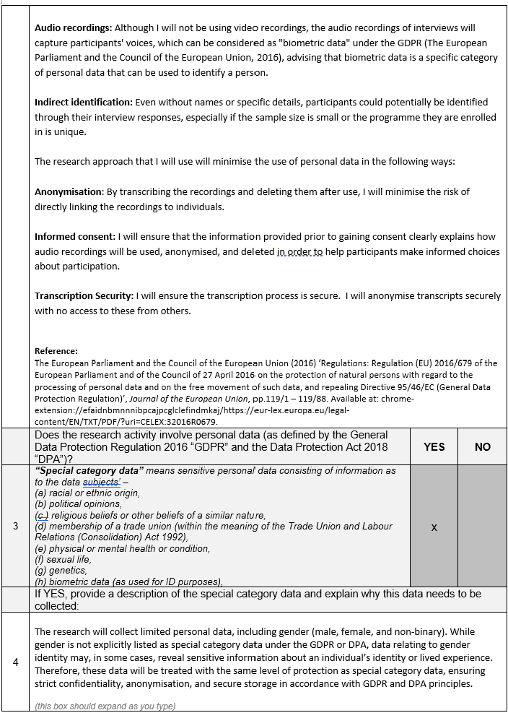

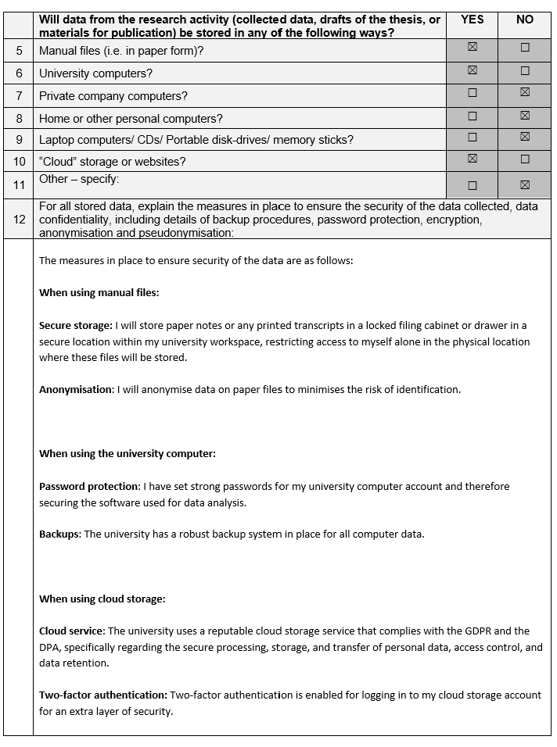

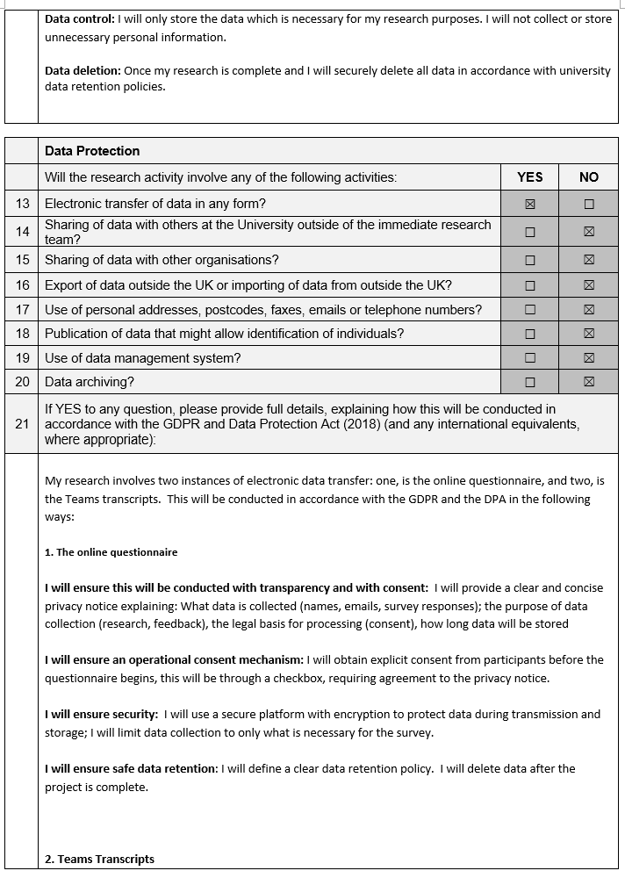

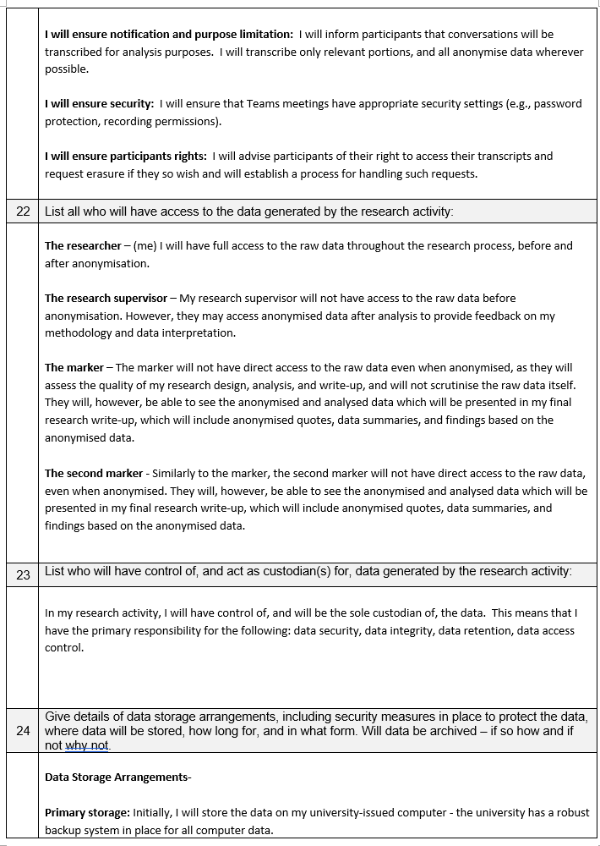

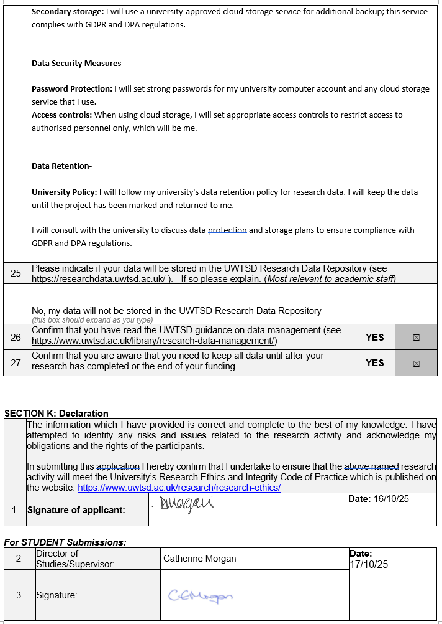

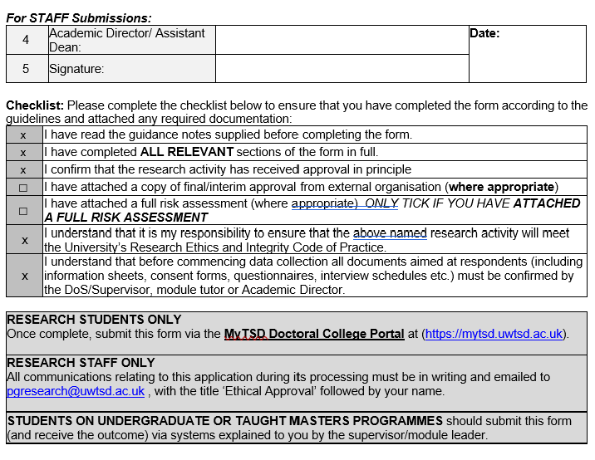

Appendix 5 - Interview Participant Information and Consent Sheet
Study title: Why Don’t Men Care? A Perspective of Gender Bias and Inequality within Nursing Education
Researcher: Donna Morgan, Doctorate in Education (EdD), University of Wales Trinity Saint David (UWTSD)
Researcher email: donna.morgan@uwtsd.ac.uk
Invitation and purpose of the study
You are invited to take part in a research interview exploring experiences of nursing education and the factors that may influence the underrepresentation of men within nursing degree programmes in Wales. The study considers why men may be less likely to enter nursing education, what motivates men who do choose nursing, and the barriers male nursing students may perceive during their studies.
Why have I been invited?
You have been invited because you are an undergraduate nursing student and indicated through the online questionnaire that you would be willing to be contacted about a follow-up interview. Participation is entirely voluntary. Choosing not to take part will not affect your education or your relationship with the University.
What will taking part involve?
The interview will take place online using Microsoft Teams at a mutually convenient time and will last no longer than one hour. You will be asked open questions about your decision to study nursing, your experiences of nursing education, gender representation and stereotypes, possible barriers to learning, and factors that may support successful completion of the programme.
With your explicit consent, the interview will be audio-recorded to support accurate transcription and analysis. Video will not be recorded. You may decline to answer any question, request a break, or stop the interview at any time without giving a reason.
Are there any risks or disadvantages?
The interview is not expected to involve highly sensitive material, although discussion of personal experiences, gender stereotypes or educational difficulties may cause mild discomfort. You do not have to discuss anything you would prefer not to share. A verbal debrief will be offered at the end of the interview, together with information about appropriate support services if required.
Are there any benefits?
There is no direct personal benefit or payment for taking part. Your contribution may help develop a better understanding of gender, recruitment, student experience and barriers within nursing education.
Confidentiality and use of your information
Your interview data will be treated confidentially. Participants will be identified by a code, such as Participant 1, rather than by name. Identifying details will be removed from transcripts and from the research report. Anonymised quotations may be used in the assignment or related research outputs where consent has been provided.
Audio recordings and research data will be stored securely using password-protected University systems and University-approved cloud storage, with access restricted to the researcher. Audio recordings will be transcribed and deleted after use. Research data will be retained in accordance with University requirements until the project has been completed and marked, after which it will be securely deleted in line with University data-retention requirements.
Your right to withdraw
You may withdraw from the study at any time without giving a reason. Interview data may be withdrawn on request for up to two weeks after participation. After this point the data will have been anonymised and incorporated into the analysis and it may no longer be possible to identify and remove your contribution.
Questions or concerns
If you have questions about the study before deciding whether to participate, please contact me, Donna Morgan, using the email address above. You will also have an opportunity to ask questions before the interview begins.

Interview Consent Form
Please read each statement and indicate your agreement. Please ask me, the researcher, if anything is unclear before signing.
Consent statement | Yes | No
I have read and understood the participant information provided for this study and have had the opportunity to ask questions. | ☐ | ☐
I understand that my participation is voluntary and that I may stop the interview at any time without giving a reason. | ☐ | ☐
I understand that I may decline to answer any question or request a break during the interview. | ☐ | ☐
I consent to the interview being audio-recorded for transcription and analysis. | ☐ | ☐
I understand that the recording will be stored securely and deleted after it has been transcribed and used for the research. | ☐ | ☐
I understand that my interview will be anonymised and that I will be identified by a participant code rather than by name. | ☐ | ☐
I consent to anonymised quotations from my interview being used in the assignment and related research outputs. | ☐ | ☐
I understand that I may request withdrawal of my interview data for up to two weeks after participation, after which anonymised data may already have been incorporated into the analysis. | ☐ | ☐
I understand that the research data will be kept confidential and stored securely in accordance with University requirements. | ☐ | ☐
I freely agree to take part in this research interview. | ☐ | ☐

Participant name: ______________________________________________
Signature: ____________________________________________________
Date: _________________________________________________________

Researcher name: Donna Morgan
Researcher signature: __________________________________________
Date: _________________________________________________________

Appendix 6 – Graphs: Questionnaire Results

Q 2. What is your gender?
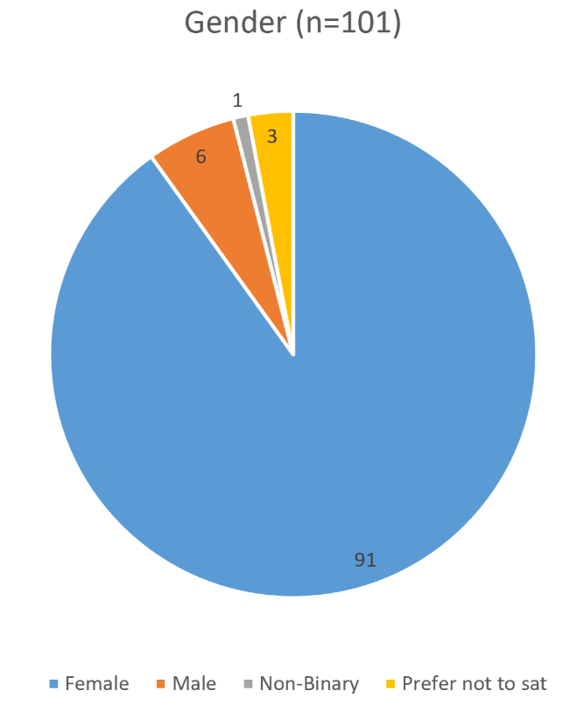
Q 3. What Year of Study are you currently in?
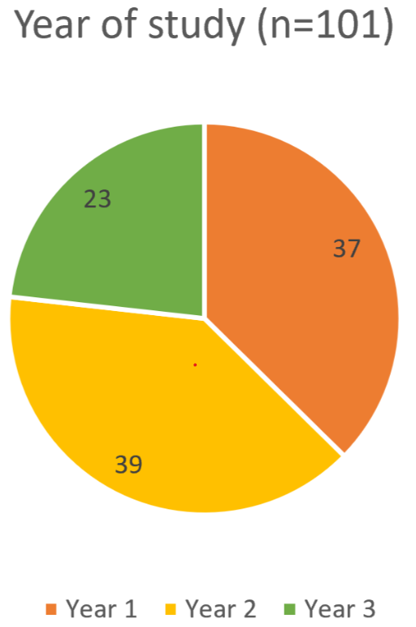

Q 4. Which field of nursing are you studying?
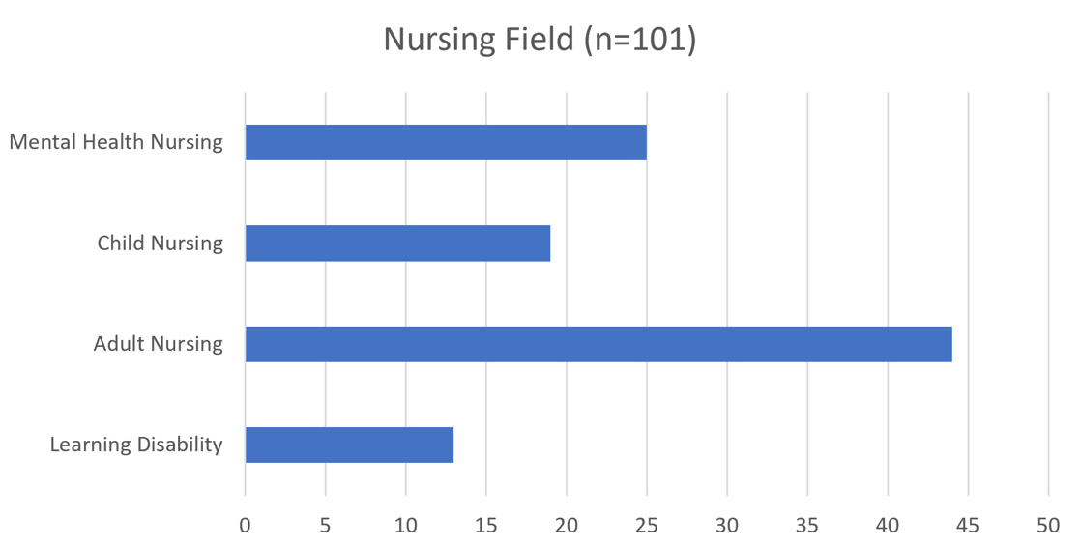

Q 5. Approximately what proportion of your nurse educators are male?
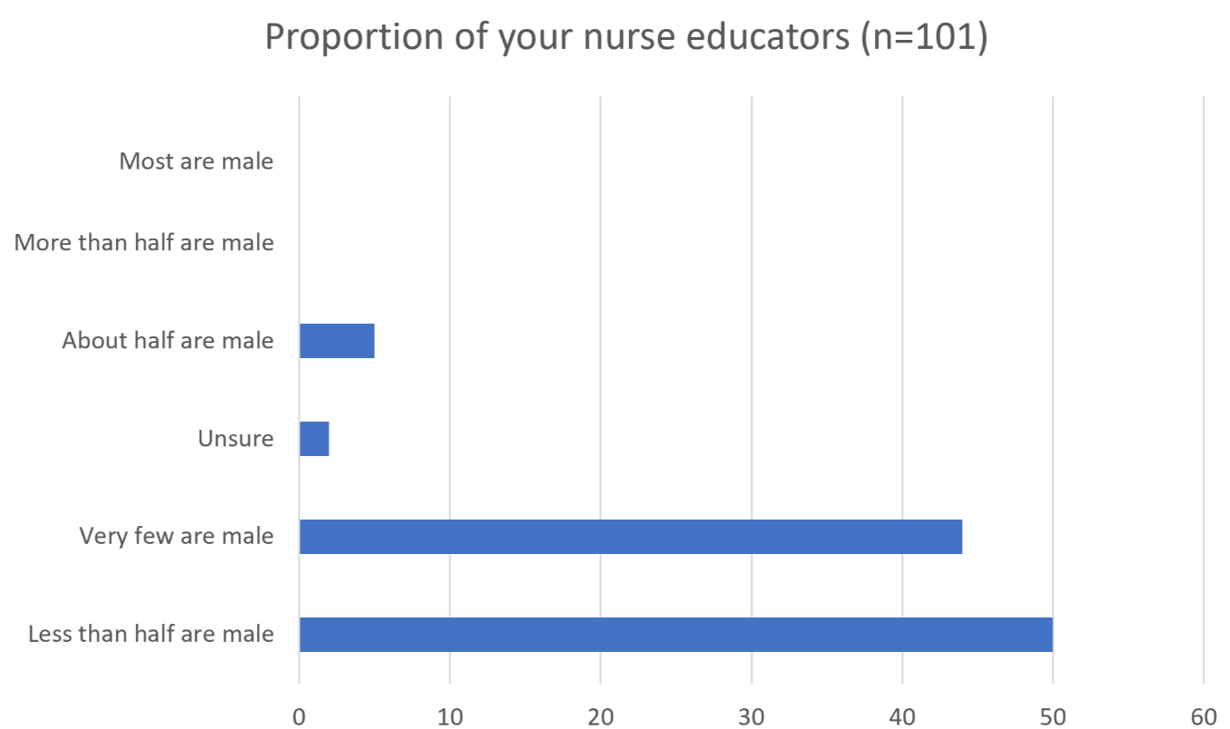

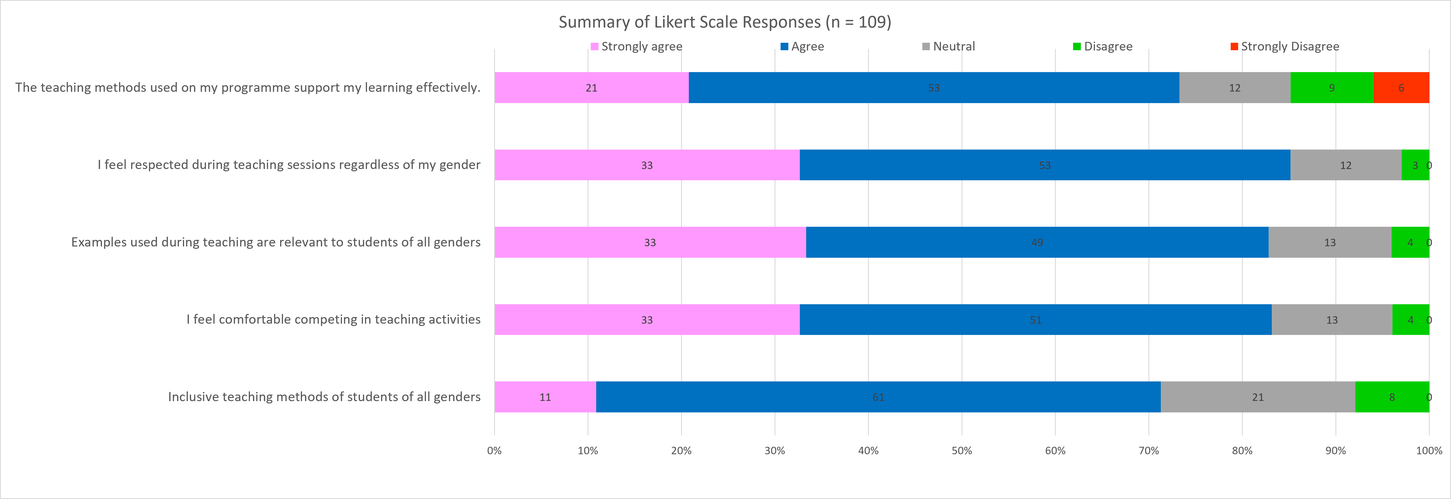
Q 6. For the following statements, please indicate your level of agreement? n=101

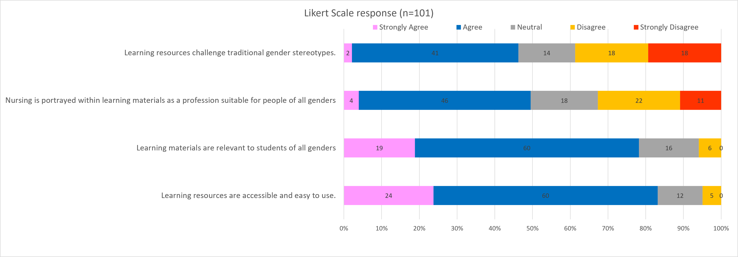
Q 7. For the following statements, please indicate your level of agreement?

Q 8. Research Suggests that men have richly contributed to nursing throughout history from as far back as 250BC, and have participated in nursing and caregiving roles for centuries.
Before reading this statement, were you aware of this?

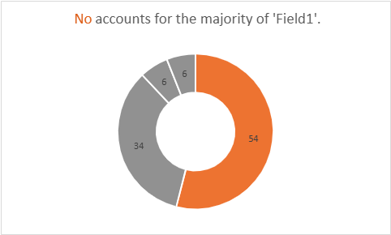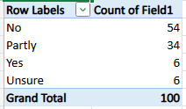

Q 9. Have you encountered any teaching related to the historical contribution of men in nursing?
If yes, please provide examples

This is an open text response – please see Appendix 7.

Q 10. For the following statements, please indicate your level of agreement.
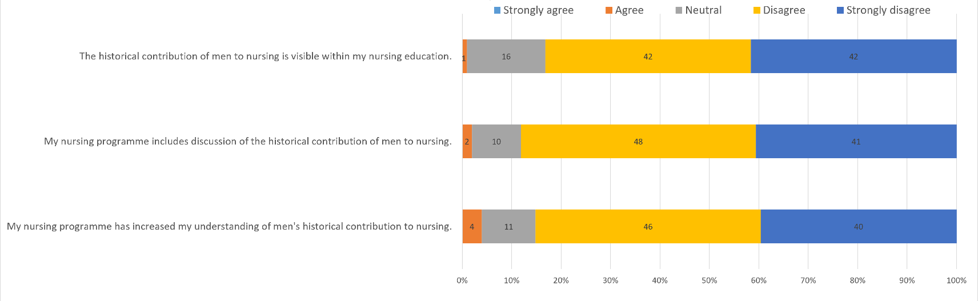

Q 11. In your experience, nursing resources most commonly refer to nurses as:

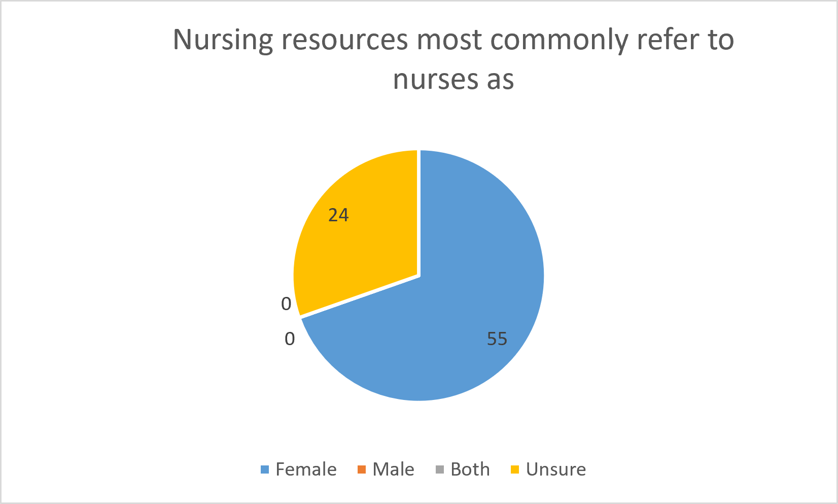

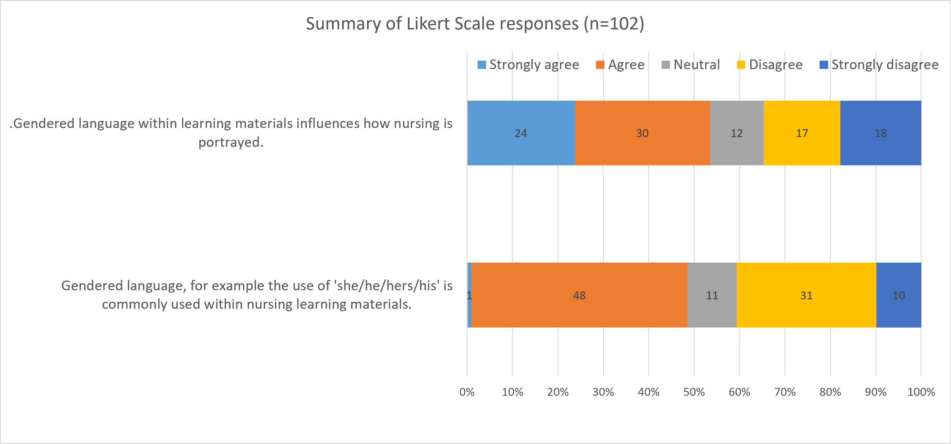
Q 12. For the following statements, please indicate your level of agreement (n=101)

Q 13. Students can experience barriers to learning for many reasons. Examples might include…
To what extent have you experienced barriers to learning during your nursing programme?
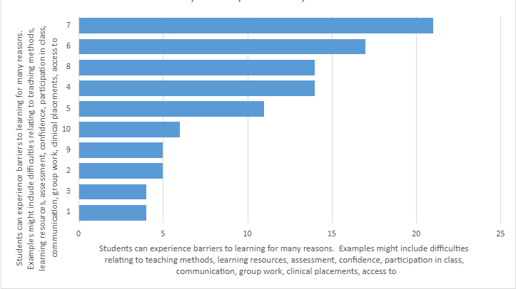

Q 14. Please describe any of these barriers and provide examples where possible.
This is an open text response – please see Appendix 7.
Q 15. To what extent do you feel that you have experienced barriers to your nursing education because of your gender?
n=101
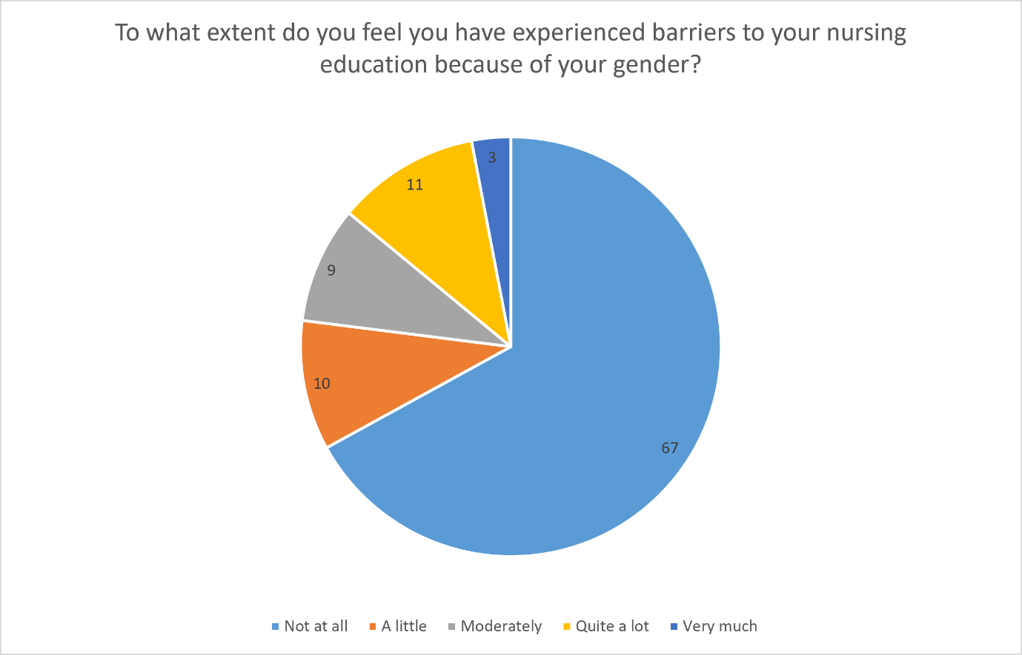
n=6
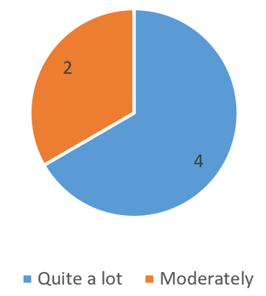
Q 16. If you feel that your gender has created barriers to your nursing education, please describe these barriers and provide examples where possible.
This is an open text response – please see Appendix 7.

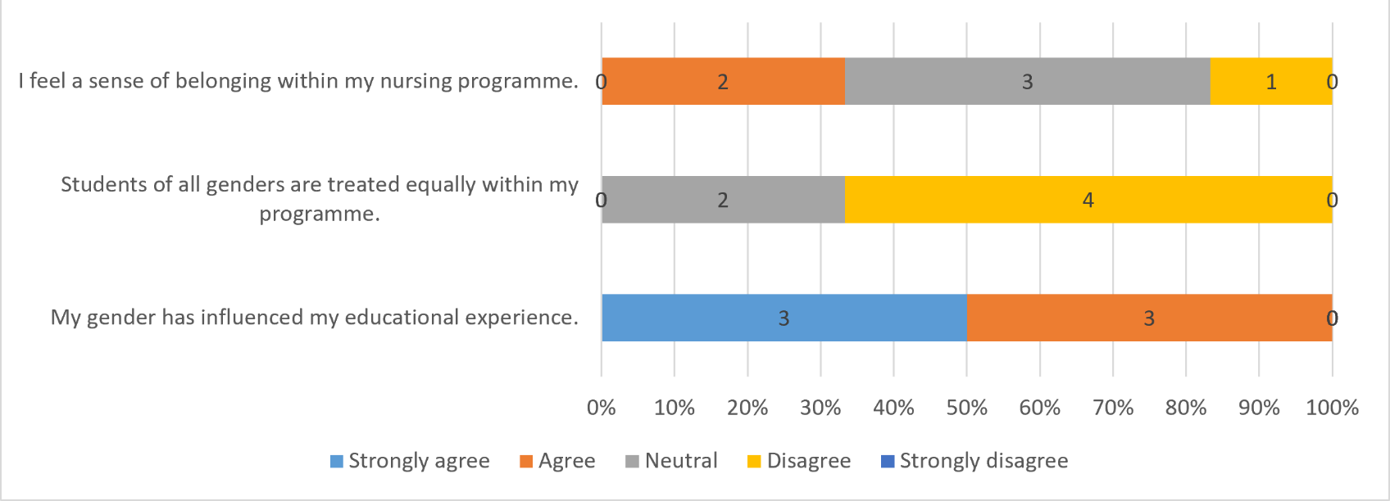
Q 17. For the following statements please indicate your level of agreement
n=101
n=6

Q 18. Is there anything else you would like to tell me about your experiences of nursing education, gender representation, inclusivity, or any other issues that you feel have not been covered in this questionnaire?
This is an open text response – please see Appendix 7.

Q 19. Would you be willing to participate in a follow-up interview about your experiences of nursing education?

Yes – 20
Female – 13
Male – 6
Non-Binary - 1

Appendix 7 - Questionnaire Open-Text Responses
The tables below reproduce all non-blank responses entered for the three open-text questions used in the Educational Barriers and Student Experience section of the questionnaire. Responses are reproduced verbatim, including original spelling, grammar and punctuation. Respondent numbers correspond to the questionnaire spreadsheet IDs. Blank cells are omitted; entries such as “no”, “N/A” and punctuation-only responses are retained because they were submitted responses.

Question 14: Open-Text Responses
Please describe any of these barriers and provide examples where possible.
Non-blank responses: 90
Respondent ID | Gender | Response (verbatim)
1 | Female | I am veryt nervopus and self consuss, i dont feel confident when doing roleplay in front of everyone. I also dont like being online as i sometimes dont understand what is going on but there are hundreds of other students in the call so im never going to ask. Id rather learn face to face.
2 | Female | childcare issues
3 | Female | One of the main challenges has been balancing the academic requirements of the programme with the demands of clinical placements and personal responsibilities. Nursing involves a significant amount of reading, academic writing, preparation and practical learning, which can sometimes feel overwhelming when combined with placement hours and other commitments. I have also found that different teaching and learning methods can affect how easily I understand and retain information. At times, I have needed additional time to process complex topics or to consolidate information independently after lectures and practical sessions.
5 | Female | I really struggle with childcare, it is very expensive for me to put my daughter in creche so I really on my Mam who cany always help
6 | Female | I dont like talking infront of the class and sometimes I feel like I dont participate enough because of this
7 | Female | Time for studies whilst on placement and running a busy house
8 | Non-Binary | online learning
9 | Prefer not to say | My main barrier is participating in discussions
11 | Female | I have Dyslexia
12 | Female | I don’t have a car so I sometimes can’t get to uni on time or to placement especially for 6:30am
13 | Female | I do struggle with the technology side, I find accessing resources difficult from blackboard as I’m not technical minded, I can never find them
14 | Female | Time, money, life
16 | Female | Being a student is expensive
17 | Female | I struggle hugely with presentations, especially online. I also hate online lectures. Some resources hard to find and theres no explanation of tasks that we access on the digital board. Childcare is a barrier as I have to take time off if the kiddos are sick and off school which gets me in trouble. Workload due to responsibilities at home.
18 | Female | I struggle with time to do my studies due to needing a part time job
19 | Female | I don’t have a car so I struggle commuting to uni
20 | Male | I have struggled with some lectures due to placement commitments and managing my own schedule due to lack of sleep.
21 | Male | My confidence, I hate speaking infront of everyone, as I feel like my views can be dismissed, some people in the class are not great at accepting views that are contradictyory to their own. For this reason I hate participating in discussion but Im asked my opinions in almost evey single class it pretty embarrasing at times.
23 | Female | juggling external commitments and studies is very challenging
24 | Male | Time for studies, I work part time and have financial responsibilities with a wife and daughter to look after. I try to do my essays on a night shift which is tough going.
25 | Female | I am shy and don’t like to participate in class and sometimes being asked to present makes me really anxious
26 | Female | mostly personal circumstances
27 | Female | Balancing life, work and uni
28 | Female | clinical placements can be quite stressful
30 | Female | Participation in class is not always possible due to work commitments
31 | Female | I find that most of the teaching is appropriate, but sometimes there is a lot of information delivered in a short period of time. I learn better when there are practical examples alongside the theory.
33 | Female | time
34 | Female | Some teaching sessions feel quite repetitive, particularly when the same information is covered across different modules.
35 | Female | I find the online learning materials useful, although occasionally information is spread across different platforms and can be difficult to find. I find the taught online sessions difficult to engage in for a variety of reasons - IT issues, too many members, hard to get clarification
36 | Female | None
37 | Female | childcare issues
38 | Female | Having several assessments close together can be stressful, especially when they are combined with placement commitments
39 | Female | I feel confident in some areas but less confident when I have to speak in front of a large group or demonstrate something in front of other students
40 | Female | My confidence has increased since starting the course, but I still sometimes question whether I am good enough, particularly when comparing myself with other students.
41 | Female | The biggest difficulty for me has been understanding exactly what is expected in some assessments. Sometimes the marking criteria feel quite broad
42 | Female | I don't always participate in discussions, not because I don't have an opinion, but because I sometimes worry about giving the wrong answer
43 | Female | I am more comfortable contributing in smaller groups than speaking in front of the whole class
44 | Female | I generally find lecturers approachable, but sometimes I feel nervous about contacting them because I don't want to appear like I haven't understood something
45 | Female | Group work can be stressful when people have different schedules because of placement and other commitments
46 | Female | have had some really supportive mentors who made me feel confident and valued as a student. Unfortunately, I have also experienced placements where I felt less supported
47 | Prefer not to say | Travelling to placement can be challenging when you are given placements that are a long distance from home.
48 | Female | Financial pressures have made studying more difficult, particularly because placement can limit the amount of time available for paid work
49 | Female | Family responsibilities can sometimes make it difficult to manage the demands of the course, particularly when placement hours change
50 | Female | I think the workload can sometimes make it difficult to maintain a healthy balance between university and personal life.
52 | Female | I generally feel like I belong on the course, although there have been times when I have felt more like a number than an individual student
53 | Female | I find academic writing and referencing more challenging than the clinical side of the course and the volume of assessments
54 | Female | For me, the biggest challenge has been balancing academic work with placement. I sometimes feel overwhelmed by the amount of information we are expected to remember, and this can affect my confidence. However, when I have supportive staff around me, I feel much more comfortable asking questions and getting involved
55 | Female | My confidence depends a lot on the environment. I feel much more confident when I know the people and feel comfortable asking questions
56 | Female | find that most of the teaching is appropriate, but sometimes there is a lot of information delivered in a short period of time. I learn better when there are practical examples alongside the theory
58 | Female | N/A
59 | Female | Making friends was difficult initially because everyone seemed to already have their own groups. It became easier as the course progressed
60 | Female | I sometimes feel anxious at the beginning of a placement because I don't know what the other nurses will be like or whether they will have confidence in me. Ive heard some horror stories of really horrible ward teams
61 | Female | Communication on placement can vary depending on the staff and the ward. Some teams are very welcoming and explain everything clearly, while others expect students to know more than they actually do
62 | Female | time management
63 | Female | Sometimes there is a gap between what we are taught at university and what happens in practice, which can be confusing when you are trying to apply your knowledge
64 | Male | Theres so much role play - i hate it, I also hate the weekly presentations. Time also as I feel I have no time to myself and always up to the deadlines with my submisiions. Maybe I will get used to it as I not done any head work for years, on the tools before this.
65 | Female | hate joining on teams constant camera issues mic issues teaching awful on line
67 | Female | online learning
68 | Female | childcare issues
69 | Female | childcare
70 | Female | Im not good on the computer I get very stressed in online classes when we have to contribute i cant do it Im too slow
71 | Female | Everything online
72 | Female | wheredo I begin. I need more than 24 hours in a day. Barriers include childcare, housework, school pickups and dropoffs,computer access, time to study, constant assignments which are hard.
73 | Female | I like being in uni but its quite a long day, but online days are even more tiring.
74 | Female | academia for me. Ive necer been a good student, I haad to resit every module in Year 1. I think I might be dyslexic too. I dont like the online learning and done want to ask infront of so many people questgions
75 | Female | so many
76 | Female | mental health
77 | Female | class issues are huge
78 | Female | IT issue
79 | Female | Worklaod also dislike groupwork and relying on others contributions for group project or group presentations
80 | Female | I think the same as everyone really, theres lots of work and when you are on placement its hard to stay motivated to do assignments. I prefer being in our classroom rotation for getting work done, theres more motivation when you are in class. Dont like online learning, I tend to switch off from whats being said, and its impossible to contribute.
81 | Female | This year has been difficult as nearly all of my classes have been pre-recorded which means I cant ask questions or check my learning and I feel a little isolated at times. I also have a rubbish laptop which causes a lot of problems at a time when workload has been so high.
82 | Female | I struggled last year to access resources on blackboared but its been easier this year. HJowever lots of barriers like juggling clinical work and assignments at the same time, thats brutal, especially with the long hours. I also dont get much of a bursary so I work in a coffee shop part time which is a barrier again with time.
83 | Female | content is difficult but enjoyable,
84 | Female | All of the above!
85 | Female | I think every student nurse experiences barriers to learning for example juggling academic work with placement, however its our responsibility to put strategies in place to overcome these. For example prioritising tasks, making a study plan.
86 | Female | babysitters, the kids are passed from piller to post as well as running a house and studying and placement
87 | Female | First year of my child nursing degree is amazing but stressful, I find class nerve wracking but its even worse on placement. I finished my first one and was a bag of nerves the whole time, its such a responsibility looking after a sick child. It is a privilage too.
88 | Female | Nursing is a very tough course to do, as well as attnding uni in person an online, you are also attending clinical placements which can mean nightshifts, weekend work and long hours. Theres a lot of travelling. You also need to have a thick skin on placement and in class. Then if you have personal responsibilities on top, look out.
90 | Female | Where do I start, so many barriers. Time - don’t have any. I’m in year 3 and on my management placement, so I’m working 12 hour shifts including night shifts. I also have to do shifts in the nurse bank to earn some extra money. On top I’m a mam of two young kids so struggle to do everything, keep house clean, do washing.  Money - I have none, I spend a lot of money getting to and from my placement. Workload - so much coursework to stay on top of and I have a biology resit hanging over my head.
91 | Female | I’m in a class with lots of mean girls, or women I should say. Not fun at all, I hate being in there but also tho I hate online learning which we have lots of, really hard to engage online so I don’t get the most out of my sessions I find online sessions very slow.
92 | Female | Childcare is a nightmare as I miss half of my lectures when the kids are sick which is all the time. I have almost 6 weeks placement to make yp as I had to take time off when my son was in hospital.
93 | Male | money parking travel placements
94 | Female | No babysitters as I’m a single mum.  No time for study as too busy with placement, children, household responsibilities, that’s a huge barrier for me.  I hate the online learning I’d much rather be face to face. My laptop is ancient and always issues.
95 | Female | I really struggle with online learning which we do a lot of, resources are hard to find and access I never know what the heck’s going on
96 | Female | Im pregnant at the moment so not allowed to attend my first placement as its challenging behaviour, so thats a barrier for me at the minute. I will have to make that time up but it will be after the baby comes which will be even more dificult. Otherwise Id say the lack of parking at the uni is costing me an absoluter fortune and ssometimes I havent come in to class as I couldnt afford it.
97 | Female | My concentration and confidence
98 | Female | I struggle with, anxiety/OCD which can sometimes be a barrier towards my learning.
100 | Female | Lots of remote work in year 3, doesnt agree with me!
101 | Female | Confidence is huge for me but I think the biggest barrier for me is that there are no jibs waiting for me when I finish thats very disheartening and has made me think what is the point of all this hard work

Question 16: Open-Text Responses
If you feel that your gender has created barriers to your nursing education, please describe these barriers and provide examples where possible.
Non-blank responses: 33
Respondent ID | Gender | Response (verbatim)
2 | Female | childcare issue
4 | Female | no barriers due to my gender
5 | Female | being a mum
7 | Female | Only now that I think about it, I’m the mum so childcare is my responsibility, so that’s gender related
10 | Female | responsibilities outside of the course
13 | Female | I was once told by a young male patient in my acute assessment placement to ‘f**k off out of his room’ as he didn’t want me to help him shower. That was because I’m a girl. That’s a big barrier if you are causing a patient to be upset’
17 | Female | Yes coz im a woman. the kiddos are my responsibility. the house is my responsibility.
20 | Male | I feel that as a man I am not often taken as seriously in the profession and this has impacted my confidence id say this is true both in clinical areas and in lectures especially class discussions. It can also be lonely as the only man in a class of women.
21 | Male | I dont feel left out of conversations and discussions, the problem is that Im always dragged in to them, often just to have an eye roll, or have one of the girls challenge me. Its draining. and I think this has affected my confidence
23 | Female | Im a mum so enough said
24 | Male | Im not sure if its a barrier but i wanted to comment of the learning resources bit before but I could not, I feel respresented in most books that i use, not all mind, but I often dont feel represented in class 99/100 the examples are all women or no gender, does not represent me, except in Johns classes, he's great and can see the male perspective. This is something i feel very stronly about. It winds me right uo, it does. I often think some of my other lecturers want to give me a cwtch and im like leave me alone woman.
33 | Female | packed lunches dont make themselves, the house doesnt clean itself and chiuldren cant be left alone - this is a gender issue for me
46 | Female | In my last placement I had a hard time from some of the female nurses there and I know its because Im a pretty girl. Girls are very bitchy to girls.
51 | Female | don't think being a woman has caused me any particular difficulties on the course, but the fact that nursing is predominantly female does make gender less noticeable compared with other university courses
62 | Female | my responsibility as a mum means I have to think of my son and daughter before I can think about my studies
64 | Male | I dont like telling new people what Im doing, my mates rip in to me. I dont care really but its a pain in the arse
68 | Female | none else to have children so I need to do drop offs and pick ups and often have to miss class. Its even worse when I am doing shifts on placement or if the kids are sick. As a Mammy I need to put my children first
69 | Female | I have responsibilities as a mum
72 | Female | what i just said its my job as the matriarch of my brood
74 | Female | maybe in placement as some people men especially, especially certain cultures can be a bit dismissive of me, I think its because they see me as a young silly girl who am ito tell them
77 | Female | lots of trouble with other girls in the class its very bitchy, I see it on the wards too, thats what happen when so many women are together and its getting worse and worse
84 | Female | mammy
86 | Female | My gender absolutely impacts my ability to complete this course successfully. As a woman and a mother I have a lot of plates to spin. More plates than my husband has to spin, thats for sure.
87 | Female | I think being female is actually a benefit when in a clinical area with children. The public assume you are good with children when you are female.
88 | Female | of course, Im a mum.
90 | Female | As a mam I definitely take more responsibility for the kids and house work and that puts additional pressure on me. By the time I do the kids homework with them, do the baths, dishes, packed lunches I then need to sit down and study and I’m too tired to think then
91 | Female | I’m in a minority in a class where I don’t really fit in as I find them all bizarre. Maybe that’s my gender, I can’t relate, I don’t no
92 | Female | Had to take time off as I’m the mummy
93 | Male | i dont have enough money to study and live ive got a mortgage and also child maintenance to pay, I nearly quit last year but made it to final year. Others barriers are in placement female patients often dont want me to care for them and male pateints can be more aggressive towardss me because Im a man. In class my gender is a barrier as Im ofted odd one out of experiences and cant relate, but also im the teachers pet so not all bad
94 | Female | As a woman I feel I have more responsibilities especially with the kids and home. I don’t ever hear the men in the class complain about having to zoom in to class cos they’ve just dropped the kids off.
95 | Female | If my gender makes me rubbish with IT then yes, if not then no!
96 | Female | pregnant
97 | Female | Im going through physical and psychological changes thanks to the menopause as a result I have some issues with self confidence and mood aswell as concentration

Question 18: Open-Text Responses
Is there anything else you would like to tell me about your experiences of nursing education, gender representation, inclusivity, or any other issues that you feel have not been covered in this questionnaire?
Non-blank responses: 54
Respondent ID | Gender | Response (verbatim)
1 | Female | most of my classes are all girls. my anatomy lecture online has a few boys in it. Otherwise no, I had not thought of gender til now
2 | Female | no
3 | Female | I think having male students on the course is really positive. Nursing can sometimes be seen as a female profession, so having more men studying nursing helps challenge that stereotype. I have always felt that the male students are treated as part of the group and are just as capable as everyone else.
4 | Female | I think gender representation is important, but it is only one part of inclusivity. Students come from different ages, cultures, backgrounds and life experiences, and I think nursing education should recognise and value that diversity.
7 | Female | No
9 | Prefer not to say | N/A
12 | Female | No
13 | Female | No
20 | Male | I do feel accepted like you asked in the last question, teachers are friendly and approachable but Its stressful as a student nurse but even more stressful as a male student nurse. I feel that Im quite criticised by the girls they think its easier for me, but its harder I think.
21 | Male | sometimes I do feel a little babied by my teachers, like im their son, thats embarrasing.
24 | Male | Im proud to be a bloke studying nursing, im passionate about supporting others to improve their mental health, and although I feel accepted at times I also think I stick out for wrong reasons
26 | Female | I think gender representation is important, but it is only one part of inclusivity. Students come from different ages, cultures, backgrounds and life experiences, and I think nursing education should recognise and value that diversity.
27 | Female | I think having more men in nursing would be a positive thing. I have never had an issue working alongside male students, and I think having a mixture of men and women makes the course more representative of the wider population we care for.
28 | Female | Because there are so few men on the course, the male students do stand out more. I don't think this is necessarily a bad thing, but I can imagine it might make some men feel self-conscious when they first start.
30 | Female | I have noticed that some patients seem more comfortable having a male nurse for certain situations, particularly male patients, male patients can feel uneasy around me, especially personal care. I think having both male and female nurses is important because patients have different preferences and needs.
31 | Female | Although this questionnaire focuses on men in nursing, I think women can also experience expectations about what type of nurse they should be. Gender stereotypes can affect everyone, so inclusivity should be about challenging those expectations generally
33 | Female | ....
34 | Female | I have noticed that male students can sometimes be asked to help with moving or handling patients because people assume they will be physically stronger. I don't think this should automatically be expected based on gender.
35 | Female | Gender hasn't really affected my own experience of nursing education. I have worked with male and female students and generally don't think about their gender. However, I recognise that being one of only a few men might be a very different experience for them
38 | Female | I have seen situations where male students are praised for choosing nursing, whereas female students are sometimes expected to go into nursing because it is traditionally seen as a woman's profession. I think this shows that gender stereotypes can work in different ways.
39 | Female | I think male students' experiences could sometimes be overlooked because women make up such a large proportion of the course. It would be useful to give them opportunities to talk about their experiences without making them feel like they are being singled out.
40 | Female | I have noticed that some of the male students seem very confident, whereas others seem more conscious of being different. I don't know whether this is specifically because of gender, but I think the course environment can influence how comfortable people feel
41 | Female | Before starting nursing, I hadn't really thought about how gendered the profession was. Being on the course has made me more aware of how unusual it still is to see large numbers of men studying nursing
42 | Female | From my perspective, the male students seem to have different experiences depending on their placement and the staff they work with. I think the environment they are in probably matters as much as gender itself.
43 | Female | I think there is sometimes an assumption that men who choose nursing must have a particular reason for doing so, whereas women aren't usually asked why they chose nursing
44 | Female | I think nursing should be seen as a career for everyone. Having more male students would make the profession feel more balanced and may help challenge some of the stereotypes around nursing
45 | Female | I think attitudes towards male nurses are changing compared with the past. Most of the patients and staff I have encountered are very accepting, although occasional stereotypes still come up
46 | Female | I don't think male nurses should automatically be associated with particular specialities. Men should be encouraged to work in areas such as children's nursing, community nursing or mental health just as women should be.
47 | Prefer not to say | I think universities and healthcare organisations could do more to promote male nurses as role models. If prospective students only see women represented when nursing is promoted, they may subconsciously think that nursing isn't a career for men
48 | Female | I don't think being male necessarily creates barriers to completing the course, but I can see how feeling different from the majority could affect someone's experience
49 | Female | I think nursing should be seen as a career for everyone. Having more male students would make the profession feel more balanced and may help challenge some of the stereotypes around nursing.
50 | Female | I don't think there is anything else I would add. Overall, my experience of nursing education has been positive and I have felt supported throughout my course
51 | Female | Personally, I don't think someone's gender has much impact on whether they will make a good nurse. The qualities that matter are compassion, communication, professionalism and being able to care for people. I think the focus should be on the individual
52 | Female | I think society still has quite traditional ideas about nursing being a woman's profession. Having male nurses and male nursing students is important because it shows younger people that nursing isn't just a career for women.
53 | Female | I have occasionally experienced the assumption that male nurses are mainly interested in areas such as emergency care or mental health rather than general nursing. I think there are still some stereotypes about what men are expected to do within nursing
54 | Female | The lack of other male students can sometimes make it difficult to feel like you belong. It would be good to see more men represented in promotional material and at university events
55 | Female | Most of my experiences with female students have been positive. I have not felt excluded because I am male, although sometimes I think there are differences in how male and female students approach certain situations
56 | Female | Some patients have been surprised when they found out I was a student nurse and occasionally asked why I chose nursing. Most were supportive, but it made me realise that nursing is still sometimes viewed as a female profession
58 | Female | N/A
59 | Female | nothing to add
60 | Female | N/A
61 | Female | --
62 | Female | --
63 | Female | /
64 | Male | Im one of very few male students in my cohort, we are the minority. I feel accepted by the girls socially but I think my opinions are not taken seriously by some people in the class. I dont mean my lecturers they are pretty sound, but some of the girls. I think that the uni could do much more to challenge gender steroetypes and increase inclusivity for men
65 | Female | I know everyone talks about male student burses being isolated but theres 2 males in my class and the lecturers are all over them in every class. They are by the favourites, teachers cant do enough for them, which I find infuriating to be fair.
74 | Female | I know what you mean, I do see that the boys in my year might not be shown in resources. I have a male in my class and he goes on about this all the time. I dont really have to worry about it. Im white and a girl im totally represented in all the resources. but i can see it, I think more effore goes in to showing multi cultures than it does go in to showiing males. I feel sorry for the boys actually. Id feel a bit marginalised if i was a boy student nurse.
76 | Female | nothing to add
87 | Female | I think being female and perceived as more trustworthy by the public is true of nursing in general, not just childrens nursing.
90 | Female | I’m obviously very aware of the gender issue of way less men than women, it’s not only the classroom but on the wards too. I have nursing texts here in the house - I’ve just looked and some of the older texts 2018 do refer to her and she, which I hadn’t noticed before.
91 | Female | Hard questions for me, font really know the answers it’s hard to describe
93 | Male | Ive enjoyed my course, theres a few of us boys and they are sound, not sure I would have met as many boys on adult or peads.
94 | Female | Dim
97 | Female | I think gender issues can affect all of us. Just now for me its the menopause, for othersit could be being a minority in a class, for others it could be being beautiful and being bullied as a result. I think we all face gender related issues in the ward too. Many patients prefer to be looked after by women, some by men, in peads family can be very picky with who they want looking after their child. Its the same for skin colour in my opinion. Thats the public and thats nursing.

