
Submitted by:

Daniela Mihalkova
Cloud Computing Level 4
Module code: ACCB4002
Student ID: 2021925

Data analysis and visualisation
Assignment 2
Contents
Introduction 3
T-test 3
Hypothesis 3
Hypotheses for the analysis 4
Null hypotheses 4
Alternative Hypotheses 4
Dataset 4
Testing of hypotheses to various level 5
Outliers in the Dataset 9
Factors 10
Outcome 10
Conclusion 10
REFERENCES 11

Introduction
This research is based on hypotheses calculation that describes with the flow of different testing level of hypotheses. Comparison between different hypotheses has been illustrated in this calculation by using a specific number of sample table. All the findings and description are based on appropriate test from hypotheses. A few significant levels have been tested to identify the difference between null and alternative hypothesis. Findings with proof has been shown whether null or alternative hypothesis would be accepted and rejected. Comparison between outliers and without outlier calculation have been shown with the features and factors which has brought up with the term of results and affects to the result.

T-test
The T test can be used to compare the means of two groups. It is one of the most often utilised statistical hypothesis tests in pain research [1]. The two types of statistical reasoning are parametric and nonparametric methods. Parametric methods are a statistical strategy that involves defining the probability distribution of probability variables and making conclusions about the parameters of the distribution. When the probability distribution cannot be defined, nonparametric methods are utilised. T tests are a sort of parametric technique that may be employed when the samples are normal, have equal variance, and are independent.
T tests are divided into two categories. When the two groups being compared are unrelated to one another, the independent t test can be employed. When the two groups being compared are dependent on one another, a paired t test might be employed. When the experimental participants are split into two independent groups, T tests are commonly employed.

Hypothesis
In a quantitative research project, the hypothesis testing procedure is a systematic series of stages for conducting statistical analyses. Hypothesis testing is, without a doubt, the most often utilised statistical method in scientific research.
The asymptotically optimal hypothesis testing issue is studied utilising generic sources as the null and alternative hypotheses under exponential-type error limitations on the first sort of error probability. The hypothesis testing problem has its own significance, which encompasses both a theoretical and an engineering perspective. Not just from a theoretical standpoint, but also from an engineering standpoint, the hypothesis testing problem is critical. The no asymptotic investigate single-shot sources using a real alphabet [2] appears to have initiated this key research issue in the hypothesis testing problem in the 1930s.

Hypotheses for the analysis
The hypotheses are based on two different and independent population which have unequal variances. Due to the variances number the test will take place in two different methods, one will be two - tailed and another will be one – tailed. To calculate the truthfulness of the data an operation has been performed on two different type people. Data analysis has done in Microsoft-excel where the sample has been taken and hypotheses has calculated.

Null hypotheses: A sort of hypothesis that asserts that the features of two groups are same [3] Null Hypotheses X={X^{n}}∞_{n=1} Any series of random sources where alphabet is used as the null hypothesis is a more acceptable definition. Z can be random variable taking values, where n=1,2…. Infinitive, then the sequence would be Z={Z_{n}}∞_{n=1} of random variables Z_{n} is called as Null Hypotheses.
Mean1- Mean2 = 0

Alternative Hypotheses: This hypothesis explains The features of one population do not correspond to those of another. Null hypotheses can be rejected in this instance if the sample includes some evidence, and an alternative hypothesis can be preferred.
Mean1- Mean2 = is not zero

The logic of this hypotheses can be used for the purpose of calculation.

Dataset
The infection rate of covid-19 is varied between the white and BAME people which has been described in the dataset, black and minority ethic people of United Kingdom. The dataset contains 40 people from both communities. The age of the people is between 20 to 100 where the analysis will be based on true hypotheses. Several data will be analysed, and their hypotheses will be implemented during this research. The test of hypotheses has been done on both type of people based on infection rate.

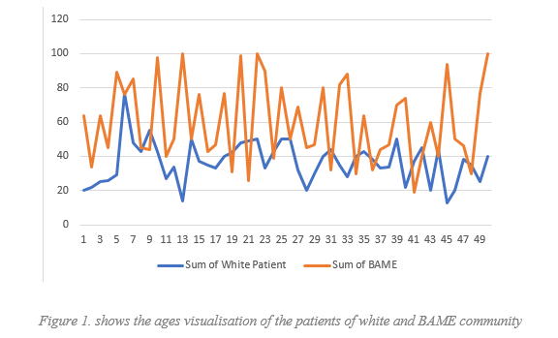

It is clear from Figure 1. that different types of people have different level of infection rate, but the significant rate of infection has been seen in the sum of BAME people they drastically increasing always more than the white people.

Testing of hypotheses to various level

By are comparing two means we will get two different obtained variances. If one simple variance is longer more than twice than other, then we can assume the variances are unequal as occurs in this case. From the provided data set we can check and compare if the variances are equal or not using the formula:
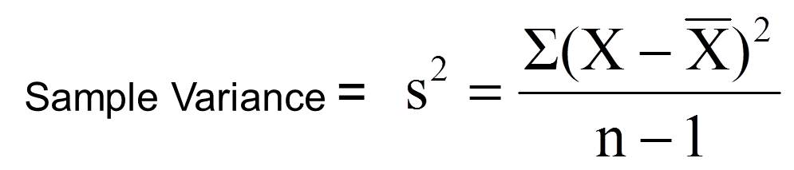
For variance of white patient, it is coming result 143.51
For variance of BAME, it is coming result 547.18
It is clearly seen that one of variances is greater more then twice we can say that the variances are unequal.

The hypotheses are calculated for various significant levels and the first significant level is 0.10

α = p = 0.10
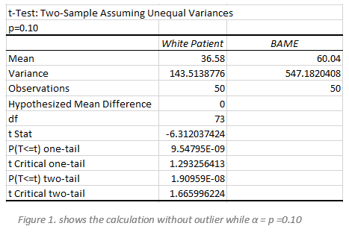
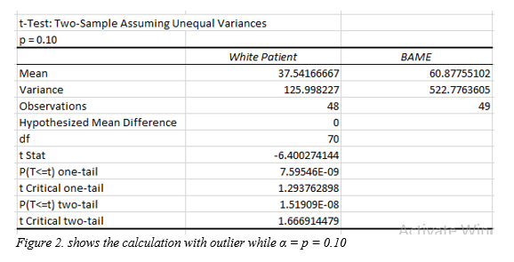

t - Distribution
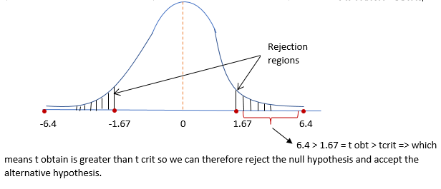

- While t Stat is greater than the critical two-tail, and here it is true as the 6.40 is greater than 1.67, that means we can reject the null hypothesis, and null hypotheses is still unsupported when unequal consideration has been accepted in terms of the infections rate calculation in white and BAME people.

- P-value of two-tail is lower than the value of alpha where null hypotheses can be rejected. From the graph it also illustrates 1.5190E-08=0.00000008 is smaller than 0.10 which is equivalent to p and it is clear for rejection of null hypotheses.

The hypotheses are calculated for various significant levels and the second significant level is 0.01

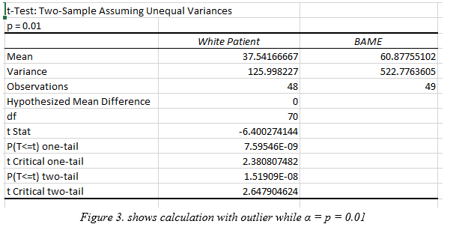
α = p = 0.01
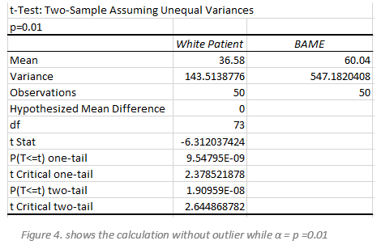
- The value express that while t Stat = t obtains = -6.400274 (we can ignore the sign and to accept 6.40) value is greater than critical two-tail value there is null hypotheses can be rejected because it is greater than t critical 2.647904 It can be confirmed from this calculation in term of outlier the null hypotheses can be rejected.

- Another different perspective can be point out from the same calculation, the calculation of with outlier as p=0.01 and another different result comes up while testing the hypotheses without outlier where t critical two-tail value 2.644868782 are also different from the same calculation of without outlier where it is value is 2.647904624 On the basis of these differences, it is fundamentally accepted as rejection of null hypotheses.

- While P(T<=t) 1.51909E-08 = 0.00000001 is less than value of alpha in between calculation of 0.01 and that is why null hypotheses can be rejected.

The hypotheses are calculated for various significant levels and the third significant level is 0.02
α = p = 0.02
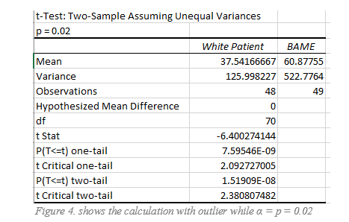

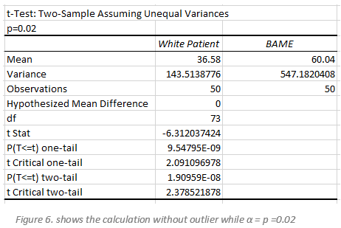

α = p = 0.02
- From the calculation of with and without outlier for t test two-tail value and t critical two-tail value has a significant amount of difference which leads to the rejection of null hypotheses.

- The chart shows from the calculation of with outlier where the value of t two-tail is 1.51909E-08 = 0.00000001 is less than the t critical two-tail value is 2.3808 which is higher than the value of t test and it leads to the rejection of null hypotheses.

- On the other hand, in case of the calculation without outlier when t is less than equal two-tail value is 1.90959E-08 = 0.00000001 and the t critical two-tail value is less than two-tail value which is 2.378521878 this also leads to the rejection of null hypotheses.

- Eventually it has been examined and analysed with proper calculation which brought up the result as always null hypotheses as rejected because they are not at all equivalent to α = p = 0.02.

Outliers in the Dataset

The data value is different because they are either sometime higher or lower from each other. This dataset contains some unusual different value which causes interruption in time of testing hypotheses which also brings unsatisfied research. These different values also cause unsignificant results and so that the value of statistical analysis differs from mean and standard deviation thus, it is necessary to perform it before any test to signify the different values.

During the t test some outliers come up with different values, though the research question is on the basis of 20-100 years people but the different ages like 14(Patient No.13), 13(Patient No.45) causes outlier and it leads to different calculation with certain verities of value. As the different age brings outlier so that 2 different hypotheses are necessary to explain the table and from there the genesis arise of two different hypotheses, one with outlier and another is without outlier.

While expectation went in different way with two outcomes with and without outlier so that data sorting procedure has become changed. The hypotheses calculation processed with the finding and sorting the data in order to get the outlier first by ascending the data with the ages which brought up the lower and higher values of the data.

The test is based on the research of the rate of infection of covid-19 between white and BAME patients, where P value is less than the significant value when the hypotheses calculated without outlier, but the p - value creates some sort of difference when the hypotheses took place with outlier as because the table have got some different age which doesn’t exist in line of 20-100 age ratio. During the analysis of hypotheses one more result come out for being rejection of null values due to calculation within outlier. Without outlier and the P value is sometime greater than the significant value and sometime the P value went lower due to within outlier that caused two different hypotheses for (α = p = 0.10, p = 0.01, and p = 0.02)

Factors

The large sample represents higher values, but the smaller sample group of value is unknown. The table of sample showed only 40 people infection rates about a pandemic where it is quite not enough to lime lite any survey with good result because it is a world-wide infection rate so that, the sample should be more creative and broad numbers of data containing table which could have bring effective result with clear concern about the pattern and particular dataset.

Lower significant value causes the ability of the significancy low as well, but during the hypotheses it has been found that the lower values acceptance become higher, and the probability went forward to reject the null hypotheses. False value causes false hypotheses and null hypotheses. So that level of significance is crucial to measure because it may lead to the rejection of null hypotheses with lower levels of significance.

The difference between the real value of the parameter and the prescribed value in the null hypothesis is expressed by the true value parameter. where it also added more ability of the hypotheses testing. During the study period, actual results were compared to null values, which should be maximised for hypotheses testing power testing.

Outcome
t-Stat and probability has been tested in a way with and without outlier where it has been shown as the null hypotheses cannot be rejected. It is unequal while the calculation took place in term of finding the result with hypotheses on behalf of values of infection rate. Present hypothesis is completely based on null hypotheses with the very different infection rate of different people. It has been shown during this research the perception which has been made based on assumption of the infection rate in both type of people and that has become so crucial by the null hypotheses.

Conclusion
Hypothesis as probability and on the basis of presumption that grows in the calculation to define the significant research for a sample table to achieve a singular result from different calculation has been shown to satisfy the demand of the analysis. Testing of different levels of hypothesis come up with different values and brought up different assumptions toward the rejection of null hypothesis. All the calculation has been grown from the calculation of the sample table from different level of aged people and applied for few hypotheses procedure which has shown its outcome as the acceptance of alternative hypothesis and rejection of null hypotheses.

REFERENCES
- Kim T. K. (2015). T test as a parametric statistic. Korean journal of anesthesiology, 68(6), 540–546. https://doi.org/10.4097/kjae.2015.68.6.540
- J. Neyman and E. S. Pearson, “On the problem of the most efficient tests of statistical hypotheses,” Phil. Trans. Roy. Soc. London, ser. A, vol. 231, pp. 289–337, 1933.
- Andrew F, Hayes Statistical Methods for Communication Science 2020

