
Effective TEAM WORKING AND COMMUNICATION
BMSW4002-SWAN

Student Name: Cretu Diana
Student Number:2123838

UNIVERSITY OF WALES TRINITY SAINT DAVID

CONTENTS Page No.

Summary………………………………………………….4

Introduction…………………………………………………………………….5
Main Findings………………………………………………………………….6
How the application of teamwork theories can improve teamwork in the organization…………………………….6-7
The importance of two-way communication in the organization…………………………………………8-10
Why effective communication (verbal and non-verbal) is important for the continued success of the organization?.....................................................................11-12
Conclusion……………………………………………………………………...13
Reference List………………………………………………………………….14

This report was requested by Melanie Squire, Lecturer of Skills for the Workplace as part of the assignment for the Effective teamworking and communication module.
Submission date: 01.07.2022

To create this assignment, the procedures used were academic journals, websites, and lecture resources.

Summary

This report is based on highlighting and solving the problems found in the case study that Andrea Jones, the new Head of Social Services in the local Council, is facing. The report's objective is to find solutions to the problems identified in the case study. To find them at the base are:
- Two theories aim to highlight teamwork, forming efficient, productive teams, and developing relationships between team members.
- Three communication models accompany the importance and presence of bidirectional communication at the team level.
- The importance of both verbal and nonverbal communication for the success of an organization.
The summary of the case study is the following:
- to form productive and efficient teams, they must first follow all the stages that a training team goes through. These stages will develop communication between team members, go through various conflicts, and finally work as an efficient team.
- the roles of each team member must be discovered to make a complete team and create the balance they need.
- communication must be developed among all members of the organization; they need complete the communication and carried to the end, which means that after the message, there is feedback.

Introduction

The essential themes of the report are teamwork which is important and necessary in any organization, and the communication that complements it.
Team- a team is defined as a dynamic entity made up of one or more interdependent individuals who share a common goal and specific tasks assigned to everyone. (Peralta, 2018).

It is not enough for teams to be formed; they must develop communication between team members to help them grow and become an effective team that is productive for the organization.
Communication is the process of transmitting different information that can be thoughts, ideas, emotions, and shared understanding from person to person. Communication is of several types: nonverbal, verbal, written, visual, and listening communication. (Genç, 2017)

The themes of the report come in solving the problems discovered in the case study that disadvantage the company and because of which productivity decreases. The problems highlighted are:
- lack of staff
- staff turnover fluctuation
- new inexperienced employees
- non-performing teams
- stress
- lack of communication
- lack of trust among employees
- low productivity

Main Findings

- How the application of teamwork theories can improve teamwork in the organization.
For an organization to be productive, it must have teams and employees that work efficiently. Referring to the case study, the lack of employees is a problem that the organization is facing and can bring many disadvantages to it. Staff shortages began with the pandemic, and employees realized that working from home was much easier and more comfortable and decided not to return to the company. To solve this problem, Andrea Jones needs to find solutions that can make workers quit working online and return to work for the company. She can make this possible with the help of rewards and recognition. Andrea needs to motivate workers and give them a benefit to get them back to work. These can be bonuses, an extra day off, diplomas after work, gift cards, and employee of the week certificates. Each manager must explain to the team the advantages of working face to face at work. Employees need to know the benefits of working physically, increasing work efficiency, expanding learning opportunities, developing communication, learn new skills.
Team working is very important because can give a team member a sense of identity, friendship, and support for personal and professional development. (Griffith and Dunham, 2015).
Because the teams are underperforming due to new employees coming in, Andrea must form productive teams for the company. One theory behind team development is Bruce Tuckman's stages of development (1965). All teams must go through the five stages of development: Forming, Storming, Norming, Performing, and Adjourning. These five stages of training play a vital role in forming a functional team because the development of a team is the most important aspect of success in practice. The posture of each member is interdependent, and a single member's performance affects the entire team's performance. The purpose of these stages of team development is to build a team that can overcome the obstacles they face during work, solve problems, find solutions, develop plans, and delivers results.
Conflicts that arise in the Storming stage between team members can have positive aspects such as: can lay problems on the table and open discussion, leading to solutions and happier outcomes for all, increasing communication between people and leading to a greater mutual understanding. In the last stage of development, each manager must provide feedback to the team for all the work done, which will make the team members feel very appreciated and feel that their work is rewarded. These stages will build high-performing teams, help gain experience for new employees, develop communication, minimize stress, and most importantly, build trust.
Trust is vital and must be developed in each team because when team members trust each other, they work much more efficiently because it provides safety, and help the growth of productivity for the organization, they share more feelings that make them open. (Erdem et al, 2003)

To form the teams and go through all the stages, Andrea must first know all the employees, what skills they have, their knowledge, attitudes, behavior, and roles each one has. She can get to know the team with the help of the 9 roles written by R. Meredith Belbin in 1981. Completer-Finisher, Monitor Evaluator, Plant, Coordinator, Resource Investigator, Shaper, Shaper, Team Worker, Implementer. All roles are essential for building an effective team. It is necessary to have functional roles. Depending on the objectives, each team member helps to achieve the objectives by fulfilling a functional role. According to Meredith Belbin, a team needs all nine roles to create the balance necessary for proper functioning. (Hunter et al,2001)
The nine roles help Andrea know what role each worker has and what roles are missing so that when forming teams to replace the missing roles to complete each team. According to the case study, Belbin's theory helps teams first because building relationships between team members helps handle and avoid conflicts arising in the Storming stage. Most importantly, this theory will help the managers of each team share the tasks because they will know which person is suitable for a specific task. Once managers divide tasks between a specific order and each employee will receive the task according to their skills and knowledge, conflicts will no longer exist, creating a pleasant atmosphere.

2.0 The importance of two-way communication in the organization.
The first model of communication is the model of Weaver and Shannon, written in 1949, composed of a transmitter, message, channel, receiver, and noise.

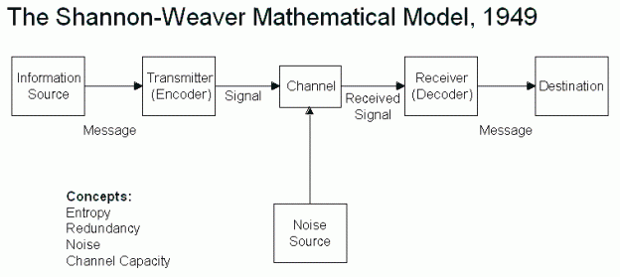

They wanted to create a communication model with an efficiency of almost 100%. For this reason, it has an additional element: noise that can interrupt communication. It can be sound distortions, static, transmission errors, etc.(Al-Fedaghi, 2012)
What is very important in communication and not in this theory is feedback. It is very important for the initiator to receive a response from the receiver to see if he understands the message and his opinion regarding the information received.

For this reason, Schramm published in 1954 a model of communication that consists of two processes between initiator and receiver, after which they exchange information and receive feedback from each other.

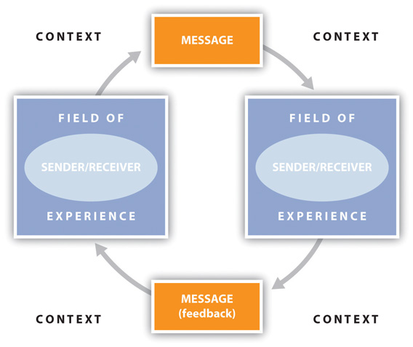

This is done with two-way communication representing the whole communication process. This two-way communication is a flow of information from the sender to the receiver and the receiver's response returns to the initiator. (Huang, 2003)

A third communication model is the SMCR model, developed by David K. Berlo in 1960, highlighting the psychological importance of the model.
The four components are the source, the message, the channel, and the receiver.

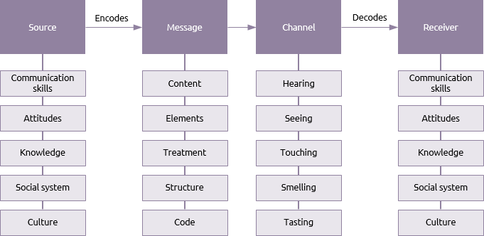

It focuses on encoding and decoding the message for more efficient communication. (Muyanga and Phiri, 2020)

Regarding the case study, two-way communication does not exist; it is a significant problem that Andrea Jones faces because the information sent by managers to associates was often addressed informally, and associates received wrong messages without being able to provide feedback.
For two-way communication to exist in the organization, Andrea Jones must ensure that each team manager, before the start of the program, holds a brief where verbal communication will occur, face to face with team members. During this meeting, the team members will receive information about the tasks of the day, will be assigned tasks, communicate various issues, and at the end, they will be able to provide feedback and ask questions.
Importance of two-way communication:

- It creates job satisfaction - If two-way communication is done in the organization and occurs between managers and staff, and employees, Andrea Jones should no longer face the change of staff and new employees. Good communication between them will create a friendly environment, and they will be able to share their thoughts, ideas, work problems, and feedback. Two-way communication will generate trust between old and new employees and loyalty to the company.

- Fewer conflicts - Two-way communication will help prevent and manage conflicts between new and old employees. With the help of clear communication and mutual discussions and answers, the employees will be able to collaborate, the new employees will gain experience, and the staff will develop both professionally and professionally.

- Helps increase productivity - Because two-way communication is vital and a problem in terms of success and failure. Andrea Jones must ensure that each manager in each department has clear communication in front of the team, so that team members understand and know exactly what tasks need to be accomplished. to help increase productivity. After the division of tasks and the communication of the problems, the managers must wait for feedback from the staff, answers only then the communication is carried to the end.

- Helps build relationships - It helps to build relationships between superiors and employees but also only between employees. Responsibility for information and tasks will make employees feel valued and believe that their responses and opinions matter to the organization, leading to loyalty. This will create a much friendlier and more efficient environment

- Proper use of resources- the lack of communication negatively affected the company when the new employees received many cases without experience due to the workload. For this not to happen again, productivity not to decrease, and resources not to be wasted, there must be two-way communication. (Addu-Oppong and Agyin-Birikorang, 2014).
2.1 Why effective communication (verbal and non-verbal) is important for the continued success of the organization?

Effective communication is listening carefully and receiving and transmitting information effectively. Effective communication is essential in an organization because it maintains quality working relationships and because every administrative function and activity involves communication, be it direct or indirect. Effective communication will improve the administrator's skills by making him a strong leader, which will lead to the organization's success. (Kikoski, 1998)

What may be in the process of communication are the barriers that are factors that interrupt communication. Barriers are of two types:
- Environmental barriers- include competition for attention and time between initiator and receiver, not paying attention to the message, listening, time, the managerial philosophy of the organization, power relations, very loud noises, and very complex messages.

- Personal barriers- are based on socio-economic background and previous receiver experiences can change the way messages are encoded and decoded

Communication in an organization can be both verbal and nonverbal communication. Effective verbal and nonverbal communication can lead to avoiding conflicts and ensuring the company's success.
Nonverbal communication is achieved through body gestures, eye contact, facial expressions, voice, and body posture. This form of communication is very easy to misunderstand and can degenerate various conflicts but when it is performed and understood positively, it increases the morale of workers, which leads to their performance.
Verbal, as well as non-verbal communication, has vital importance at work, and in addition to the actual communications included, it can also mean meetings, conferences, meetings, where associates must communicate the company's objectives. Through effective verbal communication, associates should convey class messages and ensure that the recipient correctly understands them. Effective verbal communication in an organization ensures its success. (Chang et al, 2015)

In order to make efficient communication, either verbal or non-verbal, being a bidirectional process, after the barriers that stand in the way of communication are overcome, both the sender and the receiver have a series of tasks necessary for the communication process.
In the case study, either the sender, Andrea Jones, or the department managers must perform the sender's tasks and the receiver's associates. This would ensure communication leading to the proper functioning of the teams that will provide the organization's success.
The sender’s responsibilities:
- clarify their ideas for the message before communicating it
- you need to evaluate the purpose of each communication
- it must consider both the total physical and human environment
- consult with others in some instances to communicate
- to highlight the tones of the message and its essential content
- it must convey something important, of value to the receiver
- they must follow their communication
- in an organization, communication must be done very frequently to communicate for today and the next day.
- actions must support their communication.
- to make sure that in addition to being understood, they must also understand and listen.

Receiver’s responsibilities:
- to stop talking
- to make the transmitter feel at ease
- to show that she wants to listen to him
- to remove any distraction
- to empathize with the transmitter
- be patient
- to control his temper
- to ask questions

Conclusion

In conclusion, the theories presented relate to the importance of teams, teamwork, the roles of team members, and, of course, bidirectional, verbal, and non-verbal communication for the organization's success. Communication is necessary for an organization because every function and activity impose a form of communication and is essential for establishing quality relationships.
The information presented solves the problems highlighted in the case study and helps Andrea Jones ensure the company's success by forming efficient, productive teams and developing effective communication.

References
1. Peralta C. F., 2018, Team Development: Definition, Measurement, and Relationship with Team Effectiveness, Human Performance, Vol 31, Issue 2, pp97-124
2. Griffith B. A. and Dunham E. B., 2015, Working in Teams, Moving from high potential to high performance, London, Sage Publications
3. Hunter et al, 2001, A validation study of Belbin’s team roles, European Journal of Work and Organizational Psychology, Vol10, Issue2, pp121-144
4. Erdem et al,2003, The relationship between trust and team performance, Work-Study, Vol 52, Issue 7 pp337-340
5. Addu-Oppong A. A. and Agyin-Birikorang E. 2014, Communication in the Workplace: Guidelines for improving Effectiveness, Global Journal of Commerce and Management Perspective, Vol 3, Issue 5, pp 208-213.
6. Genç R. 2017, The importance of communication in Sustainability and Sustainable Strategies, Procedia Manufacturing, Vol8, pp511-516
7. Huang C., 2003, Transitional media vs normative theories: Schramm, Altschul and China, Journal of Communication, Vol53, Issue 3, pp444-459
8. Al-Fedaghi S., 2012, A conceptual foundation for the Shannon-Weaver model of communication, international journal of soft computing, Vol7, Issue 1, pp12-19
9. Muyanga C. C. and Phiri J. 2020, Assessment of Effective Communication in International School in Developing Countries Based on the Berlo’s SMCR Model, Open Journal of Business and Management, Vol9, Issue1, pp488-459
10. Kikoski F. J. 1998, Effective Communication in the Performance Appraisal Interview: Face-to-face communication for public Managers in The Culturally Diverse Workplace, Public Personal Management, Vol28, Issue 2, pp301-320
11. Chang W. et al, 2015, Importance of Verbal and Non-Verbal Communication in the Workplace, {Available on http://amandamelvin.me/wp-content/uploads/2015/09/Collaboration-LA-4401-Importance-of-Effective-Communication-in-the-Work-Place.docx} [Accessed et 20 Jun 2022]

