
BUSINESS MANAGEMENT
The Global Business Environment LCBB4005
Environmental Analysis of Automibile Industry - BMW
by Constantin Gabriel Tacea (2122369)

Module Coordinator :Rexon Nting

ABOUT AUTOMOTIVE INDUSTRY

How did it all start?

The first car in history, in 1769 had a steam propulsion unit, but we cannot say it was a true car. The notion of automobile involves a compact, easy to handle and reliable transportation unit. At least two of these requirements were not respected by the steam vehicle.
The first car with internal combustion engine in the world was made by Siegfried Marcus. Just as all great discoveries, it all happened accidentally. In other words, the use of petrol as source of energy for the propulsion of vehicle came accidentally by the decision of the Austrian man to set fire to a mixture of petrol vapours with air. The first engine on petrol was mounted at a carriage.
Although to Siegfried Marcus we owe the discovery of the first petrol engine, the German engineers Daimler and Benz are considered the investors of the first automobile in history.

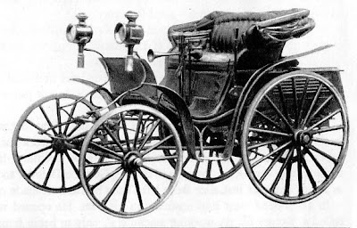
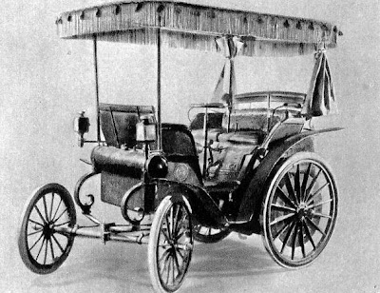

Champions on automotive market.
Each automotive equipment had ”a first time”, a prime model, in other words: the first car in the world equipped with:
- Airbag: Oldsmobile Toronado 1973
- AC: Packard Super Eight 1939
- Power steering: Chrysler Imperial 1951
- Seat belts: Nash Rambler 1949
- Electric windows: Packard 180 Series 1940
- Xenon: BMW 750 1991
- Low beam and high beam headlights: Cadillac 1917
- Tires (Michelin): Peugeot L'Eclair 1895
- Tires tubeless: Packard Patrician 1954 (Goodyear)
- Disc brakes: Lanchester 12 Tonneau 1902
- ABS: Jensen FF 1966
- traction control: Mercedes-Benz S-Class 1987
- ESP: BMW 750 1991
- Navigation system: Honda Accord 1981
- Touchscreen: Buick Riviera 1985
- engine in V: Marmon V8 1904
- diesel: Citroen Rosalie 1935
- compressor: Mercedes 1921
- turbo diesel: Mercedes-Benz 300SD 1978
- hibrida: Lohner-Porsche Mixte 1899
- eleron electric: Lanchia Thema 8.32 1986
- 6 speed gearbox: Porsche 959 1986
- 8 speed gearbox: Moskvitch 410/411 1960
- automatic: Oldsmobile 1939
- integral traction: Jensen FF 1966
- speedometer: Oldsmobile 1901
- electric wipers: Willys-Knight 1916
- windshield sprinklers: Studebaker 1936
- turn signals: Buick 1937
- automatic pilot: Chrysler Imperial 1956
- on-board computer: Cadillac Seville 1978
- GPS: Toyota Soarer GT Limited 1986
- digital navigation: Acura Legend 1990
- head-up display: Oldsmobile Cutlass Supreme 1987
- nightvision: Cadillac Deville 1999
- central locking: Scripps-Booth 1914
- alternator: Plymouth Valiant 1959
- automatic air conditioning: Cadillac 1963
- heated seats: Cadillac 1965
- ventilated chairs: Saab 9-5 1998
- radio: Ford Model T 1922
- audio system with CD: Lincoln Town Car 1986
- Bluetooth: Chrylser 1999
- electric chairs: Cadillac 1947
- MP3: Mazda Protege 2001

Digitalization in automotive field? A blessing or a problem?
Now the automotive industry is a well-defined and indispensable concept.
Digitalization was the new growth engine in all fields, including in automotive market, it offered the possibility of innovation and sustainability by electric engines.
The problem can come from the fact that there was demand for the traditional vehicles, and the diesel engines remained the basis of production for many automobile producers. Regarded in perspective, it is clear that the new trend is pro-electric cars and many new potential customers are attracted by innovation.

ABOUT BMW
On March 7, 1916, Franz-Josef Popp and Max Friz founded Bayerische Flugzeug-Werke (The Bavarian Aircraft Industry) in Munchen. In other words, BMW was initially designed for the production of aircraft engines, not cars. After two years, the company is renamed Bayerische Motoren Weke GmbH (The Bavarian Automobile Industry).
In 1928, BMW took over Fahrszenwerk Eisenach, a German company which produced cars.
The fall of the stock exchange on Wall Street in the 1930s did not affect the BMW Group, instead it was a launching ramp and an opportunity.
The first BMW model with six cylinders 303 was launched in 1933, a special model created for the speed and elegance amateurs.
When the Second World War started, the production of automobile stopped, and the company was forced to produce aircraft engines, including the first reaction engine in the world. Following the war and the significant decrease in sales, BMW faced serious problems, even was in danger of being bought by Daimler Benz. The rescue for BMW was Dr. Herbert Quadt who took over 65% of shares and after the launch of model BMW 1500, the company was rehabilitated.
BMW focused on the premium automotive segment, having in portfolio the brands: BMW, MINI and Rolls-Royce Motor Cars.
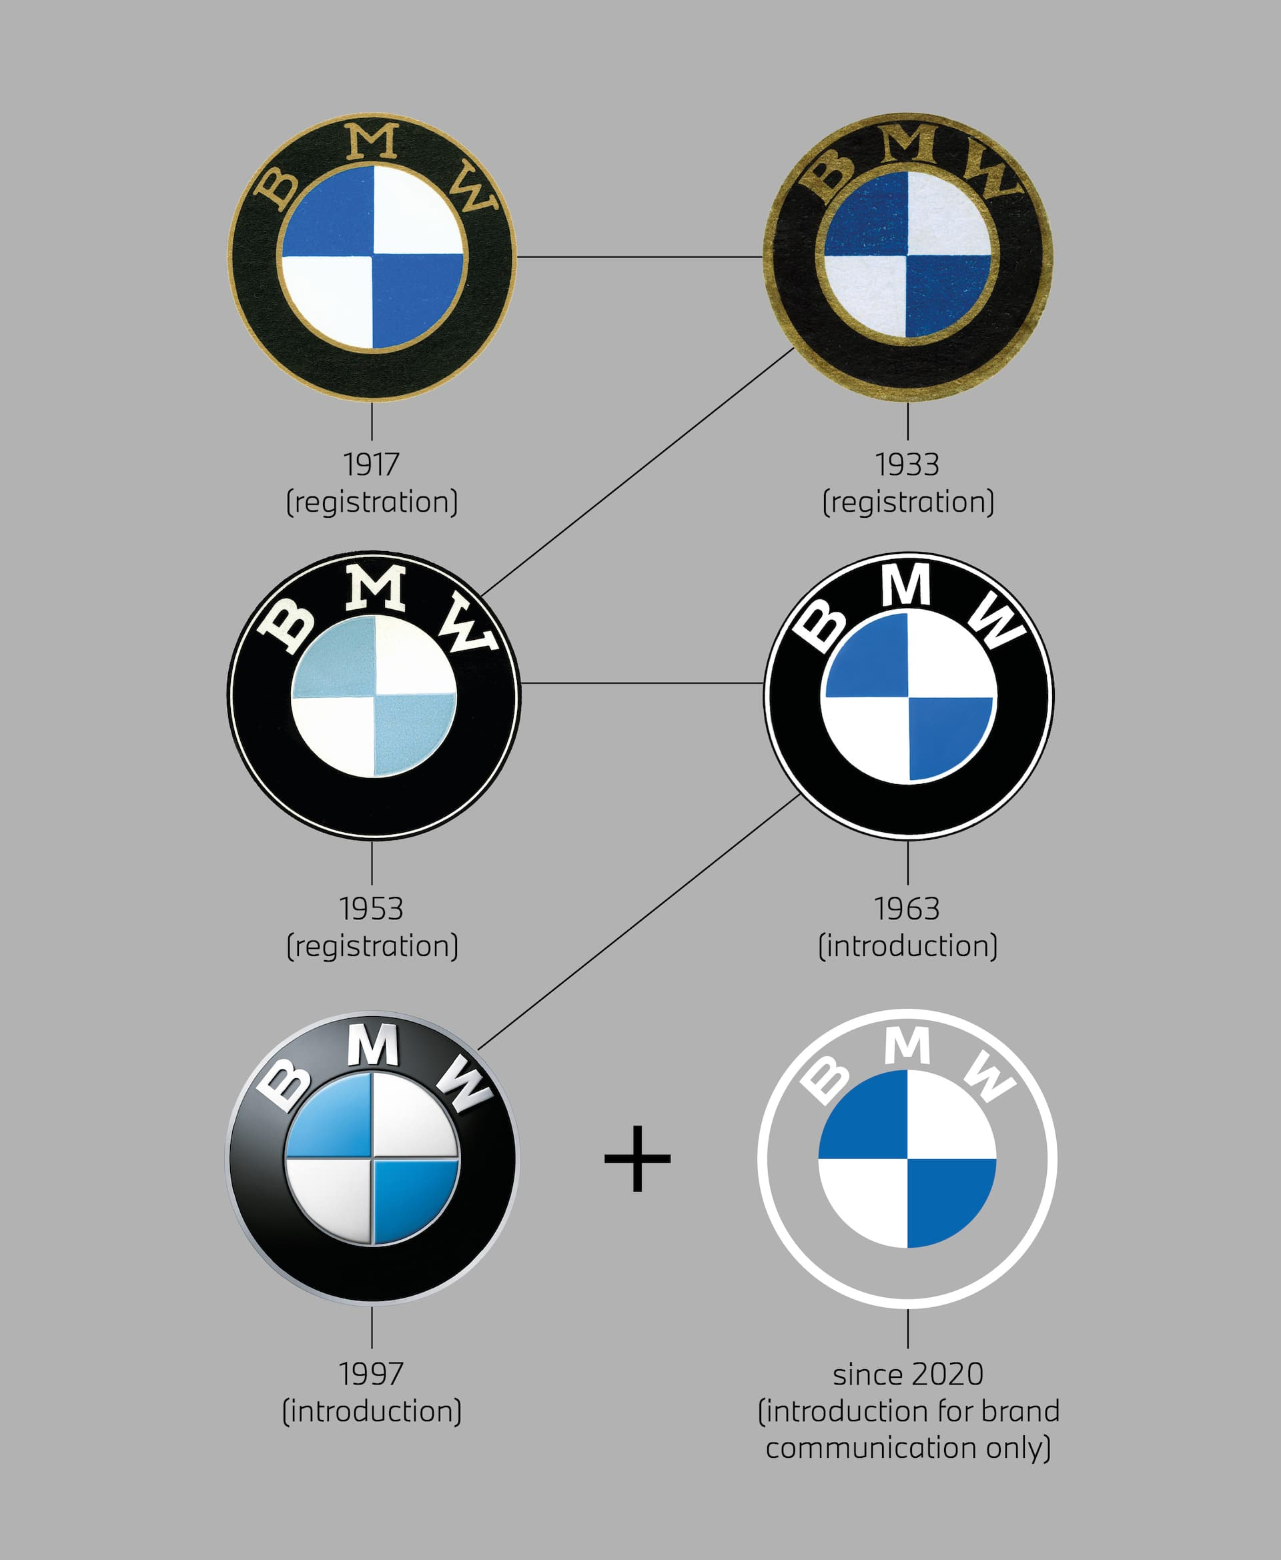

The Bavarian State is represented by the logo BMW (white and blue). In addition, the logo presents a rotary helix. This template came after an advertising spot back in the 1930s (when the BMW Logo did not exist). The commercial presents the aircrafts flying, the name BMW was written on the propeller while they are spinning. The purpose of the advertising spot was to promote the new aircraft engine produced by BMW.

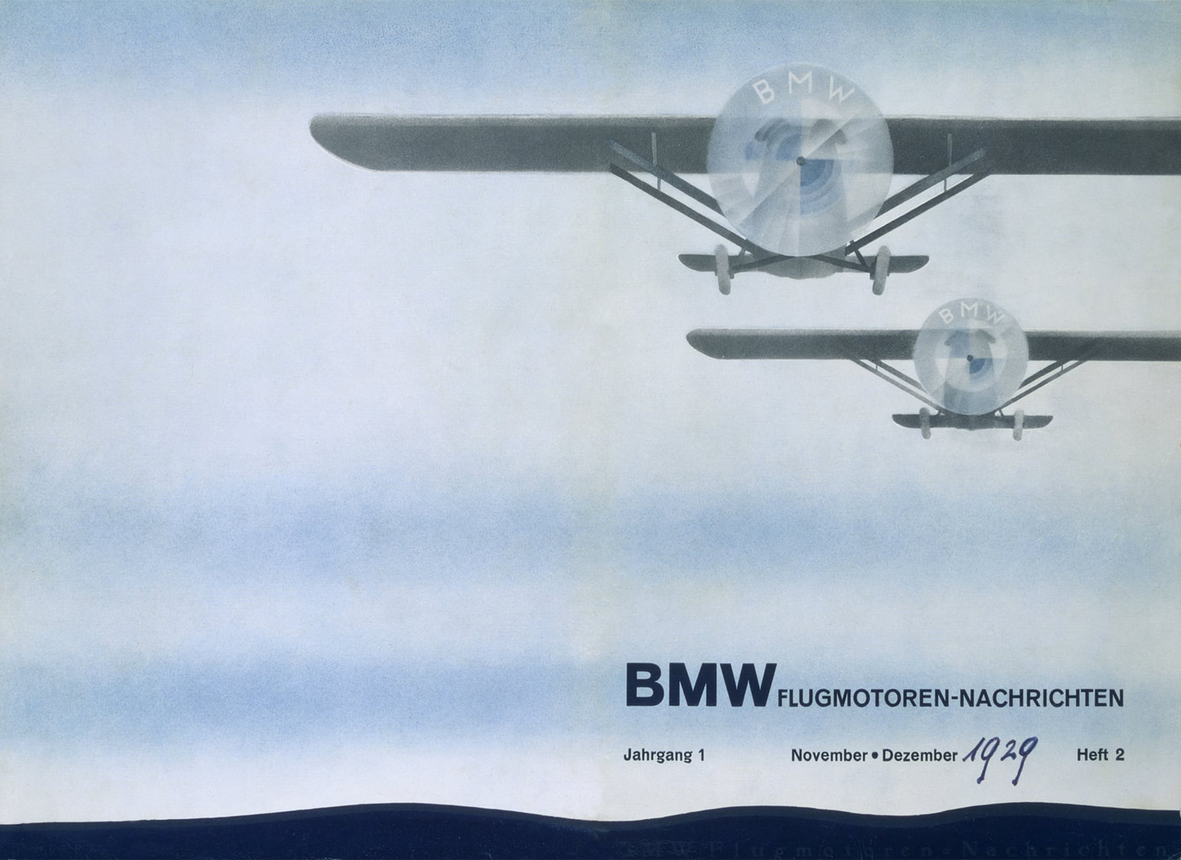

So, the famous BMW logo is based on a history which is still alive. Fred Jakobs, Manager of BMW Group Classic does not support the speculations about the rotary helix that exists in BMW logo, but for the sake of legend, he does not eliminate it.
Since 2020, the logo captured a new form, which makes reference to the future and according to Jens Thiemer, Senior Vice-President of Customer and BMW brand, “the new brand design is oriented to the challenges and opportunities of digitalization… it symbolizes the significance and relevance of brand for the mobility and pleasure of driving in the future. ”

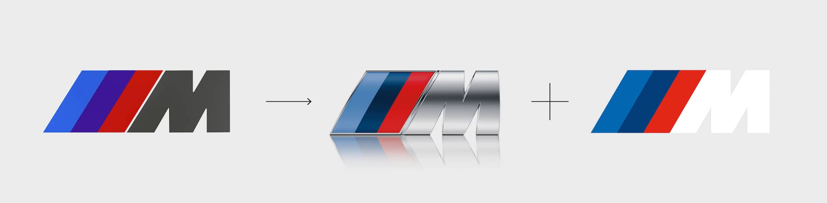

M from BMW. M comes from Motorsport, and the combination of colours presents: Bavarian Blue, which represents BMW, red is specific to engine (high horse-power) and violet is the combination of the two. A myth says that these colours were chosen because they could be distinguished on white and black photographs. The three strips before the letter “M” mark the speed of BMW M series.
In the meantime, the violet turned into dark blue, and since 2020 the brand has had a new appearance, being 3D and with the colours: blue, dark blue and white M, oriented to the future, speed, mobility and pleasure of driving.

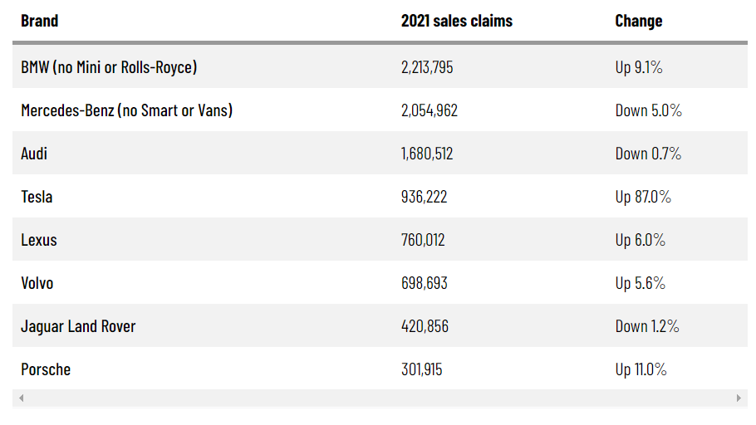

The 3 German companies compete on the international automotive market, and BMW ranks as leader in sales. According to annual reports of companies, in 2021 the Bavarian Group sold 2,521,525 cars, of which 2,213,795 cars belonging only to BMW, above the result announced by Mercedes (2,093,476) and way above Audi (1.680.512).
The most important result of BMW is the growth by 9.1% compared to the previous year (2020), and the results obtained by Audi were by 0.7% weaker than 2020, and Mercedes-Benz in 2021 had decreases by 5% compared to 2020. In other words, BMW starts off with the right foot in 2022.
Although the Bavarian Group faced supply problems, and the pandemics put its imprint on the performance of BMW Group, however, by the operational power and the varied range of products it had results above the competitors. The company based in Munchen revealed that the electric products represented the advantage of increased sales. In 2021, Pieter Nota, member of the Management Board of BMW AG and head of Group sales said that they sold over 100,000 automobiles 100% electric and about 220,000 hybrids. On the other hand, Mercedes-Benz delivered below 100,000 electric cars and Audi about 80,000 electric cars.

Situational analysis
Situational analysis analyzes both macro-environmental factors, which affect many companies, and micro-environmental factors, which specifically affect a company.
The purpose is to tell a BMW about its organizational and product position, as well as the overall survival of the company in the environment. It also means predicting results if a decision is made in both directions.
Periodic checking is suggested for a good coordination of the business plan

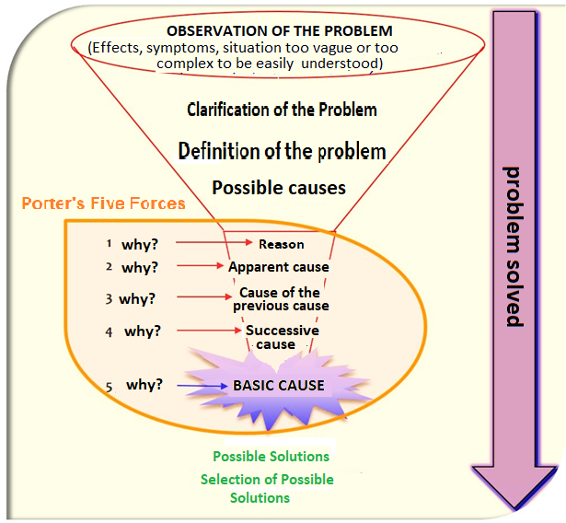

Just like a 3-year-old who has just started talking and discovering the world and wants to discover everything, Analysis 5 C asks the question "Why?" and waiting for the answer. In time and answering every question, the company grows and reaches maturity, finding solutions.
First of all, we find the problem or problems, which can be of economic nature, politics, etc. Once the problem is identified, we try to discuss and clarify it and define it. ” we find the solutions, so the problem is solved.
In practice, it is not just the simple question "Why?", But it is personalized, depending on the symptom.
A problem can be represented by the competitors, it is necessary the competitive analysis and the danger of the company towards the rivals. The current and future capacity of the competition must be observed and a plan must be prepared to overcome them. Before the fight, the competitors and potential competitors must be identified.
In order to achieve the objectives, the needs of the clients must be followed, depending on: demographics, market size and growth, motivations, distribution channels, quantity and frequency of purchase and the revenues of the clients I address.
It is also possible to resort to collaborators, in order to increase the image and profit capital.
Porter's analysis of the five forces
This BMW analysis involves scanning the environment to detect competitors 'threats and identifying issues to minimize these competitors' threats.
The ultimate goal of the BMW Porter's Five Forces model is to help companie compare and analyze their profitability and position in the industry against direct and indirect competition.

Forces | IMPACT | Type
Threatening new entrants | - Premium car producer in history who cannot be defeated by the new producers.  - There are entry and exit barriers on automotive market  - The BMW Group has share capital, human resources, deep knowledge, training and investments in research and development  - Any new player needs more resources, time and research to be a rival of BMW  - The demand of BMW was constant and very increased lately.  - The BMW sales are on the increase.  - The car market is full of risks and unpredictability which BMW Group can easily overcome, but a new competitor on the market cannot easily confront them. | WEAK
Threat of replacement | - By the variety of luxury models, BMW satisfies the needs and requirements of any customer.  - BMW is niched, addresses to premium luxury category.  - BMW has the objective to increase comfort.  - BMW thought about a strategy for environmental protection and conceived the electric models and outlined itself to the users. | MEDIUM
The power of buyers | - The customers of BMW brand are premium customers who have financial power to buy the cars.  - BMW is famous for the experience which is lived and the ”pleasure for driving”.  - The reputation of the brand cannot be fought against.  - The feedback offered by the customers is constantly pro.  - No change costs are set out considering that it is a new product | WEAK
Power of suppliers | - BMW maintains the same quality standards  - The suppliers fulfil the contract terms imposed by BMW  - BMW has over 15,000 suppliers at world level.  - The negotiation power of suppliers is low, because they do not risk losing a collaboration of the level of BMW | WEAK
Competitive rivalry | - There are competitors on the market. Among them there are: Audi, Mercedes, Tesla  - In 2021, the fiercest competitor of BMW, Mercedes recorded decreases in sales.  - All great competitors invest in research and development and in marketing | HIGH

The competitors of BMW should resort to the strategies adopted by the Bavarian Group.
As for the replacement threat, I believe that the users of brand (BMW addresses to a luxury, niche profile) will not replace the car with an average class, thus the danger of replacement is average towards low.
The great rivals of BMW represent the only problem that the Bavarian Group has. Leader now after a few years of second place, Mercedes-Benz can resume the top position.

SWOT:
This method analyzes current and future situations, analyzing current strengths and weaknesses, while looking for future opportunities and threats. The purpose of research is to develop strengths and weaknesses BMW. Future threats may be a weakness, but opportunities are considered strengths.
STRENGTHS:
- Quality of range of products,
- Innovation, Technology,
- Comfort and performance,
- Reliability, Sustainability and reduced consumption,
- Experience in time,
- Safety,
- Online services and connectivity BMW (connected drive),
- Dynamism,
- Refinement.
WEAKNESSES:
- Price,
- Niched products,
- Maintenance costs .
TIMELY
- The cheap workforce,
- entry on the market of electric cars,
- the bringing to life of a loved car model (series 8)

THREATENING
- Because of high prices, low purchasing power,
- fierce competition,
- producer independent from competitors (financial resources dependent on Audi by Volkswagen and Mercedes-Benz by Daimler Chrysler).

Conclusions

Bayerische Motoren Werke declared that its mission was ”to be the most successful premium producers in automotive industry”.
The motto of BMW “pleasure of driving” highlights the purpose which the Bavarian company follows, they are not just simply car manufacturers, but also creators of experience.
Globally speaking, the range of BMW products is characterized by: dynamism, refinement, innovation and safety.
Following the COVID 19 pandemics, BMW was not only not affected from the point of view of sales, but also at the end of year 2022 it came out leader on automobile market.
BMW – a helping hand in pandemics.
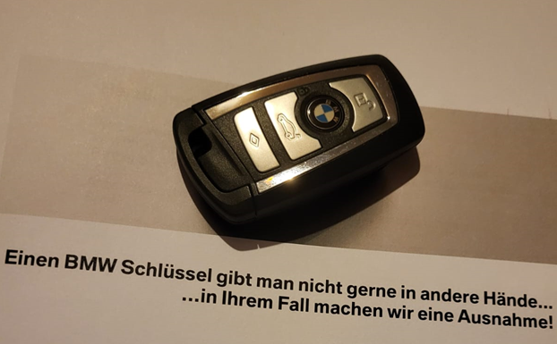

References

- Siegfried Marcus - An Uncredited Inventive Genius, https://hebrewhistory.info/factpapers/fp032-1_marcus.htm, [Accesed 26.04.2022]
- 102 Interesting Facts About Cars That You Should Know - The Fact File
https://thefactfile.org/car-facts/#:~:text=The%20world%E2%80%99s%20first%20automobile%20was%20developed%20by%20Carl,engine%20installed%20horizontally%20on%20a%20specifically%20designed%20chassis. [Accesed 26.04.2022]
- BMW’s great comeback
https://www.bmw.ro/ro/topics/fascination-bmw/news-center/carti-de-istorie.html?msclkid=ec5be467c6e111ec90d64fe7a3132695 [Accesed 26.04.2022]
- What does the BMW logo mean?
https://www.bmw.com/en/automotive-life/bmw-logo-meaning-history1.html?msclkid=456c4d31c70011ecb5473078b8d492b3 [Accesed 27.04.2022]
- The history of the BMW M logo and its colors
https://www.bmw.com/en/automotive-life/bmw-m-logo-and-colors.html?msclkid=456dbe70c70011ec8b59cd876a44e364 [Accesed 27.04.2022]
- BMW Group
https://www.bmwgroup.com/en/report/2021/index.html [Accesed 27.04.2022]
- AUDI REPORT 2021
https://www.audi.com/content/dam/gbp2/en/company/investor-relations/reports-and-key-figures/annual-reports/audi-report-2021.pdf [Accesed 27.04.2022]

- Annual sales report 2021 Mercedes-Benz Cars & Vans
https://mercedes-benz-media.co.uk/en-gb/releases/1461 [Accesed 27.04.2022]
- Luxury sales race: BMW claims title over Mercedes-Benz, Audi, Tesla
https://www.carexpert.com.au/car-news/luxury-sales-race-bmw-claims-title-over-mercedes-benz-audi-tesla [Accesed 27.04.2022]
- Brand audit BMW vs. Mercedes-Benz
https://bmvsmb.wordpress.com/2014/10/22/porters-5-forces-competitive-analysis-of-the-luxury-car-industry/ [Accesed 27.04.2022]
- Selected luxury car brands: global sales in 2020
https://www.statista.com/statistics/262921/global-production-of-luxury-cars-by-make/ [Accesed 27.04.2022]
- US Black Engineer and Information Technology , (2018), Auto Industry Prospects
https://www.jstor.org/stable/26305583 [Accesed 26.04.2022]
- Corporate Knights, (2016) Top Company Profile: BMW https://www.jstor.org/stable/44149923 [Accesed 26.04.2022]
- Christopher Ludwig (2016), BMW’s ‘connected’ logistics: Shaping a self-steering supply chain
https://web.archive.org/web/20170407053706/http://automotivelogistics.media/intelligence/bmw-shaping-self-steering-supply-chain [Accesed 26.04.2022]
- E.J. Schultz (2020), BMW changes logo for the digital age
https://europe.autonews.com/automakers/bmw-changes-logo-digital-age [Accesed 27.04.2022]

