
University of Wales Trinity Saint David
London Campus
BA (Hons) Leadership and Management Skills for the Workplace

Module
Strategic Management for Business

Module Code
LCLM 6001

Strategic Growth Strategy for Vodafone UK

Individual Report

Student Name: Luiza Florentina Pascu
Student ID: 2246735
Lecturer Name: Dr Faizu Edu

Table of Contents
Module 1
Module Code 1
Strategic Growth Strategy for Vodafone UK 1
Individual Report 1
Table of Contents 1
1. Executive Summary 2
2. Introduction to Vodafone 3
3. Evaluation of the Current Market Situation 3
3.1 PESTEL Analysis 3
Political Factors 3
Economic Factors 3
Social Factors 4
Technological Factors 4
Environmental Factors 4
Legal Factors 4
Critical Evaluation 4
3.2 Porter’s Five Forces Analysis 5
Threat of New Entrants 5
Bargaining Power of Suppliers 5
Bargaining Power of Buyers 5
Threat of Substitute Products or Services 6
Competitive Rivalry 6
Critical Evaluation 6
3.3 SWOT Analysis 7
Strengths 7
Weaknesses 7
Opportunities 7
Threats 7
Critical Evaluation 7
4. Strategic Growth Options and Proposed Strategy 8
4.1 Strategic Growth Options – Ansoff Matrix 8
Market Penetration 8
Market Development 8
Product Development 8
Diversification 8
Critical Evaluation 9
4.2 Recommended Strategy 9
4.3 Justification Using Porter’s Generic Strategies 9
Critical Evaluation 10
5. Strategy Evaluation (SFA Framework) 10
Suitability 10
Feasibility 10
Acceptability 10
Critical Evaluation 11
Table 3. SFA Evaluation of Vodafone UK’s Recommended Strategy 11
6. Stakeholder Analysis 11
7. Implementation and Monitoring 12
8. Conclusion 13
9.References 14

1. Executive Summary
This report evaluates Vodafone UK’s strategic position following its merger with Three UK and recommends a growth strategy to strengthen competitiveness in the UK telecommunications market. It applies PESTEL, Porter’s Five Forces, SWOT, the Ansoff Matrix and the Suitability–Feasibility–Acceptability (SFA) framework.
The merger has improved network coverage, operational efficiency and investment capacity although Vodafone still faces intense rivalry, rapid technological change, rising customer expectations and regulatory pressure.
The report recommends a combined market development and product development strategy, supported by differentiation through superior network quality, digital innovation and customer experience.
The proposed strategy is evaluated through SFA, stakeholder impact and an implementation plan with measurable Key Performance Indicators (KPIs).

2. Introduction to Vodafone
Vodafone Group Plc is a major telecommunications company providing mobile, broadband, Internet of Things (IoT), cloud and digital services across Europe and Africa. Founded in the UK in 1984, it has developed from a mobile operator into a technology-led organisation focused on connectivity, innovation and sustainable growth (Vodafone Group Plc, 2025).
Its merger with Three UK created VodafoneThree, the UK’s largest mobile network operator, serving about 27 million customers. The combined business plans to invest £11 billion in standalone 5G over the next decade to improve coverage, network quality and support emerging digital technologies.
Vodafone’s purpose, “Connecting for a Better Future”, reflects its emphasis on customer experience, digital transformation, innovation and responsible business practice (Vodafone Group Plc, 2025).
The UK telecommunications market remains highly competitive, with firms competing on price, service quality, innovation and customer experience. Strategic management is therefore essential for Vodafone to respond to external pressures, sustain competitive advantage and support long-term growth (Johnson et al., 2023).

3. Evaluation of the Current Market Situation
Strategic analysis helps organisations identify external opportunities and threats and assess their implications for long-term performance (Johnson et al., 2023). This section evaluates Vodafone UK through PESTEL, Porter’s Five Forces and SWOT.

3.1 PESTEL Analysis

Political Factors
Political factors strongly affect UK telecommunications because the sector is highly regulated. Government support for digital infrastructure and 5G creates growth opportunities, while the Vodafone–Three merger requires continued compliance with competition and investment commitments.

Economic Factors
Inflation, higher energy prices and operating costs may weaken demand for premium services. However, merger synergies and greater scale can improve efficiency, profitability and Vodafone’s ability to compete in a price-sensitive market.

Social Factors
Customers increasingly expect reliable, affordable connectivity and efficient digital service. Remote working, online learning, e-commerce and digital entertainment increase demand, creating opportunities for Vodafone to improve loyalty through network quality and personalised services (Kotler and Keller, 2022).

Technological Factors
Standalone 5G, AI, cloud computing and IoT create major growth opportunities. These technologies can support faster services, lower latency, new digital products and greater operational efficiency, strengthening differentiation (Vodafone Group Plc, 2025).

Environmental Factors
Environmental expectations require Vodafone to reduce emissions, improve energy efficiency and support low-carbon operations. These actions can strengthen reputation and respond to stakeholder concerns about sustainability (Vodafone Group Plc, 2025).

Legal Factors
Vodafone must comply with UK GDPR, consumer protection and competition law. Effective compliance protects customer data, reduces legal risk and supports trust (Information Commissioner’s Office, 2024).

Critical Evaluation
Overall, technological development, digital demand and government support create strong opportunities, while economic uncertainty and regulation remain important constraints. Vodafone must therefore combine innovation with disciplined compliance and cost control.
The main findings of the PESTEL analysis are summarised in Table 1.

Factor | Impact on Vodafone UK
Political | The UK government promotes digital infrastructure and 5G investment through favourable policies. The merger with Three UK supports long-term network development.
Economic | Inflation and rising operating costs may reduce consumer spending. However, merger synergies improve operational efficiency and profitability.
Social | Customers increasingly expect reliable connectivity, excellent customer service and innovative digital solutions.
Technological | Investment in 5G, AI, cloud computing and IoT enables Vodafone to improve network performance and develop new services.
Environmental | Vodafone is committed to reducing carbon emissions, improving energy efficiency and supporting sustainable business practices.
Legal | Compliance with UK GDPR, consumer protection laws and competition regulations protect customer trust and reduce legal risk.
Table 1. PESTEL Analysis of Vodafone UK

3.2 Porter’s Five Forces Analysis
Porter’s Five Forces assesses industry competition and the pressures affecting profitability (Porter, 1980). Applied to Vodafone UK, it highlights barriers to entry, supplier and buyer power, substitutes and rivalry.

Threat of New Entrants
The threat of new entrants is low because national telecoms networks require large investment, specialist technology, regulatory approval and strong brand credibility. Established operators also benefit from extensive infrastructure and customer bases (Johnson et al., 2023).

Bargaining Power of Suppliers
Supplier power is moderate because Vodafone depends on specialist technology and network vendors. Its global scale and long-term relationships, however, strengthen negotiation power (Vodafone Group Plc, 2025).

Bargaining Power of Buyers
Buyer power is high because customers can compare prices and switch providers easily. Vodafone must therefore compete through network quality, innovation and customer experience (Kotler and Keller, 2022).

Threat of Substitute Products or Services
The threat of substitutes is moderate because platforms such as WhatsApp, Teams and Zoom replace some traditional calls and messaging. Vodafone must respond with broader digital and value-added services (Johnson et al., 2023).

Competitive Rivalry
Competitive rivalry is very high, with Vodafone competing against BT/EE, Virgin Media O2 and MVNOs on price, coverage, innovation and service. The Three UK merger strengthens Vodafone’s scale and 5G investment capacity.

Critical Evaluation
Overall, high buyer power and intense rivalry are the strongest pressures. Sustainable advantage therefore depends on service quality, innovation, network performance and operational efficiency.

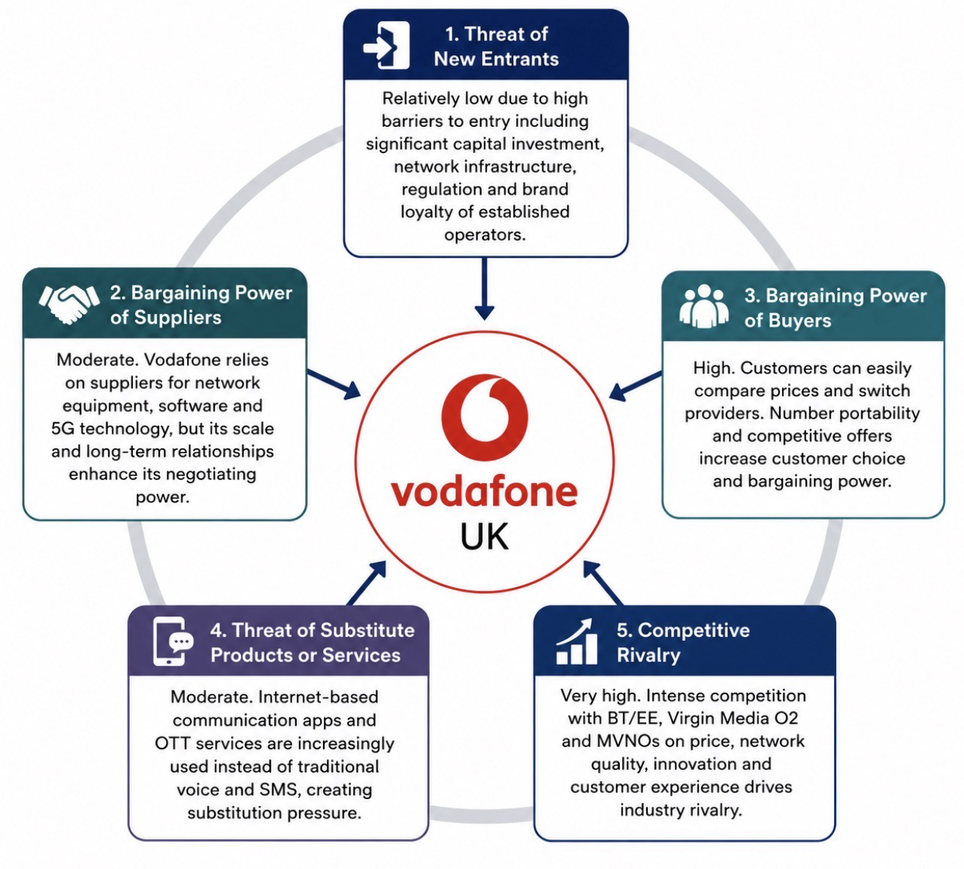
Figure 1. Porter’s Five Forces Analysis of Vodafone UK
Source: Adapted by the author from Porter (1980), Johnson et al. (2023) and Vodafone Group Plc (2025).

3.3 SWOT Analysis
SWOT evaluates internal strengths and weaknesses alongside external opportunities and threats (Gürel and Tat, 2017). For Vodafone, it highlights the benefits and risks created by the Three UK merger.

Strengths
Vodafone benefits from a recognised brand, extensive infrastructure, a large customer base and an £11 billion 5G investment plan. Its digital, cloud and IoT capabilities further support competitive advantage (Vodafone Group Plc, 2025).

Weaknesses
Key weaknesses include high capital requirements, merger integration complexity and continuing customer-service challenges. These factors may place pressure on costs, culture and performance.

Opportunities
Growth opportunities include 5G, AI, cloud computing, smart-city projects and IoT services. Rising demand from consumers, businesses and the public sector support further expansion (Johnson et al., 2023).

Threats
Threats include strong competition, rapid technological change, cybersecurity risk, regulation and economic uncertainty, all of which may reduce profitability or market share (Kotler and Keller, 2022).

Critical Evaluation
Vodafone has a strong platform for growth, but success depends on effective merger integration, continued innovation and consistent customer value. Table 2 summarises the key findings.
Strengths | Weaknesses | Opportunities | Threats
Strong global brand | High investment costs | Growth of AI and IoT | Intense competition
Large customer base | Complex merger integration | Expansion of 5G services | Rapid technological change
£11 billion investment in 5G | Customer service challenges | Government support | Cybersecurity risks
Advanced digital capabilities | Dependence on innovation | Business digital transformation | Economic uncertainty

Table 2. SWOT Analysis of Vodafone UK

4. Strategic Growth Options and Proposed Strategy
Vodafone’s strategic options are assessed through the Ansoff Matrix and Porter’s Generic Strategies to identify a growth approach that fits its resources and market position (Johnson et al., 2023).

4.1 Strategic Growth Options – Ansoff Matrix
The Ansoff Matrix identifies market penetration, market development, product development and diversification, each with a different level of risk (Ansoff, 1957).

Market Penetration
Market penetration would increase sales in the existing UK market through better coverage, service and pricing. However, the maturity and intensity of the market limit its growth potential (Kotler and Keller, 2022).

Market Development
Market development would extend existing services to new segments, particularly businesses and public-sector organisations seeking cloud, cybersecurity, IoT and connectivity solutions.

Product Development
Product development would introduce new services to current customers, including AI support, smart-home products, digital finance and advanced enterprise connectivity (Vodafone Group Plc, 2025).

Diversification
Diversification is the highest-risk option because it requires new products in new markets and substantial investment. It is therefore less suitable during post-merger integration.

Critical Evaluation
Market development and product development offer the strongest fit because they use Vodafone’s customer base, digital infrastructure and 5G investment while addressing rising demand for advanced services.
The four strategic growth options are illustrated in Figure 2.
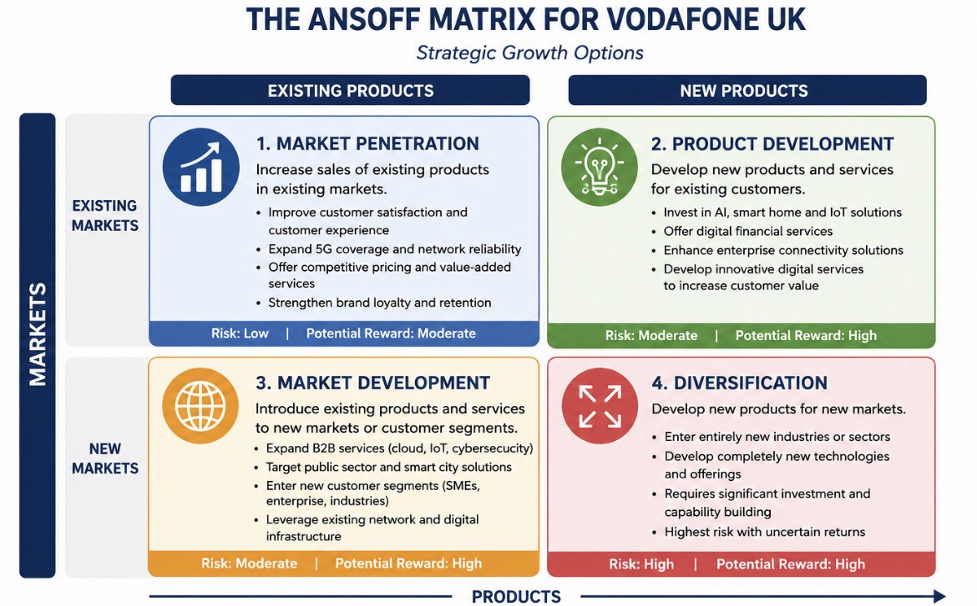

Figure 2. Ansoff Matrix for Vodafone UK
Source: Adapted by the author from Ansoff (1957), Johnson et al. (2023) and Vodafone Group Plc (2025).

4.2 Recommended Strategy
This report recommends a combined market development and product development strategy. It enables Vodafone to use the scale created by the merger while responding to demand for advanced connectivity and digital solutions.
Market development should focus on B2B and public-sector customers through cloud, cybersecurity, IoT and AI-enabled services, creating additional revenue from existing capabilities (Johnson et al., 2023).
Product development should focus on standalone 5G, AI-supported customer service, smart-home products and enterprise connectivity to strengthen customer value and loyalty (Vodafone Group Plc, 2025).
The strategy aligns with Vodafone’s purpose by combining innovation, connectivity and stakeholder value. It also builds on its brand, infrastructure and technological resources.
Overall, the combined strategy offers attractive growth with lower risk than diversification and stronger potential than market penetration alone.

4.3 Justification Using Porter’s Generic Strategies
Porter’s Generic Strategies identify cost leadership, differentiation and focus as routes to competitive advantage (Porter, 1985).
Differentiation is the strongest option for Vodafone because superior network quality, innovative digital services and customer experience can create value beyond price. Its 5G, cloud, AI and IoT capabilities provide a credible basis for this approach (Vodafone Group Plc, 2025).
Cost leadership would be difficult to sustain because telecoms require continuous investment in infrastructure, technology and compliance. Aggressive price competition could weaken margins and future investment capacity (Johnson et al., 2023).
A focus strategy would also underuse Vodafone’s national network and broad consumer and business presence.
Differentiation therefore supports innovation, stronger customer relationships and growth across consumer and business markets.

Critical Evaluation
Overall, differentiation best supports Vodafone’s long-term position by combining service quality, innovation and advanced digital solutions rather than relying mainly on low prices.

5. Strategy Evaluation (SFA Framework)
The proposed strategy of combining Market Development and Product Development should be evaluated using the Suitability, Feasibility and Acceptability (SFA) framework, developed by Johnson et al. (2023). This framework assesses whether the strategy addresses organisational needs, can be successfully implemented and is acceptable to key stakeholders.

Suitability
The recommended strategy is suitable because it responds directly to Vodafone UK’s strategic challenges and opportunities identified through the PESTEL, Porter’s Five Forces and SWOT analyses. Expanding digital services and investing in 5G, AI and IoT technologies supports market demand while strengthening Vodafone’s competitive position following the merger with Three UK. The strategy also aligns with the company’s purpose of “Connecting for a Better Future” (Vodafone Group Plc, 2025).

Feasibility
The strategy is feasible because Vodafone possesses the financial resources, technological capabilities and market experience required for implementation. The merger has strengthened operational efficiency and created opportunities to invest in advanced digital infrastructure. Existing expertise in telecommunications, cloud computing and enterprise services further supports successful execution.

Acceptability
The proposed strategy is acceptable because it is expected to deliver benefits to major stakeholders. Customers will benefit from improved network quality and innovative digital services, while shareholders are likely to benefit from sustainable revenue growth and increased competitiveness. Employees may gain opportunities for professional development through digital transformation initiatives, although effective change management will be required during implementation.

Critical Evaluation
Overall, the SFA framework demonstrates that the recommended strategy is appropriate for Vodafone UK. It aligns with organisational objectives, can be implemented using existing capabilities and is likely to create long-term value for customers, employees and shareholders.

Table 3. SFA Evaluation of Vodafone UK’s Recommended Strategy
Criteria | Evaluation
Suitability | Supports Vodafone’s strategic objectives and market opportunities.
Feasibility | Strong financial resources, technology and operational capabilities.
Acceptability | Expected to improve customer satisfaction, shareholder value and long-term growth.

Table 3. SFA Evaluation of Vodafone UK’s Recommended Strategy

6. Stakeholder Analysis
Stakeholders play an important role in the successful implementation of Vodafone UK’s recommended growth strategy. According to Freeman (1984), organisations should consider the interests and influence of key stakeholder groups when making strategic decisions. Mendelow’s Matrix helps classify stakeholders according to their level of power and interest, allowing organisations to develop appropriate engagement strategies.
Customers are the most important stakeholder group because they directly influence Vodafone’s revenue and market position. The proposed strategy aims to improve customer satisfaction through better network quality, innovative digital services and enhanced customer experience.
Employees are also key stakeholders because successful implementation depends on their skills, commitment and ability to adapt to organisational change. Vodafone should provide training and communication programmes to support employees during the implementation of new technologies and business processes.
Shareholders have high power and high interest because they expect sustainable profitability and long-term business growth. The recommended strategy is expected to improve financial performance through new revenue opportunities and operational efficiencies created by the merger.
Government and regulatory bodies, including Ofcom, have high power because they oversee competition, consumer protection and regulatory compliance within the UK telecommunications industry. Vodafone must continue complying with legal and regulatory requirements while investing in national digital infrastructure.
Overall, effective stakeholder engagement will support successful strategy implementation, reduce resistance to change and strengthen Vodafone’s long-term competitive position.
- HIGH POWER
Keep Satisfied  - Ofcom  - UK Government | Manage Closely  - Customers  - Shareholders
Monitor  - Suppliers | Keep Informed  - Employees  - Business Customers
- LOW INTEREST HIGH INTEREST

Figure 3. Mendelow’s Stakeholder Matrix for Vodafone Uk
Source: Adapted by the author from Freeman (1984), Mendelow (1991) and Johnson et al. (2023).

7. Implementation and Monitoring
Successful implementation of Vodafone UK’s recommended strategy requires effective planning, resource allocation and continuous performance monitoring. Following the merger with Three UK, Vodafone should implement the strategy in three phases to minimise disruption and maximise long-term value.
During the first phase, the company should focus on integrating operations, expanding 5G infrastructure and strengthening network performance across the UK. The second phase should introduce new digital services, including AI-powered customer support, cloud computing and Internet of Things (IoT) solutions for both consumer and business markets. The final phase should focus on evaluating performance, improving customer experience and identifying further opportunities for innovation and market expansion.
To ensure successful implementation, Vodafone should monitor progress through Key Performance Indicators (KPIs). Regular performance reviews will enable management to measure customer satisfaction, network performance, financial growth and operational efficiency. Continuous monitoring also allows the company to respond quickly to market changes and maintain its competitive advantage (Johnson et al., 2023).
Overall, an effective implementation and monitoring process will help Vodafone achieve its strategic objectives while supporting sustainable business growth and long-term competitiveness.
Implementation Phase | Key Activities | Performance Indicator (KPI)
Phase 1 | Expand 5G infrastructure and integrate operations | 95% UK 5G coverage
Phase 2 | Launch AI, Cloud and IoT services | 15% increase in digital service revenue
Phase 3 | Improve customer experience and evaluate performance | 10% increase in Customer Satisfaction (CSAT)
Table 4. Implementation Plan and Key Performance Indicators (KPIs)
Source: Developed by the author based on Johnson et al. (2023) and Vodafone Group Plc (2025).

8. Conclusion
This report has evaluated Vodafone UK’s strategic position following its merger with Three UK by applying recognised strategic management frameworks, including PESTEL, Porter’s Five Forces, SWOT, the Ansoff Matrix and the SFA framework. The analysis demonstrated that the merger has strengthened Vodafone’s market position through improved network coverage, increased operational efficiency and significant investment in standalone 5G technology.
Based on the findings, the report recommends a combined Market Development and Product Development strategy supported by Porter’s Differentiation Strategy. This approach enables Vodafone to expand digital services, improve customer experience and strengthen its long-term competitive advantage within the UK telecommunications industry.
The SFA evaluation confirmed that the proposed strategy is suitable, feasible and acceptable, while the stakeholder analysis highlighted the importance of engaging customers, employees, shareholders and regulators throughout implementation. Furthermore, the implementation plan and KPIs provide a practical framework for monitoring performance and supporting continuous improvement.
Overall, Vodafone is well positioned to achieve sustainable growth by continuing to invest in innovation, digital transformation and customer-focused services while adapting to the changing business environment.

9.References
- Ansoff, H.I. (1957) Strategies for Diversification. Harvard Business Review, 35(5), pp. 113–124.
- Barney, J.B. (1991) ‘Firm Resources and Sustained Competitive Advantage’. Journal of Management, 17(1), pp. 99–120.
- Freeman, R.E. (1984) Strategic Management: A Stakeholder Approach. Boston: Pitman.
- Grant, R.M. (2022) Contemporary Strategy Analysis. 11th edn. Wiley.
- Gürel, E. and Tat, M. (2017) ‘SWOT Analysis: A Theoretical Review’. The Journal of International Social Research, 10(51), pp. 994–1006.
- Information Commissioner’s Office (2024) Guide to UK GDPR.
- Johnson, G., Whittington, R., Scholes, K., Angwin, D. and Regnér, P. (2023) Exploring Strategy. 13th edn. Harlow: Pearson.
- Kotler, P. and Keller, K.L. (2022) Marketing Management. 16th edn. Harlow: Pearson.
- Lynch, R. (2021) Strategic Management. 9th edn. Harlow: Pearson.
- Mendelow, A.L. (1991) ‘Stakeholder Mapping’. Proceedings of the 2nd International Conference on Information Systems.
- Ofcom (2025) Connected Nations Report.
- Porter, M.E. (1980) Competitive Strategy: Techniques for Analysing Industries and Competitors. New York: Free Press.
- Porter, M.E. (1985) Competitive Advantage: Creating and Sustaining Superior Performance. New York: Free Press.
- Vodafone Group Plc (2025) Annual Report 2025.
- Vodafone Group Plc (2025) Sustainability Report 2025.
- Wheelen, T.L., Hunger, J.D., Hoffman, A.N. and Bamford, C.E. (2018) Strategic Management and Business Policy. 15th edn. Pearson.

