

Student Name: PARTH MAHESHBHAI KHIMANI

Student ID: 2531596

Module Name: Marketing Management

Module Code: LCMB7024

Lecturer’s Name: Dr. Laila Maazouz

Word Count: 2637

Term 1
Table of Contents
Task 1: Marketing Environment Analysis 3
Natural Environment: The Primary Driver of Tata Steel's Low-Carbon Transition 3
Political Environment: Policy Support and Regulatory Pressure 6
Task 2: Strategic Growth and Competitive Positioning 10
Strategic Growth Approach: Product Development Using the Ansoff Matrix 10
Competitive Positioning, Implementation Recommendations and Risks 12
Task 3: Critical Reflection on AI Usage 15
References 17

Task 1: Marketing Environment Analysis
Kotler, et al., (2019), believe that the organisation must continuously monitor macro environment factors as it has to always stay ahead to provide value to customers. The following critical discussion is related to the influence of the Natural Environment and Political Environment on Tata Steel's low-carbon products initiative.

Natural Environment: The Primary Driver of Tata Steel's Low-Carbon Transition
The natural environment includes the ecological and environmental elements impacting the organisation's performance and marketing efforts (Babu, et al., 2026). This macroenvironmental factor is becoming more important to the steel industry as the production of steel produces greenhouse gases and consumes a lot of natural resources. In 2024, on average, every tonne of steel produced led to the emission of 2.18 tonnes of CO2e. In the same year, 1,886 million tonnes (Mt) of steel were produced8, and total emissions from the sector were of the order of 4.1 billion tonnes CO2e (World Steel Association, 2026).
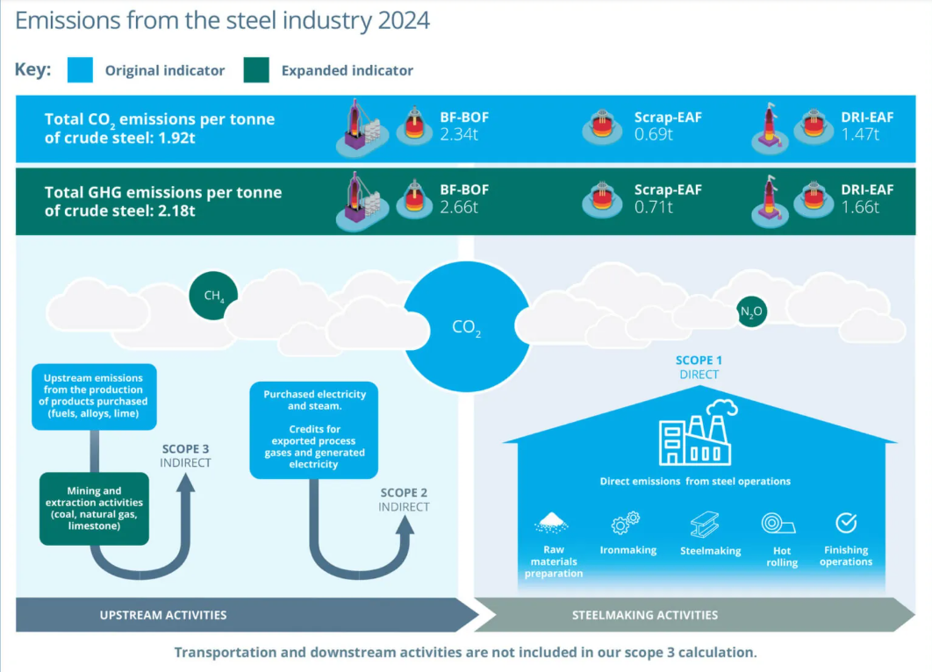
Figure 1: Emissions from the Steel Industry 2024
(Source: World Steel Association, 2026)
Recently, industrial buyers, investors and the government have begun to demand evidence of a supplier's success in reducing carbon emissions, as climate change is becoming an issue of increased consciousness. To meet those demands, Tata Steel has adopted several innovations such as renewable energy, the electric arc furnace (EAF) process, recycled steel and the hydrogen steel-making process (Tata Steel, 2026). However, many strategic risks pertain to environmental sustainability. To adapt to the gradual shift towards low-carbon steel production, the company must make significant investments in innovations and infrastructure, thus boosting its cost of capital. Moreover, there are numerous risks associated with innovations, as both hydrogen steelmaking and carbon capture technologies are still developing (Kohitlhetse and Chiririwa, 2026). Hence, Tata Steel is caught in a strategic dilemma due to the delay in investment, as this could make the investment base less competitive in the future, but the other way round could also have a lot of uncertainties in terms of finances.
The other contradiction is that of sustainability and consumer behaviour. Customers now have a greater awareness of their environment and want products that are eco-friendly, but the important factor in their buying decisions is the price of these products. The sustainable products market across the globe is forecasted to have a constant growth rate, beginning with USD 412.12 billion in 2026, reaching USD 803.68 billion in 2035, as shown in the graph below (Business Research Insights, 2026). In simple terms, businesses will face challenges in recouping the higher costs incurred while producing low-carbon steel due to price being a critical consideration in emerging markets (Kim and Sohn, 2022).
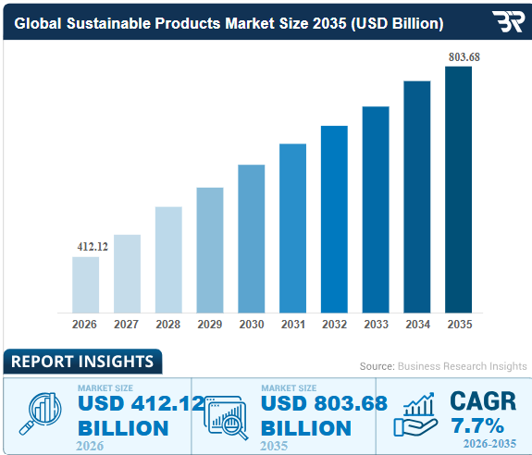
Figure 2: Sustainable Products Market Size and Share
(Source: Business Research Insights, 2026)
Different strategies used by the pioneer and followers show some difficulties which arise for firms. For example, SSAB, as a pioneer, made early investments in the manufacturing of steel using hydrogen in the HYBRIT project and gained a good reputation and partnerships, however, it took high risks in terms of technology and financing (SSAB, 2026). Tata Steel implements a similar incremental approach, considering not only the environment but also the feasibility. The strategy of the company will result in a slow process of decarbonization compared to the pioneers', but it will increase its financial sustainability because of huge investments and technological uncertainty in the industry.
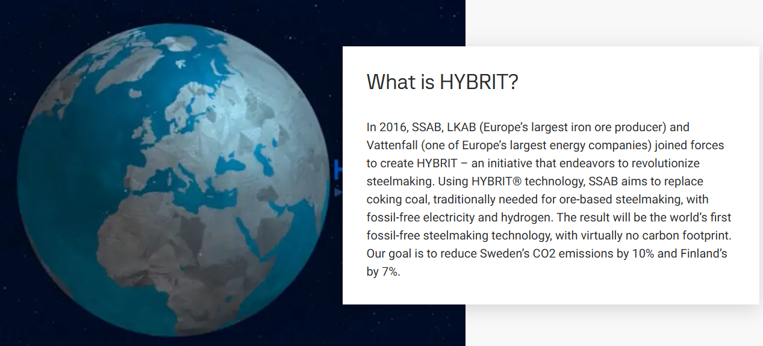
Figure 3: HYBRIT Technology by SSAB
(Source: SSAB, 2026)

Political Environment: Policy Support and Regulatory Pressure
The political environment is another important macro environment variable that can impact the transition of Tata Steel to less carbonized product. Kotler, et al., (2019), state that engaging the government in business operations involves regulations, environmental laws, taxes and industrial policies. In industries where carbon is key, such as steel, any political decision will impact investments, production and competitiveness directly. The political environment speeds up decarbonization, in contrast to the natural environment, which exerts pressure through the market. Government environmental policies have helped in investments made by Tata Steel in more sustainable technology and manufacturing processes. According to The World Economic Forum, (2021), the government's vision of achieving ‘Net Zero' by 2070 and its policies that encourage the use of renewable energy and decarbonisation of industries have raised the likelihood of Tata Steel investing in a steel manufacturing process that emits lower greenhouse gases. In a similar manner, the activities of Tata Steel in Europe are under the scope of the Carbon Border Adjustment Mechanism (CBAM) of the European Union (Tata Steel, 2026).
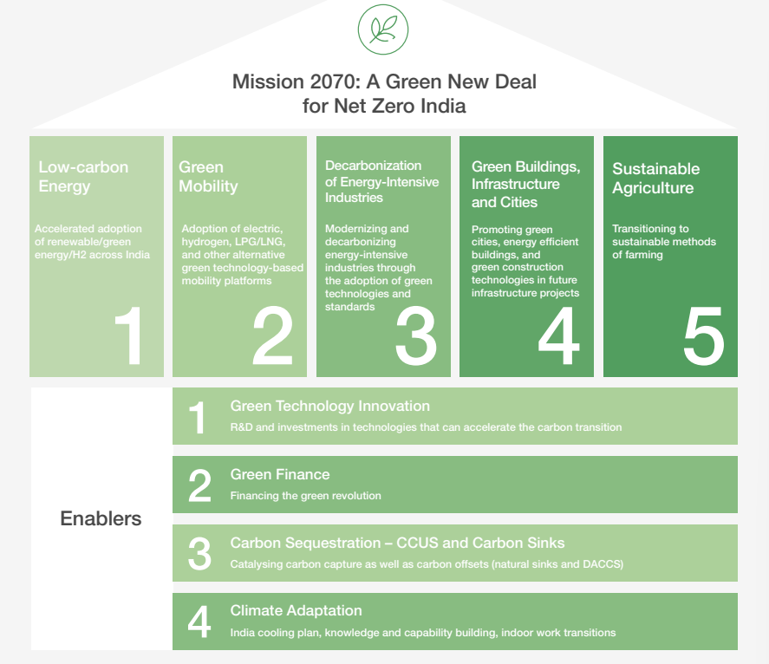
Figure 4: About Mission Net Zero by 2070
(Source: The World Economic Forum, 2021)
At the same time, there are opportunities and challenges in the political environment. Government incentives, funding of research and government or private entity collaboration lessen financial risk associated with green innovation. These will enable Tata Steel to implement its sustainability plan and bring more money into the company, and more credibility to low-carbon products into the market. The uncertainty of political actions is more or less typical in international business, however. Various environmental regulations, subsidies and prices on carbon will lead to distinct legal regimes in each country (Borowiec, et al., 2024).
The contrasting performance of pioneers and followers in terms of their behaviour will enable one to understand the effect of politics on their performance. The success of SSAB is due to the favourable political climate in Sweden, and the company's ability to be part of the profitable government policy on hydrogen steel and renewable energy, which have enabled the company to be commercialised. On the other hand, ArcelorMittal has taken a conservative approach, meaning that it is working on the company's low-carbon technologies such as XCarb in harmony with the new regulations (ArcelorMittal Projects, 2026).
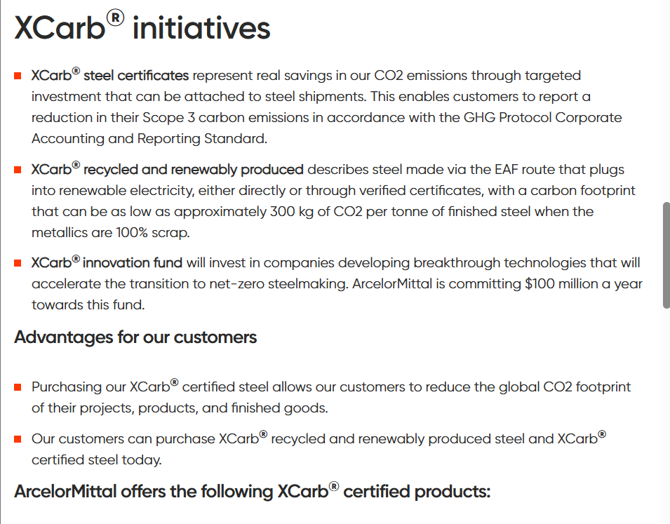
Figure 5: XCarb Initiative by ArcelorMittal
(Source: ArcelorMittal Projects, 2026)
Marketing Environment Actor | Impact on Tata Steel | Strategic Implication
Natural Environment | Investment in lower carbon technologies is driven by the following: Climate change, Carbon reduction targets, and increasing demand for green steel. | Create lower carbon products, sustainability and profitability.
Political Environment | Investment and production decisions are impacted by environmental regulations, carbon pricing and government incentives. | Fast-track decarbonisation process with compliance in international markets.
Table 1: Summary of External Marketing Environment Factors Affecting Tata Steel

Task 2: Strategic Growth and Competitive Positioning

Strategic Growth Approach: Product Development Using the Ansoff Matrix
In the Ansoff matrix, there are four strategies of growth, including market penetration, market development, product development, and diversification (Peterdy, 2022). Ansoff's matrix discusses that a company should select a strategy suited to its capabilities and that will also help it take advantage of the external opportunities of the market. From an environmental perspective, the product development strategy fits very well into the overall development of Tata Steel Company, as this strategy will enable it to launch low-carbon steel products in the industrial market. The concept of product development strategy refers to an organised approach to creating or improving products to satisfy the requirements of the market and the business (IBM, 2026).
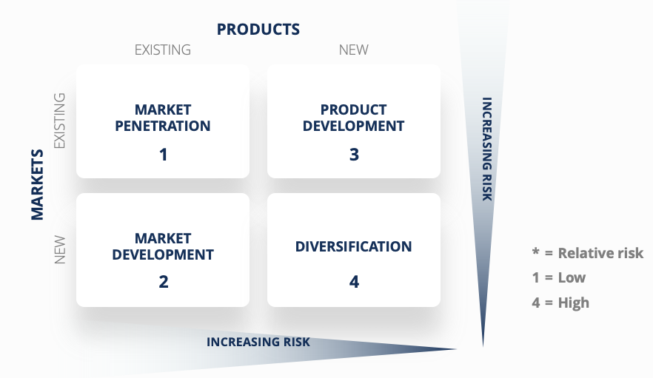
Figure 6: Ansoff Matrix
(Source: Peterdy, 2022)
This strategy closely aligns with the external pressures identified in Task 1. Environmental issues have made it more necessary to produce green steel as customers and the government have a higher standard, expecting more from the company in terms of carbon footprint reduction (Mallett and Pal, 2022). Governmental intervention and the introduction of carbon pricing have helped speed up innovation in the industry (Steel Ministry, 2025).
Secondly, product development has the least amount of risk and, for this reason, is the most strategic option when compared to diversification. For instance, diversification involves entering into a new market entirely, and therefore, there will always be risks involved as well as massive capital outlay (CFI, 2020). Market penetration strategy will lead to higher sales of existing products, but it is very unlikely that it will produce any profit as there are a lot of environmental issues that the existing steel product is facing. Moreover, market development looks unsuitable because geographical expansion without an obvious decrease in the emissions of the product will not satisfy the increasing demands for sustainability. Thus, the most promising alternative is product development which meets the needs of the market and leverages the existing knowledge base of Tata Steel.
Meanwhile, Tata Steel continues to invest in the electric arc furnace, steel recycling, renewable energy and hydrogen steelmaking technologies (Tata Steel, 2026). These innovations are the technological infrastructure to enable the commercialisation of the new product, within the framework of the current business model. Tata Steel will leverage the already existing skills, which will benefit in reducing the risk of implementation and motivate innovation.
But product development is not the only thing to do regarding the investment in technology, it is also about adding value for the customer with sustainable, quality and cost considerations (Falahat, et al., 2024). If the price of low-carbon steel does not drop and continues to be higher than the price of regular steel, then there is a possibility that this product will not be adopted because of the growing awareness of the environment. Therefore, Tata Steel should be gradually moving towards commercialisation by introducing its products in industries like the automobile industry, renewable energy infrastructure, and construction, in which companies procure their products on a sustainability basis.
Another advantage of this approach is the fact that it is recommended because of the experience that is gained by the competing companies. For instance, SSAB has been one of the leading companies that went ahead and produced fossil-free steel using hydrogen, which, however, was at high R&D expense (SSAB, 2026). However, in the case of ArcelorMittal, the introduction of new low-carbon technologies has taken place gradually and in parallel, and improvements have been made to the existing processes, using the followership approach.

Competitive Positioning, Implementation Recommendations and Risks
According to Jerab and Mabrouk, (2023), adopting the product development strategy will assist Tata Steel to enhance its competitive position by differentiating its product based on the principles of sustainability instead of competing on price. The differentiation strategy will be the one that the organisation can offer that differentiates it in a way that customers will perceive as providing more value. Because of the pressure from their own customers, shareholders and regulatory bodies on their companies to reduce emissions through their value chains, low-carbon products are increasingly becoming an opportunity for differentiation for the steel-producing companies. Therefore, Tata Steel has to develop a strategy to become a quality low-carbon steel manufacturer.
Alternatively, competitive advantage could be achieved through innovations continuously being introduced (Farida and Setiawan, 2022). Tata Steel can keep investing in electric arc furnace technology, utilisation of renewable energy and production of steel with hydrogen to maximise this result in the most environmentally friendly way. Figure 7 supports the projection that global renewable energy capacity will expand by approximately 4,600 GW between 2025 and 2030 (IEA, 2025).
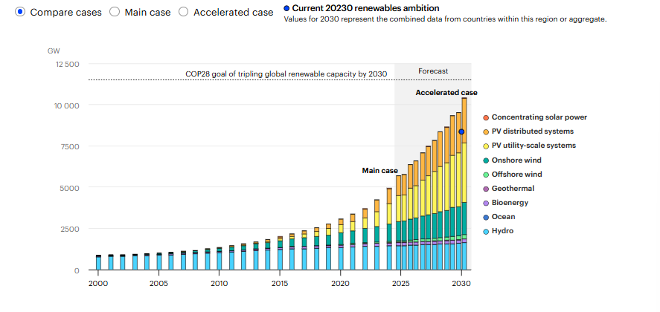
Figure 7: Renewables 2024: Analysis and Forecast to 2030
(Source: IEA, 2025)
If the above strategy is to be effective, Tata Steel needs to have a process of phased implementation of the strategy. To begin with, Tata Steel can concentrate on making low-carbon steel products for sectors which are highly committed to sustainable development. This makes products more likely to be accepted since environmental performance is a more important factor in the purchasing decision. Secondly, Tata Steel can strengthen its collaboration with technology partners, research institutes and Renewable Energy (RE) companies to promote innovations and minimise development expenses. Lastly, Tata Steel needs to boost its sustainability marketing by communicating carbon savings via a certification process and environmental reporting (Shaik, et al., 2025).
Ansoff Strategy | Recommendation for Tata Steel | Expected Competitive Advantage
Product Development | Continue to work on and market reduced carbon steel products to current industrial customers. | Product differentiation, better relationships with customers, sustainability leadership and long-term market competitiveness.
Table 2: Recommended Strategic Growth Approach for Tata Steel
But some of the risks may affect the successful implementation of this strategy. For instance, development of low-carbon steel will involve great financial costs, as well as the costs related to new technologies, which are currently too costly and unproven. In addition, customers' demand for high-cost green steel products may be lower than the expected consumption rate, resulting in low short-term profitability. Lastly, there is a possibility of a delayed transformation due to regulatory adjustments, varying energy costs and a lack of renewable energy resources (Olabi, et al., 2023). The above-listed threats prove the idea that innovation is not enough to gain a competitive advantage.
To avoid the identified threats, Tata Steel can conduct investments step by step, constantly monitor customers' needs and retain flexibility. This will enable the company to make strides towards gaining a competitive edge despite financial and technological challenges. To prevent these issues, Tata Steel can make a gradual investment and keep a check on market demand. This will give Tata Steel a competitive edge even amidst all the uncertainties that exist, in terms of finances and technology. It will allow Tata Steel to have a competitive edge by innovating in products and sustainable marketing strategies.

Task 3: Critical Reflection on AI Usage
The use of AI is to brainstorm ideas and enhance and organise the report. I used ChatGPT as an assistant for writing initial drafts, improving my writing, providing suitable headings based on the assessment criteria, and organising paragraphs. The use of AI helped clarify theoretical concepts, such as the marketing environment and Ansoff Matrix, and also helped systematically arrange my thoughts. I have made some edits and revisions to the final report in order to meet the assessment criteria and the understanding of the task, but not in any way that would mean changing the integrity of the work. Academic integrity in research writing is very important since it assures the validity of scientific knowledge, maintains ethical responsibility, and preserves intellectual property rights (Wedderkopp and Rutz, 2024).
Even though AI made the process of writing more efficient, the results provided by AI had to be checked to include them in the report. In this regard, I have applied the information obtained by AI using the support of reliable sources of the academic sphere, such as ‘Principles of Marketing by Kotler’, sustainability reports of Tata Steel and some other articles pertinent to the study. While analysing the results, I found some instances when AI provided some general information without having any evidence for that, especially about competitive strategy and innovations. Besides, descriptive content was revised into analytical content in some parts where it was generated by AI.
The presentation of arguments in the report has been done by myself, but for organising and structuring the report, I have used Artificial Intelligence. I have used AI to help with drafting paragraphs, which I am going to edit to add transitions and other changes as appropriate. It is, however, pertinent to say that my choice of Tata Steel, the use of marketing concepts, environmental aspects, Ansoff matrix strategy, and the comparison of the pioneer and the follower organisation have been based on my knowledge of academic sources and the information about the organisations.
The employment of AI in marketing analysis has many ethical and professional considerations. It is believed that AI will enhance efficiency and generate new ideas, there are potential issues that come with using AI too much, such as a lack of critical thinking and the risk of misinformation (Finn and Downie, 2025). The outputs from AI can either miss context or provide incorrect information if there is no proper assessment of the information provided by the AI. In this context, ethical concerns mean transparency regarding the use of AI, an external assessment of information, and acknowledging the role of AI (Ghosh, 2025). In the case of professional marketing, AI should not replace human decision-making processes, which are driven by ethics and critical analysis of the information.

References
ArcelorMittal Projects. (2026) XCarb: ArcelorMittal's Path to Carbon-Neutral Steel. [Online]. Available at: https://projects.arcelormittal.com/energy/sustainability/xcarb/ [Accessed on: 22-07-2026].
Babu, M.A., Rouf, M.A., Islam, M.R. and Islam, M. (2026) Examining the impact of green marketing practices on business performance: A synergistic application of resource-based view and triple bottom line theory. Plos one, 21(1), p.e0333026.
Borowiec, J., Papież, M. and Śmiech, S. (2024) The impact of environmental regulations on carbon emissions in countries with different levels of emissions. Environmental Science and Pollution Research, 31(59), pp.66759-66779.
Business Research Insights. (2026) Sustainable Products Market Size, Share, Growth. [Online]. Available at: https://www.businessresearchinsights.com/market-reports/sustainable-products-market-117731 [Accessed on: 22-07-2026].
CFI. (2020) Product Diversification. [Online]. Available at: https://corporatefinanceinstitute.com/resources/management/product-diversification/ [Accessed on: 22-07-2026].
Falahat, M., Chong, S.C. and Liew, C. (2024) Navigating new product development: Uncovering factors and overcoming challenges for success. Heliyon, 10(1).
Farida, I. and Setiawan, D. (2022) Business strategies and competitive advantage: the role of performance and innovation. Journal of open innovation: Technology, market, and complexity, 8(3), p.163.
Finn, T. and Downie, A. (2025) How does AI improve efficiency? [Online]. Available at: https://www.ibm.com/think/insights/how-does-ai-improve-efficiency [Accessed on: 22-07-2026].
Ghosh, M. (2025) Artificial intelligence (AI) and ethical concerns: a review and research agenda. Cogent Business & Management, 12(1), p.2551809.
IBM. (2026) How to build a successful product development strategy. [Online]. Available at: https://www.ibm.com/think/insights/product-development-strategy [Accessed on: 22-07-2026].
IEA. (2025) Renewable Energy Progress Tracker. [Online]. Available at: https://www.iea.org/data-and-statistics/data-tools/renewable-energy-progress-tracker [Accessed on: 22-07-2026].
Jerab, D. and Mabrouk, T. (2023) Strategic excellence: Achieving competitive advantage through differentiation strategies. Available at SSRN 4575042.
Kim, W. and Sohn, I. (2022) Critical challenges facing low carbon steelmaking technology using hydrogen direct reduced iron. Joule, 6(10), pp.2228-2232.
Kohitlhetse, I. and Chiririwa, H. (2026) Emerging Trends and Opportunities in Hydrogen-Based Direct Reduction for Sustainable Low-Carbon-Emission Steelmaking. Processes, 14(10), p.1529.
Kotler, P., Armstrong, G., Harris, L. C. and He, H. (2019) Principles of Marketing. United Kingdom: Pearson Education.
Mallett, A. and Pal, P. (2022) Green transformation in the iron and steel industry in India: Rethinking patterns of innovation. Energy Strategy Reviews, 44, p.100968.
Olabi, A.G., Elsaid, K., Obaideen, K., Abdelkareem, M.A., Rezk, H., Wilberforce, T., Maghrabie, H.M. and Sayed, E.T. (2023) Renewable energy systems: Comparisons, challenges and barriers, sustainability indicators, and the contribution to UN sustainable development goals. International Journal of Thermofluids, 20, p.100498.
Peterdy, K. (2022) Ansoff matrix. [Online]. Available at: https://corporatefinanceinstitute.com/resources/management/ansoff-matrix/ [Accessed on: 22-07-2026].
Shaik, A.S., Alsabban, A., Kautish, P. and Yaqub, M.Z. (2025) Moving markets towards climate change for sustainable development: comprehending strategic insights for efficient marketing communication. Sustainable Futures, 9, p.100428.
SSAB. (2026) Fossil-free steel- Leading the green transition. [Online]. Available at: https://www.ssab.com/en/fossil-free-steel [Accessed on: 22-07-2026].
SSAB. (2026) HYBRIT®. A new revolutionary steelmaking technology. [Online]. Available at: https://www.ssab.com/en/fossil-free-steel/insights/hybrit-a-new-revolutionary-steelmaking-technology https://www.ssab.com/en/fossil-free-steel/insights/hybrit-a-new-revolutionary-steelmaking-technology [Accessed on: 22-07-2026].
Steel Ministry. (2025) Greening the Steel Sector in India Roadmap and Action Plan. [Online]. Available at: https://steel.gov.in/sites/default/files/2025-03/GSI%20Report.pdf [Accessed on: 22-07-2026].
Tata Steel. (2026) Circular Economy. [Online]. Available at: https://www.tatasteel.com/sustainability/environment/circular-economy/ [Accessed on: 22-07-2026].
Tata Steel. (2026) Climate Change Report. [Online]. Available at: https://www.tatasteel.com/investors/integrated-report-2023-24/climate-change-report.html [Accessed on: 22-07-2026].
Tata Steel. (2026) Tata Steel Inaugurates its first Scrap-based Electric Arc Furnace in India. [Online]. Available at: https://www.tatasteel.com/newsroom/press-releases/india/2026/tata-steel-inaugurates-its-first-scrap-based-electric-arc-furnace-in-india/ [Accessed on: 22-07-2026].
The World Economic Forum. (2021) Mission 2070: A Green New Deal for a Net Zero India. [Online]. Available at: https://www3.weforum.org/docs/WEF_Mission_2070_A_Green_New_Deal_for_a_Net_Zero_India_2021.pdf [Accessed on: 22-07-2026].
Wedderkopp, N. and Rutz, E. (2024) Scientific integrity and transparency in academic writing: the foundation of credible science. Children, 11(10), p.1191.
World Steel Association. (2026) Climate change and the production of iron and steel-2025. [Online]. Available at: https://worldsteel.org/climate-action/climate-change-and-the-production-of-iron-and-steel/ [Accessed on: 22-07-2026].

